

**A project Report on**

**JUSTDIAL WEBSITE USING AUTOMATION TOOL SELENIUM WEBDRIVER WITH JAVA**

**By**

**Bhuvani Kaveri**

**Batch-EON (2021-5533)**

**Under the Guidance of,**

**Amruta Deore**

**(Technical Trainer)**

**EduBridge India Pvt. Ltd.**

**Introduction:**

This Project aims to do overall testing like functional testing, GUI testing on Justdial website to check quality of application using selenium web driver. It helps to improve quality of website and saves time for manually doing this testing.

In this project our main focus is to test the Books Module and Modular Kitchen module. The Justdial website that provides local search for different services in India over the phone, website and mobile apps.

**Software Requirements:**

Operating System: Windows 10

Browser: Latest version of Google Chrome

Platform: Eclipse IDE

Automation Tool and Language: Selenium WebDriver, Java

Files: JDK, Selenium Jar files, Common IO file

1. **JUSTDIAL MODULE**

**TC01:** Launch the browser and Justdial website

**Selenium WebDriver Test Script:**

WebDriver driver = **new** ChromeDriver();

driver.manage().window().maximize();

driver.get("https://www.justdial.com/");

System.***out***.println("Navigated to the application");

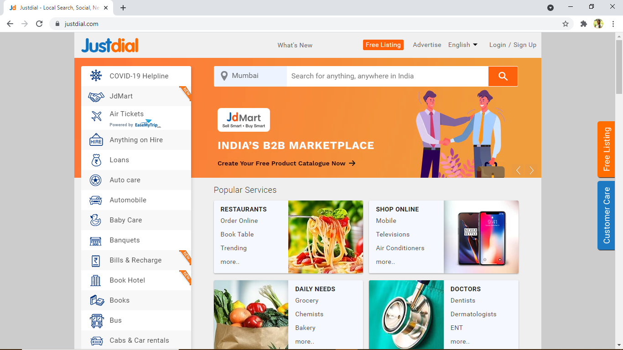

**TC02:** To verify the functionality of Justdial website logo

**Selenium WebDriver Test Script:**

//To click on the "Justdial" logo on the upper left portion

driver.findElement(By.*xpath*("//header/section[1]/div[1]/div[1]/span[1]/a[1]/img[1]")).click();

System.***out***.println("We are at Justdial's homepage");

**TC03:** To verify and display the URL of Current page of browser.

**Selenium WebDriver Test Script:**

driver.getCurrentUrl();

System.***out***.println("Current URL IS:"+driver.getCurrentUrl());

**TC04:** To verify and display the Title of the current page.

**Selenium WebDriver Test Script:**

driver.getTitle();

System.***out***.println("Title of page is:" + driver.getTitle());

**TC05:** To verify the functionality of Scrolldown

**Selenium WebDriver Test Script:**

//scrolldown

JavascriptExecutor js = (JavascriptExecutor) driver;

js.executeScript("window.scrollBy(0,1000)");

System.***out***.println("Scroll down");

Thread.*sleep*(2000);

**TC06:** To verify the functionality of Scroll up

**Selenium WebDriver Test Script:**

//scroll up

js.executeScript("window.scrollBy(0,-1000)");

System.***out***.println("Scroll up");

**TC07:** To verify the functionality of Book module from the dropdown

**Selenium WebDriver Test Script:**

//Dropdown selection

WebElement book=driver.findElement(By.*id*("hotkeys_text_11"));

book.click();

WebElement allbk=driver.findElement(By.*xpath*("//header/div[2]/div[1]/div[1]/div[1]/div[1]"));

allbk.click();

WebElement drop = driver.findElement(By.*id*("id_1007"));

drop.click();

System.***out***.println("Selected Computing, Internet & Digital Media from dropdown menu");

Thread.*sleep*(2000);

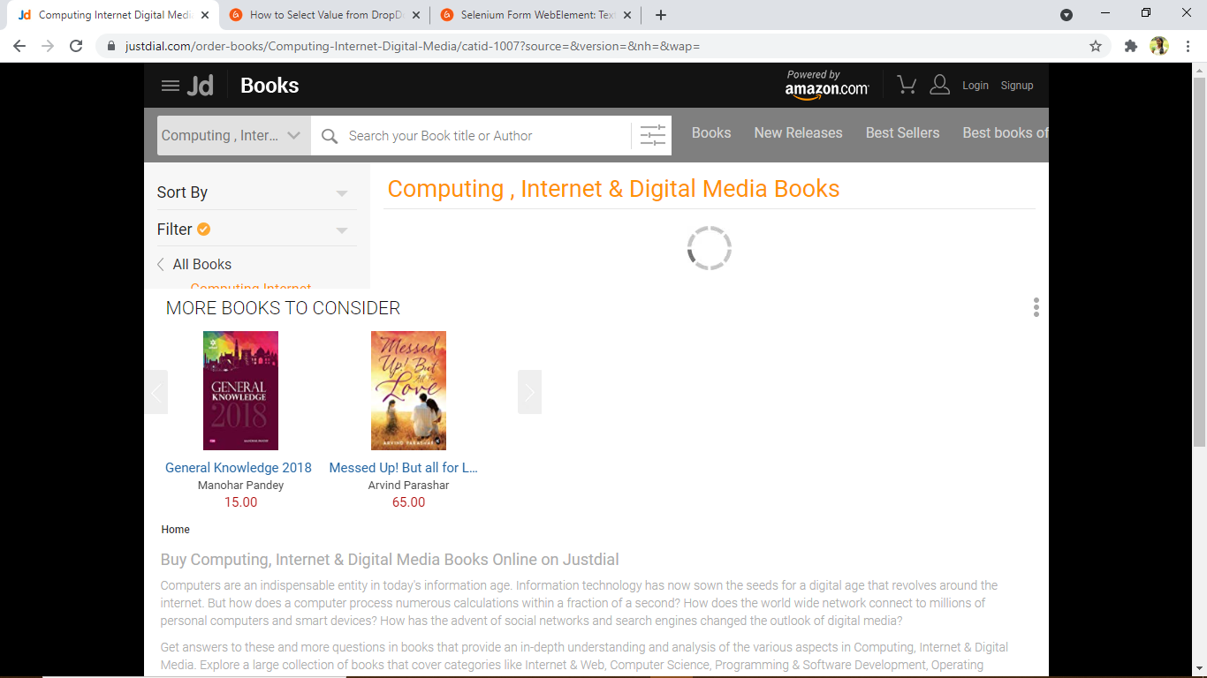

**TC08:** To verify the functionality of Navigating back

**Selenium WebDriver Test Script:**

//navigating to webpage

driver.navigate().to(“https://www.justdial.com/”);

System.***out***.println("Navigating back to Justdial");

**TC09:** To verify the checkbox button

**Selenium WebDriver Test Script:**

//Check box menu selection

WebElement kitchen=driver.findElement(By.*id*("hotkeys_text_43"));

kitchen.click();

System.***out***.println("Modular Kitchen");

driver.findElement(By.*xpath*(" //body/div[@id='']/div[2]/div[1]/div[2]/ul[1]/li[8]/a[1]")).click();

System.***out***.println("Navigating to modular Kitchen Homepage");

Thread.*sleep*(600);

driver.findElement(By.*id*("103")).click();

driver.findElement(By.*id*("122")).click();

driver.findElement(By.*id*("1037")).click();

driver.findElement(By.*id*("64560")).click();

System.***out***.println("Selected checkbox for various display option for modular kitchen");

Thread.*sleep*(2000);

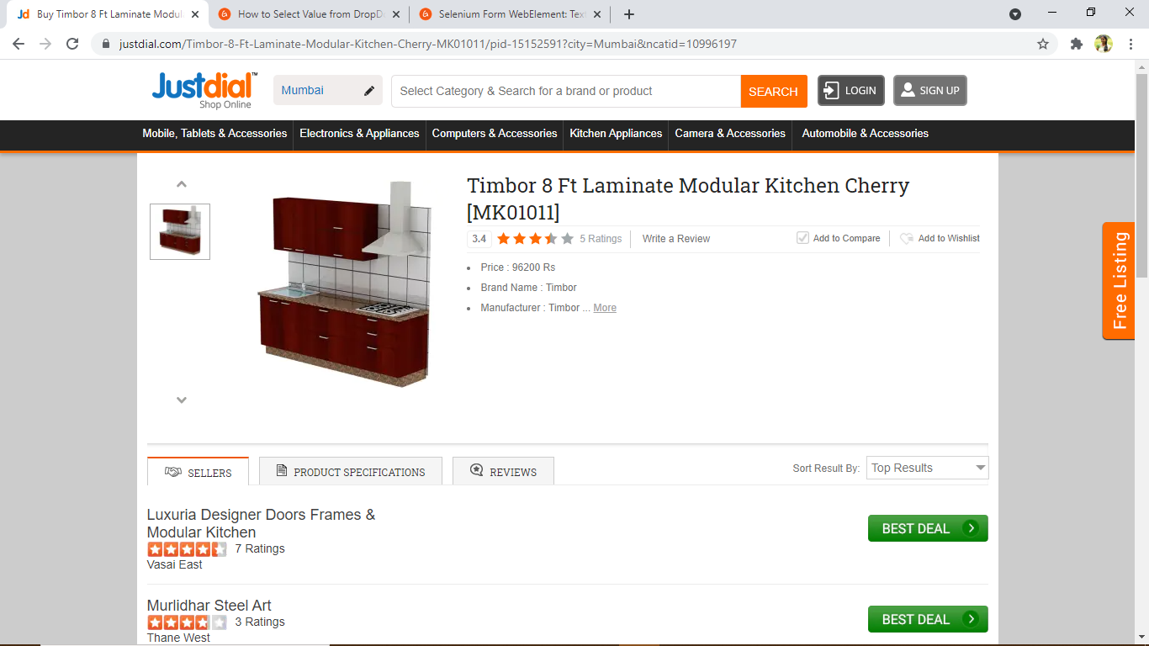

**TC10:** To verify the functionality of navigating back to home page and selecting Modular Kitchen module

//scroll up

js.executeScript("window.scrollBy(0,-1000)");

System.***out***.println("Scroll up");

driver.findElement(By.*xpath*("//body/article[1]/section[1]/section[1]/div[2]/div[8]/div[2]/a[1]/div[1]/div[2]")).click();

System.***out***.println("Modular Kitchen:Timbor 8 Ft Solid Wood Modular Kitchen Walnut");

Thread.*sleep*(500);

**TC11:** To verify the functionality of navigating to homepage

**Selenium WebDriver Test Script:**

//Navigating back to homepage

driver.navigate().to("https://www.justdial.com/");

System.***out***.println("Navigating back to homepage of justdial");

Thread.*sleep*(2000);

**TC12:** To verify and display the number of links available on page.

**Selenium WebDriver Test Script:**

List<WebElement> Links= driver.findElements(By.*tagName*("a"));

**int** Total_links=Links.size();

System.***out***.println("Total links are:" + Total_links);

**TC13:** To verify that browser is able to close.

**Selenium WebDriver Test Script:**

driver.close();