Unified Student Project Platform for Multiple Colleges online
A Project Report Submitted by
Akash Singh (2115000102)
Bhupender Singh (2115000300)
Bhuvan Tenguria (2115000302)
Kavya Sharma (2115000525)
in partial fulfillment for the award of the degree of
Bachelor of Technology

IN
Computer Science and Engineering

Under
Department of Computer Engineering & Applications


GLA University Mathura- 281406, INDIA Nov 2023



BONAFIDE CERTIFICATE

Certified that this project report “Unified Student Project Platform for multiple colleges” is the Bonafide work of “Akash Singh (2115000102), Bhupender Singh (2115000300), Bhuvan Tenguria (2115000302), Kavya Sharma (2115000525)” who carried out the project work under my/our supervision.

SIGNATURE SIGNATURE

Dr. Rohit Agarwal Ms. Robin Khurana (Head of Department) (Supervisor)

Submitted for the project viva-voce examination held on
……………….

INTERNAL EXAMINER EXTERNAL EXAMINAR

Table Of Contents:

Sr.no | Content | Page No.
1. | Abstract | 6
2. | Chapter 1: Introduction  - Objective  - Summary of similar application  - Gantt chart  - Flowchart | 7-8
3. | Chapter 2: Software Requirement Analysis  - 2.1 Functional Requirements  - 2.2 Non-functional Requirement  - 2.3 Constraints | 9-10
4 | Chapter 3: Software Design  - 3.1 Architectural Design  - 3.2 Detailed Design  - 3.3 Database Design  - 3.4 Security Design  - 3.5 Concurrency Design  - 3.6 Error Handling and Logging Design | 11-13

5 | Chapter 4: Implementation  - 4.1 Setup Development Environment  - 4.2 Front-End Development  - 4.3 Back-End Development  - 4.4 Security Implementation  - 4.5 Collaboration and Interaction features | 13-16
6 | Software Testing | 16
7 | Drawback | 17
8 | Conclusion | 18
9 | Summary | 19
10 | References | 20

List of Figures:
- Fig.1. 1 Gantt Chart
- Fig.1.2 Flowchart

Acknowledgment

We extend our sincere appreciation to Mrs. Robin Khurana, our esteemed project mentor, whose unwavering encouragement, guidance, and assistance have been instrumental in the successful completion of this project. Additionally, we express our gratitude to our dedicated team members for their unwavering support, contributing significantly to the accurate and timely realization of the project objectives. This endeavor has not only augmented our technical proficiency but has also cultivated a heightened sense of maturity in thought and vision, qualities essential for professional growth. We are grateful for the invaluable insights gained from this experience under Mrs. Robin Khurana's mentorship and the collaborative efforts of our team members.

ABSTRACT

In the dynamic realm of higher education, the Unified Student Project Platform for Multiple Universities/Colleges Online emerges as a transformative initiative to reshape the landscape of collaborative learning in Indian universities and colleges. This pioneering platform aims to create a centralized hub where students, faculty, and institutions can converge to share, explore, and collaborate on innovative academic projects. By harnessing the power of advanced web development technologies, robust security measures, and cutting-edge plagiarism detection tools, the platform seeks to redefine the traditional boundaries of academic engagement.
The core objective of this project is to establish a comprehensive online ecosystem that transcends institutional silos, allowing students to showcase their academic prowess, receive feedback, and foster cross-institutional collaboration. The platform envisions becoming a repository of knowledge, providing a unique space for the submission, categorization, and exploration of diverse projects across various technical and higher educational institutes in India.

The methodology involves a meticulous blend of front-end and back-end development, coupled with database management and security measures. Plagiarism detection tools are seamlessly integrated to uphold academic integrity, ensuring the originality of submitted projects. The proposed system outlines a structured workflow, from user registration and project submission to categorization, collaboration, and continuous improvement, fostering a user-centric and engaging experience.
Envisaging a diverse user base, the platform caters to the unique needs of students, faculty, and institutions. Through features such as project submission, categorization, search and discovery, and collaboration opportunities, the platform aims to enrich the learning experience for all stakeholders. The implementation plan is strategically phased, with a dedicated team of project managers, developers, designers, and quality assurance specialists working collaboratively to deliver a fully functional platform.

Drawing inspiration from government reports, educational policies, technology-specific resources, and plagiarism detection services, the project is grounded in a well-researched foundation. The anticipated outcomes include a fully operational platform with features such as user registration, project submission, categorization, plagiarism detection, user profiles, collaboration opportunities, analytics, and more.

Under the expert guidance of Mrs. Robin Khurana, a seasoned technical trainer, this project is poised to contribute significantly to the evolution of collaborative learning in Indian higher education. As the subsequent sections delve into the specifics of the methodology, features, implementation plan, and team dynamics, this abstract provides a comprehensive overview of the ambitious endeavor to create a Unified Student Project Platform that transcends institutional boundaries and fosters a culture of knowledge exchange and innovation.

Chapter 1: Introduction

In the rapidly evolving landscape of higher education, fostering innovation and collaboration among students is pivotal for academic growth and excellence. Recognizing the significance of project-based learning, our initiative embarks on the development of a groundbreaking platform - the Unified Student Project Platform for Multiple Universities/Colleges Online. This project aims to revolutionize the way students from diverse educational institutions in India engage with academic projects by providing a centralized, integrated, and secure online environment.

Objective

The primary objective of this initiative is to create a unified knowledge-sharing platform, transcending geographical and institutional boundaries. By establishing a common ground for students, faculty, and institutions, we aspire to cultivate a vibrant ecosystem that encourages the submission, exploration, and collaboration on innovative academic projects. Through the implementation of cutting-edge technology, robust security measures, and a commitment to academic integrity, this platform seeks to redefine the landscape of collaborative learning.

Summary of Similar Applications

In the realm of collaborative learning, platforms like GitHub Education and Google Classroom have excelled in facilitating collaborative coding and classroom interaction, respectively. ResearchGate and Academia.edu focus on academic networking and research sharing, providing spaces for researchers to connect and share publications. Turnitin remains a cornerstone for maintaining academic integrity through robust plagiarism
detection.

Gantt Chart
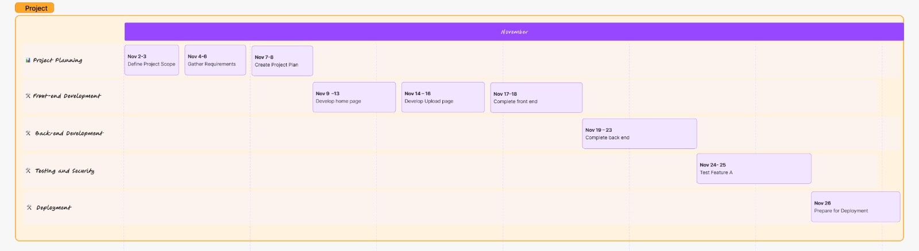
Flowchart

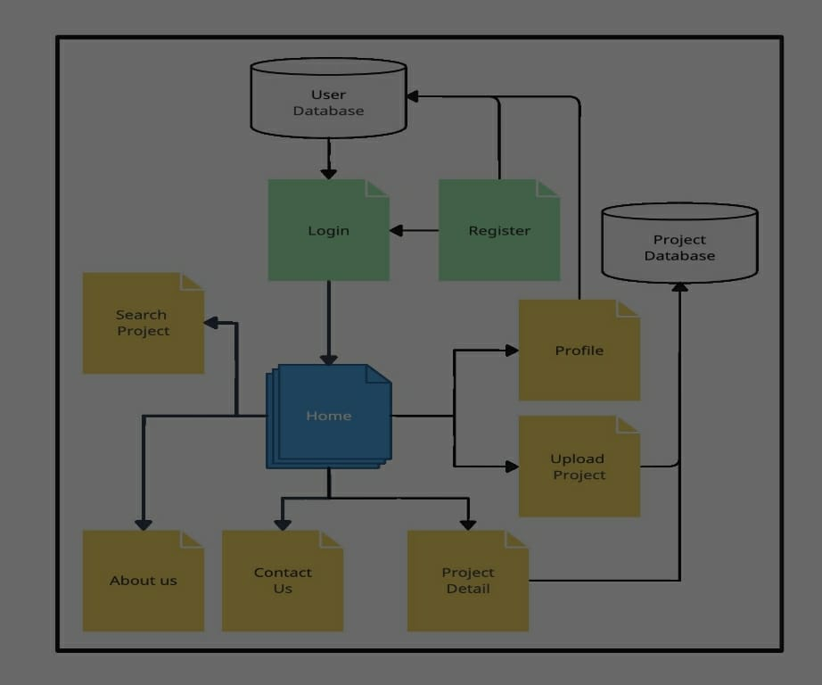

Chapter 2: Software Requirement Analysis

1. Functional Requirements:
1.1 Project Submission Module:
1.1.1 User Registration:
Users (students, faculty, institutions) can register with the platform.
- Registration details include username, email, password.
1.1.2 Project Submission Form:
- Users can submit projects with detailed descriptions, objectives, methodologies, and supporting documents.
1.1.3 Categorization and Tagging:
- Projects are categorized based on discipline, keywords, and meta data.
1.2 Discussion Forums:
- Discussion forums for in-depth project discussions.
- Option to initiate and participate in discussions.
1.3 Collaboration Module:
1.3.1 Connecting Users:
- Students interested in similar projects can connect and collaborate.
- Private messaging and collaboration requests.
1.3.2 Group Collaboration Tools:
- Shared document editing, group discussions, and task assignment.
2. Non-functional Requirements:
2.1 Security and Privacy:
2.1.1 Data Encryption:
- Ensure data transmission and storage encryption.

2.1.2 Access Controls:
- Permission-based access controls for project visibility.
2.2 Performance:
2.2.1 Platform Responsiveness:
- Ensure the platform is accessible and responsive across various devices.
- Optimize for performance to handle concurrent users.
2.3 Scalability:
2.3.1 Future Growth:
- Design the platform to accommodate a growing user base.
2.4 Compliance:
2.4.1 Plagiarism Tool Compliance:
- Ensure compliance with the terms and conditions of integrated plagiarism detection tools.
3. Constraints:
3.1 Technology Stack:
- Platform must be developed using specified technologies (HTML, CSS, JavaScript, Node.js, etc.).
- Integration with Firebase for database management.

Chapter 3: Software Design

Overview of Software Design

1. Architectural Design:
1.1 System Architecture:
- A three-tier architecture: Front-end (user interface), Back- end (server and application logic), and Database (Firebase).
- Ensures separation of concerns and scalability.
1.2 Component Design:
- Components include Project Submission, Plagiarism Detection, User Interaction, Collaboration, Analytics, and Educational Resources.
- Each component has well-defined interfaces and responsibilities.

1.3 User Interface Design:
- Responsive design using React.js for the front-end.
- Focus on an intuitive and user-friendly interface for project submission and interaction.

2. Detailed Design:
2.1 Class and Object Design:
- Classes include User, Project, Comment, Rating, and Collaboration.
- Objects represent instances of users, submitted projects, and collaborative activities.
2.2 Algorithm Design:
- Algorithms for plagiarism detection integration.
- Efficient search and sorting algorithms for project discovery.

2.3 Data Structure Design:
- Use JSON data structures for efficient data representation.
- Employ arrays and linked lists for project categorization and user interactions.

3. Database Design:
3.1 Database Schema Design:
- Firebase real-time database schema with tables for Users, Projects, Comments, Ratings, and Collaborations.
- Normalized structure to ensure data consistency.
3.2 Database Query Design:
- Optimized queries for efficient project search and retrieval.
- Indexing on critical fields for improved performance.

4. Security Design:
4.1 Authentication and Authorization:
- Firebase Authentication for user login.
- Role-based access control for different user types (students, faculty, institutions).
4.2 Data Security:
- Encryption of sensitive data during transmission.
- Firebase security rules to control access to database resources.

5. Concurrency Design:
5.1 Concurrent Processing:
- Address concurrent access to shared resources, such as collaborative project editing.
- Implement synchronization mechanisms to prevent conflicts.

6. Error Handling and Logging Design:
6.1 Error Handling Strategies:
- Graceful handling of exceptions during project submission and interaction.
- User-friendly error messages and detailed logs for debugging.
6.2 Logging Mechanism:
- Logging of critical events, such as new project submissions, collaboration requests, and plagiarism detection results.
- Facilitates auditing and system monitoring.

Chapter 4: Implementation and User Interface

1. Setup Development Environment:
- Install necessary integrated development environments (IDEs) such as Visual Studio Code.
- Set up version control systems like Git for collaborative coding.

2. Front-end Development:
2.1 User Interface (UI):
- Develop UI components using React.js, ensuring responsiveness.
- Implement user registration, project submission forms, and interactive features.
2.2 Integration with Back-end:
- Establish communication between the front-end and back- end components.
- Ensure proper handling of user inputs and responses.

3. Back-end Development:
3.1 Server-side Logic:
- Develop server-side logic using Node.js and Express.js.
- Implement routing for user authentication, project submission, and other functionalities.
3.2 Database Integration:
- Integrate Firebase real-time database for efficient data storage.
- Implement CRUD (Create, Read, Update, Delete) operations for user profiles, projects, and interactions.

4. Security Implementation:
4.1 Authentication and Authorization:
- Implement Firebase Authentication for secure user login.
- Set up role-based access controls to restrict actions based on user roles.
4.2 Data Security:
- Ensure encryption of sensitive data during transmission.
- Implement Firebase security rules to control access to database resources.

5. Collaboration and Interaction Features:
5.1 User Collaboration:
- Implement features for users to connect and collaborate on projects.
- Develop messaging and notification systems for collaboration requests.
5.2 User Interaction:
- Integrate comment sections, ratings, and discussion forums for project interactions.
- Implement features for users to leave feedback and engage in discussions

6. Testing and Debugging:
6.1 Unit Testing:
- Conduct unit testing for individual components and functions.
- Ensure that each unit of code performs as expected.
6.2 Integration Testing:
- Test the integration of front-end and back-end components.
- Ensure seamless communication and data flow between different parts of the system.

7. Deployment:
7.1 Hosting:
- Choose a hosting platform for deployment (e.g., Firebase Hosting).
- Ensure proper configuration for the live environment.
7.2 Continuous Deployment:
- Implement continuous integration and continuous deployment (CI/CD) pipelines.
Automate the deployment process for efficient updates.

8. User Testing:
8.1 Beta Testing:
- Conduct beta testing with a selected group of users.
- Gather feedback on user experience, identify bugs, and make necessary improvements.
8.2 User Feedback Integration:
- Implement changes based on user feedback.
- Ensure that the platform meets the expectations of its intended users.

9. Documentation:
9.1 Code Documentation:
- Document the codebase for future maintenance and collaboration.
- Include inline comments and README files.

Chapter 5: Software Testing
The software testing strategy for the Unified Student Project Platform involves a comprehensive approach to ensure the reliability, functionality, and security of the system. The testing process begins with unit testing, where individual components, functions, and modules are tested in isolation to verify their correctness. Integration testing follows, validating the seamless interaction between the front-end and back-end components, with a particular focus on data flow and communication. Plagiarism detection integration undergoes thorough testing to guarantee accurate and reliable results, ensuring that the platform upholds academic integrity. Security testing includes authentication and authorization checks, encryption verification, and validation of role-based access controls. User collaboration and interaction features are rigorously tested through user scenarios, including connection requests, collaborative project editing, and feedback mechanisms. The deployment process is evaluated using continuous integration and deployment pipelines to guarantee a smooth transition to the live environment. Beta testing involves real users gathering feedback on user experience, identifying any usability issues, and ensuring the platform aligns with user expectations. Throughout the testing phase, documentation is updated to reflect any changes made, providing clear guidelines for future maintenance. This holistic testing strategy aims to deliver a robust, secure, and user-friendly Unified Student Project Platform that meets the diverse,
Need of its users in Indian universities.

Chapter 6: Drawback

Despite its potential benefits, the Unified Student Project Platform comes with several drawbacks. Plagiarism detection tools may not be foolproof, leading to false negatives or positives. Privacy concerns may arise due to the storage of sensitive academic information, and dependency on external services introduces reliability issues. User adoption challenges, technical complexities, and the burden of long-term maintenance pose additional risks. Overload on the platform and resistance from educational institutions are potential obstacles, as are difficulties in managing a diverse array of project types. Lastly, accessibility issues in regions with limited internet connectivity may hinder effective platform utilization. Mitigation strategies involve fine-tuning plagiarism detection algorithms, implementing robust security measures, providing comprehensive user training, and addressing technical challenges through rigorous testing and monitoring. Additionally, open communication with educational institutions, customization features, and offline capabilities can help address resistance and accessibility concerns.

Chapter 7: Conclusion

In conclusion, the Unified Student Project Platform presents a promising solution to enhance collaboration and knowledge exchange among students in Indian universities. By providing a centralized hub for project submissions, the platform aims to foster innovation and academic excellence. However, potential challenges such as the reliability of plagiarism detection tools, data privacy concerns, and the need for widespread user adoption must be carefully addressed. The success of the platform hinges on effective mitigation strategies, including continuous improvement, robust security measures, and tailored user training. The collaboration between educational institutions and the active engagement of users will play pivotal roles in overcoming resistance and ensuring the platform's success. As the project moves forward, a vigilant approach to maintenance, updates, and responsiveness to user feedback will be crucial to its sustained impact on the academic community. Overall, the Unified Student Project Platform represents a commendable effort to create a dynamic and collaborative space for students across diverse institutions, contributing to the advancement of academic research and innovation in India

Chapter 8: Summary

The Unified Student Project Platform proposes a centralized hub for project submissions, aiming to enhance collaboration and knowledge exchange among students in Indian universities. The platform addresses the need for a common space for academic projects, promoting innovation. However, challenges such as the reliability of plagiarism detection, data privacy concerns, and user adoption need careful consideration. Mitigation strategies include continuous improvement, robust security measures, and tailored user training. Success relies on collaboration with educational institutions and user engagement. As the project progresses, maintenance, updates, and responsiveness to feedback will be crucial for sustained impact, making the platform a commendable effort to foster academic research and innovation in India.

Chapter 9: REFERENCES

- Government Reports and Education Policies:
National Education Policy (NEP) - To align the project with the national education strategy and understand its implications for technology in education.
- Technology-Specific Resources: -
- MDN Web Docs and W3Schools for HTML, CSS, and JavaScript reference.
- https://developer.mozilla.org/en-US/
- https://www.w3schools.com/
- Firebase Documentation for Authentication, Database, Storage and Fire store.
- https://firebase.google.com/docs/auth
- Fire Store:
- https://firebase.google.com/docs/firestore
- Youtube:
- https://www.youtube.com/results?search_query=Full+Stack
- GitHub:
- GitHub - https://github.com/DERNbhupender/project_unity

