**Chapter 1**

**INTRODUCTION**

**1.1 OVERVIEW**

In an era where financial stability and independence are paramount, managing personal finances has become more critical than ever. Individuals are increasingly seeking ways to monitor their income, control their spending, save effectively, and invest wisely. The complexity of modern financial ecosystems, coupled with diverse income sources and varied expenses, necessitates the use of robust financial management tools.

A Personal Finance Tracker emerges as an essential solution to these challenges. It is a digital tool designed to help users systematically track and manage their financial activities. From recording daily expenses and incomes to monitoring savings and investments, a personal finance tracker provides a holistic view of one’s financial health. This comprehensive approach to financial management allows users to make informed decisions, plan for the future, and achieve their financial goals.

The functionality of a personal finance tracker extends beyond simple record-keeping. It offers features such as budgeting tools, debt management, and financial analytics. Budgeting tools help users allocate their income effectively, ensuring that spending aligns with financial goals. Debt management features provide insights into outstanding debts, payment schedules, and strategies for debt reduction. Financial analytics generate reports and visualizations that offer deep insights into spending patterns, income trends, and overall financial status.

Moreover, the convenience of accessing these tools on multiple platforms, including web and mobile applications, means users can manage their finances anytime and anywhere. Enhanced security features ensure that users' sensitive financial information is protected, providing peace of mind in an increasingly digital world.

In essence, a Personal Finance Tracker is not just a tool but a companion in the journey towards financial well-being. It empowers individuals to take control of their finances, paving the way for a secure and prosperous future.

**1.2 PROBLEM STATEMENT**

Individuals often face difficulties in managing their personal finances due to the following challenges:

1. **Lack of Awareness**: Many people are unaware of where their money is going, leading to unplanned expenditures and poor saving habits.
2. **Time-Consuming**: Manually tracking expenses and income can be time-consuming and error-prone.
3. **Ineffective Budgeting**: Without proper tools, creating and sticking to a budget is challenging, which can result in financial stress and difficulty in achieving financial goals.
4. **Poor Investment Tracking**: Keeping track of investments, their performance, and returns is often complicated and can lead to missed opportunities or losses.
5. **Unclear Financial Insights**: Many users lack clear insights into their financial health, making it difficult to make informed financial decisions.

**1.3 INTRODUCTION TO NODE JS**

Node.js is an open-source, cross-platform runtime environment that allows developers to run JavaScript on the server side. It was developed by Ryan Dahl in 2009, and it revolutionized web development by enabling JavaScript to be used for server-side scripting.

**Key Features of Node.js**

**Event-Driven and Non-Blocking I/O**: Node.js uses an event-driven, non-blocking I/O model that makes it lightweight and efficient. This is particularly useful for real-time applications that handle a large number of simultaneous connections.

1. **Single Programming Language**: With Node.js, developers can use JavaScript for both the client-side and server-side, leading to more consistent and maintainable codebases.
2. **NPM (Node Package Manager)**: Node.js comes with NPM, the largest ecosystem of open-source libraries, which provides thousands of packages and modules to speed up development.
3. **Scalability**: Node.js is designed to build scalable network applications. Its non-blocking I/O and asynchronous event handling enable it to handle thousands of concurrent connections with minimal overhead.

#### **Architecture**

Node.js is built on the V8 JavaScript engine, the same engine used by Google Chrome. Its architecture is designed around the event loop, which allows Node.js to perform non-blocking I/O operations. Here’s a simplified overview of how it works:

1. **Event Loop**: Node.js operates in a single-threaded environment but uses an event loop to handle asynchronous operations. The event loop continuously checks the call stack and the task queue for tasks to execute.
2. **Callbacks**: Node.js relies heavily on callbacks to handle asynchronous operations. When an operation completes, the callback function is called.
3. **Libuv**: Node.js uses the libuv library to abstract non-blocking I/O operations. This library provides a mechanism to handle file system, networking, and other I/O operations asynchronous.

**1.3 APPLICATION**

Node.js is versatile and powerful, making it suitable for a wide range of applications. Here are some key areas where Node.js excels:

#### **1. Real-Time Applications**

**Example**: Chat applications, live updates, collaboration tools.

* **Reason**: Node.js's non-blocking I/O and event-driven architecture make it ideal for handling multiple simultaneous connections in real-time applications.
* **2. APIs and Microservices**
* **Example**: RESTful APIs, GraphQL APIs.
* **Reason**: Node.js is lightweight and efficient, making it perfect for creating scalable APIs and microservices. It can handle a large number of requests without significant overhead.

#### **3. Single-Page Applications (SPAs)**

**Example**: Web applications using React, Angular, or Vue.js.

* **Reason**: Node.js can be used with frontend frameworks to create SPAs that offer a seamless user experience. Tools like Webpack and Babel run on Node.js to compile and bundle frontend assets.

#### **4. Streaming Applications**

**Example**: Media streaming services, data streaming platforms.

* **Reason**: Node.js's ability to handle streaming data makes it suitable for applications that require real-time processing and transfer of data.

#### **5. IoT (Internet of Things) Applications**

**Example**: Smart home systems, sensor networks.

* **Reason**: Node.js can handle multiple concurrent connections and process data in real-time, making it suitable for IoT applications that require quick data processing and communication between devices.

#### **6. Command-Line Tools**

**Example**: Development tools, task runners.

* **Reason**: Node.js provides a rich ecosystem of libraries and modules that can be used to build command-line tools, making it easy to automate tasks and improve developer productivity.

#### **7. Serverless Computing**

**Example**: AWS Lambda, Azure Functions, Google Cloud Functions.

* **Reason**: Node.js functions can be deployed in serverless architectures, allowing developers to run code in response to events without managing servers.

**1.4 INTRODUCTION TO REACT**

React is a popular JavaScript library for building user interfaces, particularly single-page applications where the user interacts with a dynamic web page without needing to reload the page. Created by Facebook, React enables developers to create large web applications that can update and render efficiently in response to data changes.

#### **Key Features of React:**

1. **Component-Based Architecture**: React builds encapsulated components that manage their own state, making it easy to build complex UIs from simple components.
2. **Virtual DOM**: React uses a virtual DOM to optimize updates and rendering, improving performance.
3. **JSX Syntax**: JSX is a syntax extension that allows mixing HTML with JavaScript, making code more readable and easier to write.
4. **Unidirectional Data Flow**: React ensures that data flows in a single direction, making the application more predictable and easier to debug.
5. **Strong Ecosystem**: React has a rich ecosystem with libraries like React Router for navigation and Redux for state management.

#### **Creating a React App:**

Creating a React application is streamlined using the Create React App tool, which sets up the development environment quickly without any configuration.

### Step-by-Step Guide to Creating a React App:

#### Step 1: Install Node.js and npm

Ensure that you have Node.js and npm (Node Package Manager) installed on your system. You can download and install them from [nodejs.org](https://nodejs.org/).

#### Step 2: Install Create React App

Create React App is a tool that sets up a new React project with a sensible default configuration. Install it globally using npm:

#### Step 3: Create a New React App

Use the Create React App tool to set up a new React project:

This command will create a directory named my-react-app and generate a new React project with the necessary files and dependencies.

#### Step 4: Navigate to the Project Directory

#### Step 5: Start the Development Server

Start the development server, which will automatically open your new React application in the browser:

This command runs the app in development mode. Open http://localhost:3000 to view it in the browser.

### **Understanding the Project Structure:**

The Create React App sets up a basic project structure:

* **public/**: Contains static files, such as index.html where the React app is rendered.
* **src/**: Contains the source code for the React application.
  + **App.js**: Main component where the application code resides.
  + **index.js**: Entry point for the React application, rendering the App component into the DOM.
* **node_modules/**: Contains all the dependencies for the project.
* **package.json**: Lists the project dependencies and scripts for running the application.

**Chapter 2**

**LTERATURE SURVEY**

**2.1 INTRODUCTION**

A literature survey, also known as a literature review, is an essential part of academic research that involves a comprehensive examination and synthesis of existing scholarly work on a particular topic. It aims to provide a critical assessment of the state of the art, identify gaps in the current knowledge, and offer a theoretical framework for new research. Here’s an introduction to the purpose, process, and significance of a literature survey.

The main role of writing the review is to give a thorough comprehension of the present status of the information on a given point, including key speculation, ideas, observational, discoveries, systems and discussions

**2.2 RELATED WORK**

The prevalent view in various global circles is that man is presently living in an age growth of information gathering, processing and dissemination, popularly called the information age. For this reason, managers and other users of information especially in client services are demanding more kinds of information to support management and operations. They must therefore respond to the increasing requirement for information and data management. E-service, gives evidence that their holders have the permission to enter a place of entertainment, use a means of communication, or have access to some Internet services. The design of this online system will be beneficial to the company to make the user experience more robust. Therefore, client handling Company, a viable investment owned by the state government whose primary objectives are: to spread comfort and hospitality to client away from their home, to make profit, will definitely appreciate a system which can automate its manual operations in the area in order to meet customers increasing demand during peak and off-peak seasons. The ultimate expectation is to inspire a feasibility study aimed at providing proper guidance and awareness to any future potential investors, particularly those in the bus industry, to consider utilizing the services, as a gateway to the fertile soil of unlimited opportunities in the south-east Nigeria. Currently, staffs at the client managing counter is using an internal system to sell services at the counter and customers who are unable to use the services online.

**2.3 WHO WILL BENEFIT FROM THIS ?**

The Personal Finance Tracker is designed to assist a wide range of individuals in managing their finances more effectively. Here’s a detailed look at who will benefit from using this application:

#### 1. **Young Professionals**

* **Benefits**: Young professionals often face the challenge of managing their income and expenses as they begin their careers. The Personal Finance Tracker helps them:
  + Track monthly expenses and income.
  + Create and adhere to budgets.
  + Set and achieve savings goals.
  + Monitor debt and plan repayments.
* **Example**: A recent college graduate can use the app to manage student loan payments, save for future investments, and avoid unnecessary expenditures.

#### 2. **Families and Couples**

* **Benefits**: Managing combined finances can be complex for families and couples. The app provides tools to:
  + Combine and track multiple sources of income and expenses.
  + Create family budgets and track spending against them.
  + Save for family-related goals such as vacations, education, and emergency funds.
* **Example**: A family can use the app to manage their household budget, ensuring that they save for a child’s education while also managing day-to-day expenses.

#### 3. **Students**

* **Benefits**: Students often have limited budgets and need to manage their finances carefully. The app helps them:
  + Track part-time job earnings and monthly allowances.
  + Manage daily expenses and stay within their budget.
  + Save for specific goals such as tuition fees or study materials.
* **Example**: A university student can use the app to track spending on food, books, and entertainment, ensuring they stay within their budget.

#### 4. **Retirees**

* **Benefits**: Retirees need to manage their savings and pensions to ensure financial stability in their post-working years. The app assists them in:
  + Tracking pension income and savings withdrawals.
  + Managing healthcare and living expenses.
  + Monitoring investments and their performance.
* **Example**: A retiree can use the app to ensure that their retirement savings are sufficient to cover their expenses, and to keep track of medical and leisure expenses.

#### 5. **Small Business Owners**

* **Benefits**: Small business owners often need to manage both personal and business finances. The app can help them:
  + Separate personal and business expenses.
  + Track business income and expenses.
  + Plan for business investments and tax payments.
* **Example**: A freelancer can use the app to track earnings from various projects, manage business-related expenses, and save for tax payments.

#### 6. **Individuals with Irregular Income**

* **Benefits**: Those with irregular income, such as freelancers, artists, or gig workers, need to manage their finances carefully to ensure stability. The app supports them by:
  + Tracking variable income from multiple sources.
  + Creating flexible budgets that can adjust to income fluctuations.
  + Setting aside savings during high-income periods to cover low-income periods.
* **Example**: A freelance graphic designer can use the app to manage payments from different clients, track expenses, and save for future projects.

#### 7. **People in Debt**

* **Benefits**: Individuals looking to manage and pay off their debts can use the app to:
  + Track all debts in one place.
  + Plan and monitor debt repayments.
  + Set goals for debt reduction and track progress.
* **Example**: Someone with multiple credit card debts can use the app to create a repayment plan and track their progress towards becoming debt-free.

#### 8. **General Users**

* **Benefits**: Anyone looking to improve their financial literacy and management can benefit from:
  + Gaining insights into their spending habits.
  + Learning to create and stick to a budget.
  + Planning and achieving financial goals.
* **Example**: A general user can use the app to track monthly expenses, set saving goals for a vacation, and monitor progress towards financial milestones.

**2.4 PROGRAM DESIGN**

The objective of the PFT is that a user can use the web application from any device and make a successful registration. In order to achieve so, primarily the requirements analysis document has to be studied carefully and thoroughly. To give the idea a reality, a development platform is to be used like development in PHP or JavaScript or C++ or java and so on. In this case Drupal has been opted for the development of the PFT. Drupal supports many packages and modules that ease the functionality as well as provides a rich graphical UI to the user. Use of content construction kit (CCK) is advisable. After the application has been developed. a review is to be conducted for ensuring that the implementation of necessary modules is a must. If found loop holes in between, the developers must re-work to ensure the, systems safety and scope. At each phase the requirements of the PFT must be implemented using modules and custom tweaking. Finally, after the application is ready, several tests such as Black Box testing, Beta testing and other tests must be carried out to find bugs and issues in the code and fix them. Before releasing it out to the world, a sample must be tried and reviewed by a small group, like people in the neighbourhood and collect those neighbour’s feedback regarding the system. If negative feedbacks or similar statements arrive, then they have to be implemented and rectified in the system and tested again.

**2.5 DATA DESIGN**

The entities participating in the PFT to reserve a cab or a vehicle, follow a 1 to Many types of architecture. There is a hierarchy followed by any PFT' data fields. For e.g... Customer details will branch out further as Customer Name and Customer Address and so on. The data stored, will be accessed by Drupal by establishing a connection with the MySQL database.

**Chapter 3**

**SYSTEM ANALYSIS**

**3.1 EXISTING SYSTEM**

Several existing systems and applications serve as personal finance trackers, each with its unique features and functionalities. These tools aim to help users manage their finances effectively by tracking income, expenses, budgets, and savings goals. Here are some notable examples of existing systems:

#### 1. **Mint**

* **Overview**: Mint is one of the most popular personal finance management tools. It allows users to link their bank accounts, credit cards, and investment accounts to track transactions automatically.
* **Features**:
  + Automatic categorization of transactions.
  + Budgeting tools with customizable budget categories.
  + Bill reminders and alerts for due payments.
  + Insights and reports on spending habits.
  + Credit score monitoring.
* **Target Audience**: Individuals looking for an all-in-one financial management solution.

#### 2. **YNAB (You Need A Budget)**

* **Overview**: YNAB is a budgeting software designed to help users allocate every dollar of their income to specific categories, promoting proactive financial management.
* **Features**:
  + Zero-based budgeting approach.
  + Goal setting for savings and debt repayment.
  + Real-time tracking of expenses.
  + Educational resources to improve financial literacy.
* **Target Audience**: Individuals and families looking for a structured budgeting approach.

#### 3. **Personal Capital**

* **Overview**: Personal Capital is a financial planning and investment management tool that focuses on helping users track their investments alongside their personal finances.
* **Features**:
  + Portfolio tracking and analysis.
  + Retirement planning tools.
  + Cash flow tracking.
  + Net worth calculator.
  + Financial dashboard for comprehensive views of assets and liabilities.
* **Target Audience**: Individuals interested in investment tracking and retirement planning.

#### 4. **Pocket Guard**

* **Overview**: Pocket Guard simplifies personal finance tracking by showing users how much disposable income they have after accounting for bills, goals, and necessities.
* **Features**:
  + Automatic transaction tracking.
  + Budgeting based on spending limits.
  + Insights into recurring expenses.
  + Ability to link multiple accounts for comprehensive tracking.
* **Target Audience**: Individuals looking for a straightforward approach to managing day-to-day finances.

#### 5. **Good Budget**

* **Overview**: Good Budget is a virtual envelope budgeting app that allows users to allocate portions of their income to different spending categories.
* **Features**:
  + Envelope budgeting system for managing spending.
  + Sync across devices for family sharing.
  + Customizable categories and goals.
  + Expense tracking and reporting.
* **Target Audience**: Users who prefer the envelope budgeting method in a digital format.

#### 6. **Expensify**

* **Overview**: Expensify is primarily designed for expense tracking, making it popular among professionals who need to manage business expenses.
* **Features**:
  + Receipt scanning and automatic expense reporting.
  + Integration with accounting software.
  + Expense categorization and approval workflows.
* **Target Audience**: Business professionals and small businesses needing expense management tools.

#### 7. **Every Dollar**

* **Overview**: Every Dollar is a budgeting tool developed by financial expert Dave Ramsey, designed to help users create monthly budgets based on their income.
* **Features**:
  + Zero-based budgeting methodology.
  + Expense tracking with a simple user interface.
  + Goal-setting features for saving and debt repayment.
* **Target Audience**: Individuals seeking a straightforward budgeting tool aligned with Dave Ramsey's financial principles.

### **Limitations of Existing Systems:**

While these existing personal finance trackers offer valuable features, there are common limitations that can be addressed in a new application:

1. **User Experience**: Some apps may have complex user interfaces that can be overwhelming for new users.
2. **Customization**: Limited options for customizing categories and budgets may not suit every user's financial situation.
3. **Integration**: Some tools may not integrate with all financial institutions, limiting their usefulness for users with multiple accounts.
4. **Data Privacy**: Concerns about data security and privacy can deter users from linking sensitive financial information.
5. **Education**: Not all tools provide educational resources or support for users looking to improve their financial literacy.

**3.2 PROPOSED SYSTEM**

The proposed Personal Finance Tracker aims to provide a comprehensive, user-friendly, and secure platform for managing personal finances. This system will address the limitations of existing solutions by offering enhanced customization, robust data privacy, seamless integration with various financial institutions, and educational resources to improve financial literacy.

#### **Key Features and Functionalities:**

1. **User Registration and Authentication**
   * **Secure Sign-Up/Login**: Users can create accounts using email or social media logins. Multi-factor authentication (MFA) ensures additional security.
   * **User Profiles**: Personal profiles that store user preferences, financial goals, and linked accounts.
2. **Dashboard**
   * **Comprehensive Overview**: A user-friendly dashboard provides a snapshot of the user's financial status, including total income, expenses, savings, and investments.
   * **Customization**: Users can customize the dashboard layout and choose which metrics and visualizations to display.
3. **Expense and Income Tracking**
   * **Automatic Categorization**: Integration with bank accounts and credit cards to automatically import and categorize transactions.
   * **Manual Entry**: Option to manually enter transactions for cash expenses or non-linked accounts.
   * **Custom Categories**: Users can create and customize expense and income categories to suit their needs.
4. **Budgeting Tools**
   * **Flexible Budget Creation**: Users can create monthly, quarterly, or annual budgets with custom categories.
   * **Spending Limits**: Set spending limits for each category and receive alerts when approaching limits.
   * **Budget Templates**: Pre-defined budget templates based on common financial scenarios (e.g., student, family, freelancer).
5. **Savings Goals**
   * **Goal Setting**: Users can set specific savings goals (e.g., emergency fund, vacation, down payment) and track progress.
   * **Automated Savings Plans**: Recommendations for automated savings based on income and expense patterns.
   * **Visual Progress Trackers**: Graphical representations of progress toward each savings goal.
6. **Investment Tracking**
   * **Portfolio Management**: Track various investments (stocks, bonds, mutual funds) and their performance.
   * **Real-Time Updates**: Integration with investment accounts for real-time updates on portfolio value and performance.
   * **Investment Insights**: Analysis and insights into portfolio performance, risk assessment, and diversification.
7. **Financial Insights and Reports**
   * **Custom Reports**: Generate detailed reports on income, expenses, budgets, and savings.
   * **Trends and Analysis**: Visualize financial trends over time, such as spending patterns, income growth, and investment performance.
   * **Forecasting Tools**: Predict future financial scenarios based on current data.
8. **Alerts and Notifications**
   * **Bill Reminders**: Set reminders for upcoming bill payments to avoid late fees.
   * **Low Balance Alerts**: Notifications when account balances fall below a certain threshold.
   * **Custom Alerts**: Users can set custom alerts for various financial events, such as reaching savings milestones.
9. **Data Security and Privacy**
   * **Encryption**: All user data is encrypted both in transit and at rest to ensure privacy and security.
   * **Compliance**: Adherence to industry standards and regulations (e.g., GDPR, CCPA) for data protection.
   * **User Control**: Users have full control over their data, with options to export or delete their data at any time.
10. **Educational Resources**
    * **Financial Literacy Content**: Access to articles, videos, and tutorials on personal finance topics (e.g., budgeting, investing, debt management).
    * **Interactive Tools**: Calculators and simulators for loan repayments, investment growth, and retirement planning.
    * **Webinars and Workshops**: Regular webinars and workshops hosted by financial experts.
11. **Multi-Platform Accessibility**
    * **Web Application**: Full-featured web application accessible from any browser.
    * **Mobile Application**: Native mobile apps for iOS and Android for on-the-go access.
    * **Sync Across Devices**: Real-time synchronization of data across all devices.

#### **Technology Stack:**

* **Front-End**: React.js for web application, React Native for mobile applications.
* **Back-End**: Node.js with Express.js framework for server-side operations.
* **Database**: MongoDB for flexible, scalable data storage.
* **Authentication**: OAuth 2.0 for secure authentication and authorization.
* **APIs**: Integration with Plaid for financial data aggregation, Twilio for notifications, and Stripe for payment processing.
* **Hosting**: AWS or Azure for scalable cloud hosting solutions.
* **Security**: Implementation of HTTPS, data encryption, and regular security audits.

#### **Implementation Phases**

1. **Planning and Requirement Analysis**
   * Gather detailed requirements from potential users.
   * Define project scope, objectives, and deliverables.
2. **Design and Prototyping**
   * Design user interfaces and user experience (UI/UX).
   * Create prototypes and gather user feedback.
3. **Development**
   * Develop front-end and back-end components.
   * Integrate APIs and external services.
4. **Testing**
   * Conduct unit, integration, and system testing.
   * Perform security testing and user acceptance testing (UAT).
5. **Deployment**
   * Deploy the application to cloud hosting services.
   * Implement continuous integration and continuous deployment (CI/CD) pipelines.
6. **Maintenance and Updates**
   * Regularly update the application with new features and improvements.
   * Provide ongoing technical support and issue resolution.

**Chapter 4**

**OBJECTIVES AND METHODOLOGY**

**4.1 OBJECTIVES**

The primary objectives of this report on personal finance trackers are as follows:

1. To provide a comprehensive overview of personal finance trackers, their benefits, and the different methods and tools available for creating and using them.
2. To explore the existing literature on personal finance tracking, including academic research, industry reports, and case studies.
3. To analyze the system architecture and user interactions of personal finance tracking systems.
4. To discuss the implementation and future enhancements of personal finance trackers, including the use of emerging technologies such as artificial intelligence and machine learning.

The first objective of this report is to provide a comprehensive overview of personal finance trackers, their benefits, and the different methods and tools available for creating and using them. This will include:

1. Defining what a personal finance tracker is and its key components
2. Highlighting the benefits of using a personal finance tracker, such as improved financial awareness, better budgeting, and goal tracking
3. Exploring the various types of personal finance trackers, including manual methods (e.g., spreadsheets, paper-based systems), software applications, and mobile apps
4. Discussing the advantages and limitations of different personal finance tracking approaches

The primary objectives of this report on personal finance trackers are as follows:

To Provide a Comprehensive Overview of Personal Finance Trackers: This objective involves providing a detailed overview of personal finance trackers, their benefits, and the different methods and tools available for creating and using them. This includes defining what a personal finance tracker is, highlighting its key components, and discussing the advantages and limitations of various tracking approaches.

To Explore the Existing Literature on Personal Finance Tracking: This objective involves reviewing the existing literature on personal finance tracking, including academic research, industry reports, and case studies. This will include examining the effectiveness of personal finance tracking tools and strategies, as well as the challenges and barriers faced by individuals in managing their personal finances.

To Analyze the System Architecture and User Interactions of Personal Finance Tracking Systems: This objective involves analyzing the system architecture and user interactions of personal finance tracking systems. This includes identifying the key components of a personal finance tracking system, such as data sources, data processing, user interface, and reporting capabilities, as well as examining the data flow and integration between these components.

To Discuss the Implementation and Future Enhancements of Personal Finance Trackers: This objective involves discussing the implementation and future enhancements of personal finance trackers, including the use of emerging technologies such as artificial intelligence and machine learning. This includes describing the technology stack and key features of personal finance tracking systems, as well as exploring the potential of these technologies in enhancing personal finance tracking.

The first objective of this report is to provide a comprehensive overview of personal finance trackers, their benefits, and the different methods and tools available for creating and using them. This will include:

## **Defining What a Personal Finance Tracker Is:**

A personal finance tracker is a tool that enables individuals to record, categorize, and analyze their financial data, including income, expenses, assets, and liabilities. It provides a clear picture of one's financial situation, helping to improve financial awareness and decision-making.

**Highlighting the Benefits of Using a Personal Finance Tracker:**

The benefits of using a personal finance tracker include improved financial awareness, better budgeting, and goal tracking. It allows users to set and track financial goals, such as saving for a down payment on a house, paying off debt, or building an emergency fund.

## **Exploring the Various Types of Personal Finance Trackers:**

Personal finance trackers can take various forms, ranging from simple spreadsheets to

sophisticated software applications and mobile apps. While manual methods like spreadsheets offer flexibility and customization, automated tools often provide additional features such as data synchronization with financial institutions, categorization of transactions, and advanced reporting capabilities.

**Discussing the Advantages and Limitations of Different Personal Finance Tracking Approaches:**

The advantages of using a personal finance tracker include increased financial control, reduced financial stress, and improved financial decision-making. However, the limitations include the need for consistent effort and discipline in maintaining the tracker, as well as the potential for errors or inaccuracies in data entry.

## **Exploration of Existing Literature**

The second objective of this report is to explore the existing literature on personal finance tracking, including academic research, industry reports, and case studies. This will involve:

## **Reviewing Scholarly Articles and Publications:**

This includes reviewing scholarly articles and publications that examine the effectiveness of personal finance tracking tools and strategies. This will provide insights into the current state of personal finance tracking and the key factors that contribute to its success or failure.

## **Analyzing Industry Reports and Surveys:**

This includes analyzing industry reports and surveys that provide insights into the personal finance tracking landscape, including trends, challenges, and best practices. This will help to identify the most effective and widely used personal finance tracking methods.

## **Examining Case Studies:**

This includes examining case studies that illustrate the real-world implementation and impact of personal finance trackers on individuals and households. This will provide practical examples of how personal finance trackers can be used to achieve financial goals and improve financial management.

## **System Architecture Analysis**

The third objective of this report is to analyze the system architecture and user interactions of personal finance tracking systems. This will include:

**Identifying the Key Components of a Personal Finance Tracking System:**

This includes identifying the key components of a personal finance tracking system, such as data sources, data processing, user interface, and reporting capabilities. This will help to understand the technical aspects of personal finance tracking.

## **Examining the Data Flow and Integration:**

This includes examining the data flow and integration between the key components of a personal finance tracking system. This will help to understand how data is collected, processed, and presented to users.

## **Exploring User Personas and Scenarios:**

This includes exploring user personas and scenarios that drive the design and development of personal finance tracking systems. This will help to understand the user-centric aspects of personal finance tracking.

## **Identifying Functional and Non-Functional Requirements:**

This includes identifying the functional and non-functional requirements that are essential for effective personal finance tracking. Functional requirements include data entry, budgeting, and goal tracking, while non-functional requirements include security, performance, and usability.

## **Implementation and Future Enhancements**

The fourth objective of this report is to discuss the implementation and future enhancements of personal finance trackers, including the use of emerging technologies such as artificial intelligence and machine learning. This will involve:

## **Describing the Technology Stack and Key Features:**

This includes describing the technology stack and key features of personal finance tracking systems, such as data storage, processing, and visualization. This will help to understand the technical aspects of personal finance tracking.

## **Exploring the Potential of Artificial Intelligence and Machine Learning:**

This includes exploring the potential of artificial intelligence and machine learning in enhancing personal finance tracking. This includes automated categorization, personalized recommendations, and predictive analytics.

## **Identifying Other Future Enhancements and Improvements:**

This includes identifying other future enhancements and improvements to personal finance trackers, such as improved integration with financial institutions, gamification, and collaborative features.

## **Significance and Potential Impact**

Achieving these objectives is crucial for empowering individuals to take control of their personal finances and make informed decisions that align with their financial goals. By providing a comprehensive understanding of personal finance trackers, this report aims to:

## **Improve Financial Awareness and Decision-Making:**

By equipping readers with the knowledge and tools to effectively track and manage their finances, this report can help individuals gain a clearer understanding of their financial situation and make more informed decisions.

## **Facilitate Goal-Setting and Tracking:**

The report's exploration of personal finance tracking tools and strategies will enable readers to set and track their financial goals, such as saving for a down payment, paying off debt, or building an emergency fund.

## **Reduce Financial Stress and Improve Well-being:**

By providing a comprehensive approach to personal finance management, this report can help individuals reduce financial stress and anxiety, leading to improved overall well-being.

## **Contribute to Financial Literacy and Stability:**

By addressing the challenges and barriers to effective personal finance management, this report can contribute to the broader goal of improving financial literacy and stability at the individual, household, and societal levels.

## **Inspire Innovation and Technological Advancements:**

The discussion of future enhancements and the integration of emerging technologies, such as artificial intelligence and machine learning, can inspire further innovation in the personal finance tracking space.

Ultimately, the successful achievement of these objectives will position this report as a valuable resource for individuals, households, and financial service providers, empowering them to take control of their personal finances and achieve their long-term financial goals.

**4.2 METHODOLOGIES**

The methodology used in this report to achieve the stated objectives involves a combination of literature review, system analysis, and case study examination. The specific steps in the methodology are as follows:

**Literature Review**

The first step in the methodology is a comprehensive review of existing literature on personal finance tracking, including academic research, industry reports, and case studies. This will involve searching for relevant articles and publications in databases such as Google Scholar, JSTOR, and ProQuest, as well as industry reports from reputable sources such as Gartner, Forrester, and IDC.

**The literature review will focus on the following key areas:**

Effectiveness of Personal Finance Tracking Tools and Strategies: The review will examine scholarly articles and publications that evaluate the impact of personal finance tracking tools and strategies on financial awareness, decision-making, and goal achievement. This will provide insights into the current state of personal finance tracking and the key factors that contribute to its success or failure.

## **Challenges and Barriers to Personal Finance Management:**

The review will analyze industry reports and surveys that explore the challenges and barriers faced by individuals in managing their personal finances, such as lack of financial literacy, complexity of modern financial systems, and emotional and psychological factors.

## **Best Practices and Emerging Trends:**

The review will examine case studies and industry reports that highlight best practices in personal finance tracking and identify emerging trends, such as the integration of artificial intelligence and machine learning, gamification, and collaborative features.

By conducting a thorough literature review, the report will establish a solid foundation of knowledge on personal finance tracking, which will inform the subsequent steps in the methodology.

## **System Analysis**

The second step in the methodology is an analysis of the system architecture and user interactions of personal finance tracking systems. This will involve identifying the key components of personal finance tracking systems, examining the data flow and integration between these components, and exploring user personas and scenarios.

The system analysis will be based on information gathered from the literature review, as well as additional research and interviews with subject matter experts. The key aspects of the system analysis will include:

## **Key Components of Personal Finance Tracking Systems:**

This will involve identifying the core components of personal finance tracking systems, such as data sources (e.g., bank accounts, credit cards, investment accounts), data processing and storage, user interface, and reporting capabilities.

Data Flow and Integration: The analysis will examine how data flows between the various components of a personal finance tracking system, including the methods of data collection, processing, and presentation to users.

## **User Personas and Scenarios:**

The analysis will explore the different user personas and scenarios that drive the design and development of personal finance tracking systems, such as individual users, households, and small business owners.

## **Functional and Non-Functional Requirements:**

The analysis will identify the key functional requirements (e.g., data entry, budgeting, goal tracking) and non-functional requirements (e.g., security, performance, usability) that are essential for effective personal finance tracking.

By analyzing the system architecture and user interactions, the report will provide a comprehensive understanding of the technical and user-centric considerations that are crucial for the successful implementation of personal finance trackers.

## **Case Study Examination:**

The third step in the methodology is an examination of case studies that illustrate the real-world implementation and impact of personal finance trackers on individuals and households. This will involve selecting a representative sample of case studies from the literature review and analyzing them in depth to identify best practices, challenges, and lessons learned. The case study examination will focus on the following aspects:

## **Implementation Strategies:**

The examination will analyze how personal finance trackers were implemented, including the tools and methods used, the integration with existing financial systems, and the user onboarding and adoption processes.

## **Impact and Outcomes:**

The examination will assess the impact of personal finance trackers on the financial well-being of individuals and households, including improvements in financial awareness, goal achievement, and overall financial stability.

## **Challenges and Lessons Learned:**

The examination will identify the key challenges faced during the implementation and use of personal finance trackers, as well as the lessons learned that can inform future deployments.

By examining a diverse set of case studies, the report will provide practical insights and real- world examples of the benefits and challenges associated with personal finance tracking, which will complement the findings from the literature review and system analysis.

## **Expert Interviews**

In addition to the literature review, system analysis, and case study examination, the methodology will also involve interviews with subject matter experts in personal finance tracking. These experts may include financial planners, personal finance bloggers, and developers of personal finance tracking software.

The expert interviews will provide insights into the following areas:

## **Practical Challenges and Opportunities:**

The interviews will explore the practical challenges and opportunities faced by individuals and households in managing their personal finances, as well as the role of personal finance trackers in addressing these challenges.

## **Industry Trends and Best Practices:**

The interviews will gather insights into the latest trends and best practices in the personal finance tracking industry, including the integration of emerging technologies, user engagement strategies, and the evolving needs of different user segments.

## **Expert Opinions and Recommendations:**

The interviews will seek the expert opinions and recommendations on the future of personal finance tracking, including potential areas for innovation and improvement, and the key factors that contribute to the successful implementation and adoption of personal finance trackers.

By incorporating the perspectives of subject matter experts, the report will gain a more well- rounded and informed understanding of the personal finance tracking landscape, which will enhance the quality and relevance of the findings and recommendations.

## **Data Collection and Analysis**

The final step in the methodology is the collection and analysis of data on personal finance tracking, including usage statistics, user demographics, and market trends. This data will be gathered from industry reports, market research firms, and personal finance tracking software providers.

The data analysis will focus on the following areas:

## **Usage and Adoption Trends:**

The analysis will examine the trends in the usage and adoption of personal finance trackers, including the growth of the market, the most popular tools and features, and the demographic characteristics of users.

## **User Satisfaction and Engagement:**

The analysis will assess the level of user satisfaction and engagement with personal finance trackers, including user ratings, reviews, and feedback on the effectiveness and usability of the tools.

## **Market Opportunities and Competitive Landscape:**

The analysis will provide insights into the competitive landscape of the personal finance tracking industry, including the market share of different tools, the key players and their product offerings, and the emerging opportunities for innovation and growth.

By incorporating data-driven insights into the report, the findings and recommendations will be grounded in empirical evidence, enhancing the credibility and practical relevance of the report.

**Chapter 5**

**REQUIREMENTS & SPECIFICATIONS**

**5.1 HARDWARE REQUIREMENTS**

The physical components required are:

* Processor - Intel Pentium processor at 500 MHz or faster.
* Memory - 256MB RAM or more.
* Wi-Fi card or Ethernet card.
* Mouse or another pointing device.
* Keyboard
* Hard-Disk Drive / Optical Drive

**5.2 SOFTWARE REQUIREMENTS**

The software being used are:

* Operating System (ex: - Windows 10)
* VS Code
* Node JS, React JS
* Internet Browser (ex: - Chrome)
* Languages: (JavaScript, HTML, CSS)

**Chapter 6**

**SYSTEM DESIGN**

**6.1 PROGRAM OUTLINE**

Design is the first step in the development phase for any techniques and principles for the purpose of defining a device, a process or system in sufficient detail to permit its physical realization. Once the software requirements have been analysed and specified the software design involves three technical activities - design, coding, implementation and testing that are required to build and verify the software. The design activities are of main importance in this phase, because in this activity, decisions ultimately affecting the success of the software implementation and its ease of maintenance are made. These decisions have the final bearing upon reliability and maintainability of the system. Design is the only way to accurately translate the customer’s requirements into finished software or a system. Design is the place where quality is fostered in development. Software design is a process through which requirements are translated into a representation of software. Software design is conducted in two steps. Preliminary design is concerned with the transformation of requirements into data

**6.2 FLOW DIAGRAM**

A Use case is a description of set of sequence of actions. Graphically it is rendered as an ellipse with set of flow diagram boxes and lines including only its name. Use flow diagram is a behavioural diagram that shows a set of use cases and actors and their relationship. It is an association between the use cases and actors. An actor represents a real-world object. Primary Actor – Sender, Secondary Actor Receiver.

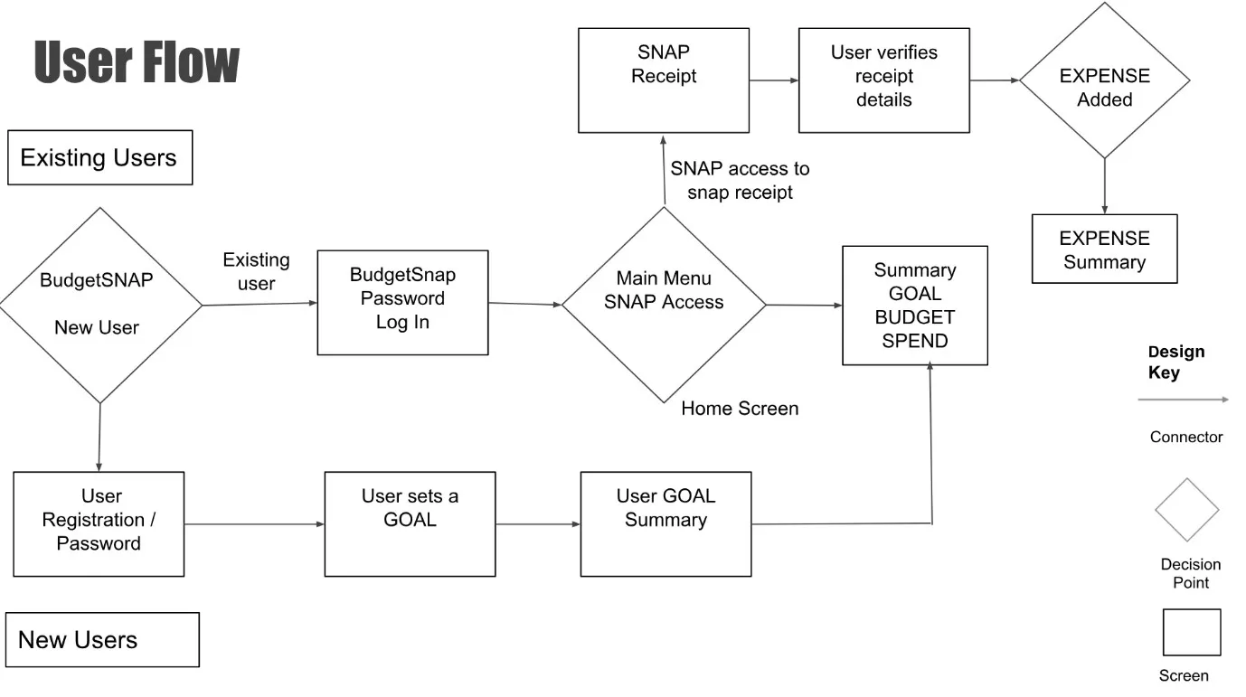

**Fig: 6.1 flow diagram**

**Chapter 7**

**IMPLEMENTATION**

The implementation consists of the five different modules which have been described below.

**7.1 DATA GATHERING**

Data collection or data gathering forms the ‘input’ step of all computing processes: Input, Process and Output. Therefore, it is important for any database analyst to know about data collection and ensure that the right data is collected. Else she will only confirm the old saying: garbage in, garbage out.

**7.2 DATA SLITTING**

Data splitting is when data is divided into two or more subsets. Typically, with a two-part split, one part is used to evaluate or test the data and the other to train the model. Data splitting is an important aspect of data science, particularly for creating models based on data.

**7.3 DATA PRECESSING AND STANDARDIZATION**

Data standardization is the process of converting data to a common format to enable users to process and analyse it. Most organizations utilize data from a number of sources; this can include data warehouses, lakes, cloud storage, and databases. However, data from disparate sources can be problematic if it isn’t uniform, leading to difficulties down the line (e.g., when you use that data to produce dashboards and visualizations, etc.).

Data standardizing is crucial for many reasons. First of all, it helps you establish clear, consistently defined elements and attributes, providing a comprehensive catalogue of your data. Whatever insights you’re trying to get or problems you’re attempting to solve, properly understanding your data is a crucial starting point.

**7.4 DATA AUGMENTATION**

Augmentation rule − If a → b holds and y is attribute set, then ay → by also holds. That is adding attributes in dependencies, does not change the basic dependencies. Transitivity rule − Same as transitive rule in algebra, if a → b holds and b → c holds, then a → c also holds.

**Chapter 8**

**CONCLUSION**

In conclusion, the Personal Finance Tracker is an indispensable tool for individuals seeking to gain control over their financial lives. By offering a comprehensive suite of features, including income tracking, expense monitoring, budgeting tools, savings and investment tracking, debt management, and detailed financial reporting and analytics, this tool provides users with a holistic view of their financial health.

The ability to access the tracker across multiple platforms ensures that users can manage their finances anytime and anywhere, enhancing convenience and accessibility. The incorporation of robust security measures, such as data encryption and secure authentication, ensures that users' sensitive financial information remains protected.

By utilizing the Personal Finance Tracker, individuals can develop better financial habits, make informed decisions, and work towards achieving financial stability and independence. Whether it's tracking day-to-day expenses, planning for long-term savings, or managing debt, the Personal Finance Tracker empowers users with the knowledge and tools necessary for effective financial management. Ultimately, this leads to a more secure and prosperous financial future, making the Personal Finance Tracker a valuable ally in anyone’s financial journey.

**Chapter 9**

**FUTURE ENHACEMENT**

As the financial landscape and user needs evolve, continuous improvement and addition of new features are essential for maintaining the relevance and effectiveness of the Personal Finance Tracker. Here are some potential future enhancements:

#### 1. **Artificial Intelligence and Machine Learning Integration**

* **Personalized Financial Advice**: Implement AI to provide personalized financial advice and recommendations based on user spending patterns, income, and financial goals.
* **Expense Prediction**: Use machine learning algorithms to predict future expenses based on historical data, helping users plan better.
* **Fraud Detection**: Employ AI to detect unusual transactions and alert users of potential fraud.

#### 2. **Enhanced Budgeting Tools**

* **Dynamic Budget Adjustments**: Allow budgets to dynamically adjust based on changes in income, expenses, and financial goals.
* **Collaborative Budgeting**: Enable multiple users (e.g., family members or roommates) to collaborate on shared budgets and track shared expenses.

#### 3. **Advanced Investment Tracking**

* **Investment Recommendations**: Provide users with investment recommendations based on risk tolerance, financial goals, and market conditions.
* **Cryptocurrency Tracking**: Include tracking and analysis of cryptocurrency investments.
* **ESG Investment Insights**: Offer insights and tracking for Environmental, Social, and Governance (ESG) investments.

#### 4. **Comprehensive Debt Management**

* **Debt Consolidation Tools**: Provide tools for evaluating and managing debt consolidation options.
* **Interest Optimization**: Suggest strategies for minimizing interest payments and optimizing debt repayment schedules.
* **Credit Score Monitoring**: Integrate credit score monitoring and improvement tips.

#### 5. **Integration with Additional Financial Services**

* **Banking Services Integration**: Partner with banks and financial institutions to offer integrated banking services such as account management and bill payments directly within the app.
* **Tax Preparation**: Integrate with tax preparation services to streamline the process of preparing and filing taxes.
* **Insurance Management**: Allow users to manage insurance policies and receive reminders for renewals and premium payments.

#### 6. **Enhanced User Experience**

* **Voice Command Integration**: Implement voice command functionality for hands-free navigation and data entry.
* **Gamification**: Introduce gamification elements to make financial management more engaging and motivating, such as achievement badges and progress tracking.
* **Customizable Dashboard Themes**: Allow users to customize the look and feel of their dashboard with different themes and layouts.

#### 7. **Global Expansion Features**

* **Multi-Currency Support**: Enable users to track expenses, income, and investments in multiple currencies, with real-time exchange rate updates.
* **Localization**: Provide language support and localization for users in different regions.
* **International Banking Integration**: Expand integrations to include international banks and financial institutions.

#### 8. **Social and Community Features**

* **Financial Communities**: Create forums or communities within the app where users can share tips, experiences, and advice on financial management.
* **Crowdfunding and Peer Lending**: Introduce features for crowdfunding financial goals and peer-to-peer lending.

#### 9. **Health and Financial Well-being Integration**

* **Health Expense Tracking**: Provide tools for tracking and managing healthcare expenses and medical bills.
* **Financial Wellness Programs**: Partner with financial wellness programs to offer resources and workshops on financial health and planning.

#### 10. **Enhanced Security and Privacy Features**

* **Biometric Authentication**: Implement biometric authentication methods such as fingerprint or facial recognition for added security.
* **Advanced Encryption Techniques**: Continuously update encryption methods to protect user data.
* **Privacy Control Settings**: Offer users more granular control over their data privacy settings.

**REFERENCES**

* https://m.youtube.com/watch?v=iQBJspbKp0s

* <https://www.github.com/>

**APPENDIX A : CODE**

**1.Header**

import React, { useEffect } from "react";

import "./styles.css";

import { Link, useNavigate } from "react-router-dom";

import { useAuthState } from "react-firebase-hooks/auth";

import { auth } from "../../firebase";

import userSvg from "../../assets/user.svg";

function Header() {

  const [user] = useAuthState(auth);

  const navigate = useNavigate();

  function logout() {

    auth.signOut();

    navigate("/");

  }

  useEffect(() => {

    if (!user) {

      navigate("/");

    } else {

      navigate("/dashboard");

    }

  }, [user, navigate]);

  return (

    <div className="navbar">

      <p className="navbar-heading">Financly.</p>

      {user ? (

        <p className="navbar-link" onClick={logout}>

          <span style={{ marginRight: "1rem" }}>

            <img

              src={user.photoURL ? user.photoURL : userSvg}

              width={user.photoURL ? "32" : "24"}

              style={{ borderRadius: "50%" }}

            />

          </span>

          Logout

        </p>

      ) : (

        <></>

      )}

    </div>

  );

}

export default Header;

**2.Loader**

import React from "react";

import "./styles.css";

function Loader() {

  return (

    <div className="wrapper">

      <div class="lds-ripple">

        <div></div>

        <div></div>

      </div>

    </div>

  );

}

export default Loader;

**3.Modals**

import React from "react";

import {

  Card,

  Col,

  Row,

  Button,

  Modal,

  Form,

  Input,

  DatePicker,

  Select,

} from "antd";

function AddExpenseModal({

  isExpenseModalVisible,

  handleExpenseCancel,

  onFinish,

}) {

  const [form] = Form.useForm();

  return (

    <Modal

      style={{ fontWeight: 600 }}

      title="Add Expense"

      visible={isExpenseModalVisible}

      onCancel={handleExpenseCancel}

      footer={null}

    >

      <Form

        form={form}

        layout="vertical"

        onFinish={(values) => {

          onFinish(values, "expense");

          form.resetFields();

        }}

      >

        <Form.Item

          style={{ fontWeight: 600 }}

          label="Name"

          name="name"

          rules={[

            {

              required: true,

              message: "Please input the name of the transaction!",

            },

          ]}

        >

          <Input type="text" className="custom-input" />

        </Form.Item>

        <Form.Item

          style={{ fontWeight: 600 }}

          label="Amount"

          name="amount"

          rules={[

            { required: true, message: "Please input the expense amount!" },

          ]}

        >

          <Input type="number" className="custom-input" />

        </Form.Item>

        <Form.Item

          style={{ fontWeight: 600 }}

          label="Date"

          name="date"

          rules={[

            { required: true, message: "Please select the expense date!" },

          ]}

        >

          <DatePicker className="custom-input" format="YYYY-MM-DD" />

        </Form.Item>

        <Form.Item

          label="Tag"

          name="tag"

          style={{ fontWeight: 600 }}

          rules={[{ required: true, message: "Please select a tag!" }]}

        >

          <Select className="select-input-2">

            <Select.Option value="food">Food</Select.Option>

            <Select.Option value="education">Education</Select.Option>

            <Select.Option value="office">Office</Select.Option>

            {/* Add more tags here */}

          </Select>

        </Form.Item>

        <Form.Item>

          <Button className="btn btn-blue" type="primary" htmlType="submit">

            Add Expense

          </Button>

        </Form.Item>

      </Form>

    </Modal>

  );

}

export default AddExpenseModal;

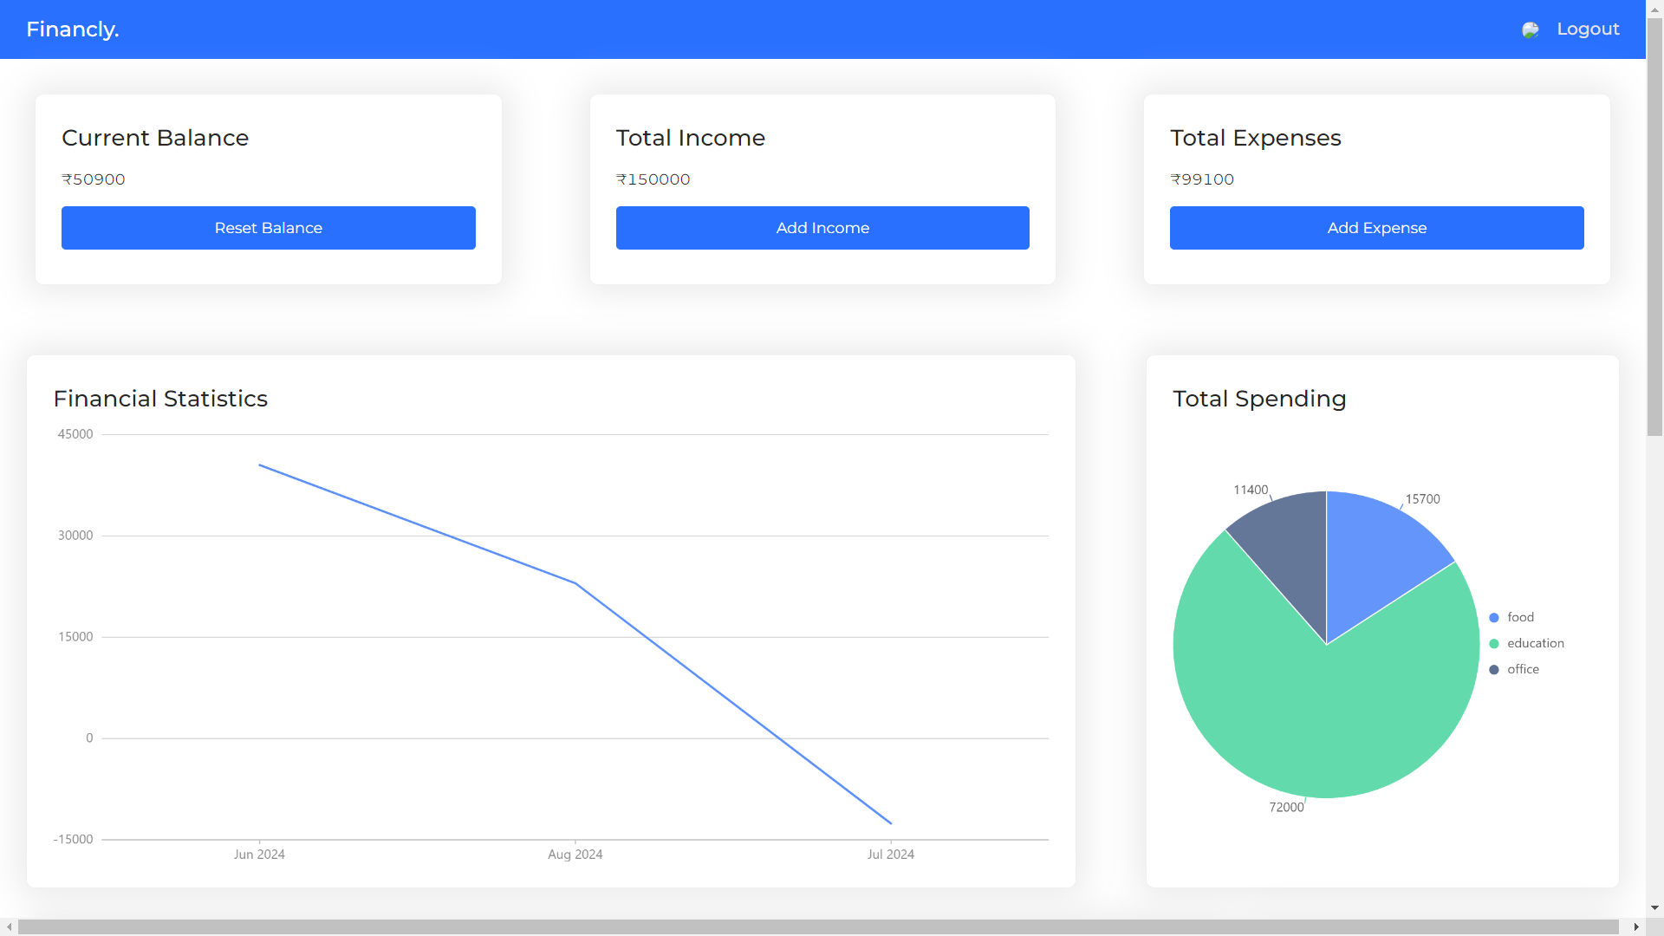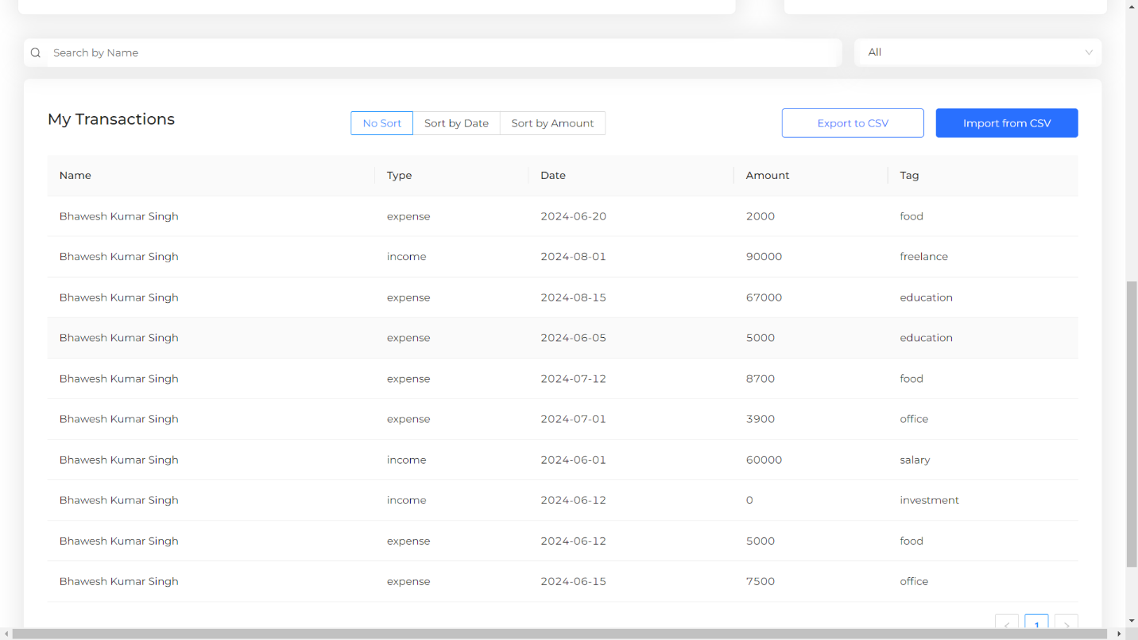**APPENDIX B: SCREENSHOTS**

Fig ss1: main page

Fig ss2:transactions

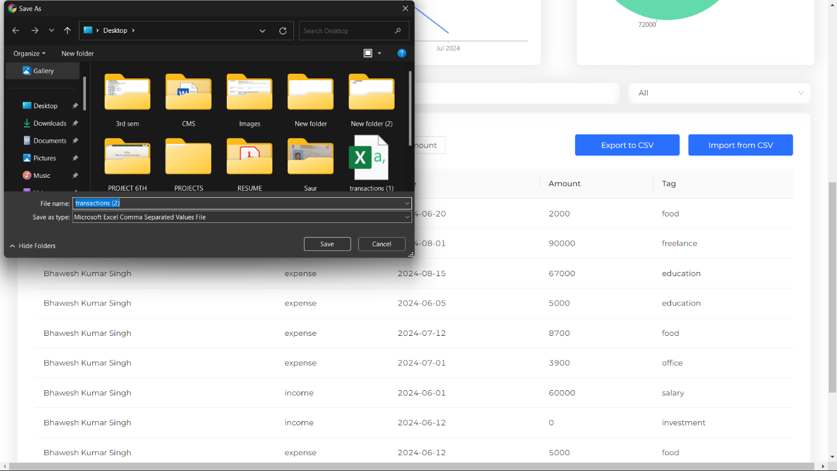 Fig ss3: transaction export

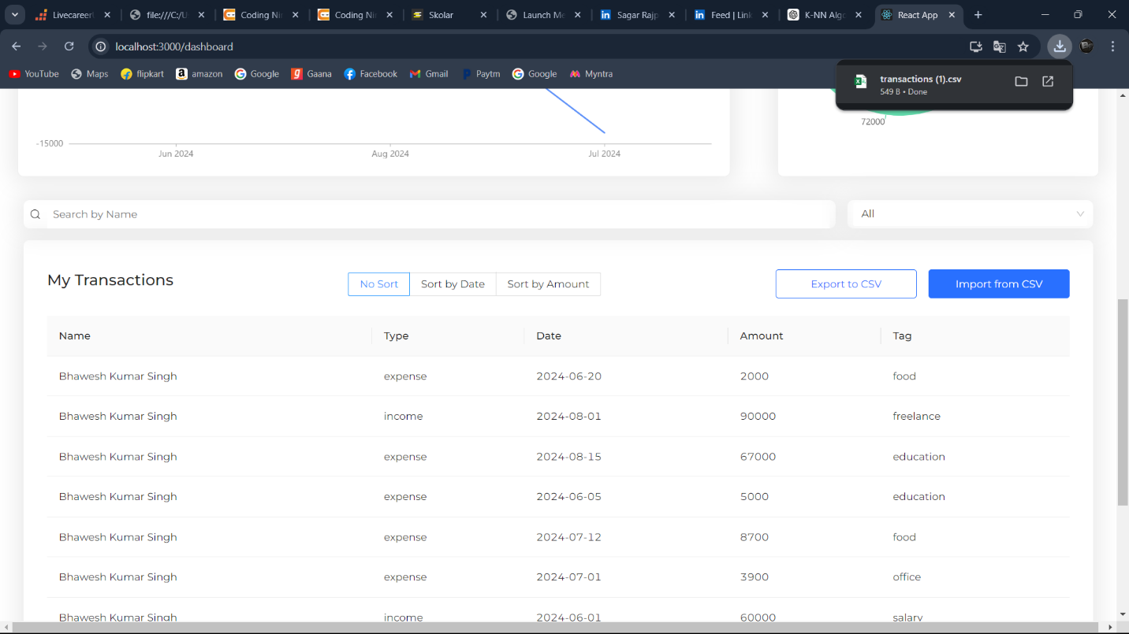

Fig ss4: transaction download

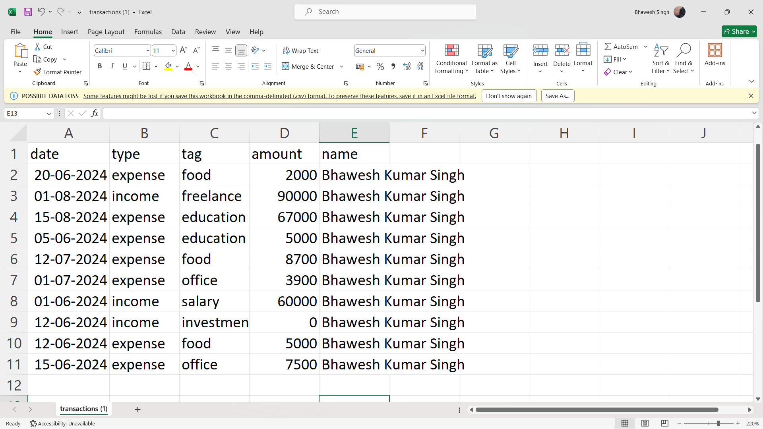

Fig ss5: excel sheet exported

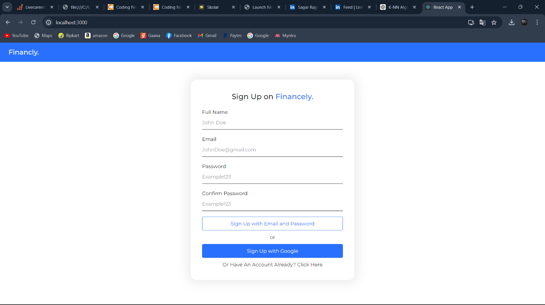

Fig ss6: Login page

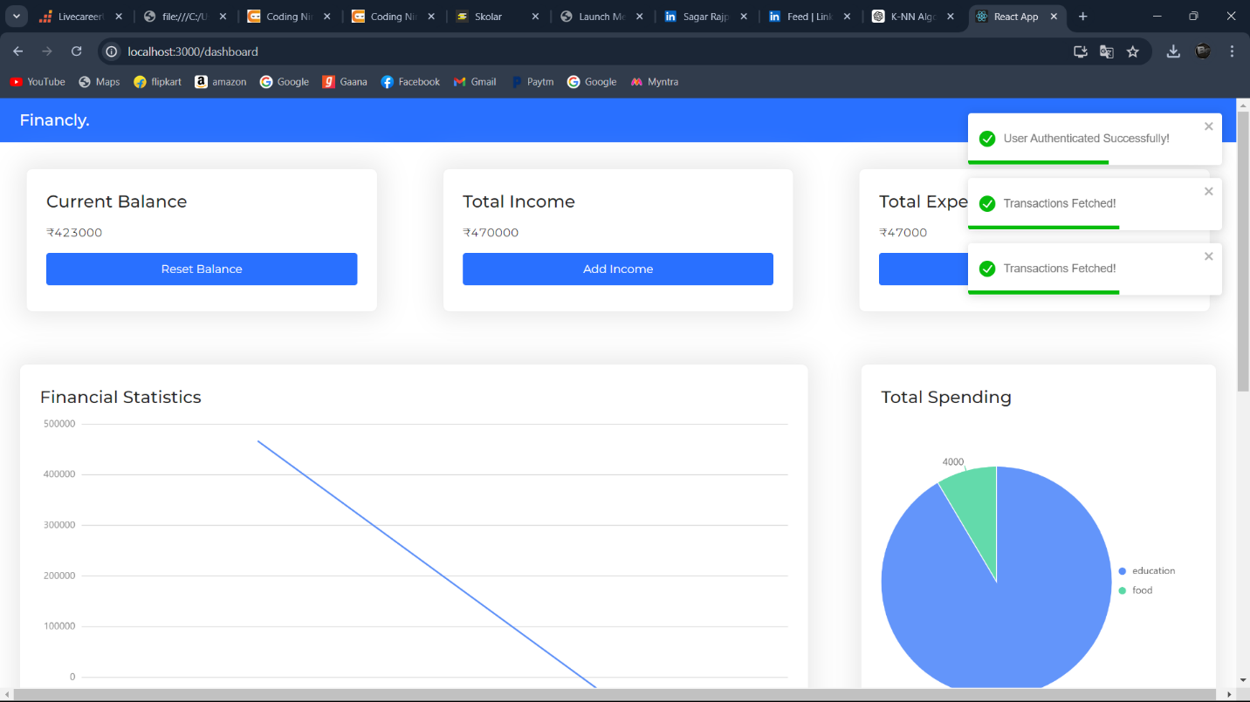

Fig ss7: after login

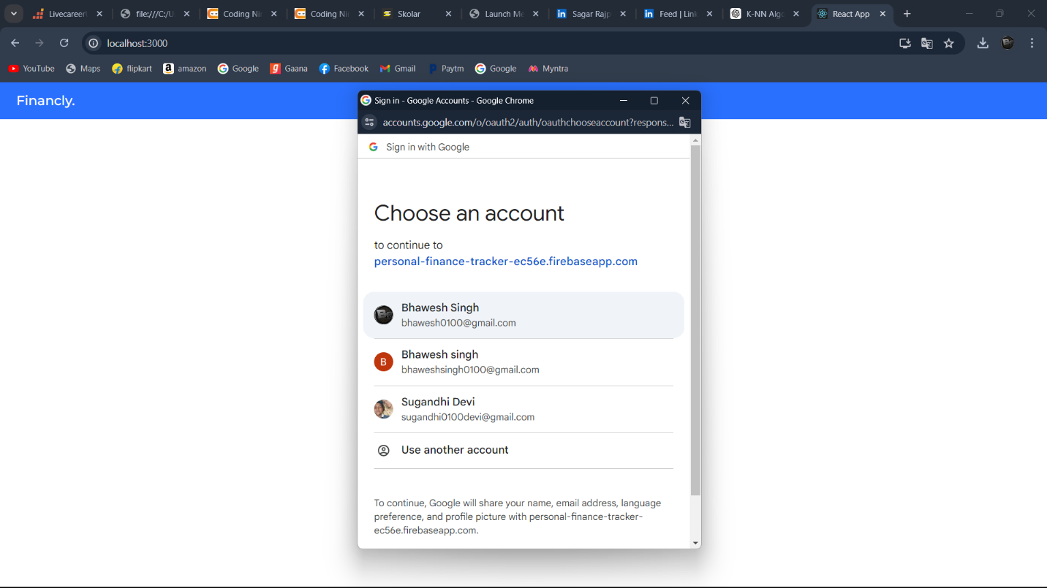

Fig ss8: email id login

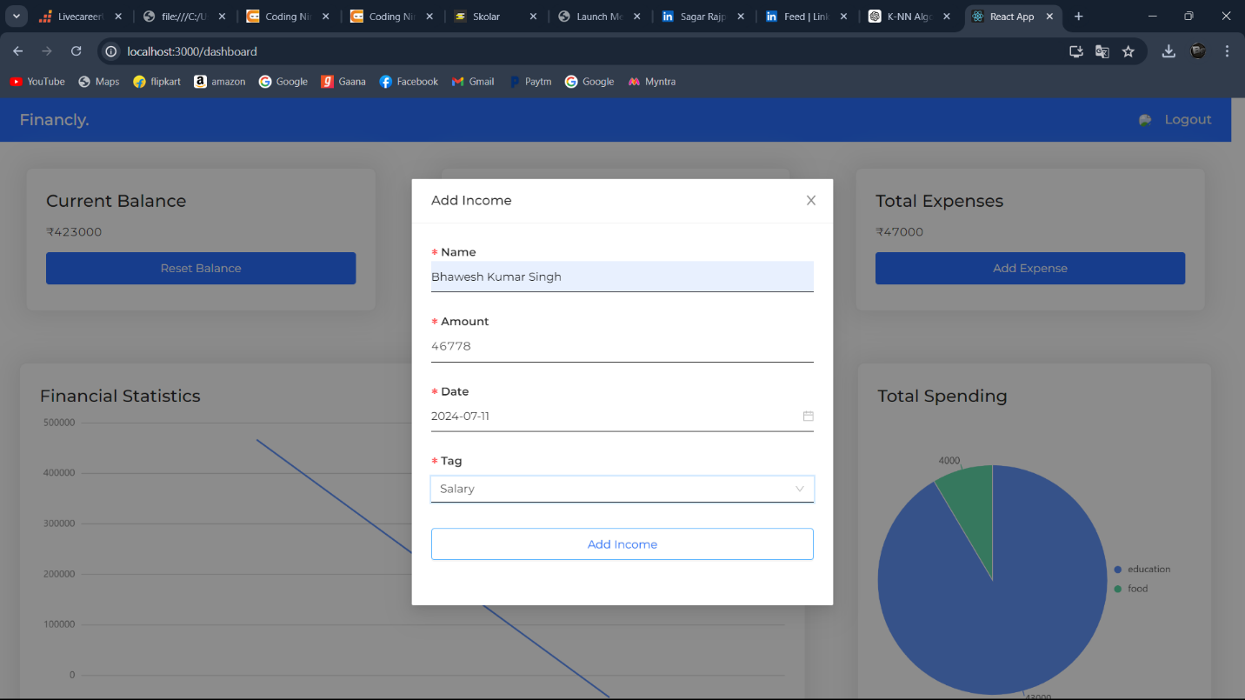

Fig ss9: income entry