CInter CRA Subscriber Shifting (ICSS) to KFintech

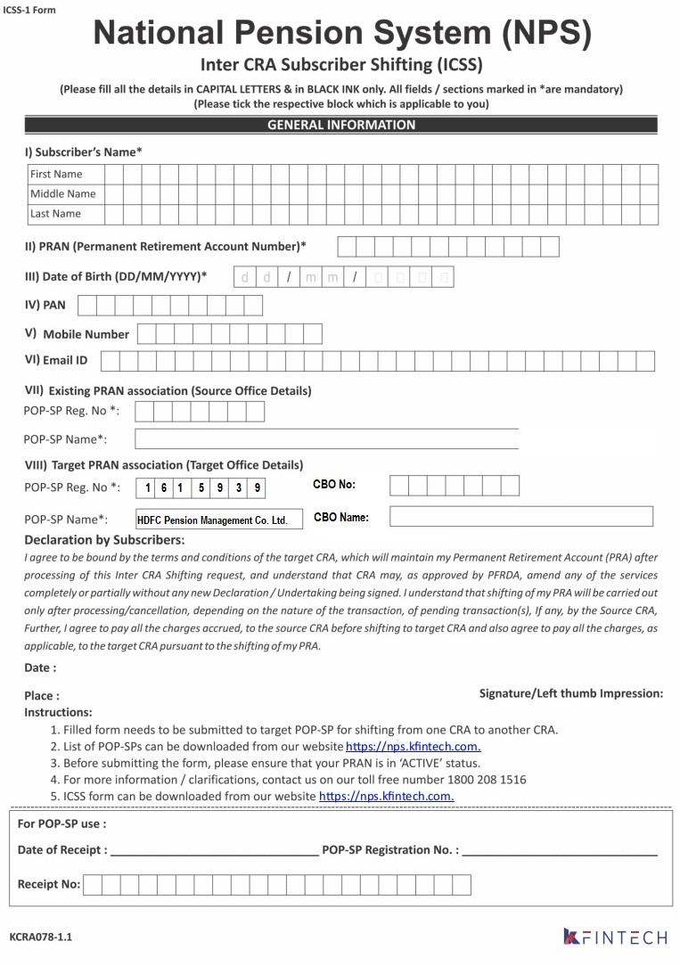

B H U M E S H W A R

P R E M D A S

L A L E

4 0 0 0 6 0 6 7 8 1 6 6

2 5 1 0 1 9 9 0

A N P P L 0 6 9 5 J

7 5 8 8 7 8 9 7 6 6

B h u m e s h w a r . l a l e @ g m a i l . c o m