Student Performance Prediction System
Project Report
Submitted by: Bhuvnesh
GitHub Repository: https://github.com/Bhuvnesh2003/student-performance-prediction

1. Objective
The objective of this project is to predict a student's final grade (G3) before the final result is out, using the student's past grades and a few basic details such as study time, absences and past failures. If the predicted grade is low, the teacher can help the student in time. In this project, a predicted grade of 10 or more is taken as PASS, and below 10 is taken as FAIL.

2. Dataset
I used the Student Performance dataset from the UCI Machine Learning Repository (file: student-mat.csv). This file is read with a semicolon separator (sep=";"). The main details of the dataset are given below.
Detail | Value
Source file | student-mat.csv (UCI)
Number of students (rows) | 395
Number of columns | 33
Target column | G3 (final grade, 0 to 20)
Average G3 | 10.42
Missing values | None
Duplicate rows | 0

3. Tools used
The project was made in Google Colab using Python. The libraries used were Pandas for handling the data, NumPy for number calculations, Matplotlib for making charts, and scikit-learn for training and testing the models.

4. Steps followed
- Loaded the dataset and checked its shape, first rows and basic information.
- Checked the data for missing values and duplicate rows. The data was already clean, so no rows had to be removed.
- Did Exploratory Data Analysis (EDA) with charts to understand the marks pattern.
- Selected the important features by checking the correlation of each column with G3.
- Split the data into training data (80%) and testing data (20%).
- Trained two models - Linear Regression and Random Forest - on the same split.
- Compared both models using R2 score, MAE and RMSE, and selected the better model.
- Made a small prediction function that gives the predicted grade and PASS or FAIL for a new student.

5. Exploratory data analysis
First, I made a histogram of the final grade G3. Most students scored around 10 to 11 marks, which matches the average of 10.42. Then I made a bar chart of average G3 for each study time level. Students who studied more had a higher average grade. I also made a scatter plot of absences against G3 to see how attendance is related to marks.

6. Features selected
I checked the correlation of all numeric columns with G3. The second period grade, G2, had the highest correlation of 0.905, so it is the strongest indicator of the final grade. The number of past failures had the highest negative correlation of -0.360, which means more past failures are linked with lower final marks. Based on this, I selected five features for the model: studytime, absences, failures, G1 and G2.

7. Models and results
I trained two regression models, because G3 is a number (0 to 20) and not a category. Linear Regression tries to fit a straight-line relation between the features and the grade. Random Forest makes many decision trees and averages their answers, so it can catch non-linear patterns as well. Both models were trained and tested on the same data split, and the results are given below.
Model | R2 score | MAE | RMSE
Linear Regression | 0.782 | 1.34 | 2.11
Random Forest | 0.871 | 1.06 | 1.63
Random Forest gave a better result on all three measures - a higher R2 score and lower MAE and RMSE. An MAE of 1.06 means that, on average, the predicted grade is about 1 mark away from the actual grade.
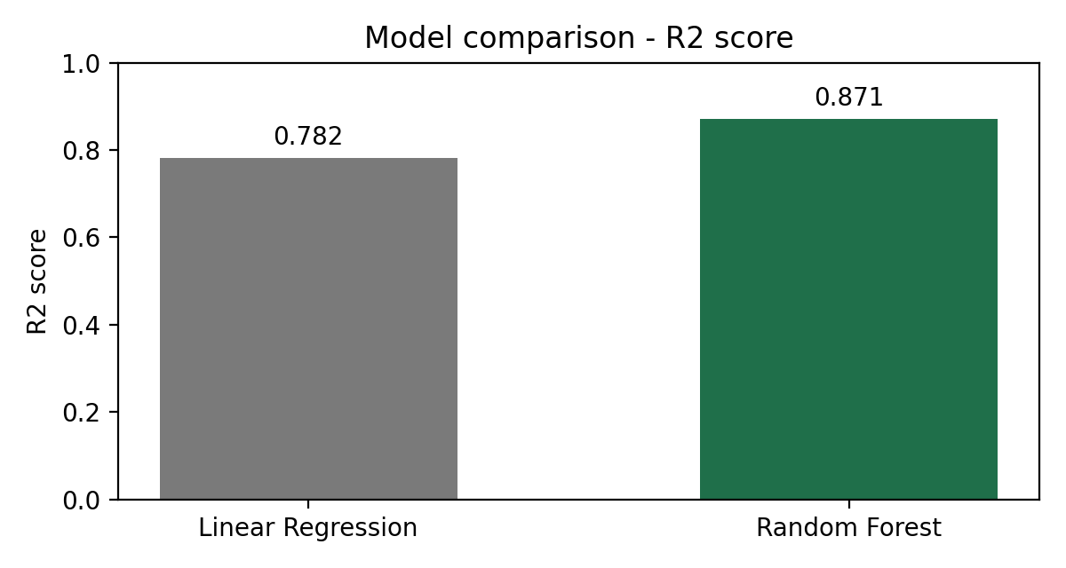
Figure 1: R2 score comparison of the two models

8. Prediction system
In the last part, I made a function named predict_grade. It takes studytime, absences, failures, G1 and G2 as input, uses the Random Forest model to predict G3, and returns the predicted grade along with PASS or FAIL. Three test cases are given below.
Input values | Predicted G3 | Result
3, 2, 0, 12, 13 | 13.1 | PASS
1, 20, 2, 5, 6 | 6.0 | FAIL
4, 0, 0, 15, 16 | 16.3 | PASS

9. Conclusion
In this project, I completed the full machine learning workflow - loading and cleaning the data, exploring it with charts, selecting features, training two models and comparing them. Random Forest performed better than Linear Regression, with an R2 score of 0.871, MAE of 1.06 and RMSE of 1.63, so I selected it as the final model. The prediction function built on this model can give an early idea of a student's final grade.

Future scope
In the future, this model can be improved by using more student data and more features. It can also be connected to a simple web page where a teacher can enter a student's details and see the predicted grade.

