**Tribhuvan University**

**SIDDHANATH SCIENCE CAMPUS**

Institute of Science and Technology

Mahendranagar, Kanchanpur



**A FINAL YEAR PROJECT REPORT**

**ON**

**HUMAN RESOURCE MANAGEMENT**

**SYSTEM**

**Submitted To:**

**Department of Computer Science and Information Technology**

**Siddhanath Science Campus**

**Mahendranagar, Kanchanpur**

***In the Partial Fulfillment of the Requirements for the Bachelor’s Degree in***

***Computer Science and Information Technology***

**Submitted by:**

Bhuwan Buda (11271/073)

**November, 2021**

**Tribhuvan University**

**SIDDHANATH SCIENCE CAMPUS**

Institute of Science and Technology

Mahendranagar, Kanchanpur



**SUPERVISOR’S RECOMMENDATION**

This is to certify that this project prepared by BHUWAN BUDA, entitled **“HUMAN RESOURCE MANAGEMENT SYSTEM**” which is being submitted to Department of Computer Science & Information Technology, Siddhanath Science Campus in partial fulfillment of the requirements for the award of the degree of Bachelor of Science in Computer Science & Information Technology is prepared under my guidance and supervision.

**......................................................**

**Mr. Keshav Datta Bhatta**

Supervisor

Department of CSIT

Siddhanath Science Campus

Mahendranagar, Kanchanpur

**Tribhuvan University**

**SIDDHANATH SCIENCE CAMPUS**

Institute of Science and Technology

Mahendranagar, Kanchanpur



**LETTER OF APPROVAL**

This is certify that this project prepared by BHUWAN BUDA entitled “**HUMAN RESOURCE MANAGEMENT SYSTEM**” in partial fulfillment of the requirements for the degree of B.Sc. in Computer Science and Information Technology has been well studied. In our opinion, it is satisfactory in the scope and quality as a project for the required degree.

…………………………….. ……………………………

**(Supervisor) (HoD)**

**Mr. Keshav Datta Bhatta Mr. Keshav Datta Bhatta**

Faculty, Department of CSIT Faculty, Department of CSIT

Siddhanath Science Campus Siddhanath Science campus

Mahendranagar, Kanchanpur Mahendranagar, Kanchanpur

……………………………… ……………………………

**(External Examiner) (Internal Examiner)**

**ACKNOWLEDGEMENT**

There are many people who deserve recognition and thanks for the help and support they have provided us during the course of the internship program. First of all, we would like to express our gratitude to the **Mr. GAJRAM DAMAI**, Campus Chief of Siddhanath Science Campus for providing us a favorableworking environment, supporting us for this internship and **Mr. KESHAV DATTA BHATTA**, Head of Computer Science and Information Technology and our respected teachers **Mr. RAJENDRA PRASAD JOSHI,** **Mr. UPENDRA RAJ JOSHI** and **Mr. DILLI PRASAD JOSHI** for giving us an opportunity andproviding me their valuable time to help through my internship.

I would like to dedicate our hearty gratitude to Prithak Creation Pvt. Ltd. Nepal for providing us with an opportunity to do internship at this reputed organization with full support and cooperation. I would also like to thank **Mr. TENISH SHRESTHA**, Senior Project Manager and entire mentors for their unquestionable support.

Finally, I would also like to take this opportunity to acknowledge the contribution of all those who have published their reports and articles related to my topic for the benefit of student like me. I would also like to appreciate and thank my family, friends for their time and suggestions.

**ABSTRACT**

The aim of this project is to manage the user’s information and hire the appropriate candidate required to the employee. This project helps employees to hire the required user for the vacancy he/she has created. Users can put all the information regarding his/her personal data such as name, address, contact as well as its academic qualifications, skills and experiences in particular field of education. Also employee can register and create its own vacancy to hire the appropriate candidate/user for the job. Employee can directly hire the user by seeing his/her data as provided.

This system helps both user and employee to help to find the appropriate vacancy for job or user for the vacancy. Users can also change the data he/she has provided at any time so that the actual data remains up-to-date for both user and employee. This system gives access to many employees and users to enroll and communicate. Each employee can create its own vacancy so that it becomes easy to see which user has applied for the vacancy he/she has created. This all system has been developed form HTML, CSS, Bootstrap and JavaScript (as frontend) and Django framework of Python (as backend). This project uses dbsqlite3 as a database. This system is fully responsive with user interactive GUI front-end. It includes all the functionalities that a project should have. Its response timing is also very fast that’s why it’s not that much time consuming for users.

**LIST OF ABBREVIATION**

API : Application Programming Interface

AJAX : Asynchronous JavaScript and XML

CSS : Cascading Style Sheet

DBMS : Database Management System

DFD : Dataflow Diagram

ERD : Entity Relationship Diagram

GB : Giga Byte

HTML : Hypertext Markup Language

IP : Internet Protocol

MB : Mega Byte

MTV : Model Template View

RAM : Random Access Memory

SDLC : System Development Life Cycle

TCP : Transmission Control Protocol

GUI : Graphical User Interface

URL : Universal Resource Locator

**LIST OF TABLES**

**Tables Page Number**

Table 1.1: Contact Details 6

Table 1.2: Internship Duration6

**LIST OF FIGURES**

**Name Page Number**

Fig 2.1: Waterfall Model………………………………………….………………...7

Fig 3.1: Use Case Diagram of Human Resource Management System..………10-11

Fig 3.2: Gantt chart of Human Resource Management System...………………….15

Fig 4.1: Context diagram of Human Resource Management System...……………19

Fig 4.2: Level 1 DFD……………………………………..………………………..20

Fig 4.3: ER-Diagram………………………………………..……………………...21

**TABLE OF CONTENTS**

SUPERVISIOR’S RECOMMENDATION…………………………………………...i

LETTER OF APPROVAL……………………………………….……………………ii

ACKNOWLEDGEMENT…………………………………………………………....iii

ABSTRACT…………………………………………………………………………..iv

LIST OF ABBREVIATION…………………………………………………………..v

LIST OF TABLES………...………………………………………………………….vi

LIST OF FIGURES………………………………………………….……………….vii

TABLE OF CONTENTS…………………………………………………………viii-x

**Chapter 1: Introduction……………………….……………….……..1-6**

1.1 Introduction to Internship…………………….…...……………………......1-2

1.2 Background……...………………………………….…...……………............2

1.3 Problem Definition ……………………..…………….…...……………….2-3

1.4 Objectives……………………………….…………….…...…………………3

1.4.1 Objectives of Internship Program…..…………….…...…………………3

1.4.2 Objectives of Project………..…………………….…...………………....3

1.5 Responsibilities Assigned……………..…………….…...…………………...4

1.6 Motivation………...……………………..…………….…...…………………4

1.7 Brief Introduction to Industry……….…..…………….…...……………….4-5

1.8 Brief Introduction to Organization……..…………….…...………………..5-6

1.8.1 About the Organization………....…………….…...……………………5

1.8.2 Website Design and Development..……..…………...…………………6

1.8.3 Search Engine Optimization...……..…………….…...…………………6

**Chapter 2: Methodology……………………………………………...7-9**

2.1 Waterfall Model................................................................................................7

2.1.1 Problem Identification………………..……..………………..…………8

2.1.2 Analysis………………………………….……………….……...............8

2.1.3 Planning………………………….………….……………………….......8

2.1.4 Design.......................................................................................................9

2.1.5 Coding……………………………..……….………................................9

2.1.6 Testing ………………………………………….….................................9

2.1.7 Deployment……………………………………………….……..............9

2.1.8 Maintenance…………………………………………....….….................9

**Chapter 3: System Requirement …………………………………..10-16**

3.1 Requirement Analysis……………………..……………….………………..10

3.1.1 Functional Requirement…………………………………………….10-11

3.1.2 Non-functional Requirement…………….………………………….11-13

3.2 Feasibility Analysis……………………...………………………...……..13-16

3.2.1 Technical Feasibility………………………………………..............13-14

3.2.2 Economic Feasibility………………………....………….......................14

3.2.3 Schedule Feasibility………………………………………………...14-15

3.2.4 Operational Feasibility………………………………..………………..16

**Chapter 4: System Design…………………………………………………17-21**

4.1 Introduction………………………………………………………………….17

4.2 Architecture Design………………………………………………………….17  
4.3 Conceptual Design…………………………………………………………...17

4.4 Logical Design…………………………………………………….................18

4.5 Physical Design………………………………………………………………18

4.6 Structuring System Requirement…………………………………………18-19

4.6.1 Dataflow Diagram…………………………………………………..19-20

4.6.2 ER- diagram…………………………………………………...……….21

**Chapter 5: System Development…………………………………………22-24**

5.1 Development Tools…………………………………………………………..22

5.1.1 PyCharm..………………………………………………………………22

5.2 Programming Tools……………………………………………………….22-24

5.2.1 Front-End Tools…………………………………………………….22-23

5.2.2 Back-End Tools……………………………………………………..23-24

**Chapter 6: Implementation and Testing…………………………..25-28**

6.1 Implementation………….………...….......…………………………………..25

6.2 Testing…………………………………………………………………….25-27  
 6.2.1 Unit Testing…………………………………………………………….26

6.2.2 Integration Testing……………………………………………………..26

6.2.3 System Testing…………………………………………………………26

6.2.4 Module Testing………………………………………………………...26

6.2.5 Acceptance Testing…………………………………………………….27

6.3 Result Analysis……………………….………………………….………27-28

6.3.1 Validation…………………………………………………………...27-28

6.3.2 Verification……………………………………………………………..28

**Chapter 7: Conclusion and Recommendation……………………….29**

7.1 Achievement of the Project………………………………………………….29

7.2 Limitation of the System…………………………………………………….29

7.3 Future Recommendation…………………………………………………….29

7.4 Conclusion…………………………………………………………………...29

**APPENDIX I (Snap shots)...................................................................................30-35**

**REFERENCES...........................................................................................................36**

**CHAPTER 1**

**INTRODUCTION**

## 1.1. Introduction to Internship

An internship is an opportunity to integrate career related experience into an undergraduate education by participating in planned, supervised work. The internship is done as a partial fulfillment of requirements of the Bachelor’s degree in Computer Science and Information Technology under Tribhuvan University. Internship is considered as the practical implementation of the theory education that provides a chance to use the skills learned in the classroom in a real-world setting. It provides opportunities to gain work experience that cannot be achieved just with the theory knowledge, which aids in shaping the professional career for beginners like university students. During internship, the works done and tasks performed are supervised by the faculty members as well as by the company representatives.

Internship mechanism is being considered as an important resource for improvement of the system of higher education and establishment of effective connection between the universities and the labor market. Internships provide opportunities to experiment and pursue careers that match academic and personal interests. Internship experiences are considered in the hiring process, and often interns are looked as the best potential candidates for full-time positions in organizations. An internship is a great way to develop specific skills and knowledge, as well as make contacts and build confidence. More and more, employers assess the skills and abilities of prospective employees by evaluating their previous experiences. If students pursue career-related opportunities prior to graduation, they may have an edge over other candidates in a competitive job market.

This internship as per the requirement of the TU for the BSc. CSIT not only fulfills that very requirement but has also developed me personally by getting myself acquainted with how the software industry regulates. This program has enhanced the skill and enthusiasm of the students are they get knowledge of the company environments and to learn different aspects of working mechanism that prevail in the organizations. Every subject learned during the B.Sc. CSIT course including Data Structure and Algorithm, Design Analysis and Algorithm, Database Management System, Data Mining and Data Warehouse, Web Technology, Distributed Database and others have been well implemented during this internship program.

## 1.2. Background

In earlier time, the college was using the manual system, which is based on the entries on the registers. When a student want placement from the college then he must do the entries in the register and also when he/her talk placed then help desk is also need to do the entry register. This process is much time consuming and also not good and efficient. Accessing the data for the user (student/teacher) is more difficult. The information recorded in the physical system is also not very accurate due to which many problem should be arises in the future for accessing and maintain the information about student, staff or other objectives of the college.

The computerized integrated system from the existing system will have the following advantage:

* Handle large volume of information and complexity of data processing
* Processing time constant.
* Computational demand.
* Instantaneous queries.
* Security features.

**1.3. Problem Definition**

By doing researches and study, author came to know that users are facing problems for getting appropriate job according to their qualification and experiences. So the employees are facing for hiring the appropriate candidate for their job. Users have to search over the internet to find the job they actually need. This is becoming very time consuming for users. Also the same problem employees are facing of not getting desired user to do their job. Here are listed some of the problems related to the todays time. Those problems are:

* User have to search over internet to get the desired job.
* Sometimes it becomes difficult to user to get the job according to their qualification, skill and experience.
* Employee has also the same problem for hiring the qualified appropriate candidate for the job.
* It is very time consuming for both user and employee.

**1.4. Objectives**

### **1.4.1 Objectives of internship program**

The following is a list of some objectives, which the internship might fulfill for both the student and the organization (agency, candidate, interest group, etc.):

* To provide students the opportunity to relate theory to practice.
* To give students in-service orientation to a career area they may wish to pursue.
* To give students opportunity to work in their area of intended specialization.
* To enhance student’s understanding of organizational and group processes.
* To enhance student’s awareness of public service obligations.
* To develop an ongoing relationship between the academic and practitioner community.

### **1.4.2 Objectives of project**

The aim in developing **Human Resource Management System** is:-

1. To provide an easy to use GUI interface for both user and employee.
2. To allow users to provide their personal as well as academic details.
3. To allow employees to create the vacancy of their requirement.
4. To allow user to apply in vacancies which they find appropriate for them.
5. To allow employee to hire the appropriate candidate according to their requirement.

## 1.5. Responsibilities Assigned

During internship at Prithak Creation, Nepal, the target was to develop an efficient College Management System. During development period various activities and tasks as per the requirement of both the organization and the project were involved. The author was assigned to study and conduct research on web development and programming and gain knowledge about Python and Django Framework. After knowing the fundamentals of Python the design was given to the author and was assigned to integrate the design.

## 1.6. Motivation

Python is an interpreted, object-oriented, high-level programming language with dynamic semantics. Its high-level built in data structures, combined with dynamic typing and dynamic binding, make it very attractive for Rapid Application Development, as well as for use as a scripting or glue language to connect existing components together. Python’s simple, easy to learn syntax emphasizes readability and therefore reduces the cost of program maintenance. Python supports modules and packages, which encourages program modularity and code reuse. The Python interpreter and the extensive standard library are available in source or binary form without charge for all major platforms, and can be freely distributed. Often, programmers fall in love with Python because of the increased productivity it provides.

## 1.7. Brief Introduction of Industry

The software industry includes businesses for development, maintenance and publication of software that are using different business models, mainly either "license/maintenance based" (on-premises) or "Cloud based. The industry also includes software services, such as training, documentation, and consulting. The software industry expanded in the early 1960s, almost immediately after computers were first sold in mass-produced quantities. Universities, government, and business customers created a demand for software. Many of these programs were written in- house by full-time staff programmers. Some were distributed freely between users of a particular machine for no charge. Others were done on a commercial basis, and other firms such as Computer Sciences Corporation (founded in 1959) started to grow. The computer/hardware makers started bundling operating systems, systems software and programming environments with their machines. The industry expanded greatly with the rise of the personal computer ("PC") in the mid-1970s, which brought computing to the desktop of the office worker. In the following years, it also created a growing market for games, applications, and utilities. DOS, Microsoft's first operating system product, was the dominant operating system at the time.

In the early years of the 21st century, another successful business model has arisen for hosted software, called software-as-a-service, or SaaS; this was at least the third time this model had been attempted. From the point of view of producers of some proprietary software, SaaS reduces the concerns about unauthorized copying, since it can only be accessed through the Web, and by definition no client software is loaded onto the end user's PC.

## 1.8. Brief Introduction of Organization

### **1.8.1 About the Organization**

Prithak Creation is a software development company based in Nepal actively working as a web development company. It has been serving both the national and international clients with services like web designing, web development, search engine optimization, graphics designing and lot more.

Prithak Creation focuses in incorporating modern technology and recent innovations in our system, thereby enable our businesses to achieve following objectives:

* + Improve performance.
  + Reduce maintenance costs.
  + Enhance productivity.
  + Increase end-user satisfaction.

### **1.8.2 Contact Information**

Followings are the contact details of Prithak Creation Pvt. Ltd.

|  |  |
| --- | --- |
| **Address** | **Kumaripati, Lalitpur, Nepal** |
| **Phone No** | **+977-9851117020** |
| **Email** | **namaste@prithakcreation.com** |
| **Website** | **www.prithakcretion.com** |

*Table 1.1: Contact Details of an Organization*

### **1.8.3 Internship Duration and Planning**

As per the requirement of the curriculum of B. Sc. CSIT 8th Semester, the minimum requirement of internship period is 10 weeks/180 hours. It consists of different phase of training or tasks performed with a specific objective for each phase. Each phase shows the progress of intern in internship. It also consists of information about how and when interns will accomplish objectives of each task. Here is my internship duration in table 1.2.

|  |  |
| --- | --- |
| Office Hour | 10:00 am – 5:00 pm |
| Working Hour | 7 Hours per day |
| Working Days | 6 days a week |
| Position | Django Developer |
| Total Duration | 3 months |
| Mentor | Mr. Tenish Shrestha |

*Table 1.2 Internship Duration*

**CHAPTER 2**

**METHODOLOGY**

This chapter of the report aims to provide a clear vision on methods and methodologies used for this project. In first, it describes the methodology and methods selected for the research and give rational why these methods and methodology have been used. Then it discusses about software development methodology and give rational for it.

**2.1. Waterfall Model**

There are different models for research. Among them, waterfall model is chosen, as it is easy to understand and implement. Many beginners use this methodology for research. Hence, this methodology is used for research in this project. Following steps have been used to formulate project.

Identify problem

System analysis

Planning

Design

Coding

Testing

Deployment

Maintenance

Fig.2.1: Waterfall Model

* + 1. **Problem Identification**

This is the first step of the research. In this step, different topics and subject area has been reviewed to find problem. After doing some researches we get to know there is need of such a system that will help both user and employee to seek and hire the vacancy of job. In this era of online jobs this system will help to find and apply for the vacancy easily.

Following are some problems found in existing system:

* Users have to search online for the job which is very time consuming.
* Users cannot get the desired vacancy according to their qualification, skills and experiences.
* Employee has to search a lot for the appropriate user for a particular job.
* It was time consuming for both user and employee.
  + 1. **Analysis**

Analysis is done to find out that the development of project is worthy or not. If the project goes in loss or it cannot fulfill user’s requirements then it is not worthy to develop the project. Feasibility study is also done in this phase to determine if project is cost effective, if there are sufficient technical or if it legal or operational and many more analysis are done.

* + 1. **Planning**

In planning phase, to develop a new system which is a first step is to identify a need for the “Human Resource Management System” and also plan how to develop the functional requirements of a system. This will include determining whether a business problem or opportunity exists, conducting a feasibility study to determine the developing a project plan.

**2.1.4 Design**

Design is the process of deciding the workflow of the project and how to work on it. For designing process different tools are used here author is using context diagram, data flow diagram and entity relationship diagram.

* + 1. **Coding**

Coding is done according to design here author used Django framework of Python for backend coding and HTML, CSS and Bootstrap for frontend coding. PyCharm Community Edition editor is used to code the project.

* + 1. **Testing**

Testing is done to see if the project is working as user requirement or not, or is it working as coded or not. Some testing performed in this project are Black Box testing, White Box testing, Unit testing, Integration testing and acceptance testing.

**2.1.7 Deployment**

After the project is ready it is deployed to the market.

**2.1.8 Maintenance**

Maintenance is the process that is done after deployment of the project.

If some problem occurs while working of the system then it is needed. Since our project is not deployed it is not necessary right now.

**CHAPTER 3**

**SYSTEM REQUIREMENT**

**3.1. Requirement Analysis**

Requirement analysis, also called requirements engineering, is the process of determining user expectations for a new or modified product. These features are called requirements, must be quantifiable, relevant and details. In software engineering, such requirement are often called functional specifications.

There are two different types of requirement analysis, they are as follows:

**3.1.1 Functional Requirement**

Functional requirements include the functions performed by specific screens, outlines of work-flows performed by the system and other requirements that the system must meet.

Developed system should have following functional requirements:

* System should have the functionality of recommendation system.
* System should provide required information to the customers.
* System should be easily access by the users.

Functional requirement has been illustrated by following use case diagram:

User

Fig (a): User Use Case Diagram

Employee

Fig (b): Employee Use Case Diagram

**Fig 3.1: Use Case Diagram for Human Resource Management System**

**3.1.2 Non-functional Requirement**

In addition to the obvious features and functions that we will provide in our system, there are other requirements that don’t actually do anything, but are important characteristics nevertheless which are called non-functional requirements or sometimes Quality Attributes. For example, attributes such as performance, security, usability, compatibility. We can’t write a specific line of code to implement them. The specification needs to describe any such attributes the user requires. We must decide the kind of requirements that apply to our project and include those that are appropriate. Each requirement is simply stated in human readable format and each requirement must be objective and quantifiable. There must be some measurable way to access whether the requirement has been met.

Some examples of non-functional requirements are given below:

* **Performance Requirements**

Requirements about resources required, response time, transaction rates, or anything else that is done with performance is the performance requirement.

* **Operating Constraints**

Operating constraints lists any non-time constraints. This could include system resources, people, needed software etc.

* **Platform Constraints**

Platform Constraints discuss about the target platform. Author have to be as specific or general as the user requires. If the user doesn’t care, there are still platform constraints.

* **Accuracy and Precision**

Accuracy and Precision discusses about the requirements about the accuracy and precision of the data.

* **Modifiability**

Modifiability discusses about the requirements about the effort required to make changes in the software.

* **Portability**

Portability tells about the effort required to move the software to a different target platform.

* **Reliability**

Reliability tells about the requirements about how often the software fails. The measurement is often expressed in mean time between failures. Author have to specify the consequences of software failure, how to protect from failure, a strategy for error detection and a strategy for correction.

* **Security**

One or more requirements about protection of our system and its data are making our data more secure. The measurement can be expressed in a variety of ways like effort, skill level, time etc.

* **Usability**

Usability discusses about the requirements about how difficult it will be to learn and operate the system. The requirements are often expressed in learning time or similar matrices.

* **Legal**

There may be legal issues involving privacy of information, intellectual property rights, export of restricted technologies etc.

The non-functional requirements include following:

* The recommendations should be fast.
* The system should provide right information.
* The user interface of the system should be easy to use i.e. the system should be more user friendly.

**3.2. Feasibility Analysis**

Feasibility study is the study of system about its ability to meet the user requirement. Feasibility is the study of impact, which happens in the organization by the development of a system. It is wise to think about the feasibility of any problem this project looks to solve or undertake. The impact can be either positive or negative. When the positives nominate the negatives, then the system is considered feasible. The main purpose of the feasibility study is check that the system is feasible or not. Our system must be feasible so that it can be implemented in time and used easily in various browsers. The main feature required for project to be a feasible are of mainly four types which are as follows:

**3.2.1 Technical Feasibility**

Technical feasibility study is the complete study of the project in terms of input, processes, output, fields, programs, and procedures. It is a very effective tool for long term planning and trouble shooting. The technical feasibility study should most essentially support the financial information of an organization.

Developed system is technically feasible. To use the system, using system doesn’t require advanced technical knowledge. It’s simple UI makes interaction easy. Anyone who has basic knowledge about computers can use this system. The entire system can be developed with the presently resource.

**Hardware Requirement (For Implement This System)**

RAM : 2 GB

Free Hard Disk Space : 20 GB

Operating System : Window XP or higher and Linux.

**Software Requirement (For Implement This System)**

Operating System : Windows Operating System and Linux.

Language : Python with Django framework installed.

Server : Python development server.

Browser : Chrome/Firefox/Microsoft Edge.

**3.2.2 Economic Feasibility**

Economic feasibility analysis is the most commonly used method for determining the efficiency of a project. It is also known as cost analysis. It helps in identifying profit against investment expected from a project. Cost and time are the most essential factors involved in this field of study. Developed system is economically feasible. It can be developed on simple PC which can be available in affordable cost.

**3.2.3 Schedule Feasibility**

Schedule Feasibility is defined as the probability of a project to be completed within its scheduled time limits by a planned due date. If a project has a high probability to be completed on time, then its schedule feasibility is high. In many cases, a project will be unsuccessful if it takes longer than it was estimated. Some external environmental conditions may change. Hence, a project can be losing its benefits, expediency and profitability. If a work to be accomplished at a project does not fit the timeframes demanded by its users or customers, then a schedule is unfeasible i.e. amount of work should be reduced or other schedule compression methods applied.

If the project managers want to see their projects completed before they can lose their utility, they need to give proper attention to controlling their schedule feasibility. To calculate and continually re-examine whether it is possible to complete all amount and scope of work lying ahead, utilizing the given amount of resources, within required period of time.

Gantt chart for the project timeline is shown below:

|  |  |  |  |  |  |  |  |  |  |
| --- | --- | --- | --- | --- | --- | --- | --- | --- | --- |
|  | Sep 2021 | | |  |  | Oct 2021 | |  | Nov 2021 |
| 20-24 | 25-28 | 29-30 | 1- 7 | 8-13 | 14-19 | 20-25 | 26-31 | 1-10 |
| Proposal Design |  |  |  |  |  |  |  |  |  |
| Setting Lab |  |  |  |  |  |  |  |  |  |
| Source code analysis |  |  |  |  |  |  |  |  |  |
| Information gathering |  |  |  |  |  |  |  |  |  |
| Automated Scanning |  |  |  |  |  |  |  |  |  |
| Manual Scanning and Testing |  |  |  |  |  |  |  |  |  |
| Gaining Access |  |  |  |  |  |  |  |  |  |
| Documenting |  |  |  |  |  |  |  |  |  |

**Fig 3.2: Gantt chart of Human Resource Management System**

**3.2.4 Operational Feasibility**

Operational feasibility is the measure of how well a proposed system solves the problems, and takes advantage of the opportunities identified during scope definition and how it satisfies the requirements identified in the requirements analysis phase of system development.

By providing the simple user interface, the system helps any users to use our system. There are no any complex languages, layout and views used so, normally anyone can easily use the system.

**CHAPTER 4**

**SYSTEM DESIGN**

**4.1. Introduction**

System design is the process of defining the architecture, components, modules, interfaces and data for a system to satisfy specified requirements of the system. System development is the process of creating along with the process, models and methodologies used to develop them. The goal of the produced model is call design of the system.

In this phase the focuses on the detail implement of system are recommended, requirement specifications are translated into design specification. In this phase the analyst develop the detailed design of system. System design goes through different phase of development.

**4.2. Architectural Design**

A systems Architect responsibility includes the ability to create, review, and update designs or blueprints to provide an overall direction for the system, project, department, or enterprise. These fundamentals of system design can go through various stages from the initial project concept to the final plan prior to implementation. Not only is it important to develop a design or roadmap at each stage but it can also be a useful tool for training and marketing of the concept. The age old saying “a picture is worth a thousand words” still holds true. Each stage builds upon the previous stage in detail allowing the individual to more completely understand the big picture and then focus on the details as it progresses.

**4.3. Conceptual Design**

A conceptual design is an abstract or high level design which includes only the most important components and entities. The main goal of conceptual design is to provide an understandable picture of the overall purpose of the proposed solution. Components may include major technology systems, external systems that are required for integration or overall functionality, high level data flow, and system functionality.

**4.4. Logical Design**

A logical design is a more detailed design which includes all major components and entities plus their relationships. The data flows and connections are detailed in this stage. The target audience is typically developers or other systems architects. However, it is possible to create logical designs for business purposes to ensure that all components and functionality is accounted and well understood. Logical design does not include physical server names or addresses. They do include any business services, application names and details, and other relevant information for development purposes.

**4.5. Physical Design**

A physical design has all major components and entities identified within specific physical servers and locations of specific software services, objects, or solutions. Include all known details such as operating systems, version numbers, and even patches that are relevant. Any physical constraints or limitations should also be identified within the server components, data flows, or connections. The UML (Unified Modeling Language) is also another method that can be explored for design and definition for these and other designs. There are several diagram types within the UML which could be developed at each one of these design stages.

**4.6. Structuring System Requirement**

In structuring system requirements, for getting the better idea about the process of the system and to know the actual mechanism of the system by giving the structure to the system requirement is done. For showing the flow of the system and to represent the system, we have to design the different models such as Flow-Chart Diagram, ER-Diagram and DFD (Data Flow Diagram).

In this project, author performed various activities regarding the relationships, data manipulations and data processing. Author created relationships between two or more entity sets so that they can provide better information while searching result in the system. The data processing is represented in the diagrammatic form so that every individual who look or seek at the diagram can understand about the main theme or motto of this system. By following the Structured Approach, the diagrams are made that contains ER-Diagram (Entity Relationship Diagram) as a data modeling approach and DFD (Data Flow Diagram) as a process modeling approach.

**4.6.1 Data flow diagram**

A data flow diagram (DFD) is a graphical representation of the “flow” of data through an information system, modeling the system process. A DFD is often used create an overview of the system. It enables us to represent the processes in our information system from the viewpoint of data. The DFD lets us visualize how the system operates, what the system accomplishes and how it will be implemented, when it is refined with further specification. DFD is one of the most important modeling tools. It is used to model the system, component that interact with the system, uses the data and information flows in the system.

**Context Diagram**

The Context Diagram shows the system under consideration as a single high-level process and then shows the relationship that the system has with other external entities such as systems, organizational groups, external data stores etc. The flow of the system is given below.

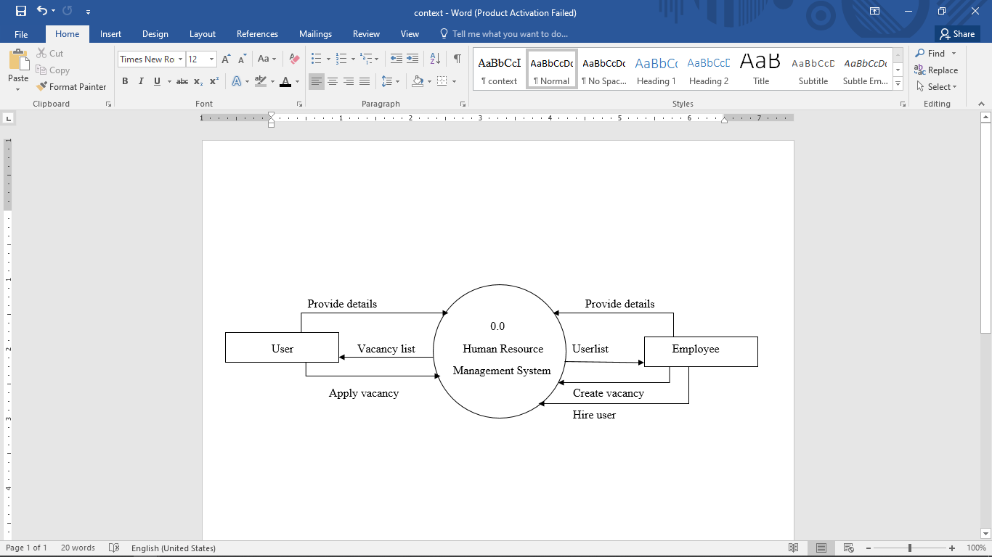

**Fig 4.1: Context diagram of Human Resource Management System**

**Level-1 Data Flow Diagram**

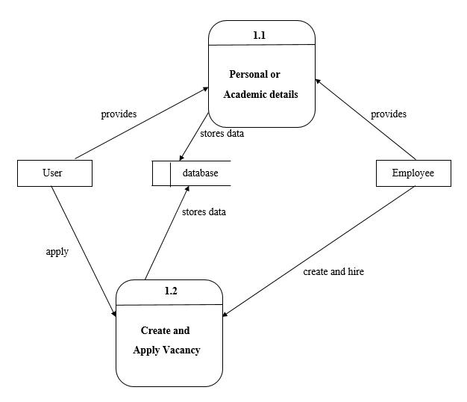

**Fig 4.2: Level-1 Dataflow Diagram of Human Resource Management System**

**4.6.2 ER-Diagram**

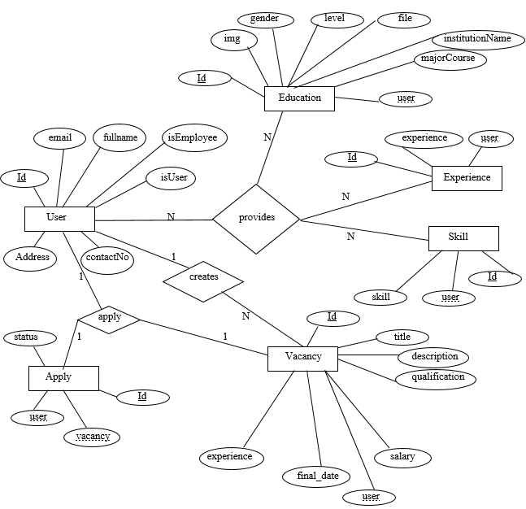

**Fig 4.3: ER-diagram of Human Resource Management System**

**CHAPTER 5**

**SYSTEM DEVELOPMENT**

**5.1. Development Tools**

As this is web based project, so the software which are used to develop the website are web based and the backend for the storing the database of the site. Technology and software for the sake of the development of this project are as follows:

**5.1.1 PyCharm**

For coding, author have used popular PyCharm which makes easier to do tasks, have better interface and easy for communication with the different sub folders and pages.

**5.2. Programming Tools**

**5.2.1 Front End Tools**

Front end also known as client-side is the practice of converting data to a graphical interface, through the use of HTML, CSS and Bootstrap for a website or Web application, so that users can view and interact with that data directly. The objective of designing a site is to ensure that when the users open up the site they see the information in a format that is easy to read and relevant. They need to ensure that their site comes up correctly in different browsers, different operating system and different devices, which requires careful planning on the side of the developer.

* **HTML**

The Hypertext Markup Language, or HTML is the standard markup language for documents designed to be displayed in a web browser. It can be assisted by technologies such as Cascading Style Sheets (CSS) and scripting languages such as JavaScript.

* **CSS**

CSS is used to describe the presentation semantics (i.e. the look and formatting) of a document written in a markup language. It is designed primarily to enable the separation of document content (written in HTML or a similar markup language) from document presentation, including elements such as the layout, colors, and fonts.

* **Bootstrap**

Bootstrap is a free and open-source CSS framework directed at responsive, mobile-first front-end web development. It contains CSS- and (optionally) JavaScript-based design templates for typography, forms, buttons, navigation, and other interface components.

**5.2.2 Back-End Tools**

The back-end of a website consists of a server, an application, and a database. A back-end developer builds and maintains the technology that powers those components which together, enable the user-facing side of the website to even exist in the first place. Simply back-end development is writing code that is not seen directly. A back-end is used to implementing algorithms and solving problems that front-end do and it is related to SQL and databases. It is also known as server-side scripting language consists of programming language like PHP, ASP.NET, JAVA, Ruby etc.

* **Python**

Python is an interpreted high-level general purpose programming language. Its design philosophy emphasizes code readability with its use of significant indentation. Its language constructs as well as its object-oriented approach aim to help programmers write clear, logical code for small and large-scale projects.

* **Django Framework**

Django is a Python-based free and open-source web framework that follows the model-template-views (MTV) architectural pattern. It is maintained by the Django Software Foundation (DSF), and independent organization established in the US as a non-profit. Django’s primary goal is to ease the creation of complex, database-driven websites. The framework emphasizes reusability and “pluggability” of components, less code, low coupling, rapid development, and the principle of don’t repeat yourself.

**CHAPTER 6**

**IMPLEMENTATION AND TESTING**

**6.1. Implementation**

The implementation phase is less creative than system design. It is primarily concerned with user training, site preparation and file conversion. During file testing, user acceptance is, tested followed by user training. Depending on the nature of system, extensive user training may be required. Conversion usually takes place at about the same time the user is being trained. Programming is thought to be modified as a result of programming effort. Programming provides a “***realty test***” for the assumption made by analyst.

System testing checks the deadlines and accuracy of the system to access update and retrieve data from new files. Once the programs become available, test data are read into the computer and processed against the file provided. For testing, it successful program is then run with “***live***” data. Otherwise, a diagnostic test to locate and correct errors. In most conversion, parallel run is conducted where the new system simultaneous run both old system. This method through costly, provided added assurance against errors in the candidate system and also the user staff an opportunity to gain experience through operation.

**6.2. Testing**

Testing is an integral part of the software development process. It is performed at each stage of the SDLC. It ensures that the developed parts confirm to the user requirements. It helps to find out whether an input given to the system is well processed or not and output meets the specified objective of the system. It mainly ensures that the system performs as planned. The testing of system was carried out step by step. Testing is performed at key points that are crucial for the working of a system. In hardware system testing is done for individual components that are used to make up a system. In other word testing is a process of Validation and Verification. Validation is the process of checking if the system will meet the customer’s actual needs, whereas Verification is concerned whether the system is well-engineered and error free.

Various types of testing procedures were performed in order to check the working mechanism and correctness of the system. Some of the types of testing that author did attempt are described below:

**6.2.1 Unit Testing**

The purpose of unit testing in this project is to check that as individual parts of the system are functioning as expected or not. Author have tested each module of this system in order to check the correctness of the output. Firstly, author found many errors and then it was resolved stepwise. For this testing, we test for order section by examining the orders and details provided by the users. We add order, in the database. Hence, unit testing is done.

**6.2.2 Integration Testing**

The purpose of integration test is to verify the functional, performance and reliability between the modules that are integrated.

**6.2.3 System Testing**

Prior to the actual implementation of the system it had to be tested comprehensively and every possible error uncovered. Since it is not possible to test the system exhaustively, the black box testing method was used for system testing. The black box testing usually demonstrates that software functions are operational, that the input is properly accepted and the output is correctly produced; and that integrity of external information (database) is maintained.

**6.2.4 Module Testing**

A module is composed of various programs related to that module. Module testing is done to check the module functionality and interaction between units within a module.

**6.2.5 Acceptance Testing**

Acceptance testing is done after implementation to check if the system runs successfully in the user’s environment.

**6.3. Result Analysis**

“Human Resource Management System” is a web based application which is still under development and even the functioning part are in various pieces. Various results have been tested for validation and verification process.

**6.3.1 Validation**

**Username Validation:**

When username is provided during signup, the username length should not be null.

**Password Validation:**

When password is provided during signup, the length of password should be greater than 5 and the password and password confirmation should be same.

Test 1:

Input: password

Output: System performs the function smoothly.

Test 2:

Input: pass

Output: Password length should be greater than 5 !!!

Test 1:

Input: Password

Output: Input is accepted.

Test 2:

Input:

Output: This field is required.

**6.3.2 Verification**

Once user has done signup, to log into system the email and password is verified as provided by the user/employee.

**CHAPTER 7**

**CONCLUSION AND RECOMMENDATION**

**7.1. Achievement of the Project**

This project has gone through a series of activities to develop a complex solution for the Human Resource Management System. After analysis of the project’s goal and research direction, a set of objectives were established. All the activities done during the project were attempts to realize these objectives.

**7.2. Limitations of the System**

There are some of the limitations of the system. The user and employee cannot make any kind of contact except applying and hiring job, they have to contact externally. Employee don’t have access to cancel request of user for the vacancy. Once the user has applied for the vacancy he/she cannot undo the process. Same for as employee, he/she cannot undo the process if he/she has already hired someone.

**7.3. Future Recommendation**

In addition to the unfinished requirements, there are other possibilities of further improving the project. The improvements may include:

* Overcoming the limitations mentioned above.
* May add more functions of making contact between user and employee.
* User must have access to undo the process of applying for vacancy.
* Employee must have access to undo the process of hiring the user.
* Project can also be extended for the receiving and sending the projects or other documentations required for job.

**7.4. Conclusion**

Hence, author have developed web-based system named as “Human Resource Management System”. This project allows user to provide their personal as well as academic details. And user can view and apply for the vacancy created by the employee. Also employee can also create the vacancy for the user and hire the appropriate user required for the project / job.

**APPENDIX I (SNAPS SHOTS)**

1. **Signup Page**

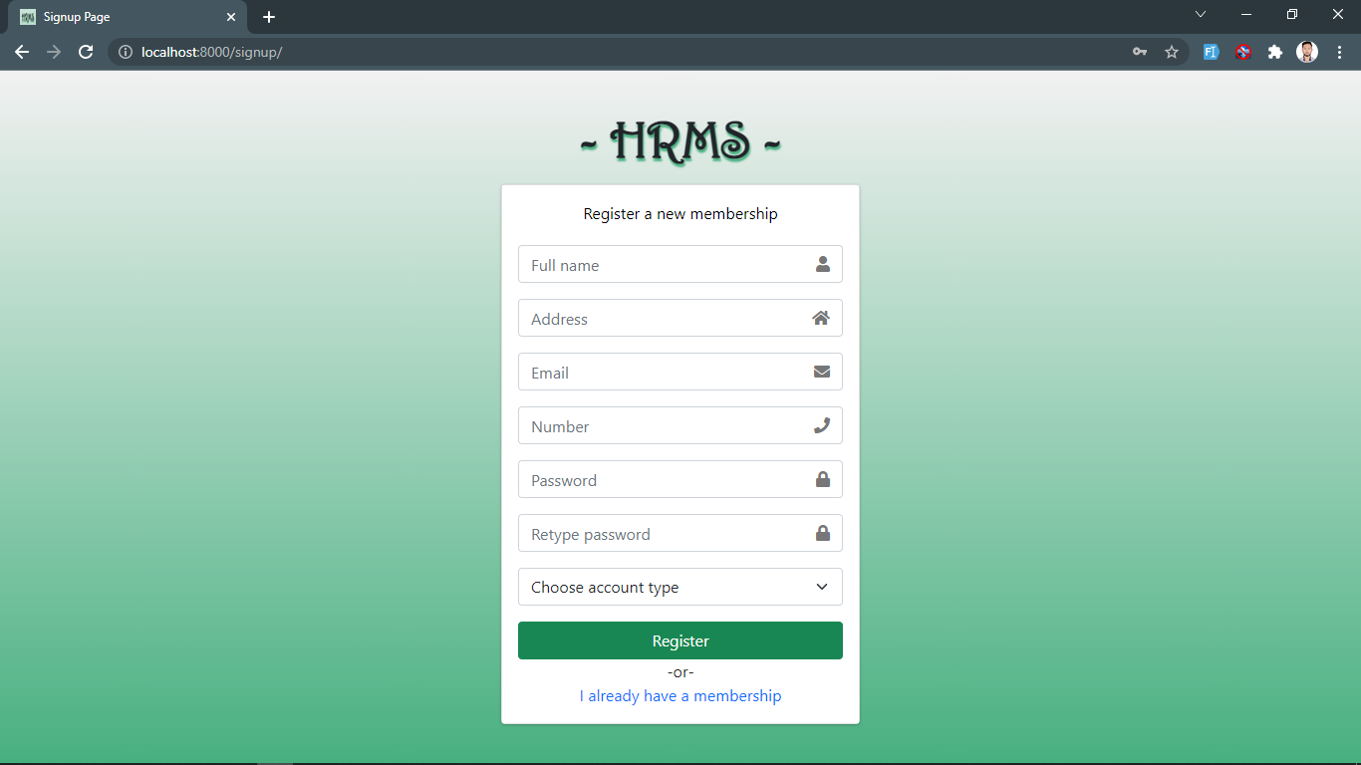

Figure 1: Signup Page

**2. Login Page**

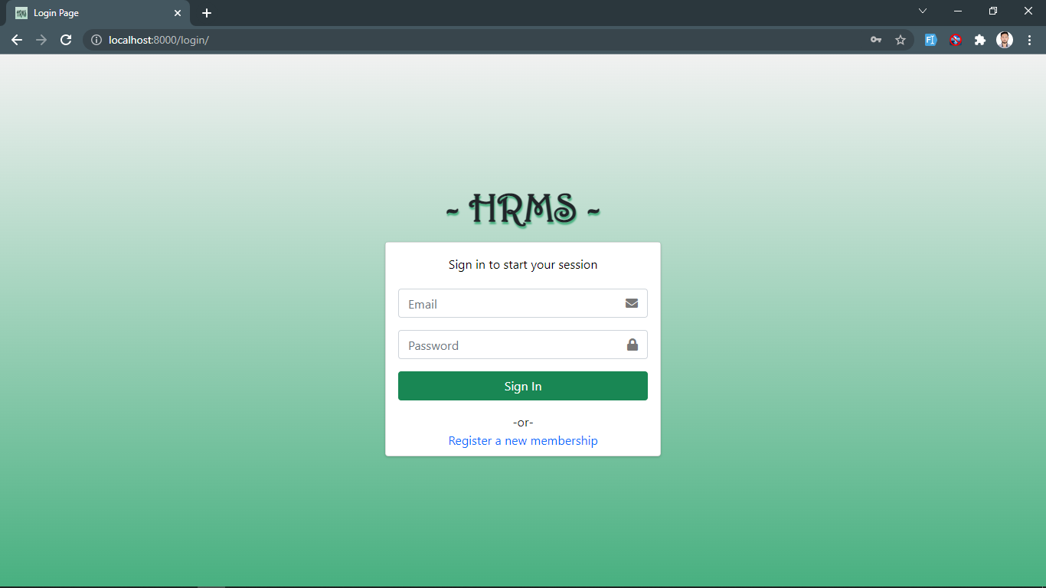

*Figure 2: Login Page*

**3. View User Dashboard Page**

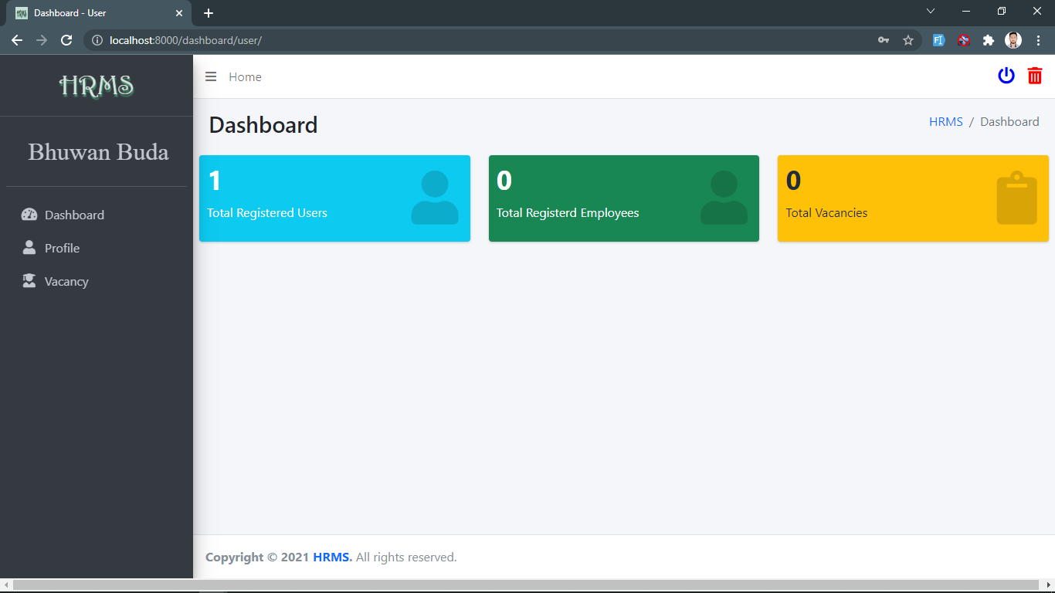

Figure 3: View User Dashboard Page

**4. Add User Details Page**

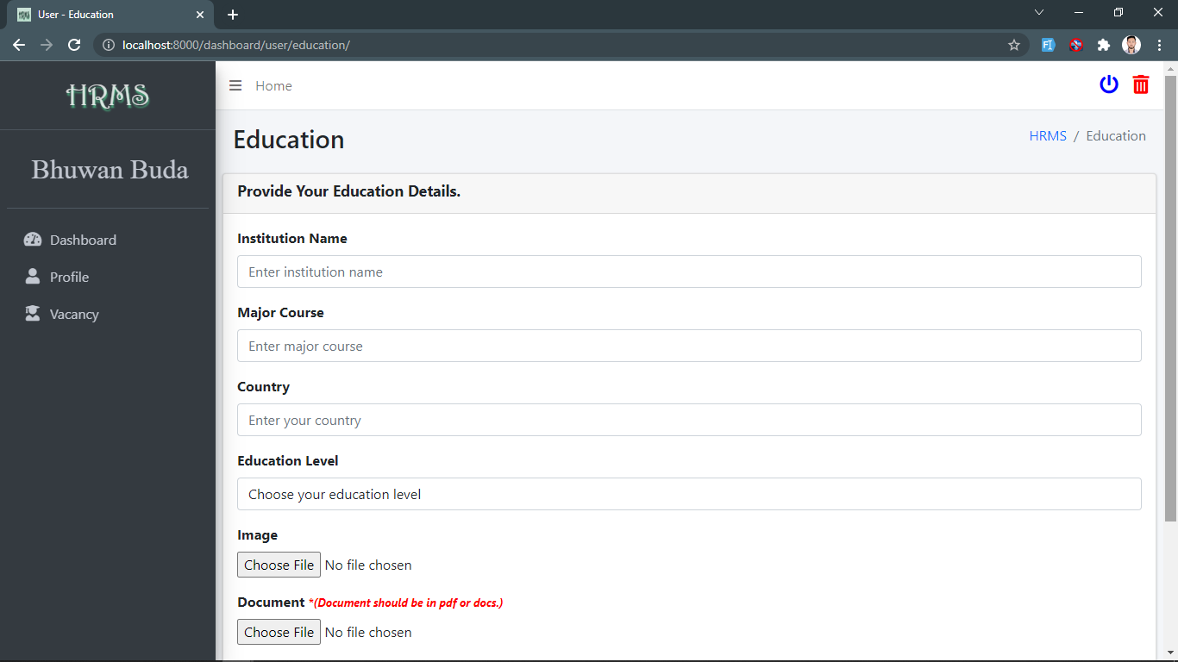

Figure 4: Add User Details Page

**5. View User Profile Page**

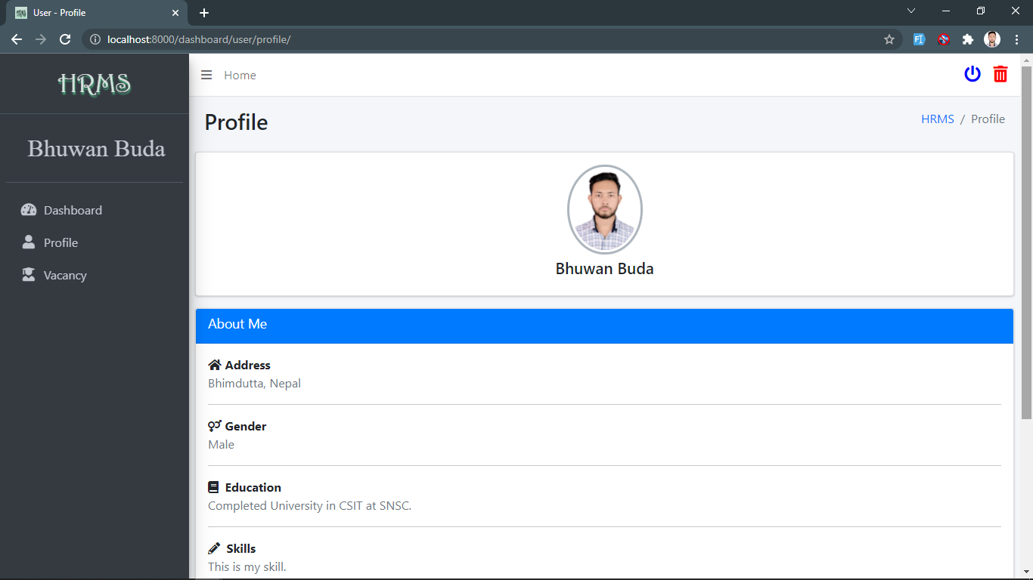

Figure 5: View User Profile Page

**6. View Vacancy Page (User)**

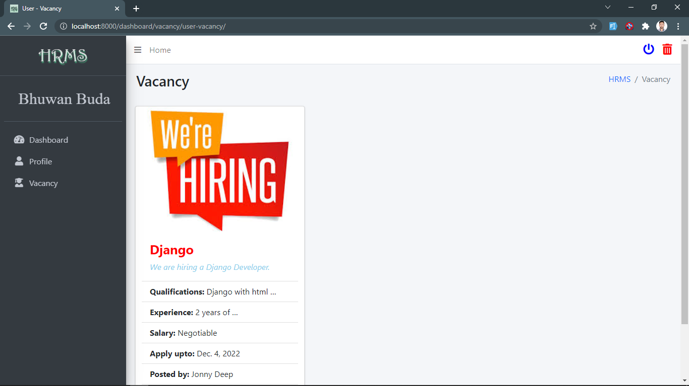

*Figure 6: View Vacancy Page*

**7. Apply Vacancy Page (User)**

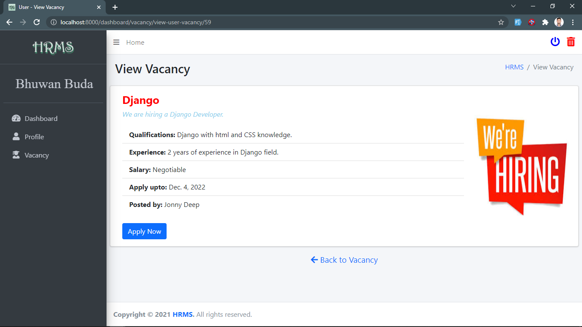

*Figure 7: View Apply Vacancy Page (User)*

**8. View Employee Dashboard Page**

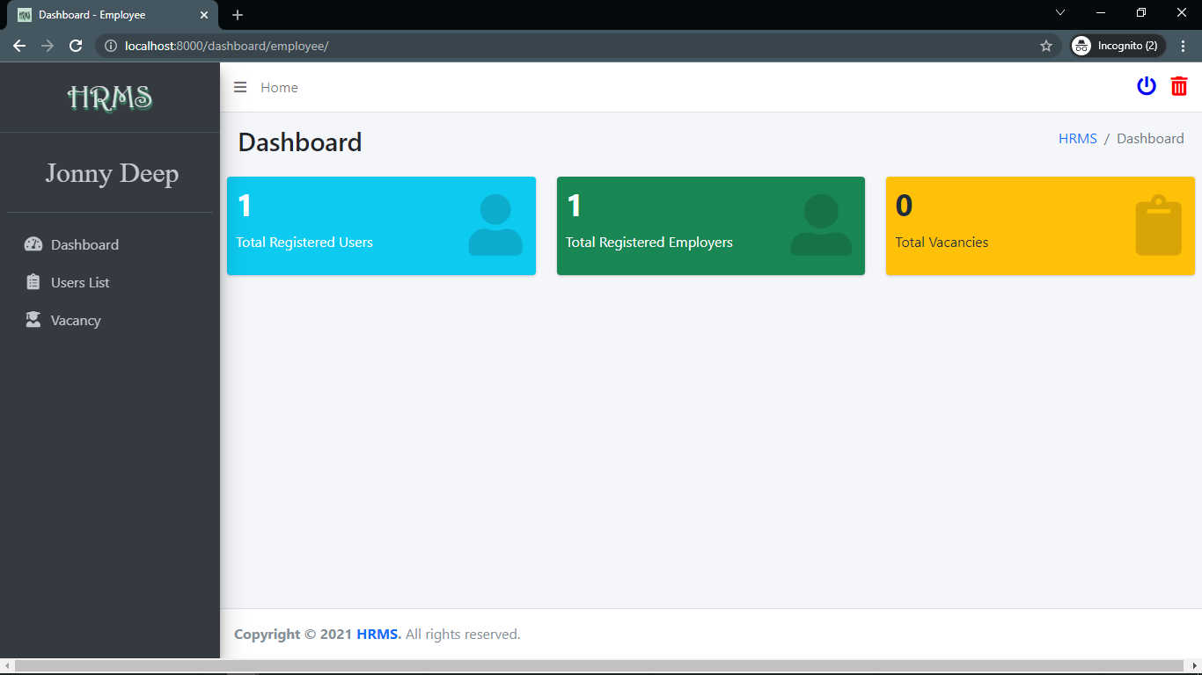

*Figure 8: View Employee Dashboard Page*

**9. View Employee Profile Page**

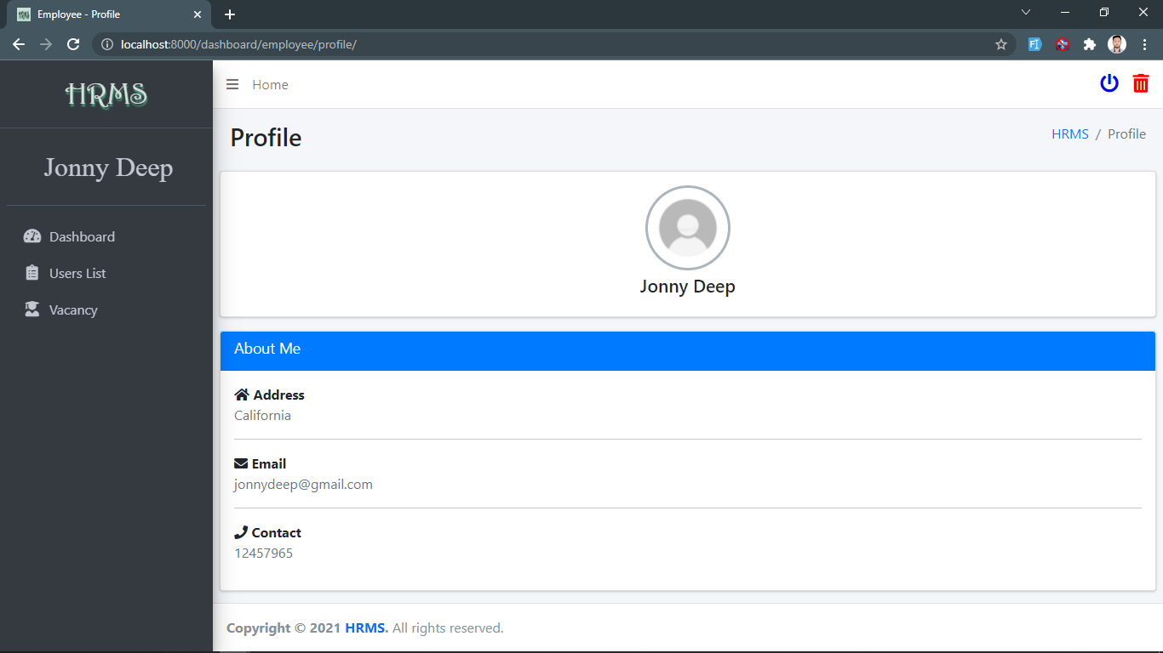

*Figure 9: View Employee Profile Page*

**10. View Employee Create Vacancy Page**

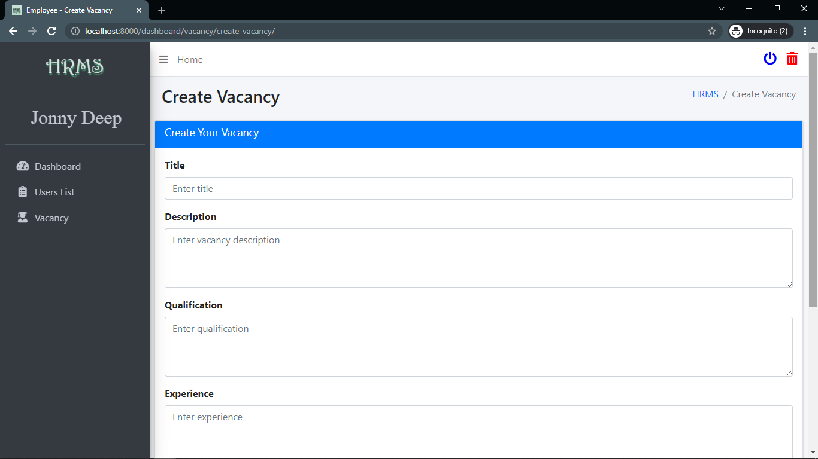

*Figure 10: View Employee Create Vacancy Page*

**11. View Employee Users List Page**

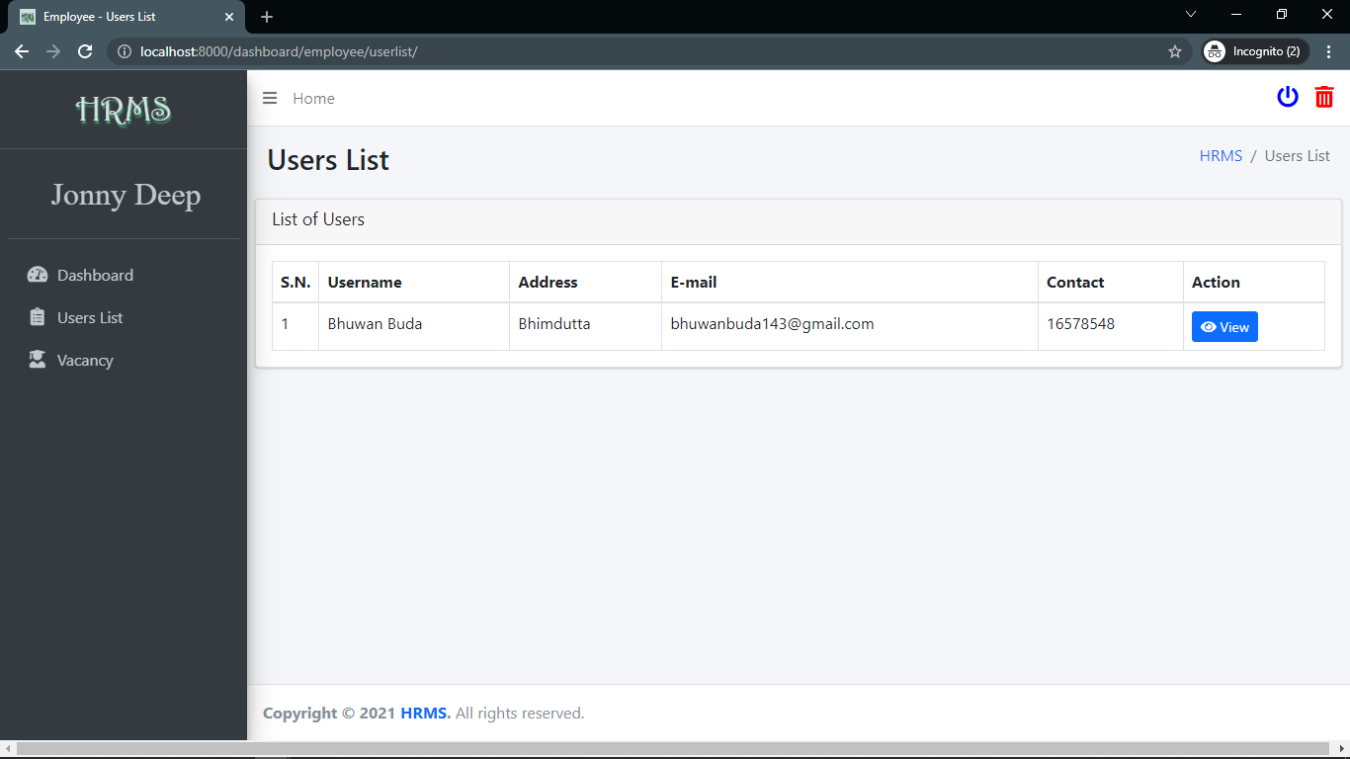

*Figure 11: View Employee Users List Page*

**12. View Each Vacancy Page**

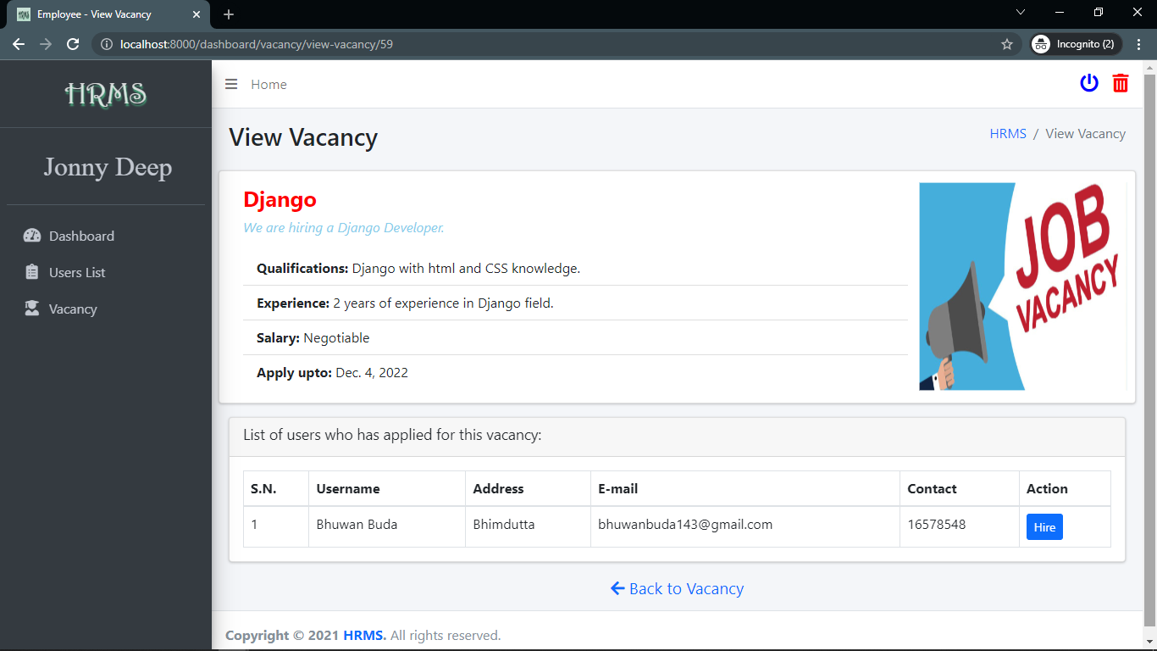

*Figure 11: View Each Vacancy Page*

# **References**

[1] *All HTML Codes.* (n.d.). Retrieved from adminlte.io: https://adminlte.io/

[2] *CSS Tutorial*. (n.d.). Retrieved from w3schools: <https://www.w3schools.com/css/default.asp>

[3] *Bootstrap.* (n.d). Retrieved from getbootstrap.com: https://getbootstrap.com/

[4] *Font Awesome Icons.* (n.d.)*.* Retrieved from fontawesome.com: https://fontawesome.com/

[5] *Stackoverflow*. (n.d.). Retrieved from: https://stackoverflow.com

[6] *Django Documentation.* (n.d.) Retrieved from: https://docs.djangoproject.com/en/3.2/