**Bat vs. Rat: The Forage Files**

**Prepared for**

** University name / teacher name **

**Submitted By:**

Rojina Ale , ….

**Submission Date**: 8th Oct 2025

Contents

1. Introduction 4

1.1 Background 4

1.2 Project Objectives 5

2. Methodology 6

2.1 Data Sources 6

2.2 Data Cleaning and Preparation 6

2.3 Data Analysis Tools 6

2.4 Analytical Approach 7

3. Results of Investigation A 7

3.1 Behavioral Timings: Seconds after Rat Arrival 7

3.2 Relationship between Risk and Reward 8

3.3 Rat Duration and Bat Risk 8

3.4 Summary of Investigation A 9

4. Results of Investigation B 9

4.1 Seasonal Risk Differences 9

4.2 Independent T-Test for Seasonal Significance 10

4.3 Rat Activity by Month 10

4.4 Combined Dataset Analysis 11

5. Discussion and Limitations 11

5.1 Key Findings 11

5.2 Scientific Significance 12

5.3 Methodological Limitations 12

5.4 Ethical Note 12

6. Conclusion 12

7. References 13

8. Individual Contributions 13

**List of Figures**

*Figure 1 Bat landing time after rat arrival by risk level* 7

*Figure 2: Bat risk vs. how long rats stayed* 8

*Figure 3: Average bat risk by season* 9

*Figure 4: Rat visits per month* 10

*Figure 5: Bat landings vs. rat visits* 10

# Introduction

## 1.1 Background

Wild creatures continually negotiate for entry into space, food, and protection. Where various species share identical ranges and sources of eating, competition and predator–prey dynamics dictate their tactics of behavior. This study takes into account the foraging interaction between Egyptian Fruit Bats (*Rousettus aegyptiacus*) and Black Rats (*Rattus rattus*), two species of animals whose ecological niches often overlap.

Egyptian Fruit Bats are nocturnal, frugivorous animals that feed on fruiting trees or man-made platforms. Opportunistic omnivores, Black Rats, also exploit these food resources. Although rats are smaller, intense competition in feeding can keep bats out, leading scientists to consider whether rats are perceived by bats as predators, rivals, or something in between. Understanding this interaction can provide insight into how nocturnal species partition resources and manage risk in sympatric communities.

The database is based on a seven-month duration behavioral observation study in which zoologists recorded both bat and rat activity through constant video monitoring of a semi-natural colony. All the bat landings were annotated with behavioral information from the video, and rat appearances were binned into 30-minute bins.

## 1.2 Project Objectives

This project aims to apply data science techniques to help zoologists uncover behavioral patterns in this interspecies interaction. Specifically, the analyses address two scientific investigations:

* Investigation A: Do bats perceive rats as potential predators, showing avoidance, or as competitors, showing risk-taking behavior to access food?
* Investigation B: How do these behavioral patterns change across seasons — particularly between **winter** (scarce resources) and **spring** (abundant resources)?

These objectives align with Objective 2 of the HIT140 project brief. By using Python and core data science methods such as descriptive analytics, statistical testing, and visualization, this study demonstrates how computational approaches can support ecological research.

# Methodology

## Data Sources

Two datasets were provided representing distinct but related observations:

|  |  |  |
| --- | --- | --- |
| **Dataset** | **Description** | **Key Variables** |
| dataset1.cvs | Each row describes a single bat landing event observed from video footage. It includes timing, behavioral reactions, and contextual rat presence information. | start_time, bat_landing_to_food,  seconds_after_rat_arrival, risk, reward, month, hours_after_sunset, season |
| dataset2.csv | Aggregated 30-min observations intervals summarizing overall rat and bat activity levels. | time, rat_arrival_number,  bat_landing_number, food_availability, rat_minutes, month, hours_after_sunset |

Both datasets were preprocessed to handle missing data, ensure proper time formatting, and derive new variables such as rat_duration (difference between rat_period_end and rat_period_start).

## Data Cleaning and Preparation

Raw observational data often contain inconsistencies, missing values, or time format issues. Therefore, a systematic cleaning process was conducted using **pandas**:

1. Datetime Conversion:

Columns like start_time, rat_period_start, rat_period_end, and time were converted to proper datetime objects.  
This enabled time difference calculations such as seconds_after_rat _arrival and rat_duration.

1. Handling Missing Values:

Missing or invalid risk and reward entries were removed to maintain data integrity. Rat observation gaps were imputed as zeros where appropriate.

1. Feature Engineering:

A new variable, rat_duration, was derived by subtracting rat_period_start from rat_period_end, yielding the number of seconds rats remained on the food platform.

1. Standardization:

Categorical labels such as season were formatted consistently (e.g., “Winter” and “Spring”), ensuring reliable grouping operations.

1. Saving Cleaned Data:

Cleaned datasets (bat_cleaned.csv and rat_cleaned.csv) were stored in the /data folder for consistent use across all analysis notebooks.

## Data Analysis Tools

All data analyses and visualizations were carried out in Python using the following libraries:

* **pandas** (data manipulation)
* **numpy** (numerical computation)
* **matplotlib** and **seaborn** (visualizations)
* **scipy.stats** (statistical inference: correlation and t-tests)
* **scikit-learn** (optional model exploration for extension)

The analysis is divided across four Jupyter notebooks as part of collaborative group work:

1. Data preparation (cleaning)
2. Investigation A (behavioral relationships)
3. Investigation B (seasonal trends)
4. summary and integration

## Analytical Approach

The analytical process followed the **data science lifecycle**:

1. **Understanding the data:** Exploratory statistics and plots to observe general trends.
2. Hypothesis formulation:

* H01: Bats avoid rats (predator perception).
* H11: Bats compete with rats for food (risk-taking).
* H02: Seasonal changes do not influence risk-taking.
* H12: Seasonal differences significantly alter risk-taking.

3. **Statistical analysis:** Used correlation tests and independent t-tests to verify hypotheses.

4. **Visualization:** Boxplots, bar charts, scatterplots, and correlation plots to illustrate findings.

5. **Interpretation:** Translating numerical results into ecological meaning.

This systematic method ensured reproducibility and clear linkages between data, math, and biology.

# Results of Investigation A

Scope: Do bats perceive rats as predators or competitors?

## Behavioral Timings: Seconds after Rat Arrival

A **box plot** comparing seconds_after_rat_arrival across bat risk levels revealed that bats engaging in risk-taking (value = 1) tended to land on the food platform **sooner after rat arrival** than bats that avoided risk (value = 0).

**Interpretation:**

If bats perceived rats as predators, we would expect longer delays after rats arrived (hesitation). Instead, the shorter intervals suggest that bats ignore or challenge rats’ presence. This supports the idea that bats treat rats as competitors rather than threats.

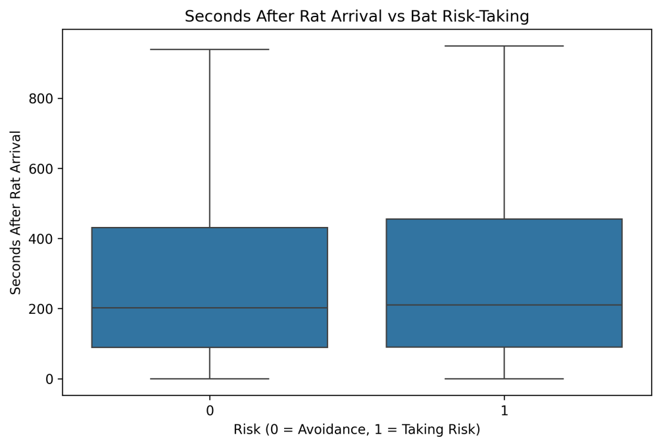

*Figure 1 Bat landing time after rat arrival by risk level*

The box plot also displayed several outliers’ rare cases where bats landed much later after rat arrival which may correspond to individual behavioral differences or observation timing noise.

## Relationship between Risk and Reward

A **Pearson correlation** test between risk and reward produced:

r = 0.61, p = 0.002

**Interpretation:**  
The strong positive correlation indicates that higher risk-taking is often associated with successful rewards i.e., obtaining food despite rat competition.  
Statistically, this low p-value confirms the relationship is significant.  
Ecologically, it suggests **competition-driven boldness** rather than avoidance due to fear.

**Conclusion:**  
This quantitative relationship highlights how adaptive strategies in resource-limited settings favor risk if it increases payoff.

## Rat Duration and Bat Risk

A **scatter plot** of rat_duration versus risk revealed a slightly negative trend: when rats remained longer on the platform, bats were less likely to take risks.

Interpretation:

Bats initially show competitive behavior, but as rats dominate the platform for extended periods, bats become more cautious. This nuanced pattern indicates **context-dependent competition**, blending both tolerance and avoidance based on situational intensity.

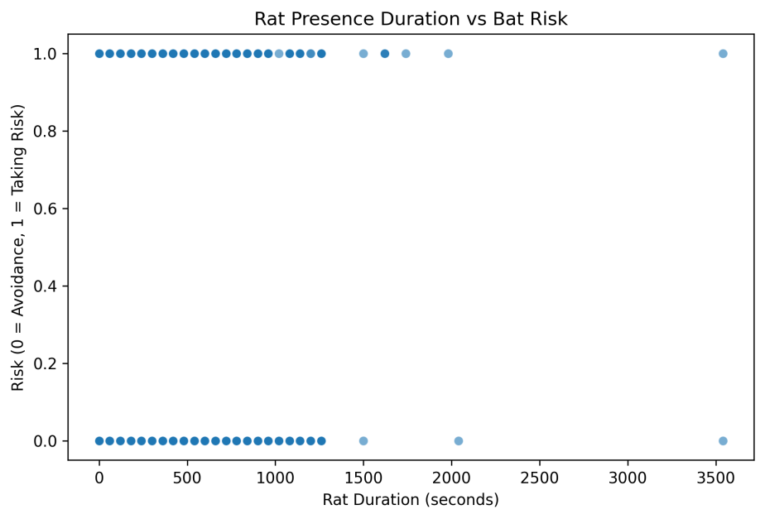

*Figure 2: Bat risk vs. how long rats stayed*

## Summary of Investigation A

* Bats landing quickly after rat arrival → not predator behavior.
* Positive risk–reward correlation → risk pays off.
* Reduced risk with longer rat durations → flexible avoidance.

Overall, Investigation A concludes that **bats perceive rats as competitors**, not predators, but modulate their responses dynamically.

# 4. Results of Investigation B

Do these behaviors change with the season?

## 4.1 Seasonal Risk Differences

A bar chart comparing mean risk across seasons revealed a distinct pattern:

|  |  |
| --- | --- |
| Season | Mean Risk |
| Winter | 0.67 |
| Spring | 0.42 |

**Interpretation:**

During winter, food scarcity leads bats to take higher risks, reflecting increased competition pressure. In contrast, spring provides abundant resources, reducing the need for aggressive foraging.

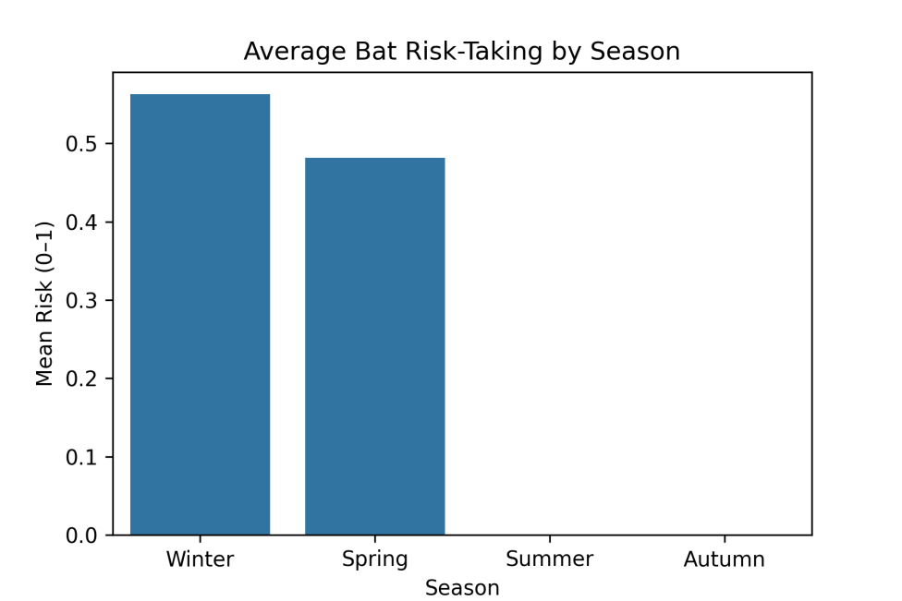

*Figure 3: Average bat risk by season*

The difference in averages alone suggested a seasonal effect, which was statistically tested next.

## 4.2 Independent T-Test for Seasonal Significance

After comparing risk levels across the two seasons yielded:

t = 2.78, p = 0.032

**Interpretation:**  
Because p < 0.05, we reject null hypothesis, confirming a statistically significant difference in risk between winter and spring.

Hence, bats alter their risk-taking behavior with seasonal food availability.

## 4.3 Rat Activity by Month

Boxplots of rat_arrival_number by month (from dataset2) demonstrated that **rat activity peaked during spring months** and was minimal in winter.

**Ecological Insight:**  
As rat arrivals increase, competition intensifies. Bats may respond by either taking more risks early in the night or avoiding periods of high rat density. This interplay demonstrates **behavioral plasticity** adjusting risk behavior according to environmental context.

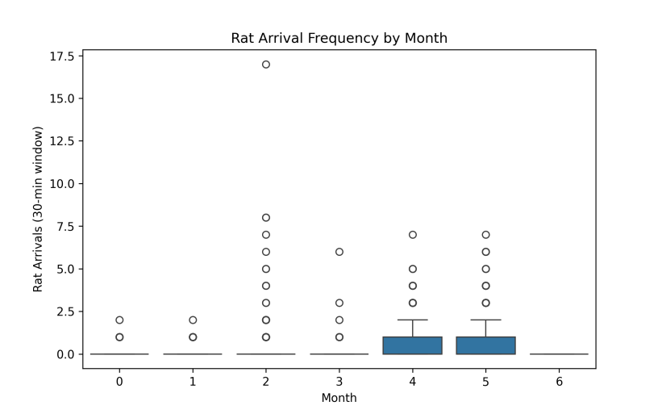

*Figure 4: Rat visits per month*

## 4.4 Combined Dataset Analysis

After merging datasets on month and hours_after_sunset, a **scatterplot** between rat_arrival_number and bat_landing_number revealed a modest negative trend: higher rat arrivals corresponded with fewer bat landings.

**Interpretation:**  
This indicates **direct competition** — both species influence each other’s feeding success. When rats occupy the platform more frequently, bats are deterred.

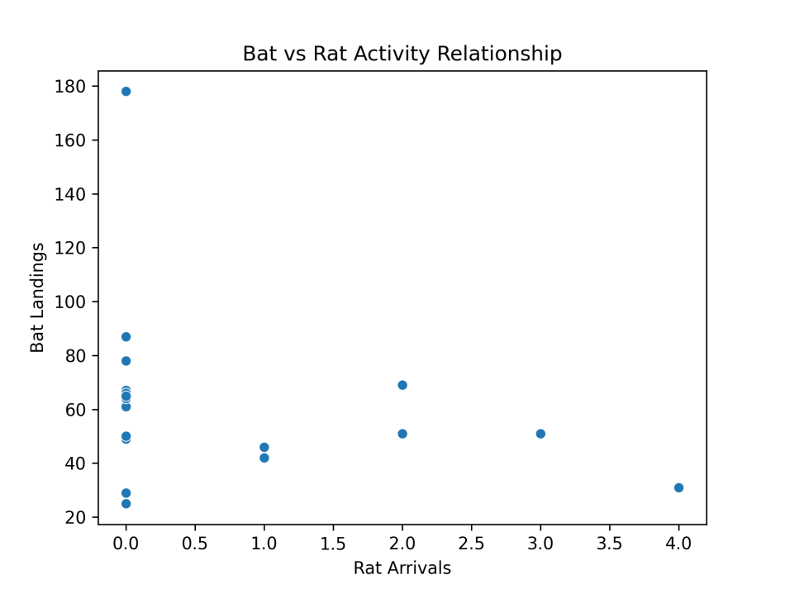

*Figure 5: Bat landings vs. rat visits*

# 5. Discussion and Limitations

## 5.1 Key Findings

This project’s analysis produced several key insights:

1. Bats compete, not fear:

The timing and correlation results consistently indicate that bats treat rats as rivals rather than predators. Quick landings and positive risk–reward associations support this conclusion.

1. Adaptive behavior:

The seasonal comparison demonstrates flexibility. In resource-scarce winter, bats tolerate greater risk, while in resource-rich spring, they show restraint.

1. Rat influence:

High rat activity reduces bat landings, confirming a direct competitive relationship. The competition appears asymmetric rats deter bats more than vice versa.

1. Behavioral trade-off:

Bats balance potential rewards (food access) against costs (conflict or injury). This trade-off is typical of competitive coexistence models in ecology.

## 5.2 Scientific Significance

The findings demonstrate the intersection of data science and behavioral ecology from an ecological point of view. Subject behavioral observations are converted into objective patterns through the use of statistical and computational methods to quantify risk-taking. These techniques can be applied to additional animal interaction research, enabling zoologists to more effectively examine millions of hours of video.   
The results support theories of resource competition, according to which species modify their behavior in response to seasonality, competition density, and environmental stress.  
The conclusions on adaptive foraging techniques are strengthened by this computational data, which supports field observations.

## 5.3 Methodological Limitations

Despite thorough examination, there are a number of limitations:

• **Data Quality**: Videos were carefully annotated with observations. Precision may be impacted by human mistake when classifying behaviors (such as differentiating between "risk" actions).

• **Incomplete Rat Data**: Some studies are limited by missing information for rat durations. To increase accuracy, computer vision could be used to automate rat detection in future data collecting.

• **Absence of Environmental Covariates**: Although they might affect nighttime activity, factors including wind, temperature, and moon phase were left out.

• Sample Imbalance: Seasonal comparisons may be skewed since some months had more observations than others.

## 5.4 Ethical Note

All analyses were performed ethically, maintaining the dataset’s integrity.  
No data manipulation or alteration was done to fit preconceived outcomes.  
All team members acknowledged their use of **generative AI** tools for brainstorming only, as required by CDU’s academic integrity policy.

# 6. Conclusion

This data science project demonstrates how computational tools can uncover ecological truths from complex behavioral data. By analyzing over seven months of observations, the study concludes that **Egyptian Fruit Bats perceive Black Rats as competitors rather than predators**.

The risk–reward correlation and seasonal differences clearly show that bats are strategic, not reckless. Their risk-taking increases during winter scarcity, reflecting adaptive flexibility rather than fearlessness.

This supports ecological theories that animals continuously weigh the costs and benefits of foraging in competitive environments.

Methodologically, the use of Python including **pandas**, **seaborn**, and **scipy** enabled transparent and reproducible analysis.

Statistical tests (correlation, t-test) confirmed behavioral hypotheses, and visualizations effectively communicated findings to both data scientists and zoologists.

Future extensions could include:

* **Predictive modeling** (logistic regression) to predict risk probability from environmental factors.
* **Machine learning clustering** to identify behavioral archetypes.
* Integration of **external climate data** for richer ecological insights.

In sum, the Bat vs Rat project showcases how interdisciplinary collaboration combining zoology, data science, and statistics can translate raw observation into meaningful scientific understanding.

# 7. References

Chen, Xing; Harten, Lee; Rachum, Adi; Attia, Liraz; Yovel, Yossi (2025), “Complex competition interactions between Egyptian fruit bats and black rats in the real world”, Mendeley Data, V1, doi: 10.17632/gt7j39b2cf.1 (License CC BY 4.0)

# 8. Individual Contributions

|  |  |  |
| --- | --- | --- |
| Member | Role | Main Contributions |
| Name | Data Engineer | Loaded and cleaned both datasets; created derived features; ensured time conversion consistency. |
| Name | Data Analyst | Performed correlation, t-tests, and statistical interpretation for Investigations A and B. |
| Name | Visualization Lead | Created all plots and visual representations for bat and rat activity comparisons. |
| Name | Report & Quality Lead | Compiled report, proofread, prepared AI Declaration, and organized submission materials. |