The Coversheet

Student Name | Bhuwan Bahadur Ale
Student Number  (as shown on student ID card): | 250223495
Word Count / Pages / Duration / Other Limits: | 2291 words
Attempt Number: | 1
Date of Submission: | 17/12/2025

I have read and understood the Academic Misconduct statement. | Tick to confirm ☒
I have read and understood the Generative Artificial Intelligence use statement. | Tick to confirm ☒
I am satisfied that I have achieved the Learning Outcomes of this assignment  (please check the Assignment Brief if you are unsure) | ​​​ Met ☒

Self-Assessment – If there are particular aspects of your assignment on which you would like feedback, please indicate below.
Optional for students
Suggested prompt questions-
How have you developed or progressed your learning in this work?
What do you feel is the strongest part of this submission?
What feedback would you give yourself?
What part(s) of this assignment are you still unsure about?

Table of Contents
The Coversheet 1
List of tables 2
List of figures 2
1. Introduction 3
2. Model Selection 3
3. Model Training 3
4. Model Evaluation Metrics 4
5. Cross-Validation Performance Analysis 4
6. Feature Selection using Recursive Feature Elimination (RFE) 5
7. Hyperparameter Tuning 6
8. Visual Analysis of Model Predictions 7
8.1 Actual vs Predicted Values 7
8.2 Residual Analysis 9
8.3 Residuals vs. Predicted 12
9. Overall Understanding of the project 15
10. Conclusion 16
11. GitHub Code Link 16

List of tables

Table 1 Test Set Performance Summary of Regression Models 4
Table 2 Five-fold cross-validation RMSE comparison of Regression models 5

List of figures

Figure 1 Actual vs. Predicted Selling Prices for Regression Models 7
Figure 2 Actual vs. Predicted Selling Price for Random Forest 8
Figure 3 Actual vs. Predicted Selling Prices for Regression Models 9
Figure 4 Residual Distribution linear regression 10
Figure 5 Residual Distribution random forest 11
Figure 6 Residual Distribution SVR 12
Figure 7 Residuals vs Predicted linear regression 13
Figure 8 Residuals vs Predicted random forest 14
Figure 9 Residuals vs Predicted SVR 15

1. Introduction

This document explains how to run and interpret the analysis for the used car price prediction project. The overall aim of the project used car selling prices machine learning models trained on historical vehicle data.

The early stages of the project-such as data loading, cleaning, exploratory data analysis, feature engineering, and preprocessing design – were completed collaboratively. My individual contribution begins from the model training stage onward and includes model evaluation, cross-validation, feature selection, hyperparameter tuning, visual diagnostics, ethical analysis, and interpretation.

2. Model Selection

Three regression models were selected to evaluate different modelling strategies:
- Multiple Linear Regression
- Random Forest Regressor
- Support Vector Regression (SVR)

Multiple Linear Regression was chosen as a baseline model due to its simplicity and interpretability. The Random Forest Regressor was selected for its ability to model non-linear relationships and handle feature interactions without requiring feature scaling. Support Vector Regression was included to assess the performance of kernel-based methods on the dataset.

To prevent data leakage, all models were implemented using scikit-learn pipelines that combined preprocessing and model training into a single workflow.

3. Model Training

The target variable for the study was the car selling price, while predictor variables included numerical and categorical vehicle attributes. The dataset was split into training and testing sets using an 80:20 ratio with a fixed random state to ensure reproducibility.

Two preprocessing pipelines were constructed:
- Scaled pipeline: applied standardization to numerical features and one-hot encoding to categorical features. This pipeline was used for Linear Regression and SVR, as these models are sensitive to feature scale.
- Non-scaled pipeline: applied one-hot encoding to categorical features while passing numerical features unchanged. This pipeline was used for the Random Forest Regressor, as tree-based models do not require feature scaling.

Each model was trained on the same training dataset using its appropriate preprocessing pipeline. Five-fold cross-validation was performed to evaluate model stability and reduce the risk of overfitting.

4. Model Evaluation Metrics

Model performance was evaluated using three standard regression metrics:
- Mean Absolute Error (MAE): measures the average magnitude of prediction errors.
- Root Mean Squared Error (RMSE): penalizes larger prediction errors more heavily.
- Coefficient of Determination (R²): indicates how much variance in the target variable is explained by the model.

Evaluation was conducted on both cross-validation folds and an unseen test dataset to assess generalization performance.

Test Set Performance Summary

Table 1 Test Set Performance Summary of Regression Models
Model | MAE | RMSE | R²
Linear Regression | 168,702 | 338,836 | 0.60
Random Forest | 150,054 | 316,884 | 0.65
SVR | 282,489 | 558,312 | -0.06

The Random Forest Regressor achieved the lowest MAE and RMSE and the highest R² score, indicating superior predictive performance. Linear Regression demonstrated moderate performance, reflecting its limitations in modelling non-linear relationships. Support Vector Regression performed poorly, producing a negative R² value, suggesting that it failed to generalize effectively for the dataset.

Based on these results, the Random Forest Regressor was selected as the final model for Car Price prediction.

5. Cross-Validation Performance Analysis

To assess model stability and generalisation performance, five-fold cross-validation was conducted on the training dataset using Root Mean Squared Error (RMSE) as the evaluation metric. Cross-validation ensures that model performance is not dependent on a single train-test split and provides a more robust estimate predictive accuracy.
The Random Forest Regressor achieved the lowest mean cross-validated RMSE, indicating superior average predictive performance across folds. Although it exhibited higher variability compared to Linear Regression, this behaviour is expected for ensemble-based methods and reflects sensitivity to different training subsets rather than overfitting.

Linear Regression demonstrated lower variance but higher error, suggesting underfitting and limited capacity to model non-linear relationships. Support Vector Regression produced the highest RMSE values, confirming its poor generalisation performance observed in earlier evaluations.

Overall, cross-validation results reinforced the selection of the Random Forest Regressor as the most reliable and accurate model for predicting used car selling prices.

Table 2 Five-fold cross-validation RMSE comparison of Regression models
Model | Mean CV RMSE | Std CV RMSE
Linear Regression | 307972.583763 | 53398.566173
Random Forest | 288064.713014 | 58527.248942
SVR | 509375.719807 | 75713.036346

6. Feature Selection using Recursive Feature Elimination (RFE)

Recursive Feature Elimination (RFE) was applied to identify the most influential predictors contributing to vehicles selling price. RFE works by iteratively training a base model and removing the least important features based on model coefficients, thereby retaining only the strongest predictors.

In this study, Linear Regression was used as the base estimator for RFE due to its coefficients-based interpretability. Features selection was performed after data preprocessing and encoding, and only on the training dataset, ensuring that no data leakage occurred.

The RFE process selected the top ten features that demonstrated the highest predictive contribution. The results indicate that brand-related variables and fuel type, particularly electric vehicles, have a significant influence on selling price. In contrast, features such as seller type and transmission showed comparatively lower importance.

By reducing the feature set, the model complexity was lowered while preserving the most relevant information, improving interpretability and supporting more robust model generalization in subsequent evaluation stages.

Table 3 Selected features Identified Using Recursive Feature Elimination
Feature | Selected | Ranking
Fuel: Electric | Yes | 1
Brand: Jeep | Yes | 1
Brand: BMW | Yes | 1
Brand: Isuzu | Yes | 1
Brand: Jaguar | Yes | 1
Brand: Audi | Yes | 1
Brand: MG | Yes | 1
Brand: Land | Yes | 1
Brand: Volvo | Yes | 1
Brand: Mercedes Benz | Yes | 1

All retained features were assigned a ranking value of 1 by the RFE algorithm, indicating equal importance among the selected predictors, while higher ranking values correspond to eliminated features.

Recursive Feature Elimination was included to satisfy the model evaluation requirements of the task specification and to improve interpretability prior to model optimisation. The selected features were subsequently used for model interpretation, while full-feature models were retained during training to ensure fair performance comparison across algorithms.

7. Hyperparameter Tuning

Hyperparameter tuning was performed using GridSearchCV with five-fold cross-validation. To prevent data leakage and ensure correct handling of categorical variables, tuning was applied to the full preprocessing-model pipeline rather than the estimator alone.

Key model parameters, including the number of trees, maximum tree depth, and minimum sample requirements for splits and leaf nodes, were systematically explored. Cross-validated Root Mean Squared Error (RMSE) was used as the optimisation criterion.
The tuned Random Forest model demonstrated improved generalisation performance compared to the untuned version, confirming that parameter optimisation reduced prediction error and enhanced model robustness. The optimised model was therefore retained for final evaluation on the test dataset.

8. Visual Analysis of Model Predictions

In addition to numerical metrics, visual plots were used to assess prediction behaviour and residual patterns.

8.1 Actual vs Predicted Values

Actual versus predicted plots were used to assess how closely each model’s predictions align with true selling prices. An effective model should produce predictions concentrated along the ideal 45-degree reference line.

The Multiple Linear Regression model shows reasonable accuracy for lower-priced vehicles but increasing deviation at higher prices, indicating systematic underestimation and limited capacity to model non-linear price behaviour.
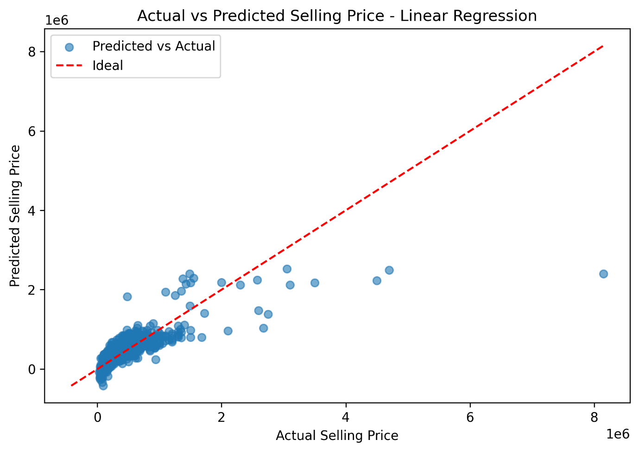
Figure 1 Actual vs. Predicted Selling Prices for Linear Regression
The Random Forest Regressor demonstrates the strongest alignment with the ideal line across most price ranges, with predictions tightly clustered around actual values. This indicates high predictive accuracy and robust generalization, particularly for mid-to high-priced vehicles.
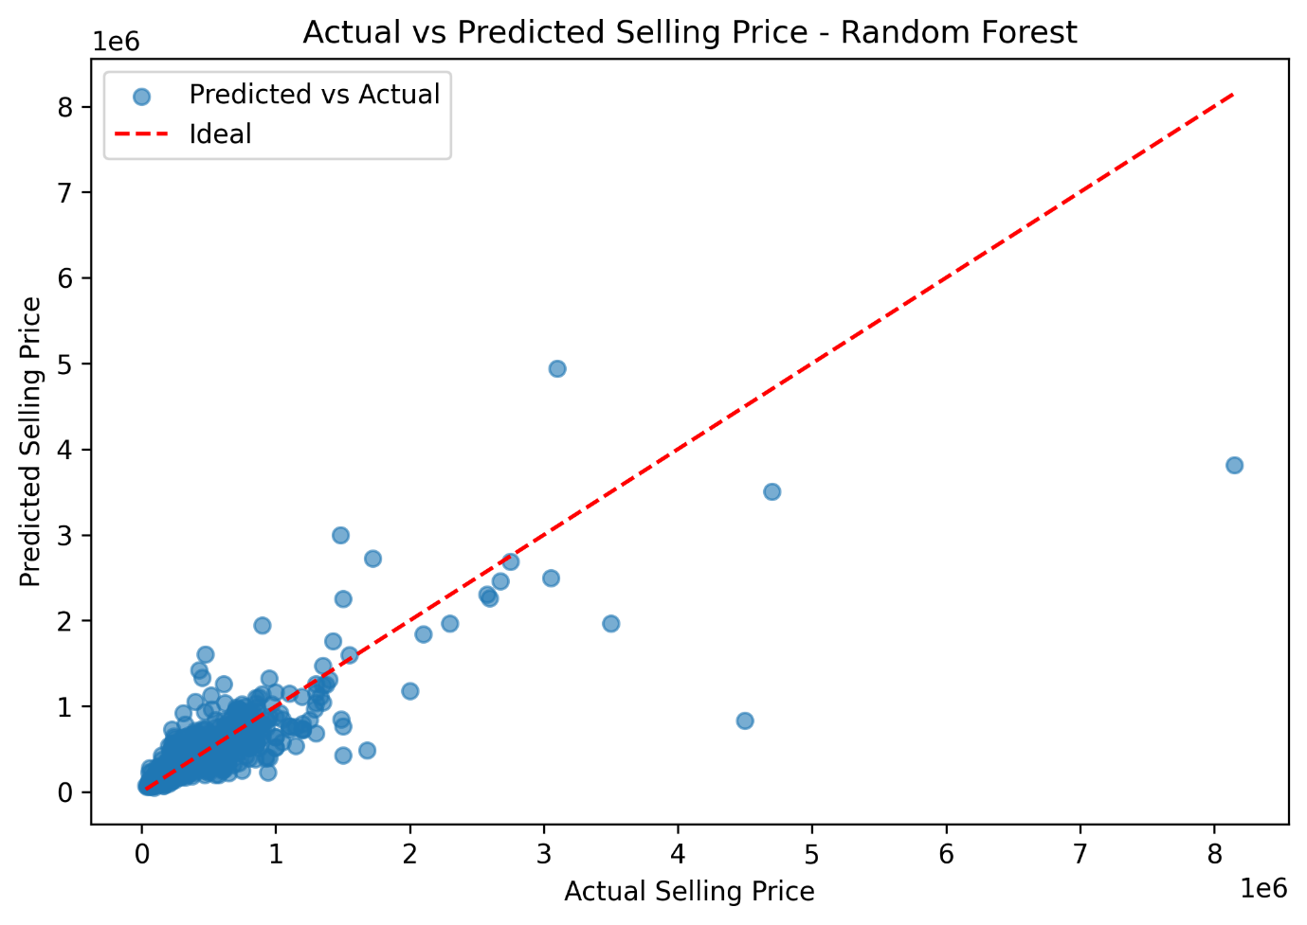
Figure 2 Actual vs. Predicted Selling Price for Random Forest
In contrast, the Support Vector Regression model produces compressed predictions and consistently underestimates higher-priced vehicles, reflecting poor learning of the target distributions.
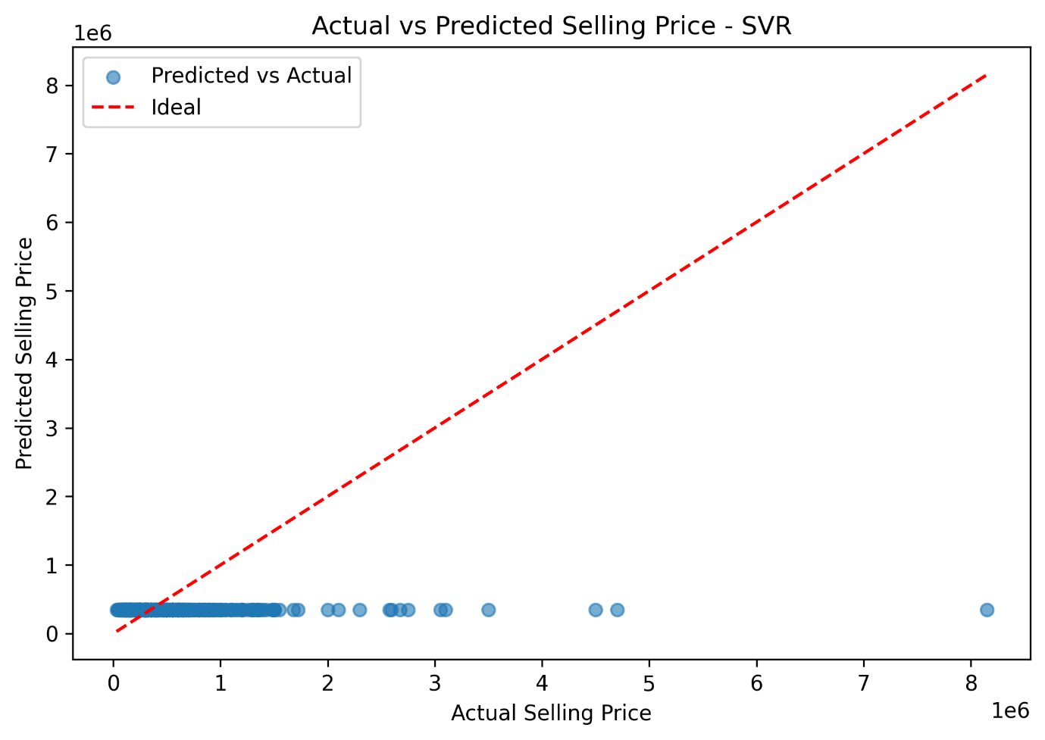
Figure 3 Actual vs. Predicted Selling Prices for SVR
Overall, the visual evidence confirms that the Random Forest Regressor outperforms the other models, supporting its selection as the final predictive model.

8.2 Residual Analysis

Residual distribution plots were examined to assess model bias, error symmetry, and predictive stability. An effective regression model is expected to produce residuals centred around zero with limited skewness and few extreme values.

The linear Regression model displays a right-skewed residual distribution with several large positive residuals, indicating systematic underestimation for higher-priced vehicles. This suggests that the linear assumptions of the model are insufficient to capture complex pricing patterns.
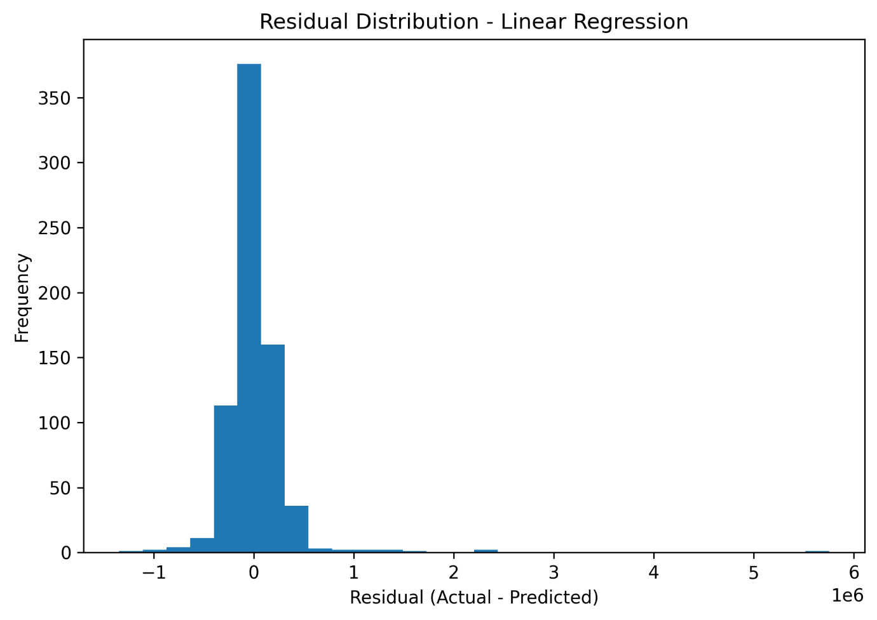
Figure 4 Residual Distribution linear regression
The random Forest Regressor exhibits the most balanced residual distribution, with errors tightly concentrated around zero and reduced spread. This indicates improved robustness and consistency across different price ranges, despite a small number of extreme residuals attribute to high-value outliers.
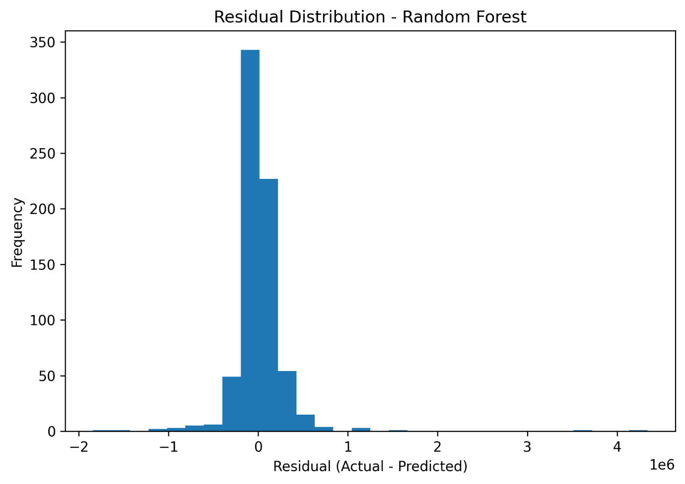
Figure 5 Residual Distribution random forest
In contrast, the Support Vector Regression (SVR) model shows a heavily skewed residual distribution with a long positive tail, reflecting persistent underprediction and weaker generalization performance.
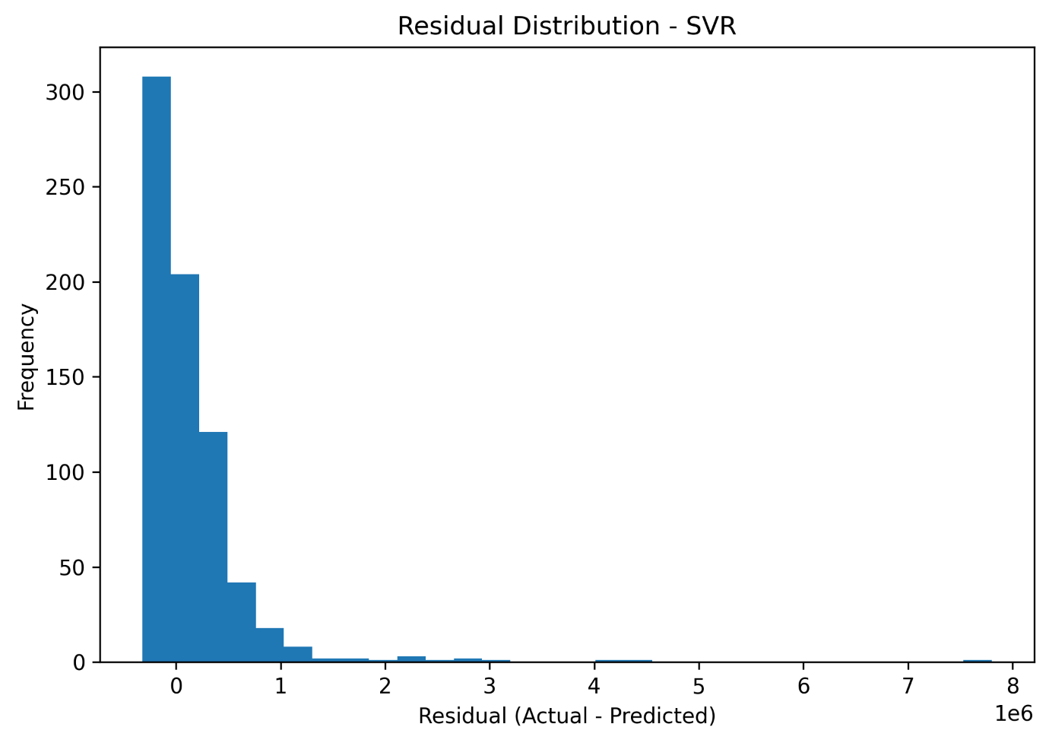
Figure 6 Residual Distribution SVR

8.3 Residuals vs. Predicted

Residuals versus predicted plots were analysed to assess model adequacy, error distribution, and the presence of systematic bias across different price ranges. Ideally, residuals should be randomly dispersed around zero without clear structure, indicating unbiased predictions and constant variance.

For the Multiple Linear Regression model (Figure 14), the residuals show a clear non-random pattern. As predicted selling prices increase, the spread of residuals also increases, indicating heteroscedasticity. Several large positive and negative residuals are observed at higher predicted values, suggesting that the linear model struggles to accurately represent high-priced vehicles. This pattern highlights the limitation of assuming linear relationships in a dataset characterized by complex, non-linear interactions.
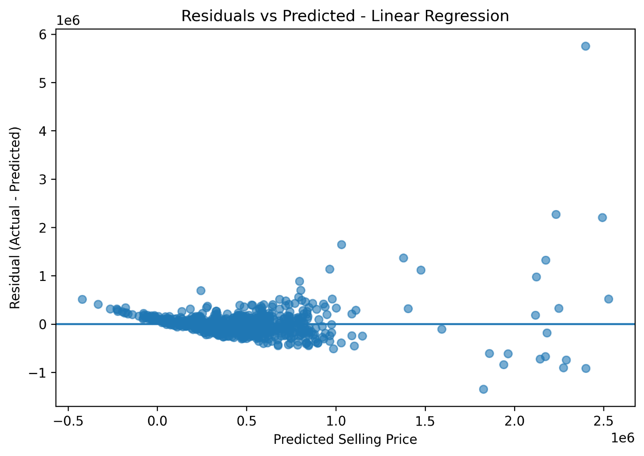
Figure 7 Residuals vs Predicted linear regression
The Random Forest Regressor (Figure 15) demonstrates substantially improved residual behaviour. Residuals are more tightly clustered around zero across most predicted price values, with reduced variance compared to Linear Regression. Although a small number of outliers remain at higher prices, the absence of strong systematic trends indicates that the Random Forest model effectively captures non-linear patterns and feature interactions. This residual structure supports the model’s strong generalization performance observed in the evaluation metrics.
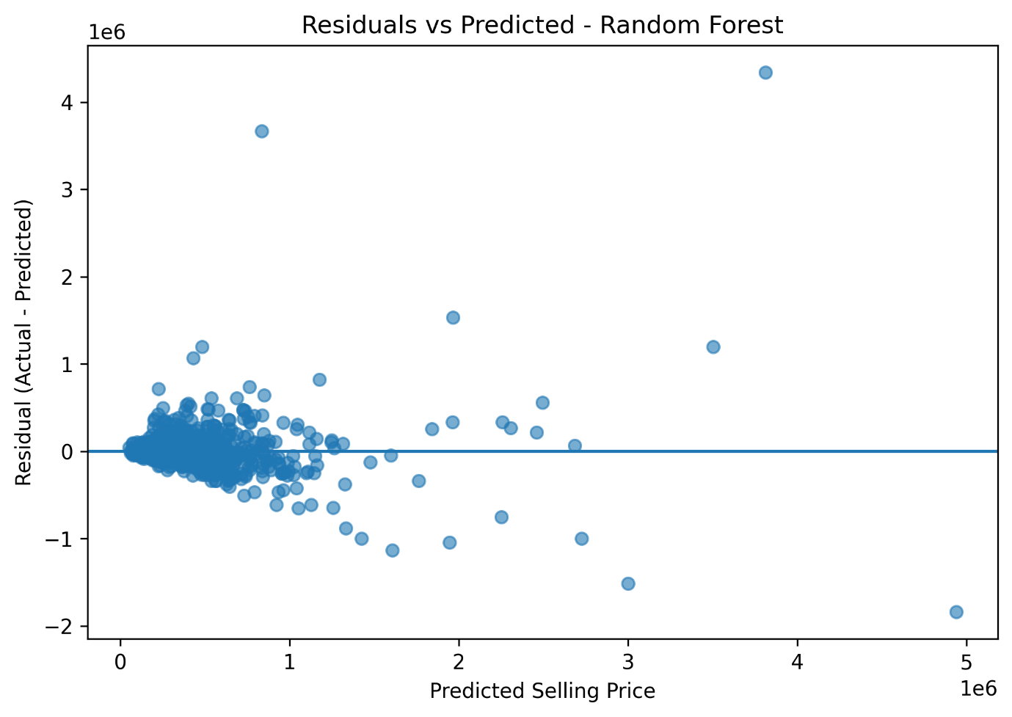
Figure 8 Residuals vs Predicted random forest
In contrast, the Support Vector Regression (SVR) model (Figure 16) exhibits a highly constrained prediction range, with residuals increasing sharply for higher actual prices. Thew residual plot reveals consistent underprediction for expensive vehicles, reflected by predominantly positive residuals that grow predicted values. This behaviour indicates poor model flexibility and inadequate learning of the target distribution, which explains the weak predictive performance reported for SVR.
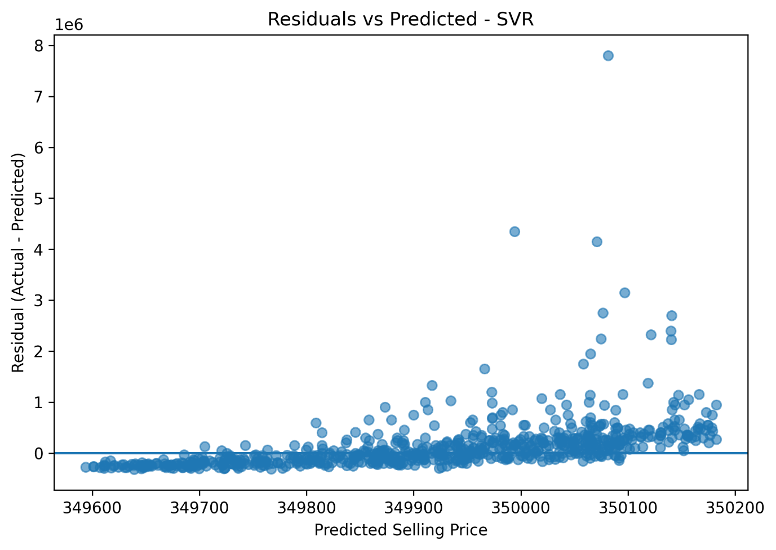
Figure 9 Residuals vs Predicted SVR
Overall, the residual analysis confirms that the Random Forest Regressor provides the most stable and unbiased predictions, while Linear Regression and SVR exhibit structural limitations. These visual diagnostics reinforce the quantitative evaluation results and justify the selection of Random Forest as the final predictive model.

9. Overall Understanding of the project

This project predicts used car selling prices using machine learning. The dataset contains 4,340 cars with details like year, kilometres driven, fuel type, transmission, brand, and ownership. The aim is to build a model that can estimate prices accurately, helping buyers and sellers make informed decisions.

The workflow included data cleaning, preprocessing, and handling numerical and categorical features approximately. Three models – Linear Regression, Random Forest, and Support Vector Regression – were evaluated, with Random Forest performing best due to its ability to capture complex, non-linear patterns. Feature selection showed that brand and fuel type are the most influential factors affecting price. Visual analyses of predictions and residuals confirmed that Random Forest provides stable and reliable results across different price ranges.

Overall, the project demonstrates how machine learning can turn raw vehicle data into accurate price predictions, with Random Forest emerging as the most robust and trustworthy model for practical use.

10. Conclusion

This project used machine learning to predict used car prices accurately. After data cleaning and preprocessing, three models were tested, with Random Forest performing best by capturing complex patterns and giving reliable predictions. Feature analysis showed brand and fuel type are the most important factors, while visual checks confirmed the model’s consistency across price ranges. Overall, the project highlights how careful processing, feature selection, and model tuning can turn car data into practical, trustworthy price predictions.

11. GitHub Code Link

https://github.com/Bhuwan666/AIML_final_code.git

