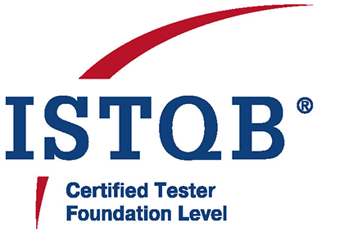Bhuwan Agrawal

B-105, Stellar MI CitiHomes, Omicron 3, Greater Noida

Phone: +91-8800149988 | Email: bhuwan83@gmail.com

# Professional Summary

Quality Assurance Professional with over 13 years of experience in software testing, automation, and quality management. Proficient in manual and automated testing using tools such as Selenium, Cypress, Ranorex, and TestComplete. Skilled in test case design, defect tracking, team management, and client communication. Proven ability to lead QA teams, deliver high-quality products, and ensure testing best practices.

# Core Skills

* Testing Tools: Selenium, Cypress, Ranorex, TestComplete, QTP
* Languages: Java, VBScript
* Test Management Tools: TestRail, TestLink
* Bug Tracking: JIRA, QC, MKS
* Version Control: SVN, GitHub
* Database: SQL Server
* Operating Systems: Windows XP/7/10, Windows Server 2008
* Other: Agile Methodologies, Project Planning, Team Leadership, SDLC/STLC, Regression & Functional Testing

# Professional Experience

**QA Manager – Bitxia Tech Pvt. Ltd., Gurugram (Sep 2022 – Present)**

* eNAM 2.0 (Dec 2024 – Present)
* APL Logistics (Apr 2023 – Present)
* Investor Portal (Sep 2022 – Apr 2023)
* Jarvis Retail Lending (Sep 2022 – Apr 2023)

**Responsibilities:** Team leadership (5–6 QA members), client communication, project estimation, manual testing (functional, regression, GUI), tools used: Jira, TestRail

**Sr. Test Engineer – DLT LABS, Noida (Jun 2021 – Sep 2022)**

* PPD (DL Asset Track) (Mar 2022 – Sep 2022)
* THOR (DL Asset Track) (Jun 2021 – Feb 2022)

**Responsibilities:** Manual testing of blockchain applications, test case management in TestLink, defect tracking in Jira.

**Associate Team Lead – Xorlabs.com, Greater Noida (Mar 2014 – Jun 2021)**

* SQLCM (Sep 2016 – Jun 2021)
* XMF Automation (Jan 2019 – Dec 2020)
* CML Configurator (May 2015 – May 2019)
* SQL Secure (Aug 2017 – Oct 2017)
* Uptime (Jan 2017 – Jul 2017)
* ASD (Mar 2014 – Dec 2016)
* One Source Configurator (Mar 2014 – Dec 2016)
* MSQT (Mar 2014 – Dec 2015)

**Responsibilities:** Manual & automation testing using Ranorex, Selenium, TestComplete. Defect tracking in Jira.

**Software Test Engineer – Safenet Infotech Pvt. Ltd., Noida via Magna InfoTech (Mar 2012 – Mar 2014)**

* Usage Reporting System (Dec 2012 – Mar 2014)
* WPS Online (Mar 2012 – Dec 2012)
* WPS Client (Mar 2012 – Dec 2012)

**Responsibilities:** Manual and automation testing (QTP/VBScript), functional, GUI, and database testing. Bug tracking via MKS.

# Certifications

* ISTQB Certified Tester – Foundation Level

# Education

* Master of Computer Applications (MCA), UP Technical University – 64.28%
* Bachelor of Computer Applications (BCA), Allahabad Agriculture Institute – 7.96 CGPA