**Curriculum Vitae**

Bhuwan Agrawal

**QA Manager**

**Address:** B-105 Stellar Mi Citihomes, Omicron 3,

Greater Noida, 201310

[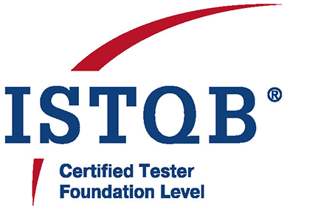](https://www.istqb.in/about-us/certified-tester/foundation-level/36257-bhuwan-agrawal)**Phone:** +91-8800149988 | **Email:** bhuwan83@gmail.com

**LinkedIn:** linkedin.com/in/bhuwanagrawal

**GitHub:** github.com/BhuwanAgrawal

# Career Objective

To leverage over 13+ years of experience in software quality assurance and test automation to lead high-performing QA teams, drive continuous improvement, and deliver high-quality digital solutions in a fast-paced environment.

# Profile Summary

Quality Assurance Professional with over 13+ years of experience in software testing, automation, and quality management. Proficient in manual and automated testing using tools such as Selenium, Cypress, Ranorex, and TestComplete. Skilled in test case design, defect tracking, team management, and client communication. Proven ability to lead QA teams, deliver high-quality products, and ensure testing best practices.

# Technical Skills

* Testing Tools: Selenium, Cypress, Ranorex, TestComplete, QTP
* Languages: Java, Python
* Test Management Tools: TestRail, TestLink
* Bug Tracking: JIRA, QC, MKS
* Version Control: SVN, GitHub
* Database: SQL Server
* Operating Systems: Windows XP/7/10, Windows Server 2008
* Other: Agile Methodologies, Project Planning, Team Leadership, SDLC/STLC, Regression & Functional Testing

# Work Experience

* QA Manager – Bitxia Tech Pvt. Ltd., Gurugram (Sep 2022 – July 2025)
* Sr. Test Engineer – DLT LABS, Noida (Jun 2021 – Sep 2022)
* Associate Team Lead – Xorlabs.com, Greater Noida (Mar 2014 – Jun 2021)
* Software Test Engineer – Safenet Infotech Pvt. Ltd. via Magna InfoTech, Noida (Mar 2012 – Mar 2014)

# Project Experience

**Bitxia Tech Pvt. Ltd.**

* eNAM 2.0 (Dec 2024 – July 2025)
* APL Logistics (Apr 2023 – Dec 2024)
* Investor Portal (Sep 2022 – Apr 2023)
* Jarvis Retail Lending (Sep 2022 – Apr 2023)
* Responsibilities: Team leadership (5–6 QA members), client communication, project estimation, manual testing (functional, regression, GUI), Jira, TestRail

**DLT LABS**

* PPD (DL Asset Track) (Mar 2022 – Sep 2022)
* THOR (DL Asset Track) (Jun 2021 – Feb 2022)
* Responsibilities: Manual testing of blockchain apps, TestLink, Jira

**Xorlabs.com**

* SQLCM, XMF Automation, CML Configurator, SQL Secure, Uptime, ASD, One Source Configurator, MSQT
* Responsibilities: Manual & automation testing (Ranorex, Selenium, TestComplete), Jira

**Safenet Infotech Pvt. Ltd.**

* Usage Reporting System, WPS Online, WPS Client
* Responsibilities: Manual & QTP automation (VBScript), functional, GUI, DB testing, MKS

# Certifications

* ISTQB Certified Tester – Foundation Level

# Academic Background

* MCA – UP Technical University – 64.28%
* BCA – Allahabad Agriculture Institute – 7.96 CGPA