GESTURE-BASED VOLUME CONTROL SYSTEM
A Computer Vision Application for Touchless System Audio Control
PROJECT REPORT
by
BHUWAN SONI
Integrated M.Tech – Artificial Intelligence
VIT Bhopal University


Under Supervision of
Dr. Vikas Pel Veelon
SCHOOL OF COMPUTING SCIENCE ENGINEERING AND ARTIFICIAL INTELLIGENCE (SCAI)
VIT BHOPAL UNIVERSITY

September 2026

CERTIFICATE

This is to certify that the project entitled “Gesture-Based Volume Control System” has been prepared as an academic project report. The project presents a computer-vision based approach for controlling system audio volume through hand gestures captured using a camera. The report describes the problem, methodology, software architecture, implementation, testing, limitations, and future scope of the proposed system.

Project Guide: Date:
Dr. Vikas Pel Veelon 18th September , 2026

ACKNOWLEDGEMENT

I would like to express my sincere gratitude to my faculty members and mentors for their guidance and support during the development of this project. I am also thankful to the developers and open-source communities behind Python, OpenCV, MediaPipe, NumPy, and Pycaw, whose tools made it possible to implement the computer-vision and system-audio components of this application. Finally, I acknowledge the support of my university and peers throughout the development and testing process.

ABSTRACT

The Gesture-Based Volume Control System is a touchless human-computer interaction application that allows a user to adjust the computer’s system audio volume using hand gestures. Traditional volume control generally involves a physical keyboard, mouse, or touch interface. The proposed system replaces them with a camera-based approach, where the user’s hand is detected and tracked in real time. Computer vision is used to detect hand landmarks, while the distance between selected fingertips is interpreted as a control signal. The gesture value is mapped to the operating system’s volume range and applied through a system-audio interface. Implementation details use Python, OpenCV for camera capture and image processing, MediaPipe for hand landmark detection, NumPy for numerical operations, and Pycaw/COM interfaces for Windows audio control. The design prioritizes real-time interaction and simplicity. Current prototype is intended primarily as an academic demonstration, and can be extended with gesture classification, smoothing, calibration, multi-hand interaction, visual feedback, and cross-platform audio backends.
Keywords: Computer Vision, Hand Gesture Recognition, MediaPipe, OpenCV, Human-Computer Interaction, Gesture Control, Volume Control, Python, Pycaw1.

INTRODUCTION

Human-computer interaction is increasingly moving toward natural and contactless interfaces. Computer vision provides a practical way to interpret human actions through cameras and convert them into commands. Hand gestures are particularly useful because they are intuitive, require no physical controller, and can be recognized from ordinary RGB camera input.
This project implements a gesture-based system-volume controller. A webcam continuously captures frames. MediaPipe hand processing identifies hand landmarks, and the application extracts the positions of relevant fingertips. The distance between the fingertips acts as a continuous control variable. This variable is normalized and mapped to the system’s volume range. On Windows, Pycaw provides access to the audio endpoint volume interface.
The project demonstrates how computer vision, numerical processing, and operating-system APIs can be integrated into a single real-time application.

PROBLEM STATEMENT

Traditional computer volume controls necessitate the use of standard computer controls like keyboard keys, mouse controls, touch panels, or onscreen sliders. There is a need for a simple touchless interface that can perform real-time with common computer hardware.
Problem: How can a webcam-based hand gesture be detected and converted into a reliable continuous control signal to adjust a computer’s system audio volume?

3.AIM AND OBJECTIVES
Aim: To design and implement a real-time computer-vision application that controls system audio volume using hand gestures.
- Capture live video from a webcam using OpenCV.
- Detect and track hand landmarks using MediaPipe.
- Use fingertip positions to derive a gesture measurement.
- Map the gesture measurement to a usable audio-volume range.
- Control the Windows system audio endpoint through Pycaw and COM interfaces.
- Provide a simple, responsive and touchless user interaction mechanism.
- Maintain a modular design so the audio-control backend can be replaced or extended.

4. EXISTING SYSTEM AND PROPOSED SYSTEM

Aspect | Conventional Control | Proposed Gesture Control
Input | Keyboard, mouse, touch | Camera + hand gesture
Physical contact | Required | Not required
Interaction | Button/slider based | Natural hand movement
Processing | Direct OS/UI input | Computer vision + mapping
Audio interface | OS controls | Pycaw/Windows Core Audio
Potential use | General desktop operation | Touchless interaction and demonstrations

5. SYSTEM REQUIREMENTS

5.1 Hardware Requirements
- Computer/laptop with a functioning webcam.
- Windows computer for the current Pycaw-based audio backend.
- At least 4 GB RAM recommended.
- Working speakers or headphones.
- Adequate lighting and sufficient camera visibility of the hand.
5.2 Software Requirements
- Python 3.11 development environment.
- Visual Studio Code or another Python IDE.
- OpenCV (opencv-python).
- MediaPipe.
- NumPy.
- Pycaw.
- Comtypes.
6. TECHNOLOGIES AND TOOLS

Technology | Purpose | Role in Project
Python | Application development | Coordinates the complete pipeline
OpenCV | Computer vision/video | Webcam capture and frame processing
MediaPipe | Hand landmark detection | Detects and tracks hand key points
NumPy | Numerical computation | Distance and value calculations
Pycaw | Windows audio control | Accesses system endpoint volume
Comtypes | COM interface | Supports Windows audio endpoint communication
VS Code | Development environment | Editing, debugging and terminal execution

7. SYSTEM ARCHITECTURE

The system follows a sequential real-time processing pipeline:
- Webcam captures a video frame.
- OpenCV reads and processes the frame.
- MediaPipe detects the hand and estimates landmark coordinates.
- Relevant landmark coordinates are extracted.
- A geometric measurement, such as the distance between thumb and index finger, is calculated.
- The measurement is normalized and mapped to the desired audio-volume range.
- The Windows audio endpoint is updated using Pycaw.
- The processed frame may be displayed with visual feedback.
Webcam → OpenCV → MediaPipe Hand Detection → Landmark Extraction → Gesture Measurement → Volume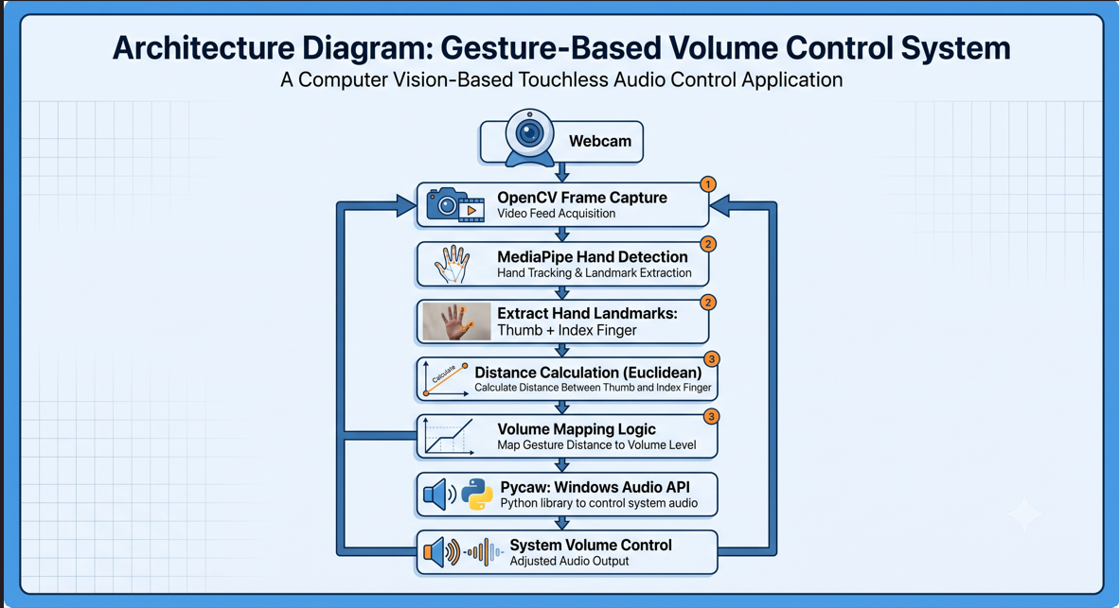me Mapping → Pycaw/Windows Audio → System Volume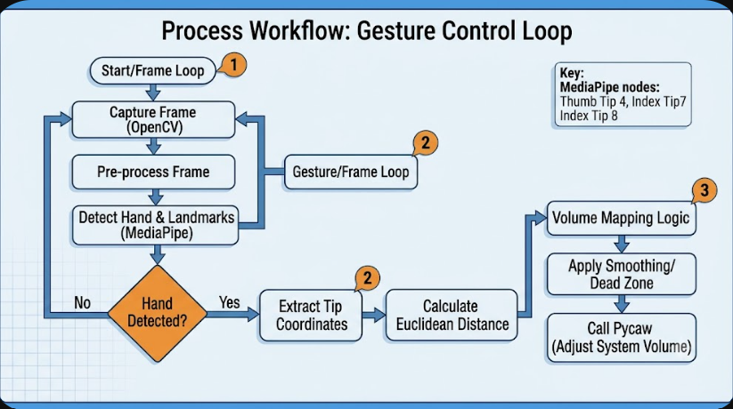

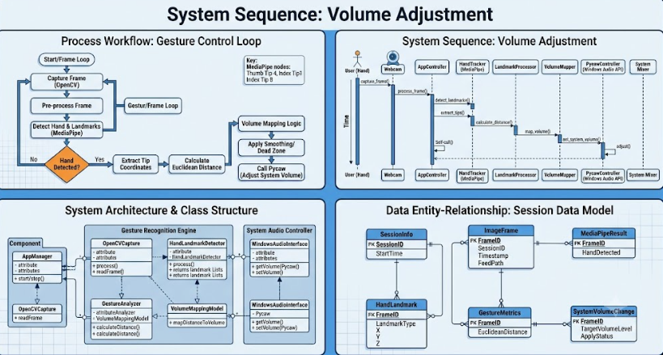

8. METHODOLOGY
8.1 Video Capture
The OpenCV library utilizes its video-capture function that gains access to the webcam. Individual frames are being continuously read, processed, and interpreted in order to establish a real-time response to the movement of the hand.
8.2 Hand Detection and Landmark Extraction
The MediaPipe library makes use of a built-in hand-tracking solution that effectively recognizes key points of the observed hand. Each of the detected landmarks contains information about normalized image coordinates. The thumb tip and index-finger tip landmarks are used as primary controllers of the volume gesture.
8.3 Gesture Measurement
The distance between two specified landmarks is utilized as a continuous controller of the gesture. The value of the distance can be directly related to the volume level. The greater the distance between fingertips is, the higher the target volume of the audio will be. The orientation of the scale can be reverted in the case of necessity.
8.4 Volume Mapping
The distance, as it is measured from the webcam, does not naturally relate to a percentage, so a linear conversion should be applied to read the value on the valid range of the audio’s volume level. This can be mathematically represented by an equation below:
V = Vmin + ((d − dmin) / (dmax − dmin)) × (Vmax − Vmin)
Whereas, the d represents a distance between specified two landmarks; dmin, dmax determines the range of distance values; Vmin, Vmax determines the range of target volume values. The final value must be clamped on the valid range from 0 to 1.
8.5 Windows Audio Interface
The current implementation makes use of the Pycaw, a Python wrapper around the Windows Core Audio API, that exposes some of the Core Audio interfaces as classes and COM objects readable in Python. The audio-endpoint volume interface is being received via the AudioUtilities module and casted to the IAudioEndpointVolume interface.

9. ALGORITHM AND MATHEMATICAL MAPPING
Algorithm: Gesture-Based Volume Control
9. Initialize the webcam and the necessary libraries
10. Initialize the MediaPipe hand processing module.
11. Initialize the windows audio endpoint volume interface
12. Read a webcam frame
13. Process the webcam image for the hands.
14. Find the position of the hand landmarks
15. If the specified landmarks are found
16. Get the coordinates of the thumb and index finger
17. Calculate the Euclidean distance between two points
18. Normalize the distance to the volume level of 0-1
19. Clamp the value to the specified range
20. Change the system volume using the audio endpoint interface
21. Show the volume and repeat the process until the user stops the program.
9.1 Euclidean Distance
For two points P1(x1, y1) and P2(x2, y2), the 2D distance is:
d = √[(x2 − x1)² + (y2 − y1)²]
9.2 Smoothing
Raw landmark measurements can fluctuate because of camera noise, hand tremor, lighting, and tracking uncertainty. A moving average or exponential smoothing filter can reduce audible volume jitter. For example:
s(t) = αx(t) + (1 − α)s(t−1), 0 < α ≤ 1

10. IMPLEMENTATION DETAILS
10.1 Core Imports
import sys
import platform
import math
import subprocess
import time

import cv2
import mediapipe as mp
import numpy as np

10.2 Platform-Specific Audio Backend
The project uses the VolumeController abstraction class to encapsulate platform-specific code. The class checks the operating system and attempts to initialize the Windows-specific implementation if the platform is Windows. It would be fairly straightforward to add a new backend for a different platform.
10.3 MediaPipe Compatibility Note
The current example uses the MediaPipe Solutions style of accessing the package (mp.solutions.hands). Note that the version of the package and the API can change, and you will have to make sure that the version you install matches the one the code was written for, or update the code to use the newer MediaPipe Tasks API.
10.4 Error Handling
The Windows-specific initialization code is wrapped in a try/except block to handle possible exceptions. A production-quality app would need to do more robust error checking, such as making sure the camera is available on the platform, and release resources when the app is closed.
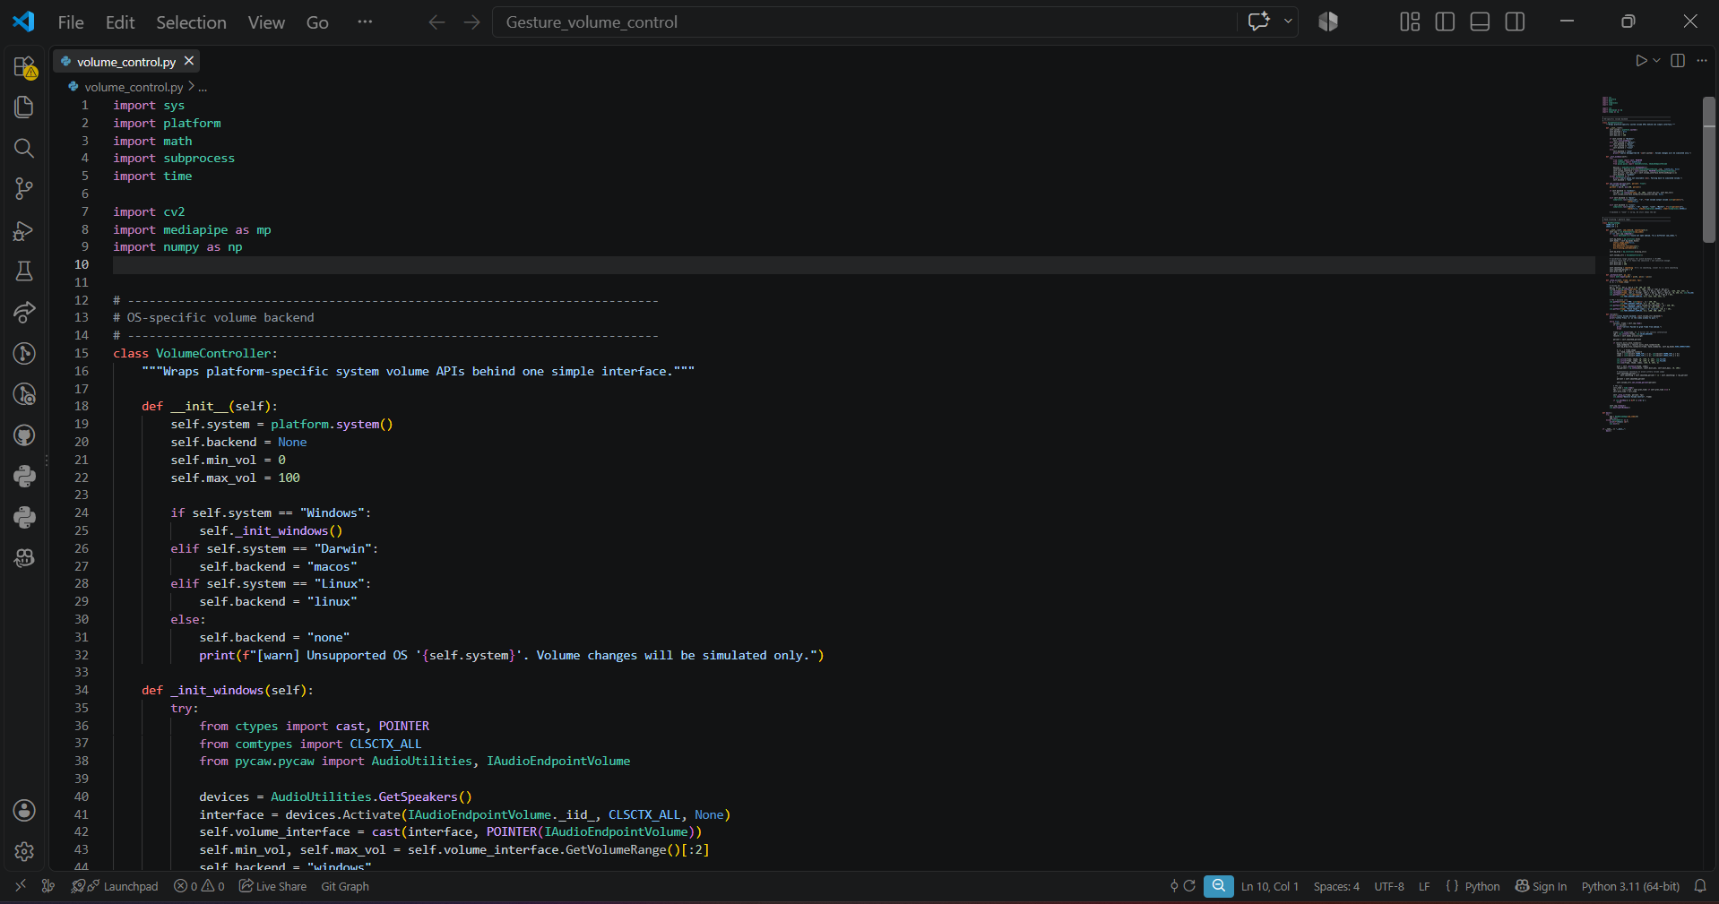

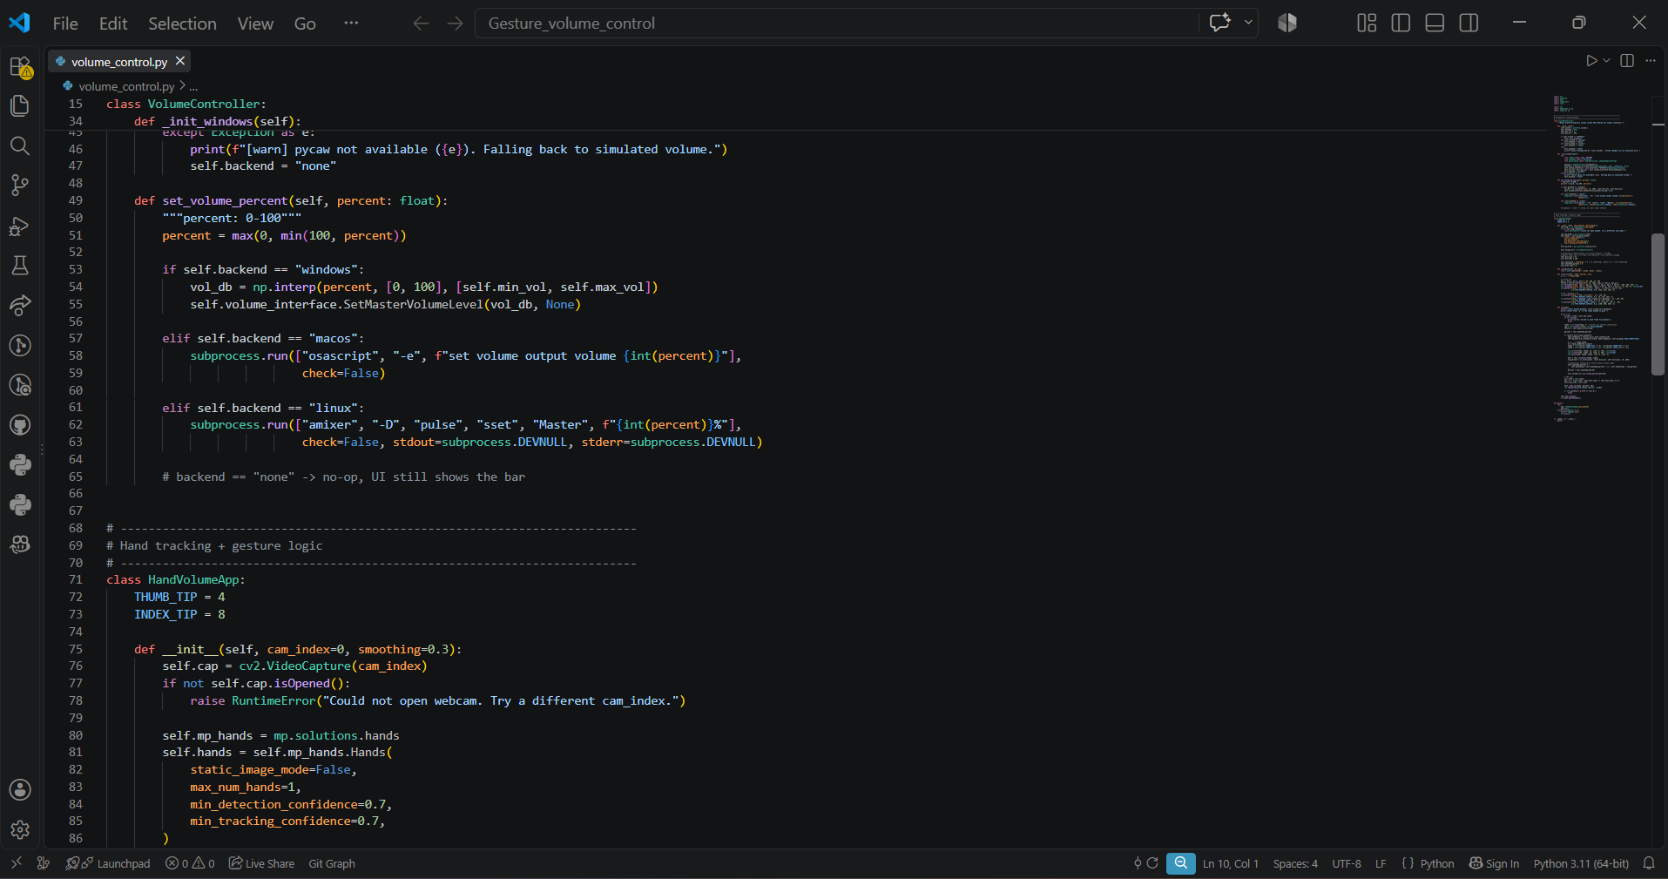

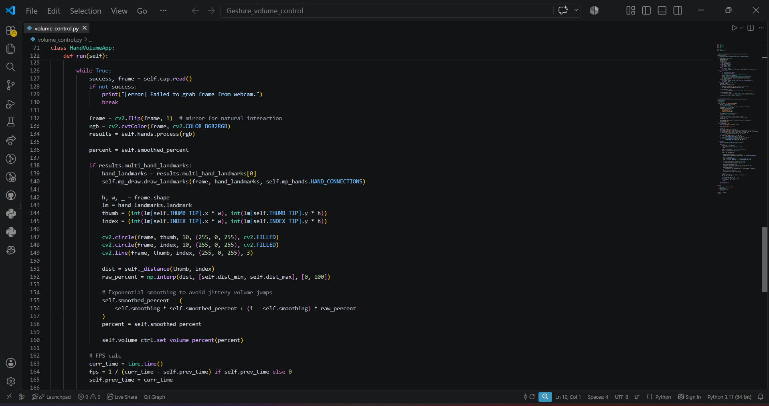

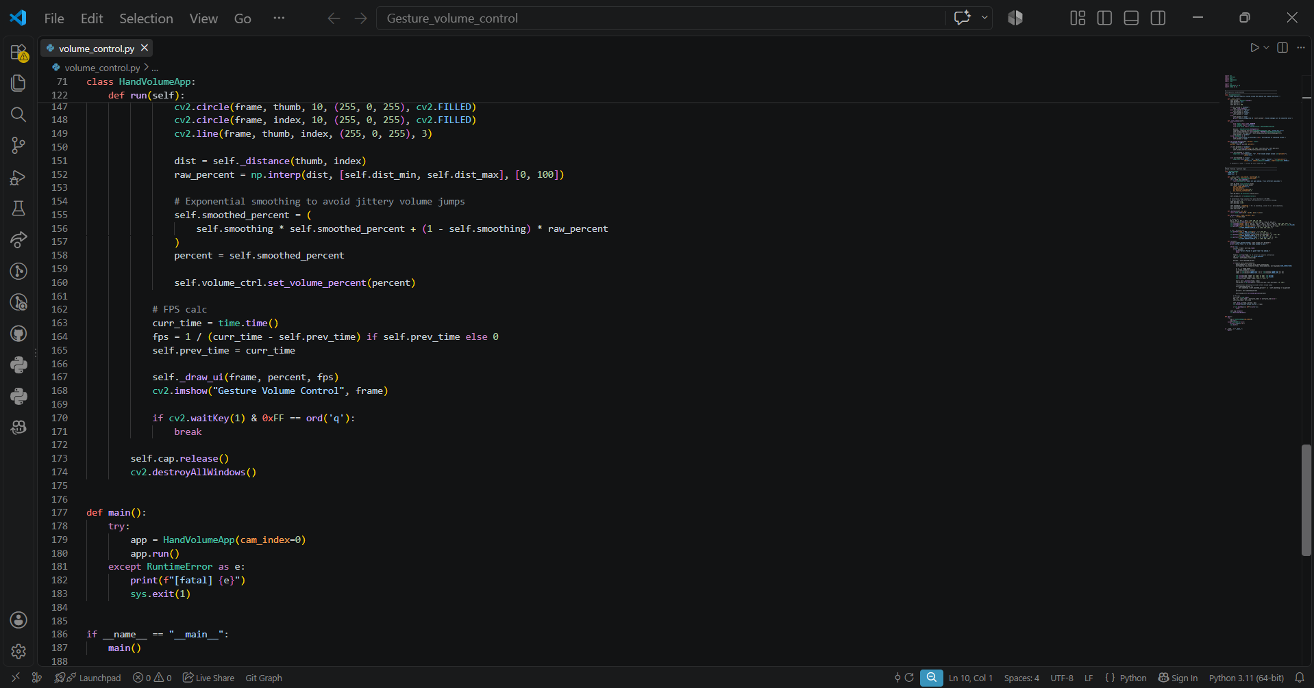

11. TESTING AND RESULTS

Testing should be done with different hand positions, light conditions, camera distance, and environments. During development, the OpenCV library was successfully detected in the Python environment, but the application faced a MediaPipe API compatibility error as the code expected mp.solutions.hands, but the installed MediaPipe package did not expose the solutions attribute. It is a dependency/API compatibility error that needs to be resolved before final performance testing of the application.
Test Case | Input/Condition | Expected Result | Status
T1 | Webcam available | Frames captured continuously | To be verified
T2 | No hand in frame | No unintended volume change | To be verified
T3 | Thumb and index close | Volume approaches lower range | To be verified
T4 | Thumb and index far apart | Volume approaches upper range | To be verified
T5 | Continuous hand movement | Smooth volume response | To be verified
T6 | Variable lighting | Graceful tracking degradation | To be evaluated
T7 | MediaPipe API mismatch | Application reports/import issue | Observed

Screenshots

12. ADVANTAGES

- Touchless and intuitive interaction.
- Uses a standard webcam instead of specialized hardware.
- Real-time operation is possible on a typical laptop.
- Combines computer vision with operating-system control.
- Modular design allows the gesture and audio backend to be improved independently.
- Can serve as a foundation for other gesture-controlled applications.

13. CHALLENGES FACED

The current audio-control backend is Windows-specific because of the use of Pycaw/Windows Core Audio.
• Hand tracking can be affected by poor lighting, occlusion, motion blur, or complex backgrounds.
• Raw distance measurements can result in volume fluctuations without smoothing.
• A fixed gesture-to-volume mapping can behave differently for different users or camera positions.
• The current prototype primarily demonstrates continuous volume control rather than a complete multi-gesture interface.
• MediaPipe API changes might require dependency pinning or code migration.

14. FUTURE ENHANCEMENTS

- Automatic calibration for different users and camera distances.
- Exponential or moving-average smoothing to reduce jitter.
- Additional gestures such as pinch-to-mute and open-palm/unmute.
- On-screen volume and gesture-state feedback.
- A dedicated gesture classifier for multiple commands.
- Temporal filtering/debounce logic to prevent accidental commands.
- Cross-platform audio backends for Linux and macOS.
- A graphical user interface and packaged desktop application.
- Quantitative evaluation of FPS, latency, stability, and gesture recognition.

15. CONCLUSION

The Gesture-Based Volume Control System exemplifies the combination of computer vision and operating-system audio control into a practical touchless human-computer interaction application. The key innovation is the transformation of relative hand movements into a numerical control signal by tracking hand landmarks and measuring the distance between selected fingertips. OpenCV enables real-time video capture, MediaPipe enables hand landmark detection, NumPy enables numerical calculations, and Pycaw enables access to Windows system audio.
The project also emphasizes the practical importance of dependency and API compatibility. The current implementation uses the MediaPipe Solutions API and therefore requires a compatible MediaPipe version or an update to the newer API. Once this compatibility issue is resolved, the application can be calibrated and evaluated in different real-world conditions and extended into a broader gesture-controlled desktop system.

16. REFERENCES

1. OpenCV Documentation – Tutorials and API reference for OpenCV-Python.
2. MediaPipe Documentation – Hand landmark detection and hand tracking documentation.
3. Numpy Documentation – Official documentation for numerical computations with Python.
4. Pycaw Project Documentation – Documentation for Windows Core Audio control from Python.
5. Microsoft Documentation – Documentation for Windows Core Audio and endpoint volume APIs.
6. Python Documentation – Python’s official documentation including the ctypes module.

