CYB 401
FUNDAMENTALS OF CYBERSECURITY
Classroom Component — Weeks 1 to 8
A University Class Note for Undergraduate Cybersecurity Students

Course Code | CYB 401
Course Title | Fundamentals of Cybersecurity
Semester Structure | 8 Weeks Theory + 7 Weeks Practical (15 weeks total)
This Document Covers | Weeks 1–8 (Classroom / Theory Component only)
Intended Level | Undergraduate — Introductory / No prior security experience assumed
Academic Session | 2026/2027 — First Semester (Commencing October 2026)

A Note on Scope and Curriculum Assumptions
No official CYB 401 syllabus or course descriptor was supplied for this class note. In the absence of an institutional syllabus, the following 8-week theory curriculum has been designed to reflect a standard, defensible undergraduate 'Fundamentals of Cybersecurity' course — the kind typically taught as an introductory core course in a Computer Science, Software Engineering, Cyber Security, or Information Technology programme in the 400-level or as a foundational cybersecurity course.
The curriculum was built around three anchors:
- Established academic frameworks — the topic sequence follows the logic used in the NIST Cybersecurity Framework, the (ISC)² Certified in Cybersecurity (CC) exam outline, and CompTIA Security+ objectives, which are the most widely recognised reference points for 'what an introductory cybersecurity course should contain.'
- Current industry hiring signals for 2026 — research into entry-level job postings (SOC Analyst, GRC Analyst, Security Administrator, IAM Analyst) consistently lists networking fundamentals, operating system security, identity and access management, threat awareness, and basic security operations as the core expectations for graduates, alongside foundational scripting and documentation skills.
- A logical teaching progression — each week builds on the one before it, moving from 'what is security and why does it matter' toward 'how do real organisations detect, respond to, and manage security risk.'
If your institution provides an official CYB 401 course descriptor, this note can be re-aligned to it — the modular week-by-week structure makes it straightforward to substitute or reorder topics without rebuilding the whole document.

The 8-Week Sequence at a Glance
Week | Topic | Core Question Answered
1 | Introduction to Cybersecurity & the CIA Triad | What are we protecting, and from what?
2 | Networking Fundamentals for Security | How does data travel, and where can it be attacked?
3 | Operating System Security (Linux & Windows) | How is a single computer protected and controlled?
4 | Identity, Authentication & Access Control | How do we prove who someone is, and limit what they can do?
5 | Threats, Attackers & Malware | Who attacks organisations, and with what tools and code?
6 | Social Engineering & Web Application Security | How are humans and websites tricked or broken into?
7 | Security Operations, SIEM & Incident Response | How do organisations detect and respond to attacks in real time?
8 | Risk Management, Governance & Career Readiness | How do organisations decide what to protect, and how do I get hired?

Course Introduction
Cybersecurity is the practice of protecting computers, networks, programs, and data from unauthorised access, damage, or disruption. It is no longer a specialist topic that only concerns IT departments — it now affects banks, hospitals, universities, government agencies, telecommunications companies, and individual students who simply want to check their results online.
CYB 401 is your formal introduction to this field. Over the next 8 weeks, you will build a solid theoretical foundation before moving into hands-on laboratory work later in the semester. This note deliberately avoids two extremes. It does not turn you into a memoriser of definitions with no understanding of why those definitions matter. It also does not throw you into advanced, unexplained jargon before you are ready for it. Instead, every topic follows a simple teaching pattern:
Simple Explanation → Technical Term → Real Example → Industry Application
By the end of Week 8, you should be able to hold an informed conversation about cybersecurity fundamentals with a working IT professional, understand what a Security Operations Centre (SOC) analyst, GRC analyst, or IT security administrator actually does day to day, and know precisely which skills you must keep developing to become employable in this field.

Why This Course Matters in Nigeria and Africa
Africa's digital economy is expanding rapidly — mobile banking, fintech, e-government services, telemedicine, and university e-learning portals are now everyday infrastructure. This growth has been matched by a rise in cybercrime targeting the same region: business email compromise against Nigerian companies, SIM-swap fraud against bank customers, ransomware against healthcare providers, and credential theft against university portals are now well-documented, recurring problems. Throughout this note, examples are drawn from contexts you can relate to — university systems, Nigerian banks, telecommunications providers, and government agencies — alongside global incidents, so that the lessons feel immediately relevant rather than abstract.
⚙ INDUSTRY TIP
Organisations such as the Nigeria Computer Emergency Response Team (ngCERT) and the Central Bank of Nigeria (CBN) publish cybersecurity advisories and regulations relevant to the Nigerian financial and public sectors. Cybersecurity professionals working locally are expected to know both global standards (NIST, ISO 27001) and local regulatory expectations.

Course Learning Outcomes
By the end of the 8-week classroom component, students will be able to:
- Explain core cybersecurity concepts (confidentiality, integrity, availability, threats, vulnerabilities, and risk) in plain language and apply them to real scenarios.
- Describe how computer networks operate at a basic level and identify common points where network traffic can be attacked, monitored, or defended.
- Explain how Linux and Windows operating systems enforce security through permissions, accounts, and logging.
- Distinguish between authentication and authorisation, and describe common access control and identity management practices used in organisations.
- Identify common categories of cyber threats and malware, and explain how attackers typically gain access to systems.
- Recognise social engineering techniques and common web application vulnerabilities, and explain basic defensive measures.
- Describe how a Security Operations Centre (SOC) detects and responds to incidents, including the role of SIEM tools and log analysis.
- Explain the fundamentals of risk management and common cybersecurity governance frameworks (NIST CSF, ISO 27001).
- Identify the industry tools relevant to each stage of cybersecurity work and explain, at a conceptual level, what each tool is used for and why.
- Describe what entry-level cybersecurity employers expect from graduates, and identify a personal pathway (certifications, skills, portfolio) toward employability.

How to Use This Class Note
Each week is organised the same way, so that once you understand the structure of Week 1, you can navigate every subsequent week with ease:
- Learning Objectives — what you should be able to do by the end of the week.
- Introduction — a simple, plain-language opening to the topic.
- Core Concepts — the main body of theory, explained progressively.
- Key Terms — a short glossary of important vocabulary.
- Real-Life Scenario — a relatable situation that brings the theory to life.
- Industry Connection — how professionals actually use this knowledge at work.
- Industry Tools — real tools used in the field, and what problem each one solves.
- Illustration — at least one diagram to help you visualise the concept.
- Common Mistakes — errors that beginners typically make.
- Career Connection — how the topic links to real cybersecurity jobs.
- Summary — the key takeaways in a few sentences.
- Review Questions — short-answer, conceptual, and scenario-based questions.
- Further Reading — reputable sources if you want to go deeper.
★ REMEMBER
You are not expected to memorise every tool name or acronym on first reading. Focus on understanding why each concept exists and what problem it solves — the vocabulary becomes natural once the underlying logic makes sense.
⚠ SECURITY ALERT
A recurring theme throughout this note: you must only ever test, scan, or attempt to access systems that you own or have explicit written permission to test. Unauthorised access to computer systems is illegal in Nigeria under the Cybercrimes (Prohibition, Prevention, etc.) Act, and in most other jurisdictions. Everything discussed here is for educational and defensive understanding.

WEEK 1: INTRODUCTION TO CYBERSECURITY & THE CIA TRIAD

Learning Objectives
By the end of this week, students should be able to:
- Define cybersecurity in plain language and explain why it matters to every organisation, not just IT departments.
- Explain the CIA Triad (Confidentiality, Integrity, Availability) and apply it to real situations.
- Distinguish between a threat, a vulnerability, and a risk.
- Describe common categories of cybersecurity roles and how they relate to each other.
- Explain the idea of 'defence in depth' at a basic level.

1. Introduction
Imagine you keep money in a bank. You expect three things from that bank: nobody else should be able to withdraw your money without your permission (secrecy), your account balance should reflect exactly what you deposited and withdrew — no silent changes (accuracy), and you should be able to access your money whenever you need it (readiness). Cybersecurity exists to give computer systems and data those same three guarantees.
In simple terms, cybersecurity is the practice of protecting computers, networks, software, and data from unauthorised access, damage, theft, or disruption. It combines technology (firewalls, encryption, monitoring tools), processes (policies, procedures, training), and people (security teams, and every employee who uses a computer) working together.
Every organisation that uses computers — a university, a hospital, a bank, a telecom company, a small business — has something worth protecting: student records, patient files, customer transactions, call data, or simply the ability to keep operating. Cybersecurity is how organisations defend those things.

2. Core Concepts

2.1 The CIA Triad
The CIA Triad is the foundational model that almost every cybersecurity decision is built on. CIA here has nothing to do with intelligence agencies — it stands for Confidentiality, Integrity, and Availability.
- Confidentiality — only the people who are authorised to see information can see it. In simple terms: keeping secrets secret. Example: only the registrar's office and the student concerned should be able to view a specific transcript.
- Integrity — information stays accurate and is not changed without authorisation. In simple terms: keeping data trustworthy. Example: a student's CGPA in the database should match what was actually earned, with no silent tampering.
- Availability — systems and data are accessible to authorised users when they are needed. In simple terms: keeping the lights on. Example: the university result portal should be online and responsive during the result-checking period, not the moment traffic spikes.
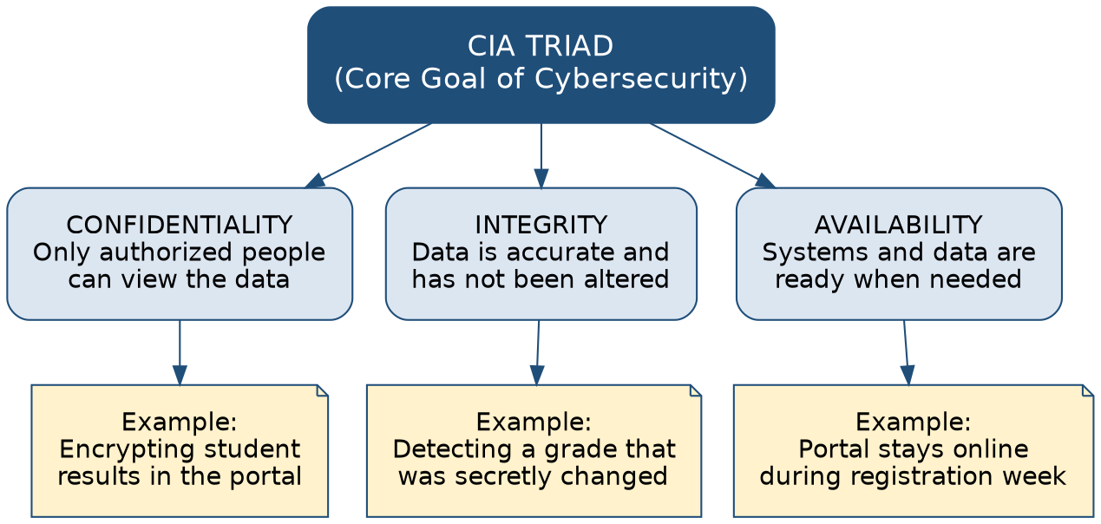
Figure 1: The CIA Triad
Every security control you will study this semester exists to protect at least one leg of this triangle. When you analyse any incident later in the course, a useful habit is to ask: which of the three — confidentiality, integrity, or availability — was actually broken?
✓ WHAT EMPLOYERS LOOK FOR
A junior security analyst should be able to look at an incident description and correctly identify which CIA property was violated. This is one of the most common conceptual questions asked in entry-level cybersecurity interviews.

2.2 Threat, Vulnerability, and Risk — Three Words Students Often Confuse
These three terms are used constantly in cybersecurity, and beginners frequently mix them up. Getting this distinction right early will make the rest of the course much easier to follow.
Term | Simple Meaning | Example
Threat | Anything that could cause harm — a person, event, or circumstance | A hacker group targeting Nigerian banks; a lightning strike; a disgruntled employee
Vulnerability | A weakness that a threat could exploit | Software that has not been updated; a weak password policy; an unlocked server room
Risk | The likelihood that a threat will exploit a vulnerability, combined with the resulting impact | 'There is a high risk of account takeover because passwords are weak and attackers actively target this system'
★ REMEMBER
A simple formula many professionals use informally: Risk = Threat × Vulnerability × Impact. Remove any one factor and the risk drops. This is why organisations spend money on patching vulnerabilities even when no attack has happened yet — they are reducing risk before a threat finds the weakness.

2.3 What Does 'Security' Actually Involve?
Security is rarely a single wall around a system. Real organisations use layered defences, a concept known as defence in depth: multiple overlapping controls, so that if one fails, another can still stop the attacker. A firewall alone is not 'security' — it is one layer among many, alongside strong authentication, patched software, trained staff, monitoring, and a tested response plan.
Cybersecurity work is also commonly divided into a few broad functions, which you will explore in more depth across the semester:
Function | Simple Description | Example Role
Governance, Risk & Compliance (GRC) | Deciding policy, assessing risk, ensuring rules/regulations are followed | GRC Analyst
Security Operations | Watching systems in real time, detecting and responding to incidents | SOC Analyst
Identity & Access Management | Controlling who can log in and what they can do | IAM Analyst
Offensive Security | Legally testing systems to find weaknesses before attackers do | Penetration Tester
Security Engineering | Building and configuring the tools and systems that enforce security | Security Engineer

3. Key Terms
Term | Simple Meaning
Cybersecurity | The practice of protecting computers, networks, and data from unauthorised access or harm
Asset | Anything of value to an organisation — data, hardware, software, or reputation
Threat actor | The person or group carrying out, or intending to carry out, an attack
Attack surface | All the possible points where an unauthorised user could try to get into a system
Defence in depth | Using multiple, overlapping layers of security controls rather than relying on one
Control | A safeguard put in place to reduce risk (e.g., a firewall, a policy, a lock)

4. Real-Life Scenario

Scenario: A University Portal Attack
It is result-release week at a Nigerian university. Suddenly, students report they cannot log into the student portal. The IT team investigates and finds an unusually high volume of login attempts from a small number of external IP addresses, several of which succeeded using weak, previously reused student passwords. One compromised account is later found to have downloaded another student's transcript.
Using this week's concepts: the threat actor is whoever ran the login attempts. The vulnerability is the weak/reused password policy that allowed guessing to succeed. The risk that was realised is unauthorised access. The confidentiality of a transcript was violated (someone unauthorised viewed it), and the availability of the portal was degraded for everyone else because of the load generated by the attack.

5. Industry Connection
In real organisations, the CIA Triad is not just a classroom model — it directly shapes decisions. When a bank decides to encrypt customer data, that is a confidentiality control. When a hospital keeps audit logs of who edited a patient's file, that is an integrity control. When a telecom company builds redundant data centres so a fire in one location does not take down the network, that is an availability control. Security teams use the CIA Triad daily when prioritising which risks to fix first, and when explaining incidents to non-technical management.

6. Industry Tools
This early in the course, you do not yet need hands-on tool skill — that comes in the practical component later in the semester. What you should understand now is the landscape of tool categories you will keep meeting:
Tool / Category | What It Is | Why It Matters
MITRE ATT&CK | A public knowledge base of real attacker tactics and techniques | Gives defenders a shared language to describe how attacks unfold — referenced throughout this course
NIST Cybersecurity Framework (CSF) | A voluntary framework describing how organisations should manage cyber risk (Govern, Identify, Protect, Detect, Respond, Recover) | Widely used to structure a security programme — you will revisit this in Week 8
Vulnerability scanners (e.g., Nessus, OpenVAS) | Tools that automatically check systems for known weaknesses | Introduced conceptually now; explained in depth in Week 5
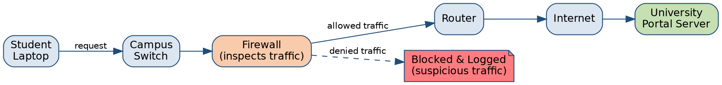
Figure 2: Where Security Sits Along a Simple Data Path
Even a simple request from a student laptop to a university server passes through several points — a switch, a firewall, a router, the internet — each of which is a potential place to both attack and defend. You will study this path in far more detail in Week 2.

7. Common Mistakes
- Treating cybersecurity as 'only an IT problem' rather than an organisation-wide responsibility.
- Confusing a vulnerability (a weakness) with a risk (the likelihood and impact of that weakness being exploited).
- Assuming that having one strong control (e.g., a firewall) means a system is fully secure.
- Believing security is only about stopping outsiders — insider mistakes and insider threats are just as important.

8. Career Connection
Almost every entry-level cybersecurity role — SOC Analyst, GRC Analyst, Security Administrator, IAM Analyst — expects candidates to explain the CIA Triad and the threat/vulnerability/risk distinction fluently, because these ideas underpin how professionals reason about every incident and decision. Interviewers frequently open with a scenario question ('a laptop was stolen — what security property was affected?') specifically to test this foundational understanding.
☁ CAREER TIP
Start a simple personal note-taking habit now: whenever you read about a cyberattack in the news, write two sentences — what happened, and which CIA property (or properties) it violated. By the end of the semester you will have a small portfolio of analysed incidents, which is genuinely useful to mention in interviews.

9. Summary
Cybersecurity protects the confidentiality, integrity, and availability of information and systems. A threat is a potential source of harm, a vulnerability is a weakness, and risk is the combination of likelihood and impact when a threat meets a vulnerability. Real organisations use layered, defence-in-depth strategies and organise security work into functions such as GRC, security operations, identity management, offensive security, and security engineering.

10. Review Questions

Short-Answer
- In your own words, explain the difference between a threat, a vulnerability, and a risk.
- Give one real-world example each of a confidentiality control, an integrity control, and an availability control.

Conceptual
- Why is 'defence in depth' considered safer than relying on a single strong security control?
- Explain why availability is sometimes overlooked as a security property compared to confidentiality.

Scenario-Based
- A hospital's patient database is still accessible and has not been changed, but a nurse discovers she can see the records of patients she is not assigned to. Which CIA property has been violated, and why?
- A denial-of-service attack floods a bank's website with traffic so real customers cannot log in, even though no data was stolen or altered. Which CIA property was violated? Justify your answer.

11. Further Reading
- NIST, 'Cybersecurity Framework (CSF) 2.0' — nist.gov/cyberframework
- NIST Computer Security Resource Center, 'Glossary' — csrc.nist.gov/glossary
- (ISC)² Certified in Cybersecurity (CC) — Exam Outline (foundational domains) — isc2.org
- MITRE ATT&CK — attack.mitre.org

WEEK 2: NETWORKING FUNDAMENTALS FOR SECURITY

Learning Objectives
- Explain, in simple terms, how devices communicate over a network using IP addresses and ports.
- Distinguish between TCP and UDP and explain why the difference matters for security.
- Explain what a firewall does and why traffic filtering matters.
- Interpret a simple network diagram and identify likely attack and defence points.
- Explain what tools like Wireshark and Nmap are used for, at a conceptual level.

1. Introduction
You cannot protect what you do not understand. Almost every cyberattack you will study this semester travels over a network at some point — an email, a login attempt, a file download, a command to a compromised machine. This week builds the minimum networking knowledge every cybersecurity professional needs, not to make you a network engineer, but to make you able to read and reason about network traffic and network-based attacks.
Think of a network the way you think of a postal system. Every device needs an address (an IP address), every service running on a device has a 'door' it listens on (a port), and there are agreed rules for how messages are packaged and delivered (protocols such as TCP and UDP). Security professionals spend a large part of their time watching this postal system for suspicious activity.

2. Core Concepts

2.1 IP Addresses and Ports
An IP address is a unique number that identifies a device on a network, similar to a house address. Most networks today use IPv4 addresses (e.g., 192.168.1.10) or the newer IPv6 format. A port is a number that identifies a specific service running on that device — think of the IP address as the building, and the port as the specific office inside it. For example, web traffic conventionally uses port 80 (HTTP) or port 443 (HTTPS), while email servers commonly use ports 25, 587, or 993.
✓ WHAT EMPLOYERS LOOK FOR
A junior SOC analyst is expected to recognise common ports on sight (80/443 for web, 22 for SSH, 3389 for Windows Remote Desktop, 53 for DNS) because unusual port activity is one of the simplest early signs of a possible compromise.

2.2 TCP vs UDP
TCP (Transmission Control Protocol) is a 'reliable' protocol — it confirms that data arrived correctly, resending anything lost, similar to a phone call where both sides confirm they heard each other. UDP (User Datagram Protocol) is a 'fire and forget' protocol — faster, but with no guarantee of delivery, similar to sending a text message and hoping it arrives. TCP is used where accuracy matters most (web browsing, email, file transfer); UDP is used where speed matters more than perfection (video calls, online gaming, DNS lookups).
Protocol | Reliability | Typical Use | Security Relevance
TCP | Reliable — confirms delivery (three-way handshake) | Web browsing, email, file transfer, SSH | Connection-based, so it's easier to track a full session; commonly scanned by attackers port-by-port
UDP | Unreliable — no delivery confirmation | DNS, video/voice calls, streaming | Easier to spoof the sender's address, which is exploited in certain denial-of-service attacks

2.3 Firewalls and Traffic Filtering
A firewall is a security control — hardware, software, or both — that monitors and filters network traffic based on defined rules, deciding what is allowed in or out. In simple terms, a firewall is a checkpoint that inspects every 'car' (packet of data) trying to enter or leave a network and only lets through the ones that match the rules.
Figure 3: A Simplified Campus Network Path
A request from a student laptop passes through a switch, a firewall, and a router before reaching the internet and, ultimately, the university's portal server. The firewall is the point where suspicious traffic is most commonly filtered out and logged.
Firewalls can operate at different levels of sophistication — from simple rules ('block all traffic from this IP address') to modern next-generation firewalls that inspect the content of traffic and can recognise known attack patterns.

2.4 DNS — How Names Become Addresses
Humans remember names ('www.university.edu.ng'), not numbers. The Domain Name System (DNS) translates human-friendly domain names into IP addresses. Attackers frequently target DNS — for example, by registering look-alike domains ('universlty-portal.com' instead of 'university-portal.com') as part of phishing campaigns, a topic you will revisit in Week 6.

3. Key Terms
Term | Simple Meaning
IP address | A unique number identifying a device on a network
Port | A number identifying a specific service on a device
Protocol | An agreed set of rules for how data is formatted and transmitted
Packet | A small unit of data transmitted across a network
Firewall | A control that filters network traffic based on defined rules
DNS | The system that translates domain names into IP addresses
Network traffic | The flow of data moving across a network

4. Real-Life Scenario

Scenario: Unusual Traffic at a University Data Centre
The IT team at a university notices that the firewall logs show a large number of connection attempts, late at night, from an external IP address to port 3389 (Windows Remote Desktop) on a server that should not be exposed to the internet at all. This is a textbook sign of an attacker probing for remote access. Because the firewall was configured to block and log unrecognised inbound connections to that port, the attempts failed — but the volume and pattern (many attempts, off-hours, external origin) are enough to trigger an investigation.
This scenario illustrates why firewall rules and logs matter: the firewall did its job by blocking the traffic, but a human analyst still needs to review the pattern to judge whether this was random internet 'noise' or a targeted, ongoing attack.

5. Industry Connection
Network fundamentals are foundational to almost every cybersecurity specialism. A SOC analyst reads firewall and network logs daily to spot suspicious patterns. A penetration tester maps a network's open ports and services before testing for weaknesses. A cloud security engineer configures virtual firewalls (security groups) to control which cloud resources can talk to each other. Even a GRC analyst needs enough networking literacy to understand an auditor's or engineer's report.

6. Industry Tools
Two tools are especially important for building networking literacy, and you will meet both again in the practical component of this course:
Tool | What It Is | Why Professionals Use It | Simple Example
Wireshark | A packet-capture and analysis tool that shows the raw contents of network traffic | To investigate exactly what data is being sent, diagnose problems, or confirm an attack | An analyst uses Wireshark to confirm that a suspicious connection was actually transmitting stolen data, not just background noise
Nmap | A network scanning tool that discovers live hosts, open ports, and running services | To map what is actually exposed on a network — both for defenders auditing their own systems and for penetration testers | An IT team runs Nmap against its own network to confirm no unexpected port was left open after a server update
⚙ INDUSTRY TIP
Knowing that Wireshark or Nmap 'exists' is very different from being able to use it professionally. Employers distinguish between candidates who can name a tool and candidates who can describe, even briefly, what the output of that tool looks like and how they would interpret it. The hands-on practice for these tools comes in your practical laboratory weeks.

7. Common Mistakes
- Assuming a firewall alone makes a network 'secure' — it is one layer, not a complete solution.
- Confusing a port number with an IP address, or assuming every service uses a fixed, unchangeable port.
- Overlooking DNS as an attack surface, focusing only on 'bigger' components like servers.
- Believing that internal, private networks do not need monitoring because they are 'behind the firewall.'

8. Career Connection
Networking fundamentals appear on nearly every entry-level cybersecurity certification, including CompTIA Security+ and the (ISC)² Certified in Cybersecurity (CC). Job postings for SOC Analyst and Security Administrator roles routinely list 'understanding of TCP/IP, ports, and firewalls' as a baseline requirement, even before any specific tool experience.
☁ CAREER TIP
If you want a low-cost way to strengthen this area before your practical weeks, learn to read Nmap and Wireshark sample outputs online (many are published for teaching purposes) and practise describing, in your own words, what each field means. This builds comfort with the tools before you ever touch them hands-on.

9. Summary
Devices communicate using IP addresses and ports, following protocols such as TCP (reliable) and UDP (fast, unreliable). Firewalls filter traffic based on rules, and DNS translates domain names into IP addresses. Tools such as Wireshark (traffic analysis) and Nmap (network scanning) are core to how security professionals investigate and audit networks.

10. Review Questions

Short-Answer
- Explain the difference between an IP address and a port using a simple analogy.
- State one key difference between TCP and UDP.

Conceptual
- Why might an attacker prefer UDP for a denial-of-service attack rather than TCP?
- Explain why DNS is considered a valuable target for attackers even though it does not store sensitive data itself.

Scenario-Based
- A university firewall log shows hundreds of connection attempts to port 22 (SSH) from a foreign IP address over one hour, all blocked. What should a SOC analyst do next, and why?
- A lecturer clicks a link that goes to 'portall-university.com' instead of 'portal-university.com'. What networking concept explains how this attack works, and what should the lecturer check before entering any credentials?

11. Further Reading
- Cisco Networking Academy, 'Introduction to Networks' — netacad.com
- Wireshark Foundation, 'Wireshark User Guide' — wireshark.org/docs
- Nmap Project, 'Nmap Reference Guide' — nmap.org/book
- NIST SP 800-41, 'Guidelines on Firewalls and Firewall Policy' — csrc.nist.gov

WEEK 3: OPERATING SYSTEM SECURITY (LINUX & WINDOWS)

Learning Objectives
- Explain how an operating system enforces security through accounts, permissions, and privilege levels.
- Compare how Linux and Windows implement file permissions and administrative control.
- Explain the purpose of system logs and why they matter for investigation.
- Describe common hardening practices at a conceptual level.
- Explain what tools such as the Linux command line, PowerShell, and Event Viewer are used for.

1. Introduction
Every server, laptop, and phone runs on an operating system (OS) — the software that manages hardware and allows applications to run. If the operating system itself is poorly secured, every application running on top of it is at risk, no matter how well those applications are written. This week looks at how the two most common operating systems in professional environments — Linux and Windows — enforce security.
In simple terms, an operating system's job in security is to answer two questions for every action attempted on the computer: who is trying to do this, and are they allowed to?

2. Core Concepts

2.1 Accounts and Privilege Levels
Both Linux and Windows organise users into accounts, and accounts into different privilege levels. A standard user account can typically only affect their own files and settings. An administrative account (called 'root' on Linux, or an 'Administrator' account on Windows) can make system-wide changes — install software, modify other users' files, or change security settings.
The principle of least privilege states that every user, account, or process should be given only the minimum access necessary to do its job — nothing more. This single principle underlies a huge amount of practical cybersecurity work, from how organisations assign employee accounts to how software processes are configured.
★ REMEMBER
Least privilege is one of the most frequently tested concepts across cybersecurity certifications and interviews. Whenever you are unsure how much access to grant someone or something, the safe default is: start with the least access needed, and add more only if justified.

2.2 Linux File Permissions
Linux uses a permission system built around three types of access — read (r), write (w), and execute (x) — assigned separately to the file's owner, a group, and everyone else. A file listing such as '-rwxr-xr--' tells you the owner can read/write/execute, the group can read/execute, and everyone else can only read. The 'sudo' command allows a standard user to temporarily perform an action with administrative (root) privileges, and every use of sudo is typically logged — an important accountability feature.

2.3 Windows Security Model
Windows uses NTFS permissions, a more detailed system that can grant or deny specific actions (read, write, modify, full control) to specific users or groups on files and folders. Windows also uses User Account Control (UAC) — the pop-up that asks 'Do you want to allow this app to make changes to your device?' — as a safeguard against software silently gaining administrative rights without the user noticing.
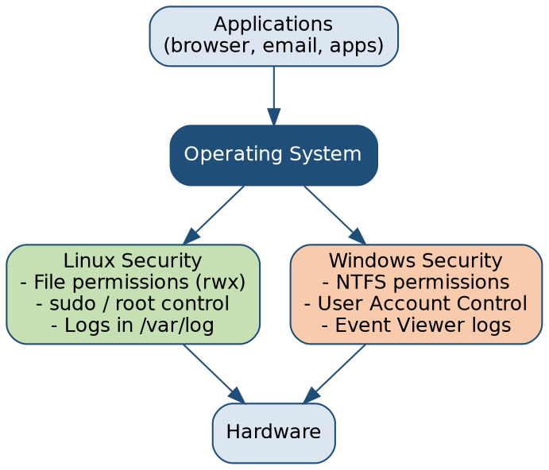
Figure 4: Where Linux and Windows Security Fit Together
Both operating systems sit between applications and hardware, and both enforce security primarily through permissions, privileged accounts, and logging — the specific mechanisms differ, but the underlying goals are identical.

2.4 Logs — The Operating System's Memory
Every meaningful action on a well-configured system is recorded in a log: successful and failed logins, privilege escalations, software installations, file access. On Linux, many of these logs live under /var/log. On Windows, the Event Viewer records Security, System, and Application events. Logs are the raw material investigators use to reconstruct what happened during an incident — a theme you will return to in depth in Week 7.

3. Key Terms
Term | Simple Meaning
Privilege | The level of access an account or process has been granted
Least privilege | The principle of granting only the minimum access necessary
root / Administrator | The highest-privilege account on Linux / Windows respectively
Permission | A rule defining what a user or process can do with a file or resource
Hardening | The process of reducing a system's attack surface by disabling unnecessary features and applying secure configurations
Log | A recorded entry describing an event that occurred on a system

4. Real-Life Scenario

Scenario: A Misconfigured Server
A university's exam results database runs on a Linux server. A junior IT staff member, in a hurry, sets the permissions on the results file to be readable and writable by 'everyone' on the system so that a script can update it without permission errors. Months later, a compromised student account on the same server is used to directly edit the results file, changing several grades before anyone notices. An investigation finds the overly broad file permission as the root cause — not a sophisticated attack, but a basic hardening failure.
This scenario reflects a very common real pattern: the biggest weaknesses are often not exotic attacks, but simple misconfigurations that violate least privilege.

5. Industry Connection
System administrators and security engineers spend significant time hardening operating systems: disabling unused services, enforcing least privilege, applying patches, and reviewing permission settings. SOC analysts rely heavily on OS-level logs (Linux auth logs, Windows Event Logs) to investigate suspicious activity. Even developers benefit from understanding OS permissions, since insecure default permissions in deployed applications are a common source of vulnerabilities.

6. Industry Tools
Tool | What It Is | Why It Matters | Simple Example
Linux command line (bash) | The text-based interface for interacting with a Linux system | Used to inspect permissions, manage users, and review logs efficiently | An analyst runs a command to list all users with administrative (sudo) rights on a server
PowerShell | A scripting shell and language built into Windows | Used to automate account management, audit configurations, and investigate systems | An IT administrator uses PowerShell to list all accounts that logged in within the last 24 hours
Windows Event Viewer | A built-in tool that displays Windows system, security, and application logs | The first place many Windows investigations begin | An analyst checks Event Viewer for repeated failed logon events (Event ID 4625) on a suspicious account
⚙ INDUSTRY TIP
You do not need to memorise Windows Event IDs by heart at this stage — that level of detail belongs in your practical and SOC-focused training. What matters now is understanding that logs are structured, searchable records, and that specific event types (like repeated failed logins) are meaningful security signals.

7. Common Mistakes
- Granting 'everyone' or 'full control' access to make a technical problem disappear quickly, without considering the security consequence.
- Assuming that because a system 'works,' its permissions must be correctly configured.
- Ignoring log review until after an incident has already occurred, rather than as routine practice.
- Treating Linux and Windows security models as identical when their mechanisms actually differ in important ways.

8. Career Connection
Comfort with both Linux and Windows is expected in almost every entry-level technical security role. SOC Analyst and Security Administrator job postings frequently list 'basic Linux and Windows administration' or 'comfortable working from the command line' as baseline requirements, because so much investigation and hardening work happens directly on these operating systems.
✓ WHAT EMPLOYERS LOOK FOR
Employers do not expect a fresh graduate to be a Linux or Windows expert, but they do expect familiarity with basic navigation, checking permissions, viewing running processes, and reading logs on both operating systems. This is one of the most practical, learnable skills you can build before graduating.

9. Summary
Operating systems enforce security through accounts, privilege levels, and permissions. Linux uses read/write/execute permissions and the sudo mechanism; Windows uses NTFS permissions and User Account Control. Both operating systems generate logs that are essential for security investigation, and the principle of least privilege underlies secure configuration on both platforms.

10. Review Questions

Short-Answer
- Define the principle of least privilege in your own words.
- Name one similarity and one difference between how Linux and Windows manage file permissions.

Conceptual
- Why is granting broad, 'everyone' access to a file or folder considered a security risk, even if it solves an immediate technical problem?
- Explain why system logs are considered a critical security control, even though they do not actively block anything.

Scenario-Based
- A new employee is given full administrative rights 'to make things easier,' even though their job only requires updating a spreadsheet. Using this week's concepts, explain why this is a poor practice and what should be done instead.
- An investigator reviewing Event Viewer logs on a Windows server sees 200 failed login attempts against the same account within 10 minutes, followed by one successful login. What does this pattern likely indicate, and what should happen next?

11. Further Reading
- CIS (Center for Internet Security), 'CIS Benchmarks for Linux and Windows' — cisecurity.org
- Microsoft Learn, 'Windows Security Documentation' — learn.microsoft.com/windows/security
- Red Hat, 'Understanding Linux File Permissions' — redhat.com/sysadmin
- NIST SP 800-123, 'Guide to General Server Security' — csrc.nist.gov

WEEK 4: IDENTITY, AUTHENTICATION & ACCESS CONTROL

Learning Objectives
- Distinguish clearly between authentication and authorisation.
- Explain multi-factor authentication (MFA) and why it significantly reduces account takeover risk.
- Describe common access control models (RBAC, and the general idea of access control lists).
- Explain the purpose of identity and access management (IAM) in organisations.
- Describe common tools and standards used for authentication (SSO, OAuth/SAML at a conceptual level).

1. Introduction
Before a system can decide what someone is allowed to do, it must first establish who that person is. This is the job of authentication. Once identity is established, the system must decide what that identified person is permitted to do — this is authorisation. These two ideas are among the most confused terms in cybersecurity, and getting the distinction exactly right will help you throughout your career.
Simple explanation: authentication answers the question 'who are you?' Authorisation answers the question 'what are you allowed to do?' A university ID card at the gate proves who you are (authentication); the specific buildings you are allowed to enter based on your role — student, staff, visitor — is authorisation.

2. Core Concepts

2.1 Authentication — Proving Identity
Authentication is the process of proving who you are before a system allows you in. This is commonly done using one or more of three factors:
Factor Type | Description | Example
Something you know | A secret only you should know | Password, PIN
Something you have | A physical or digital item you possess | Phone (for an SMS/app code), hardware token, smart card
Something you are | A physical characteristic unique to you | Fingerprint, face recognition
Multi-factor authentication (MFA) combines two or more of these factors. Even if a password is stolen (something you know), an attacker still cannot log in without also possessing the second factor (something you have). This is why MFA is considered one of the single most effective controls against account takeover.
⚠ SECURITY ALERT
A large proportion of real-world account compromises — including many documented incidents affecting banks, universities, and businesses in Nigeria and globally — succeed specifically because MFA was not enabled. Password theft alone is rarely enough to stop a well-configured account protected by MFA.

2.2 Authorisation — Controlling What You Can Do
Once identity is confirmed, authorisation determines the specific actions and resources available to that identity. A common model is Role-Based Access Control (RBAC), where permissions are attached to roles (e.g., 'Student', 'Lecturer', 'Registrar') rather than to individual people. When someone changes roles — say, a student becomes a graduate teaching assistant — their access changes automatically because their role changed, rather than requiring manual reconfiguration for every single person.
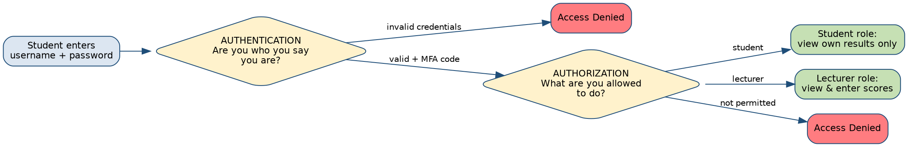
Figure 5: Authentication vs Authorisation in a University Portal
Authentication (proving identity, often strengthened with MFA) always happens first. Authorisation (deciding what the now-identified user can do) happens second, and depends on the person's assigned role.

2.3 Identity and Access Management (IAM)
Identity and Access Management (IAM) is the organisational discipline of managing who has accounts, what those accounts can access, and ensuring access is removed when no longer needed (for example, when a student graduates or an employee leaves). Poorly managed IAM — accounts that are never disabled, excessive permissions left unreviewed — is a very common, very preventable source of real breaches.

2.4 Single Sign-On (SSO) and Federated Identity
Single Sign-On (SSO) allows a user to log in once and gain access to multiple related systems without re-entering credentials each time — for example, logging into a university's central account and automatically gaining access to email, the learning management system, and the library portal. This is commonly implemented using standards such as SAML or OAuth/OIDC, which allow one trusted system to vouch for a user's identity to other systems, without those systems needing to store the user's password themselves.

3. Key Terms
Term | Simple Meaning
Authentication | The process of proving that you are who you claim to be
Authorisation | The process of determining what an authenticated identity is allowed to do
Multi-factor authentication (MFA) | Authentication using two or more independent proof factors
Role-Based Access Control (RBAC) | An access control model where permissions are assigned to roles, not individuals
Identity and Access Management (IAM) | The organisational practice of managing accounts and access throughout their lifecycle
Single Sign-On (SSO) | A system allowing one login to grant access to multiple related applications

4. Real-Life Scenario

Scenario: A Compromised Lecturer Account
A lecturer's email password is stolen through a phishing email (a topic explored fully in Week 6). Because the university's email system does not enforce MFA, the attacker logs in successfully using only the stolen password. Once inside, the attacker — now authenticated as the lecturer — attempts to access the grading system. However, the grading system correctly checks the lecturer's authorisation and confirms this account only has access to the two courses the lecturer actually teaches, not the entire university's grade records. The attacker changes grades for those two courses before the compromise is detected and the account is disabled.
This scenario shows both a failure (no MFA allowed authentication to be bypassed with a stolen password) and a success (authorisation correctly limited the damage to only the courses the lecturer was permitted to access) — illustrating why both authentication and authorisation controls matter together.

5. Industry Connection
IAM Analysts, a genuinely common entry-level role, spend their working days provisioning accounts, reviewing access requests, enforcing least privilege, and auditing who has access to what. Security teams broadly rely on strong authentication (especially MFA) as one of the highest-return investments available, because it directly blocks one of the most common attack paths — stolen or guessed credentials.

6. Industry Tools
Tool / Standard | What It Is | Why It Matters
Microsoft Entra ID / Azure AD | A cloud-based identity and access management platform | Widely used by organisations to centrally manage user accounts, MFA, and access policies
Active Directory (on-premises) | A directory service for managing users, groups, and permissions within an organisation's own network | Still common in many organisations, including universities, for managing staff and student accounts
OAuth / SAML / OIDC | Standards that allow systems to share proof of identity securely | Underpin Single Sign-On and 'Login with...' functionality across modern applications
⚙ INDUSTRY TIP
For entry-level roles, employers rarely expect deep configuration expertise in these platforms on day one. What matters is understanding the concepts they implement — accounts, roles, MFA, access reviews — since the specific software changes between employers but the underlying ideas do not.

7. Common Mistakes
- Treating authentication and authorisation as the same thing.
- Believing a strong password alone is 'enough' security without MFA.
- Granting broad access 'just in case it's needed later' instead of following least privilege.
- Forgetting to disable accounts promptly when someone leaves an organisation or changes roles — a very common real-world audit finding.

8. Career Connection
Identity and access management is one of the most durable, in-demand cybersecurity specialisations, partly because every organisation with computer accounts needs it, and partly because cloud adoption has made identity — rather than the network perimeter — the primary security boundary in many modern organisations.
☁ CAREER TIP
A typical entry pathway into IAM work starts from help desk or general IT support, where you already handle account creation, password resets, and access requests — experience that translates directly. If this specialisation interests you, mention any help desk, admin, or account-management experience prominently on your CV.

9. Summary
Authentication proves identity; authorisation determines what an authenticated identity may do. MFA significantly strengthens authentication by requiring more than one proof factor. RBAC assigns permissions to roles rather than individuals, and IAM is the organisational discipline of managing accounts and access across their entire lifecycle, including timely removal of access.

10. Review Questions

Short-Answer
- In one sentence each, define authentication and authorisation.
- Name the three general categories of authentication factors.

Conceptual
- Why does MFA significantly reduce the risk of account takeover, even if a password is stolen?
- Explain why RBAC is generally easier to manage at scale than assigning permissions to each individual person.

Scenario-Based
- A former employee's account is discovered still active and able to log in six months after they left the organisation. Which IAM practice failed, and what should have happened?
- A student is authenticated successfully into the university portal but is unexpectedly able to view another student's financial records. Which security property has failed here — authentication or authorisation — and why?

11. Further Reading
- NIST Special Publication 800-63, 'Digital Identity Guidelines' — pages.nist.gov/800-63-3
- CISA, 'Multi-Factor Authentication' guidance — cisa.gov/mfa
- Microsoft Learn, 'What is Identity and Access Management (IAM)?' — learn.microsoft.com
- OWASP, 'Authentication Cheat Sheet' — cheatsheetseries.owasp.org

WEEK 5: THREATS, ATTACKERS & MALWARE

Learning Objectives
- Classify common types of threat actors and their typical motivations.
- Distinguish between malware, an exploit, and a vulnerability.
- Explain the differences between viruses, worms, Trojans, and ransomware.
- Describe the basic stages of a cyberattack using the MITRE ATT&CK framework.
- Explain what tools such as VirtualTotal, antivirus/EDR, and vulnerability scanners are used for.

1. Introduction
So far, this course has focused mostly on defensive foundations. This week turns to the other side: who attacks organisations, why, and with what tools. Understanding attackers is not about learning to become one — it is about learning to think like a defender who anticipates how an intrusion is likely to unfold, which is exactly what security professionals are paid to do.

2. Core Concepts

2.1 Who Attacks, and Why
Threat Actor Type | Typical Motivation | Example
Cybercriminals | Financial gain | Ransomware gangs, business email compromise fraudsters
Nation-state actors | Espionage, political or strategic advantage | State-sponsored groups targeting government or critical infrastructure
Hacktivists | Ideological or political statement | Website defacement to protest a policy
Insiders | Financial gain, revenge, negligence | A disgruntled employee leaking data; an employee who makes a careless mistake
Script kiddies | Curiosity, reputation, low skill but real risk | Using pre-built attack tools without deep technical understanding
✓ WHAT EMPLOYERS LOOK FOR
A junior analyst is not expected to attribute an attack to a specific group — that is specialist threat-intelligence work. What is expected is the ability to describe, generally, what kind of actor a given behaviour pattern is consistent with (e.g., 'financially motivated' vs 'targeted/espionage-style').

2.2 Malware, Vulnerability, and Exploit — Another Common Confusion
A vulnerability is a weakness (recall Week 1). An exploit is the specific piece of code or technique that takes advantage of a vulnerability. Malware (malicious software) is software specifically written to cause harm — steal data, damage systems, or give an attacker unauthorised control. An exploit is often the way malware gets onto a system in the first place, but not all malware requires an exploit — some spreads through tricking users (see Week 6).

2.3 Types of Malware
Type | Simple Definition | Key Distinguishing Feature
Virus | Malicious code that attaches to a legitimate file or program and spreads when that file is run or shared | Needs a host file and human action to spread
Worm | Malicious code that spreads automatically across a network without needing a host file or human action | Self-propagating — the key difference from a virus
Trojan | Malware disguised as legitimate, useful software | Relies on deception, not self-replication, to get installed
Ransomware | Malware that encrypts a victim's files and demands payment for the decryption key | Directly monetises the attack by holding data hostage
Spyware | Malware that secretly monitors and collects information about a user | Focused on covert data collection rather than damage
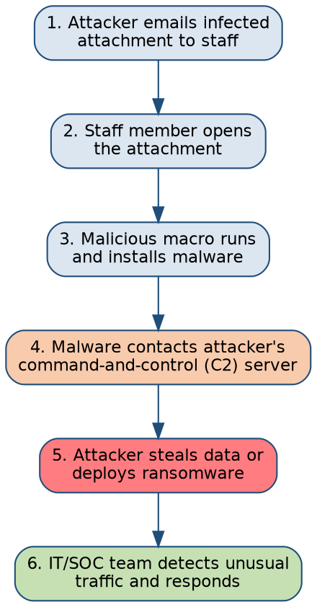
Figure 6: A Typical Malware Infection Chain
Most malware infections follow a recognisable chain: delivery (often by email), execution, installation, communication with the attacker's infrastructure, and finally the attacker's objective — data theft or ransomware deployment. Breaking the chain at any single stage can stop the attack.

2.4 Thinking in Attack Stages: MITRE ATT&CK
MITRE ATT&CK is a publicly available, continuously updated knowledge base that organises real-world attacker behaviour into stages — reconnaissance, initial access, execution, persistence, privilege escalation, lateral movement, and exfiltration, among others. Rather than memorising every technique, the value for a beginner is the mental model: attacks are processes with stages, not single events, and defenders can disrupt an attack at any stage, not just the first one.

2.5 Vulnerability Assessment — Finding Weaknesses Before Attackers Do
A vulnerability assessment is the systematic process of identifying, classifying, and prioritising weaknesses in systems — typically using automated vulnerability scanners such as Nessus or OpenVAS, which check systems against a database of known vulnerabilities. This differs from penetration testing (a topic touched on further in Week 6), which goes further by actively attempting to exploit weaknesses to demonstrate real-world impact, under authorisation.

3. Key Terms
Term | Simple Meaning
Malware | Software specifically designed to cause harm or gain unauthorised access
Exploit | Code or a technique that takes advantage of a specific vulnerability
Ransomware | Malware that encrypts data and demands payment for its release
Command-and-control (C2) | Infrastructure an attacker uses to communicate with and control compromised systems
Vulnerability assessment | The process of identifying and prioritising security weaknesses
Indicator of Compromise (IoC) | Evidence suggesting a system may have been breached

4. Real-Life Scenario

Scenario: Ransomware Against a Regional Hospital
A hospital's administrative staff member opens an email attachment that appears to be an invoice. The attachment silently installs ransomware, which spreads across the hospital's internal network overnight, encrypting patient record systems. By morning, staff cannot access patient files, and a ransom note demands payment in cryptocurrency. This general pattern reflects a well-documented category of real incidents that has affected hospitals worldwide, disrupting patient care, not just data. It illustrates why availability (Week 1's CIA Triad) is just as critical a target as confidentiality, and why basic controls — email filtering, backups, network segmentation, and staff awareness — matter enormously in preventing and limiting such incidents.

5. Industry Connection
Threat intelligence analysts track which threat actors and malware families are currently active and relevant to their industry. SOC analysts use knowledge of common malware behaviour to recognise Indicators of Compromise in logs and alerts. Vulnerability management teams run regular scans and prioritise patching based on which vulnerabilities are most likely to be exploited. All of these roles depend on the foundational classifications covered this week.

6. Industry Tools
Tool | What It Is | Why It Matters | Simple Example
VirusTotal | A free online service that scans files and URLs against dozens of antivirus engines and threat databases | Gives a quick second opinion on whether a file or link is likely malicious | An analyst uploads a suspicious email attachment's hash to VirusTotal before opening it in a safe environment
Antivirus / EDR (Endpoint Detection & Response) | Software that detects, blocks, and investigates malicious activity on individual devices | The primary line of defence against malware on laptops and servers | EDR software flags an unusual process trying to encrypt many files rapidly and blocks it automatically
Nessus / OpenVAS | Vulnerability scanners that check systems against known weaknesses | Used to find and prioritise vulnerabilities before attackers exploit them | A weekly scan reveals ten servers still running outdated, vulnerable software versions
MITRE ATT&CK | A knowledge base of attacker tactics and techniques | Provides a shared vocabulary to describe and map attacker behaviour | An analyst labels an incident as 'Initial Access via Phishing' using ATT&CK terminology in their report

7. Common Mistakes
- Using 'virus' as a catch-all term for every kind of malware, obscuring important differences.
- Assuming antivirus software alone is sufficient protection against modern malware.
- Believing vulnerability scanning and penetration testing are the same activity.
- Underestimating insider-related risk while focusing entirely on external attackers.

8. Career Connection
Threat and malware awareness is core to SOC Analyst, Threat Intelligence Analyst, and Vulnerability Management roles. Understanding the MITRE ATT&CK framework in particular is increasingly expected even at entry level, since many SOC tools and job descriptions now directly reference it.
☁ CAREER TIP
Practising with intentionally safe, legal environments — such as published malware analysis write-ups, sandboxed CTF challenges, or vendor threat reports (Microsoft, CrowdStrike, Mandiant all publish free, readable threat reports) — is an excellent, low-cost way to build real familiarity with this material before your practical weeks begin.

9. Summary
Threat actors vary widely in motivation, from financially driven cybercriminals to nation-state and insider threats. Malware is malicious software, distinguished from the exploit that may deliver it and the vulnerability it takes advantage of. Viruses, worms, Trojans, and ransomware each behave differently, and frameworks such as MITRE ATT&CK help defenders think about attacks as multi-stage processes that can be disrupted at several points.

10. Review Questions

Short-Answer
- Explain the difference between a virus and a worm.
- Define ransomware in one sentence.

Conceptual
- Why is it useful for defenders to think of an attack as a multi-stage process rather than a single event?
- Explain the difference between vulnerability assessment and penetration testing.

Scenario-Based
- A company's files are suddenly encrypted, and a note demands payment for a decryption key. What type of malware is this, and name two general defensive measures that could have reduced the impact.
- An organisation's vulnerability scan reveals a critical, unpatched weakness on a public-facing server, but the organisation has not yet observed any attack. Using this week's concepts, explain why they should still treat this as urgent.

11. Further Reading
- MITRE ATT&CK — attack.mitre.org
- CISA, 'Stop Ransomware' resource hub — stopransomware.gov
- ENISA, 'Threat Landscape' annual report — enisa.europa.eu
- NIST SP 800-83, 'Guide to Malware Incident Prevention and Handling' — csrc.nist.gov

WEEK 6: SOCIAL ENGINEERING & WEB APPLICATION SECURITY

Learning Objectives
- Explain social engineering and recognise common techniques including phishing.
- Describe common web application vulnerabilities, including SQL injection and cross-site scripting (XSS), at a conceptual level.
- Distinguish between penetration testing and vulnerability scanning.
- Explain the purpose of tools such as Burp Suite and OWASP ZAP.
- Explain the role of the OWASP Top 10 in guiding secure development and testing.

1. Introduction
Not every attack targets a machine directly. Many of the most damaging breaches begin by targeting a person, tricking them into giving up access voluntarily. Others target the websites and web applications that organisations run — often the most exposed, internet-facing part of any organisation's technology. This week covers both: the human side (social engineering) and the web application side of cybersecurity.

2. Core Concepts

2.1 Social Engineering — Attacking the Human
Social engineering is the manipulation of people into performing actions or revealing confidential information, exploiting trust, urgency, fear, or authority rather than technical weaknesses. It works because humans, unlike firewalls, can be persuaded, rushed, or deceived.
Technique | Simple Description | Example
Phishing | Fraudulent emails or messages designed to trick recipients into clicking malicious links or revealing credentials | A fake 'your account will be suspended' email with a link to a fake login page
Spear phishing | Phishing tailored specifically to a targeted individual using personal or organisational details | An email that references the victim's actual manager and a real ongoing project
Vishing | Voice-based social engineering over phone calls | A caller impersonating a bank's fraud department, asking for a one-time PIN
Pretexting | Inventing a fabricated scenario to obtain information or access | Someone posing as IT support, asking an employee to 'confirm' their password
Baiting | Offering something enticing to lure a victim into a trap | A USB drive labelled 'Salary List 2026' left in a car park, containing malware
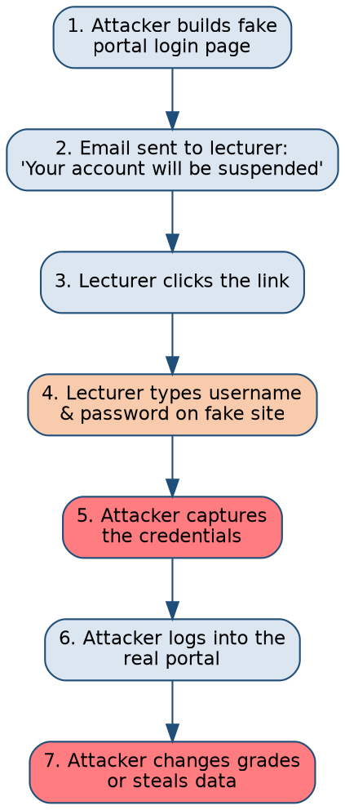
Figure 7: Anatomy of a Phishing Attack
Phishing follows a predictable sequence: a convincing pretext is built, a message is delivered, the victim is pressured into acting quickly, credentials are captured, and those credentials are then used for further access — exactly the kind of authentication bypass discussed in Week 4.
⚠ SECURITY ALERT
A slightly misspelled domain name, an unexpected sense of urgency ('act within 24 hours or your account will be suspended'), and a request to enter credentials via a link rather than navigating to the site directly are three of the most reliable warning signs of phishing. When in doubt, never click — navigate to the official site directly instead.

2.2 Web Application Vulnerabilities
Websites and web applications are built from code, and like all code, that code can contain mistakes that create vulnerabilities. Two of the most well-known categories are worth understanding conceptually:
- SQL Injection — occurs when an application inserts user input directly into a database query without properly checking it, allowing an attacker to manipulate the query itself. In simple terms: if a login form does not properly check what a user types, an attacker can type something clever instead of a normal username and trick the database into giving up information it should not.
- Cross-Site Scripting (XSS) — occurs when an application allows an attacker to inject malicious script into a page viewed by other users, letting the attacker's code run in the victim's browser. In simple terms: if a comment box on a website does not properly clean the text before displaying it to other visitors, an attacker can hide malicious code inside a 'comment' that runs on everyone else's screen.
Both vulnerabilities exist because the application trusted user input without validating or properly handling it — a lesson that generalises well beyond these two specific examples: never trust input, always validate it.

2.3 The OWASP Top 10
The Open Worldwide Application Security Project (OWASP) publishes the OWASP Top 10, a regularly updated, widely respected list of the most critical web application security risks (including categories like Injection and Broken Access Control). It is one of the most referenced documents in web security, used by developers, testers, and auditors as a common baseline for what to check for.

2.4 Vulnerability Scanning vs Penetration Testing (Revisited)
Building on Week 5: a vulnerability scan automatically checks a web application against known weakness patterns and reports what it finds. A penetration test goes further — a skilled, authorised tester actively attempts to exploit weaknesses (including chaining several minor issues together) to demonstrate real, concrete impact, and then documents findings with remediation recommendations. Both are valuable; they answer different questions ('what looks weak?' versus 'what can actually be broken into, and how badly?').

3. Key Terms
Term | Simple Meaning
Social engineering | Manipulating people into performing actions or revealing information
Phishing | Fraudulent messages designed to trick recipients into clicking links or revealing credentials
SQL Injection | A web vulnerability allowing attacker-controlled input to manipulate a database query
Cross-Site Scripting (XSS) | A web vulnerability allowing attacker-controlled script to run in another user's browser
Input validation | Checking that user-provided data meets expected rules before processing it
Penetration testing | Authorised, active testing that attempts to exploit weaknesses to demonstrate real impact

4. Real-Life Scenario

Scenario: Phishing Against a University Lecturer (Revisited from Week 4, Now in Full)
A lecturer receives an email that appears to come from the university's IT department, warning that their email storage is full and providing a link to 'upgrade' their account. The link leads to a convincing but fake login page. The lecturer, rushing between classes, enters their credentials. The attacker now has valid credentials and — as explored in Week 4 — the impact from here depends heavily on whether MFA and proper authorisation limits were in place.
This scenario is deliberately revisited from Week 4 to reinforce a key theme of this course: individual weekly topics are not isolated — a single real incident usually involves several concepts (social engineering, authentication, authorisation) working together, both on the attacker's side and the defender's side.

5. Industry Connection
Security awareness teams run phishing-simulation programmes to train staff to recognise real phishing attempts safely. Web application security engineers and penetration testers use frameworks like the OWASP Top 10 to guide code reviews and testing. Incident responders regularly investigate phishing as the starting point ('initial access,' in MITRE ATT&CK terms) for larger incidents.

6. Industry Tools
Tool | What It Is | Why It Matters | Simple Example
Burp Suite | A widely used web application security testing platform | Allows testers to intercept, inspect, and modify web traffic to find vulnerabilities | A tester uses Burp Suite to see exactly what data a login form sends, and experiments with altering it safely in a test environment
OWASP ZAP | A free, open-source web application vulnerability scanner | A popular starting point for learning web security testing | An organisation runs OWASP ZAP against its own staging website before a new feature goes live
Kali Linux | A Linux distribution pre-loaded with security testing tools | Provides a ready-made environment for authorised security testing and learning | Referenced here conceptually; hands-on use belongs to your practical laboratory weeks
⚙ INDUSTRY TIP
Burp Suite and OWASP ZAP are tools for authorised testing only — used against systems you own or have explicit permission to test, typically in training labs or approved engagements. Understanding what these tools do conceptually now will make your later hands-on practical sessions far easier to follow.

7. Common Mistakes
- Assuming phishing is 'obviously' easy to spot — well-crafted phishing emails are often indistinguishable from legitimate ones at a glance.
- Believing web security is 'only a developer's problem' rather than a shared organisational concern.
- Confusing SQL injection and XSS, or assuming both target the same part of an application.
- Underestimating how quickly a single successful phishing email can escalate into a much larger incident.

8. Career Connection
Security awareness and phishing-simulation work is a common early-career security responsibility. Web application security, meanwhile, is a specialised and well-paid path (application security engineer, penetration tester) that typically requires deeper hands-on skill built over time, often starting with OWASP Top 10 familiarity and platforms like OWASP ZAP or Burp Suite's free Community Edition.
☁ CAREER TIP
Capture the Flag (CTF) competitions — many free and beginner-friendly — are one of the most respected ways to build and demonstrate practical web security skills outside of a formal job. Mentioning CTF participation, even at beginner level, signals genuine hands-on initiative to employers.

9. Summary
Social engineering exploits human trust rather than technical weaknesses, with phishing as its most common form. Web applications can contain vulnerabilities such as SQL injection and cross-site scripting, both rooted in insufficient input validation. The OWASP Top 10 provides a widely used reference for common web risks, and tools such as Burp Suite and OWASP ZAP support authorised testing of these weaknesses.

10. Review Questions

Short-Answer
- Define phishing in your own words.
- Name one difference between SQL injection and cross-site scripting.

Conceptual
- Why does social engineering often succeed even against technically well-secured organisations?
- Explain why 'never trust user input' is considered a foundational principle in web application security.

Scenario-Based
- A university staff member receives an email asking them to log into the university portal using a link. The page looks genuine, but the URL is slightly different from the real portal address. What type of attack may this be, and what should the staff member do?
- A tester finds that typing a single quote character into a website's search box causes an unusual database error message to appear. What vulnerability category does this suggest, and why is the error message itself a useful clue?

11. Further Reading
- OWASP, 'OWASP Top 10' — owasp.org/www-project-top-ten
- CISA, 'Avoiding Social Engineering and Phishing Attacks' — cisa.gov
- PortSwigger, 'Web Security Academy' (free) — portswigger.net/web-security
- SANS, 'Security Awareness' resources — sans.org/security-awareness-training

WEEK 7: SECURITY OPERATIONS, SIEM & INCIDENT RESPONSE

Learning Objectives
- Explain the purpose and structure of a Security Operations Centre (SOC).
- Explain what a SIEM platform does and why log correlation matters.
- Describe the standard phases of incident response.
- Distinguish between an event and an incident.
- Explain the role of tools such as Splunk, Microsoft Sentinel, and Elastic/Kibana in security operations.

1. Introduction
Everything covered so far — networking, operating systems, identity, threats, social engineering, and web security — eventually flows into one place in most organisations: the Security Operations Centre (SOC). This week ties the semester together by examining how organisations actually watch for, detect, and respond to security incidents in real time.

2. Core Concepts

2.1 What Is a SOC?
A Security Operations Centre (SOC) is a team (and often a physical or virtual facility) responsible for continuously monitoring an organisation's systems, detecting suspicious activity, and coordinating a response. Many organisations run their SOC on a shift basis, so that monitoring continues 24 hours a day, since attacks do not wait for business hours.
SOC teams are commonly organised into tiers:
Tier | Typical Responsibility | Example Task
Tier 1 (Triage) | Monitor alerts, perform initial investigation, escalate genuine threats | Reviewing a SIEM alert and deciding if it needs deeper investigation
Tier 2 (Investigation) | Deeper analysis of escalated incidents | Tracing how an attacker gained access and what they did afterward
Tier 3 (Advanced/Hunting) | Proactive threat hunting, complex investigations, tool tuning | Searching for subtle attacker activity that automated alerts missed
✓ WHAT EMPLOYERS LOOK FOR
Tier 1 SOC Analyst is one of the most common and accessible entry-level cybersecurity roles. Employers expect comfort with logs, an ability to follow documented procedures (playbooks) carefully, clear written communication, and a calm, methodical approach under pressure — more than deep specialist expertise on day one.

2.2 Event vs Incident
An event is any observable occurrence in a system — a login, a file access, a network connection. Most events are entirely normal. An incident is an event (or combination of events) that indicates an actual or likely violation of security policy — unauthorised access, data loss, service disruption. Not every event is an incident, but every incident is made up of events. A large part of SOC work is filtering the enormous volume of normal events to find the rare ones that indicate a real incident.

2.3 SIEM — Security Information and Event Management
A SIEM (Security Information and Event Management) platform collects log data from many different sources across an organisation — firewalls, servers, applications, endpoints — and centralises it in one place, applying correlation rules to spot patterns that would be invisible looking at any single log source alone.
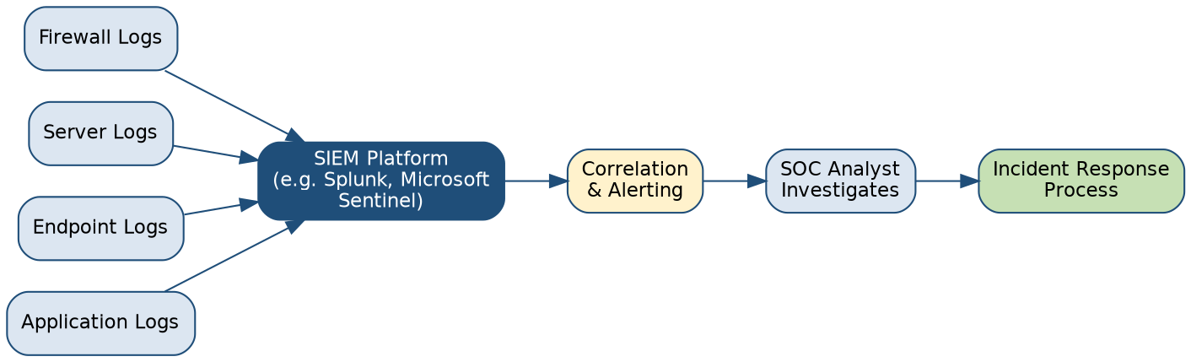
Figure 8: SIEM Architecture and the Path to Incident Response
Logs from multiple sources feed into a SIEM platform, which correlates events and generates alerts. A SOC analyst investigates those alerts, and confirmed incidents are handed into the formal incident response process.
For example, a single failed login is unremarkable. But a SIEM correlating failed logins across dozens of accounts from the same external IP address, all within a few minutes, can automatically flag this as a likely credential-stuffing attack — a pattern a human would struggle to notice manually across thousands of daily log entries.

2.4 The Incident Response Lifecycle
Most organisations follow a structured incident response process, commonly modelled on NIST's guidance, consisting of clear phases:
Phase | Simple Description
1. Preparation | Building the plans, tools, and trained people needed before an incident happens
2. Detection & Analysis | Identifying that an incident is occurring and understanding its scope
3. Containment | Limiting the damage — e.g., isolating an infected machine from the network
4. Eradication | Removing the cause — e.g., deleting malware, closing the vulnerability used
5. Recovery | Restoring systems to normal, verified-safe operation
6. Post-Incident Review | Documenting lessons learned and improving defences for next time
★ REMEMBER
Containment should generally happen before full investigation is complete if an incident is actively causing damage — stopping the bleeding takes priority over understanding every detail immediately. This is a common, deliberately tested scenario question in cybersecurity coursework and interviews.

3. Key Terms
Term | Simple Meaning
Security Operations Centre (SOC) | A team responsible for monitoring, detecting, and responding to security threats
SIEM | A platform that collects and correlates security log data from multiple sources
Event | Any observable occurrence within a system
Incident | An event or set of events indicating an actual or likely security violation
Alert | A notification generated when monitoring detects something that may require investigation
Playbook | A documented, step-by-step procedure for responding to a specific type of incident

4. Real-Life Scenario

Scenario: Detecting a Data Exfiltration Attempt
A SIEM platform at a Nigerian bank correlates two seemingly unrelated events: an employee account logging in from an unusual location at 2 a.m., followed shortly after by a large, unusual volume of data being transferred to an external file-sharing site. Individually, either event might have been dismissed. Together, correlated by the SIEM and reviewed by a Tier 1 SOC analyst, they trigger an escalation. The Tier 2 team confirms the account was compromised and the transfer was unauthorised. Following the incident response lifecycle, the account is immediately disabled (containment) while investigation continues, well before the full scope is understood — precisely illustrating why containment often precedes complete analysis.

5. Industry Connection
This week represents the operational heart of practical cybersecurity work. SOC analysts, incident responders, and threat hunters spend their careers inside this cycle: monitor, detect, investigate, respond, improve. Every concept from earlier weeks — networking, OS logs, identity, malware behaviour, social engineering, web vulnerabilities — becomes raw material that SOC teams interpret daily.

6. Industry Tools
Tool | What It Is | Why It Matters | Simple Example
Splunk | A leading commercial SIEM and log-analysis platform | Widely used across industries to search, visualise, and correlate log data | An analyst writes a Splunk search to find all failed logins across the network in the last hour
Microsoft Sentinel | A cloud-native SIEM platform integrated with the Microsoft ecosystem | Increasingly common as organisations move infrastructure to the cloud | A SOC uses Sentinel's built-in rules to automatically flag impossible-travel logins (e.g., Lagos then London within minutes)
Elastic Stack (Elasticsearch/Kibana) | An open-source data search and visualisation platform, popular for log analysis | A cost-effective option many organisations use to build their own SIEM-like capability | A team builds a Kibana dashboard showing login attempts by country over time
Security Onion | A free, open-source platform combining several security monitoring tools | Popular in training and smaller organisations for hands-on SOC learning | Referenced here conceptually; hands-on configuration belongs to your practical laboratory weeks

7. Common Mistakes
- Treating every alert as equally urgent, leading to alert fatigue and missed real incidents.
- Waiting for 'complete certainty' before containing an active incident, allowing damage to spread.
- Skipping the post-incident review phase, so the same weakness gets exploited again later.
- Assuming a SIEM alone detects everything — a SIEM is only as good as the log sources feeding it and the analysts interpreting it.

8. Career Connection
Tier 1 SOC Analyst remains one of the clearest, most reachable entry points into cybersecurity, frequently hiring directly from bootcamps, certifications, or adjacent IT roles. This is precisely the pathway most current industry career guidance for 2026 points toward for beginners.
☁ CAREER TIP
Building a small home lab — even using free tools like Security Onion or Splunk's free tier, with sample log data — and practising writing simple searches or building one dashboard is one of the most concrete, resume-worthy projects a student can complete before graduating.

9. Summary
A SOC monitors, detects, and responds to security threats, typically organised into escalating tiers. A SIEM centralises and correlates log data from multiple sources to surface meaningful alerts from an enormous volume of ordinary events. Incident response follows a structured lifecycle — preparation, detection and analysis, containment, eradication, recovery, and post-incident review — with containment often prioritised even before full analysis is complete.

10. Review Questions

Short-Answer
- Define the difference between an event and an incident.
- List the six phases of the incident response lifecycle in order.

Conceptual
- Why might a SIEM flag two individually normal-looking events together as suspicious?
- Explain why containment is sometimes performed before an investigation is fully complete.

Scenario-Based
- A SOC analyst sees a single failed login for an employee account. Should this immediately be escalated as an incident? Justify your answer using this week's concepts.
- After a ransomware incident is fully resolved, a SOC team decides to update its firewall rules and staff training. Which phase of the incident response lifecycle does this represent, and why does it matter for the future?

11. Further Reading
- NIST SP 800-61 Rev. 2, 'Computer Security Incident Handling Guide' — csrc.nist.gov
- SANS Institute, 'Incident Handler's Handbook' — sans.org/reading-room
- Splunk, 'What is a SIEM?' — splunk.com/en_us/data-insider/what-is-siem
- Microsoft Learn, 'Microsoft Sentinel Documentation' — learn.microsoft.com/azure/sentinel

WEEK 8: RISK MANAGEMENT, GOVERNANCE & CAREER READINESS

Learning Objectives
- Explain the basic risk management process used by organisations.
- Distinguish between risk assessment and vulnerability assessment.
- Describe major cybersecurity frameworks (NIST CSF, ISO/IEC 27001) at a conceptual level.
- Explain the four common risk treatment options.
- Identify a personal, realistic pathway toward an entry-level cybersecurity role.

1. Introduction
Organisations cannot protect everything equally — budgets, time, and people are limited. Risk management is the discipline that helps organisations decide where to focus their limited security resources for the greatest effect. This final theory week also turns directly to you: what employers in 2026 are actually looking for, and how to build a realistic, evidence-based pathway into the field.

2. Core Concepts

2.1 The Risk Management Process
Building on Week 1's definition of risk (threat × vulnerability × impact), organisations follow a structured process to manage risk systematically rather than reactively:
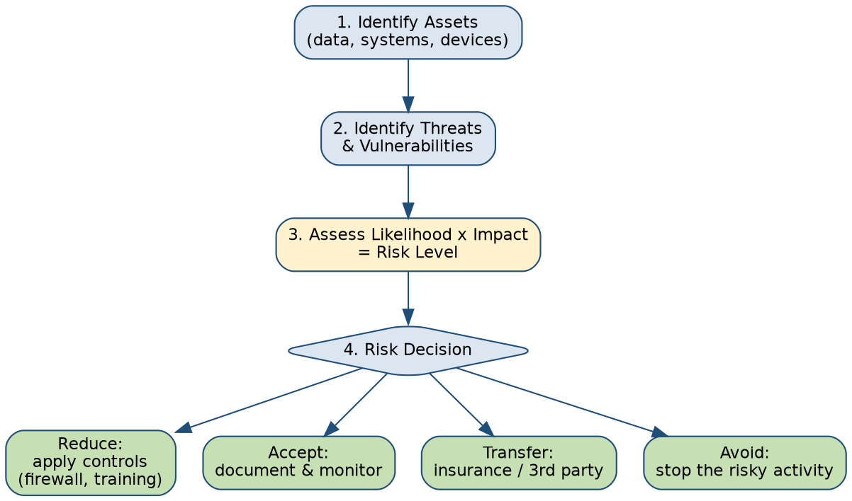
Figure 9: The Risk Management Process
Risk management is cyclical, not a one-time event: assets and threats change, so the assessment and treatment decisions must be revisited regularly, not treated as a single project that is 'finished.'
Risk Treatment Option | Simple Description | Example
Reduce (Mitigate) | Apply controls to lower likelihood or impact | Installing a firewall; enforcing MFA; staff training
Accept | Knowingly take no further action because the risk is low or the cost of fixing it outweighs the benefit | Accepting minor risk from an old printer with no sensitive data
Transfer | Shift some financial impact of the risk to another party | Purchasing cyber-insurance
Avoid | Eliminate the risk entirely by not engaging in the risky activity | Deciding not to offer a risky, unnecessary public-facing service
★ REMEMBER
Risk assessment (identifying and evaluating risks) is different from vulnerability assessment (technically scanning for specific weaknesses, covered in Week 5). Risk assessment is broader and includes business context — a vulnerability assessment might feed into a risk assessment as one input among several, including impact and likelihood judgements that go beyond pure technical scanning.

2.2 Cybersecurity Frameworks and Governance
Organisations do not invent their security programmes from scratch — most align with established, publicly available frameworks that provide structure and shared vocabulary.
Framework | What It Provides | Structure (Simplified)
NIST Cybersecurity Framework (CSF) 2.0 | A voluntary, widely adopted framework for managing cybersecurity risk | Six core functions: Govern, Identify, Protect, Detect, Respond, Recover
ISO/IEC 27001 | An international standard for building and certifying an Information Security Management System (ISMS) | Requires a systematic, documented, continuously improved approach to information security
CIS Controls | A prioritised, practical list of defensive actions organisations should take | Ranges from basic asset inventory to advanced controls, often used as an implementation checklist
Governance, Risk, and Compliance (GRC) is the organisational function responsible for aligning security work with these frameworks, applicable laws and regulations, and business objectives — ensuring that security decisions are not made in a vacuum but connect to real organisational priorities and legal obligations.
⚙ INDUSTRY TIP
In Nigeria, organisations — particularly in banking and telecommunications — must also align with local regulatory expectations, such as Central Bank of Nigeria (CBN) cybersecurity guidelines for financial institutions and the Nigeria Data Protection Act (NDPA), alongside global frameworks like ISO 27001. A GRC professional working locally needs literacy in both.

2.3 Bringing the Semester Together
Every week of this course maps onto this governance and risk picture. Week 1's CIA Triad defines what we protect. Weeks 2–4 (networking, operating systems, identity) describe the technical foundation being protected and controlled. Weeks 5–6 (threats, malware, social engineering, web security) describe what we are protecting against. Week 7 (SOC, SIEM, incident response) describes how organisations detect and respond in real time. This week closes the loop: risk management and governance decide where, how much, and why organisations invest in all of the above.

3. Key Terms
Term | Simple Meaning
Risk management | The structured process of identifying, assessing, and treating risk
Risk assessment | The process of identifying and evaluating risks, considering likelihood and impact
Risk treatment | The decision and action taken in response to an assessed risk (reduce, accept, transfer, avoid)
Framework | A structured, publicly recognised set of guidelines for managing security
Governance, Risk & Compliance (GRC) | The organisational function aligning security work with policy, regulation, and business goals
Compliance | Meeting the requirements of applicable laws, regulations, or standards

4. Real-Life Scenario

Scenario: Prioritising a Limited Security Budget
A mid-sized Nigerian fintech company has a security budget that cannot address every identified risk this year. A risk assessment reveals three findings: (1) a critical, internet-facing vulnerability with a known, actively used exploit — high likelihood, high impact; (2) an outdated internal tool with a moderate vulnerability but no internet exposure and no sensitive data — low likelihood, low impact; (3) no cyber-insurance policy in place, despite operating in a regulated financial sector. Applying this week's concepts, the company reduces risk 1 immediately (patch/mitigate), accepts risk 2 for now given its low likelihood and impact, and transfers part of its remaining exposure by purchasing cyber-insurance — a realistic, defensible allocation of limited resources rather than an attempt to fix everything at once.

5. Industry Connection
GRC analysts, risk managers, and CISOs (Chief Information Security Officers) use exactly this kind of reasoning daily, translating technical findings (from vulnerability scans, audits, and incident history) into business decisions about where to spend limited time and money. Even technical roles like SOC analysts benefit from understanding this bigger picture, since it explains why certain alerts or vulnerabilities are prioritised over others by management.

6. Industry Tools
Tool / Resource | What It Is | Why It Matters
NIST CSF 2.0 (framework document + online tools) | Free, publicly available framework and self-assessment resources | Widely referenced starting point for structuring a security programme
ISO/IEC 27001 (standard) | An internationally recognised, certifiable standard | Often required by clients or regulators as proof of a mature security programme
Risk register (spreadsheet or GRC platform) | A structured log of identified risks, their assessment, and treatment status | The core working document of most risk management processes, however simple or sophisticated the organisation

7. Common Mistakes
- Treating risk management as a one-time project rather than an ongoing, cyclical process.
- Confusing 'accepting' a risk with 'ignoring' it — acceptance should be a documented, deliberate decision, not neglect.
- Assuming frameworks like NIST CSF or ISO 27001 are purely bureaucratic paperwork rather than practical tools that shape real security investment.
- Focusing entirely on technology while overlooking legal, regulatory, and business context.

8. Employability: What CYB 401 Has Prepared You For
Across this semester, you have built the conceptual foundation that current 2026 industry research consistently identifies as the baseline for entry-level cybersecurity roles: the CIA Triad and risk fundamentals, networking basics, operating system security, identity and access management, threat and malware awareness, social engineering and web security awareness, and security operations fundamentals.
✓ WHAT EMPLOYERS LOOK FOR
Recurring 2026 hiring signals for roles such as SOC Analyst, GRC Analyst, and Security Administrator include: comfort with networking and OS fundamentals, understanding of authentication/authorisation and MFA, basic log-reading ability, familiarity with a recognised framework (commonly NIST CSF), and — increasingly — some evidence of hands-on practice (a home lab, CTF participation, or a relevant beginner certification such as CompTIA Security+ or the (ISC)² Certified in Cybersecurity). Employers consistently value demonstrable, practical evidence of these skills over the ability to simply define terms.

Knowing a Tool Exists vs Being Able to Use It Professionally
A theme repeated throughout this note deserves a final, direct statement: being able to name Wireshark, Nmap, Splunk, or Burp Suite in an interview is not the same as being able to use them competently on real (or realistic lab) data. This class note has intentionally focused on the 'what, why, and where it fits' of each tool, precisely so that your upcoming 7-week practical component can focus on genuine, hands-on skill-building without wasting time on basic conceptual orientation.
☁ CAREER TIP
A simple, realistic 6–12 month post-graduation roadmap that current industry guidance widely supports: (1) complete your practical laboratory weeks and build a small home-lab portfolio; (2) pursue one recognised entry-level certification such as CompTIA Security+ or (ISC)² Certified in Cybersecurity; (3) apply intentionally to SOC Analyst, GRC Analyst, or Security Administrator roles, or adjacent IT/help-desk roles as a deliberate stepping stone; (4) keep documenting what you learn — a simple portfolio of analysed scenarios, lab write-ups, or CTF challenges is one of the most concrete things you can show an interviewer.

9. Summary
Risk management is the structured, ongoing process of identifying, assessing, and treating risk, using options such as reduction, acceptance, transfer, and avoidance. Frameworks such as NIST CSF and ISO 27001 give organisations, and GRC professionals specifically, a shared, structured way to organise security decisions. This final week also connects the entire semester's material directly to what 2026 employers are actively looking for in entry-level cybersecurity candidates, and offers a realistic pathway forward.

10. Review Questions

Short-Answer
- Name the four common risk treatment options.
- Name one difference between NIST CSF and ISO/IEC 27001.

Conceptual
- Explain why 'accepting' a risk should be a deliberate, documented decision rather than simply doing nothing.
- Why do employers value demonstrable, hands-on evidence (labs, CTFs, certifications) more highly than the ability to define terms alone?

Scenario-Based
- A university identifies a low-impact, low-likelihood vulnerability in a rarely used, non-sensitive internal tool, but lacks the budget to fix it immediately. Which risk treatment option is most appropriate, and what should the university document regardless of its choice?
- Reflecting on all 8 weeks of this course, choose any two weekly topics and explain, in a short paragraph, how they connect to one another in a single realistic incident.

11. Further Reading
- NIST, 'Cybersecurity Framework (CSF) 2.0' — nist.gov/cyberframework
- ISO, 'ISO/IEC 27001 Information Security Management' — iso.org
- CompTIA, 'Security+ Certification Exam Objectives' — comptia.org
- (ISC)², 'Certified in Cybersecurity (CC)' — isc2.org
- CyberSeek, 'Cybersecurity Career Pathway & Workforce Data' — cyberseek.org

References & Further Reading (Consolidated)
The following authoritative sources were used to ground this class note's coverage of current cybersecurity concepts, tools, and 2026 industry expectations. Students are encouraged to bookmark these for ongoing study beyond the classroom.
- National Institute of Standards and Technology (NIST), Cybersecurity Framework (CSF) 2.0 — nist.gov/cyberframework
- NIST Computer Security Resource Center — csrc.nist.gov
- NIST SP 800-61 Rev. 2, Computer Security Incident Handling Guide — csrc.nist.gov
- NIST SP 800-63, Digital Identity Guidelines — pages.nist.gov/800-63-3
- NIST SP 800-41, Guidelines on Firewalls and Firewall Policy — csrc.nist.gov
- NIST SP 800-83, Guide to Malware Incident Prevention and Handling — csrc.nist.gov
- NIST SP 800-123, Guide to General Server Security — csrc.nist.gov
- Cybersecurity and Infrastructure Security Agency (CISA) — cisa.gov, including the Stop Ransomware initiative (stopransomware.gov) and MFA guidance
- MITRE ATT&CK Knowledge Base — attack.mitre.org
- Open Worldwide Application Security Project (OWASP) — owasp.org, including the OWASP Top 10 and Authentication Cheat Sheet
- (ISC)², Certified in Cybersecurity (CC) Exam Outline — isc2.org
- CompTIA, Security+ Certification Exam Objectives — comptia.org
- International Organization for Standardization, ISO/IEC 27001 — iso.org
- Center for Internet Security (CIS), CIS Benchmarks and CIS Controls — cisecurity.org
- Cisco Networking Academy — netacad.com
- Microsoft Learn — learn.microsoft.com (Windows Security, Identity & Access Management, Microsoft Sentinel documentation)
- Wireshark Foundation — wireshark.org
- Nmap Project — nmap.org
- Splunk, 'What is a SIEM?' — splunk.com
- PortSwigger, Web Security Academy — portswigger.net/web-security
- SANS Institute — sans.org, including the Incident Handler's Handbook
- European Union Agency for Cybersecurity (ENISA), Threat Landscape Report — enisa.europa.eu
- CyberSeek, Cybersecurity Career Pathway and Workforce Data — cyberseek.org
- U.S. Bureau of Labor Statistics, Occupational Outlook Handbook: Information Security Analysts — bls.gov

End of Classroom Component (Weeks 1–8). The 7-week practical/laboratory component of CYB 401 will be developed separately, building hands-on skill with the tools and concepts introduced throughout this note.

