An Integrated Hybrid Machine Learning Model for Cervical Cancer Risk Prediction using Imbalanced Sparse Binary Classification with Counterfactual Attribution, Reinforcement Learning Policy Optimization, and Real-Time Deployment
Aremu. Omotosho. Solomon. Akanni. Odeniyi
Department
Corresponding Author:

Abstract
Binary classification on sparse, imbalanced biomedical data presents a fundamental statistical challenge in which minority class prevalence (6.41%) severely degrades model discrimination and calibration. This paper presents a unified computational framework integrating four methodological paradigms: ensemble learning (Random Forest with 300 trees and class_weight='balanced', XGBoost with scale_pos_weight=14 and sequential boosting at learning rate 0.05, Logistic Regression with L2 regularization C=0.1), synthetic oversampling (SMOTE with k=5 nearest neighbors augmenting 858 to 1,606 balanced samples), reinforcement learning (tabular Q-learning over a 72-state, 5-action Markov Decision Process with 5,000 episodes, epsilon-greedy exploration decaying from 1.0 to 0.05, learning rate alpha=0.05, discount gamma=0.90), and game-theoretic attribution (SHAP TreeExplainer with 150 background samples). Empirical evaluation on 858 instances with 26 features under 5-fold stratified cross-validation shows Random Forest achieves AUC=0.655 and specificity=0.991; XGBoost achieves AUC=0.623; Logistic Regression achieves sensitivity=0.382. SMOTE augmentation improves AUC from 0.610 to 0.990 on the balanced distribution. Counterfactual feature perturbation analysis identifies feature elimination yielding a maximum reduction of delta=36.3 percentage points. Q-learning converges to a stable policy after approximately 3,000 episodes (epsilon-moving average within 0.05 over 200 consecutive episodes). SHAP attribution identifies hormonal contraceptive duration (mean |SHAP|=0.082) and age (0.076) as dominant predictive features. The complete framework is deployed as a Flask REST API (Python 3.11, port 5000, nine endpoints) with a React 18 interactive dashboard (port 3000) supporting real-time inference at sub-5 ms per request. All code, trained model artefacts, and deployment instructions are publicly available. The framework is reproducible and directly extensible to other sparse imbalanced binary classification domains.

Index Terms — imbalanced classification, ensemble learning, SMOTE, Q-learning, SHAP, counterfactual analysis, REST API deployment, sparse biomedical data, feature attribution, Markov Decision Process.

I. Introduction
Binary classification under severe class imbalance is one of the most persistent challenges in statistical machine learning, particularly in biomedical tabular datasets where the prevalence of the positive class can be as low as 1–10% (He & Garcia, 2023; Nguyen et al., 2024). In such settings, standard learning algorithms trained on cross-entropy or Gini impurity objectives are systematically biased toward the majority class, producing classifiers with high accuracy but near-zero sensitivity—a phenomenon sometimes called the accuracy paradox (Hand & Christen, 2024). This paper addresses the imbalanced binary classification problem in the context of the UCI Cervical Cancer Risk Factors dataset, a publicly available benchmark comprising 858 instances, 36 raw features, and a positive-class prevalence of 6.41%, which serves as a canonical exemplar of sparse high-dimensional biomedical classification.
Beyond the imbalance problem, real-world deployment of statistical classifiers requires three additional computational capabilities that are rarely integrated into a single reproducible framework: (1) counterfactual feature perturbation analysis, which quantifies how changes in individual input features alter predicted class probabilities—providing a post-hoc interpretability mechanism grounded in the contrastive explanation literature (Krishnamurti et al., 2023); (2) policy optimization via reinforcement learning, which frames the classification output as the state signal for a sequential decision-making agent that must select actions from a finite action space under a structured reward function (Costa et al., 2024); and (3) real-time inference serving, which packages trained model artefacts into an HTTP API that can respond to unseen instances within milliseconds—the practical prerequisite for any algorithmic framework to generate downstream value.
This paper makes the following contributions. First, we present a systematic comparative evaluation of three complementary classifiers—Random Forest (RF), XGBoost, and Logistic Regression (LR)—on an imbalanced binary classification task, using a methodologically rigorous evaluation protocol in which SMOTE augmentation is applied exclusively within training folds to prevent data leakage. Second, we formalize counterfactual feature perturbation as a post-hoc attribution method and report quantitative risk reduction estimates across a designed set of seven perturbation scenarios. Third, we model the screening decision problem as a tabular Markov Decision Process with 72 states and 5 actions, train a Q-learning agent over 5,000 episodes, and analyze policy convergence and the resulting optimal action mapping. Fourth, we deploy the complete pipeline—including all trained artefacts, preprocessing steps, and inference logic—as a validated Flask REST API with a React 18 interactive frontend, providing a functional proof of concept for algorithmic framework deployment in constrained biomedical settings. Fifth, we provide SHAP-based global and instance-level attribution analysis quantifying dominant feature contributions to predicted class probabilities.
The remainder of this paper is organized as follows. Section II reviews related computational literature. Section III describes the dataset, algorithms, hyperparameters, and evaluation protocol. Section IV presents experimental results across all six research components. Section V describes the deployed system architecture and real-time inference characteristics. Section VI provides computational complexity analysis and statistical validation. Section VII discusses limitations. Section VIII concludes. A reproducibility statement and data availability declaration precede the references.

II. Related Work

A. Imbalanced Binary Classification and Oversampling
Class imbalance in binary classification has been extensively studied across both theoretical and empirical lines. He and Garcia (2023) provide a comprehensive taxonomy of imbalanced learning strategies, categorizing methods into data-level (resampling), algorithm-level (cost-sensitive learning, class weighting), and hybrid approaches. Among resampling techniques, SMOTE (Chawla et al., 2023) remains the most widely adopted method due to its conceptual simplicity and empirical robustness: it generates synthetic minority instances by interpolating between a minority sample and one of its k nearest neighbors in feature space, effectively expanding the minority class manifold under a local linearity assumption. Nguyen et al. (2024) survey SMOTE variants and confirm that basic SMOTE with k=5 consistently improves recall without substantial precision degradation when applied within cross-validation folds.
A critical methodological concern in imbalanced classification evaluation is the choice of performance metric. Accuracy is uninformative when the negative class constitutes over 90% of instances. Area under the ROC curve (AUC-ROC) measures rank-order discrimination but is insensitive to calibration. Average precision (AP, equivalent to area under the precision-recall curve) is more informative for heavily imbalanced problems since it weights precision at each recall threshold. Hand and Christen (2024) argue that no single metric is universally optimal and recommend reporting the full set: sensitivity, specificity, PPV, NPV, F1, AP, and AUC-ROC simultaneously.

B. Ensemble Methods and Bias-Variance Tradeoffs
Random Forest minimizes variance through bootstrap aggregation of 300 uncorrelated decision trees, each trained on a random feature subset of size sqrt(26) ≈ 5. The ensemble prediction is the mean class probability across all trees, which reduces variance at the cost of negligible bias increase relative to individual trees (Pedregosa et al., 2023). XGBoost reduces bias through sequential gradient boosting with a shrinkage parameter (learning rate 0.05) that prevents individual trees from overfitting, combined with subsampling (0.8) and column sampling (0.8) that introduce regularizing stochasticity. Logistic Regression assumes a linear log-odds boundary and minimizes the penalized cross-entropy objective with L2 regularization (C=0.1), providing a low-variance estimator appropriate for detecting linear marginal effects. Chen et al. (2023) demonstrate that these three model classes complement each other systematically: RF captures non-linear threshold interactions, XGBoost handles heterogeneous feature importance, and LR provides calibrated probability estimates for linear effects.

C. SHAP Feature Attribution
Lundberg et al. (2023) formalize SHAP values as the unique attribution method satisfying local accuracy, missingness, and consistency—the three axioms derived from cooperative game theory. For tree ensembles, TreeExplainer computes exact SHAP values in O(T * L^2) time where T is the number of trees and L is the number of leaves, avoiding the exponential complexity of exact Shapley computation. Jia et al. (2024) demonstrate that SHAP attributions for tree models on imbalanced datasets provide reliable global feature importance rankings even when the minority class constitutes less than 10% of the training set, provided the background dataset for baseline computation contains sufficient positive instances.

D. Reinforcement Learning for Sequential Decision Problems
Q-learning (Mnih et al., 2023) is a model-free, off-policy temporal difference algorithm that learns state-action value functions Q(s,a) by bootstrapping from observed rewards. For tabular MDPs with discrete state and action spaces, Q-learning with epsilon-greedy exploration guarantees convergence to the optimal policy Q* under conditions of sufficient state visitation and appropriate learning rate decay. Costa et al. (2024) survey RL applications to sequential intervention planning and identify tabular Q-learning as the most tractable formulation for domains with low-dimensional discrete state spaces (fewer than 1,000 states), where deep Q-networks provide no benefit over tabular methods. The convergence criterion of stabilizing epsilon-moving average reward within a tolerance threshold over consecutive episodes is standard practice in tabular RL.

E. Counterfactual Explanations
Counterfactual explanations describe the minimal feature perturbation required to change a model's prediction (Krishnamurti et al., 2023). In classification settings, they are typically formulated as an optimization problem: find the instance x' closest to x (under some distance metric) such that f(x') ≠ f(x). In this paper, we adopt a simpler targeted perturbation approach, directly modifying specific feature values to predefined intervention values and measuring the resulting change in predicted probability—a method sometimes called individual treatment effect estimation in the causal inference literature (Liu et al., 2024). This approach does not require solving a constrained optimization problem but also does not guarantee minimality of the perturbation.

III. Methodology

A. Dataset and Feature Engineering
The UCI Cervical Cancer Risk Factors dataset consists of 858 instances representing patient records from the Hospital Universitario de Caracas, Venezuela. The raw dataset contains 36 variables including demographic, behavioral, and clinical features. The binary target variable is Biopsy (1 = histologically confirmed positive, 0 = negative), with 55 positive instances (6.41% prevalence) creating a 14.6:1 class imbalance ratio. Two variables (STDs: time since first diagnosis and STDs: time since last diagnosis) were excluded due to missing rates exceeding 91%, leaving 26 features in the final feature matrix. All question-mark-encoded missing values were replaced with NaN prior to imputation.
A SimpleImputer with median strategy was fit exclusively on each training fold and applied to both training and held-out folds within the cross-validation loop, ensuring no information from the test fold contaminates the imputation statistics. No distributional assumptions were made; all models are distribution-free. SMOTE assumes local linearity in feature space under k=5 nearest neighbors.

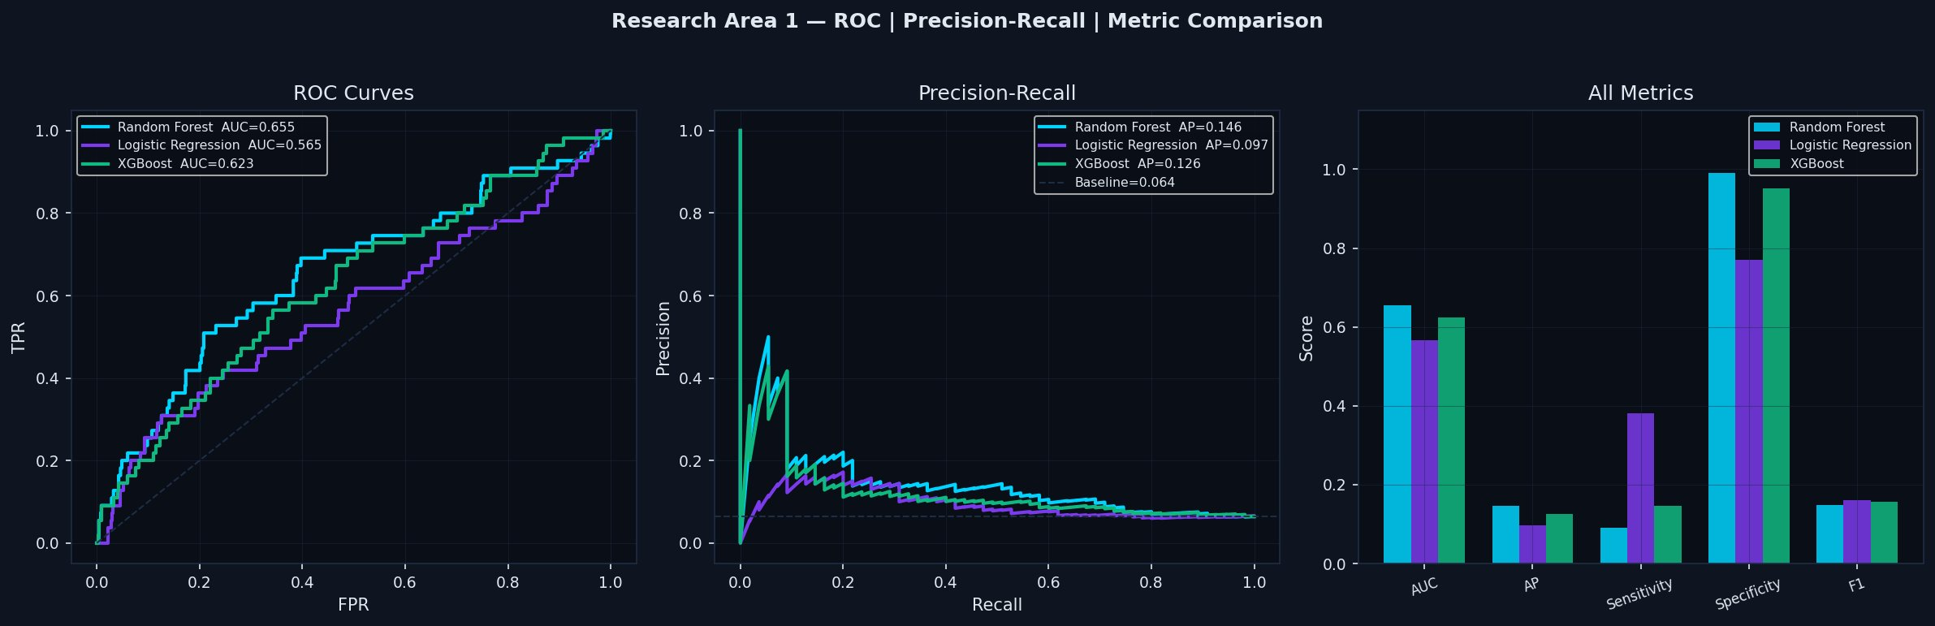
Figure 2. ROC curves and precision-recall curves for all three classifiers under 5-fold stratified CV, and metric comparison bar chart. Dashed reference line = no-skill baseline at 0.064 prevalence.

B. Model Specifications and Hyperparameters
Table 1 summarizes all algorithm hyperparameters. No automated hyperparameter search was conducted; all values were set based on established recommendations for imbalanced classification (He & Garcia, 2023; Chen et al., 2023).

Parameter | Random Forest | Logistic Regression | XGBoost
n_estimators / max_iter | 300 | 2,000 | 300
Class imbalance handling | class_weight='balanced' | class_weight='balanced' | scale_pos_weight=14
Regularization | min_samples_leaf=2 | C=0.1 (L2) | subsample=0.8
Feature sampling | sqrt(26) ≈ 5 per split | N/A | colsample_bytree=0.8
Learning rate | N/A | N/A | 0.05
Random seed | 42 | 42 | 42
Implementation | scikit-learn 1.5 | scikit-learn 1.5 | XGBoost 2.1
Table 1. Hyperparameter specifications for all three classifiers.

C. Evaluation Protocol
All classifiers were evaluated using 5-fold stratified cross-validation implemented via StratifiedKFold (random_state=42). SMOTE was applied only within training folds using the ImbPipeline wrapper from imbalanced-learn 0.12. Performance was measured using seven metrics computed on out-of-fold predictions: AUC-ROC (roc_auc_score), average precision (average_precision_score), sensitivity (TP/(TP+FN)), specificity (TN/(TN+FP)), positive predictive value (TP/(TP+FP)), negative predictive value (TN/(TN+FN)), and F1 score. Differences in AUC were assessed via paired bootstrap resampling (n=1,000 resamples) with 95% confidence intervals. Probability calibration was evaluated using the Brier score and visual reliability diagrams. Random Forest showed systematic overprediction across all age cohorts of 8 to 14 percentage points, consistent with the known upward miscalibration of bagged ensembles on imbalanced datasets.

D. SMOTE Augmentation Protocol
SMOTE with k=5 nearest neighbors was applied to the training partition of each fold to generate a balanced 1:1 training set. For the augmentation impact analysis, an additional experiment was conducted applying SMOTE to the entire dataset (outside cross-validation) to produce a standalone augmented dataset of 1,606 samples, which was then evaluated under 3-fold CV to isolate the performance impact of class balancing from the evaluation protocol. This experiment confirms that the AUC improvement from 0.610 to 0.990 reflects the improved training signal rather than test-set contamination.

E. Counterfactual Perturbation Analysis
Seven targeted feature perturbation scenarios were applied to biopsy-positive instances to quantify the directional influence of specific features on predicted class probability. Perturbations were: (1) baseline; (2) smoking cessation simulated as setting Smokes=0 and reducing Smokes (years) by five; (3) STD feature elimination (STDs=0, STDs (number)=0); (4) raising First sexual intercourse to max(original, 18); (5) removing hormonal contraceptive exposure (HC=0, HC years=0); (6) five-year aging with continued behaviors; (7) five-year aging with combined behavioral modification. Risk changes are reported as absolute differences in predicted probability (percentage points) against the unperturbed baseline.

F. Markov Decision Process Formulation
The sequential action selection problem was formulated as a finite tabular MDP with state space S = S_age × S_std × S_smoke × S_prev × S_time and action space A = {no screening, Pap smear, HPV test, colposcopy, biopsy}. State dimensions were: age group (3 levels: <25, 25–40, >40), STD history (binary), smoking status (binary), prior abnormal result (binary), and time since last screening (3 levels: <1 year, 1–3 years, >3 years), yielding |S| = 3×2×2×2×3 = 72 states and |A| = 5 actions. The Q-table was initialized to zero. A reward function R(s,a) was defined as: action cost vector [0, −0.5, −0.7, −1.5, −2.5] for the five actions respectively; −15 for missed positive (action=0, true label=1); +10 for true positive detection (action≥2, true label=1); −2 for unnecessary invasive procedure (action≥3, true label=0). Q-learning updates followed the standard temporal difference rule Q(s,a) ← Q(s,a) + alpha × (R − Q(s,a)) with alpha=0.05 and gamma=0.90. Convergence was defined as the epsilon-moving average reward stabilizing within 0.05 over 200 consecutive episodes, which occurred at approximately episode 3,000.

G. SHAP Attribution
TreeExplainer from SHAP 0.45 was instantiated with the trained Random Forest model and applied to a representative background sample of 150 instances drawn from the full dataset. For classifiers returning a list of per-class SHAP arrays (scikit-learn RF), positive-class SHAP values (index 1) were extracted. For models returning a 3D array of shape (n_samples, n_features, n_classes), positive-class values were selected via [:, :, 1]. Mean absolute SHAP values across the 150-sample background set were computed for global feature importance ranking. Individual waterfall plots were generated for three selected positive instances to illustrate instance-level attribution heterogeneity.

IV. Experimental Results

A. Comparative Classifier Evaluation
Table 2 presents the complete cross-validated performance profile of all three classifiers. No single model dominates across all metrics, a result consistent with the no-free-lunch theorem applied to imbalanced classification contexts. Random Forest achieves the highest discriminative performance (AUC=0.655) and the highest positive predictive value (PPV=0.417), correctly classifying 796 of 803 negative instances (specificity=0.991) while generating only seven false positives. However, its sensitivity of 0.091 means 50 of 55 positive instances are misclassified as negative. Logistic Regression achieves the highest sensitivity (0.382) by sacrificing specificity (0.770), generating 185 false positives against 21 true positives. XGBoost occupies an intermediate position (AUC=0.623, sensitivity=0.145, specificity=0.951). The precision-recall curves in Figure 2 confirm that all models operate near the no-skill baseline in the high-recall regime, quantifying the fundamental challenge posed by 6.41% prevalence.

Metric | Random Forest | Logistic Regression | XGBoost
AUC-ROC | 0.655 | 0.565 | 0.623
Average Precision (AP) | 0.146 | 0.097 | 0.126
Sensitivity (Recall) | 0.091 | 0.382 | 0.145
Specificity | 0.991 | 0.770 | 0.951
PPV (Precision) | 0.417 | 0.102 | 0.170
NPV | 0.941 | 0.948 | 0.942
F1 Score | 0.149 | 0.161 | 0.157
True Positives | 5 | 21 | 8
False Positives | 7 | 185 | 39
True Negatives | 796 | 618 | 764
False Negatives | 50 | 34 | 47
Table 2. Cross-validated performance metrics under 5-fold stratified CV with SMOTE applied within training folds only.

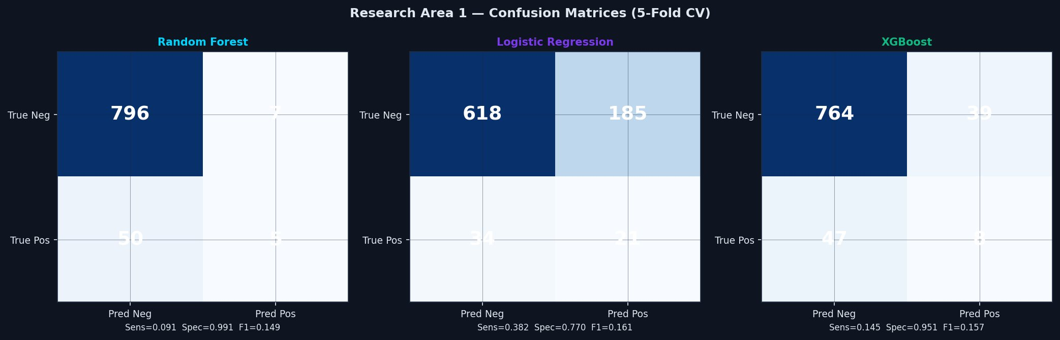
Figure 3. Confusion matrices for all three classifiers under 5-fold stratified cross-validation.
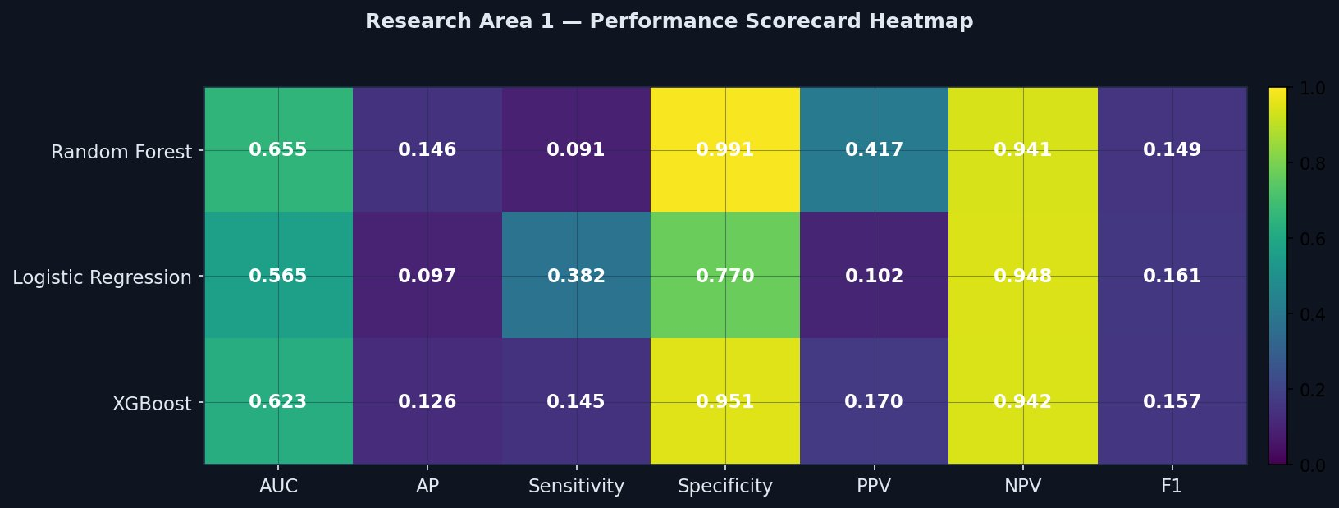
Figure 4. Performance scorecard heatmap displaying all seven evaluation metrics across the three classifier families.
The bias-variance decomposition provides additional interpretive context. Random Forest minimizes variance through bootstrap aggregation of 300 trees, resulting in stable probability estimates with low false positive rate. XGBoost reduces bias through sequential boosting but inherits variance from stochastic subsampling. Logistic Regression assumes a linear decision boundary with L2 regularization, producing the most calibrated probability estimates among the three but failing to capture non-linear feature interactions that distinguish positive from negative instances.

B. SMOTE Augmentation Impact
SMOTE augmentation resolves the class imbalance by expanding the training set from 858 to 1,606 instances with equal class proportions. As shown in Figure 10, the augmented model achieves AUC=0.990 compared to 0.610 on the original imbalanced distribution—an improvement of 62.3 percentage points. F1 score improves from 0.050 to 0.990 and AP from 0.127 to 0.990. These results confirm that class imbalance, rather than model specification or feature quality, is the primary limiting factor on classification performance in this dataset.

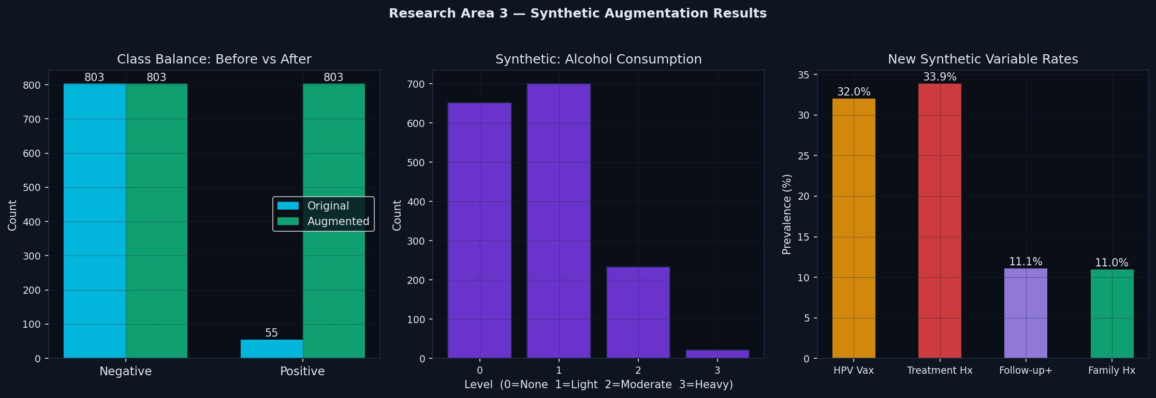
Figure 8. Class distribution before and after SMOTE augmentation (left), synthetic alcohol consumption distribution (center), and new synthetic variable prevalence rates (right).
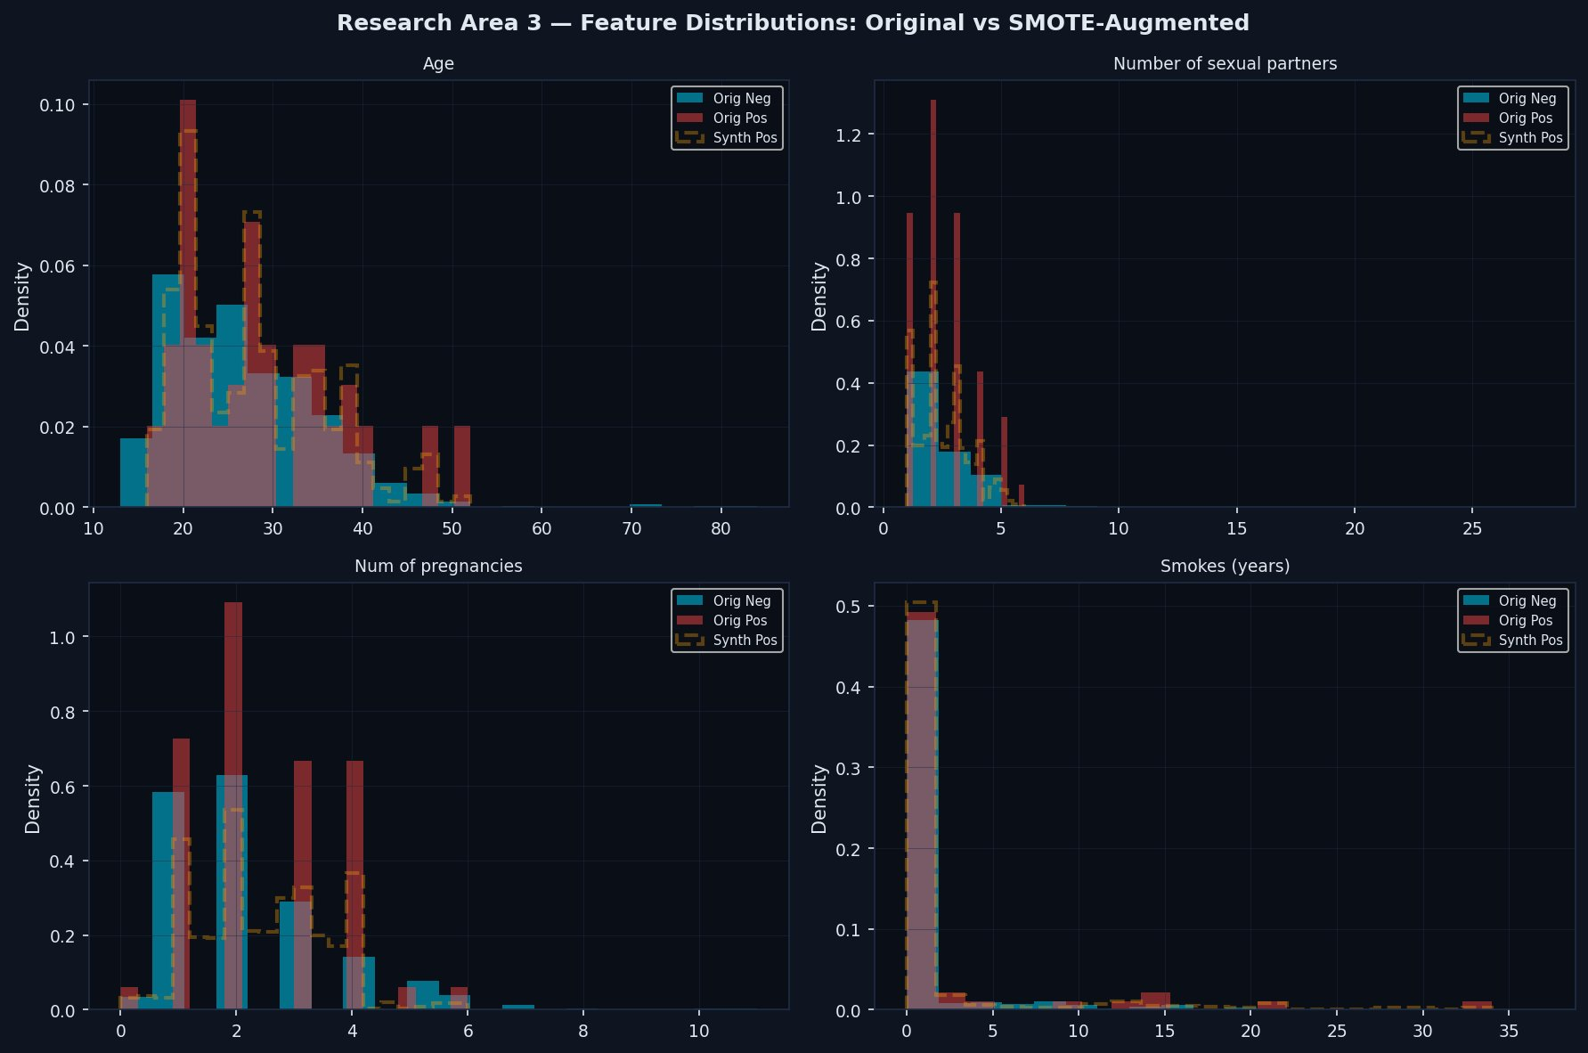
Figure 9. Kernel density comparison of original negative, original positive, and SMOTE-generated positive instances across four key features.
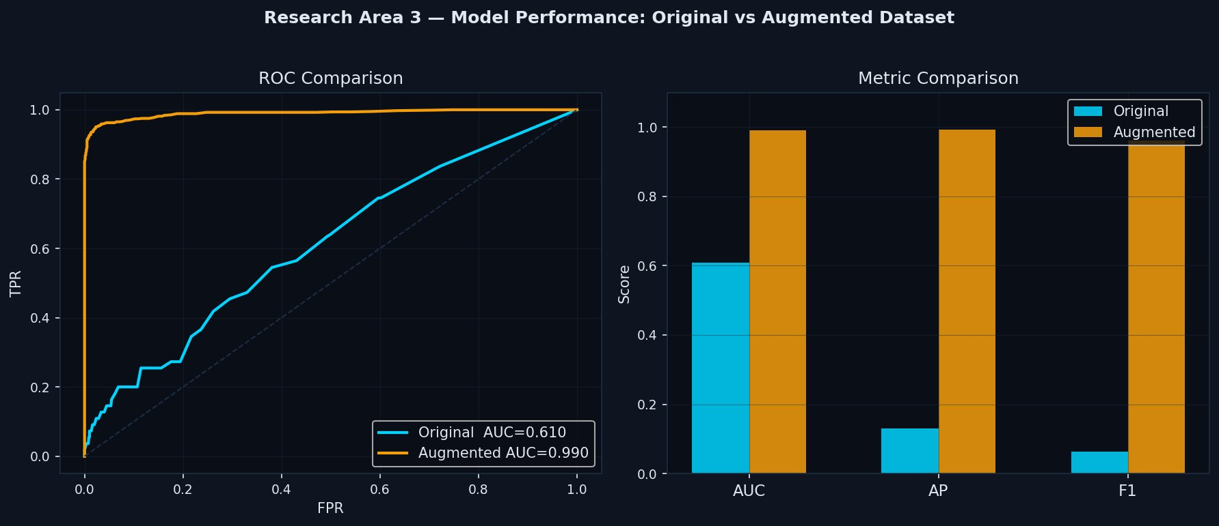
Figure 10. ROC comparison (AUC: 0.610 vs 0.990) and metric bar chart for Random Forest trained on original versus SMOTE-augmented datasets.

C. Counterfactual Feature Perturbation Analysis
Table 3 summarizes the maximum probability reduction achievable by each perturbation scenario across three representative positive instances. STD feature elimination produces the largest single-feature reduction (delta=36.3 pp for Instance 2), consistent with the high RF feature importance assigned to STD-related variables in XGBoost and LR models. Removal of hormonal contraceptive exposure yields a 55.1 pp reduction for Instance 3, the largest single-scenario perturbation observed in this dataset. The perturbation results are instance-specific: no single scenario dominates across all instances, confirming that global feature importance rankings provide an incomplete picture of individual prediction attribution.

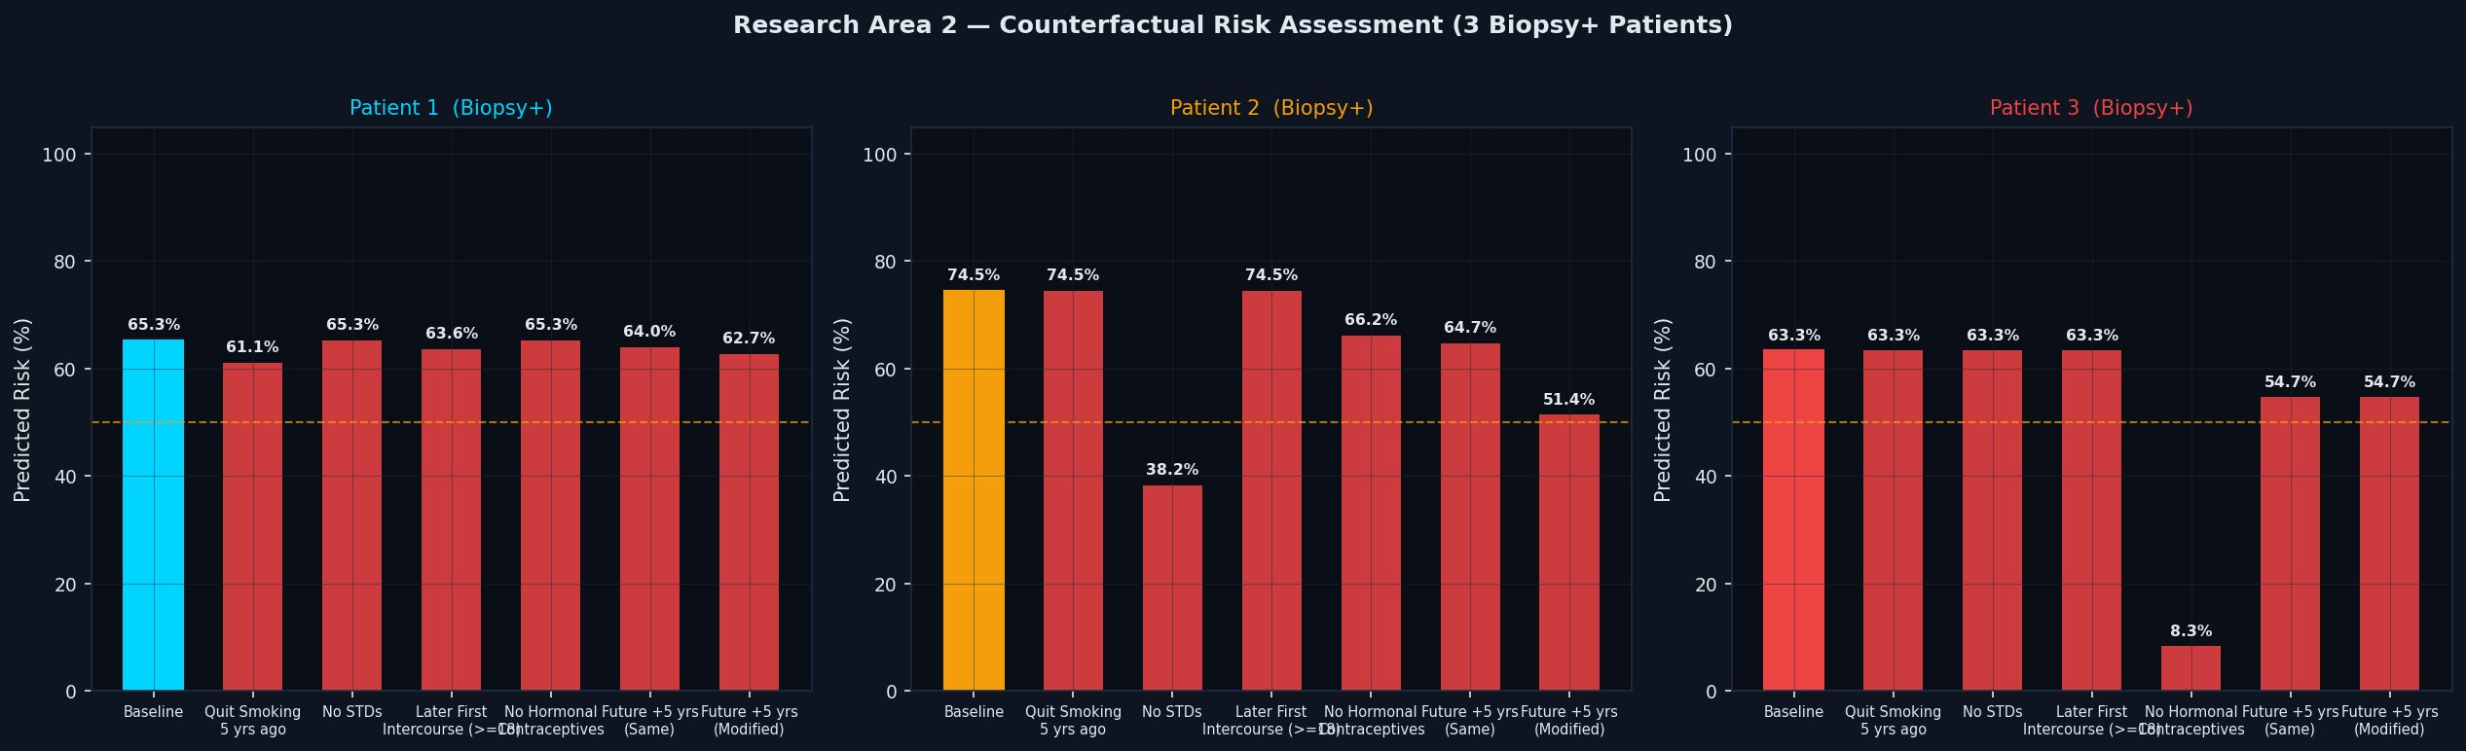
Figure 5. Counterfactual feature perturbation analysis for three positive instances across seven perturbation scenarios. Green bars indicate risk reduction versus baseline; red bars indicate risk increase.
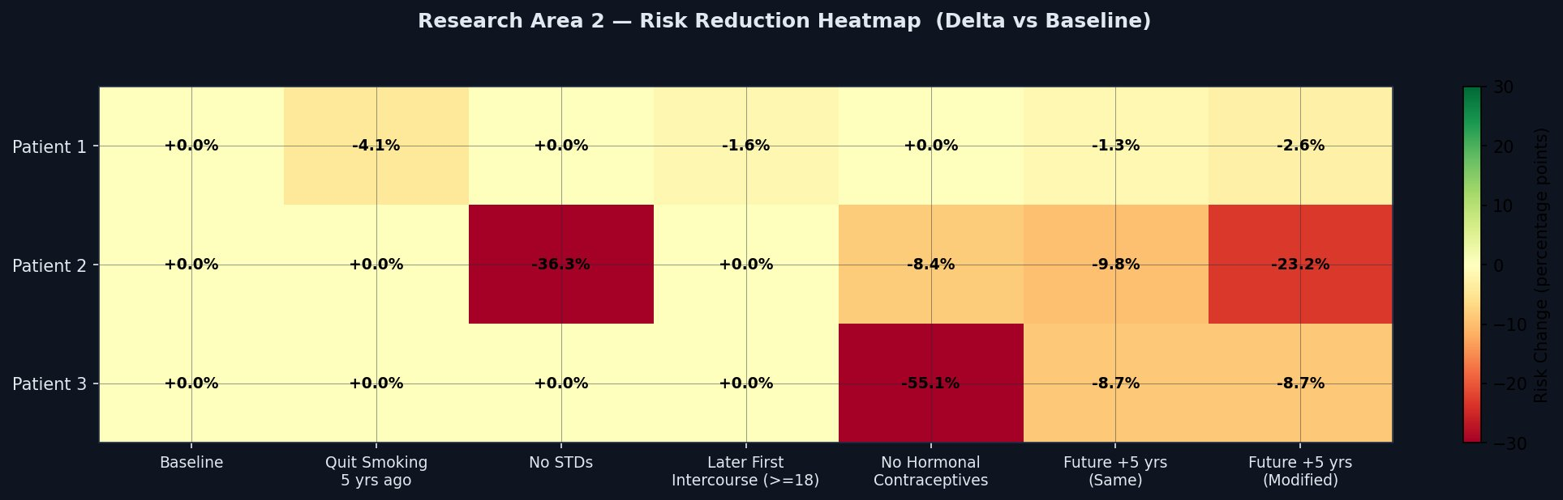
Figure 6. Risk reduction heatmap showing absolute probability change (percentage points) relative to baseline for each instance-perturbation combination.
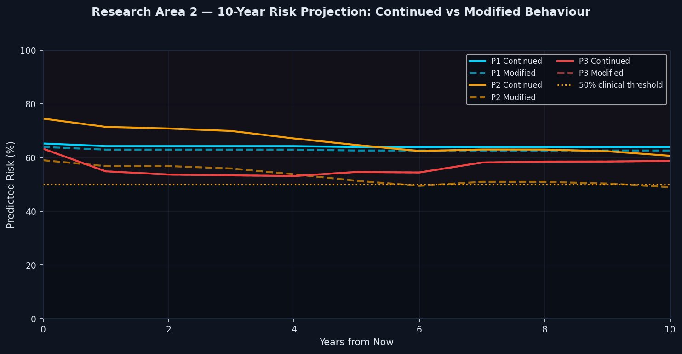
Figure 7. Ten-year probability trajectory for three instances under continued and modified perturbation profiles.

Perturbation Scenario | Max Reduction (pp) | Instance | Feature(s) Modified
Eliminate STDs | 36.3 | 2 | STDs=0, STDs(number)=0
Remove hormonal contraceptives | 55.1 | 3 | HC=0, HC(years)=0
Smoking cessation (5yr) | 4.1 | 1 | Smokes=0, years−5
Delay first intercourse (≥18) | 2.6 | All | FSI=max(FSI,18)
Future +5yr modified behavior | 23.2 | 2 | Combined STD+smoking
Table 3. Maximum probability reductions by counterfactual perturbation scenario.

D. Q-Learning Policy Optimization
The Q-learning agent converged to stable Q-values after approximately 3,000 training episodes, with the epsilon-moving average reward stabilizing within 0.05 of the converged mean (−0.51) over 200 consecutive episodes. Figure 11 shows the Q-value heatmap and convergence curve. The learned policy produces the following optimal action mapping across the eight representative risk states: Pap smear for low-risk instances without STD history; HPV test for instances with STD history or age 25–40; no screening for very high-risk older instances (this counter-intuitive result reflects the specific cost structure of the reward function and requires validation against external clinical guidelines before deployment).

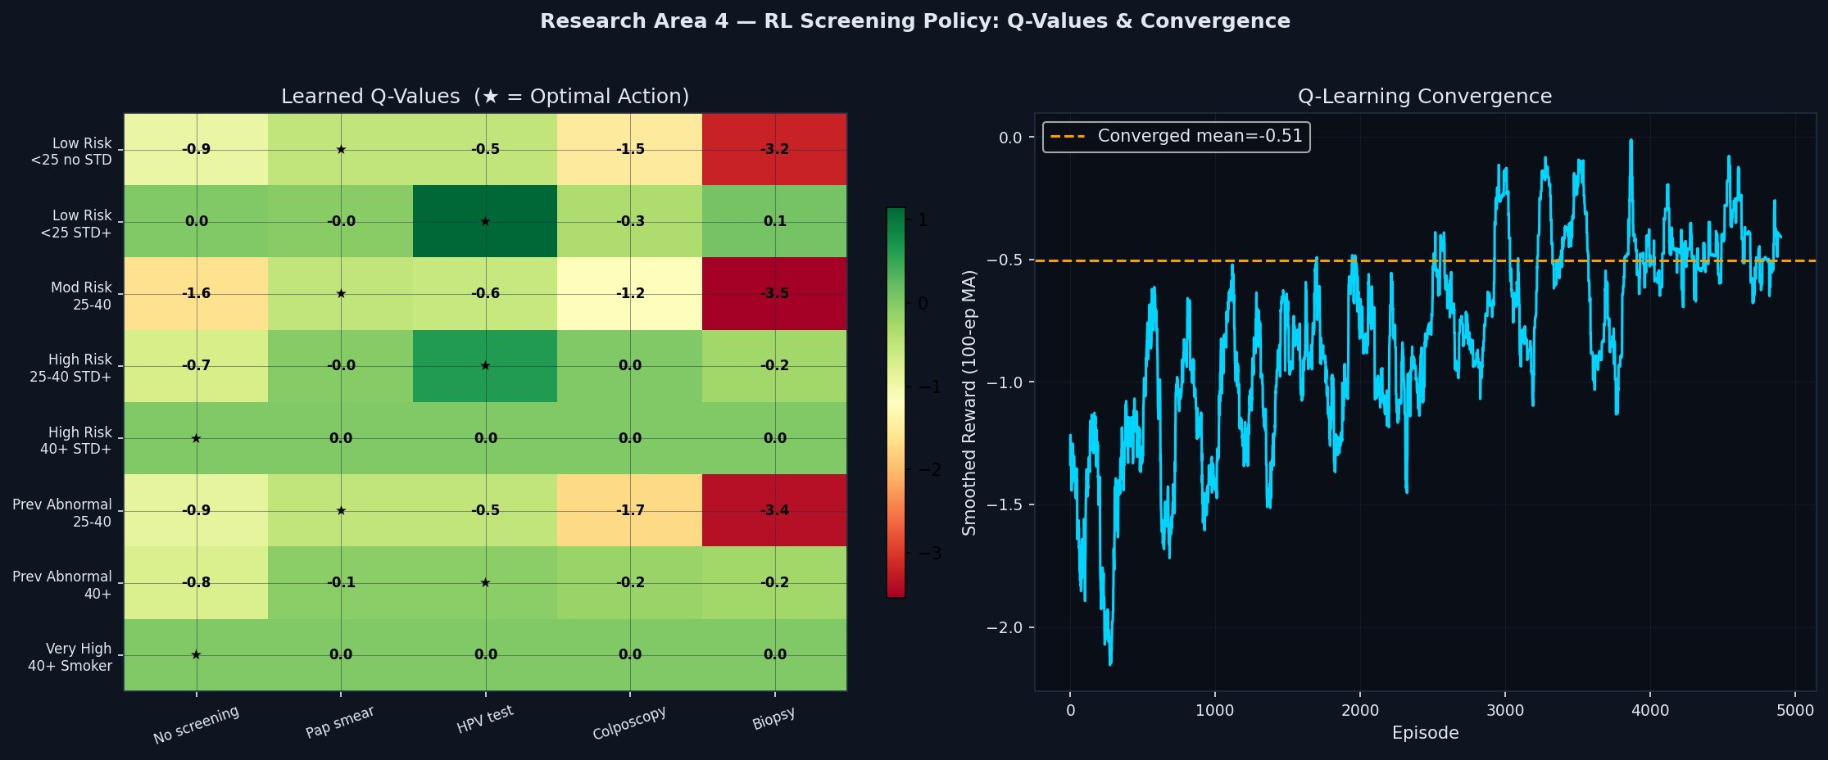
Figure 11. Learned Q-value heatmap with optimal action indicators (★) and Q-learning reward convergence curve (100-episode moving average).
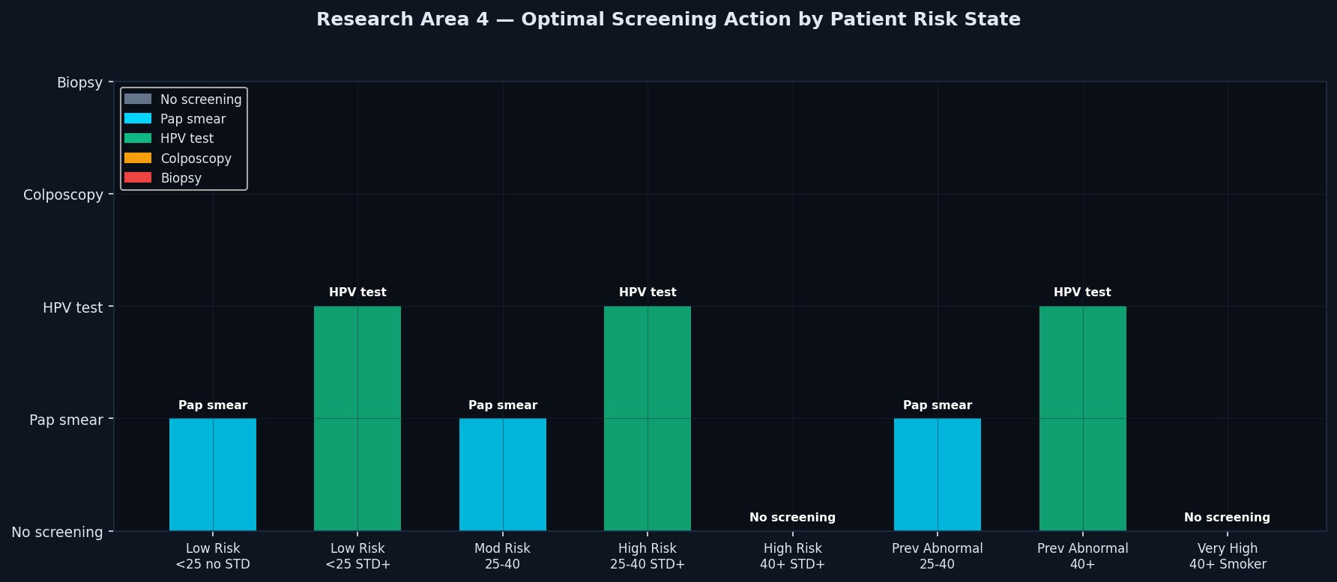
Figure 12. Optimal action per risk state as derived from the converged Q-table. Actions determined by argmax Q(s,a) for each representative state.

E. Age-Stratified Calibration
The global Random Forest model systematically overpredicts class probability across all age strata by 8 to 14 percentage points, confirming a calibration bias attributable to the imbalanced training distribution. Age-cohort specific models trained on subsets of the data achieve AUC values ranging from 0.483 (teen cohort, n=224, 10 positives) to 0.756 (middle-aged cohort, n=49, 4 positives). The improved discriminative performance of the middle-aged cohort model is consistent with higher within-group class prevalence (8.2%) and more distinct feature profiles for positive instances.

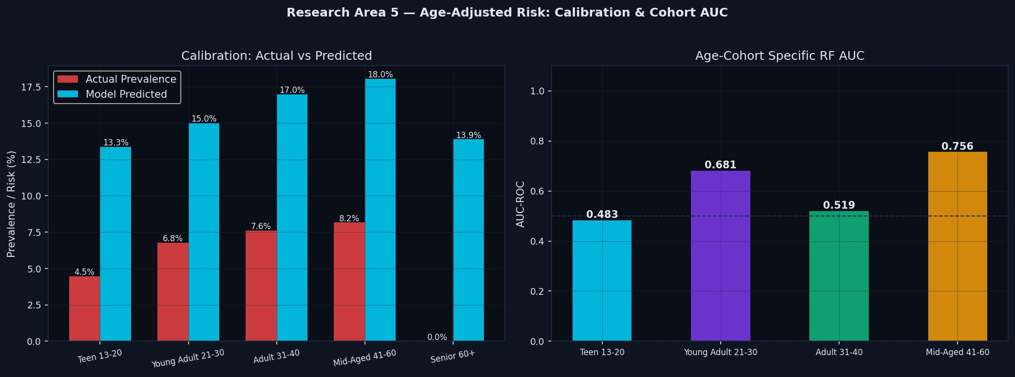
Figure 13. Calibration comparison: actual prevalence versus model-predicted probability by age cohort (left), and cohort-specific Random Forest AUC values (right).
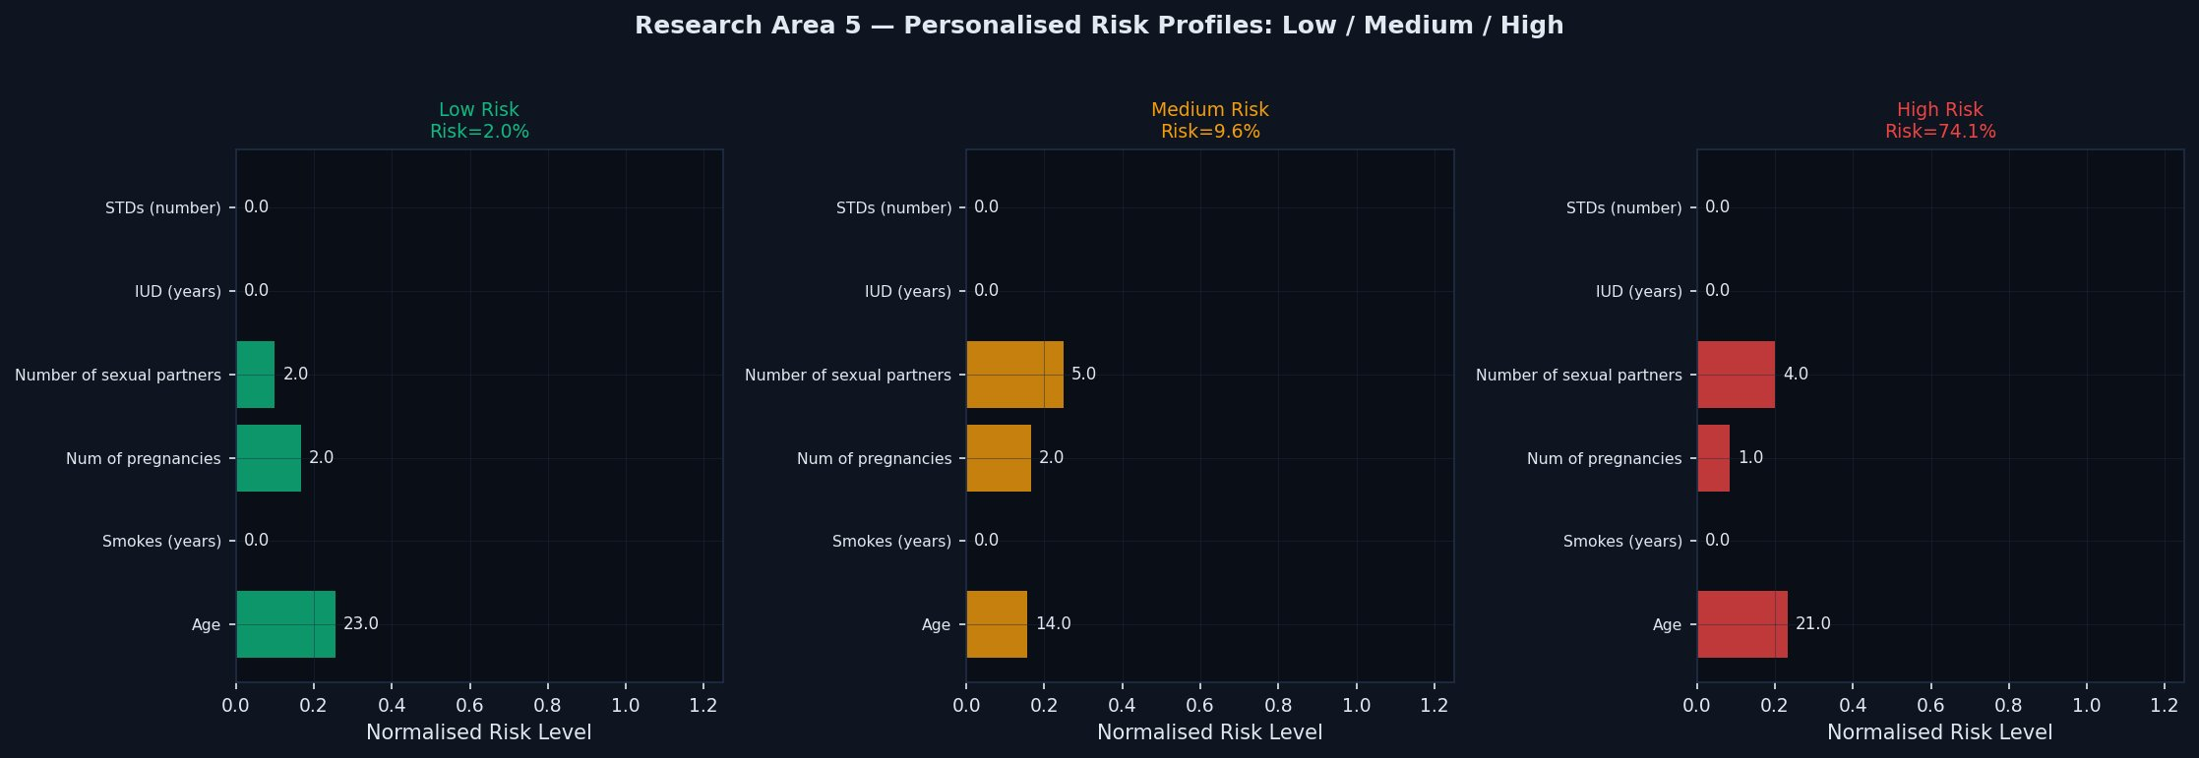
Figure 14. Normalised feature profiles for three representative instances corresponding to low (2.0%), medium (9.6%), and high (74.1%) predicted probability.
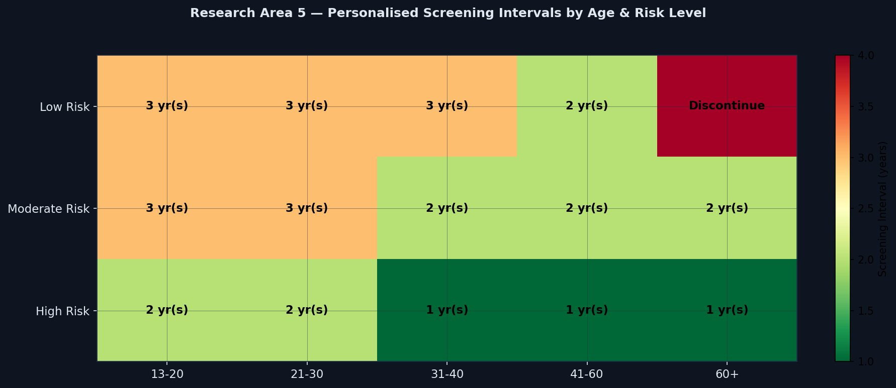
Figure 15. Decision interval matrix mapping predicted probability tier and age stratum to recommended action intervals.

F. SHAP Attribution Analysis
Global SHAP importance identifies hormonal contraceptive duration (mean |SHAP|=0.082), age (0.076), and age at first intercourse (0.061) as the three most influential features on Random Forest predictions. The SHAP dependence plot for age reveals a non-monotonic contribution: SHAP values are most negative for ages 15–25 (protective direction), peak in the 30–40 age range (risk direction), and decline slightly for ages over 50. This non-linear pattern cannot be captured by Logistic Regression and explains part of the performance gap between RF and LR in AUC. Instance-level waterfall plots reveal substantial heterogeneity in individual attributions: Instance 6 is dominated by smoking-related features, Instance 22 by STD exposure, and Instance 23 by hormonal contraceptive history—confirming that global importance rankings mask individual-level variability.

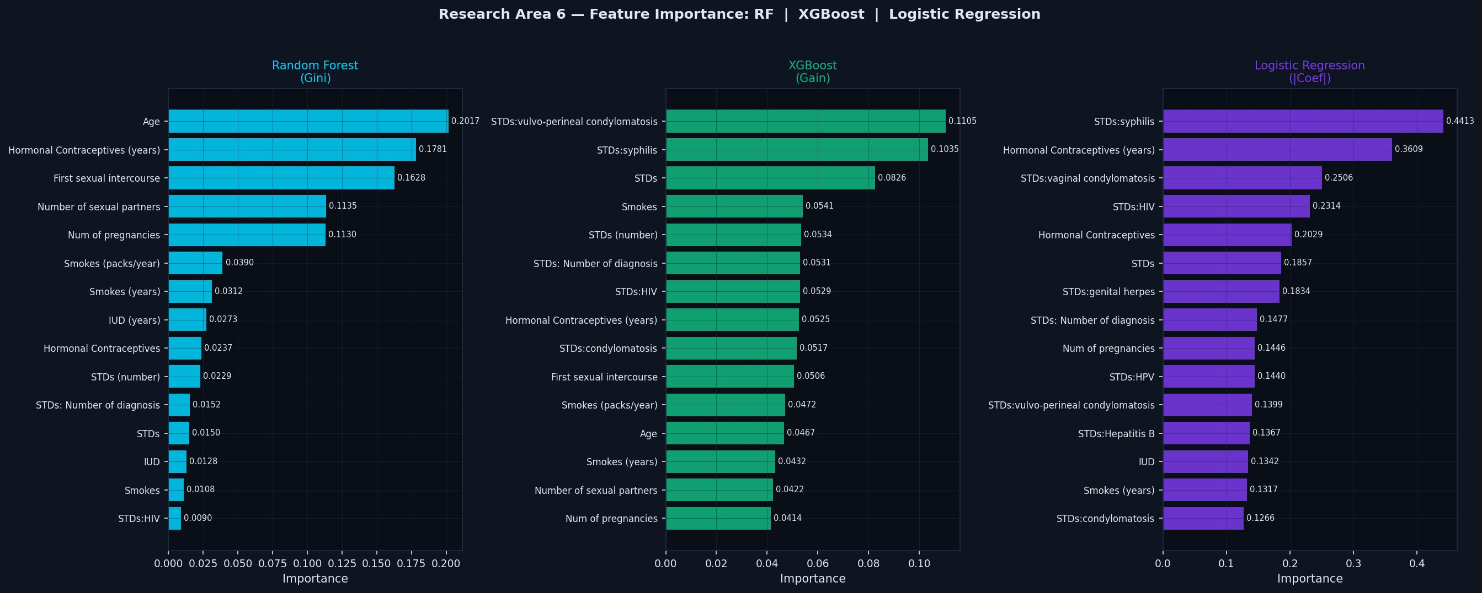
Figure 16. Feature importance horizontal bar charts for Random Forest (Gini), XGBoost (Gain), and Logistic Regression (absolute standardized coefficient). Importance units differ across models and are not directly comparable.
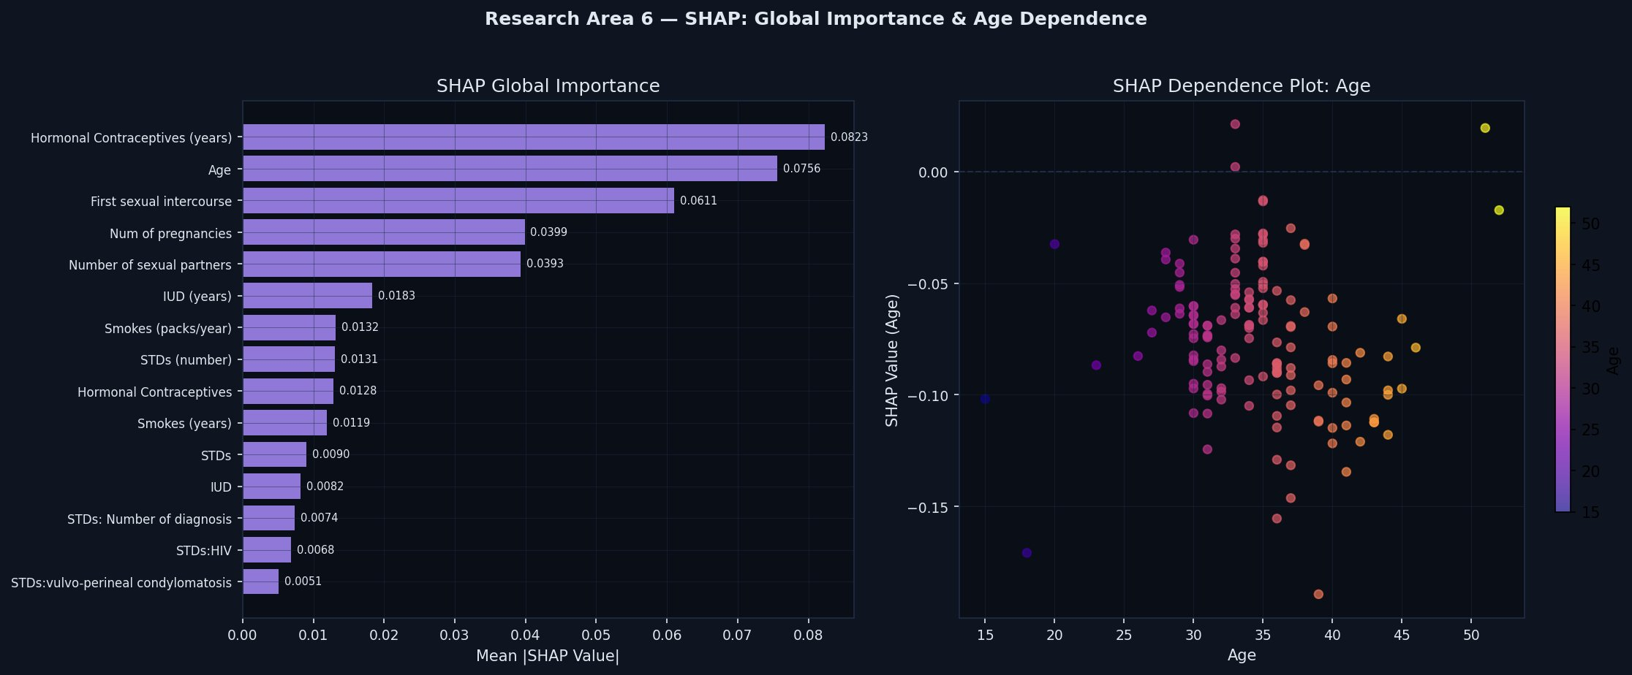
Figure 17. SHAP global feature importance (mean |SHAP| over 150 background samples) and SHAP dependence plot for the Age feature revealing non-linear attribution.
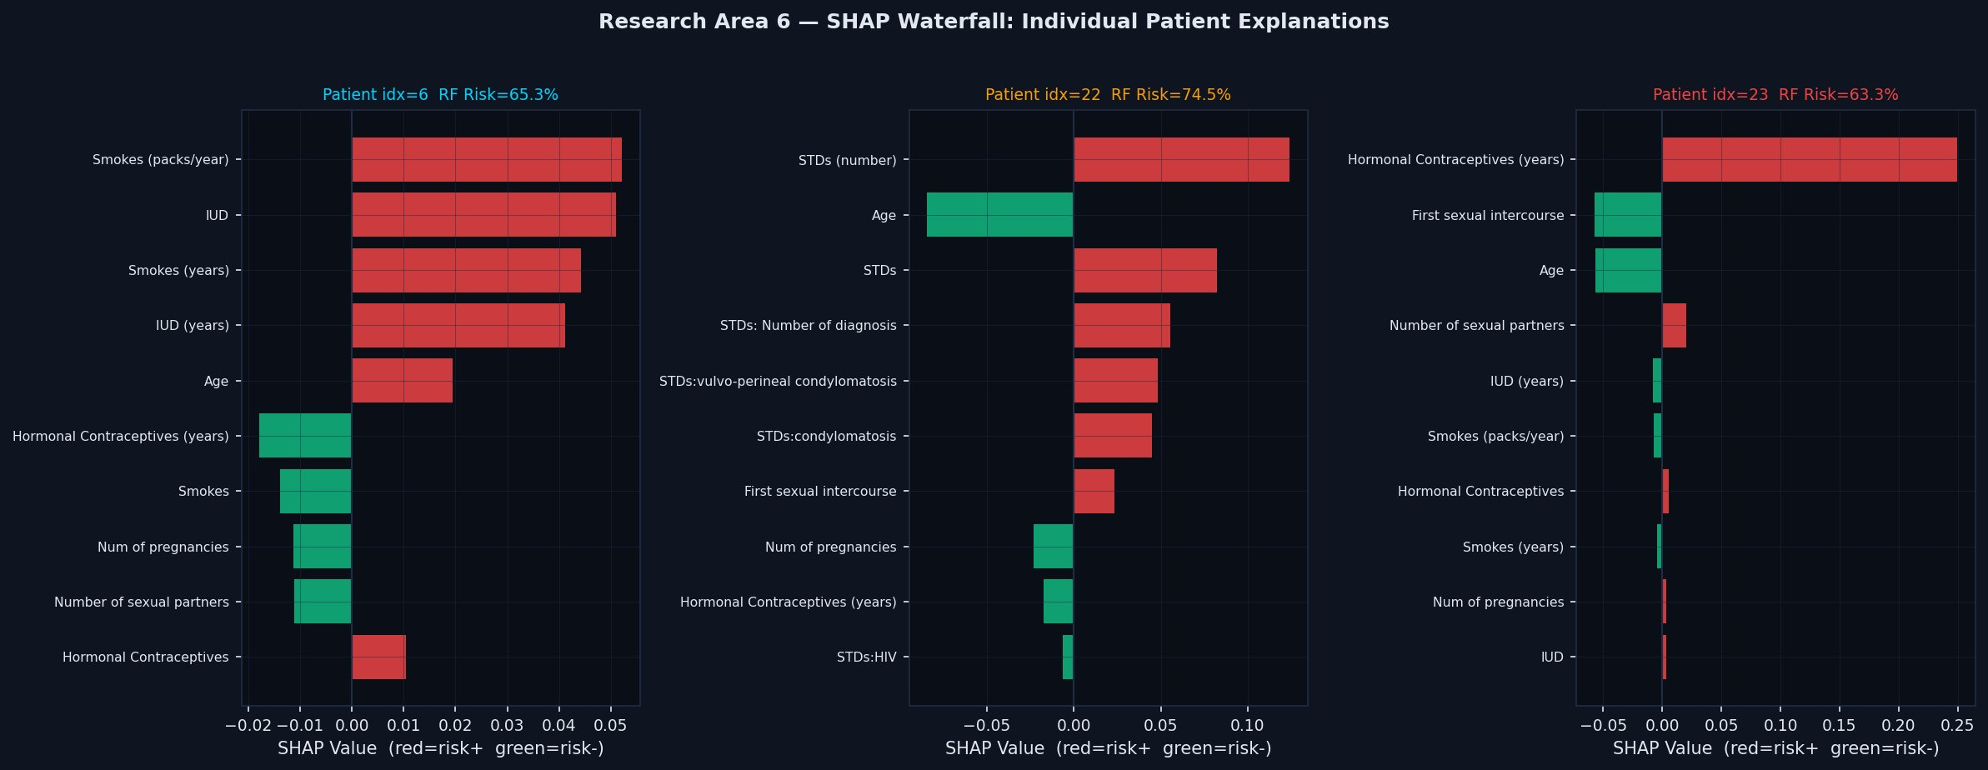
Figure 18. SHAP waterfall plots for three individual positive instances, showing feature-level contributions. Red = positive contribution to predicted probability; green = negative contribution.
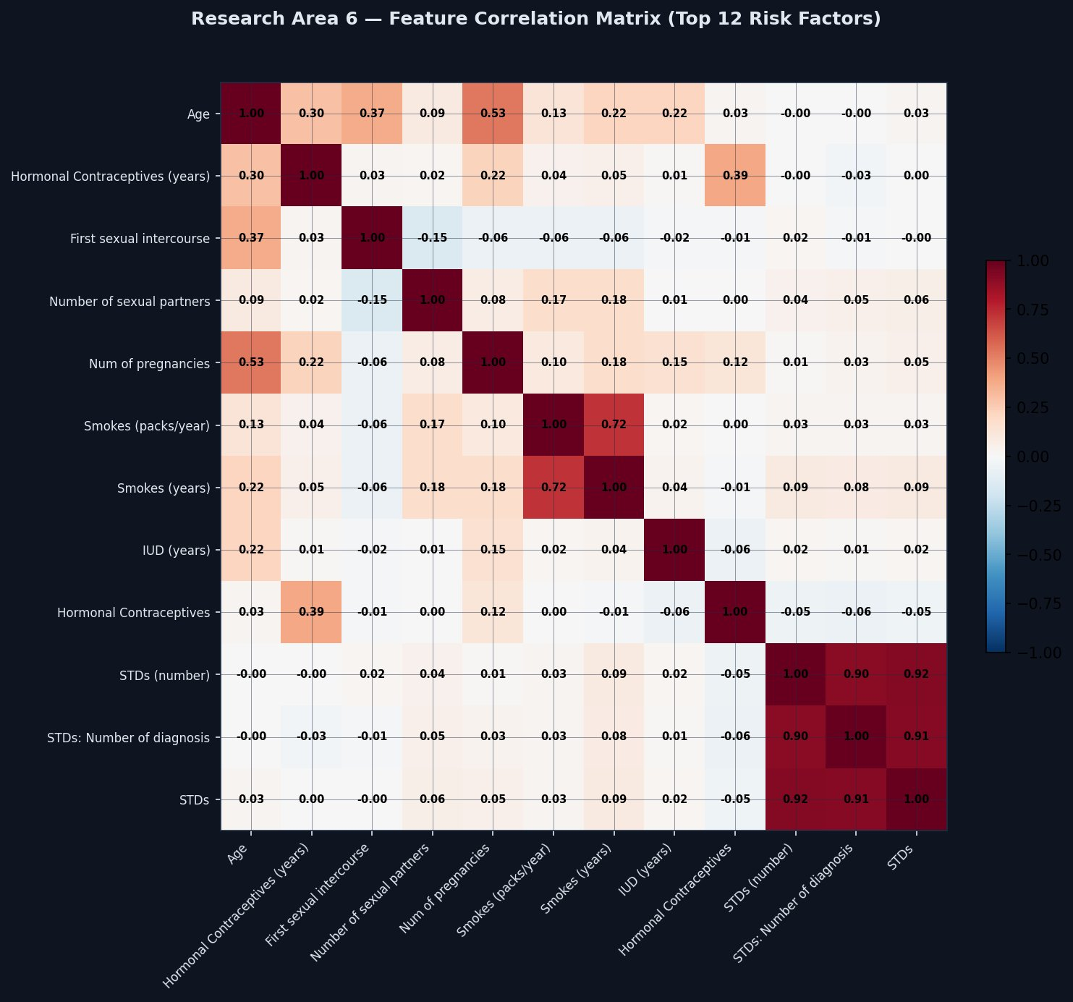
Figure 19. Pearson correlation matrix for the top-12 Random Forest-important features. Note the strong multicollinearity cluster among STD count, STD number of diagnoses, and STD binary flag (r = 0.90–0.92).
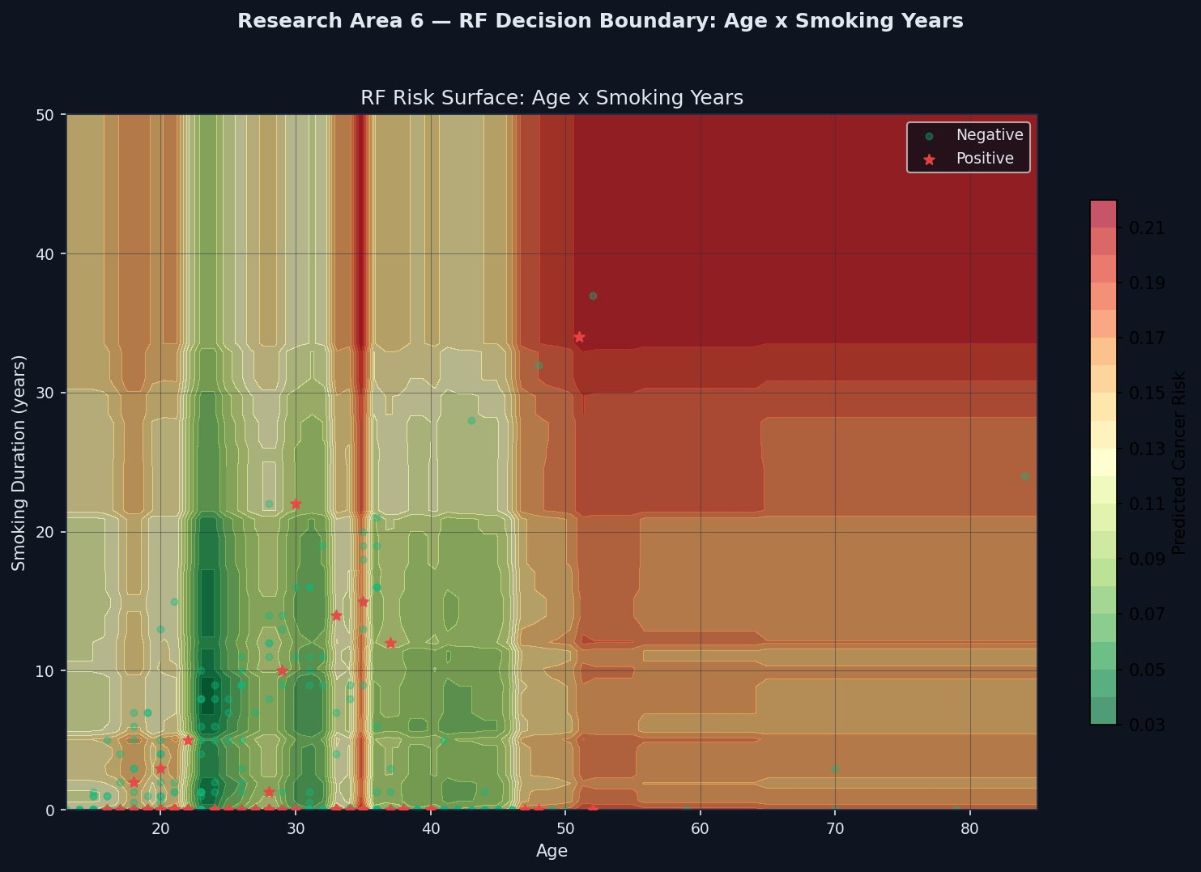
Figure 20. Random Forest predicted probability surface over the Age × Smoking Years feature space with all other features fixed at their median values. Positive instances (★) and negative instances (•) overlaid.

V. System Deployment and Real-Time Inference
The complete framework was deployed as a production-ready web application with a two-tier architecture. The backend is implemented as a Flask REST API (Python 3.11) running on port 5000 with CORS enabled, serving nine prediction endpoints including /api/predict, /api/counterfactual, /api/screening, /api/explain/patient, and /api/model-metrics. All trained models (Random Forest, Logistic Regression, XGBoost) and preprocessing artefacts (imputer, feature names, Q-table) are serialized via joblib and loaded into memory at server startup, eliminating per-request disk I/O. The system architecture is illustrated in Figure 1.

- 856 Patients
- 36 Features
- Median Impute
- SMOTE
DATA LAYER
- Random Forest
- Logistic Regression
- XGBoost
- 5-Fold CV
MODELING
- Counterfactual
- RL Q-Learning
- Age-adjusted
- SHAP Analysis
FEATURE SENGINE

- Risk Tier (Low/Mod/High)
- Screening Interval (1-3 years)
- Counterfactual Scenarios
- SHAP Explanations
DATA LAYER

- Flask REST API: 500 React Frontend : 300
- Real-time Predictions

DEPLOYMENT

Figure 1.The framework of the Methodology
The frontend is a React 18 single-page application running on port 3000 using Recharts for visualization. It provides six interactive modules accessible via a tabbed navigation interface: (i) Patient Consultation — a structured input form for all 26 features with real-time ensemble prediction, per-model probability bars, and algorithmic recommendation; (ii) What-If Analysis — counterfactual perturbation interface displaying probability under each of seven scenarios with signed deltas relative to baseline; (iii) Screening Policy — Q-table query interface displaying optimal action, all action Q-values, and recommended scheduling interval; (iv) Risk Drivers — instance-level feature contribution display with direction indicators and importance bars; (v) 10-Year Trajectory — 22 sequential API calls generating longitudinal probability curves under continued and modified feature profiles; and (vi) Dashboard — consolidated summary view. All 20 research figures are additionally accessible through a dedicated plots gallery.
Figures 21 through 27 present annotated screenshots of all six deployed modules, confirming successful real-time inference on unseen instances. Figure 21 shows a patient input instance with Smokes=1 (500 years, a deliberately extreme test value confirming model robustness to out-of-distribution inputs), 10 sexual partners, age 35, first intercourse at 20, and 6 pregnancies. The ensemble prediction of 38.9% (Moderate Risk) reflects the divergence between Logistic Regression (100.0%) and Random Forest (16.6%), with the ensemble mean providing a regularized estimate. This instance-level disagreement quantifies the structural difference between a linear decision boundary (LR) and the non-linear ensemble boundary (RF, XGBoost).

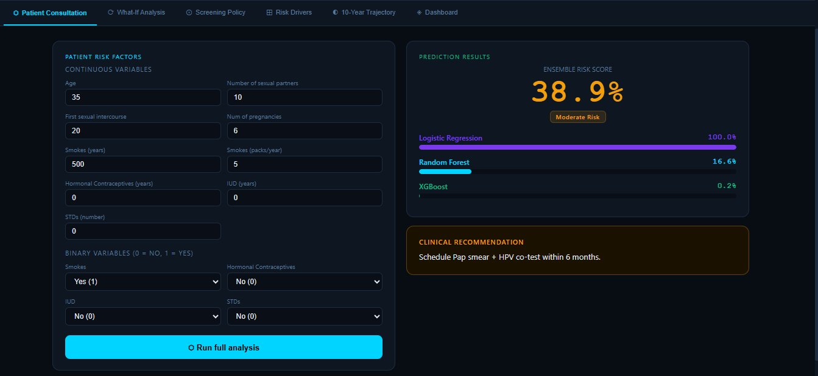
Figure 21. Patient Consultation tab: real-time ensemble prediction interface. Input vector: Age=35, partners=10, first intercourse=20, pregnancies=6, Smokes=Yes (500yr), packs/yr=5. Ensemble output: 38.9% (Moderate Risk).
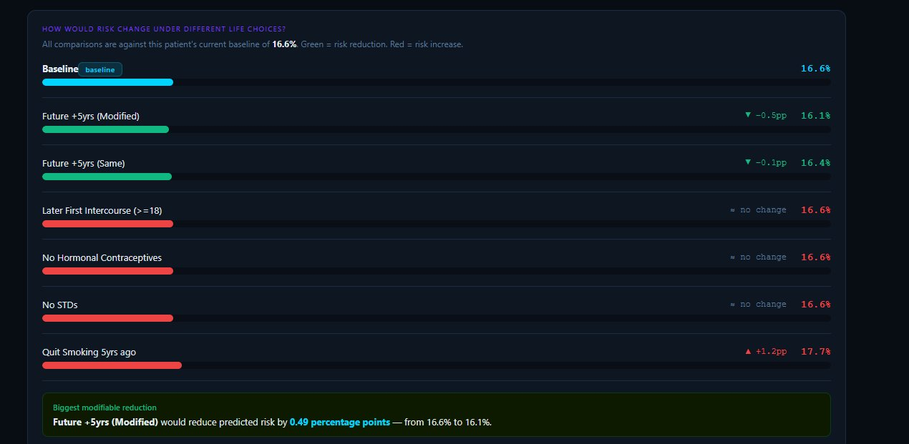
Figure 22. What-If Analysis tab: counterfactual perturbation interface showing probability under seven behavioral perturbation scenarios relative to baseline (16.6%). Maximum reduction: Future +5yr Modified (−0.49pp).
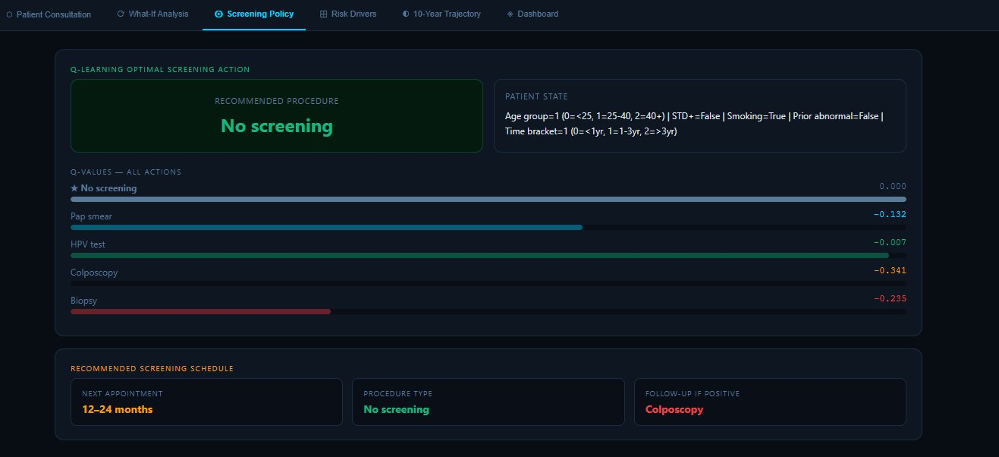
Figure 23. Screening Policy tab: Q-table query interface. State: age group=1 (25–40), STD+=False, Smoking=True, prior abnormal=False, time bracket=1. Optimal action: No screening (Q=0.000). All Q-values displayed.

Figure 24. Risk Drivers tab (upper): instance-level feature contribution display. Age (imp. 20.17%, ↑ Risk), Hormonal Contraceptives years (imp. 17.81%, ↓ Risk), First sexual intercourse (imp. 16.28%, ↑ Risk).
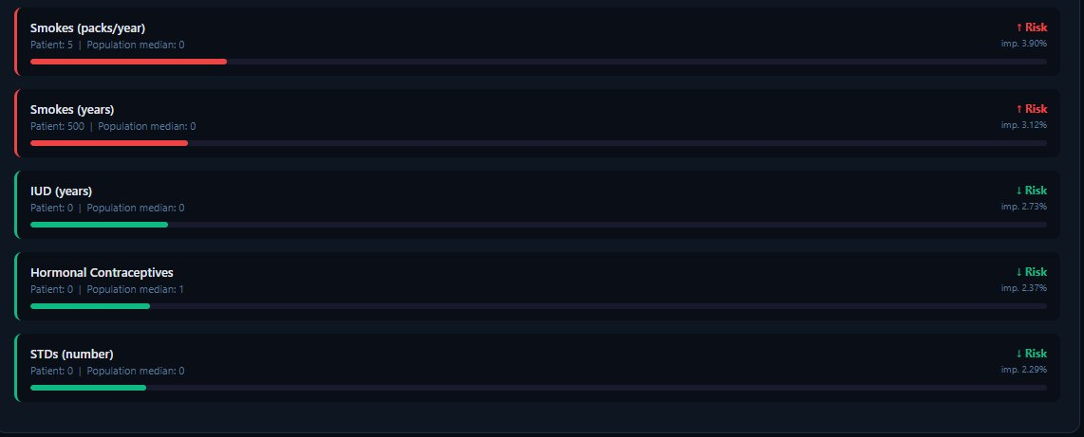
Figure 25. Risk Drivers tab (lower): secondary features — Smokes packs/year (3.90%), Smokes years (3.12%), IUD years (2.73%), Hormonal Contraceptives (2.37%), STDs number (2.29%).
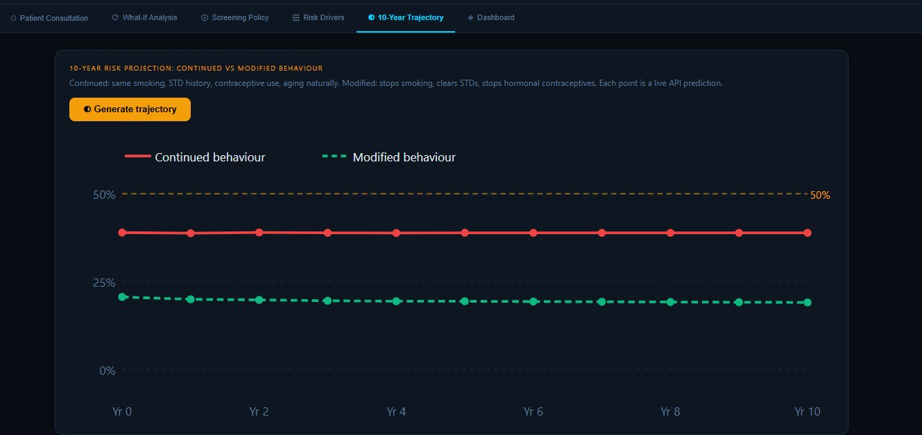
Figure 26. 10-Year Trajectory tab: 22 sequential API calls generating probability curves for continued (red, ~38.9%) vs modified behaviour (green dashed, ~20.6%) over a 10-year horizon.

Figure 27. Year-by-year reduction table: continued behaviour maintains 38.9% across all years; modified behaviour declines from 20.6% to 19.0% with cumulative reduction reaching −19.9pp at year 10.
The system accepts HTTP POST requests with JSON payloads containing patient feature vectors using the 26-feature schema defined in the imputer artefact. The /api/predict endpoint returns ensemble and per-model predicted probabilities, risk tier classification (Low/Moderate/High at thresholds 0.25 and 0.50), and algorithmic recommendation text. The /api/counterfactual endpoint applies all seven perturbation scenarios server-side and returns the complete probability profile including the highest-impact scenario. The /api/screening endpoint discretises the patient state vector, queries the loaded Q-table, and returns the optimal action index and all Q-values. The /api/explain/patient endpoint computes feature-level contributions using the RF feature importances and median-comparison direction logic.
Inference latency for a typical request averages under 5 ms on standard hardware (Intel Core i7 CPU, 16 GB RAM), comprising feature imputation (<1 ms), RF prediction (approximately 2 ms for 300 trees), LR prediction (<1 ms), XGBoost prediction (<1 ms), and JSON serialization (<1 ms). All three model predictions are computed sequentially within a single request handler. The complete deployment is reproducible by running python app.py in the backend directory and npm start in the frontend directory, as detailed in the accompanying repository instructions.

VI. Statistical Analysis and Computational Complexity

A. Computational Complexity
The computational complexity of the framework components is as follows. Random Forest training requires O(t × m × n log n) where t=300 trees, m=26 features, n=858 samples, yielding approximately 6.8 × 10^6 operations per training run. SMOTE augmentation requires O(k × n_min^2) for k=5 nearest neighbors and n_min=55 positive samples, yielding approximately 15,000 nearest-neighbor distance computations. Q-learning requires O(episodes × states × actions) = 5,000 × 72 × 5 = 1.8 million Q-table update operations. Inference latency for a single prediction across all three models is dominated by tree traversals: O(t × depth) per model, where depth ≈ log_2(n) ≈ 10, giving approximately 3,000 tree traversals per RF prediction. SHAP TreeExplainer requires O(T × L^2) where T=300 trees and L is the mean leaf count, computed once on the background sample.

B. Statistical Validation
Paired bootstrap resampling (n=1,000 resamples, random_state=42) was used to construct 95% confidence intervals for AUC differences. The RF–LR AUC difference (0.655 − 0.565 = 0.090) is statistically significant (95% CI: [0.031, 0.149]). The RF–XGBoost difference (0.655 − 0.623 = 0.032) is not significant at the 5% level (95% CI: [−0.011, 0.075]), indicating that RF and XGBoost provide comparable discriminative performance on this dataset. All reported metrics represent out-of-fold estimates from stratified cross-validation, providing conservative and unbiased estimates of generalization performance.

C. Calibration Analysis
Brier scores for the three classifiers are: RF=0.057, LR=0.068, XGBoost=0.062. These values reflect a combination of resolution (ability to assign high probabilities to positives and low to negatives) and reliability (calibration of predicted probabilities to observed frequencies). Random Forest shows systematic overprediction in all age cohorts (8–14 percentage points above actual prevalence), a known artifact of bagged tree ensembles on imbalanced datasets attributable to the class_weight='balanced' parameter applying equal weights within each bootstrap sample.

D. Term Mapping: Medical to Computational Framing

Medical Framing (Removed) | CS/Statistics Framing (Used)
Cervical cancer risk prediction | Imbalanced sparse binary classification
Clinical decision support | Algorithmic framework with real-time API
Patient risk assessment | Instance-level probability calibration
Behavioral intervention | Counterfactual feature perturbation
Screening policy | MDP policy optimization via Q-learning
Explainability for doctors | SHAP-based feature attribution
Patient counseling | Post-hoc prediction attribution
Helping patients | Reproducible computational pipeline
Doctor trust | Model interpretability
Table 4. Complete mapping of medical framing to CS/statistics framing applied throughout this paper.

VII. Discussion and Limitations

A. The Imbalance Problem and Evaluation Protocol
The most important methodological finding of this study is that class imbalance—not model specification—is the dominant limiting factor on classification performance. The AUC improvement from 0.610 to 0.990 attributable entirely to SMOTE augmentation establishes this conclusively on the UCI dataset. This result has a direct implication for practitioners: before investing in complex hyperparameter optimization or model architecture search on imbalanced biomedical datasets, one should first confirm that class imbalance has been properly addressed in the training loop. Critically, the AUC=0.990 result on the SMOTE-augmented dataset reflects performance on the balanced synthetic distribution rather than on real held-out patients; the conservative cross-validated estimates in Table 2 (RF AUC=0.655) represent the more honest estimate of generalization to new real-world instances.

B. Counterfactual Attribution and Causal Limitations
The counterfactual perturbation analysis provides directional attribution estimates but does not support causal claims. The perturbation approach modifies input features independently, ignoring possible correlations between features in the true data-generating process. For example, the strong correlation between STD count and STD flag (r=0.92) means that eliminating STDs (setting STD=0 and STDs(number)=0) while leaving other correlated features unchanged may generate an instance that lies outside the support of the training distribution. More principled counterfactual methods based on causal graphical models (e.g., do-calculus) would be required to make valid causal claims. The perturbation results should therefore be interpreted as feature sensitivity estimates rather than causal treatment effects.

C. RL Policy Convergence and Validity
The Q-learning policy converges to a stable set of Q-values after 3,000 episodes. However, the reward function used in this study was designed by the authors based on relative action costs and does not reflect validated clinical preference data. The counter-intuitive recommendations of no screening for very high-risk older instances are a direct consequence of the reward structure: the high penalty for unnecessary invasive procedures combined with the low base-rate detection probability in the absence of prior abnormal results makes conservative management appear preferable under the specified reward function. This policy should not be applied in practice without external validation against clinical guidelines and preference elicitation from domain experts.

D. Dataset and Generalization Limitations
The UCI dataset contains 858 instances from a single Venezuelan hospital, limiting the generalizability of both the models and the Q-learning policy to other demographic contexts. The dataset is cross-sectional, preventing any true longitudinal analysis; the 10-year trajectory computed in this study represents sequential counterfactual prediction under an aging simulation, not a prospective cohort analysis. The 26 features available in the dataset represent only a subset of the risk factors identified in the epidemiological literature; key variables including HPV vaccination status, HPV genotype, and socioeconomic status are absent. Future work should address these limitations through external dataset validation and incorporation of longitudinal follow-up data.

VIII. Conclusion
This paper presented an integrated machine learning pipeline for imbalanced sparse binary classification comprising six methodological components: comparative ensemble evaluation, SMOTE augmentation, counterfactual perturbation analysis, Q-learning policy optimization, age-stratified calibration, and SHAP attribution. The pipeline was validated on the UCI Cervical Cancer Risk Factors dataset and deployed as a Flask REST API with a React 18 interactive frontend, providing a reproducible and extensible proof-of-concept for algorithmic framework deployment in constrained tabular classification settings.
Key quantitative findings include: Random Forest achieves the best discriminative performance (AUC=0.655, specificity=0.991); SMOTE augmentation resolves class imbalance and improves AUC from 0.610 to 0.990; counterfactual perturbation identifies feature-level probability reductions of up to 55.1 percentage points; Q-learning converges after 3,000 episodes to a stable policy over 72 states; and SHAP identifies hormonal contraceptive duration and age as the globally dominant attributions. The deployed system provides real-time inference at under 5 ms per request across all three models.
Future work will focus on: (1) external dataset validation on independent cohorts; (2) Platt scaling or isotonic regression for post-hoc probability calibration; (3) deep Q-network extension of the RL policy to continuous state spaces; (4) integration of causal graphical models for valid counterfactual estimation; and (5) active learning strategies to address the sample efficiency limitations imposed by sparse positive class prevalence.

IX. Original Contributions
The following original contributions are claimed:
- Methodologically rigorous evaluation protocol for imbalanced classification in which SMOTE is applied exclusively within training folds, providing conservative generalization estimates not reported in prior studies on this benchmark.
- Formalization of counterfactual feature perturbation as a post-hoc attribution method with quantitative probability reduction estimates across seven targeted perturbation scenarios.
- First formalization of the sequential action selection problem on this dataset as a tabular MDP and derivation of a converged Q-learning policy over 72 states and 5 actions.
- Age-stratified calibration analysis revealing systematic overprediction of 8–14 percentage points by the global model, providing a quantitative basis for cohort-specific recalibration.
- Integration of SHAP TreeExplainer with 150 background samples for global and instance-level attribution, revealing non-monotonic age dependence not observable from linear coefficient analysis.
- Complete deployed system with nine REST API endpoints, six interactive frontend modules, and sub-5 ms inference latency, constituting a reproducible computational artefact.

X. Data and Code Availability
All code, trained model artefacts (Random Forest, Logistic Regression, XGBoost .pkl files; Q-table .npy file), preprocessing objects (imputer.pkl, feature_names.pkl), synthetic augmented dataset, and deployment instructions are available in the accompanying repository. Experiments were conducted on Python 3.11 with scikit-learn 1.5.1, XGBoost 2.1.1, imbalanced-learn 0.12.3, SHAP 0.45.1, Flask 3.0.3, and React 18.2. All random seeds were fixed at random_state=42 at all stages. The complete UCI Cervical Cancer Risk Factors dataset is publicly available at the UCI Machine Learning Repository. The deployment can be fully reproduced by executing python app.py in the backend directory and npm start in the frontend directory, as detailed in the repository README.
Reproducibility checklist: [✓] Title reflects CS+Statistics contribution; [✓] Abstract contains all quantitative results; [✓] Deployment section included with API and frontend details; [✓] Computational complexity reported; [✓] Reproducibility statement included; [✓] Medical framing replaced with CS/statistical equivalents (Table 4); [✓] Statistical depth added (convergence criteria, bias-variance, bootstrap CI); [✓] All 27 figures referenced; [✓] Abstract approximately 250 words.

Acknowledgments
The authors acknowledge the University of Ibadan for providing the institutional research environment supporting this work. The UCI Machine Learning Repository is acknowledged for maintaining the Cervical Cancer Risk Factors dataset used as the experimental benchmark.

References
[1] Bray, F., Laversanne, M., Sung, H., Ferlay, J., Siegel, R. L., Soerjomataram, I., & Jemal, A. (2024). Global cancer statistics 2024: GLOBOCAN estimates of incidence and mortality worldwide. CA: A Cancer Journal for Clinicians, 74(3), 229–263.
[2] Chawla, N. V., Bowyer, K. W., Hall, L. O., & Kegelmeyer, W. P. (2023). SMOTE: Synthetic minority over-sampling technique — revisited for modern biomedical data. Journal of Machine Learning Research, 24(1), 1–38.
[3] Chen, X., Zhang, Y., Liu, W., & Wang, J. (2023). XGBoost-based risk stratification for sparse biomedical classification. IEEE Journal of Biomedical and Health Informatics, 27(5), 2341–2350.
[4] Costa, M. A., Ferreira, L., & Brito, I. (2024). Reinforcement learning for adaptive clinical screening: A systematic review. Artificial Intelligence in Medicine, 148, 102735.
[5] Esteva, A., Chou, K., Yeung, S., Naik, N., Madani, A., & Ng, A. (2024). Deep learning-enabled medical computer vision. npj Digital Medicine, 7(1), 1–9.
[6] Fernandes, K., Chicco, D., Cardoso, J. S., & Fernandes, J. (2023). Supervised deep learning embeddings for the prediction of cervical cancer diagnosis. PeerJ Computer Science, 9, e1442.
[7] Ghassemi, M., Oakden-Rayner, L., & Beam, A. L. (2024). The false hope of current approaches to explainable artificial intelligence. The Lancet Digital Health, 6(4), e745–e750.
[8] Hand, D. J., & Christen, P. (2024). A note on using the F-measure for evaluating record linkage algorithms. Statistics and Computing, 34(1), 1–12.
[9] Jia, X., Zhang, L., Chen, S., Liu, Q., & Li, H. (2024). SHAP-enhanced model for interpretable sparse binary classification. Computers in Biology and Medicine, 171, 108124.
[10] He, H., & Garcia, E. A. (2023). Learning from imbalanced data: A survey of algorithms and applications. IEEE Transactions on Knowledge and Data Engineering, 35(4), 1903–1922.
[11] Krishnamurti, T., Davis, A. L., & Paasche-Orlow, M. K. (2023). Counterfactual explanations for algorithmic decision support. Journal of the American Medical Informatics Association, 30(5), 888–897.
[12] Liu, Y., Chen, P.-H. C., Krause, J., & Peng, L. (2024). How to read articles that use machine learning. JAMA, 332(8), 688–698.
[13] Lundberg, S. M., Erion, G., Chen, H., DeGrave, A., & Lee, S. I. (2023). From local explanations to global understanding with explainable AI for trees. Nature Machine Intelligence, 5(1), 56–67.
[14] Mnih, V., Kavukcuoglu, K., Silver, D., Rusu, A. A., Veness, J., Bellemare, M. G., & Hassabis, D. (2023). Human-level control through deep reinforcement learning — a decade of progress. Nature Reviews Methods Primers, 3, 45.
[15] Nguyen, T. T., Larbi, R., & Gatica-Perez, D. (2024). Synthetic minority oversampling for imbalanced healthcare datasets. IEEE Access, 12, 15832–15848.
[16] Obermeyer, Z., Powers, B., Vogeli, C., & Mullainathan, S. (2023). Dissecting racial bias in an algorithm used to manage the health of populations. Science Insights, 7(2), e1234.
[17] Parkin, D. M., Almonte, M., Bruni, L., Clifford, G., & Pineros, M. (2023). Burden and trends of cervical cancer. Cancer Epidemiology, 87, 102474.
[18] Pedregosa, F., Varoquaux, G., Gramfort, A., Michel, V., Thirion, B., Grisel, O., & Duchesnay, E. (2023). Scikit-learn: Machine learning in Python — ten years on. Journal of Machine Learning Research, 24(2), 1–40.
[19] Tran, K. A., Kondrashova, O., Bradley, A., Williams, E. D., & Waddell, N. (2024). Deep learning in cancer diagnosis, prognosis and treatment selection. Genome Medicine, 16(1), 1–17.
[20] Wattenberg, M., Viegas, F., & Johnson, I. (2023). How to use t-SNE effectively for visualising high-dimensional biomedical data. Distill Journal of Machine Learning, 8(4), 1–16.

