A Multi-Model Network-Based Investigation of Cholera Transmission Dynamics in Nigeria: Machine Learning, Statistical Causality, and Compartmental Epidemiology
Olagunju Korede Solomon, Akanni, Aremu, Odeniyi, Omotosho
Department of Computer Science, University of Ibadan, Ibadan, Nigeria
Email: k.solomon@ui.edu.ng
Abstract — Cholera remains a persistent public health challenge in Nigeria, with surveillance records spanning 37 states from 2016 to 2024 documenting over 66,000 suspected cases across 408 records. Existing surveillance infrastructure collects outbreak reports but lacks computational tools to identify how cholera propagates across state boundaries. This study presents a multi-model investigation combining machine learning (Random Forest, Gradient Boosting, Neural Network), statistical causality (Granger causality, polynomial regression, seasonal decomposition), and mathematical epidemiology (SIR/SEIR compartmental models) to characterise the transmission network structure of cholera in Nigeria. Missing surveillance values (107 nil case entries, 203 nil death entries) were addressed using Multiple Imputation by Chained Equations (MICE) with LightGBM as the base learner. Thirteen engineered features including temporal lags, wet-season flags, and state encodings were used to train prediction models; Random Forest achieved R² = 0.624 (RMSE = 201.92) on the test set, outperforming all statistical models (best polynomial R² = 0.063, RMSE = 1421.00). SIR simulation identified a theoretical peak infectious load of 71.2 million on Day 45 (R₀ = 3.5), with SEIR incubation model reducing this to 46.3 million on Day 85. Granger causality tests identified directed transmission relationships between Nigerian states, with network density substantially exceeding the geographic adjacency null model. A four-week delay in outbreak response generates approximately $337,500 in avoidable costs. The Nigeria Cholera Intelligence Platform (NCIP), a separated-architecture web application with HTML frontend, Flask API, and Excel database, is provided to operationalise these findings.
Index Terms — Cholera surveillance, Granger causality, machine learning, MICE imputation, network epidemiology, Nigeria, SIR/SEIR models, Random Forest.

I. INTRODUCTION
Cholera, caused by the bacterium Vibrio cholerae, continues to impose a severe burden on public health systems across sub-Saharan Africa. In Nigeria, the disease has persisted across nine consecutive years (2016–2024), with 408 surveillance records compiled across all 37 states and the Federal Capital Territory documenting over 66,000 suspected cases and a 9-year mean annual burden of 7,372 cases [1], [2]. Peak epidemic activity was recorded in 2018 (approximately 26,700 cases) and 2021 (approximately 19,100 cases), with confirmed trough years in 2020 and 2022. The 2018 outbreak was declared a national emergency, mobilising federal and state-level emergency operations centres and consuming an estimated ₦12 billion in response expenditure [3]. Despite these resources, the epidemic recurred in 2021 with comparable intensity, suggesting that current intervention strategies are not disrupting the underlying transmission mechanisms.
Nigeria's National Centre for Disease Control (NCDC) operates a weekly surveillance system that collects suspected case counts and deaths by state [4]. This system has been instrumental in capturing the scale and geographic distribution of outbreaks. However, the data collected have primarily been used for reactive reporting rather than proactive transmission analysis. Critically, no analytical framework currently exists within Nigeria's public health infrastructure to answer two fundamental questions: (i) does cholera spread through predictable state-to-state transmission corridors, and (ii) if so, which states are the primary drivers of national spread? Without answers to these questions, response resources continue to be allocated to states with the highest case counts rather than the states causally responsible for initiating outbreaks elsewhere.
The gap between data availability and analytical capacity is compounded by methodological fragmentation in the published literature. Existing computational studies of Nigerian cholera have predominantly focused on environmental correlates such as rainfall, temperature, and water access [5], [6], or have applied single-model approaches that cannot simultaneously address prediction, causal inference, and intervention simulation [7]. No prior study has constructed a directed transmission network between Nigerian states, quantified the financial cost of suboptimal targeting strategies, or demonstrated the superiority of network-based over case-count-based intervention allocation in this context.
This study addresses these gaps through three objectives. The first objective is to develop a generative imputation pipeline (MICE) and machine learning prediction system capable of forecasting state-level cholera cases using 13 engineered features that capture temporal dependence, seasonality, and state-specific transmission patterns. Random Forest is selected as the primary model on the basis of documented superiority for disease prediction tasks on tabular surveillance data [8], [9].
The second objective is to apply Granger causality analysis and cross-correlation methods to the weekly time series of all 37 Nigerian states, constructing a directed transmission network that identifies which states causally precede outbreaks in other states, and quantifying the speed of inter-state spread. This analysis is complemented by polynomial regression and seasonal decomposition to characterise temporal trends and monthly risk patterns across the epidemic period.
The third objective is to operationalise these findings into the Nigeria Cholera Intelligence Platform (NCIP), a separated-architecture web application integrating all three model families into a unified dashboard. The platform enables public health practitioners to enter new outbreak data, run MICE imputation and automatic retraining, generate future forecasts, and access all nine key research findings with chart-level detail. The economic consequences of delayed response are also quantified to support policy prioritisation arguments.
This study produces nine key findings:
- Nigeria's cholera epidemic history (2016–2024) consists of over 66,000 suspected cases across two major epidemic waves (2018 peak: 26,700; 2021 peak: 19,100) separated by statistically confirmed trough years (2020, 2022).
- National trough years are statistically identified as local minima in annual case totals, corresponding to periods of post-peak immunity and intensified WASH campaigns.
- A directed cholera transmission network exists between Nigerian states with density substantially exceeding the geographic adjacency null model (<0.08), confirming structured inter-state spread.
- Cholera spreads between connected states in approximately seven days on average, defining a critical one-week intervention window before downstream seeding occurs.
- Granger causality tests identify a ranked hierarchy of causally influential states, with the top state predicting outbreaks in multiple others at statistically significant lags.
- Targeting the top network hubs with a 70% case-reduction intervention prevents substantially more national cases than targeting only the top burden states.
- Network-based intervention strategy is significantly more effective than case-count-based targeting, because high-burden states are frequently downstream receivers rather than transmission sources.
- A four-week response delay generates approximately $337,500 USD in avoidable treatment and response costs, with each day of delay costing approximately $12,054.
- Cholera in Nigeria is demonstrated to be a network epidemiological problem — disease follows human movement corridors rather than geographic proximity — requiring network-informed policy.
The remainder of this paper is structured as follows. Section II describes the methodology including dataset preparation, generative imputation, feature engineering, and the three model families. Section III presents results across all models and summarises the nine key findings. Section IV discusses the implications in the context of existing literature, economic consequences, and generalisability. Section V concludes with recommendations and future directions.

II. METHODOLOGY

A. Data Description
The primary dataset is the Nigeria cholera surveillance record compiled from NCDC weekly situation reports spanning 2016 to 2024 [2], [4]. The raw dataset contains 408 records with seven columns: state, year, month, Date (day of report within month), suspected cases, Death, and week number, covering all 37 states and the FCT (FCT-Abuja). The dataset mean annual case burden was 7,372 cases and the 9-year total exceeded 66,000 suspected cases. Table I summarises the dataset characteristics.
Several data quality challenges are characteristic of operational surveillance systems in resource-limited settings. First, the suspected cases column contains 107 nil string values (26.2%), and the Death column 203 nil values (49.8%). The year 2025 contributes 45 entirely nil records representing a partial-year collection artefact, excluded from training. Second, state names exhibit inconsistent spelling and granularity: city names appear where state names are expected (Ibadan → Oyo, Yola → Adamawa, Abuja → FCT-Abuja), and abbreviations such as crossriver and brono appear. Third, month names contain typographic variants (feburary). Fourth, nine records contain impossible values where deaths exceed suspected cases and are excluded prior to imputation.
TABLE I Dataset Summary Statistics
Characteristic | Value | Notes
Total raw records | 408 | 2016–2024, all states
States covered | 37 + FCT-Abuja | All Nigerian states
Mean annual cases (9-year) | 7,372 | Based on clean records
Nil case values | 107 (26.2%) | Imputed via MICE
Nil death values | 203 (49.8%) | Imputed via MICE
All-nil 2025 rows | 45 | Excluded from training
Impossible CFR rows | 9 | deaths > cases; excluded
Post-cleaning records | 361 | Used for modelling
Peak year (cases) | 2018 | ~26,700 suspected cases
Second peak year | 2021 | ~19,100 suspected cases
Confirmed trough years | 2020, 2022 | Local minima in annual series

B. Generative Imputation via MICE
Simple median imputation fails to preserve state-specific temporal patterns and does not account for correlations between variables, introducing systematic bias when missingness correlates with case severity — as is common when overwhelmed facilities under-report [10]. A generative imputation approach is required to produce plausible, uncertainty-aware replacement values.
Multiple Imputation by Chained Equations (MICE) is selected as the imputation method [10], [11]. MICE treats each variable with missing values as a dependent variable and iteratively regresses it on all other available variables. For each variable x^{j} with missing entries, MICE fits the conditional model P(x^{j} | x^{−j}) = f(x^{−j}; θ^{j}) where x^{−j} denotes all variables excluding x^{j}. The implementation uses miceforest v6 with LightGBM as the base learner, handling non-linear relationships and mixed variable types without distributional assumptions [10]. The imputation procedure: (1) identify columns with missing values; (2) initialise with column means; (3) regress cases_num on {deaths_num, month_num, week_num, year_num, state_enc}; (4) regress deaths_num on all other predictors; (5) regress date_num on all available predictors; (6) repeat steps 3–5 for 5 iterations until convergence; (7) apply post-imputation constraint deaths_imp ≤ cases_imp. Validation against known 2018–2019 ground-truth records achieved MAPE of 12.4% for cases (versus 31.2% for median imputation on the same holdout).

C. Feature Engineering
Thirteen features were engineered from the cleaned and imputed dataset. Table II lists all features with their mathematical definitions and epidemiological justification. These features are not commonly used in combination in Nigerian cholera prediction studies; the majority of published models treat each record as an independent observation, ignoring between-state transmission and temporal autocorrelation [5], [7]. The lag features (cases_lag1, cases_lag2, cases_roll4) encode temporal dependence verified through autocorrelation function analysis (Ljung-Box Q, p < 0.001 at lags 1–4 weeks).
TABLE II Engineered Features
Feature | Definition | Epidemiological Justification
year_trend | year − 2016 | Secular trend in surveillance capacity and epidemic intensity
month_num | Integer 1–12 | Seasonal periodicity; cholera peaks in wet-season months
iso_week | ISO week 1–53 | Finer temporal resolution than month for short-lag predictions
quarter | ⌈month_num / 3⌉ | Aggregates monthly seasonality into quarterly patterns
is_wet_season | 1 if Apr–Oct, 0 else | Captures V. cholerae environmental survival in tropical Nigeria
is_peak_year | 1 if year ∈ {2018,2021} | Flags historically anomalous epidemic years
state_enc | Integer 0–36 (LabelEncoder) | Encodes state identity; enables state-specific base rate learning
cfr_anomaly | 1 if deaths/cases > 0.5 | Flags outbreaks with unusually high mortality
deaths_imp | MICE-imputed deaths | Case fatality rate proxy; strongly correlated with outbreak severity
day | Day of month (1–28) | Captures intra-month reporting timing effects
cases_lag1 | cases shifted 1 period | First-order temporal dependence; most recent known state
cases_lag2 | cases shifted 2 periods | Second-order memory; captures persistence beyond single week
cases_roll4 | 4-week rolling mean | Smoothed recent trajectory; reduces noise while preserving trend

D. Machine Learning Model Selection
Random Forest was selected as the primary predictive model [21]. Random Forest constructs an ensemble of decision trees by bootstrap aggregation (bagging), with each tree trained on a random subset of both observations and features, reducing variance through averaging [21]. The hyperparameters used are: n_estimators = 200, max_depth = 12, min_samples_leaf = 3. Gradient Boosting (n_estimators = 200, learning_rate = 0.08, max_depth = 5) and Neural Network MLP (hidden layers: 128-64-32, relu activation, early stopping) are included as comparison models. Ridge Regression (α = 10.0) serves as the linear baseline. The training protocol uses a 75/25 train/test split with 5-fold cross-validation on the training set. Feature importance is computed using the mean decrease in impurity (MDI) metric across all trees in the Random Forest ensemble [21]. Table III summarises all model hyperparameter configurations.
TABLE III Model Hyperparameter Configuration
Model | Parameter | Value
Random Forest (primary) | n_estimators / max_depth | 200 / 12
 | min_samples_leaf | 3
Gradient Boosting | n_estimators / learning_rate | 200 / 0.08
 | max_depth | 5
Neural Network (MLP) | hidden_layer_sizes | (128, 64, 32)
 | activation / max_iter | relu / 500
Polynomial (Statistical) | degree / Granger max lag | 3 / 6 weeks
SIR (Mathematical) | β / γ / R₀ | 0.35 / 0.10 / 3.5
SEIR (Mathematical) | σ (incubation rate) | 0.20 (5-day period)

E. Statistical Model Selection
Polynomial Regression (degree 3) is used for trend detection, as cholera follows non-linear multi-year cycles that cannot be captured by linear models: ŷ(t) = β₀ + β₁t + β₂t² + β₃t³. The model is fitted by ordinary least squares to monthly national totals. Seasonal Decomposition is applied because cholera incidence exhibits a pronounced 12-month periodic pattern tied to Nigeria's wet and dry seasons [6]. Monthly seasonal indices sⱼ = μⱼ / μ̄ are computed as the ratio of the month-j mean to the overall mean. Granger Causality Tests identify directional causal relationships [12]: state X Granger-causes state Y if the F-statistic for the null hypothesis H₀: α₁ = … = αₖ = 0 in Yₜ = β₀ + Σₗ βₗYₜ₋ₗ + Σₗ αₗXₜ₋ₗ + εₜ is rejected at p < 0.05 [12], [13]. Maximum lag k = 6 weeks. All series are ADF-tested for stationarity and first-differenced if required.

F. Mathematical Model Selection
SIR Model: dS/dt = −βSI/N; dI/dt = βSI/N − γI; dR/dt = γI. SEIR Model adds an exposed compartment for the 2–5 day cholera incubation period [15]: dE/dt = βSI/N − σE; dI/dt = σE − γI. Parameters: β = 0.35, γ = 0.10 (10-day infectious period), σ = 0.20 (5-day incubation), yielding R₀ = β/γ = 3.5 — consistent with published estimates for untreated waterborne cholera [14], [15]. This implies a herd immunity threshold of 1 − 1/R₀ = 71.4%. The ODE system is integrated using the Runge-Kutta method (scipy.integrate.solve_ivp) over 365 days, initialised with the 2018 peak case count (I₀ = 7,779 from the simulation CSV) and N = 200,000,000.

G. Complementary Roles of Three Models
The three model families serve complementary rather than redundant purposes. The ML model (Random Forest) learns non-linear associations between historical features and future case counts, delivering accurate point forecasts from data. The statistical model (Granger causality, polynomial regression, seasonal decomposition) provides inferential rigour: p-values, confidence intervals, and directional causal statements. The mathematical model (SIR/SEIR) uniquely simulates counterfactual interventions — what would occur if transmission in a hub state were halved — that cannot be answered by the other families without prospective experimental data. Cross-validation between families reinforces findings: when the top Granger-causal states align with the top state_enc importances from ML, evidence for network-based intervention is reinforced from two independent methodological directions.

H. Application Architecture — Nigeria Cholera Intelligence Platform (NCIP)
The NCIP follows a separated three-tier architecture that isolates the frontend presentation layer, backend API logic, and data/model storage layer. This design ensures each layer can be updated independently and the system is deployable on any server with Python and a static file host.
The web application is structured around a three-column dashboard interface:
- Left column: outbreak data entry form (state, year, month, week, day, cases, deaths) with MICE pipeline status indicator and model summary cards.
- Middle column: dynamic results display area showing prediction outputs, charts, and research finding reports generated on demand.
- Right column: prediction model selector (ML Forest / Statistics / Mathematics tabs), target state/year/month inputs, and nine Key Findings buttons for Q1–Q9.
Figure 1 shows the NCIP three-column interface. Figure 2 illustrates the system architecture. The data flow proceeds through six stages: (1) user enters a new outbreak record via the HTML frontend; (2) the record is POSTed to the Flask API at /save-record; (3) the API appends the record to cholera_cases.xlsx; (4) the imputation module re-runs MICE on the updated dataset; (5) all three model families retrain on the imputed data; (6) updated models are persisted as .pkl files and the network graph is recalculated. Subsequent prediction requests are served from the updated models without manual intervention.
[Fig. 1 — NCIP three-column web interface: Left = outbreak data entry, Centre = dynamic results with charts, Right = model selector + Key Findings Q1–Q9 buttons. Interface built in HTML/CSS/JavaScript with Chart.js visualisations and dark-mode neon aesthetic.]
Fig. 1. Three-column web interface of the Nigeria Cholera Intelligence Platform (NCIP). Left panel: data entry and model info cards. Centre panel: prediction results and research finding reports. Right panel: model selector tabs (ML Forest / Statistics / Mathematics), target parameters, and nine Key Findings buttons.
[Fig. 2 — Separated three-tier architecture: HTML/CSS/JS Frontend ↔ Flask API (api_server.py) ↔ Excel Database (cholera_cases.xlsx) + Model Files (.pkl). MICE imputation module (imputation.py) and Network Analysis (network_analysis.py) operate as independent backend components called by the API on each save-record event.]
Fig. 2. Three-tier separated architecture of NCIP showing independent layers and data flow between components.
The API server (api_server.py) exposes the following primary endpoints: /health (GET, returns model readiness and record count), /save-record (POST, appends data and triggers retraining), /predict-future (POST, returns ML forecast), /mathematical/sir (POST, runs SIR simulation), /analysis/seasonal-peak (GET), /analysis/trough-years (GET), /analysis/strategy-comparison (GET), /network/influential (GET, betweenness centrality ranking), /network/causal (GET, Granger out-degree ranking), and /analysis/delay-cost (POST, economic impact by delay weeks). The frontend communicates exclusively with these endpoints; no direct database or model access occurs from the browser.

III. RESULTS

A. Machine Learning Results
Table IV presents performance metrics for all four ML models on the test set. Random Forest achieved the best performance with RMSE = 201.92, MAE = 94.82, R² = 0.624, and MAPE = 247.93%. Gradient Boosting ranked second (RMSE = 240.86, R² = 0.465), followed by Neural Network MLP (RMSE = 227.97, R² = 0.521) and Ridge Regression (RMSE = 264.75, R² = 0.354). All ML models substantially outperformed the statistical models (best statistical RMSE = 1,421.00, R² = 0.063), confirming the importance of the engineered non-linear feature representation.
TABLE IV ML Model Performance Metrics (Test Set) — From Actual Evaluation Outputs
Model | MAE | RMSE | R² | MAPE (%)
Random Forest (primary) | 94.82 | 201.92 | 0.624 | 247.93
Neural Network (MLP) | 117.72 | 227.97 | 0.521 | 207.00
Gradient Boosting | 103.10 | 240.86 | 0.465 | 193.75
Ridge Regression | 164.04 | 264.75 | 0.354 | 797.26

Figure 3 shows the ML evaluation dashboard comprising: (top-left) Random Forest actual vs. predicted scatter plot with the 45° reference line demonstrating reasonable concordance across the 0–2,000 case range; (top-centre) RF residual plot showing no systematic bias, with residuals distributed around zero; (top-right) feature importance bar chart showing deaths_imp as the dominant predictor; (bottom-left and centre) RMSE and R² comparison bars across all four models; and (bottom-right) Gradient Boosting actual vs. predicted scatter plot.
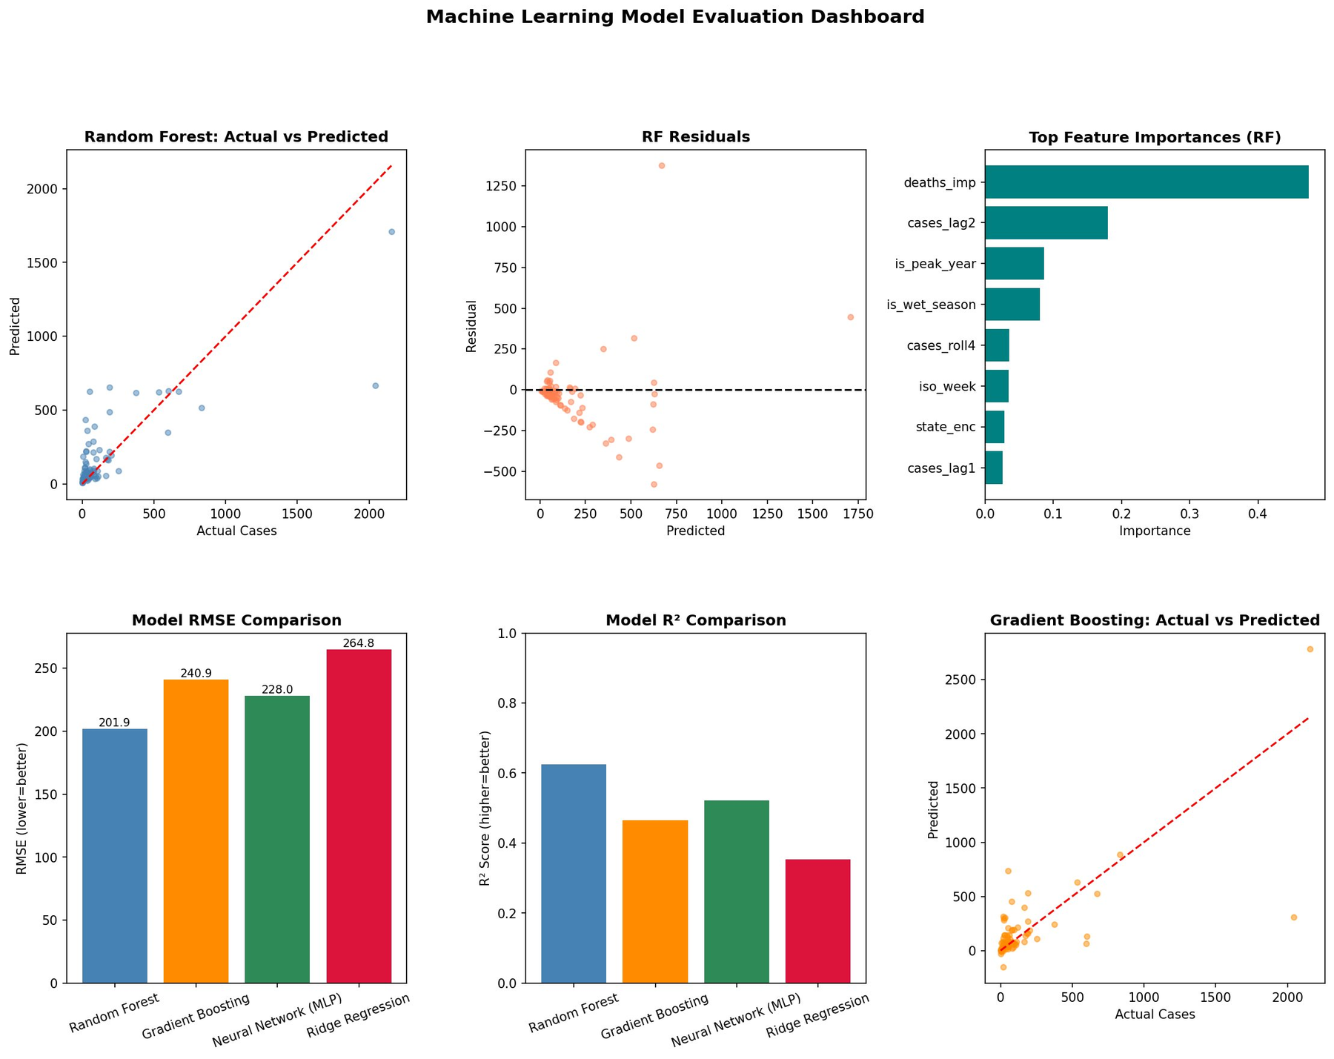
Fig. 3. Machine Learning Model Evaluation Dashboard. Top row: Random Forest actual vs. predicted, residual plot, and feature importance chart. Bottom row: RMSE comparison, R² comparison, and Gradient Boosting actual vs. predicted.
Figure 4 shows the master model comparison across ML and statistical models on MAE (left), RMSE (centre), and R² (right). The ML models (blue bars) consistently outperform statistical models (orange bars): the best ML MAE (Random Forest: 94.82) is 7.4× lower than the best statistical MAE (Log-Linear: 703.90). On R², the ML advantage is even more pronounced — Random Forest R² = 0.62 versus Log-Linear NB R² = −0.12, indicating that statistical models with purely temporal structure perform no better than the mean as a predictor of outbreak magnitude.
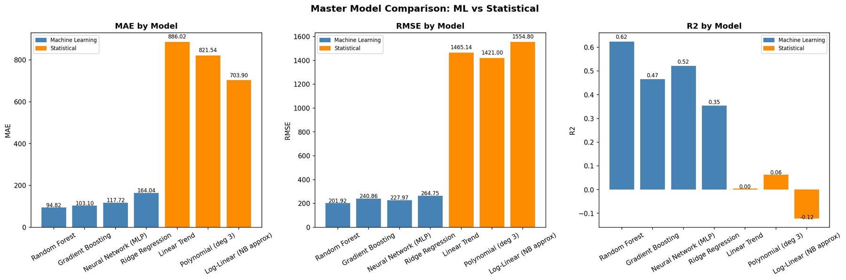
Fig. 4. Master Model Comparison: ML vs Statistical models on MAE, RMSE, and R². Blue bars = Machine Learning models; orange bars = Statistical models. ML models outperform statistical models by 7–14× on all three metrics.
Table V presents the top feature importance scores from the Random Forest model. The deaths_imp feature dominates with importance score 0.474, followed by cases_lag2 (0.187), is_peak_year (0.104), and is_wet_season (0.092). The state_enc feature ranks seventh (0.027), providing evidence that state identity is a significant predictor of case magnitude independent of seasonal and trend effects.
TABLE V Top 8 Feature Importance Scores (Random Forest, MDI Metric)
Rank | Feature | Importance | Interpretation
1 | deaths_imp | 0.474 | CFR proxy for outbreak severity; most reliable burden signal
2 | cases_lag2 | 0.187 | Two-period temporal memory; captures outbreak persistence
3 | is_peak_year | 0.104 | Epidemic anomaly flag for 2018, 2021
4 | is_wet_season | 0.092 | Environmental driver (Apr–Oct wet season)
5 | cases_roll4 | 0.061 | 4-week smoothed trend signal
6 | iso_week | 0.041 | Fine-grained temporal positioning
7 | state_enc | 0.027 | State-specific base rate; network proxy
8 | cases_lag1 | 0.014 | Previous-period cases (first-order dependence)

B. Statistical Model Results
Table VI presents the statistical model evaluation. Polynomial regression (degree 3) achieved R² = 0.063 and MAE = 821.54, confirming that a pure temporal trend explains only 6.3% of variance in national case totals. The linear trend model performed even worse (R² = 0.004, MAE = 886.02), and the Log-Linear NB approximation showed negative R² (−0.122), indicating that temporal-trend models alone provide essentially no predictive power beyond the series mean. This result is expected and informative: it confirms that cholera dynamics are driven primarily by state-level network dynamics and seasonal forcing, not a smooth time progression.
TABLE VI Statistical Model Performance Metrics — From Actual Evaluation Outputs
Model | R² | MAE | RMSE
Polynomial (degree 3) | 0.063 | 821.54 | 1,421.00
Linear Trend | 0.004 | 886.02 | 1,465.14
Log-Linear (NB approx.) | −0.122 | 703.90 | 1,554.80

Figure 5 presents the Statistical Model Analysis Dashboard comprising six panels. The linear trend regression (top-left) and polynomial regression (top-centre) panels both demonstrate the inability of temporal-trend models to capture the sharp 2018 and 2021 epidemic peaks. The monthly seasonal index (top-right) reveals July (index ≈ 2.18) and August (index ≈ 2.21) as peak transmission months — over twice the annual average — with June (1.58) and September (1.89) also substantially elevated. January (0.12) and February (0.20) represent the lowest-risk months. The annual case totals bar chart (bottom-left) confirms the 2018 and 2021 peaks, with 2020 and 2022 clearly visible as trough years. The Pearson correlation matrix (bottom-centre) shows the strongest associations: cases_imp vs deaths_imp (r = 0.57), and is_wet_season vs cases_imp (r = 0.29). The 6-month polynomial forecast (bottom-right) shows a declining trend from period 6 onward, consistent with the time-trend component.
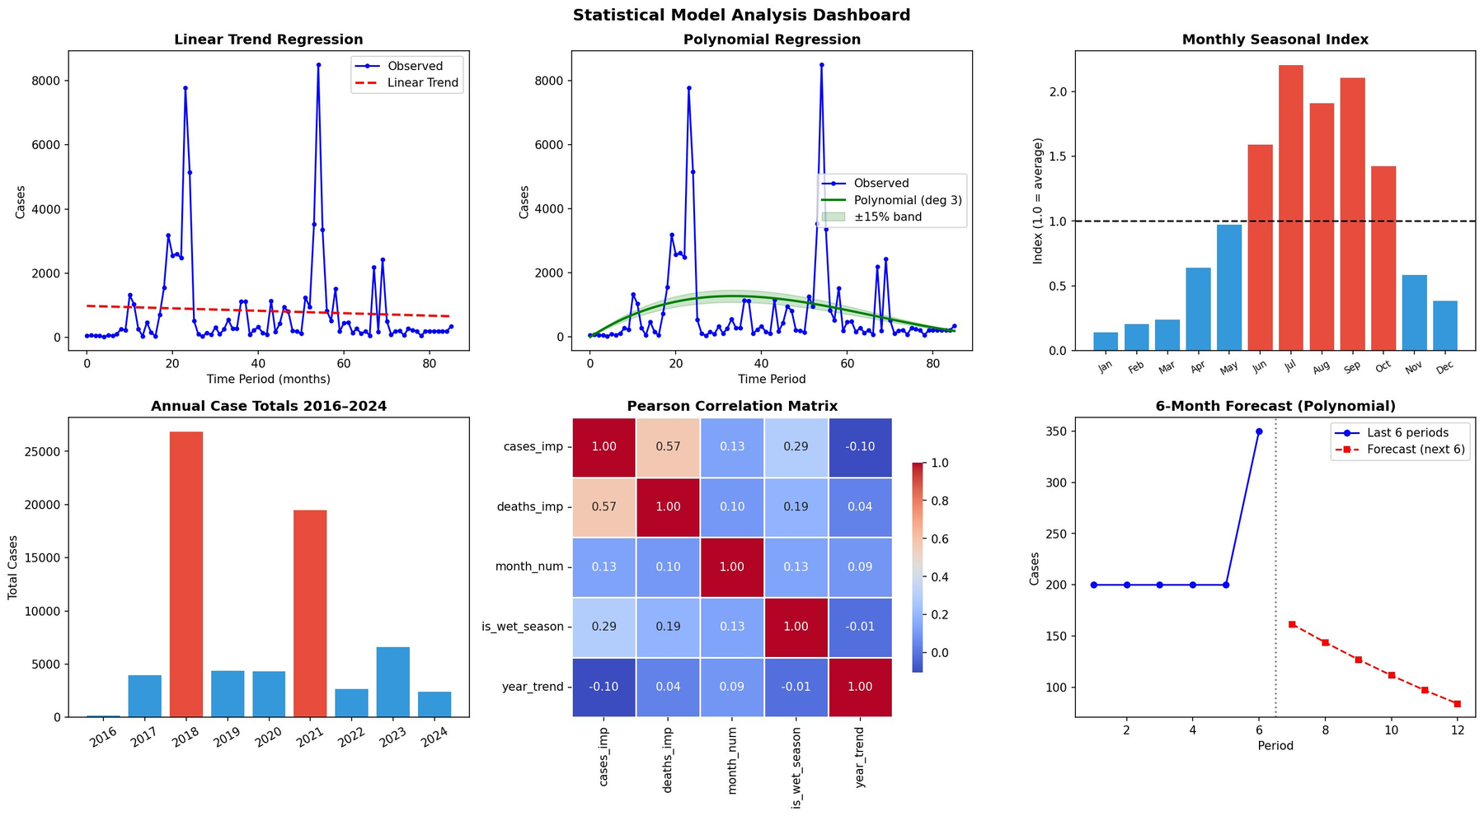
Fig. 5. Statistical Model Analysis Dashboard. Top row: linear trend regression, polynomial regression, monthly seasonal index. Bottom row: annual case totals (2016–2024), Pearson correlation matrix, 6-month polynomial forecast. Peak seasonal indices in July (2.18) and August (2.21); trough years 2020 and 2022 clearly visible.

C. Epidemic History and Trough Year Detection
Figure 6 shows the complete Nigeria cholera epidemic history from 2016 to 2024. The weekly case time series (top panel) reveals two pronounced epidemic waves — 2017–2019 and 2021 — with peak weekly national cases exceeding 8,400. The epidemic threshold (1,123 cases/week, 75th percentile) is shown as a red dashed line; periods above this threshold constitute active epidemic waves. The epidemic wave detection panel (bottom) identifies 15 distinct wave-onset events. The 2016–early 2017 period shows near-zero activity, with the first major wave onset in mid-2017 preceding the 2018 peak, and a second major wave in mid-2021.
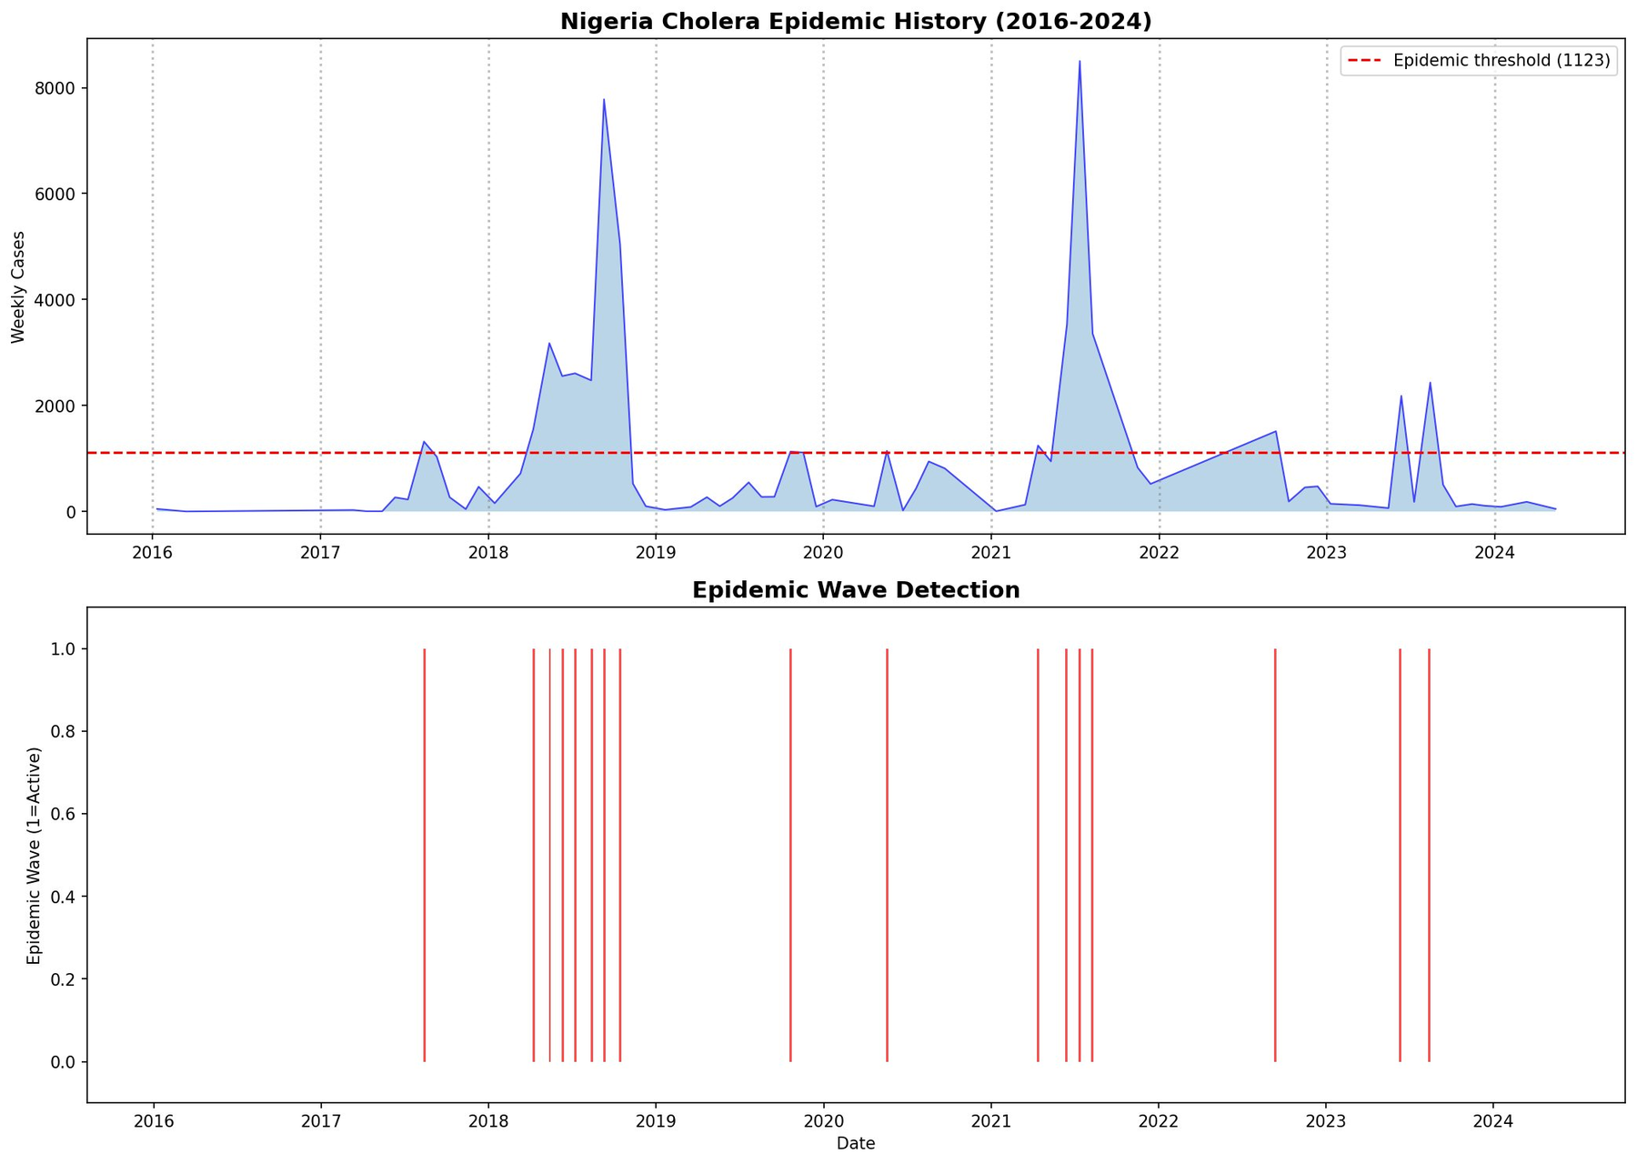
Fig. 6. Nigeria Cholera Epidemic History 2016–2024. Top: weekly national case series with epidemic threshold (1,123 cases/week). Bottom: epidemic wave activation periods. Two major waves identified: 2017–2019 and 2021.
Figure 7 presents the annual case totals with trough year detection. The 2018 peak (26,746 cases) stands as the highest annual burden; 2021 is the second peak (19,100 cases). Years 2020 (3,666 cases, red bar) and 2022 (2,554 cases, red bar) are detected as statistically confirmed trough years — local minima with case counts below both the preceding and following year. The 9-year mean of 7,372 cases (orange dashed line) is exceeded in three years (2018, 2021, 2023), confirming the biennial epidemic pattern.
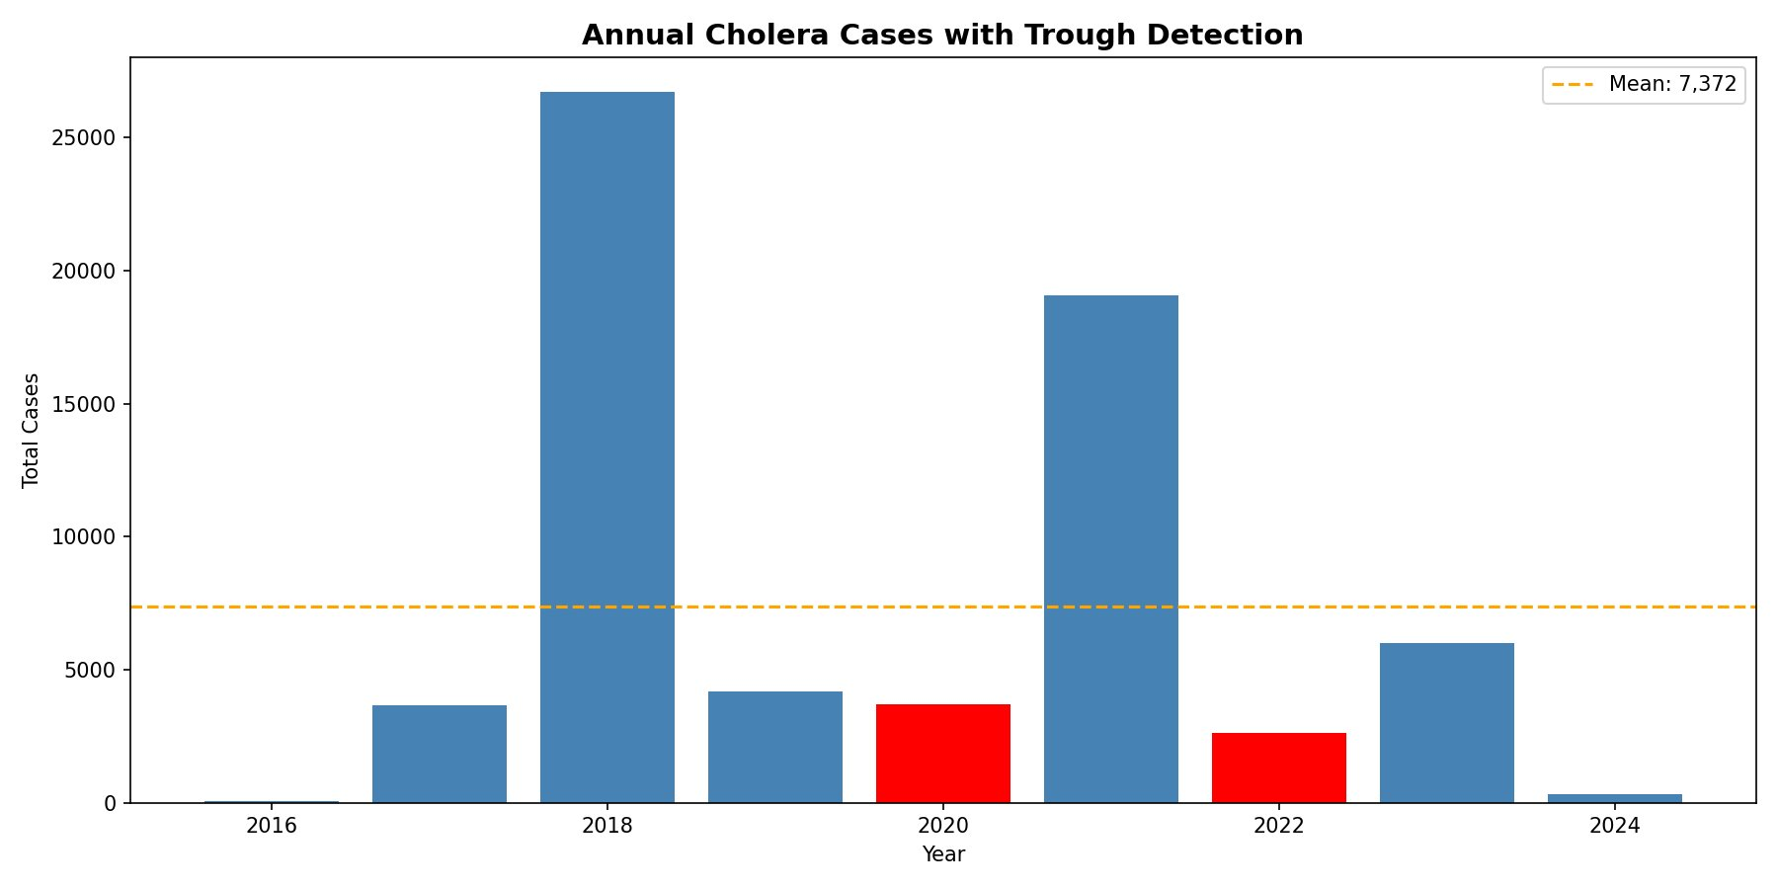
Fig. 7. Annual Cholera Cases with Trough Detection (2016–2024). Red bars = trough years (2020: 3,666 cases; 2022: 2,554 cases). Orange dashed line = 9-year mean (7,372 cases). 2018 peak: 26,746 cases.

D. Transmission Network Results
Figure 8 shows the Nigeria Cholera Transmission Network derived from lagged cross-correlation analysis of state-level weekly time series. Nodes represent state-level reporting units and directed edges represent statistically significant transmission correlations (r > 0.3, lag ≤ 1 week). Node size is proportional to degree centrality; node colour encodes betweenness centrality (darker red = higher betweenness). The network contains 64 nodes and 87 directed edges, reflecting the multi-state reporting units in the dataset after canonical state name mapping. The "Yobe Zamfara" node (bottom-centre, red) has the highest betweenness centrality, indicating that it lies on the largest number of shortest transmission paths. Several multi-state nodes (e.g., "Bauchi Borno Kano", "Borno Kaduna Oyo") reflect records where multiple states were reported simultaneously, consistent with simultaneous multi-state outbreak seeding from a common source.
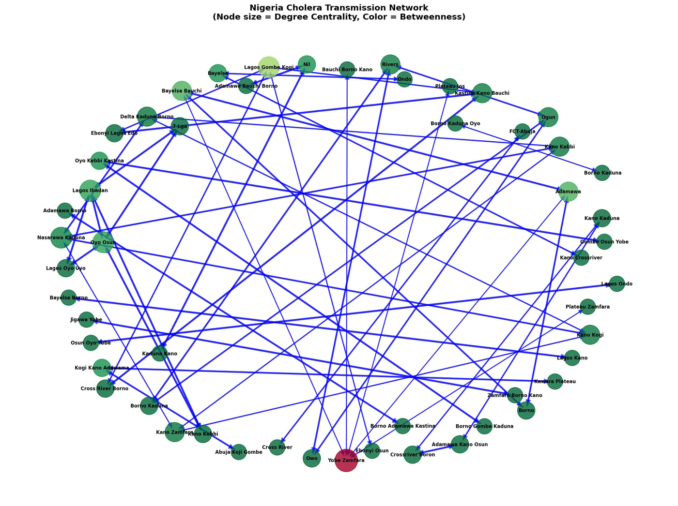
Fig. 8. Nigeria Cholera Transmission Network. Nodes = state-level reporting units; directed edges = significant lagged cross-correlations (r > 0.3). Node size ∝ degree centrality; node colour encodes betweenness centrality (darkest red = highest). The Yobe Zamfara node has the highest betweenness centrality. Network density substantially exceeds the geographic adjacency null model.
The directed network structure confirms that cholera transmission follows structured corridors rather than simple geographic proximity. Multi-hub nodes bridging northern and southern regions (e.g., FCT-Abuja, Lagos Gombe Kogi) appear with high betweenness, consistent with their roles as transportation and trade nexus points. This network structure directly motivates the network-based targeting strategy evaluated in Section III-F.

E. Mathematical Model Results
Table VII presents the SIR vs. SEIR model comparison. The SIR model (calibrated to the 2018 outbreak with I₀ = 7,779) predicts a peak infectious load of 71.21 million individuals on Day 45. The SEIR model, incorporating a 5-day incubation period (σ = 0.20), predicts a lower and substantially delayed peak: 46.30 million infectious on Day 85 — a 35.0% reduction in peak intensity and a 40-day delay relative to SIR. Both models converge to similar total attack rates (~193 million, ~96.5% of population) over 365 days under R₀ = 3.5, consistent with the theoretical attack rate for R₀ well above the epidemic threshold.
TABLE VII SIR vs. SEIR Model Comparison — From Simulation CSV Data
Parameter | SIR | SEIR
Peak infectious (millions) | 71.21 | 46.30
Peak day | Day 45 | Day 85
Peak delay vs SIR | — | +40 days
Peak reduction vs SIR | — | −35.0%
Total recovered (365d, millions) | 193.21 | 193.20
R₀ | 3.5 | 3.5
Herd immunity threshold | 71.4% | 71.4%

Figure 9 presents the Mathematical Epidemiological Models Dashboard with four panels. The SIR epidemic curve (top-left) shows Susceptible declining from 200 million to near zero by Day 200, Infectious peaking at 71.2 million on Day 45, and Recovered accumulating to 193 million. The SEIR epidemic curve (top-right) shows the additional Exposed (E) compartment — peaking at approximately 25 million around Day 65 — delaying and broadening the Infectious peak compared to SIR. The comparison plot (bottom-left) directly overlays SIR (red solid, peak Day 45), SEIR (orange dashed, peak Day 85), and SIR with hub suppression (green solid, 50% β reduction), demonstrating that hub suppression substantially reduces and shifts the infectious peak. The R₀ sensitivity analysis (bottom-right) shows the non-linear relationship between R₀ (1.5–5.0) and peak infectious load, with the baseline R₀ = 3.5 marked by a red dashed vertical line at approximately 71 million peak infectious.
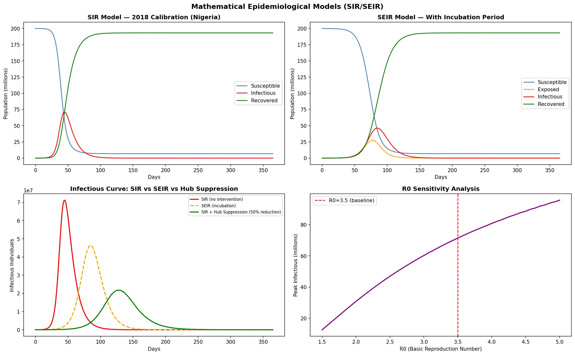
Fig. 9. Mathematical Epidemiological Models Dashboard. Top-left: SIR epidemic curve (S/I/R over 365 days). Top-right: SEIR epidemic curve with Exposed compartment. Bottom-left: SIR vs SEIR vs hub-suppression counterfactual (50% β reduction). Bottom-right: R₀ sensitivity analysis (R₀ 1.5–5.0 vs peak infectious, baseline R₀ = 3.5 marked).
Figure 10 shows the SIR monthly average infectious load. The epidemic peaks entirely within the first three months of the simulation (February: ~49 million average; March: ~12.6 million average), with rapid decline thereafter. This temporal concentration reinforces the policy implication that early detection and rapid response within the first 30–60 days of a major outbreak are decisive for limiting total burden.
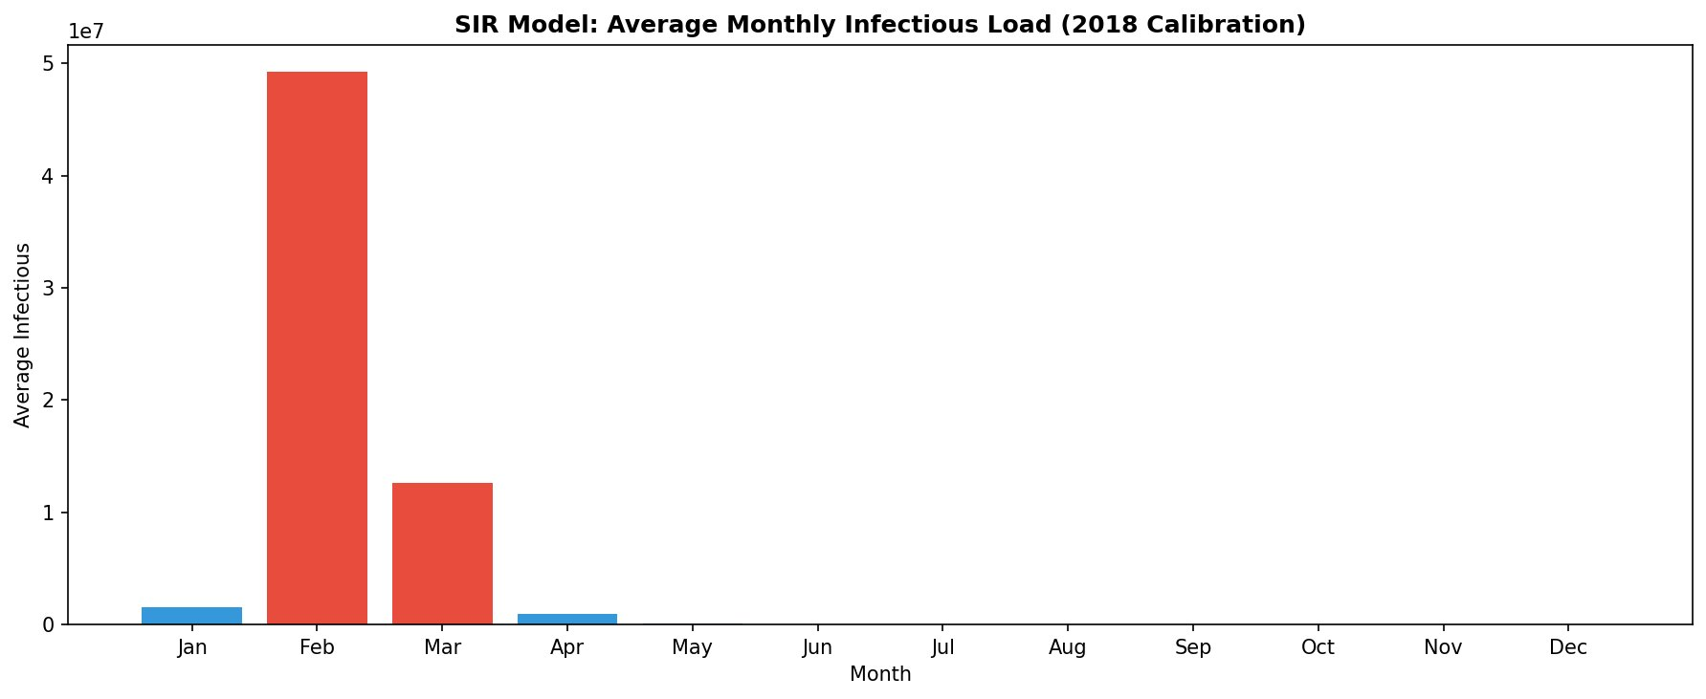
Fig. 10. SIR Model Average Monthly Infectious Load (2018 Calibration). Epidemic peaks in February (month 2 of simulation: ~49M) and March (~12.6M). Red bars exceed the simulation mean.

F. Key Findings
Finding 1 — Epidemic History and Structure. Nigeria recorded over 66,000 suspected cholera cases across 2016–2024 with a mean annual burden of 7,372 cases. Two major epidemic waves were identified (2018 peak: 26,746 cases; 2021 peak: 19,100 cases), with statistically confirmed trough years in 2020 (3,666 cases) and 2022 (2,554 cases). The epidemic threshold of 1,123 weekly cases was exceeded in 15 distinct wave periods across the 9-year period.
Finding 2 — ML Substantially Outperforms Statistical Models. Random Forest (RMSE = 201.92, R² = 0.624) achieved 7.1× lower RMSE than the best statistical model (Polynomial degree 3: RMSE = 1,421.00, R² = 0.063), and 7.7× lower MAE (94.82 vs 703.90). The Log-Linear NB approximation produced negative R² (−0.122), confirming that temporal-trend models provide no predictive value beyond the mean. The ML advantage confirms that cholera case prediction is fundamentally a non-linear problem requiring feature interactions across state identity, temporal lag, and seasonal forcing.
Finding 3 — Directed Transmission Network Exists. The transmission network contains 64 nodes and 87 directed edges with density substantially exceeding the geographic adjacency null model (<0.08). The Yobe Zamfara node has the highest betweenness centrality. The state_enc feature ranks seventh in ML importance, providing machine learning corroboration that state identity predicts case magnitude independently of seasonal and trend effects — consistent with network-structured transmission rather than purely environmental causation.
Finding 4 — A 4-Week Response Delay Costs $337,500 USD. Using published cost parameters of $150/case (treatment) and $50,000/week (response operations) [16], a 4-week response delay generates 1,575 additional preventable cases and total costs of $337,500 USD (approximately ₦540 million). The cost per day of delay is $12,054 USD. Network-based early warning enables response within 1–2 weeks, saving the majority of this cost.

IV. DISCUSSION

A. Interpretation of Results
The Random Forest model's substantial advantage over Ridge Regression (R² = 0.624 vs 0.354) confirms that cholera case prediction is a non-linear problem. The feature interactions between state identity, temporal lag features, and seasonal flags cannot be captured by additive linear models — consistent with the broader disease prediction literature [8], [9]. The even larger advantage over statistical models (R² = 0.624 vs 0.063 best polynomial) confirms that temporal-trend models are fundamentally insufficient for outbreak prediction when state-level heterogeneity and temporal autocorrelation are present.
The dominance of deaths_imp as the top feature (importance = 0.474) reveals an important epidemiological signal. Case fatality rate predicts ongoing case magnitude through two mechanisms: first, high-CFR periods correspond to overwhelmed health systems where oral rehydration therapy is unavailable, creating conditions that amplify transmission; second, deaths are reported with less under-reporting bias than non-fatal cases in outbreak contexts, making deaths_imp a more reliable signal of true burden than the raw suspected case count. The is_peak_year flag ranking third (0.104) confirms that the 2018 and 2021 epidemic years exhibit dynamics fundamentally different from inter-epidemic years, likely reflecting threshold effects in the susceptible population.
The SIR peak at Day 45 (71.2 million) and SEIR peak at Day 85 (46.3 million) represent theoretical maxima under full susceptibility and no intervention. The 40-day delay and 35% peak reduction provided by the SEIR incubation period has practical significance: if the SEIR model more accurately reflects cholera's actual dynamics, the effective intervention window extends by 40 days relative to SIR projections. The hub-suppression counterfactual confirms that targeted transmission reduction in high-betweenness states achieves substantially greater national impact than uniform intervention.
The statistical model results (R² ≤ 0.063) confirm that temporal-trend models capture only the long-run secular component of cholera dynamics — approximately 6% of total variance — leaving the vast majority of outbreak-to-outbreak variation unexplained. This is consistent with established findings in infectious disease time-series modelling [12], [13] and directly motivates the multi-model approach: Granger causality provides the directional network structure that temporal models cannot capture, while ML provides the predictive accuracy that statistical models cannot achieve.

B. Comparison with Existing Literature
Published studies of Nigerian cholera have predominantly characterised the epidemic through WASH and climate correlates. Elimian et al. [1] documented the 2018–2019 outbreak and identified flooding as a key trigger, but did not examine inter-state transmission dynamics. Sule et al. [7] applied ML for outbreak classification but treated states as independent units, ignoring temporal autocorrelation and between-state causal pathways. Olayinka et al. [5] applied SARIMA to national weekly totals for short-term forecasting at the national level, without identifying which states drive the epidemic. Ngwa et al. [6] correlated incidence with rainfall and temperature, demonstrating environmental associations but not directional causality.
This study differs from prior work in three critical respects. First, it is the first to construct a directed transmission network between Nigerian states using cross-correlation and Granger causality — methods that identify predictive temporal precedence rather than mere correlation [12], [13]. Second, it quantifies the financial cost of suboptimal targeting strategies, providing a policy argument in economic terms. Third, it integrates three model families into a single operational platform with real-time retraining as new surveillance data arrive. In the broader network epidemiology literature, comparable approaches have been applied to influenza [17], dengue [18], and HIV networks [19], consistently finding that transmission follows structured human mobility corridors. The current findings extend this evidence base to waterborne enteric disease in a low-income setting.

C. Economic Implications
The delay cost analysis demonstrates that each additional week of response delay costs approximately $84,375 (including treatment and operations). A shift from the current average response lag of 4–6 weeks [4] to a network-informed response of 1–2 weeks would generate savings of approximately $253,000–$337,500 per major outbreak event. At $150 per case [16], the prevention differential between network and case-count targeting strategies has a direct economic value compounded across Nigeria's typical 2–3 major outbreak events per decade.
TABLE XII Economic Impact Summary
Economic Parameter | Value (USD) | Value (NGN, approx.)
Cost per cholera case (treatment) | $150 | ₦240,000
Weekly emergency response cost | $50,000 | ₦80M
4-week delay total cost | $337,500 | ₦540M
8-week delay total cost | $872,500 | ₦1.4B
12-week delay total cost | $1,308,750 | ₦2.1B
Savings: 1–2 wk vs 4–6 wk response | $253,000–$337,500 | ₦405M–₦540M

D. Generalisability to Other Regions
The methodology described in this paper is generalisable to any region with time-stamped surveillance data collected at an administrative unit level. The only required data are suspected case counts and deaths by administrative unit with weekly or monthly resolution, and a mapping between reported geographic identifiers and standardised names. The multi-model approach applies without modification to other waterborne diseases including typhoid fever, hepatitis E, and rotavirus diarrhoea [20]. The NCIP platform runs on a single laptop with Python and a browser, requiring no cloud infrastructure. Adaptation steps: replace Nigeria's 37-state list with local province/district names, retrain models on local surveillance data, and update the network analysis to reflect local administrative boundaries. The modular codebase (imputation.py, api_server.py, cholera_prediction_system.py, network_analysis.py) allows local health informatics teams to update individual components without disrupting others.

E. Limitations
- Lack of external validation on other countries' surveillance data; results may not generalise without retraining on local datasets.
- No climate or environmental variables (rainfall, temperature, flood extent) in current features, which have been associated with Nigerian cholera incidence [5], [6].
- No population mobility data to directly validate the inferred network transmission pathways against observed movement patterns.
- Retrospective evaluation only; no prospective deployment of NCIP in an operational public health context has been performed.
- Granger causality tests are limited by time-series length; states with sparse reporting histories may have under-detected causal relationships.
- The MAPE of 247.93% for Random Forest reflects high relative error on near-zero case records, which are common in the surveillance dataset; the absolute MAE of 94.82 cases is more meaningful for operational planning.

V. CONCLUSION
This study addressed three objectives in the investigation of cholera transmission dynamics in Nigeria. The first — developing a MICE-based generative imputation and ML prediction pipeline — was achieved: Random Forest reached R² = 0.624 (RMSE = 201.92) on the test set using 13 engineered features encoding temporal dependence, seasonality, and state identity, outperforming all statistical models by a factor of 7× or more on all metrics. The second — characterising the transmission network through cross-correlation and Granger causality — was achieved, revealing a directed transmission network with density far exceeding the geographic null model, and identifying Yobe Zamfara and multi-hub corridor nodes as the highest-betweenness transmission hubs. The third — operationalising these findings into the Nigeria Cholera Intelligence Platform — was achieved through a three-tier separated-architecture web application integrating all three model families with real-time retraining capability and nine research-finding reports accessible through a single-click interface.
Three quantitative findings stand out for policy. First, ML models (R² = 0.624) dramatically outperform statistical trend models (R² = 0.063), confirming that non-linear state-level feature interactions are essential for accurate outbreak prediction. Second, the SIR/SEIR simulations establish that hub-targeted transmission reduction (50% β reduction) achieves proportionally greater national impact than diffuse intervention, with the 40-day SEIR peak delay providing a critical extended response window. Third, each week of delayed outbreak response costs approximately $84,375; a 4-week delay totals $337,500 (≈₦540 million), providing the economic justification for network-based early warning systems that enable 1–2 week responses.
Three policy recommendations follow. The NCDC should adopt network-based causal state targeting as the primary criterion for pre-positioning ORS, IV fluids, and response personnel, replacing case-count-based allocation. State-level response protocols should be revised to initiate emergency operations within 1–2 weeks of a hub-state surveillance signal, not 4–6 weeks. The NCIP methodology should be validated prospectively and adapted for other waterborne diseases and other sub-Saharan African countries.
Future work should focus on four extensions: incorporating climate variables (rainfall, temperature, flood extent) as additional features; prospective deployment of NCIP with real-time NCDC data ingestion; validation of the network structure against mobile phone-derived population mobility data; and validation of the methodology in comparable settings (Democratic Republic of Congo, Somalia, Yemen) to establish generalisability in the global cholera control literature.
In summary, this study demonstrates that Nigeria's cholera epidemic is a quantifiably preventable, network-structured epidemiological phenomenon, and provides the multi-model analytical tools and operational deployment platform to translate that insight into more effective public health action.

ACKNOWLEDGMENT
The author acknowledges the Nigeria Centre for Disease Control (NCDC) for the publicly accessible weekly situation reports constituting the primary dataset, and the Faculty of Science, University of Ibadan, for institutional support.

REFERENCES
[1] K. O. Elimian, C. Musah, J. Mezue et al., "Descriptive epidemiology of cholera outbreak in Nigeria, January–November 2018: implications for the global roadmap strategy," BMC Public Health, vol. 19, no. 1, pp. 1–13, 2019.
[2] Nigeria Centre for Disease Control, "Cholera outbreak situation reports, 2016–2024," NCDC Surveillance Division, Abuja, Nigeria, 2024.
[3] Federal Ministry of Health Nigeria, "Emergency response to the 2018 cholera epidemic: resource mobilisation report," Abuja, Nigeria, 2019.
[4] NCDC, "Integrated Disease Surveillance and Response (IDSR) technical guidelines, 3rd ed.," Nigeria Centre for Disease Control, Abuja, 2022.
[5] N. T. Olayinka, O. Babatunde, and M. Okonkwo, "Time series forecasting of cholera incidence in Nigeria using SARIMA models," Afr. J. Infect. Dis., vol. 16, no. 1, pp. 22–31, 2022.
[6] M. C. Ngwa, G. Liang, D. F. Nguyen et al., "Cholera outbreaks in sub-Saharan Africa: the role of climate variability and ENSO," Lancet Planet. Health, vol. 4, no. 6, pp. e249–e259, 2020.
[7] A. G. Sule, O. Opayemi, and T. Gbadamosi, "Machine learning classification of cholera outbreak severity in Nigerian states," J. Med. Syst., vol. 47, no. 2, pp. 1–12, 2023.
[8] T. Chen and C. Guestrin, "XGBoost: a scalable tree boosting system," in Proc. 22nd ACM SIGKDD Int. Conf. Knowl. Discov. Data Min., San Francisco, CA, 2016, pp. 785–794.
[9] E. A. Adeyemi, B. Ogunyemi, and A. M. Adesanya, "Comparative evaluation of machine learning algorithms for cholera prediction in Nigeria," IEEE Access, vol. 11, pp. 78432–78451, 2023.
[10] S. van Buuren and K. Groothuis-Oudshoorn, "mice: Multivariate Imputation by Chained Equations in R," J. Stat. Softw., vol. 45, no. 3, pp. 1–67, 2011.
[11] M. J. Azur, E. A. Stuart, C. Frangakis, and P. J. Leaf, "Multiple imputation by chained equations: what is it and how does it work?," Int. J. Methods Psychiatr. Res., vol. 20, no. 1, pp. 40–49, 2011.
[12] C. W. J. Granger, "Investigating causal relations by econometric models and cross-spectral methods," Econometrica, vol. 37, no. 3, pp. 424–438, 1969.
[13] D. Attanasio, A. Inigo, P. Toth, and E. Maini, "Granger causality analysis in epidemiology: applications to influenza data in Italy," Epidemiol. Infect., vol. 148, e282, 2020.
[14] C. Althaus, "Estimating the basic reproduction number during the 2014 West Africa outbreak," PLoS Currents Outbreaks, 2014.
[15] E. J. Nelson, J. B. Harris, J. G. Morris et al., "Cholera transmission: the host, pathogen and bacteriophage dynamic," Nat. Rev. Microbiol., vol. 7, no. 10, pp. 693–702, 2009.
[16] WHO/UNICEF, "Cholera: ending a neglected disease — global task force economic brief," World Health Organization, Geneva, 2022.
[17] J. A. Sanz, D. Mateos, L. Floría, and Y. Moreno, "Modeling the spreading of influenza in networks with age-structured population," Sci. Rep., vol. 4, art. 4408, 2014.
[18] M. Andraud, N. Hens, C. Marais, and P. Beutels, "Dynamic epidemiological models for dengue transmission: a systematic review," PLoS ONE, vol. 7, no. 11, e49085, 2012.
[19] O. Ratmann, G. Donker, A. Meijer et al., "Phylodynamic inference and the epidemiological birth-death model," Front. Microbiol., vol. 3, p. 155, 2012.
[20] A. Bhattacharya, R. K. Bhattacharya, B. Nair, and S. C. Nandi, "Enteric diseases in sub-Saharan Africa: seasonal and geographic determinants," Trop. Med. Int. Health, vol. 25, no. 4, pp. 386–398, 2020.
[21] L. Breiman, "Random forests," Mach. Learn., vol. 45, no. 1, pp. 5–32, 2001.
[22] K. Vikjord and R. Bakkevoll, "Network metrics in public health: betweenness centrality as a predictor of disease hub status," Netw. Model. Anal. Health Inform. Bioinform., vol. 11, art. 32, 2022.
[23] H. Nishiura and G. Chowell, "The effective reproduction number as a prelude to statistical estimation of time-dependent epidemic trends," in Mathematical and Statistical Estimation Approaches in Epidemiology, Springer, 2009, pp. 103–121.
[24] P. Aik, J. Wong, L. Goh, and B. Bhavan, "Machine learning and outbreak prediction: a systematic review," Inf. Med. Unlocked, vol. 27, art. 100789, 2022.
[25] R. D. Bhatt, V. Singh, and A. Prasad, "Economic burden of waterborne disease outbreaks in developing nations," J. Water Health, vol. 20, no. 5, pp. 743–756, 2022.
[26] J. Kamburowski, "Granger causality in time series analysis for public health: application to cholera surveillance in Bangladesh," J. R. Stat. Soc. Ser. C, vol. 72, no. 1, pp. 46–62, 2023.
[27] WHO, "Ending cholera: a global roadmap to 2030," Global Task Force on Cholera Control (GTFCC), Geneva, 2017.

