NUVRA — Business Workflow Overview
This document outlines the core business workflows of the NUVRA Sports Team Management Platform, detailing the transition of states and responsibilities between Players and Organizers (Club Owners).

1. User Roles
Role | Key Capabilities & Responsibility | Typical Accounts
Player | Browse games, register to play, submit payment receipts, track digital profile stats (FIFA-card style). | player1@nuvra.com (password: password)
Organizer / Club Owner | Create games, set match details & pricing, upload payment QR codes, approve/reject bookings, log performance stats. | owner@nuvra.com (password: password)

2. Core Game Booking Lifecycle
The following diagram illustrates the typical lifecycle of a match booking:
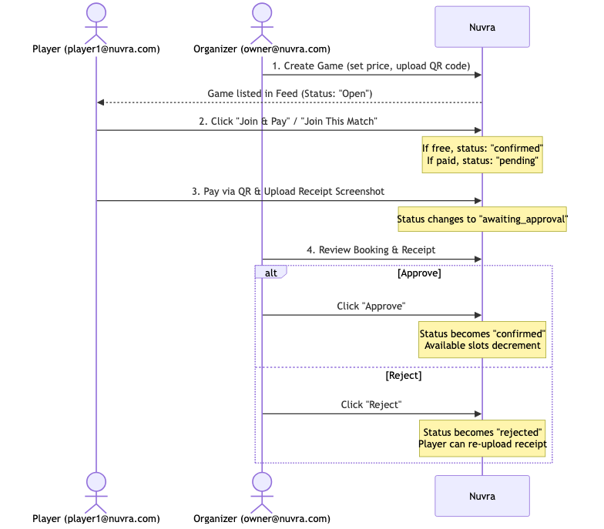

3. Step-by-Step Workflow Explanation
Step 1: Game Creation (Organizer)
- Role: Organizer (owner@nuvra.com)
- Action: Goes to Create Game via the navigation bar.
- Fields: Fills in Title, Venue, Date & Time, Team names, Pricing (RM), and max slots per team.
- Payment Setup: Uploads a payment QR code. This is saved to the organizer's profile and displayed to players joining their games.
- Outcome: The game is posted as open and shows up in the public community feed.
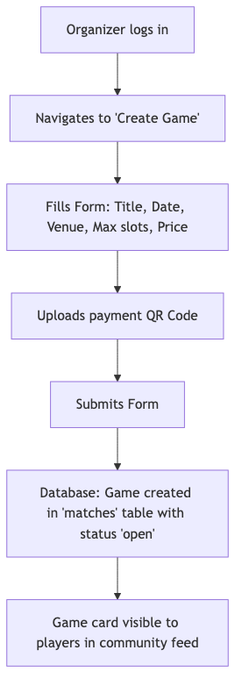

Step 2: Discovery & Registration (Player)
- Role: Player (player1@nuvra.com)
- Action: Logs in, browses the Feed, selects an upcoming game, and clicks Join Game.
- State Transition:
- If the game is Free (RM 0): The player is immediately marked as Confirmed and added to the roster.
- If the game is Paid (RM > 0): The registration is saved as Pending.
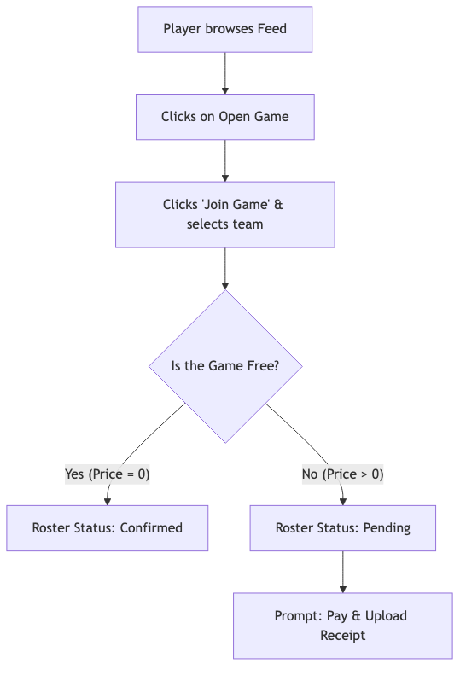

Step 3: Payment Upload (Player)
- Role: Player (player1@nuvra.com)
- Action: While in Pending status, the player sees the organizer's Payment QR Code on the Game Details page.
- Steps:
- The player scans the QR code using their bank/e-wallet app and completes the transfer.
- The player uploads a screenshot of the payment receipt.
- State Transition: The booking status changes from pending to awaiting_approval.
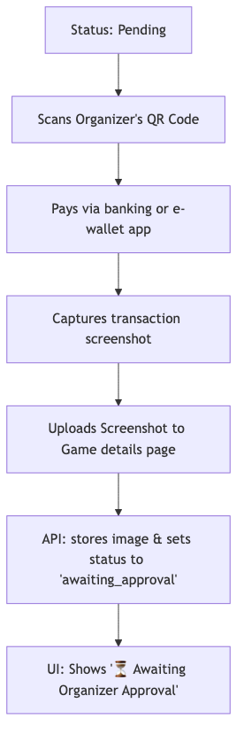

Step 4: Verification & Approval (Organizer)
- Role: Organizer (owner@nuvra.com)
- Action: Opens the Game Details page for their created game. They see a Manage Bookings panel showing all bookings sorted with those Awaiting Review at the top.
- Actions:
- Approve: Clicking this confirms the booking (status becomes confirmed), adding the player to the active roster and decrementing the game's available slots.
- Reject: Clicking this marks the booking as rejected, letting the player know their payment was invalid and allowing them to re-upload.

Step 5: Post-Game Performance Analytics (Organizer & Player)
- Role: Organizer (owner@nuvra.com)
- Action: Once a game has finished, the Organizer can input stats for all confirmed players (Goals, Assists, Rating, Cleansheet status, Minutes played) directly from the Game Details page.
- Role: Player (player1@nuvra.com)
- Outcome: The player's digital profile (FIFA-card style) instantly updates, recalculating average ratings, goals, assists, and displaying form analytics on their dashboard.
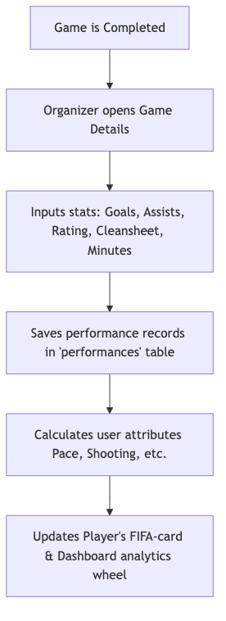

4. Other Operational Features
- Announcements: Organizers can post news or guidelines directly to the community feed.
- Organizer Analytics: Organizers can access their dashboard to track total revenue generated, player growth, and game activity rates.
- Member Directory: All users can browse public player profiles to check other players' attributes, form, and game stats.

