**General information (relevant for all patients):**

R version 4.1.0 (2021-05-18); Platform: x86_64-pc-linux-gnu (64-bit) ; cytoscapeVersion: "3.8.2"

[1] "These biomarkers do not have an identfier mapping: cyshcys"

[1] "These biomarkers are not annotated with a ChEBI ID: 2,8-dihydroxyadenine"

[1] "These biomarkers (ChEBI IDs) are not in a pathway: 35621, 17755, 70744, 43433, 89698, 27596, 50599, 86498, 17261, 49015, 61511"

**Patient A**

[1] "Selected Patient ID is: A , age is between: 1 to 5 years old"

[1] "There are 16 biomarkers relevant for patient A , the ChEBI-IDs are ch:17821 ch:17568 ch:16964 ch:17553 ch:18095 ch:18237 ch:17748 ch:7274 ch:17191 ch:15603 ch:17295 ch:57966 ch:57743 ch:17755 ch:15428 ch:15727"

[1] "These biomarkers (as ChEBI IDs) are not in any pathway: 17755"

Relevant pathway models

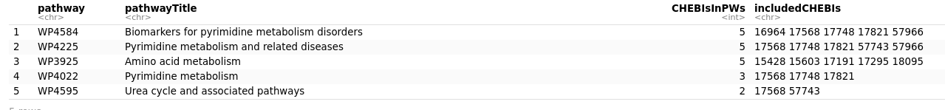

Data visualized on first three pathways (manual selection based on covering most biomarkers for this patient). One biomarker is not visualized now:

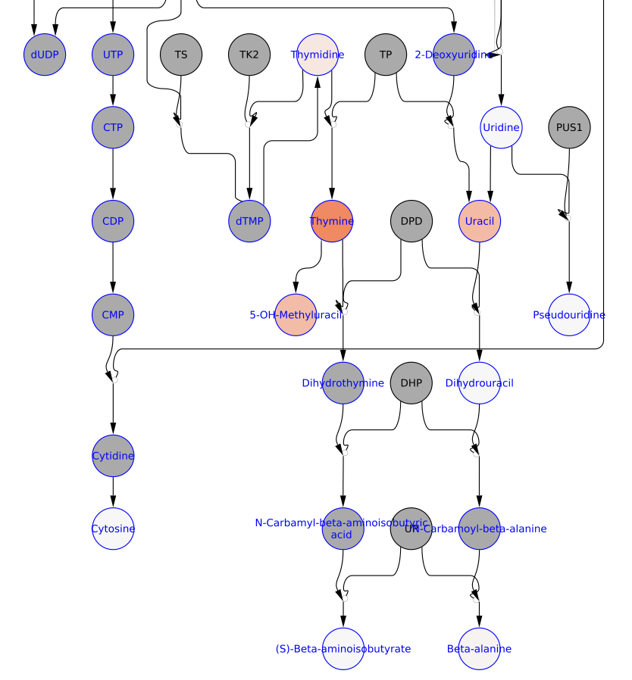Figure 1_A: **left** five biomarkers [thymidine 6.78, uracil 3.71, 5-OH-methyluracil 3.67, thymidine 1.0, beta-alanine 0.26] visualized in WP4584 (yFiles hierarchical layout); **right top** one biomarker [citrulline] visualized in WP4225 (same layout); **right bottom** color scale for log2(change)-value (positive = red is above highest reference value, negative = blue is below lowest reference value, white indicates value is between highest and lowest reference value).

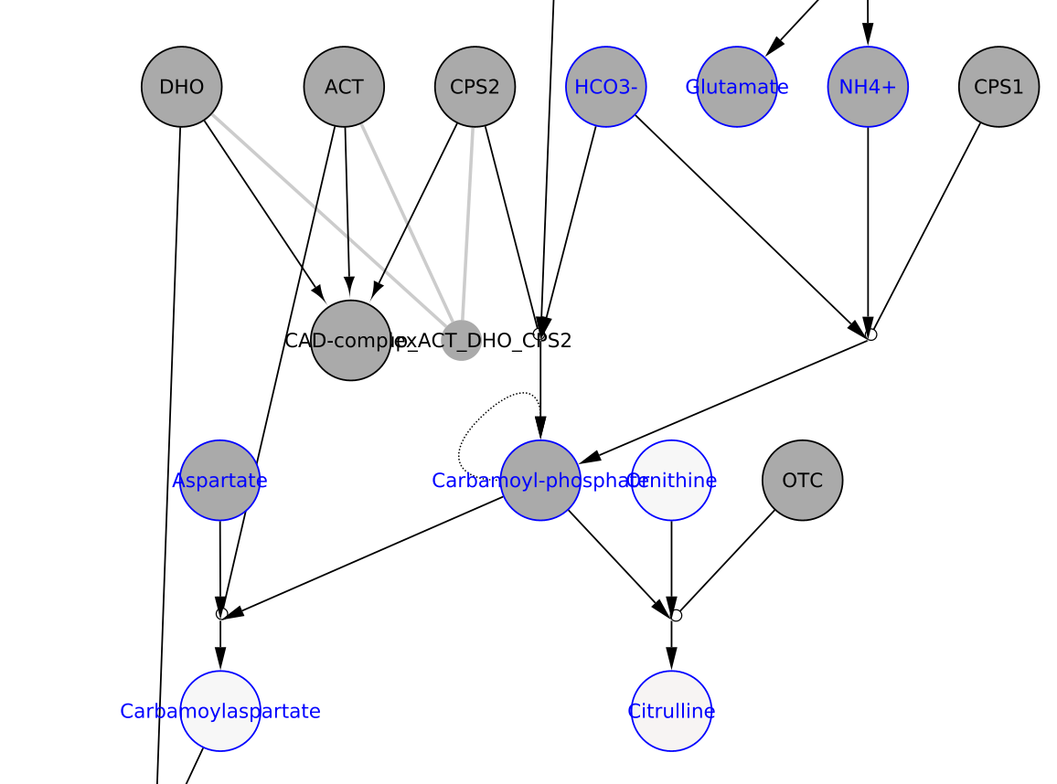

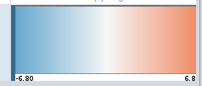

Figure 2_A: **top** two biomarkers [glycine, phenylalanine] visualized in WP3925 (yFiles hierarchical layout); **bottom left** two biomarker [isoleucine, leucine] visualized in WP3925 (same layout); **bottom right** one biomarker [hydroxy-proline]visualized in WP3925 (same layout), mapped HMDB to ChEBI for WP3925. *Same scale as previous Figure.

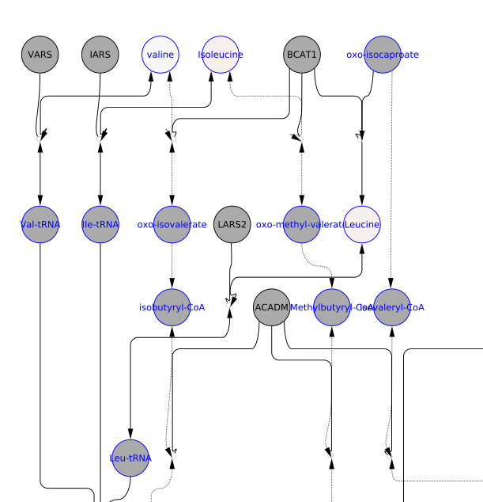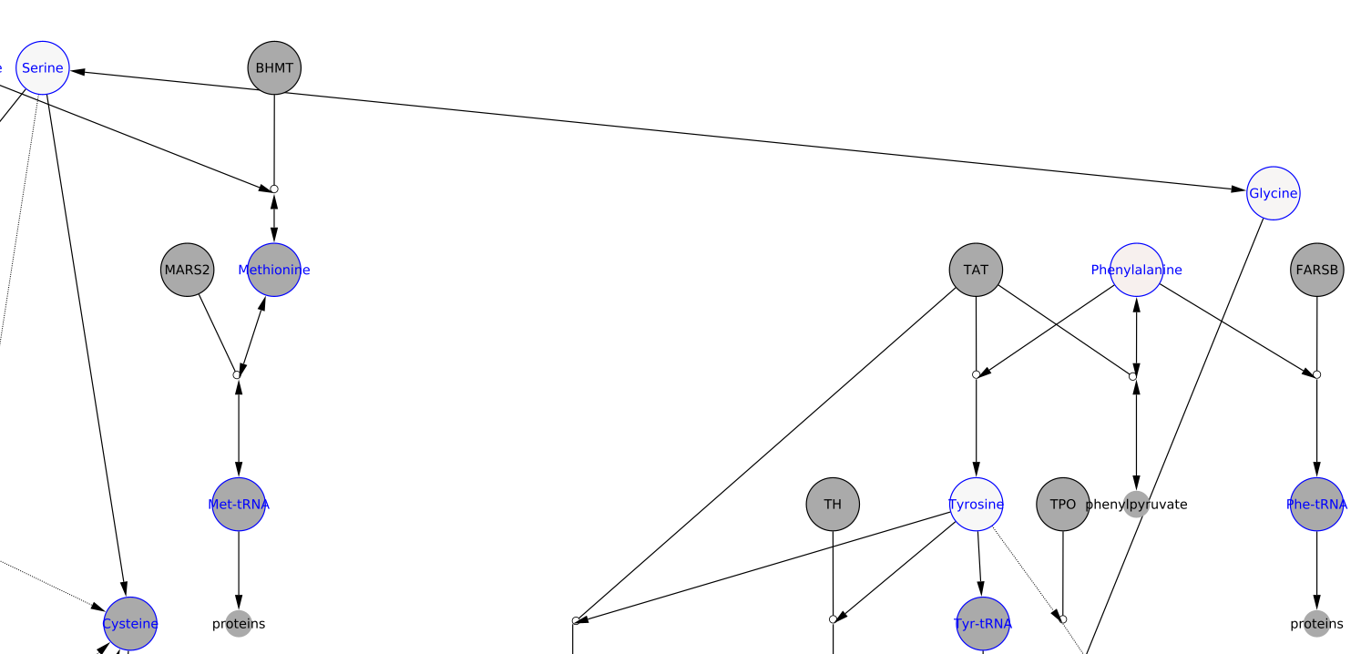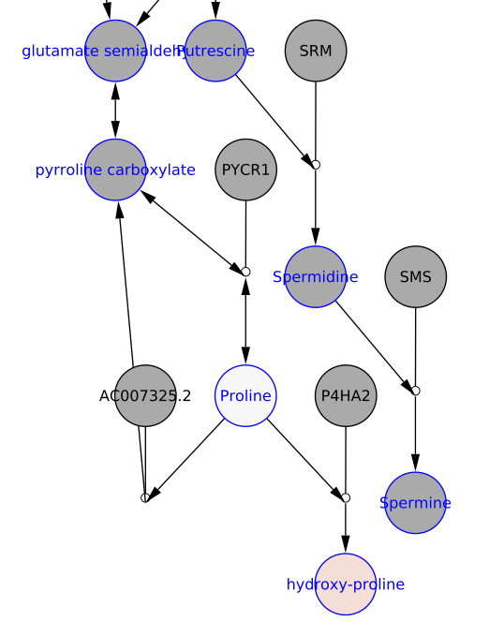

**Results interpretation 1:** DPD

**Results interpretation 2:**

Dihydropyrimidine dehydrogenase defiency based on increased uracil, thymine and 5-OH-Me-Uracil.

A secondary increase a suggested by the figure is logical as thymine is a degradation product of thymidine. Relevant downstream markers in blue: dihydrouracil, beta-aminoisobutyrate, beta-alanine and carnosine.

Carbamoyl-Aspartate is a pyrimidine de novo biosynthesis biomarker. Feedback inhibition?

Cytosine perhaps same if de novo synthesis is the preferred source of CTP biosynthesis.

I cannot place the role of the altered amino acids in DPD deficiency.

**Patient D**

[1] "Selected Patient ID is: D , age is between: 0 to 1 years old"

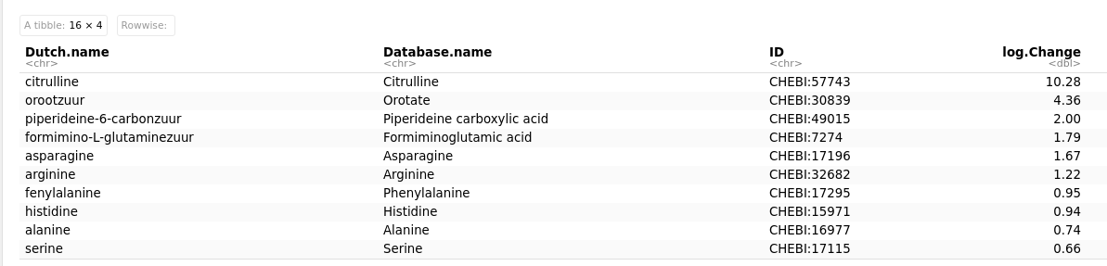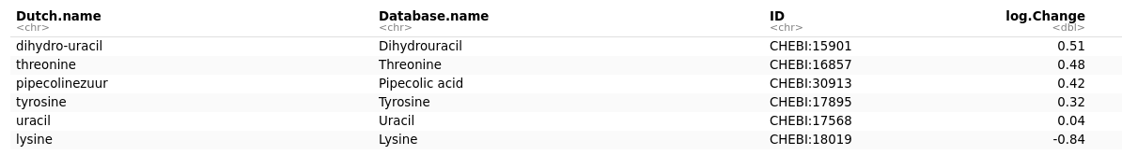[1] "There are 16 biomarkers relevant for patient D , the ChEBI-IDs are ch:30839 ch:15901 ch:17568 ch:17196 ch:17115 ch:16857 ch:57743 ch:16977 ch:7274 ch:30913 ch:17895 ch:17295 ch:15971 ch:18019 ch:32682 ch:49015"

[1] "These biomarkers (as ChEBI IDs) are not in a pathway: 49015"

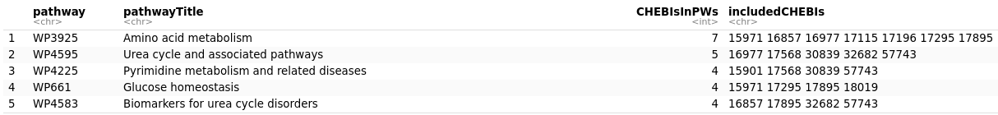

Figure 1_D: **left** four biomarkers [serine 0.66, threonine 0.48, tyrosine 0.32, phenylalanine 0.95] visualized in WP3925 (yFiles organic layout); **right** three biomarker [asparagine 1.67, histidine 0.94, alanine 0.74] visualized in WP3925 (same layout), mapped HMDB to ChEBI for WP3925.

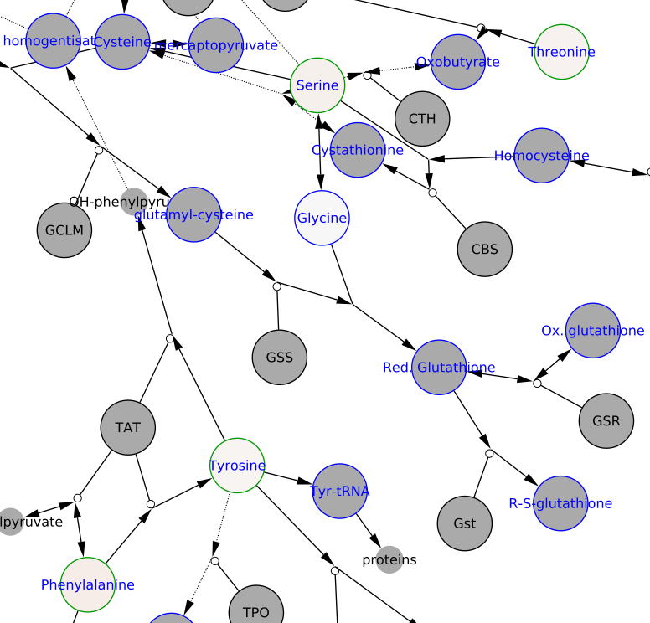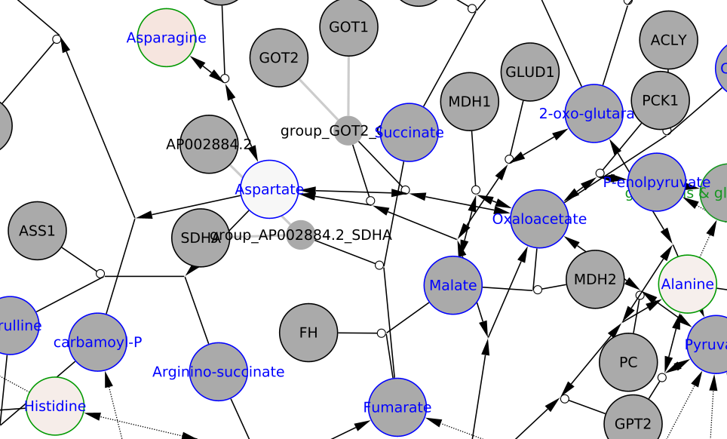

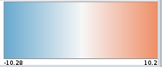

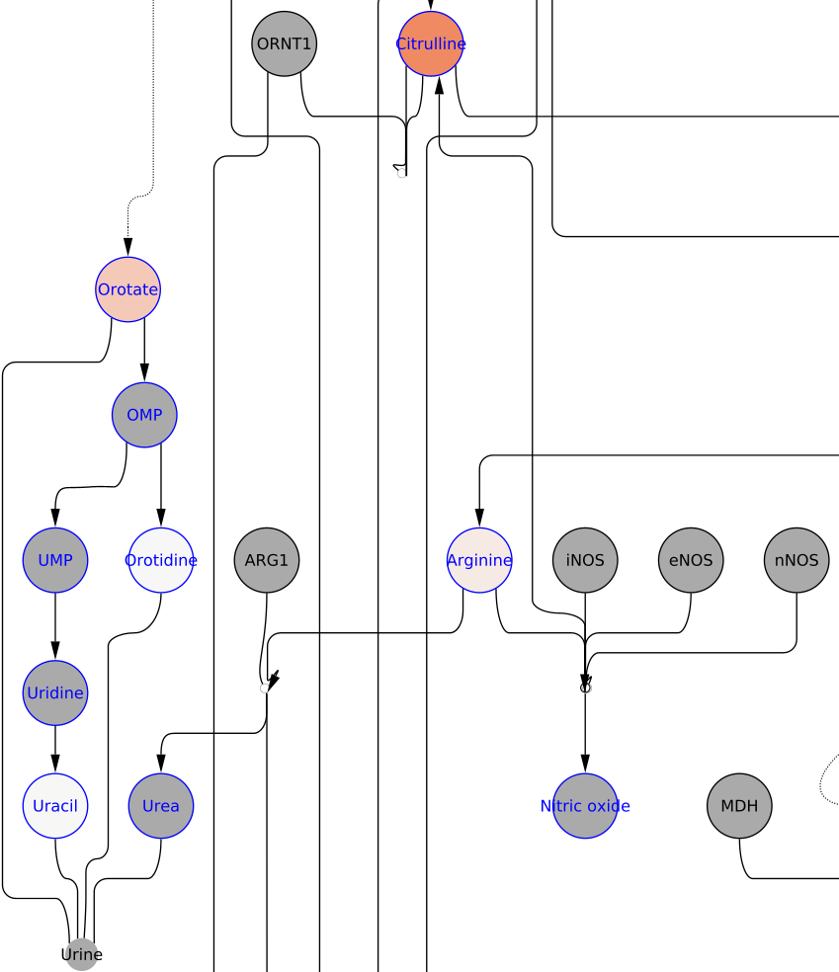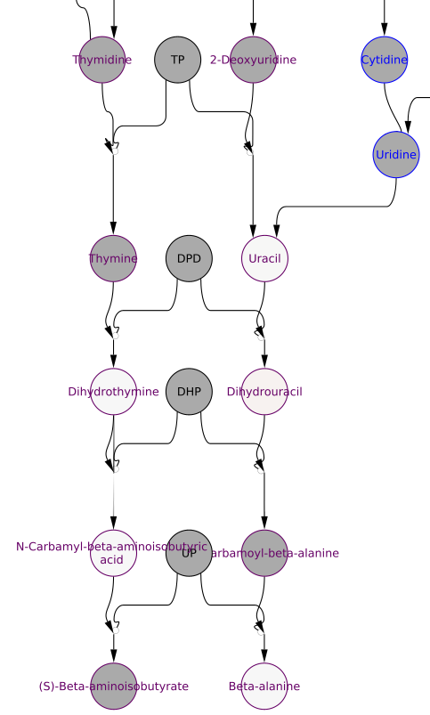Figure 2_D: **left** four biomarkers [citrulline 10.28, orotate 4.36, arginine 1.22, uracil 0.04] visualized in WP4595 (yFiles hierarchical layout); **right** two biomarker [uracil 0.04, dihydrouracil 0.51] visualized in WP3925 (same layout). *Same scale as previous Figure.

**Results interpretation 1:**

ASS (Citrullinemia Type I)

**Results interpretation 2:**

Citrullinaemia with hyperammonaemia, based on high citrulline and orotate.

**Patient E**

[1] "Selected Patient ID is: E , age is between: 5 to 16 years old"

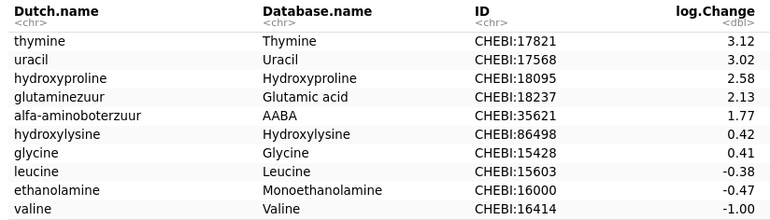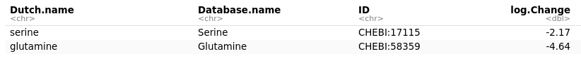[1] "There are 12 biomarkers relevant for patient E , the ChEBI-IDs are ch:17568 ch:17821 ch:18095 ch:17115 ch:58359 ch:15428 ch:18237 ch:35621 ch:16414 ch:16000 ch:15603 ch:86498"

[1] "These biomarkers (as ChEBI IDs) are not in a pathway: 35621, 86498"

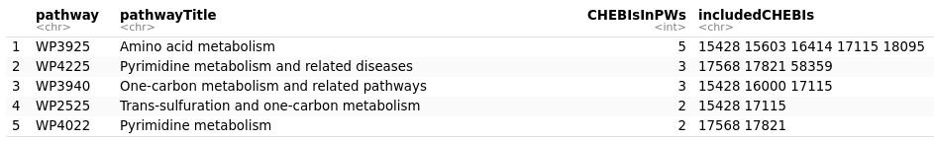This biomarker will not be visualized:

Figure 1_E: **left** two biomarkers [serine -2.17, glycine 0.41] visualized in WP3925 (yFiles hierarchical layout); **right top** two biomarker [valine -1, leucine -0.38] visualized in WP3925 (same layout); **right bottom** one biomarker [hydroxyproline 2.58] visualized in WP3925 (same layout), mapped HMDB to ChEBI for WP3925.

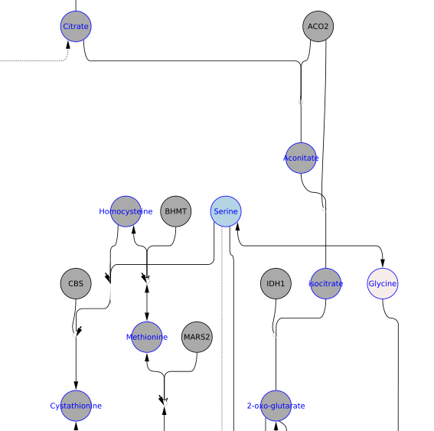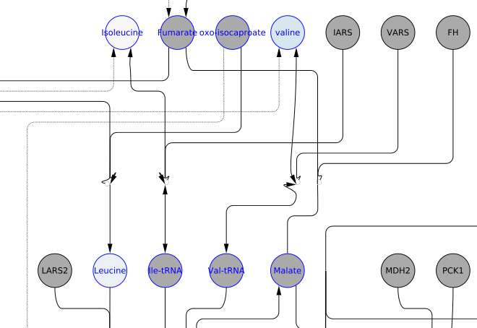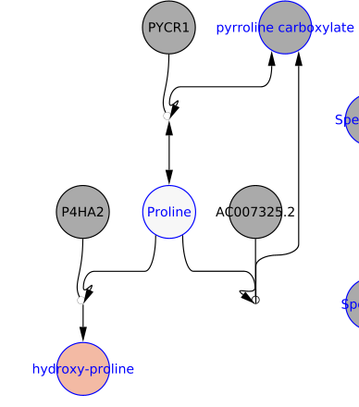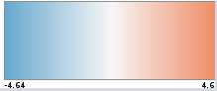

Figure 2_E: **top** one biomarker [glutamine -4.64] visualized in WP4225 (yFiles hierarchical layout); **middle** **left** two biomarkers [uracil 3.02, thymine 3.12] visualized in WP4225 (same layout); **middle right** two biomarker [L-serine -2.17, Glycine 0.41] visualized in WP3940 (yFiles organic layout); **bottom right** one biomarker [ethanolamine -0.47] visualized in WP3940 (yFiles organic layout), mapped KEGG Compound to ChEBI for WP3940. *Same scale as previous Figure.

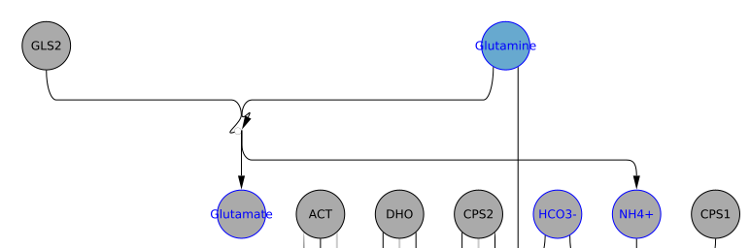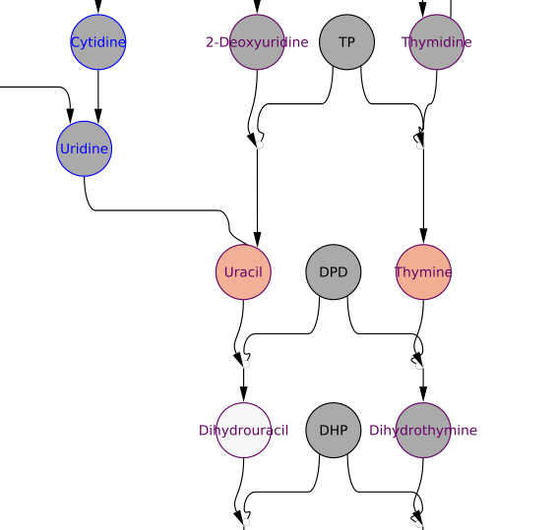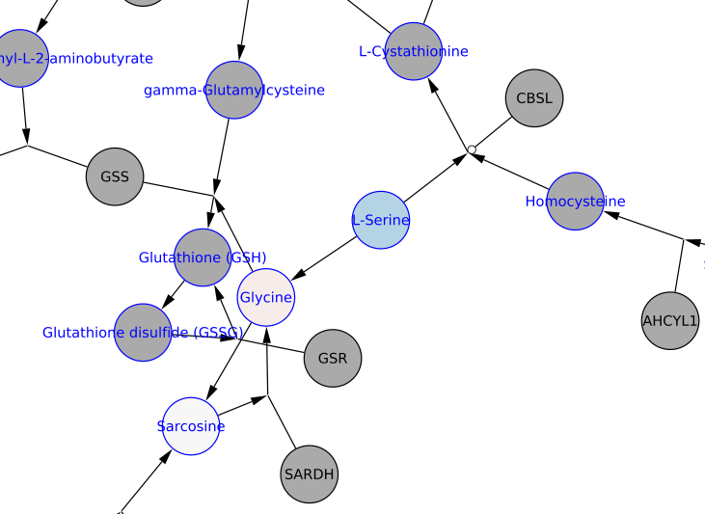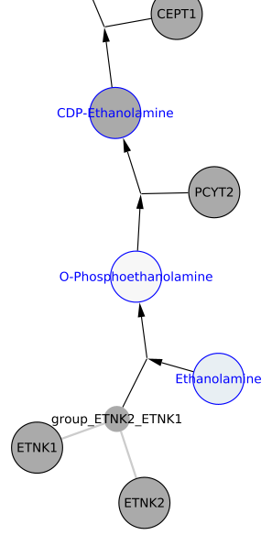

**Results interpretation 1:** DPD

**Results interpretation 2:** Increased uracil and thymine, decreased glutamine. From the table, glutamic acids seems elevated. Low glutamine and high glutamic acid most often means degradation of Gln to Glu. Hydroxyproline increased without proline? Can’t make something of that.

I would say this is an atypical thymine-uraciluria. Probably the sample from the DPT scheme a few years ago.

Final conclusion: results are indicative for DP(Y)D and require further testing.

**Patient F**

[1] "Selected Patient ID is: F , age is between: 16+ years old"

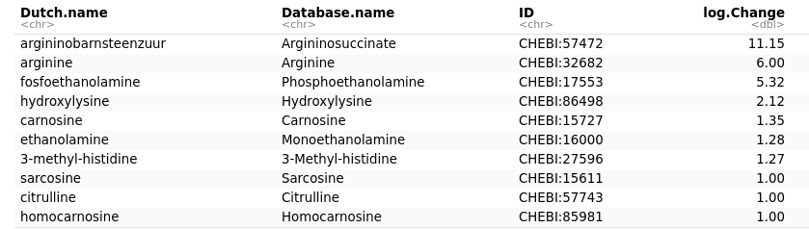[1] "There are 12 biomarkers relevant for patient F , the ChEBI-IDs are ch:17568 ch:17553 ch:15611 ch:57743 ch:58148 ch:16000 ch:57472 ch:27596 ch:86498 ch:32682 ch:15727 ch:85981"

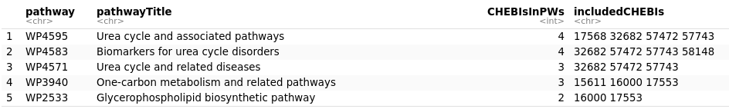[1] "These biomarkers (as ChEBI IDs) are not in a pathway: 27596, 86498"

These biomarkers will not be visualized:

Figure 1_F: four biomarkers [argininosuccinate 11.15, arginine 6.0, citrulline 1, uracil 0.15] visualized in WP4595 (WikiPathways-As-Network layout).

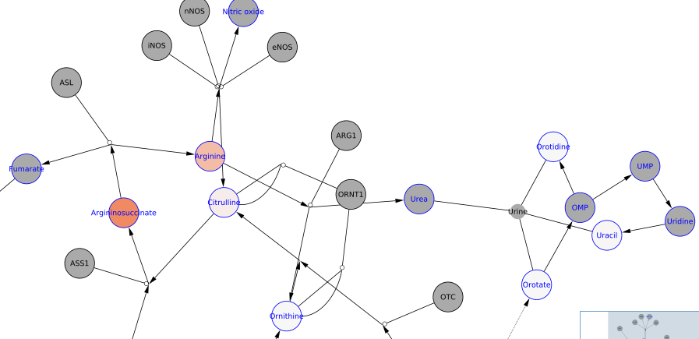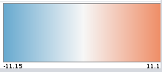

Figure 2_F: **top** four biomarker [argininosuccinate 11.15, arginine 6.0, citrulline 1, homocitrulline 0.74] visualized in WP4583 (WikiPathways-As-Network layout); bottomthree biomarker [ethanolamine 5.32, O-phosphoethanolamine 1.28, sarcosine 1.0] visualized in WP3940 (same layout); mapped KEGG to ChEBI for WP3940. *Same scale as previous Figure.

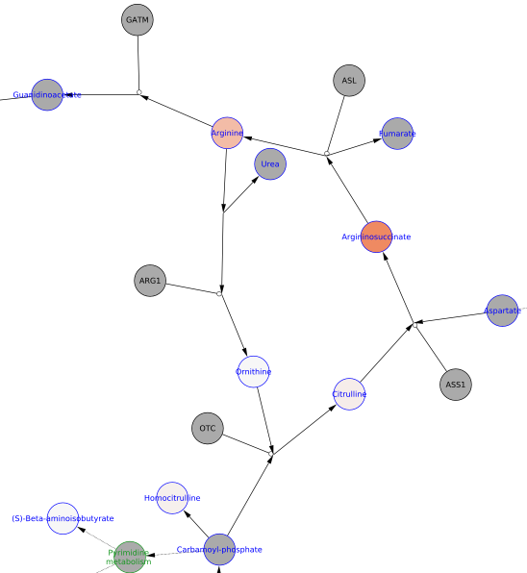

**Results interpretation 1:**

ASL

**Results interpretation 2:**

Argininosuccinate lyase deficieny based on increased argininosuccinate. Patient is supplemented with arginine. No hyperammonaemia.