**Selected Patient ID is: G , age is between: 1 to 5 years old**

Relevant Biomarker data:

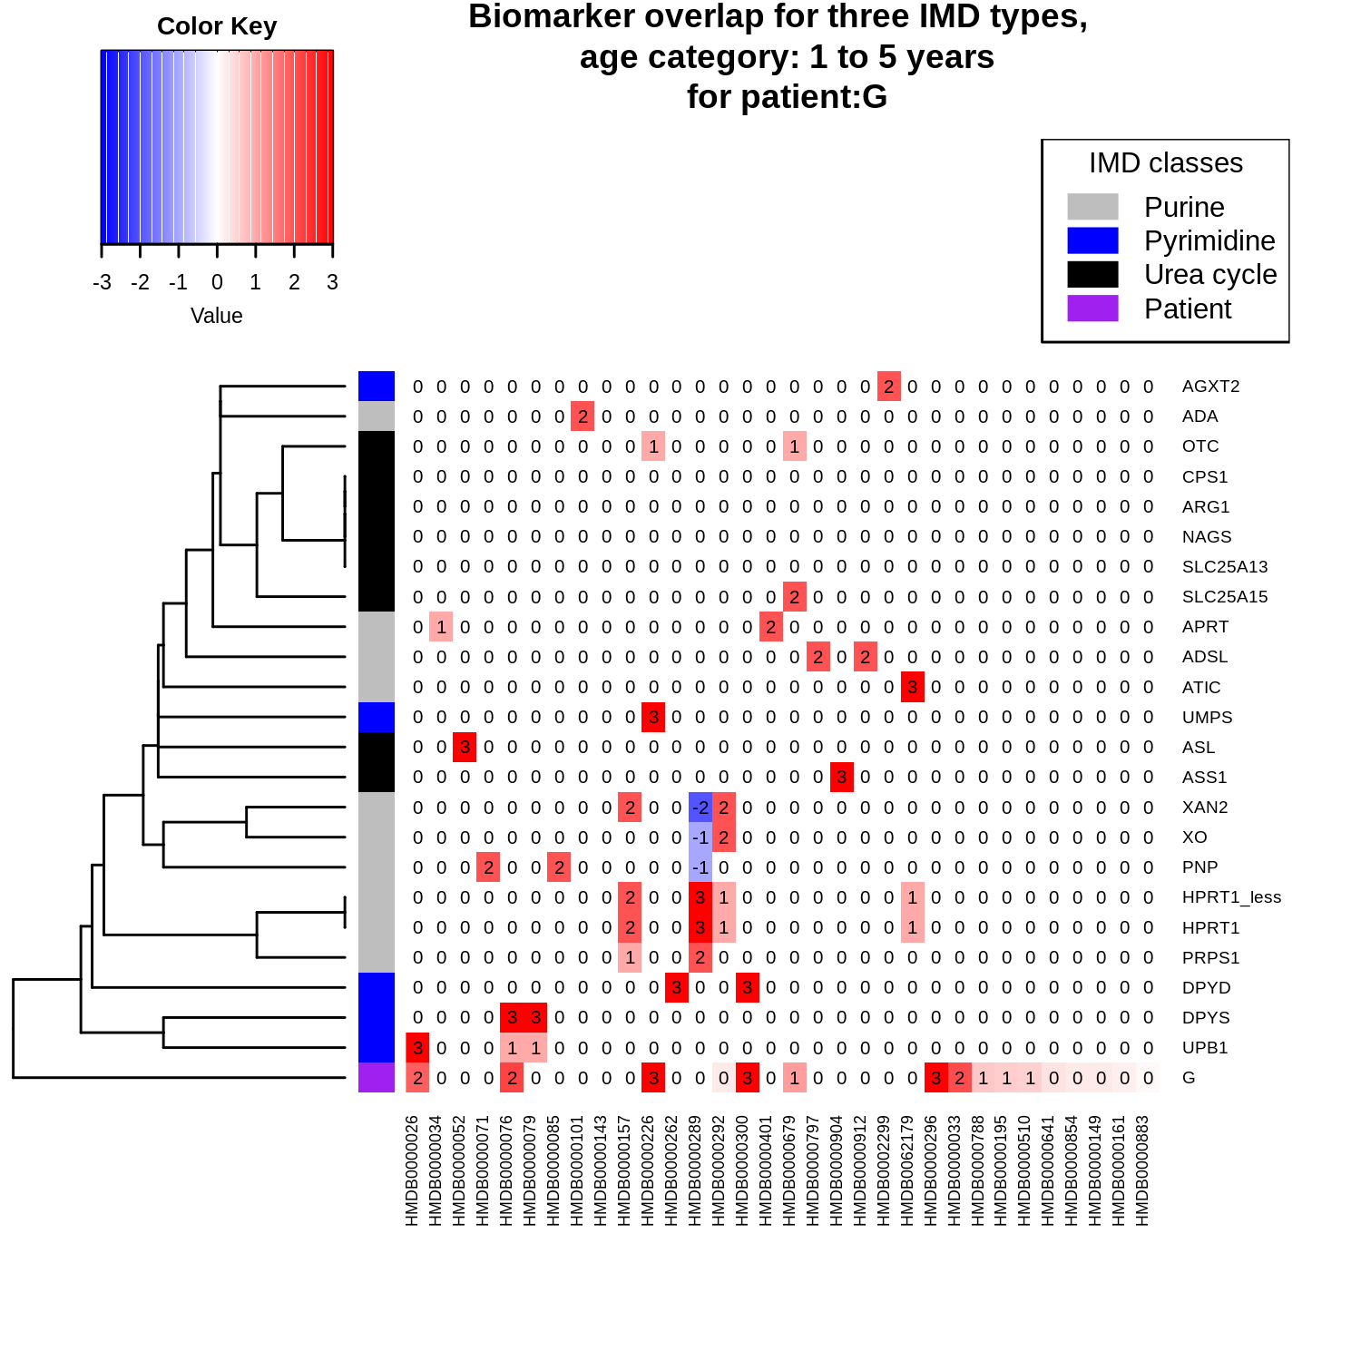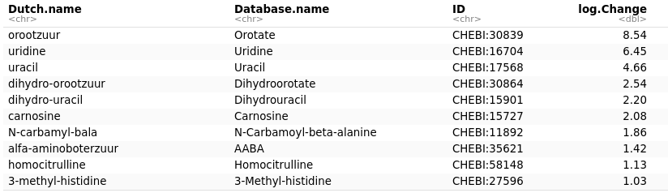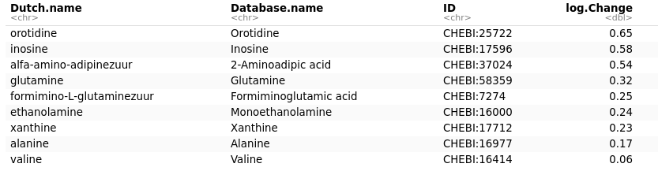[1] "These biomarkers (as ChEBI IDs) are not in a pathway: 35621, 27596; with the following Database names: AABA, 3-Methyl-histidine"

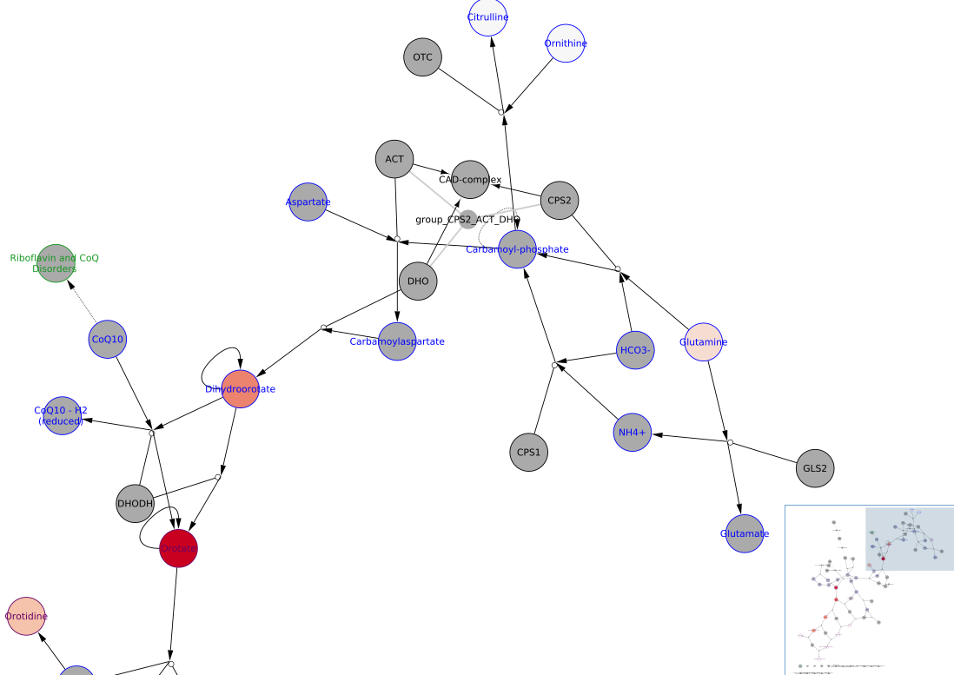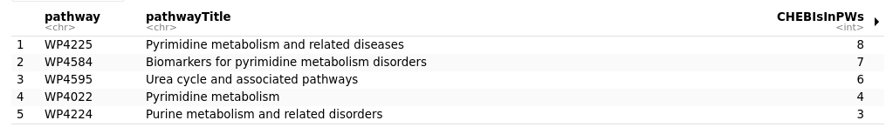

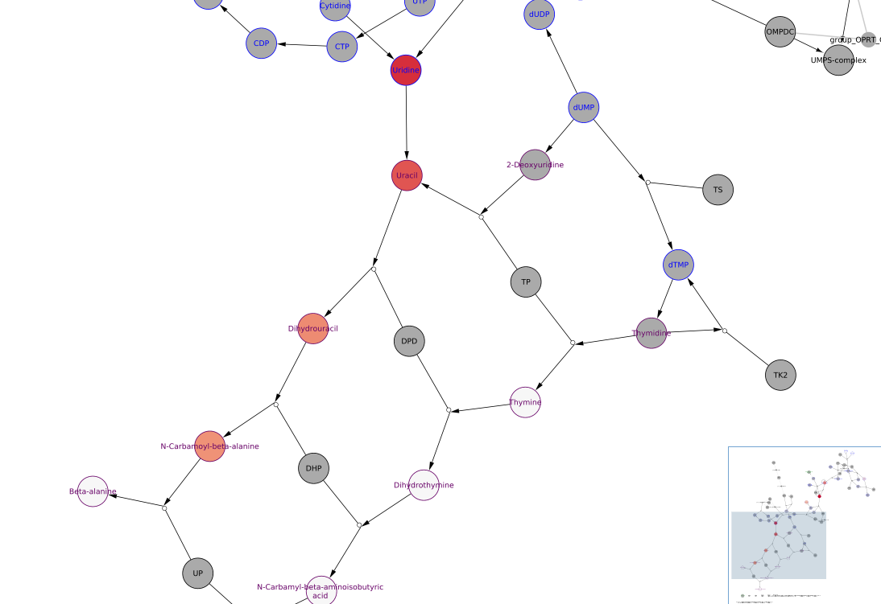

**Interpretation 1:** OTC

**Interpretation 2:** hyperammonaemia, no apparent UCD

Final conclusion: Visualization is indicative of testing for OTC.

**Selected Patient ID is: H , age is between: 5 to 16 years old**

Relevant Biomarker Data (48 in total)

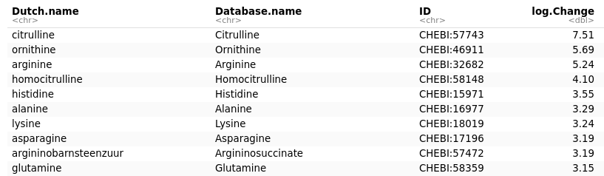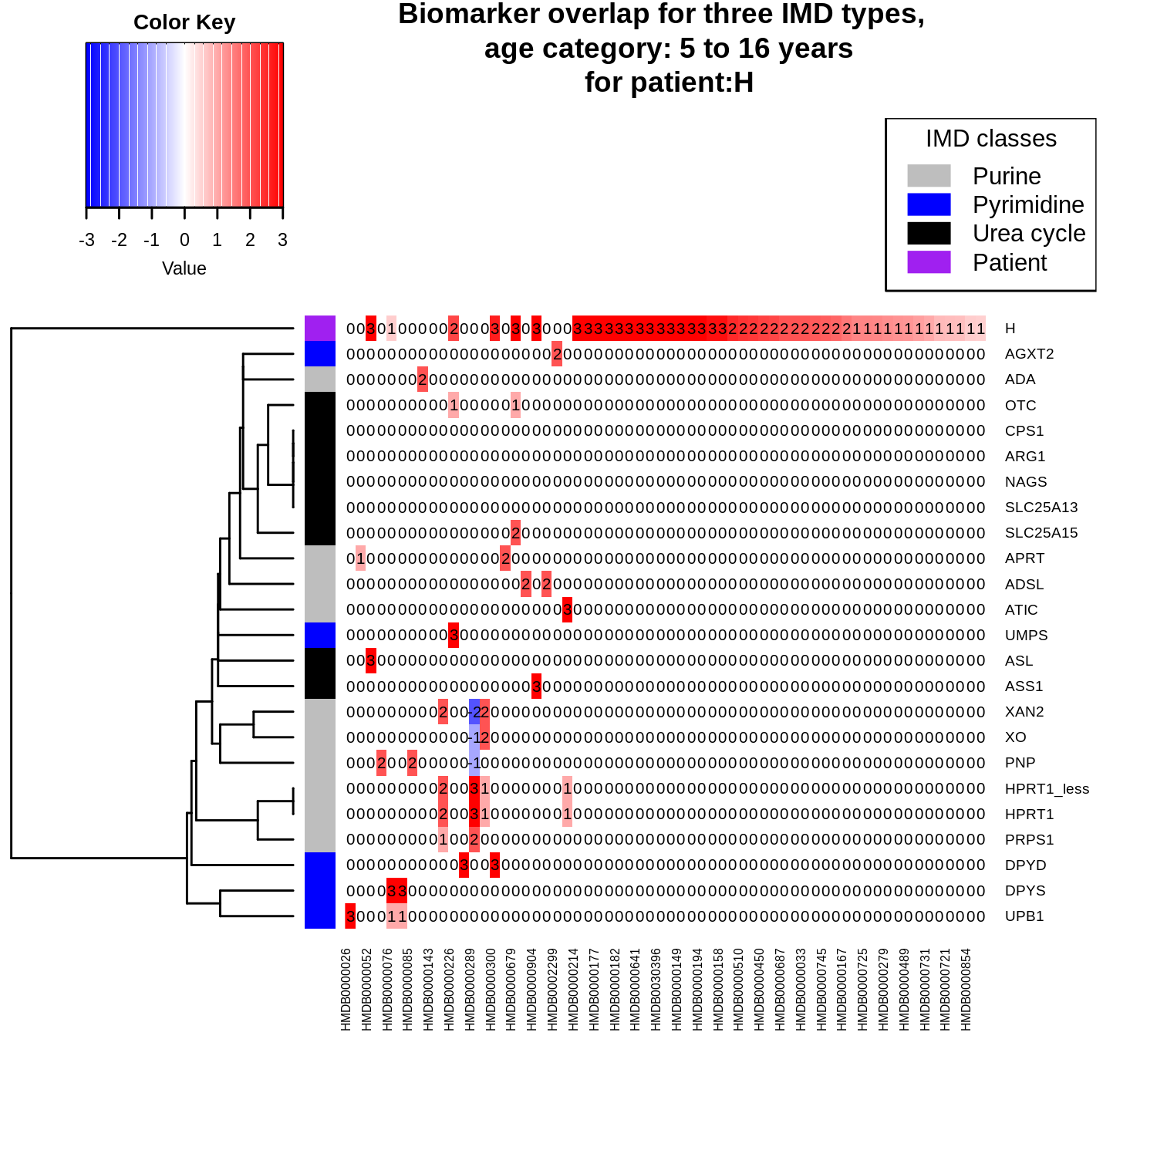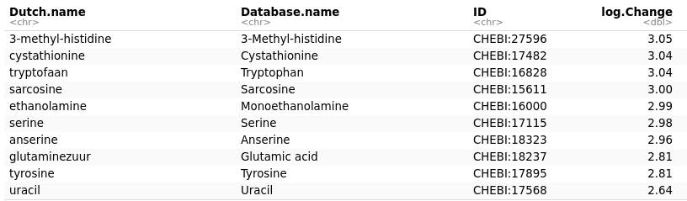

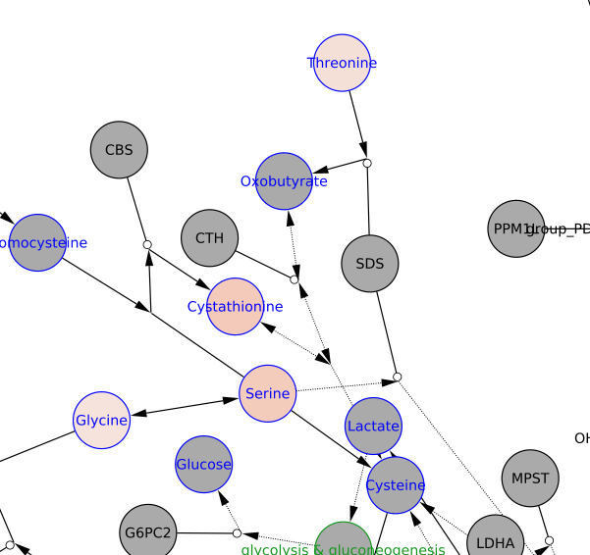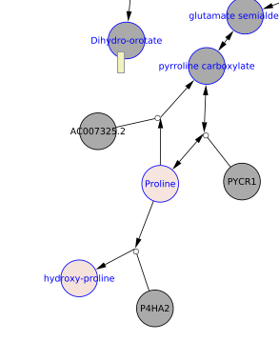

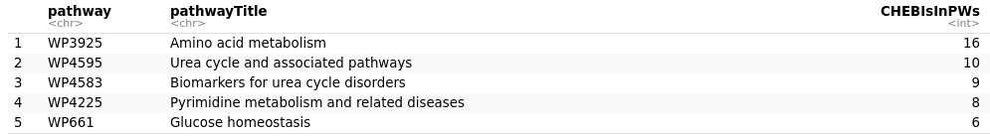

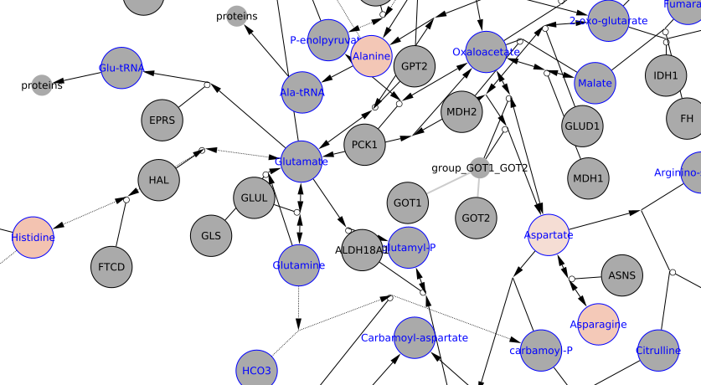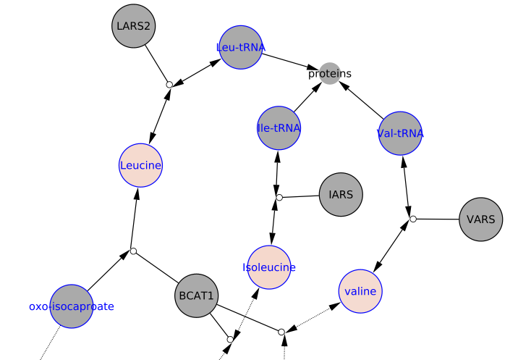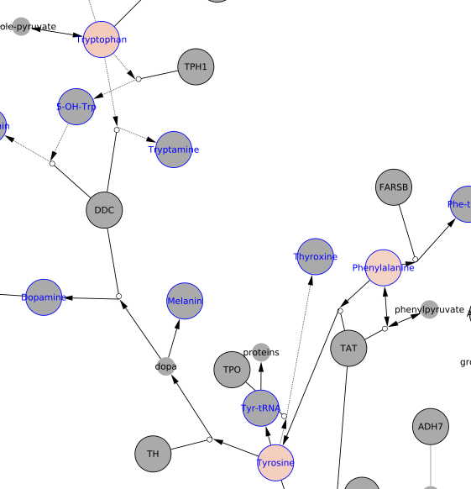

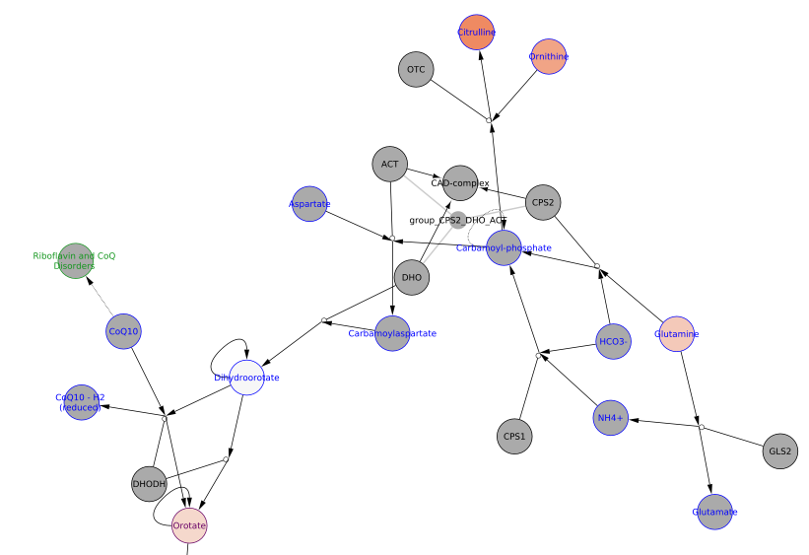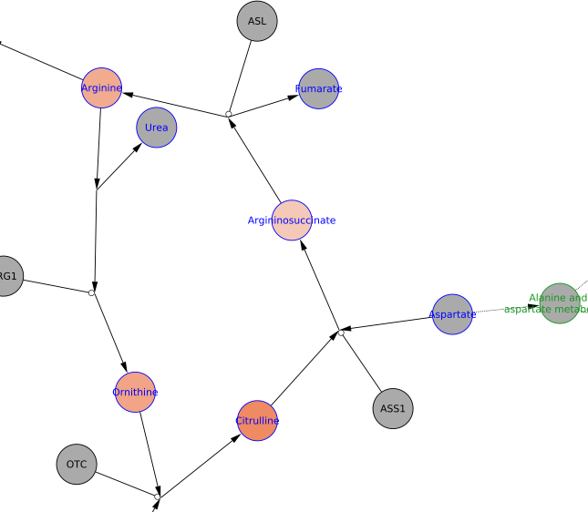

**Interpretation 1:** ASL

**Interpretation 2:** citrullinaemia type I or II

Final conclusions: Argininosuccinate is normally only elevated in ASL, so this is an unexpected finding. Example for “blind spot”. Citrulline was added as treatment for this patient, which made this case difficult to diagnose.

**Selected Patient ID is: I , age is between: 0 to 1 years old**

Relevant biomarkers

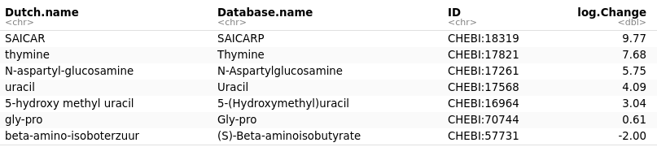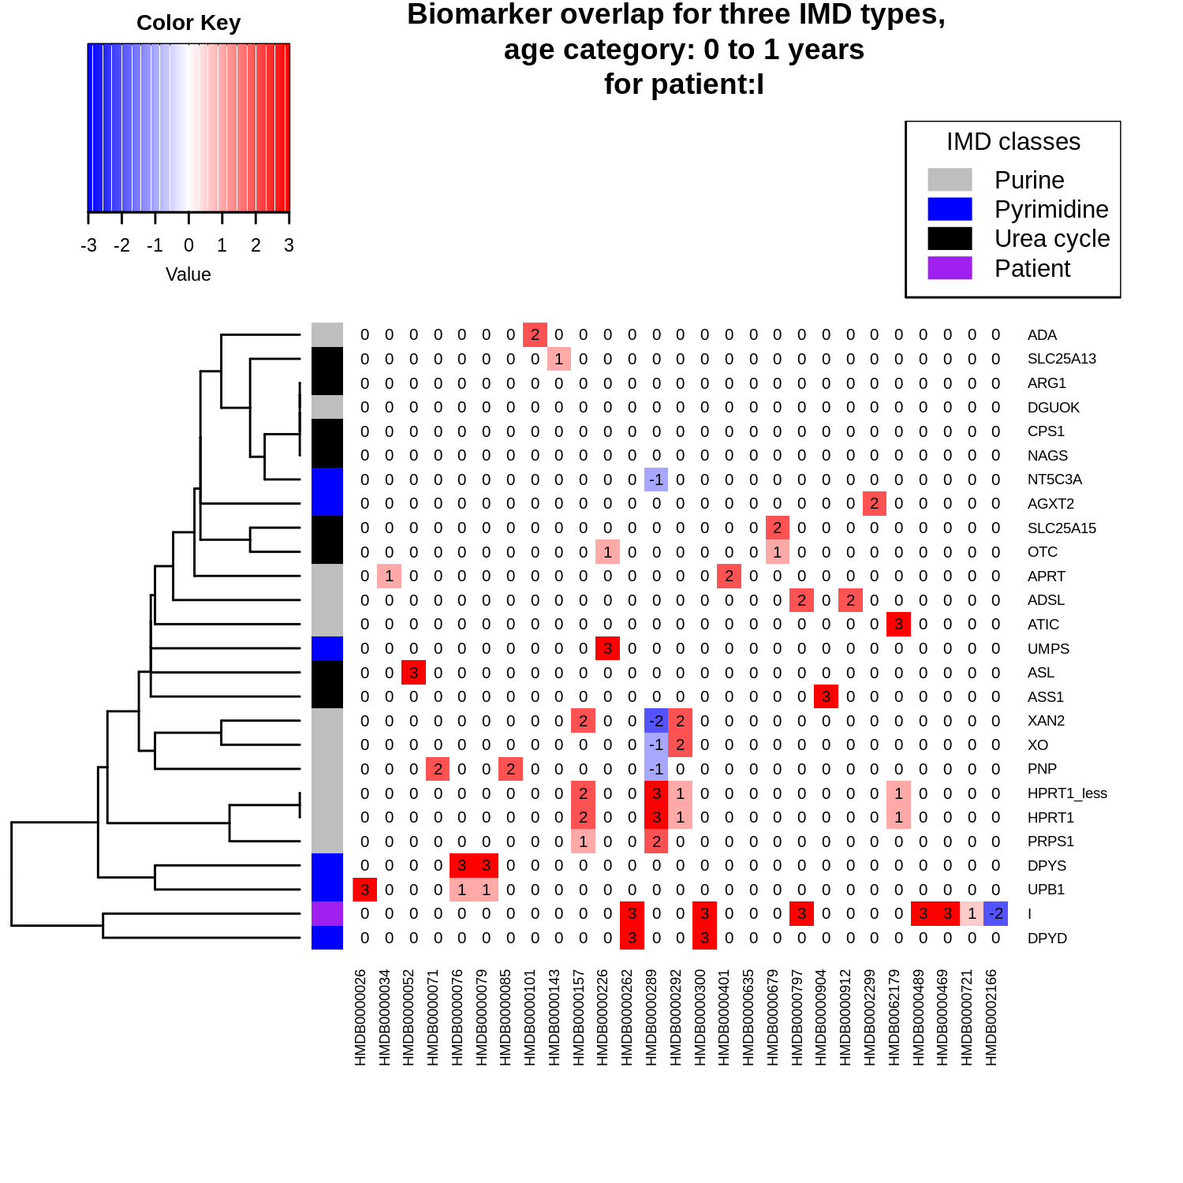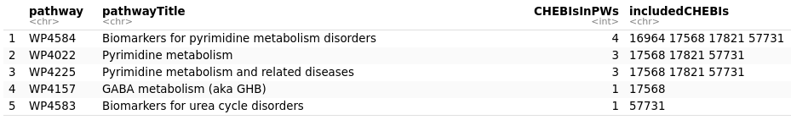

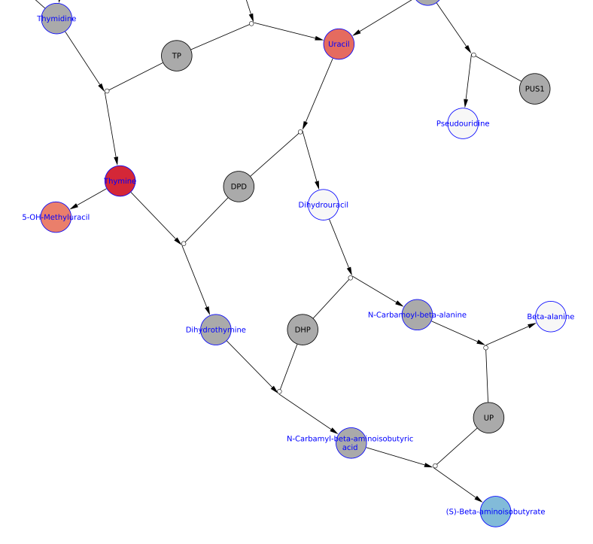

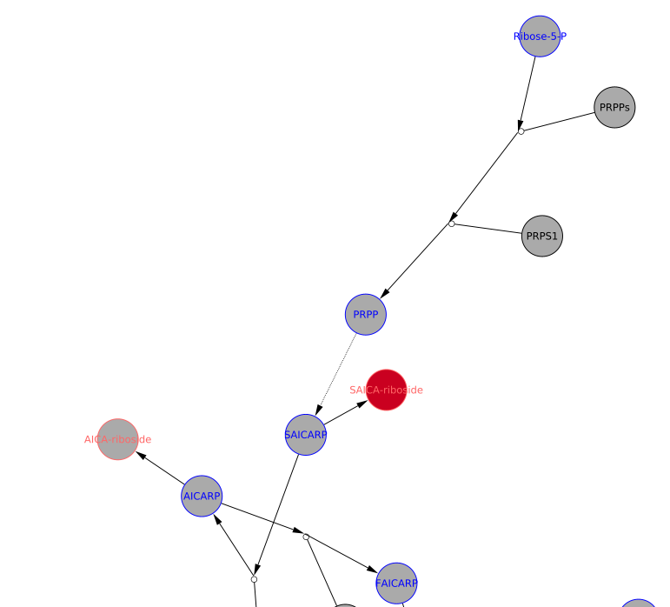

**Interpretation 1:** DPYD

**Interpretation 2:** DPYD, Interpretation: Thymine, Uracil and 5-OH-Me-Uracil are suggestive of dihydropyrimidine dehydrogenase deficiency. SAICAriboside does not make sense and by itself maybe suggests immaturity. Without SAdo or AICAriboside no indication of ADSL or ATIC deficiency.

**Selected Patient ID is: J , age is between: 0 to 1 years old**

Relevant Biomarkers:

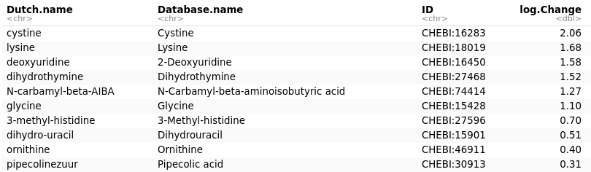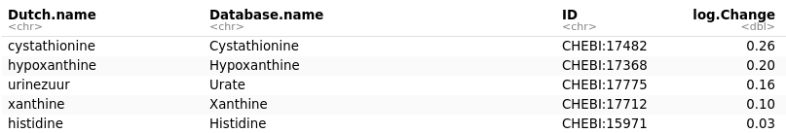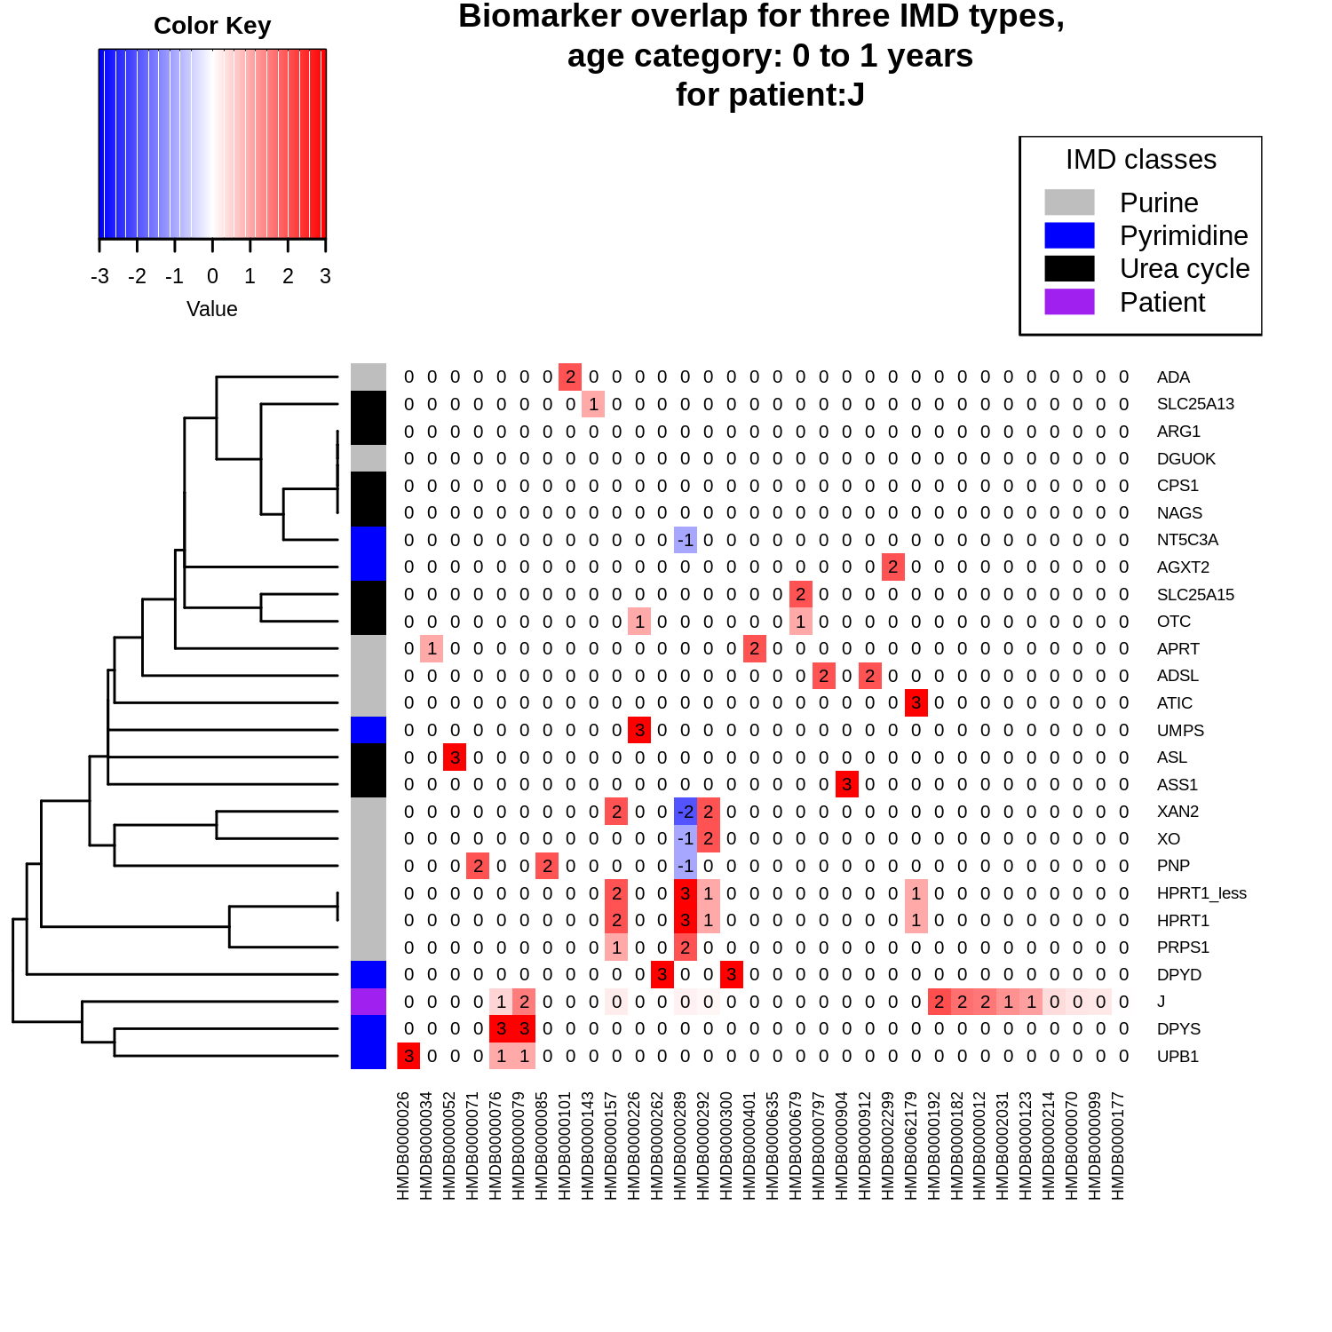

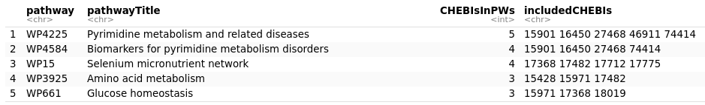

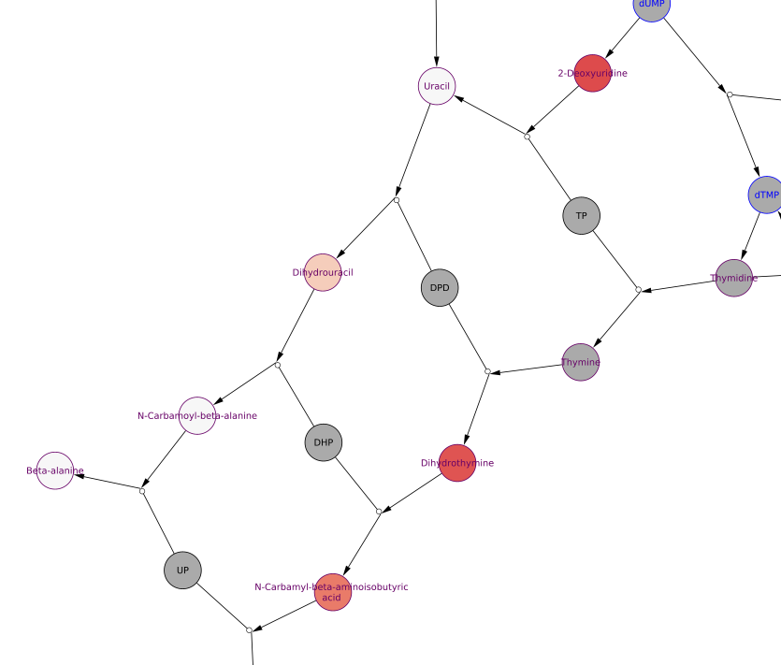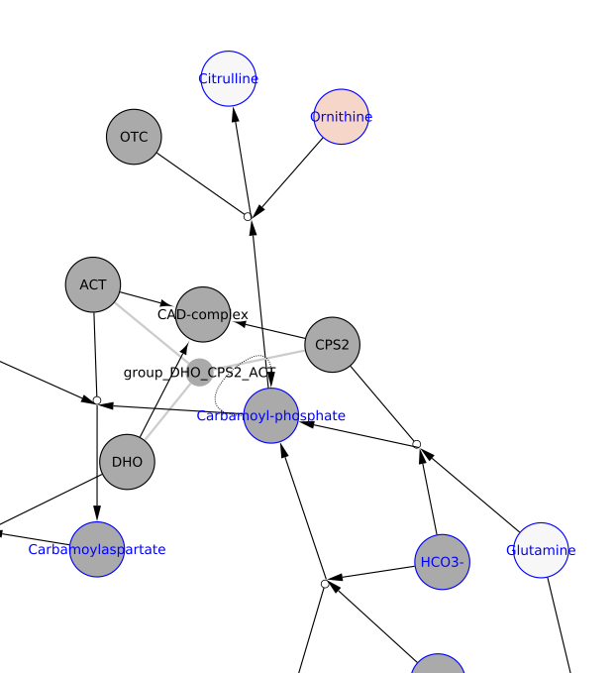

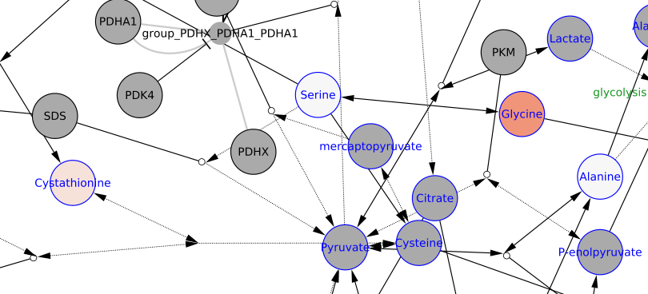

**Interpretation 1:** Cystinuria?

**Interpretation 2:** Interpretation: no diagnosis. Cystine and lysine suggest immaturity. Thymine degradation prominent, but pattern does not fit beta-ureidoprionase deficiency. Probably very young infant.

Final conclusions: Difficult sample to diagnose.

**Selected Patient ID is: K , age is between: 16+ years old**

Relevant Biomarkers:

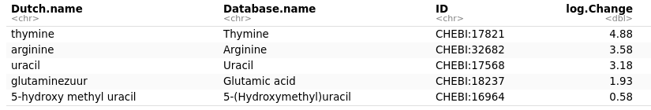

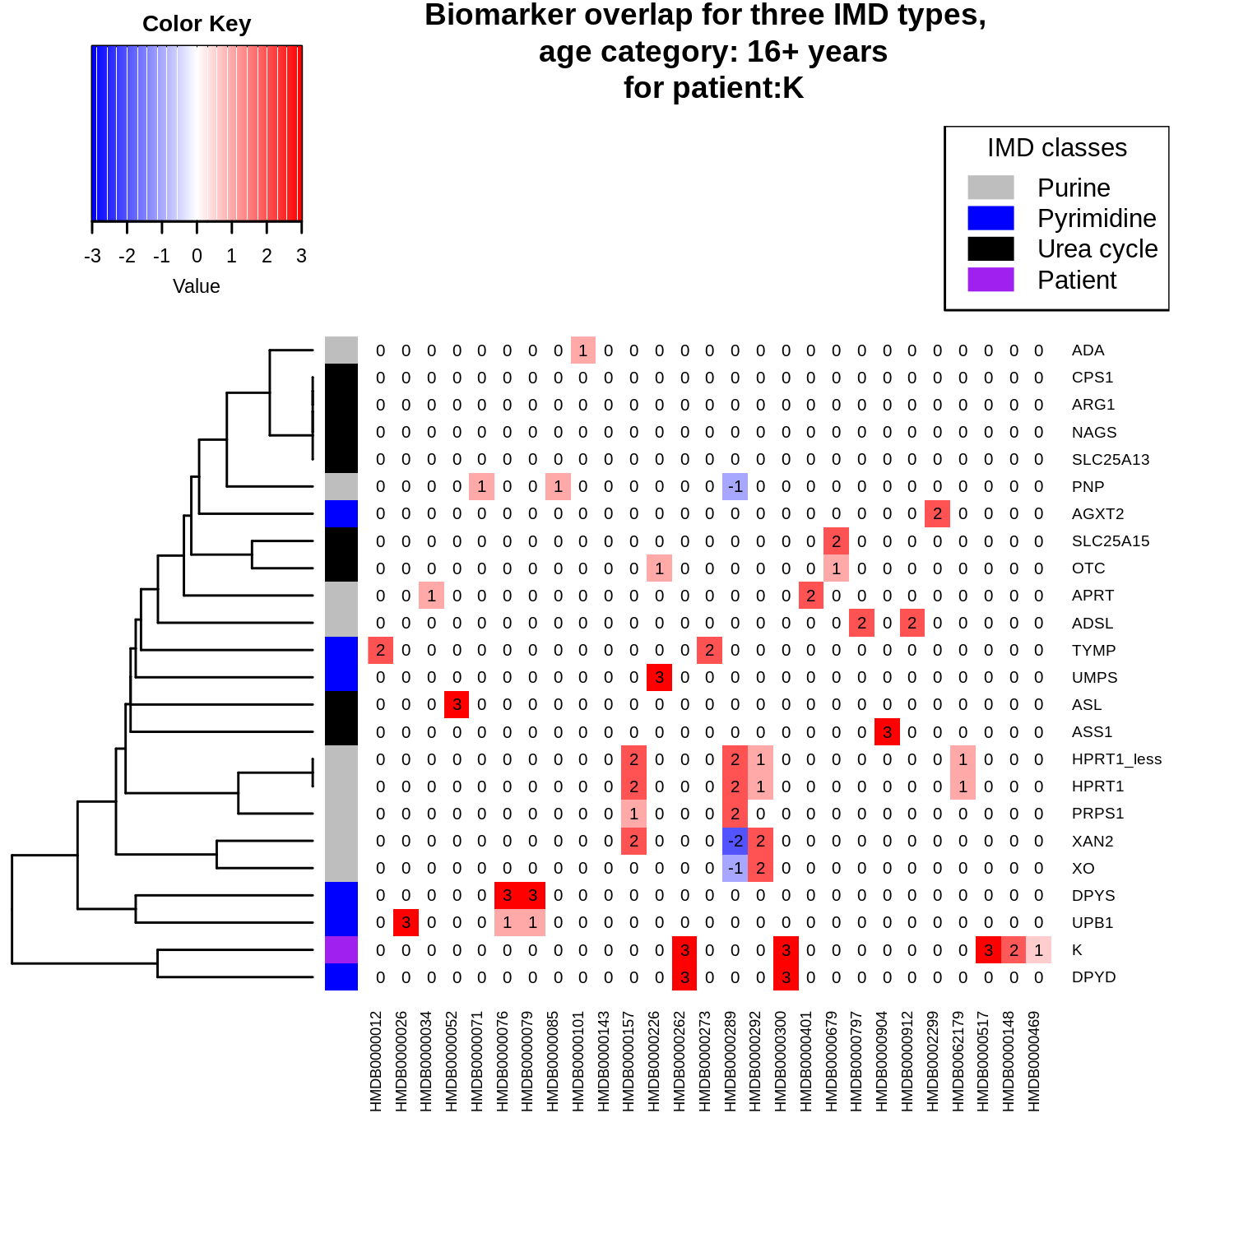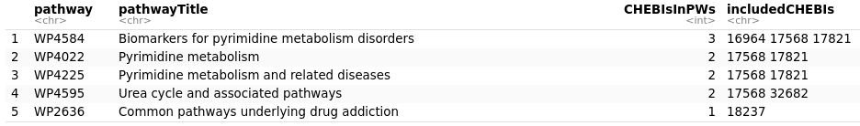

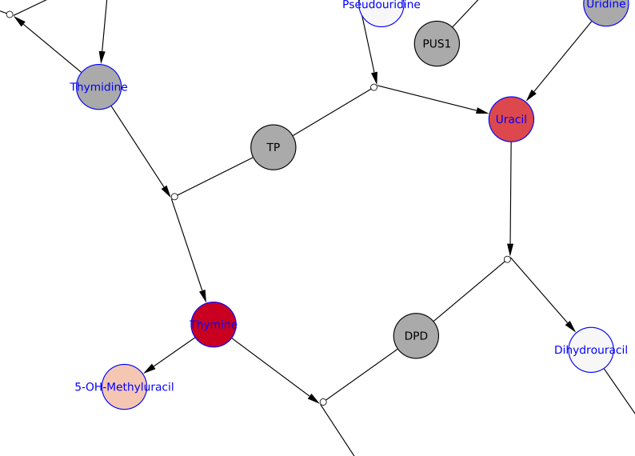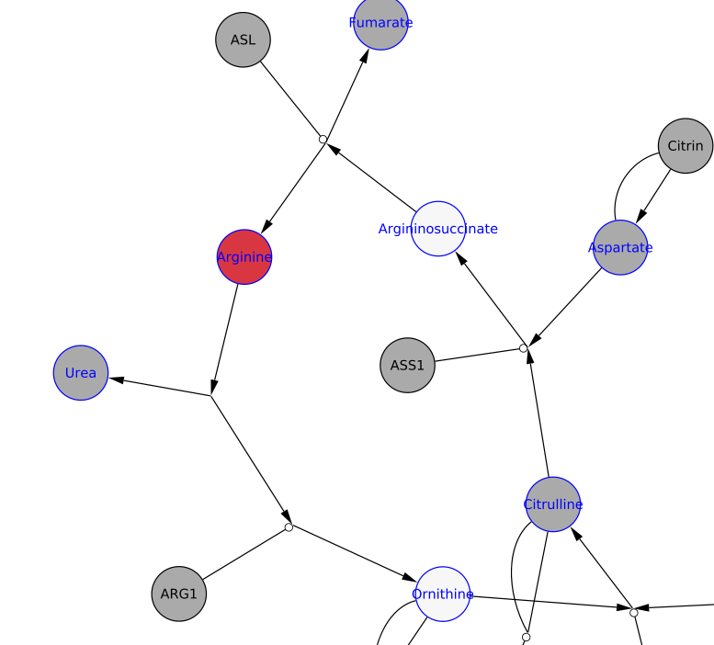

**Interpretation 1:** DPYD

**Interpretation 2:** DPYD, Interpretation: Thymine, Uracil and 5-OH-Me-Uracil are suggestive of dihydropyrimidine dehydrogenase deficiency. 5-OH-Me-Uracil is significantly lower than in patient I. Arginine is elevated, I cannot explain well why.

**Selected Patient ID is: L , age is between: 5 to 16 years old**

Relevant Biomarkers:

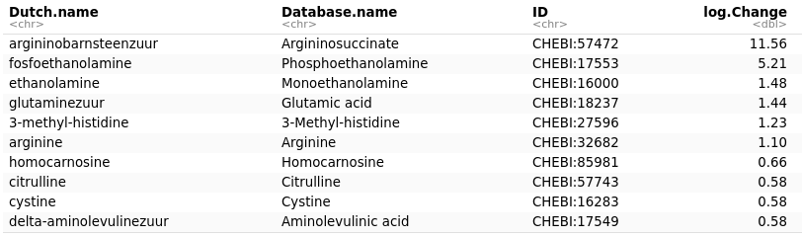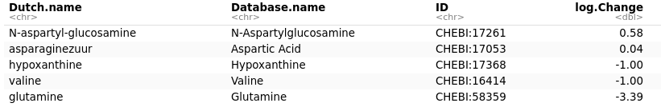

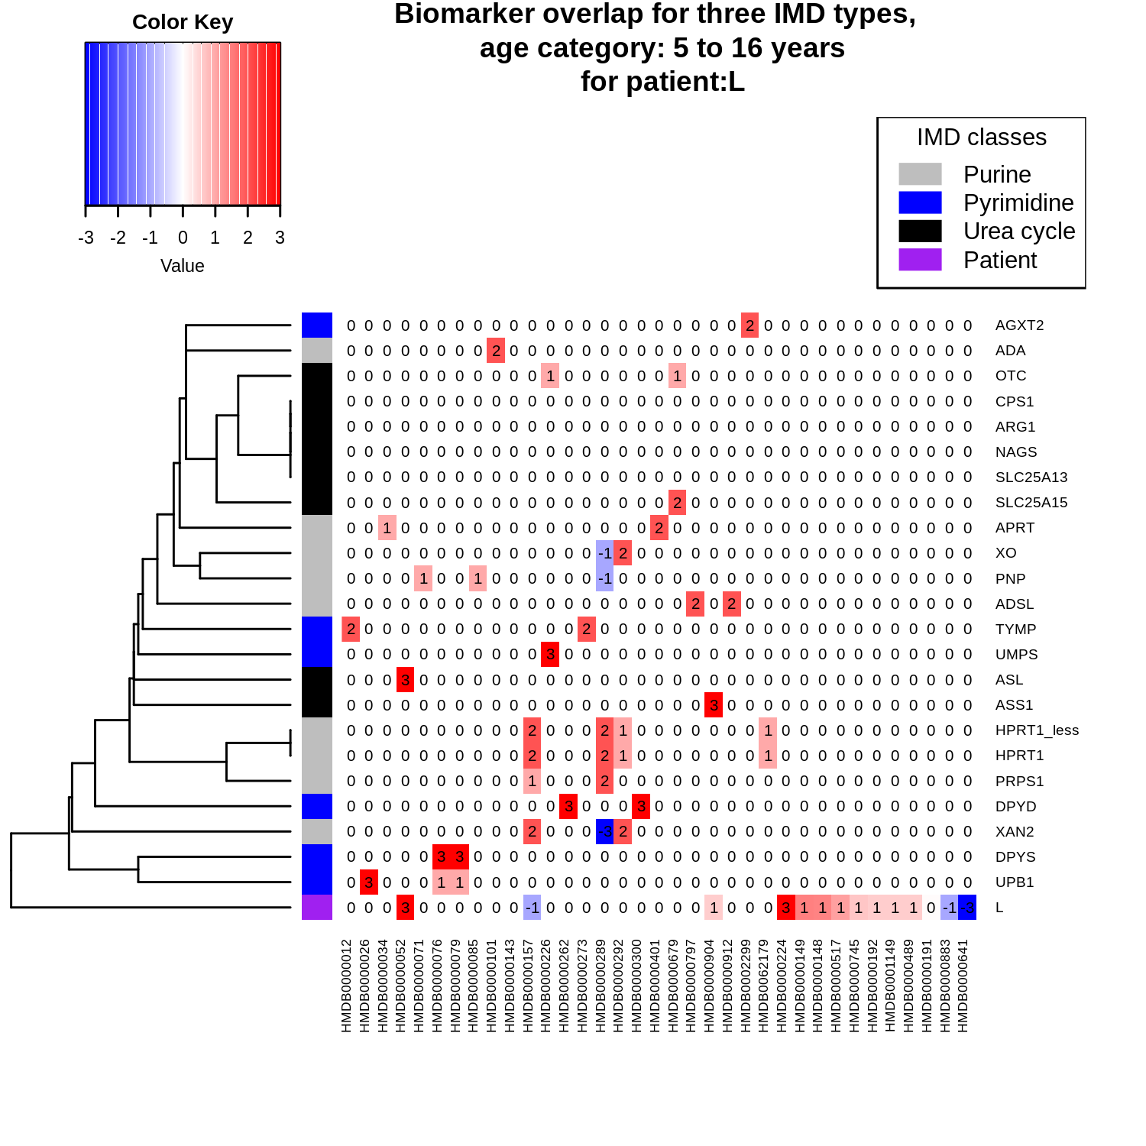

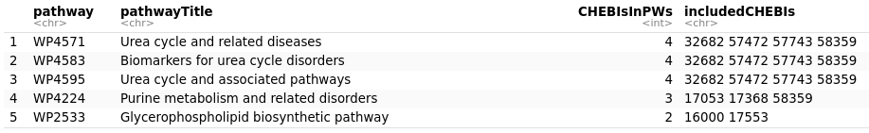

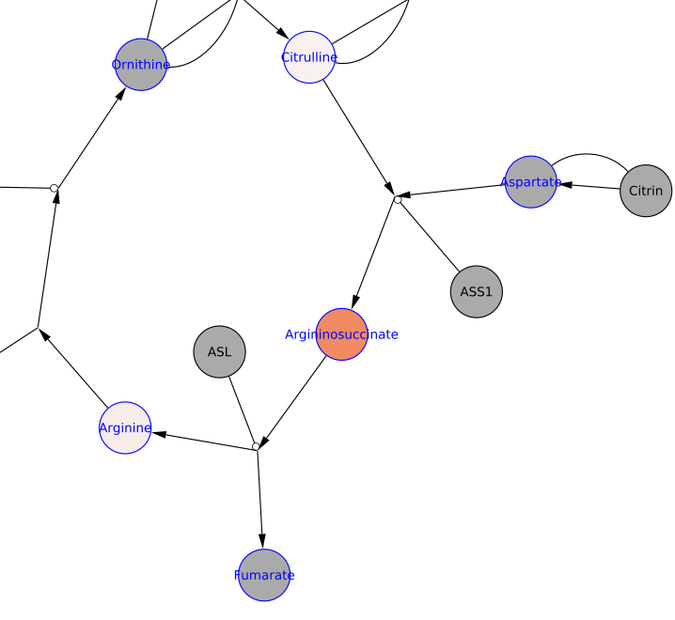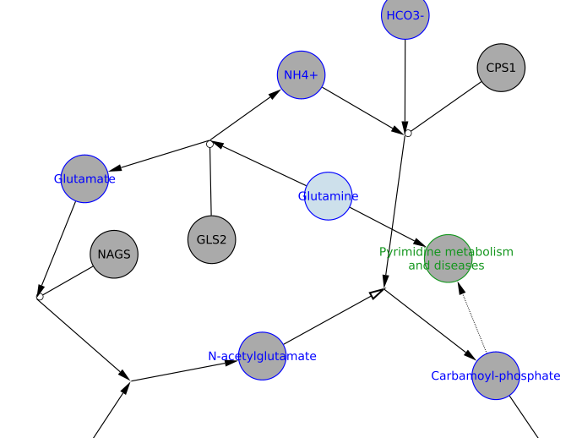

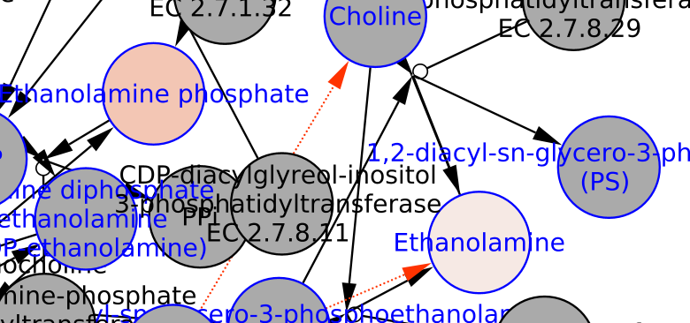

**Interpretation 1:** ASL

**Interpretation 2:** ASL

**Selected Patient ID is: M , age is between: 1 to 5 years old**

Relevant Biomarkers (out of 30):

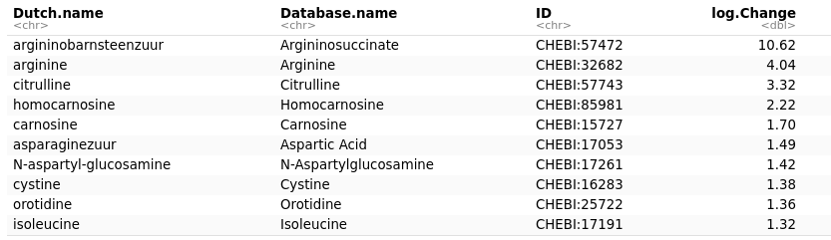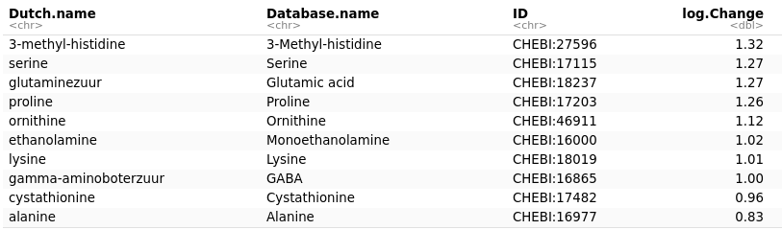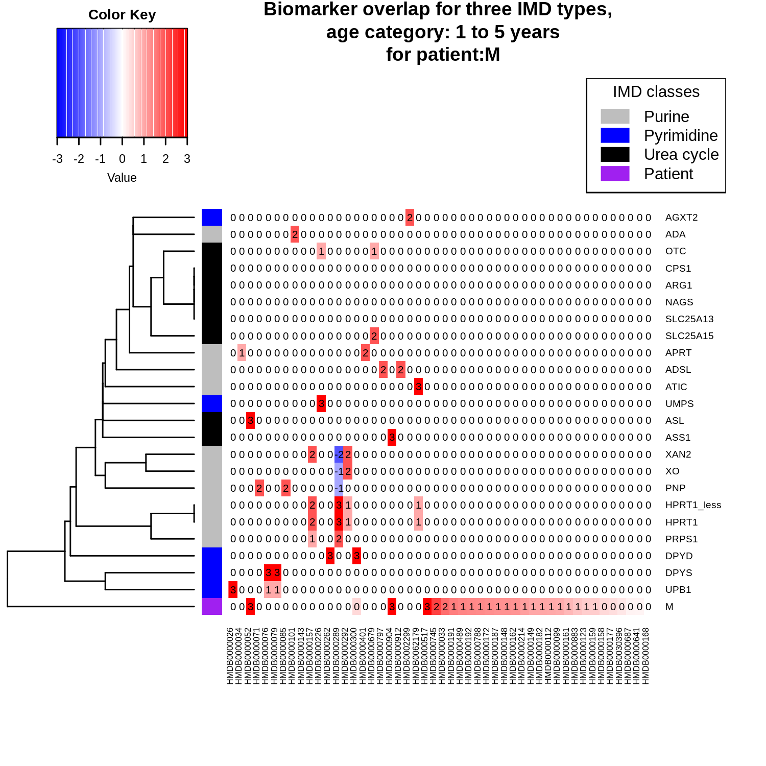

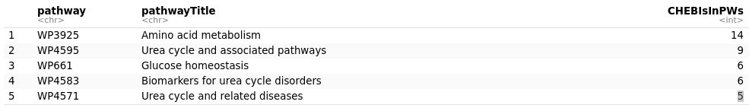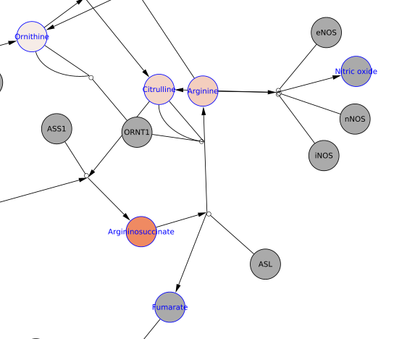

**Interpretation 1:** ASL

**Interpretation 2:** ASL

**Selected Patient ID is: N , age is between: 1 to 5 years old**

Relevant Biomarkers (out of 36):

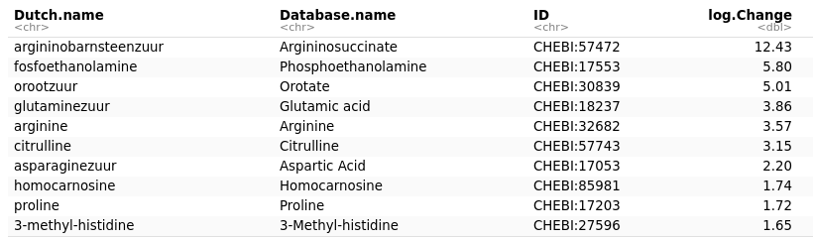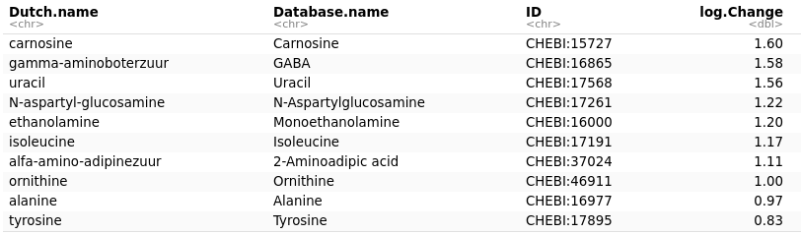

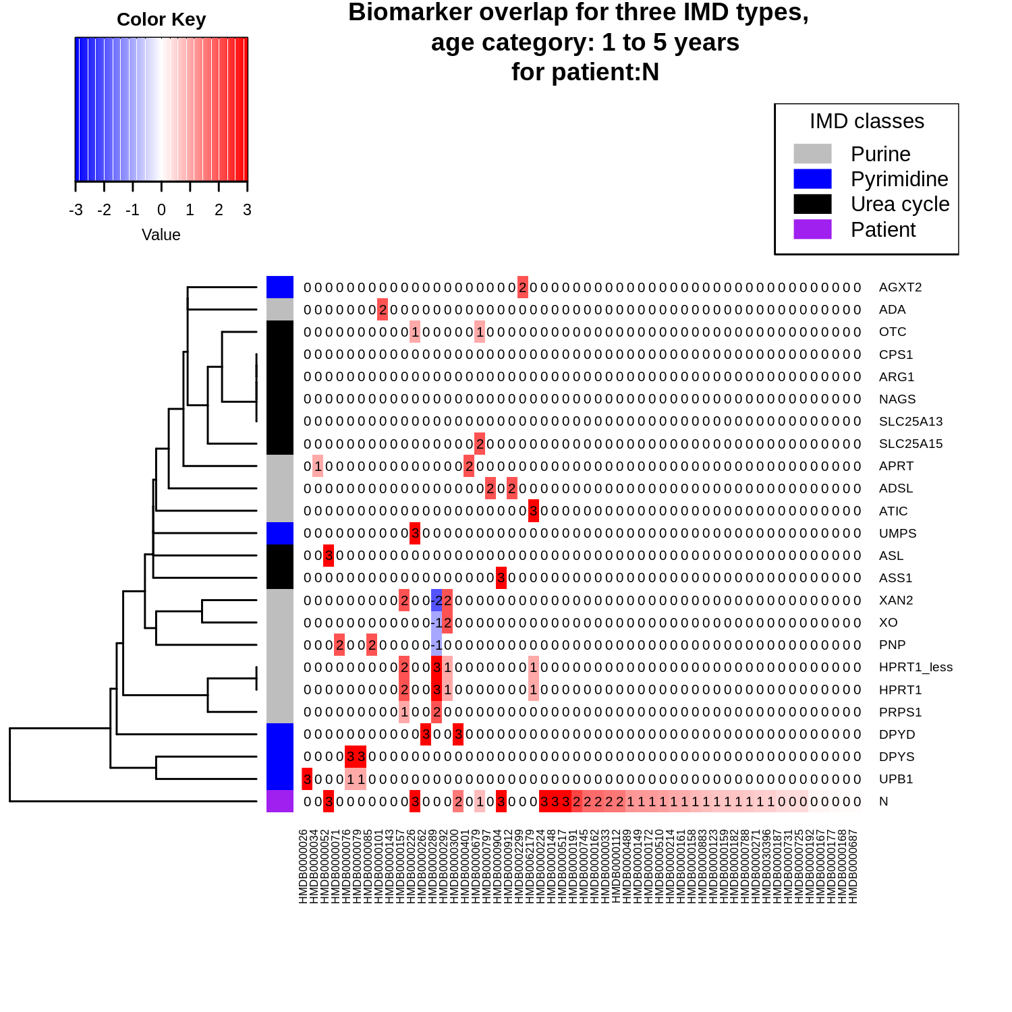

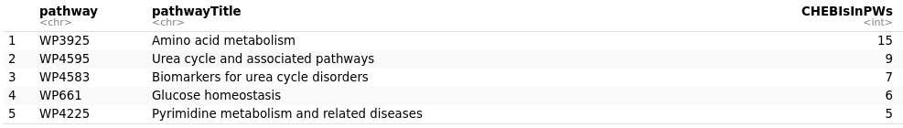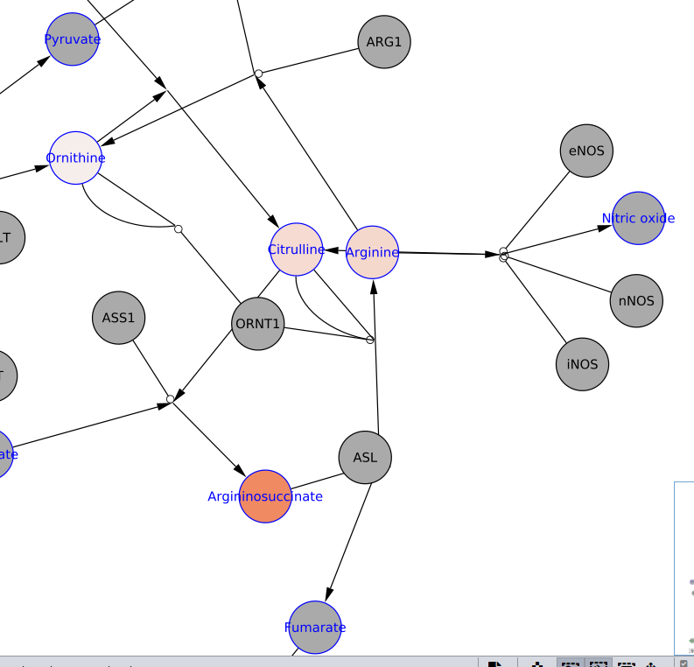

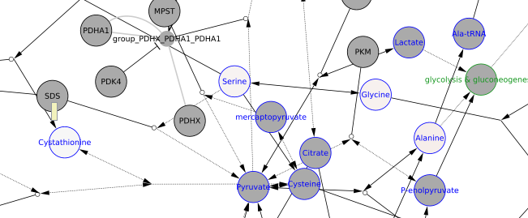

**Interpretation 1:** ASL

**Interpretation 2:** ASL