**Selected Patient ID is: O , age is between: 16+ years old**

Relevant Biomarkers (out of 42):

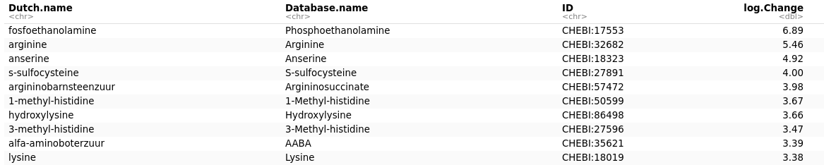

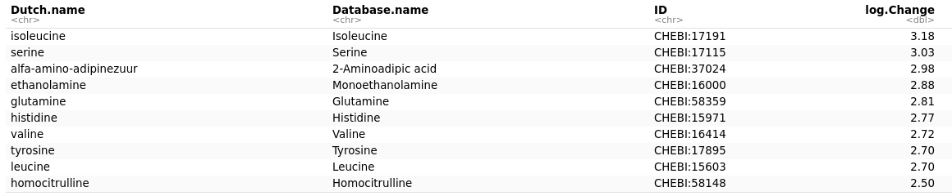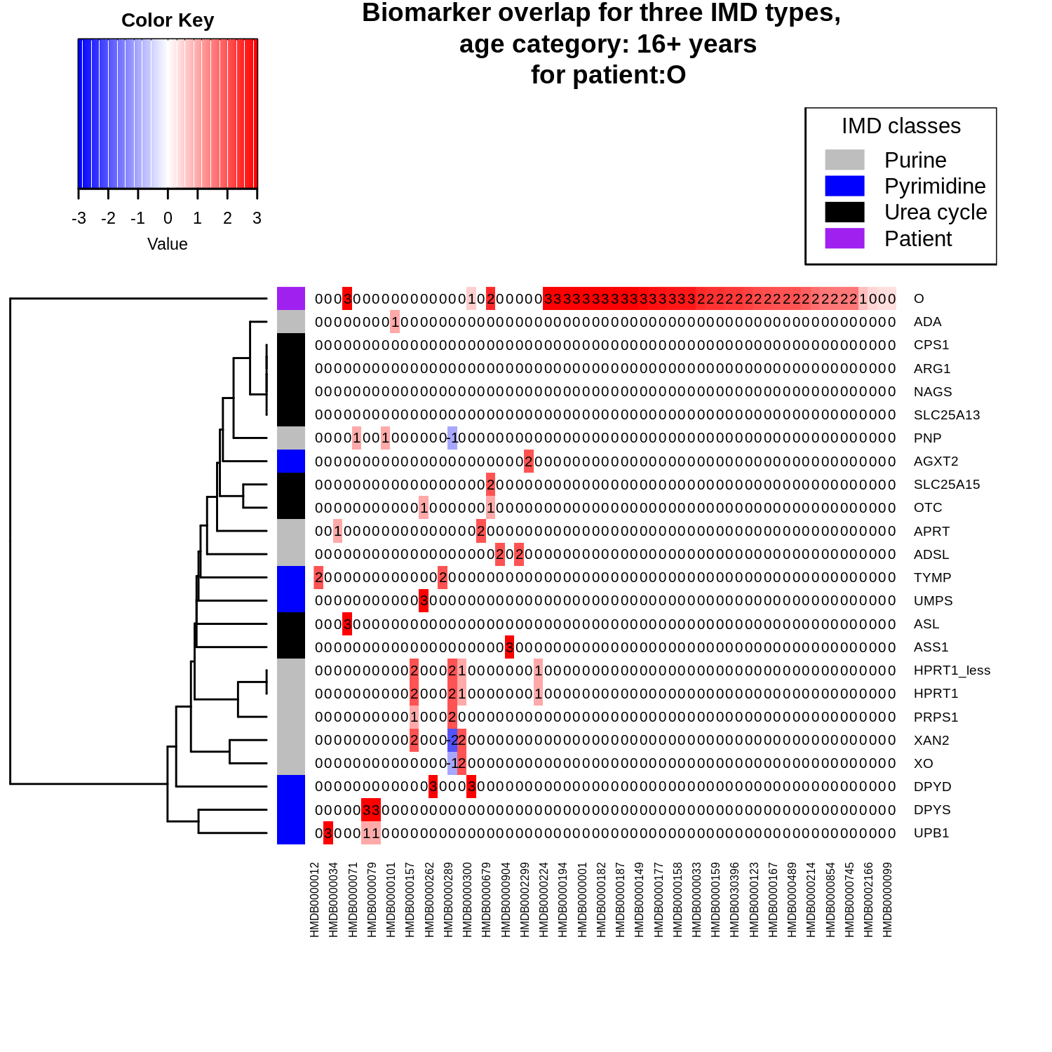



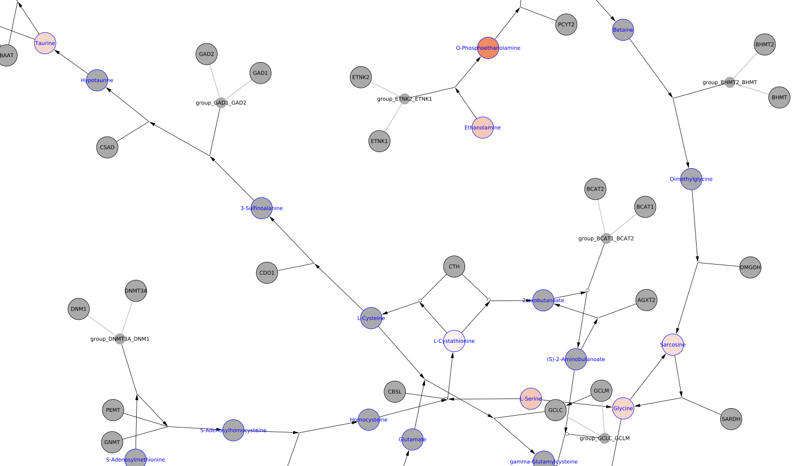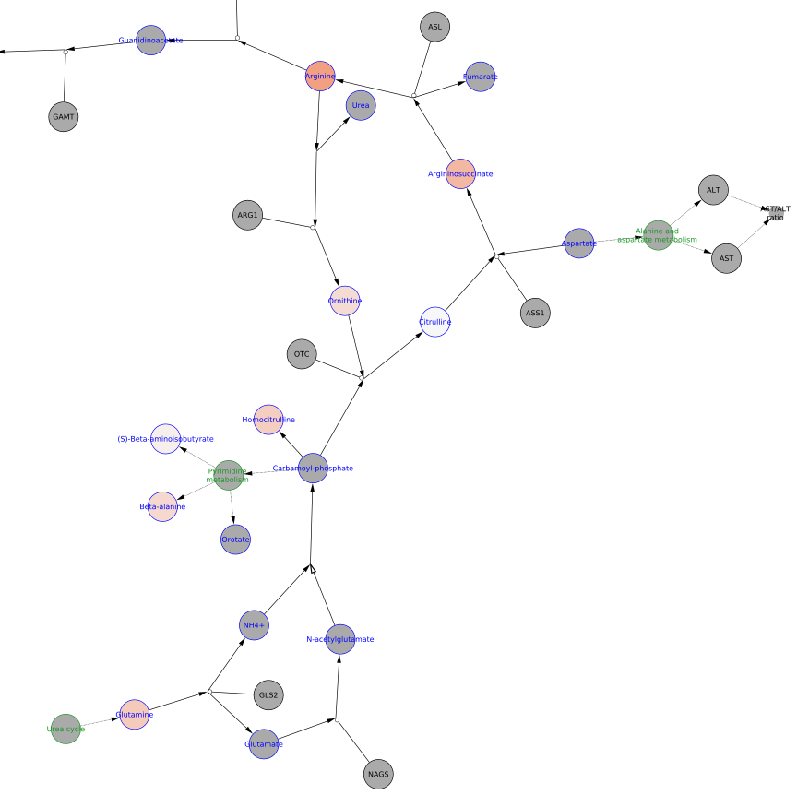

**Interpretation 1:** ARG

**Interpretation 2**: Hypophosphatasia, Other metabolites due tubular dysfunction.

Final conclusion: Difficult to diagnose, Cycle between arginine, arginosuccinate and ornithine are scewing the expected biomarker pattern. Raised arginine (higher than ornithine) is unexpected for this disorder .

**Selected Patient ID is: R , age is between: 5 to 16 years old**

Relevant Biomarkers (out of 43):

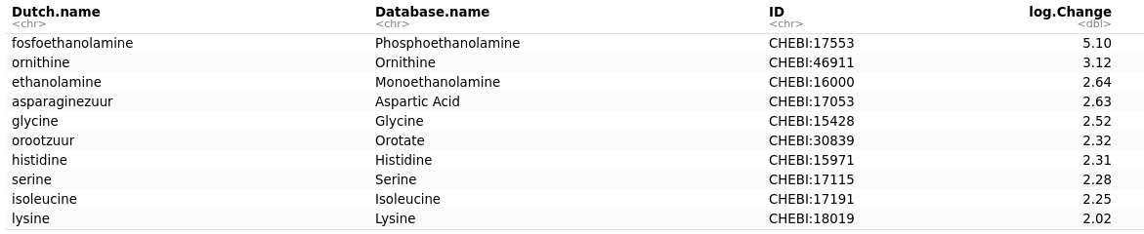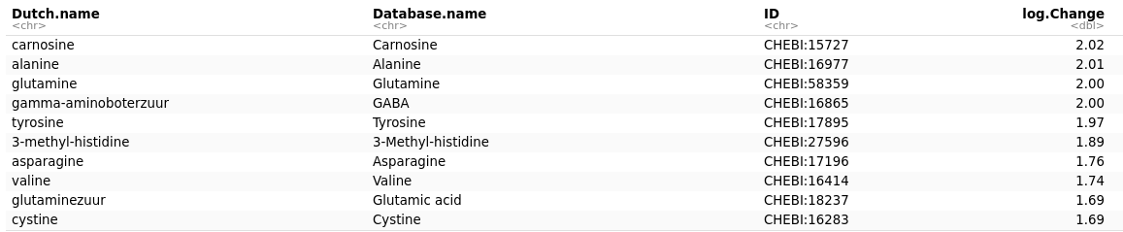

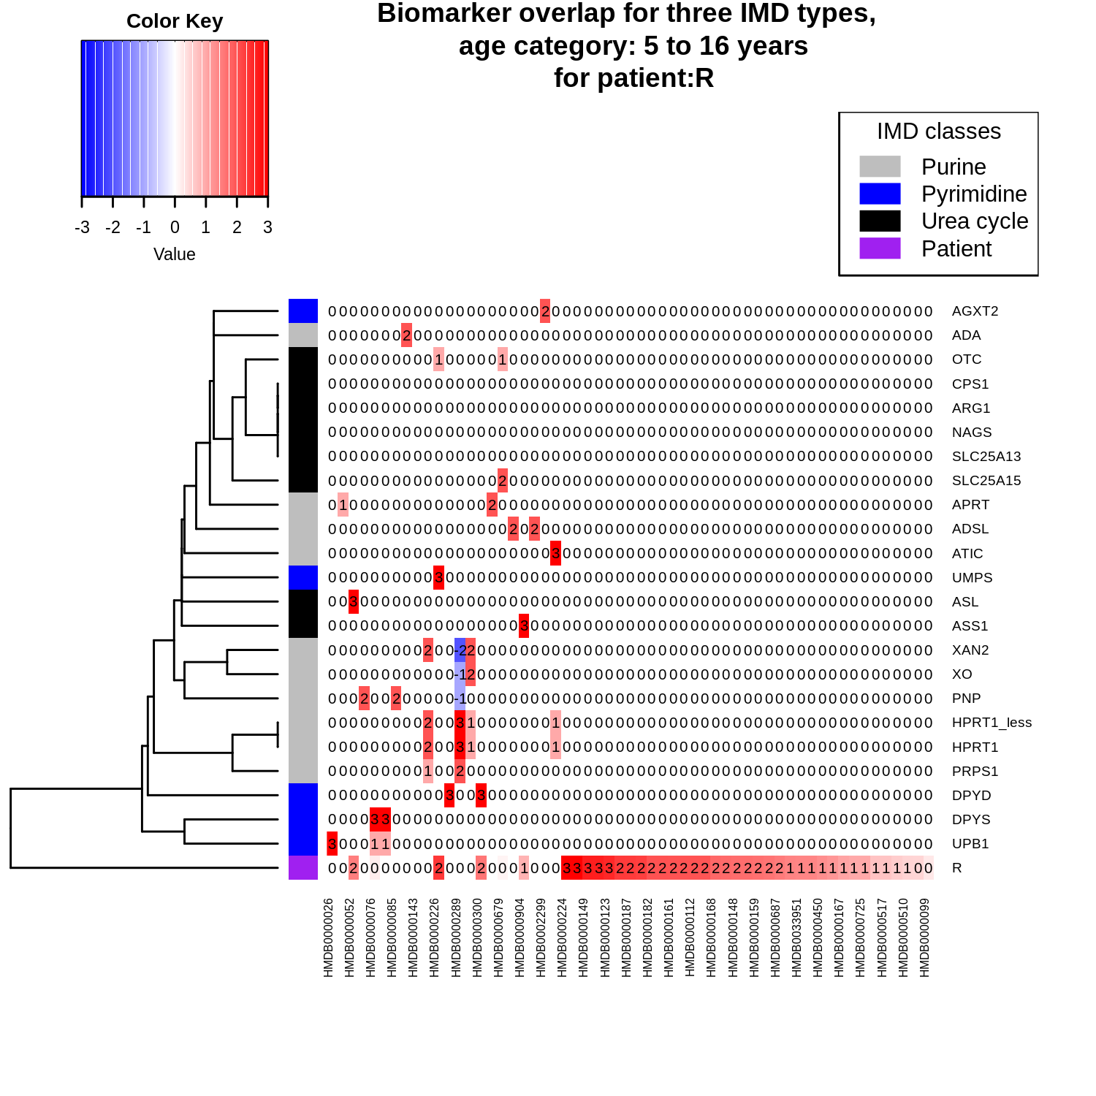

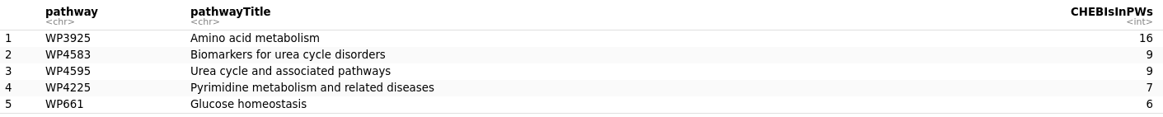***Note that phosphoethanolamine, the biomarker with the highest change, is not part of the top 3 pathways.

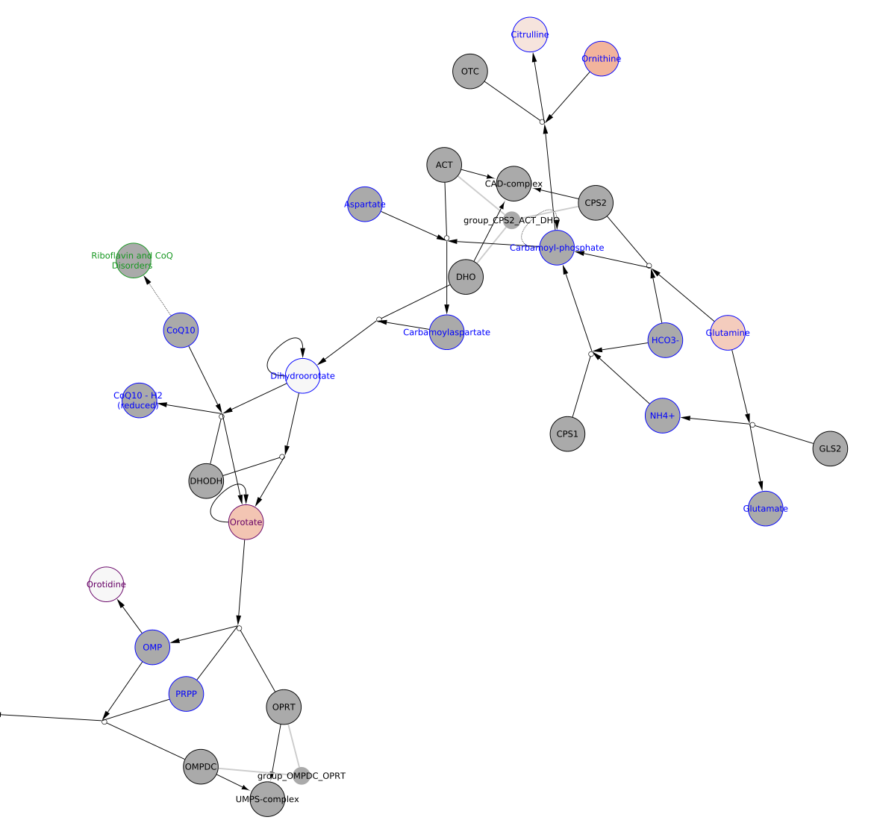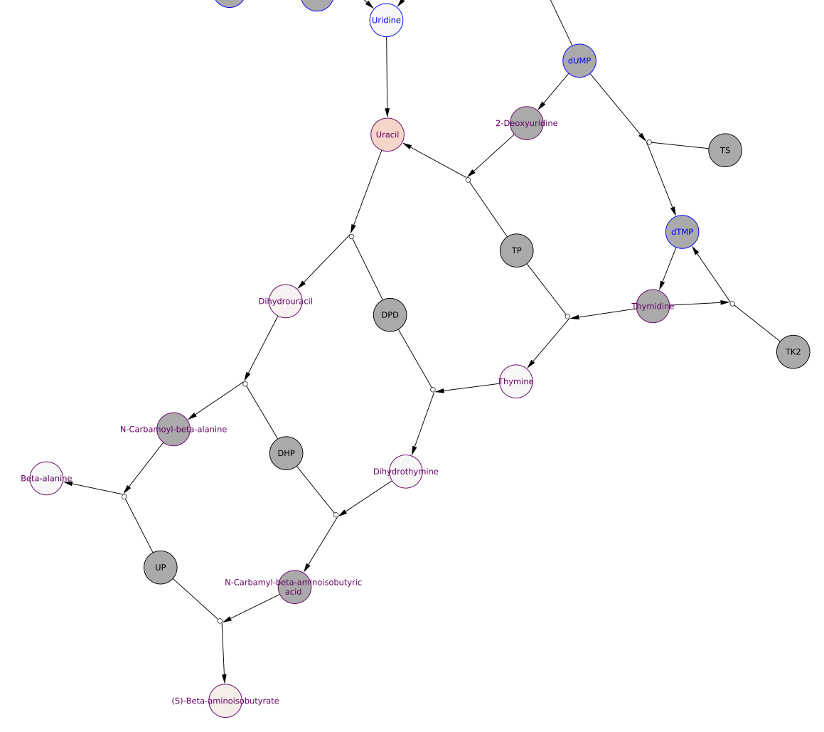

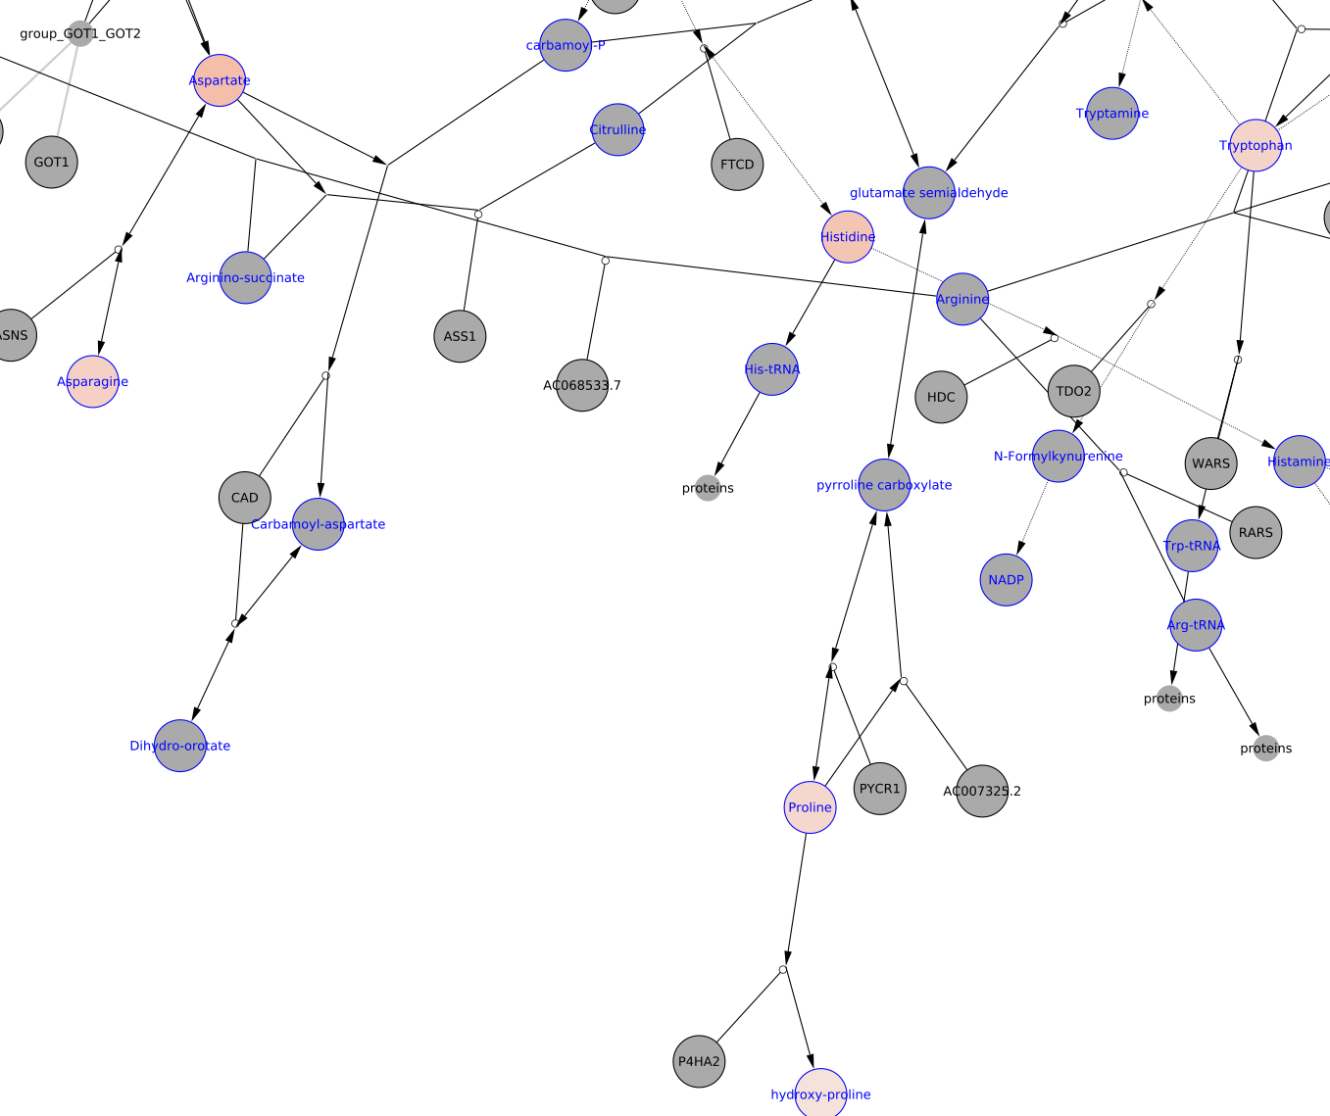

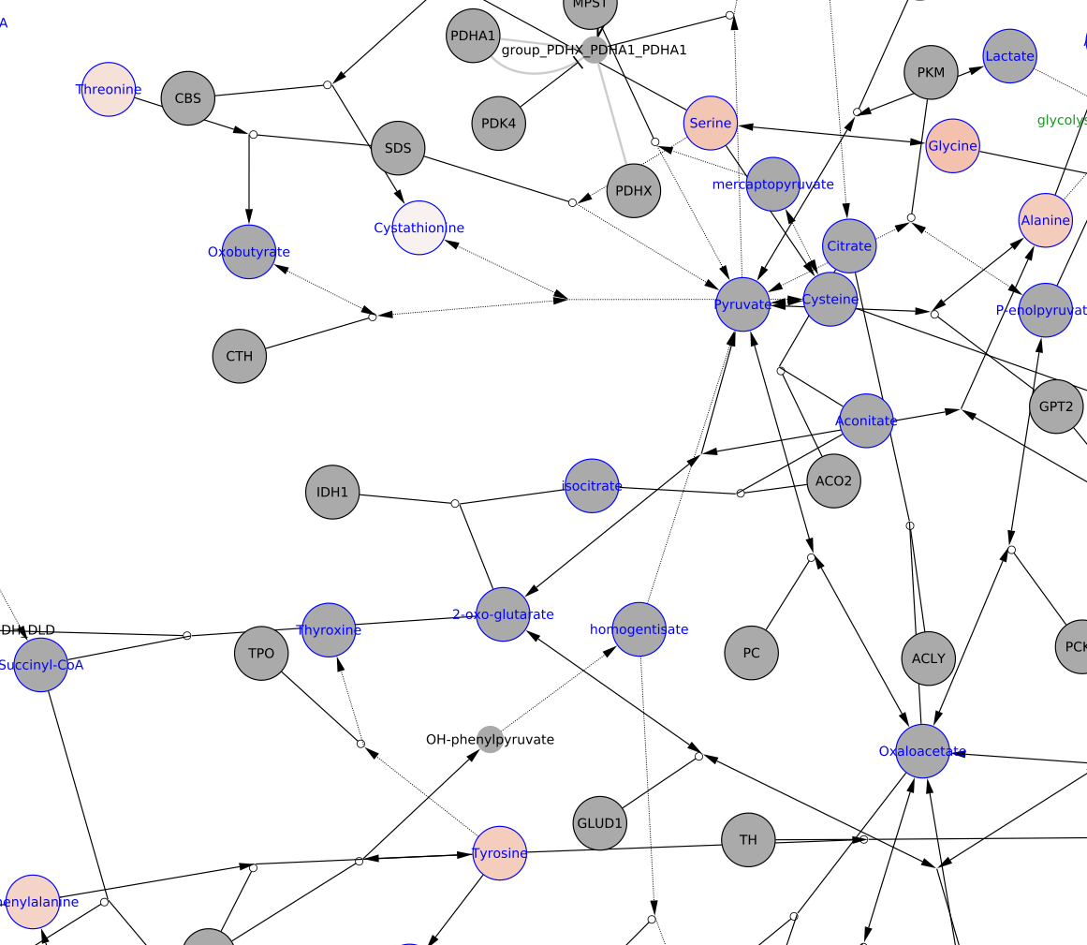

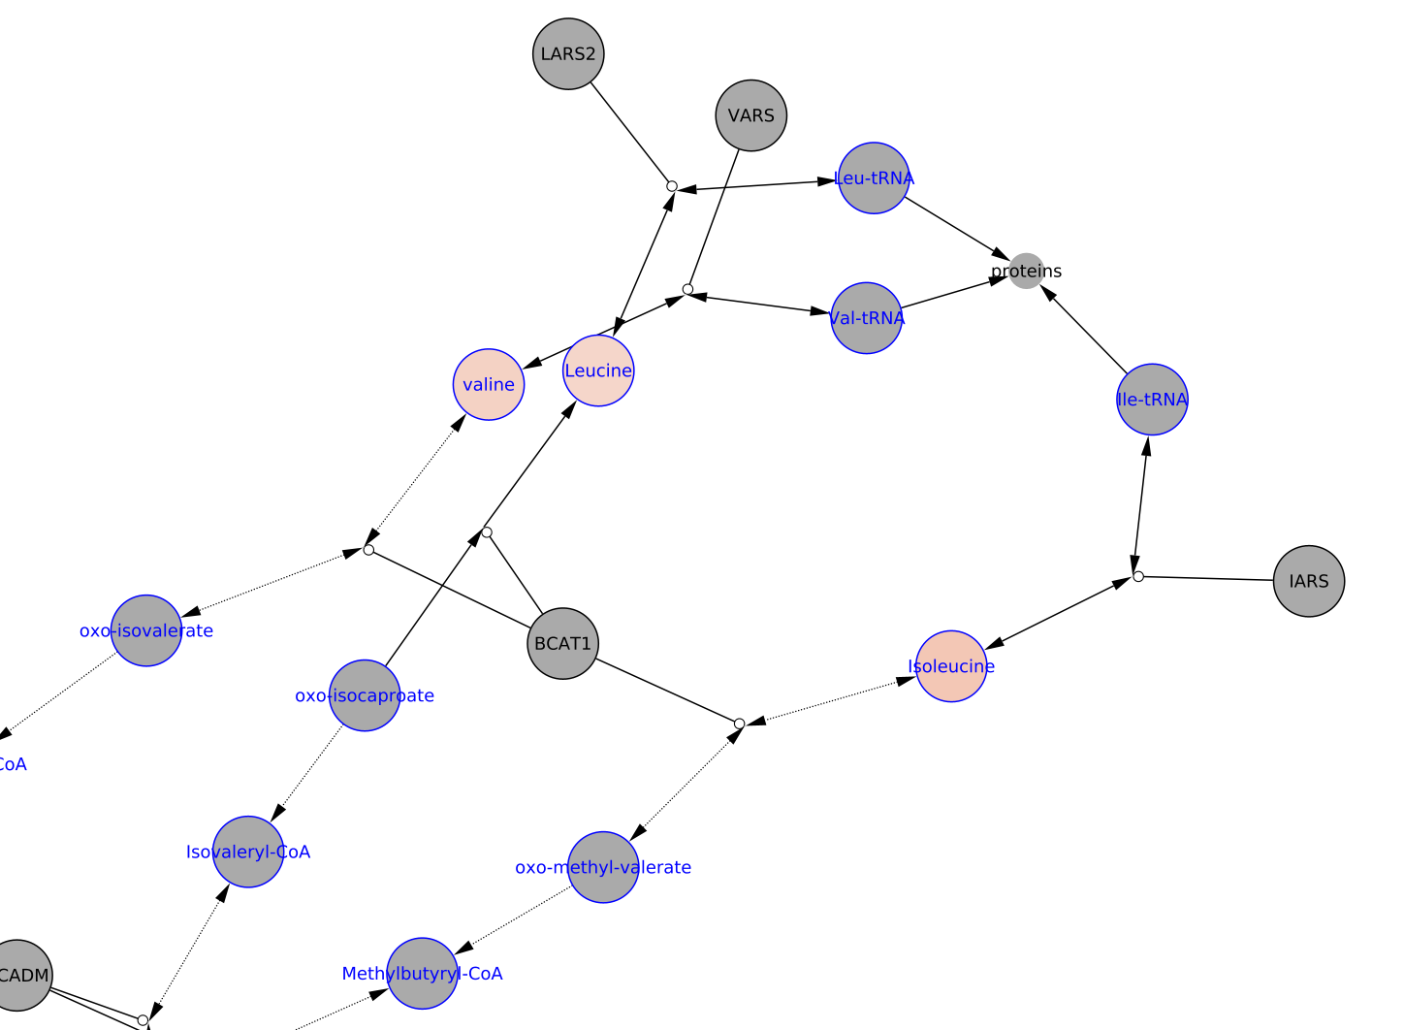

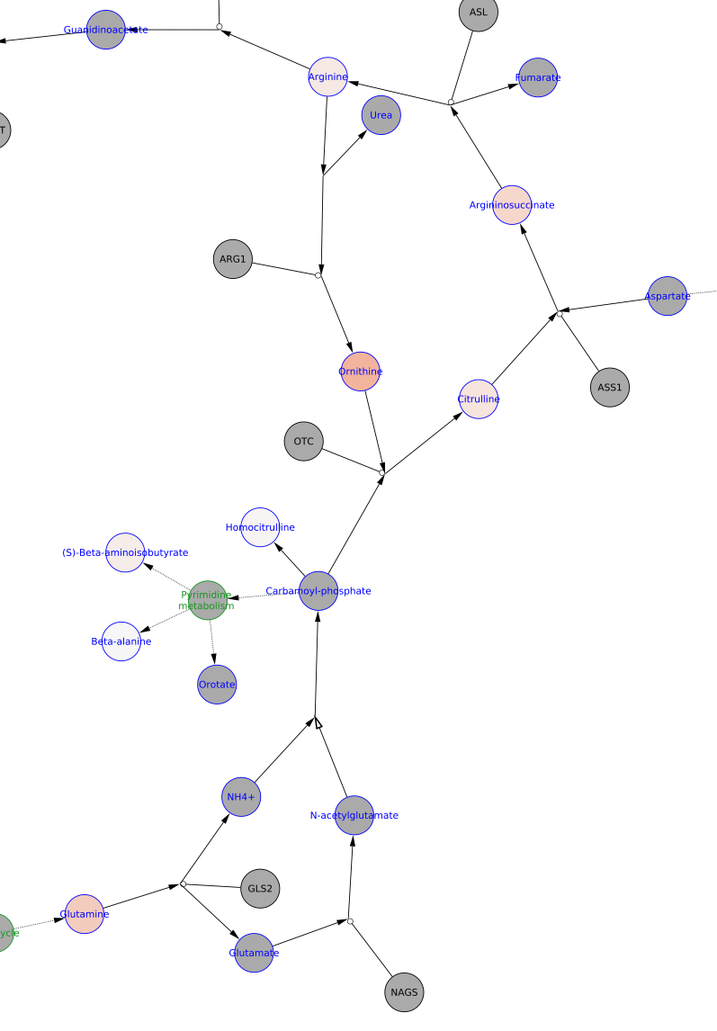

**Interpretation 1:** OTC

**Interpretation 2:** Hypophosphatasia, other metabolites due tubular dysfunction.

Final conclusion: Indicative for OTC, requires more testing. OTC has a “tail” of biomarkers which are altered in the pyrimidine de novo part.

**Selected Patient ID is: S , age is between: 5 to 16 years old**

Relevant Biomarkers (out of 36):

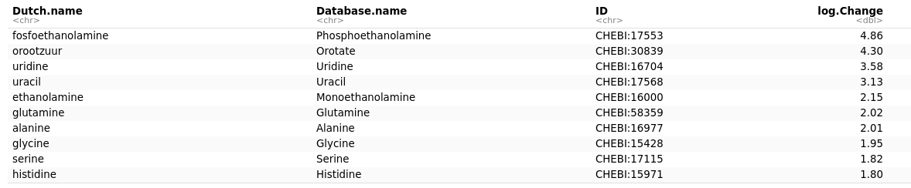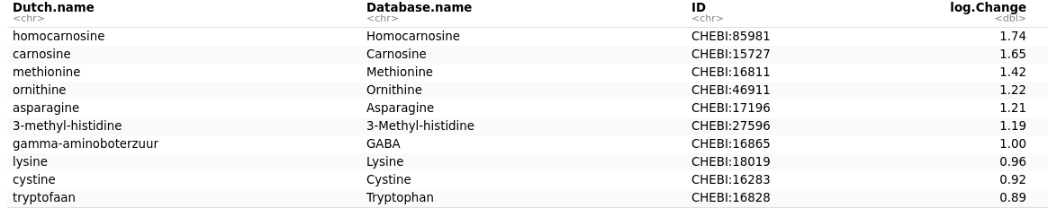

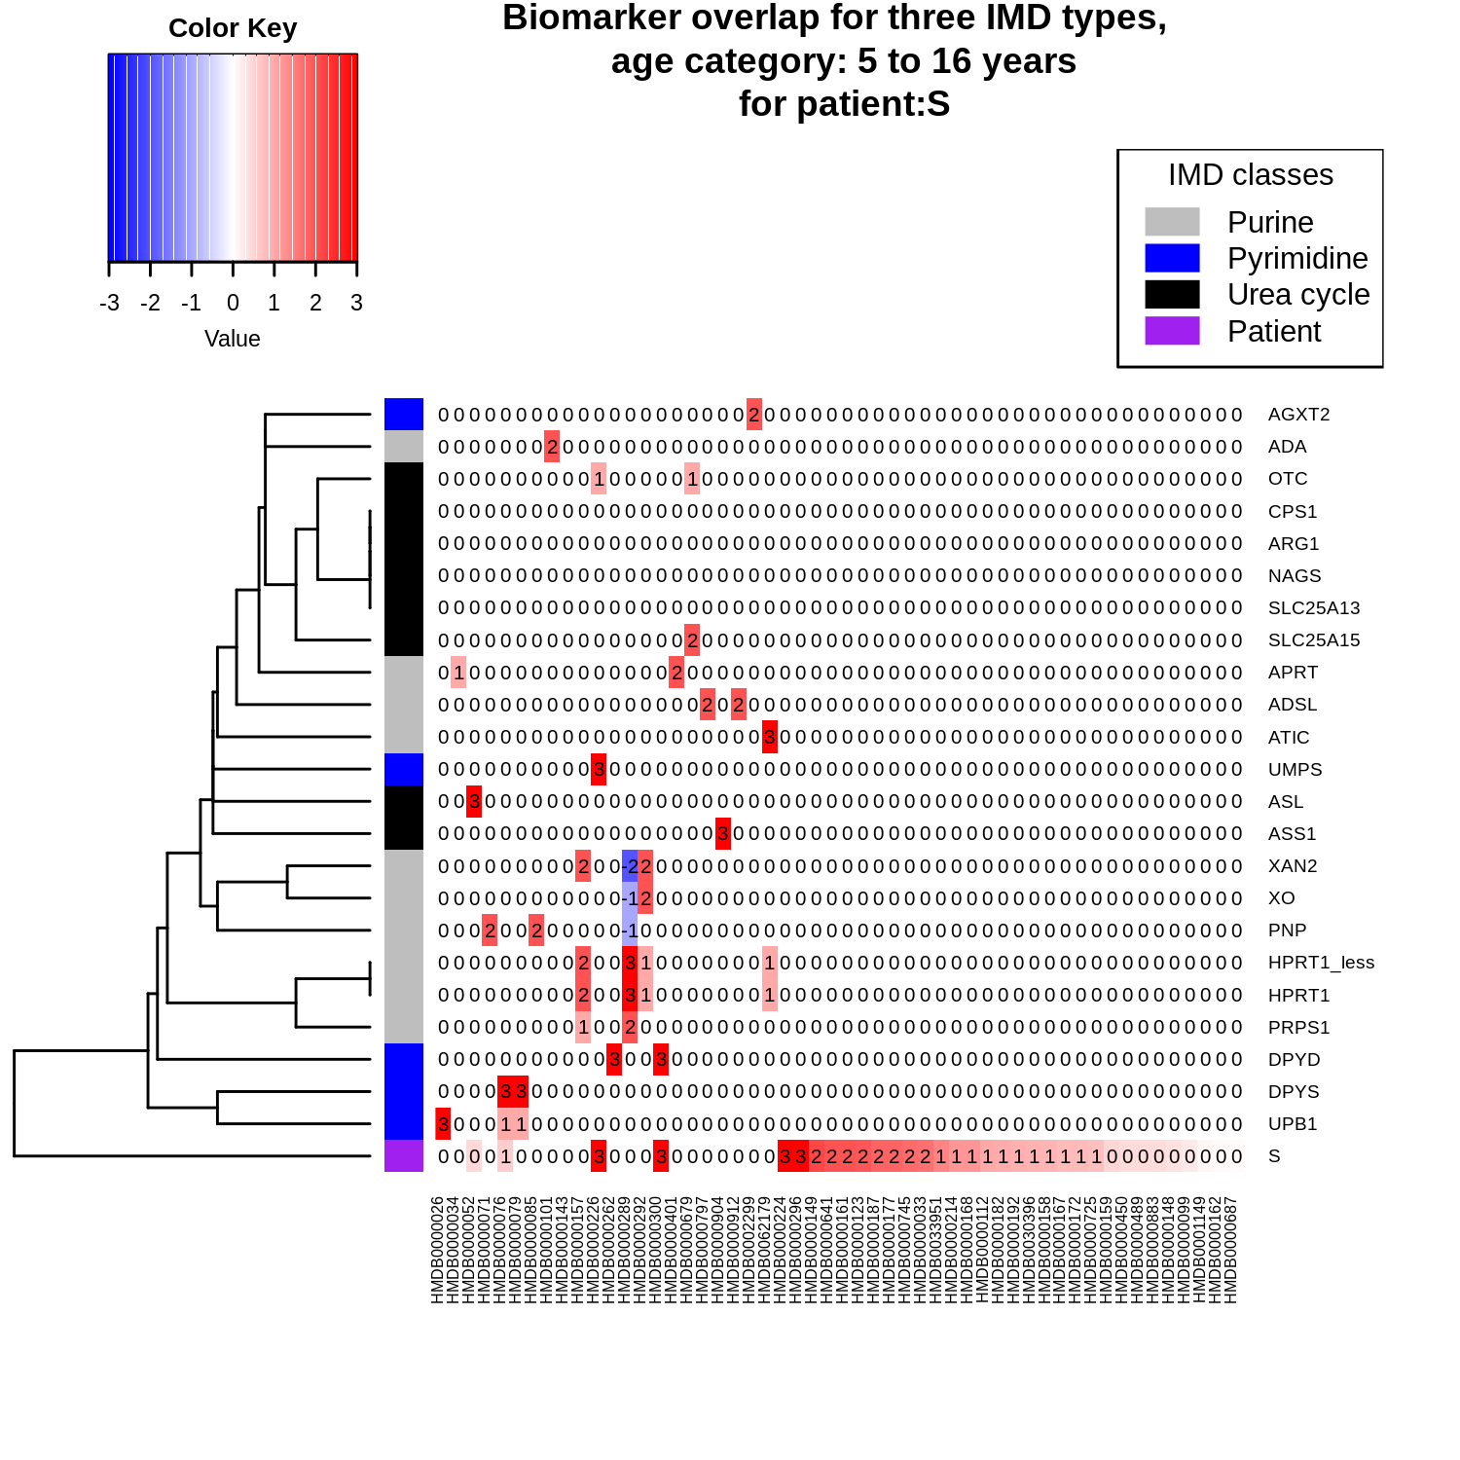



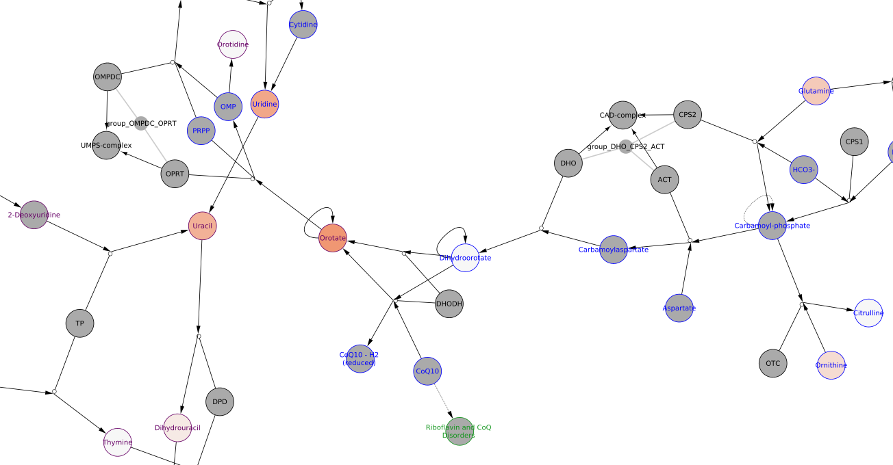

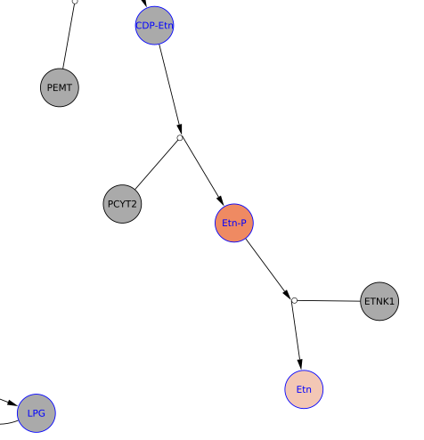

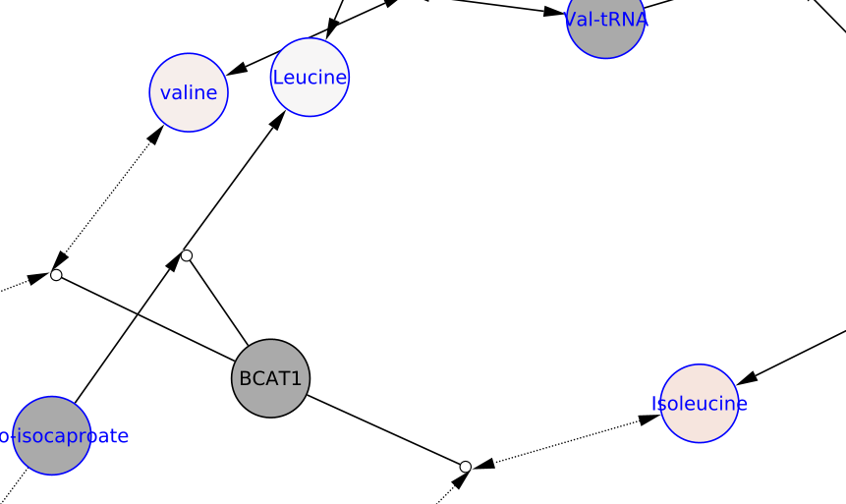

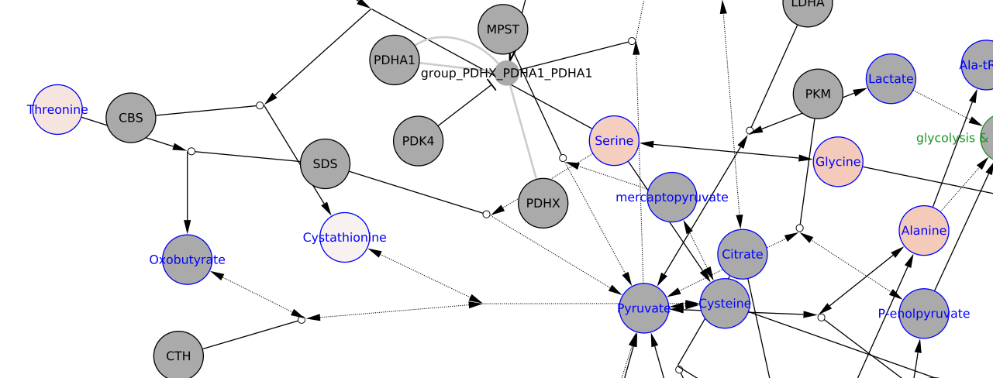

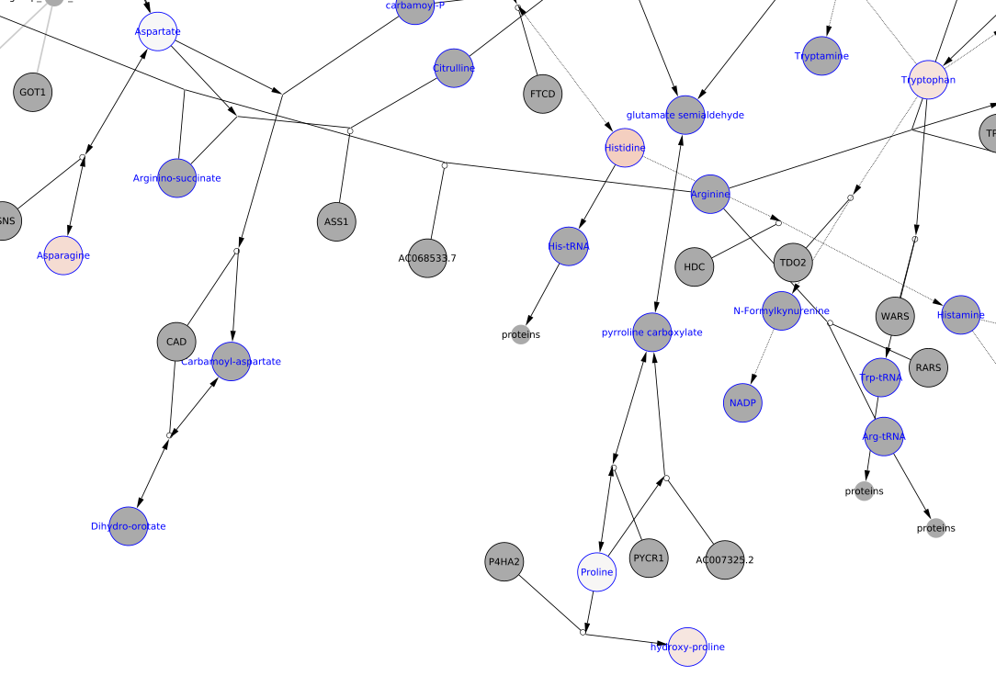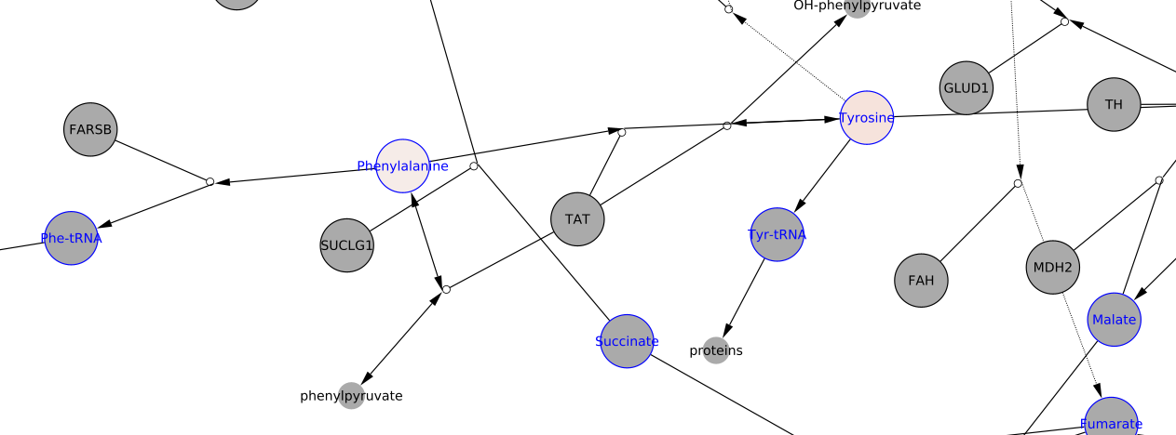

**Interpretation 1:** OTC

**Interpretation 2:** Hypophosphatasia, other metabolites due tubular dysfunction.

Final conclusion: Indicative for OTC, requires more testing (plasma measurement). Phosphoethanolamine seems to be a potential biomarker for this and previous OTC cases; however unclear molecular origin.

**Selected Patient ID is: T , age is between: 5 to 16 years old**

Relevant Biomarkers (out of 32):

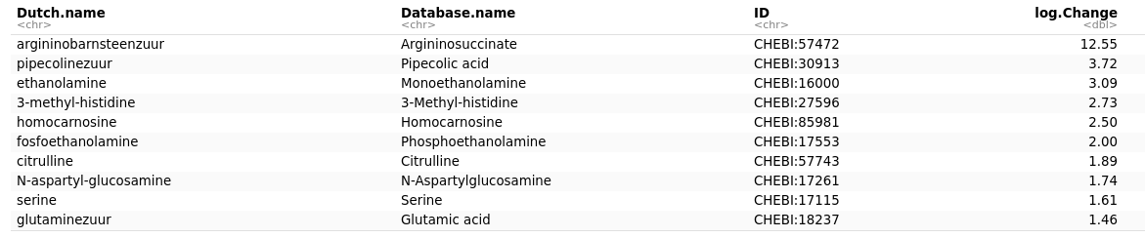

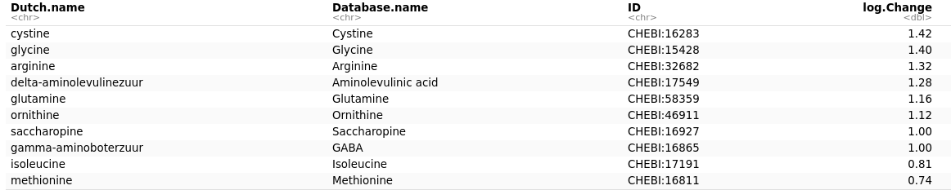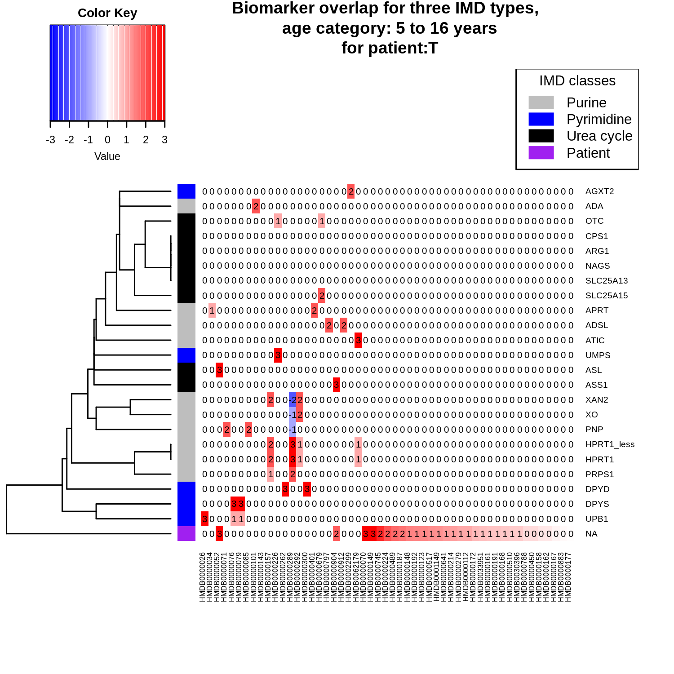

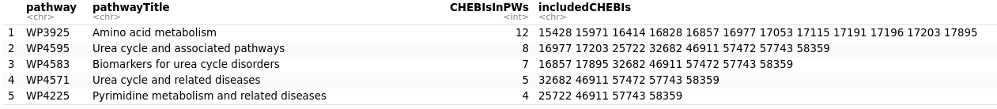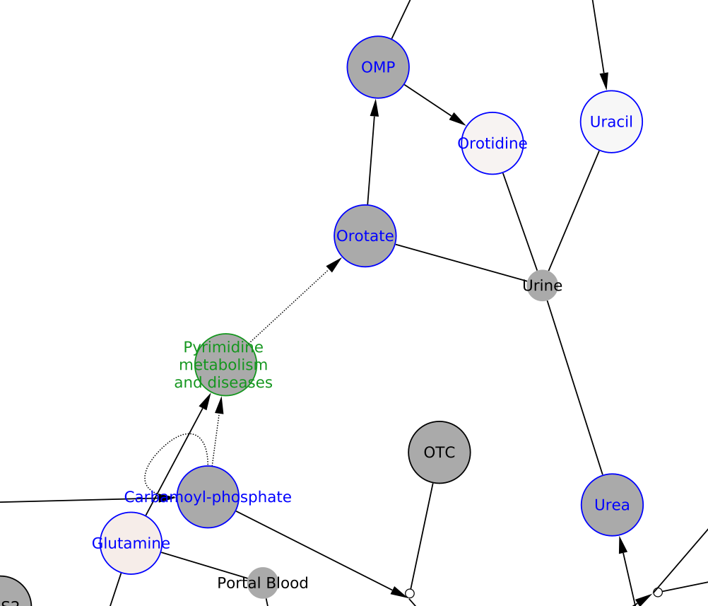

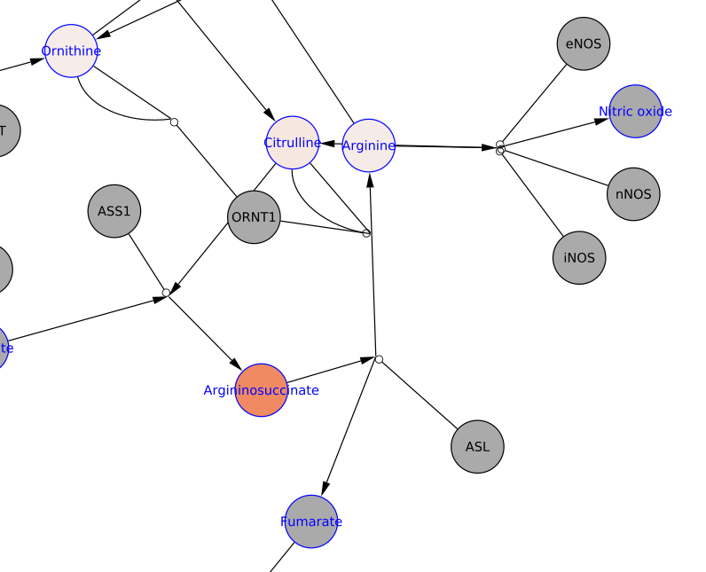

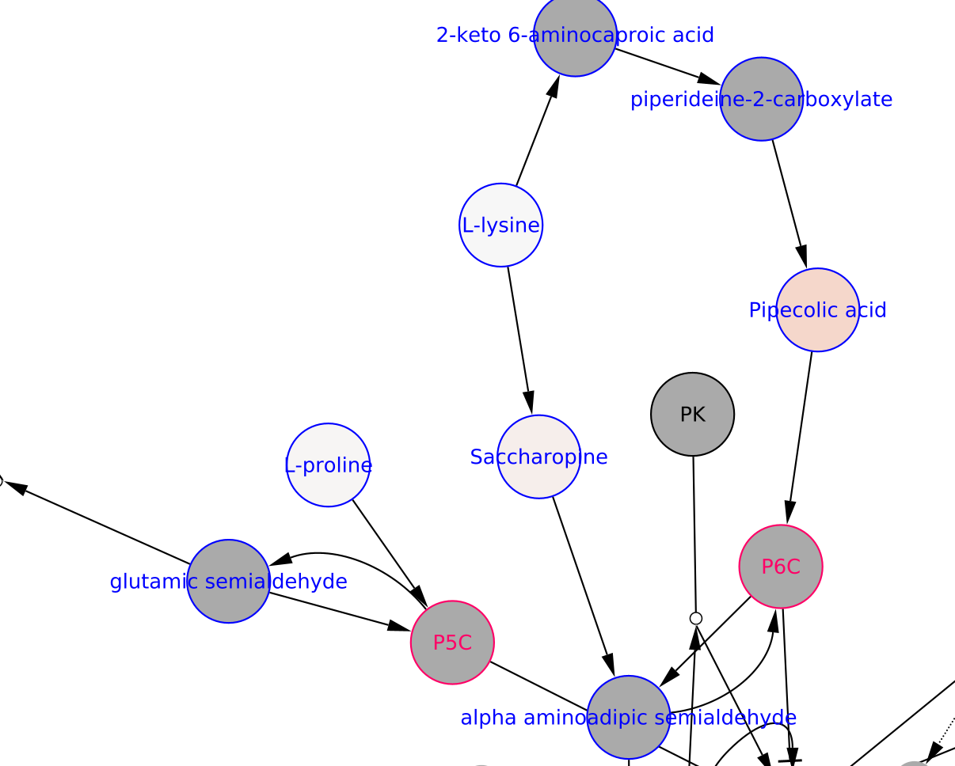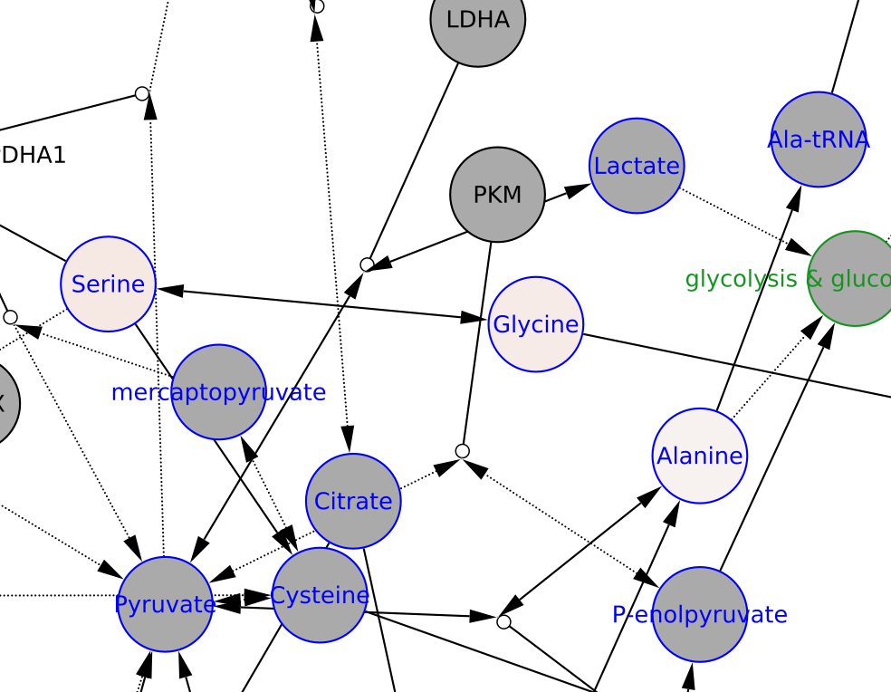

**Interpretation 1:** ASL

**Interpretation 2:** ASL