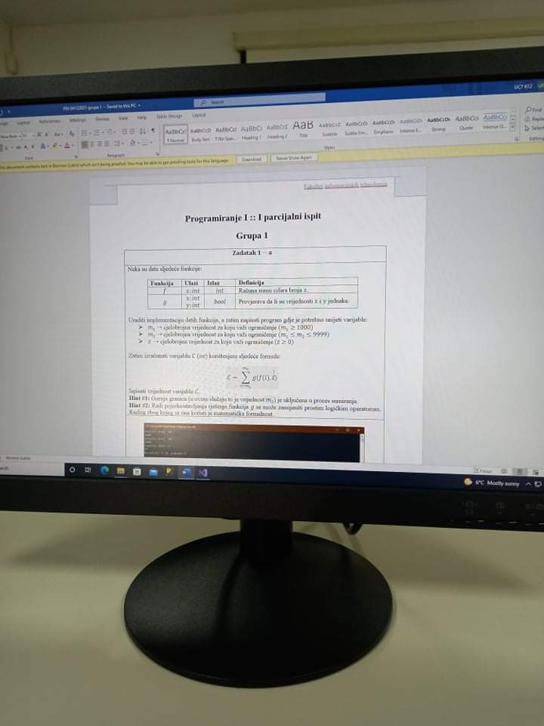

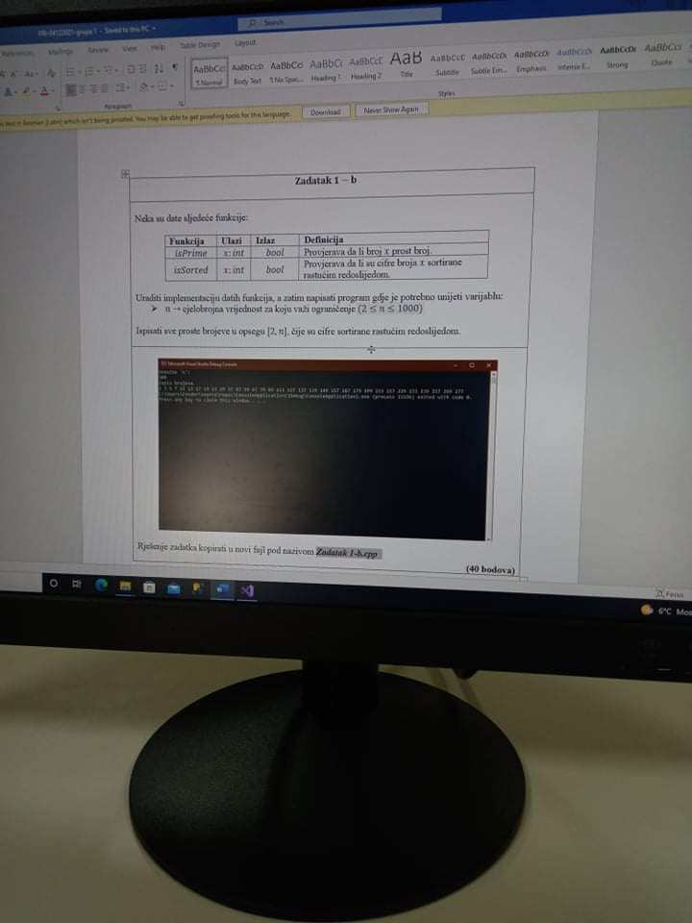

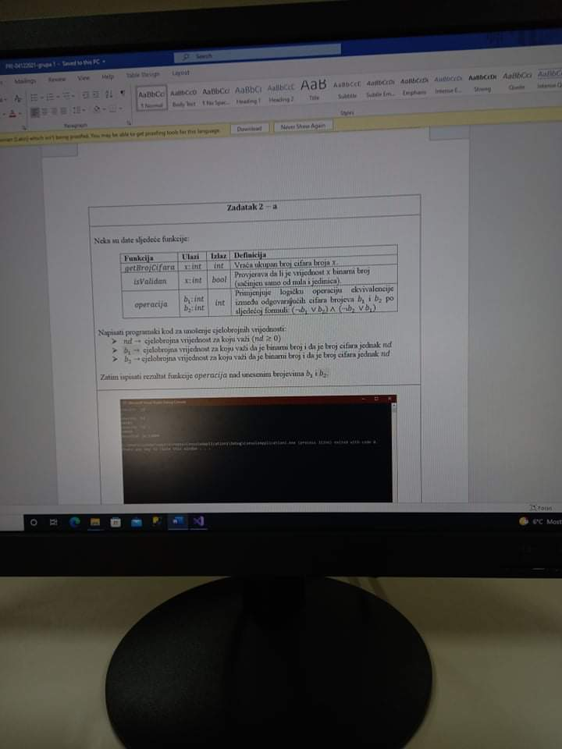

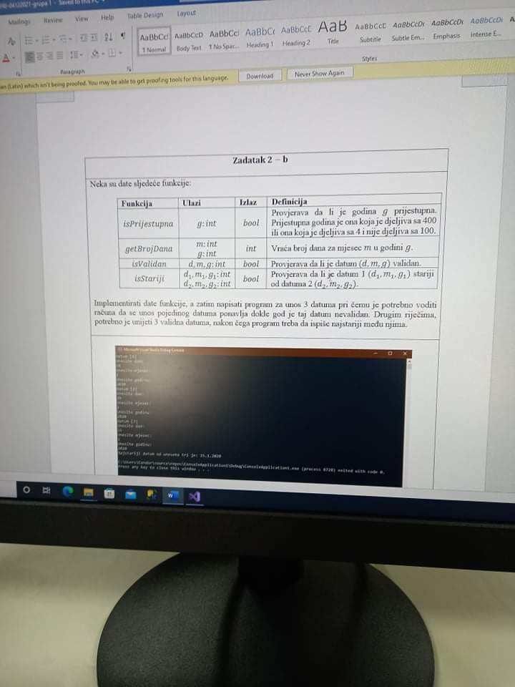

#include <iostream>

using namespace std;

bool isPrime(int num)

{

int cn = 0;

for (int i = 2; i <= num / 2; i++)

if (num % i == 0)

cn++;

if (cn > 0) return false;

else return true;

}

bool isSorted(int num)

{

int current_dig = 0;

int past_dig = 0;

bool first_dig = true;

do

{

current_dig = num % 10;

num /= 10;

if (first_dig == true && num == 0)

return true;

if (first_dig == true)

{

past_dig = current_dig;

first_dig = false;

continue;

}

if (current_dig > past_dig)

return false;

past_dig = current_dig;

} while (num!=0);

return true;

}

int main()

{

int n = 0;

do

{

cout << "Unesite n: ";

cin >> n;

} while (n < 2 || n>1000);

for (int i = 2; i <= n; i++)

{

if (isPrime(i)==true && isSorted(i)==true)

cout << i << " ";

}

return 0;

}

#include <iostream>

using namespace std;

int f(int num)

{

int dig = 0;

int sum = 0;

do

{

dig = num % 10;

num /= 10;

sum += dig;

}

while (num!=0);

return sum;

}

bool g(int num1, int num2)

{

return (num1 == num2);

}

int main()

{

int m1 = 0;

int m2 = 0;

int z = 0;

int C = 0;

do

{

cout << "Unesite m1: ";

cin >> m1;

} while (m1<1000);

do

{

cout << "Unesite m2: ";

cin >> m2;

} while (m1>m2 || m2>9999);

do

{

cout << "Unesite z: ";

cin >> z;

} while (z < 0);

for (int i = m1; i <= m2; i++)

{

C += g(f(i), z);

}

cout << "Rezultat je: " << C;

return 0;

}