Task1
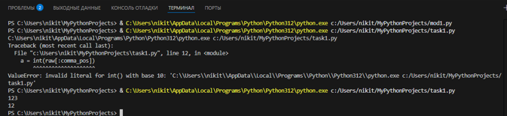
Task2
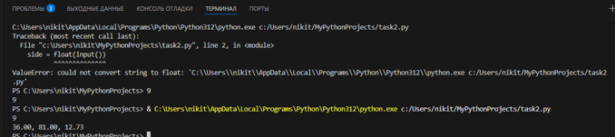
Task3
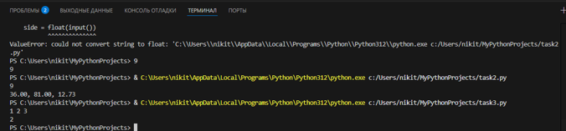

Task4
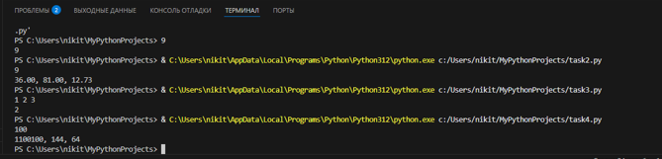

Task5
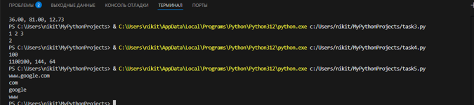

Task6
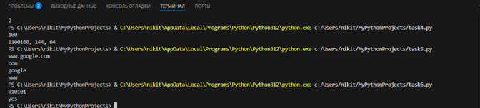

Task7
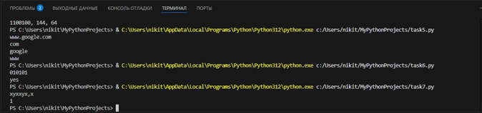

Task8
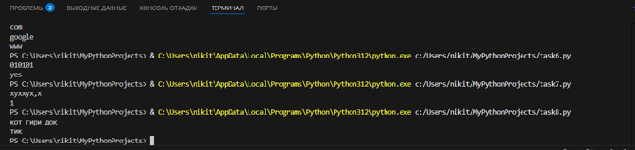

Task9
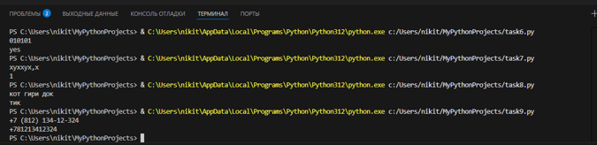

Task10
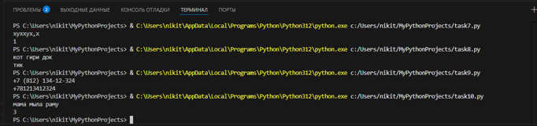

Task11
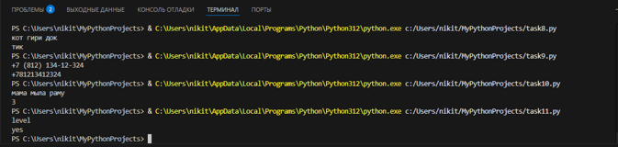

Task12
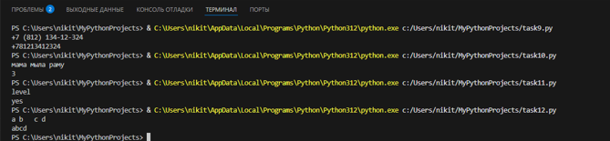

Task13
