Problema 1

Subpunctul 1: calculul mediei si variantei

Eb <- 0

Eb2 <- 0

Vb <- 0

Ep <- 0

Ep2 <- 0

Vp <- 0

func <- function(t,z)

{ r = (z*exp(-z*x)) return(r) }

func2 <- function(u1,t1)

{ r = (1/(sqrt(2*pi)*sqrt(t1))*exp(-(x-u1)/(2*t1)))) return(r) }

b1 <- function(n,p){ for (i in 1:1000)

{ Eb <- Eb+x1[i]*(factorial(n)/(factorial(x1[i])*factorial(n-x1[i])))*(p^x1[i])*((1-p)^(n-x1[i]))

Eb2 <- Eb2+(x1[i]^2)*(factorial(n)/(factorial(x1[i])*factorial(n-x1[i])))*(p^x1[i])*((1-p)^(n-x1[i])) }

Vb <- Eb2 - Eb^2 }

pois <- function(l)

{ for (i in 1:1000)

{ Ep <- Ep+x1[i]*exp(-l)*(l^x1[i])*factorial(x1[i])

Ep2 <- Ep2+(x1[i]^2)*exp(-l)*(l^x1[i])*factorial(x1[i]) } Vp <- Ep2 - Ep^2 }

Exp <-function(li){

Expp <- integrate(func,0,1000,z=li)$value

Vexpp <- (integrate(func,0,1000,z=li)$value)- Expp^2 }

N <-function(u,t)

{ Expp <- integrate(func2,0,1000,u1=u,t1=t)$value

Vexpp <- (integrate(func2,0,1000,u1=u,t1=t)$value)- Expp^2 }

x1 <- sample(1:20, 1000, replace=T)

E <- sample(0:0, 1000, replace=T)

Subpunctul 2: Trasarea graficelor densitatilor / repartitiilor maselor

a <-b1(2,2)

p <-pois(4)

g <- Exp(4)

a <- seq(0,40,by = 2)

b <- dbinom(a,40,0.4)

plot(a,b,type="l",col="blue")

par(new=TRUE)

a1 <- seq(0,40,by = 4)

b1 <- dbinom(a1,40,0.7)

plot(a1,b1,col="purple",type="l")

par(new=TRUE)

a2 <- seq(0,40,by = 2)

b2 <- dbinom(a2,40,0.9)

plot(a2,b2,col="red",type="l")

par(new=TRUE) a3 <- seq(0,40,by = 2)

b3 <- dbinom(a3,40,0.1)

plot(a3,b3,col="green",type="l")

par(new=TRUE)

a4 <- seq(0,40,by = 2)

b4 <- dbinom(a4,40,0.5)

plot(a4,b4,col="darkgreen",type="l")

par(new=FALSE)

plot( dpois( x=0:10, lambda=6 ),col="green",type="l")

par(new=TRUE)

plot( dpois( x=0:10, lambda=9 ),col="red",type="l")

par(new=TRUE)

plot( dpois( x=0:10, lambda=2 ),col="blue",type="l")

par(new=TRUE)

plot( dpois( x=0:10, lambda=3 ),col="purple",type="l")

par(new=TRUE)

plot( dpois( x=0:10, lambda=7 ),col="black",type="l")

x <- seq(-10, 10, by = .1)

y <- dnorm(x, mean = 2.5, sd = 0.5)

plot(x,y,type="l",col="blue")

par(new=TRUE)

x <- seq(-10, 10, by = .1)

y <- dnorm(x, mean = 2, sd = 0.5)

plot(x,y,type="l",col="red")

par(new=TRUE)

x <- seq(-10, 10, by = .1)

y <- dnorm(x, mean = 2.5, sd = 1)

plot(x,y,type="l",col="purple")

par(new=TRUE)

x <- seq(-10, 10, by = .1)

y <- dnorm(x, mean = 5, sd = 0.5)

plot(x,y,type="l",col="green")

par(new=TRUE)

x <- seq(-10, 10, by = .1)

y <- dnorm(x, mean = 1, sd = 1.5)

plot(x,y,type="l",col="black")

x <- seq(0, 20, length.out=1000)

plot(dexp(x, rate=0.65),type="l",col="black")

par(new=TRUE)

x <- seq(0, 20, length.out=1000)

plot(dexp(x, rate=0.50),type="l",col="blue")

par(new=TRUE)

x <- seq(0, 20, length.out=1000)

plot(dexp(x, rate=0.25),type="l",col="purple")

par(new=TRUE)

x <- seq(0, 20, length.out=1000)

plot(dexp(x, rate=0.35),type="l",col="green")

par(new=TRUE)

x <- seq(0, 20, length.out=1000)

plot(dexp(x, rate=0.75),type="l",col="pink")

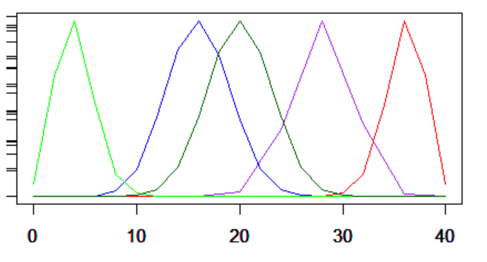

Graficul Binomialei (cu 5 seturi de parametri diferiti)

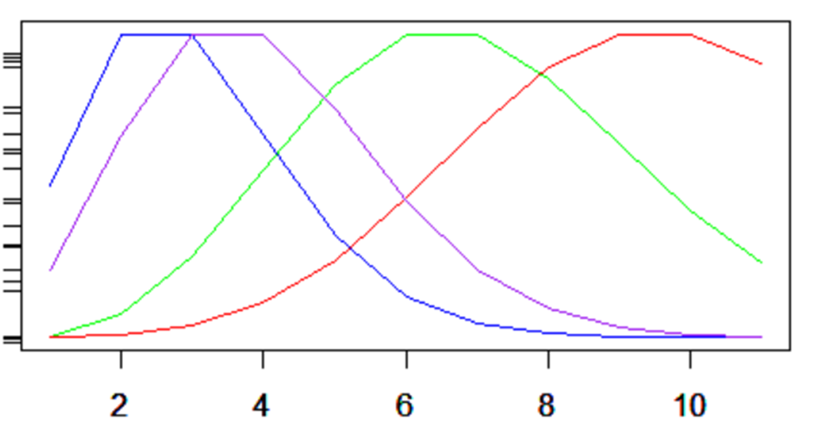

Graficul Poisson (cu 5 valori diferite pentru lambda)

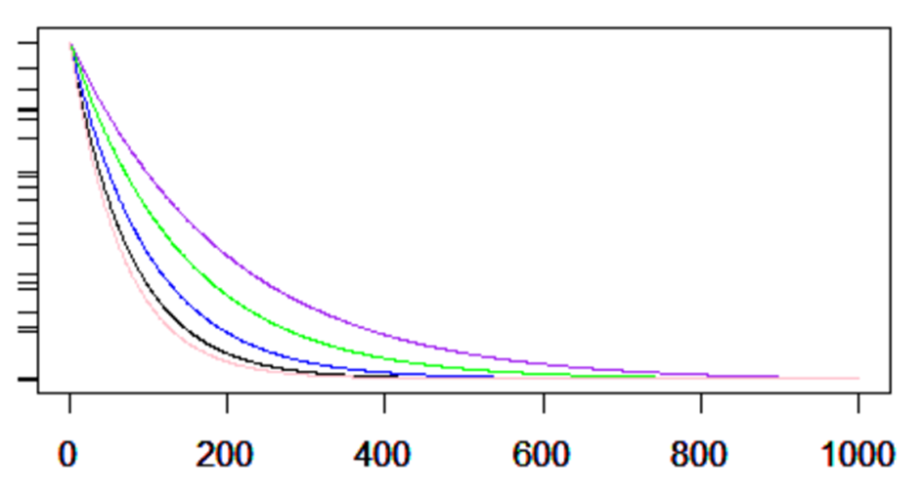

Graficul Exponentialei (pentru 5 valori ale lui lambda)

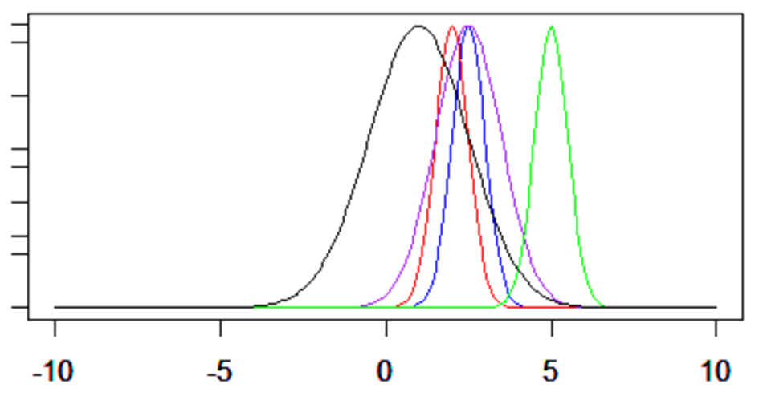

Graficul Normalei (pentru 5 seturi de parametri)

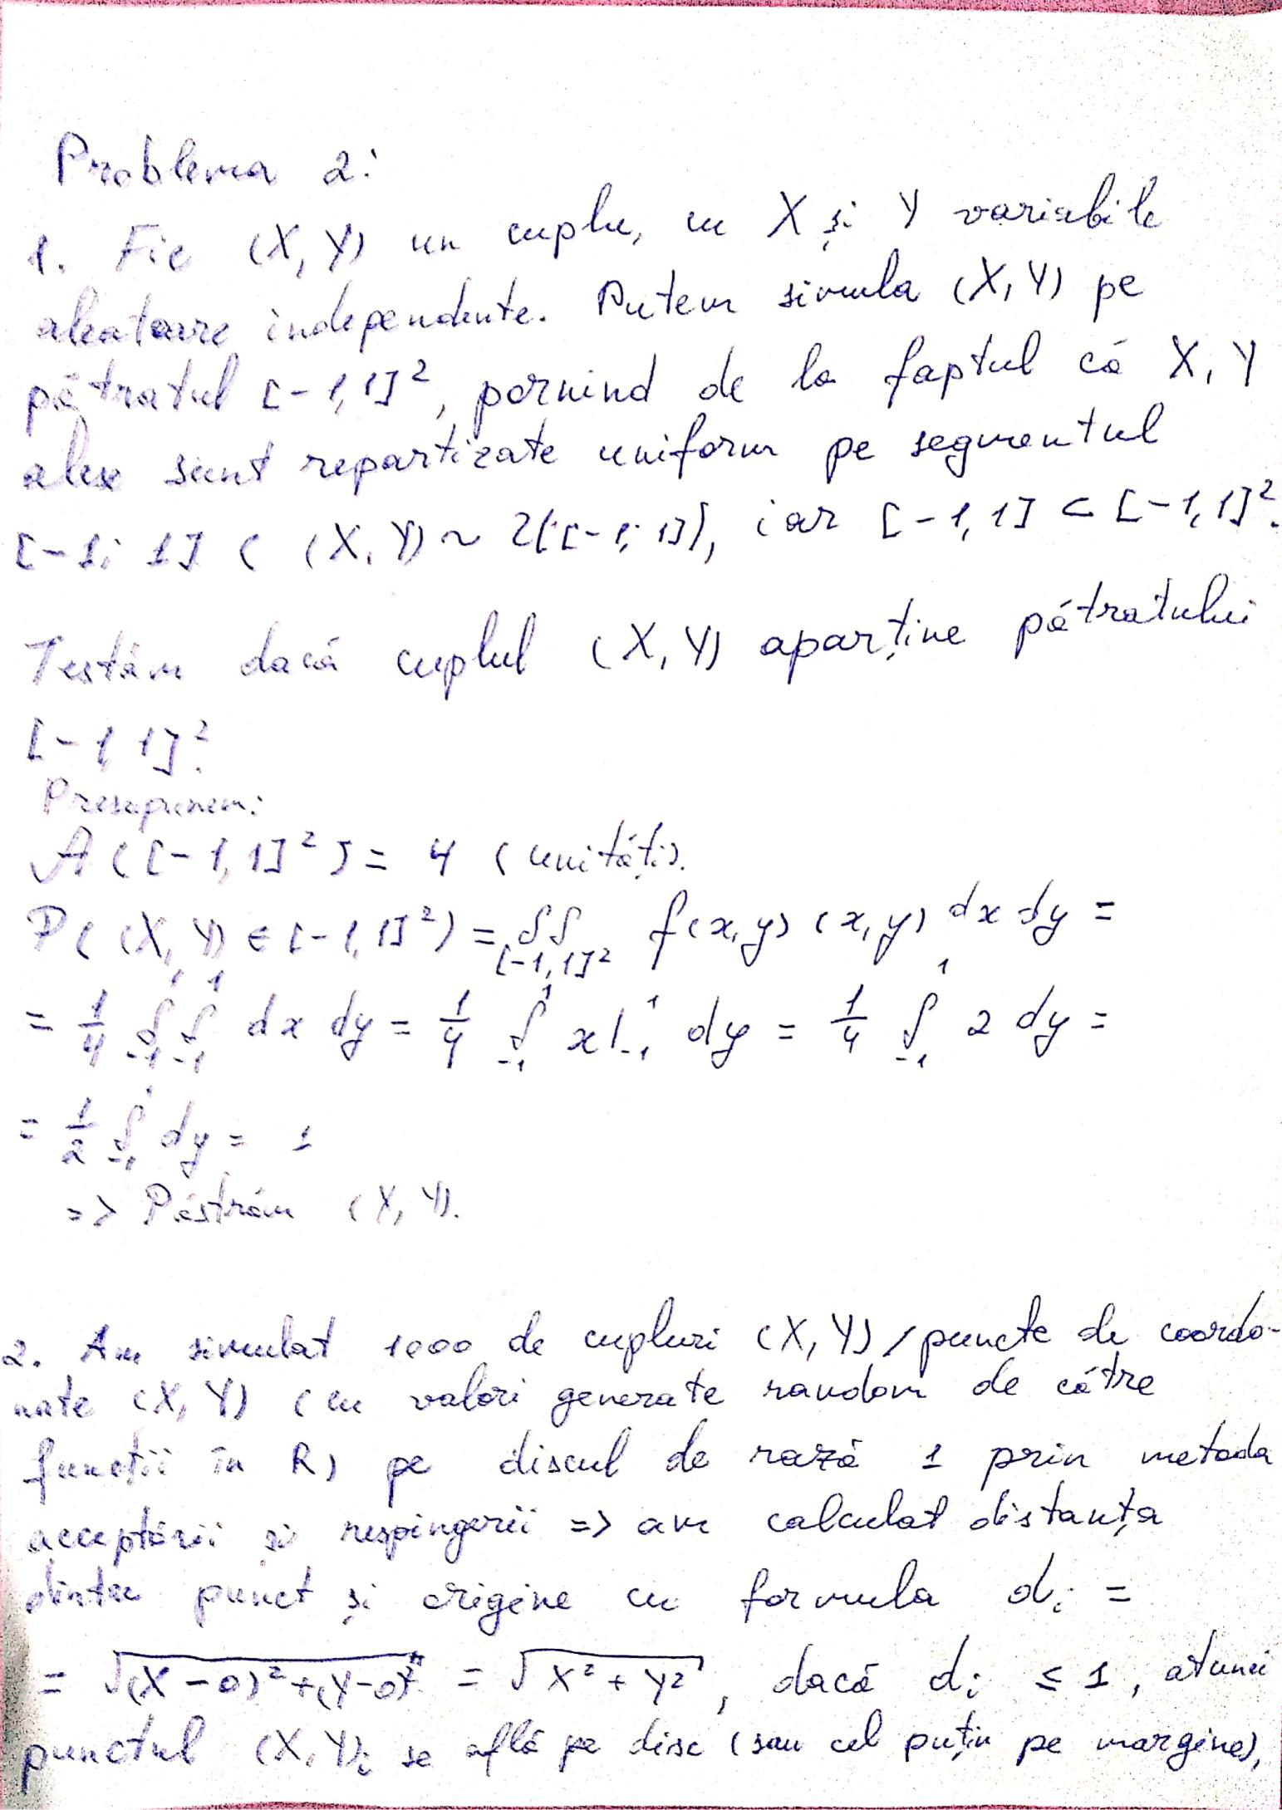

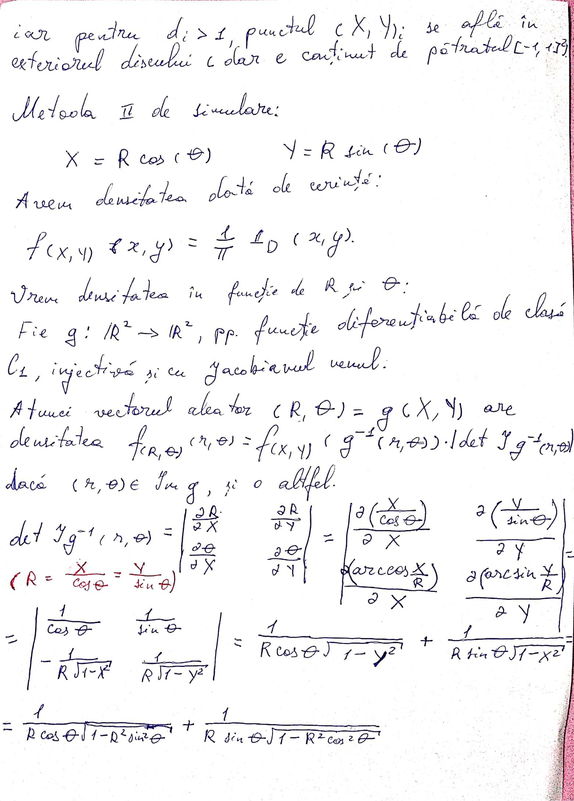

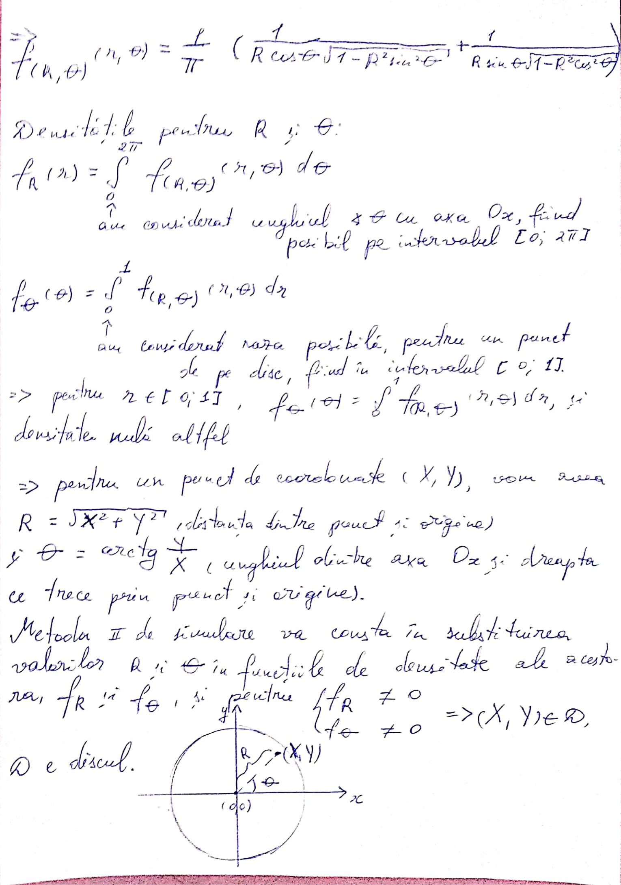

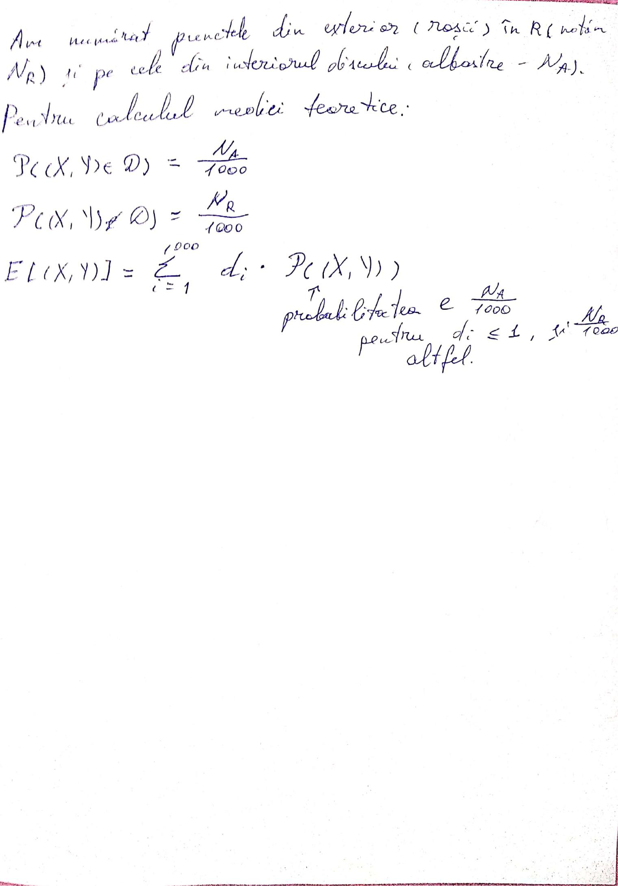

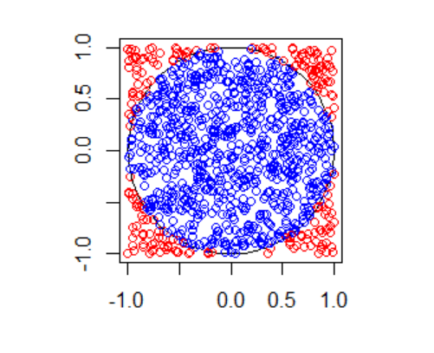

Metoda 1:

#install.packages("plotrix")

library("plotrix")

par(pty="s")

plot(seq(-1,1,length=10),seq(-1,1,length=10),type="n",xlab="",ylab="") #draw.circle(2,4,c(1,0.66,0.33),border="purple", # col=c("#ff00ff","#ff77ff","#ffccff"),lty=1,lwd=1)

draw.circle(0,0,radius = 1,border="black",lty=1,lwd=1)

x=runif(1000,-1,1)

y=runif(1000,-1,1)

ma <-0

nra <-0

nrr <-0

for (i in 1:1000)

{ if(sqrt(x[i]^2+y[i]^2) <=1)

{

points(x[i],y[i],col="blue")

nra <- nra+1

}

else

{

points(x[i],y[i],col="red")

nra <- nrr+1

}

ma <- ma + sqrt(x[i]^2+y[i]^2)

}

Calculam media teoretica:

mt<-0

ma <- ma/1000

for (i in 1:1000)

{

if(sqrt(x[i]^2+y[i]^2) <=1)

{

mt <- mt+(nra/1000)*sqrt(x[i]^2+y[i]^2)

}

else

{

mt <- mt+(nrr/1000)*sqrt(x[i]^2+y[i]^2)

}

}

Metoda 2:

#points(x[2],y[2],col="darkgreen")

Funct5 <-function(r,t)

{

return(1/pi*(1/(r*cos(t)*sqrt(1-(r^2)*(cos(t)^2)))+1/(r*sin(t)*sqrt(1-(r^2)*(sin(t)^2)))))

}

R <-function(r1)

{

return(integrate(Funct5, 0, 2*pi,r=r1,subdivisions=2000)$value)

}

Te <-function(t1)

{

return(integrate(Funct5, 0, Inf,t=t1)$value)

}

ttttt<-Funct5(1/sqrt(2),-pi/4)

teta<-Te(pi/4)

rrr<-R(1/sqrt(2))

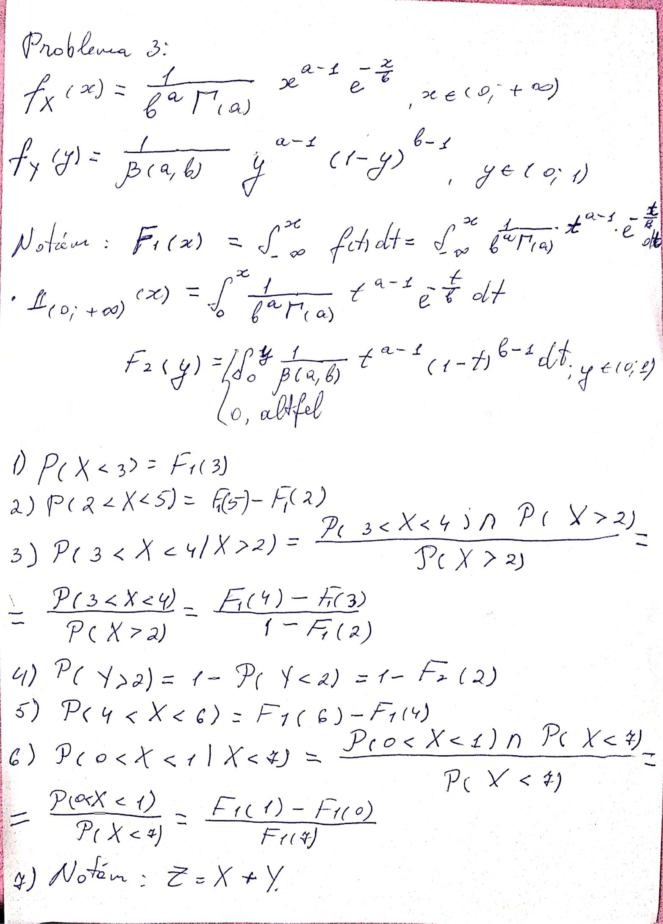

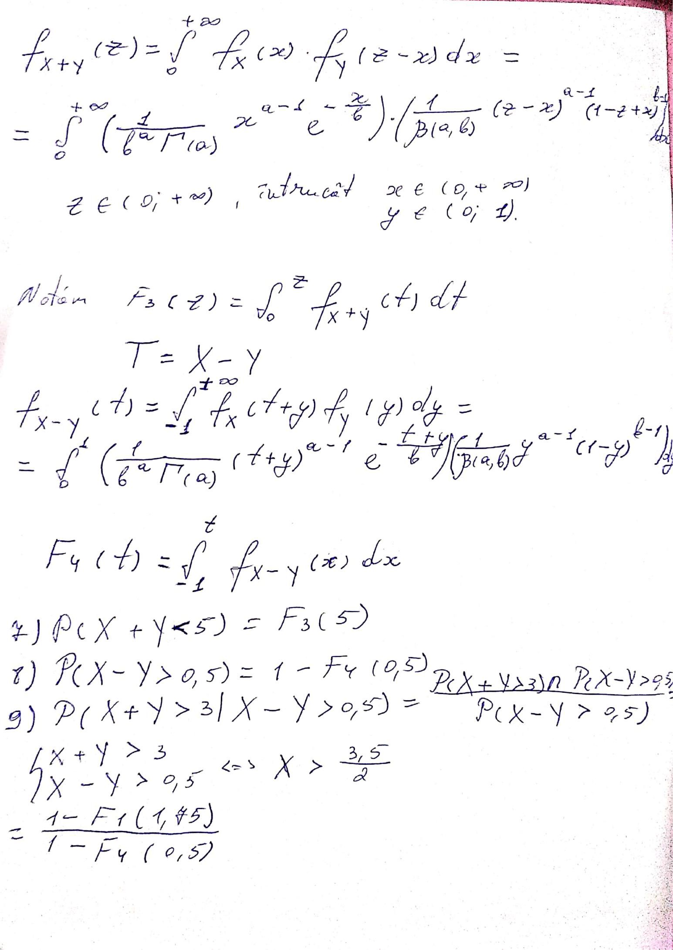

# Problema 3

# Subpunctul a) Functia Gamma:

func <- function(t,z)

{

r = (t**(z-1))*exp(1)**(-t) return(r)

}

fgam <- function(n)

{

if(n == 1)

{

return(1)

}

if(n == 1/2)

{

return(sqrt(pi))

}

if(n>0 && identical(round(n), n))

{

return(factorial(n-1))

}

if(n>1.0){ return((n-1)*fgam(n-1)) }

if(n<1 && n>=0)

{

o = integrate(func,0,Inf,z=n) return(o$value)

}

}

b) Functia Beta:

fbet <- function(a,b)

{

if(a>0 && b>0 && (a+b == 1))

{

return(pi/sin(a*pi))

}

else

{

return((fgam(a)*fgam(b))/fgam(a+b))

}

}

F1 <- function(a,b,t)

{

1/(b^a*(fgam(a)))*(t^(a-1))*exp(-t/b)}

F2 <- function(a,b,t)

{

1/fbet(a,b)*(t^(a-1))*((1-t)^(b-1))

}

F3 <- function(a,b,t,z0)

{

(1/(b^a*(fgam(a)))*(t^(a-1))*exp(-t/b)) * (1/fbet(a,b)*((z0-t)^(a-1))*((1-z0+t)^(b-1)))

}

# xz

c) Probabilitatile:

fprobgammanr <-function(a1,b1)

{

a <- a1

b <- b1

if(x<=0)

{

return(0)

}

else

{

return(integrate(F1, 0, x, a=a1,b=b1)$value)

}

}

fprobbetanr <-function(a2,b2)

{

a <- a2

b <- b2

if(y<=0 || y>=1 )

{ return(0)

}

else

{ return(integrate(F2, 0, 1,a = a2,b = b2)$value)

}

}

fprobnr <- function(an,bn)

{

x <- 3

x1 <- fprobgammanr(an,bn)

x <- 5

aux1 <- fprobgammanr(an,bn)

x <- 2

aux2 <- fprobgammanr(an,bn)

x2 <- aux1 - aux2

x <- 4

aux1 <- fprobgammanr(an,bn)

x <- 3

aux3 <- fprobgammanr(an,bn)

x3 <- (aux1 - aux3)/(1 - aux2)

y <- 2

y4 <- 1 - fprobbetanr(an,bn)

x <- 6

aux1 <- fprobgammanr(an,bn)

x <- 4

aux2 <- fprobgammanr(an,bn)

x5 <- aux1 - aux2

x <- 1

aux1 <- fprobgammanr(an,bn)

x <- 0

aux2 <- fprobgammanr(an,bn)

x <- 7

aux3 <- fprobgammanr(an,bn)

x6 <- (aux1 - aux2)/aux3

f6 <-function(z,x)

{

z1 <- integrate(F3, 0,Inf, a=an, b=bn, z0=5)

return(z1$value)

}

z1r <- integrate(f6, 0,5,z=5)

}

d) Tabel:

d<-fprobnr(1,2)

mat <-c(0,0,0,0,0,0,0,0,0,0,0,0)

mat[1] <-pgamma(q = 3, shape = 1, scale = 2)

mat[3] <-pgamma(q = 5, shape = 1, scale = 2)-pgamma(q = 2, shape = 1, scale = 2)

mat[5] <-(pgamma(q = 4, shape = 1, scale = 2)-pgamma(q = 3, shape = 1, scale = 2))/pgamma(q = 2, shape = 1, scale = 2)

mat[7] <-1-pbeta(q = 2, 1, 2)

mat[9] <-pgamma(q = 6, shape = 1, scale = 2)-pgamma(q = 4, shape = 1, scale = 2)

mat[11] <-(pgamma(q = 1, shape = 1, scale = 2)-pgamma(q = 0, shape = 1, scale = 2))/pgamma(q = 7, shape = 1, scale = 2)

smoke<- matrix(mat,ncol=2,byrow=TRUE) colnames(smoke) <- c("Repartitia Gamma","Ce am facut noi")

rownames(smoke) <- c("P(X<3)","P(2<X<5)","P(3<x<4|X>2)","P(Y>2)","P(4<X<6)","P(0<X<1|X<7)") smoke <- as.table(smoke)

smoke