Test report

Content

Description of the testing process**1**

synopsis 2

Bug report3

Full description **4**

Proposals to improve 5

Description of the testing process

The testing was completed on Windows 10, NPM version 8.3.1, Node.js version 17.4.0 and in the browser: Yandex.browser version 22.1.3.848 (64-bit)

Testing was done by a black box method:

* Functional tests were performed according to the documentation 8base Quick Start
* Tests UI was executed according to the user story

Synopsis

This version the app has failed testing. Some of the functionality is not functional.

Existing app has 1 blocker, 1 critical and 3 major error

Bug report

|  |  |  |  |  |  |  |
| --- | --- | --- | --- | --- | --- | --- |
| **ID** | **Summary** | **Environment** | **Steps to reproduce** | **Expected result** | **Actual result** | **Severity** |
| 1 | The environment limit counter does not work on the homepage of the workspace | Yandex.browser v. 22.1.3.848 (64-bit) | 1. Open Home page 2. Create multiple environments 3. Check counter limit environment | The counter is equal to the number of environments | The counter is not equal to the number of environments | Major |
| 2 | In chapter 2.1 Quick Start, the options described in the table do not match the screenshot provided as an example | Yandex.browser v. 22.1.3.848 (64-bit) | 1. Open 2.1 Quick Start 2. compare the table „Add user to Notes” with the screenshot | The parameters in the screenshot match the parameters in the table „Add user to Notes” | The parameters in the screenshot don’t match the parameters in the table „Add user to Notes” | Trivial |
| 3 | The mutation from 2.1 does not work, the message "Records for current filter not found" is displayed. | Yandex.browser  v. 22.1.3.848 (64-bit) | 1. Execute all steps of Quick Start 2.1 before mutation 2. Use mutation | Mutation executed without error | The mutation is performed with an error and the message "Records for current filter not found" is displayed. | Major |
| 4 | In paragraph 3 and 3.1., when attempting to copy a shell command, the heading of the following paragraph is selected | Yandex.browser  v. 22.1.3.848 (64-bit) | 1. Open 3 or 3.1 Quick Start 2. Select the shell command before the heading of the next item | The command is selected by the cursor | The title of the following paragraph is selected | Trivial |
| 5 | In paragraph 3.2 initialization function «8base init . --functions=resolver:myCustomResolver» is not working. | Windows 10 cmd, 8base cli | 1. Open 3.2 Quick Start 2. Initialize a function using the proposed command | The function initializes successfully | The function is not initialized, the error “Invalid project name: name cannot start with a period.” | Major |
| 6 | In paragraph 4 ExampleApp could not be started | Windows 10 cmd, npm version 8.3.1, Node.js version 17.4.0 | 1. In folder react -8base-starter-app execute the command “npm install” 2. Create file .env.local 3. Edit .env.local content according to README.md 4. Execute the command „npm run start” | The Example App is being started | Example App does not start, 11 error messages «Module not found:» are displayed | Blocker |
| 7 | Could not execute migration commit | Windows 10 cmd, 8base cli | 1. In the project folder execute migration generate 2. In the project folder execute migration commit | Migration commit is executed successfully | Migration commit is not executed, the error "The project size is too big for the fast deployment. Please, try to remove the package-lock.json file or reduce node modules.» | critical |

Full description

The following bugs were discovered during Quick Start:

* The environment limit counter does not work on the homepage of the workspace  
  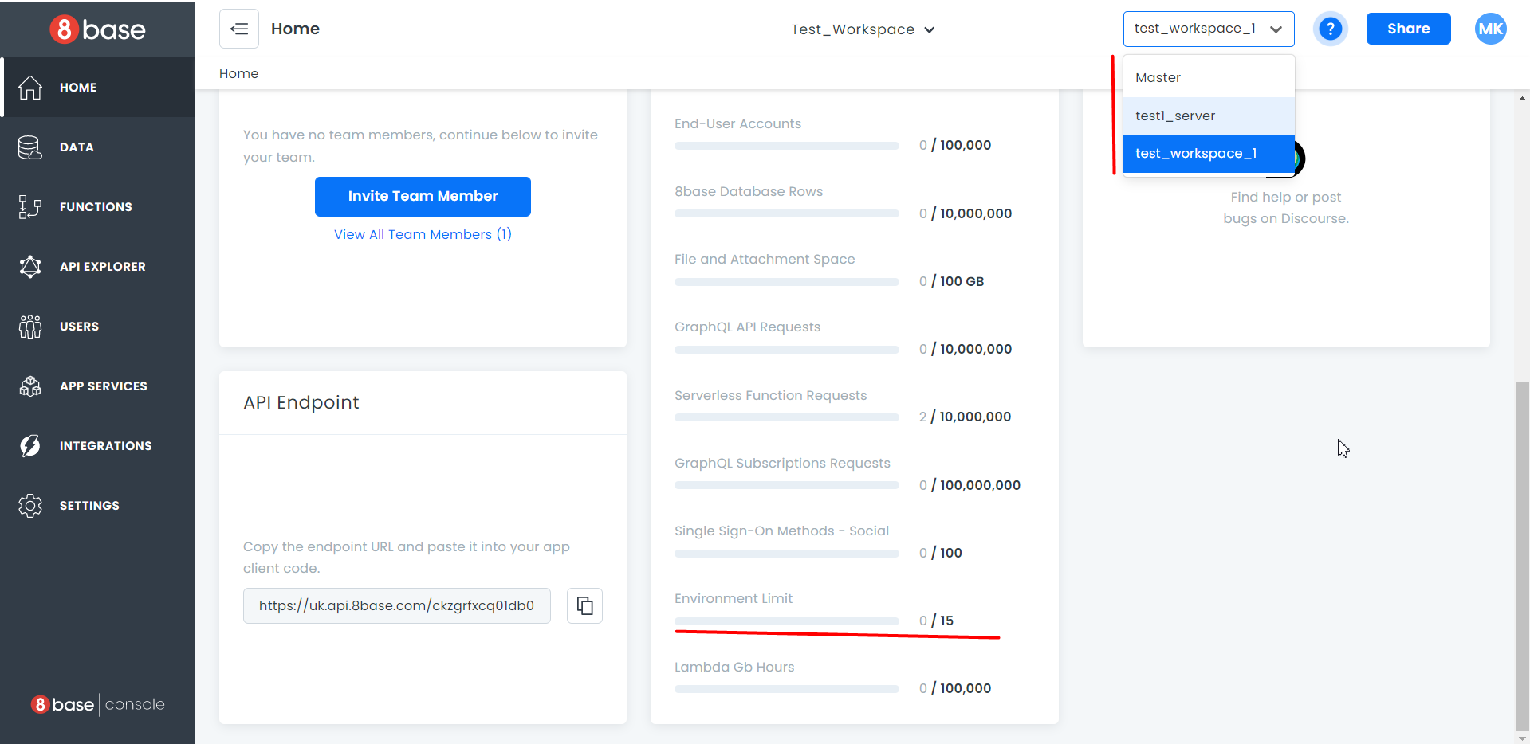
* In chapter 2.1 Quick Start, the options described in the table do not match the screenshot provided as an example Изображение выглядит как текст, монитор, снимок экрана

  Автоматически созданное описание
* The mutation from 2.1 does not work, the message "Records for current filter not found" is displayed. If you first create a user with email that you plan to insert into the mutation, it will work
* In paragraph 3 and 3.1., when attempting to copy a shell command, the heading of the following paragraph is selected  
  Изображение выглядит как текст

  Автоматически созданное описание  
    
  Изображение выглядит как текст

  Автоматически созданное описание  
    
  The rest of the commands not near the item headers work fine  
  Изображение выглядит как текст

  Автоматически созданное описание
* In paragraph 3.2 initialization function «8base init . --functions=resolver:myCustomResolver» is not working.  
   But if instead of a dot write a folder name, for example, «8base init <<FolderName>> -functions=resolver:myCustomResolver» then a new folder will be created and the function initialized in it
* Point 4 failed to run ExampleApp.
* There are 11 errors in parser.mjs with file location  
  in ./node_modules/graphql-prettier/node_modules/graphql/language/parser.mjs 1:0-41  
    
  Module not found: Error: Can't resolve '../jsutils/inspect' in 'C:\Users\Bialy Wilk\OneDrive\Рабочий стол\8base_test_task\8base-starter-app\Test_Workspace\client\react-8base-starter-app\node_modules\graphql-prettier\node_modules\graphql\language'  
    
  Module not found: Error: Can't resolve '../jsutils/devAssert' in …\client\react-8base-starter-app\node_modules\graphql-prettier\node_modules\graphql\language'  
    
  Module not found: Error: Can't resolve '../jsutils/defineToJSON' in '…\client\react-8base-starter-app\node_modules\graphql-prettier\node_modules\graphql\language'  
    
  Module not found: Error: Can't resolve '../error/syntaxError' in '…\client\react-8base-starter-app\node_modules\graphql-prettier\node_modules\graphql\language'  
    
  Module not found: Error: Can't resolve './kinds' in ‘…\client\react-8base-starter-app\node_modules\graphql-prettier\node_modules\graphql\language'  
    
  Module not found: Error: Can't resolve './source' in ‘…\client\react-8base-starter-app\node_modules\graphql-prettier\node_modules\graphql\language'.  
    
  Module not found: Error: Can't resolve './lexer' in ‘…\client\react-8base-starter-app\node_modules\graphql-prettier\node_modules\graphql\language'  
    
  Module not found: Error: Can't resolve './directiveLocation' in ‘…\client\react-8base-starter-app\node_modules\graphql-prettier\node_modules\graphql\language'  
    
  Module not found: Error: Can't resolve './tokenKind' in '…\client\react-8base-starter-app\node_modules\graphql-prettier\node_modules\graphql\language'  
    
  Module not found: Error: Can't resolve './visitor' in ‘…\client\react-8base-starter-app\node_modules\graphql-prettier\node_modules\graphql\language'  
    
  Module not found: Error: Can't resolve './blockString' in ‘…\client\react-8base-starter-app\node_modules\graphql-prettier\node_modules\graphql\language'
* Migration to the master failed. The message that the project is too big is displayed. Removing all package-lock.json and reducing node modules didn't help. Изображение выглядит как текст

  Автоматически созданное описание

Proposals to improve

Make the Quick Start manual more detailed, add the steps needed to execute items like in 2.1 when using mutation  
  
For the web toolkit introduction part, add small videos or GIF animations to the Quick Start guide that would clearly show the playback of the steps