Proiect PRBD

~Rezervatii naturale de ursi~

Nume student: Brutaru Bianca-Ioana

Prezentare

Scopul acestei baze de date este de a tine evidenta tuturor ursilor din rezervatiile naturale de prin lume.

Fiecare rezervatie se afla intr-o anumita zona care ofera habitatul perfect pentru anumite specii.

Fiecare specie este tratata individual in functie de caracteristicile acesteia.

Fiecarei zone ii sunt asignati unul sau mai multi veterinari si ingrijitori.

Fiecare specie va avea un anumit tip de mancare.

Consultatiile vor fi facute odata la 6 luni pentru a asigura sanatatea ursilor si in urma acestora se va administra sau nu un tratament. Tratamentele constau in administrarea unor medicamente specifice, provenite de la firme recunoscute.

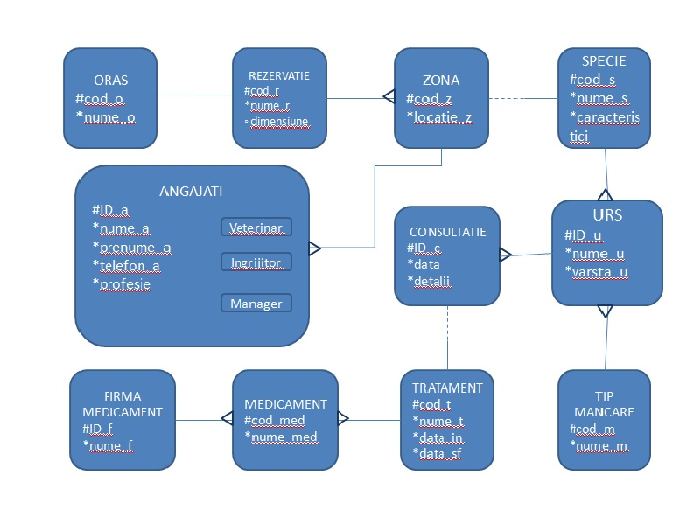

Mapare Tabela ORASE

|  |  |  |  |
| --- | --- | --- | --- |
| **Nume** **Coloana** | **Tip** | **Tip** **cheie** | **Optionalitate** |
| Cod_o | NUMBER(2,0) | P.K | * |
| Nume_o | VARCHAR2(20) |  | * |

Tabela REZERVATII

|  |  |  |  |
| --- | --- | --- | --- |
| **Nume** **Coloana** | **Tip** | **Tip** **Cheie** | **Optionalitate** |
| Cod_r | NUMBER(2,0) | P.K | * |
| Nume_r | VARCHAR2(30) |  | * |
| Dimensiune | NUMBER(4,2) |  | o |
| Cod_o | NUMBER(2,0) | F.K | * |

Tabela ZONE

|  |  |  |  |
| --- | --- | --- | --- |
| **Nume** **Coloana** | **Tip** | **Tip** **cheie** | **Optionalitate** |
| Cod_z | NUMBER(2,0) | P.K | * |
| Locatie_z | VARCHAR2(20) |  | * |
| Cod_r | NUMBER(2,0) | F.K | * |

Tabela SPECII

|  |  |  |  |
| --- | --- | --- | --- |
| **Nume** **Coloana** | **Tip** | **Tip** **cheie** | **Optionalitate** |
| Cod_s | NUMBER(2,0) | P.K | * |
| Nume_s | VARCHAR2(20) |  | * |
| Caracteristici_s | VARCHAR2(200) |  | * |
| Cod_z | NUMBER(2,0) | F.K | * |

Tabela URSI

|  |  |  |  |
| --- | --- | --- | --- |
| **Nume** **Coloana** | **Tip** | **Tip** **cheie** | **Optionalitate** |
| ID_u | NUMBER(2,0) | P.K | * |
| Nume_u | VARCHAR2(20) |  | * |
| Varsta_u | NUMBER(2,0) |  | * |
| Cod_s | NUMBER(2,0) | F.K | * |

Tabela TIPURI MANCARURI

|  |  |  |  |
| --- | --- | --- | --- |
| **Nume** **Coloana** | **Tip** | **Tip** **cheie** | **Optionalitate** |
| Cod_m | NUMBER(2,0) | P.K | * |
| Nume_m | VARCHAR2(20) |  | * |
| ID_u | NUMBER(2,0) | F.K | * |

Tabela CONSULTATII

|  |  |  |  |
| --- | --- | --- | --- |
| **Nume** **Coloana** | **Tip** | **Tip** **cheie** | **Optionalitate** |
| ID_c | NUMBER(2,0) | P.K | * |
| Data | DATE |  | * |
| Detalii | VARCHAR2(200) |  | * |
| ID_u | NUMBER(2,0) | F.K | * |

Tabela TRATAMENTE

|  |  |  |  |
| --- | --- | --- | --- |
| **Nume** **Coloana** | **Tip** | **Tip** **cheie** | **Optionalitate** |
| Cod_t | NUMBER(2,0) | P/K | * |
| Nume_boala | VARCHAR2(30) |  | * |
| Medicamente | VARCHAR2(20) |  | * |
| Data_in | DATE |  | * |
| Data_sf | DATE |  | * |
| ID_c | NUMBER(2,0) | F.K | * |

Tabela MEDICAMENTE

|  |  |  |  |
| --- | --- | --- | --- |
| **Nume** **Coloana** | **Tip** | **Tip** **cheie** | **Optionalitate** |
| Cod_med | NUMBER(2,0) | P.K | * |
| Nume_med | VARCHAR2(20) |  | * |
| Cod_t | NUMBER(2,0) | F.K | * |
| ID_f | NUMBER(2,0) | F.K | * |

Tabela FIRME MEDICAMENTE

|  |  |  |  |
| --- | --- | --- | --- |
| **Nume** **Coloana** | **Tip** | **Tip** **cheie** | **Optionalitate** |
| ID_f | NUMBER(2,0) | P.K | * |
| Nume_f | VARCHAR2(20) |  | * |
| Cod_med | NUMBER(2,0) | F.K | * |

Tabela ANGAJATI

|  |  |  |  |
| --- | --- | --- | --- |
| **Nume** **Coloana** | **Tip** | **Tip** **cheie** | **Optionalitate** |
| ID_a | NUMBER(2,0) | P.K | * |
| Nume_a | VARCHAR2(20) |  | * |
| Prenume_a | VARCHAR2(20) |  | * |
| Telefon_a | VARCHAR2(10) |  | * |
| Profesie | VARCHAR2(15) |  | * |
| Cod_z | NUMBER(2,0) | F.K | * |