`
Department of Information Systems
Systems Analysis (INF2009F)
USER REQUIREMENTS SPECIFICATION (URS):
Insert Project name and
Team number here

TEAM MEMBERS
Student number: | Name:
Student number: SHBLWA011 | Name: Lwandile Shabangu
Student number: MSLKEN005 | Name: Keneilwe Masola
Student number: NGBBIA002 | Name: Bianca Ngobeni
Declaration
- We know that plagiarism is wrong. Plagiarism is to use another's work and pretend that it is one's own.
- This User Requirements Specification is our own work.
- We have not allowed, and will not allow, anyone to copy our work with the intention of passing it off as their own work.
Team Member Name……………...…….Signature:……………..…….. Date ..…/..…/…....
Team Member Name…………..….…….Signature:……………..…….. Date ..…/.…./…....
Team Member Name…………..….…….Signature:……………..…….. Date ..…/.…./…....
Team Member Name Bianca Ngobeni.Signature:…BA NGOBENI….. Date ..09/05./2025..

TABLE OF CONTENTS

1. BACKGROUND 1
1.1. Business overview 1
1.2. Project definition statement 1
1.3. Work method followed 2
2. USER REQUIREMENTS 3
2.1. Overview 3
2.2. Use Case Diagram 7
2.3. Use Case Narrative 8
2.4. System Sequence Diagram 9
3. OBJECTS, RELATIONSHIPS AND BEHAVIOUR 12
3.1. Analysis Class Diagram 12
4. NON-FUNCTIONAL REQUIREMENTS 14
4.1. Performance requirements 14
4.2. Usability requirements 14
4.3. Security requirements 15
4.4. Volume and storage requirements 15
4.5. Configuration / compatibility requirements 15
4.6. Reliability requirements 16
4.7. Backup / recovery requirements 16
4.8. Training requirements 16
5. SUMMARY 16
5.1. Project status to date 16
5.2. Project planning 16

BACKGROUND

Business overview
The Phumla Kamnandi Hotel Group is a newly established empowerment group managing a diverse portfolio of approximately 30 independently operated small hotels across South Africa. While each hotel varies in appearance and facilities, the group’s strategic focus is on standardizing operations to ensure consistent customer interactions, high-quality service, and cost-effective management. The group’s head office, located in Century City, Cape Town, oversees key functions such as marketing, CRM, loyalty programs, and centralized training, while individual hotels handle day-to-day operations.
Project Motivations:
The hotels operate with inconsistent IT systems, this ranges from standalone PCs to basic networked setups thus leading to inefficiencies and lack of standardized reporting. To better the brand and improve operational efficiency here are the things the group with our help aims to implement:
- Enforce practises of standardization across all hotels.
- Efficient financial and management reporting for better consolidation.
- Reduce costs through shared outsourced software, hardware and training.
- Improve guest experience with an integrated system for booking, billing, and service management.

Project definition statement
Agreed Solution:
Implement a centralized, integrated Hotel Management System to replace the
inefficient IT systems across all hotels. The solution will:
- Be an outsourced, commercially proven and tailored to the group’s needs. This will ensure cost efficiency and quicker deployment of the quality system.
- Be cloud-based ensuring real-time data consolidation and remote accessibility.
- Fully automated and integrated to handle reservations, billing, inventory and reporting.
- Through automation, the system will phase out manual processes such as manual registers within the reservation and booking management, chits within the billing system etc.
Objectives:
- Reduction of costs, we will lower costs through shared IT infrastructure.
- Standardize operations, ensure uniform practises across all groups to maintain consistency and deal with inadequacies to strengthen the brand.
- More financial control, through real-time tracking of transactions we eliminate the possibility of revenue leakage as we’ll gain more control of debtors and creditors.
- Improve guest experience, automate billing, streamline bookings, and integrate loyalty programs.
- Data-driven decisions, performance monitoring and overall decisiveness in future about the direction of the brand.
Scope:
The project will run throughout a 12-month period and will include:
- Deployment of the new system across all 30 hotels.
- Integration with already existing programs and some operations.
- Staff training.
It is important to note that the implementation of the project may be constrained by budgetary constraints (expenditure), time (it might take longer) and compliance.

Work method followed
We have chosen to integrate the agile and waterfall methodologies. The agile seems like obvious choice but would bring about challenges with standardization, it would require us to rigorously offer our services, while that might be very good, but we want guest experience to be very seamless, smooth, and enjoyable. So, we use a hybrid method.
This hybrid model allows for flexibility and control, stakeholder engagement and mitigation of risk.
Major Steps Followed to obtain User Requirements:
- Stakeholder Identification and Consultation
- We consulted with the head-office which gave us all the relevant information to conduct much needed research to help improve the brand.
Fact-finding techniques:
- Interviews: Had sessions with hotel managers and other relevant staff.
- Observation: Observed processes during peak hours and days for processes we are trying to improve.
- Workshops
- Process Investigation, the team collaborated over diagramming “as-is” and “to-be” workflows.
- Developed a use-case

*Note: Number 1 is performed under the assumption that as we have been working on the project, initially, we had an engagement with the head-office and they allowed us the chance to engage with staff across hotels and travel agents that book with them to conduct a more thorough research in understanding processes more than what is on paper. We also include the workshops we’ve had.

USER REQUIREMENTS

Overview
For each system under discussion (Sud) – in this instance the Phumla Kamnandi Hotels Booking and Billing System.
- Show the Sud in context with the other parts of the system (package diagram with Sud highlighted would perform this function).
- Create an actor table to describe all the actors involved in the system under discussion. This table should include the actor role, level (primary, secondary or stakeholder), and description.
- Create a table of base use cases (in table format) containing use case number, primary actor, use case name and priority level.

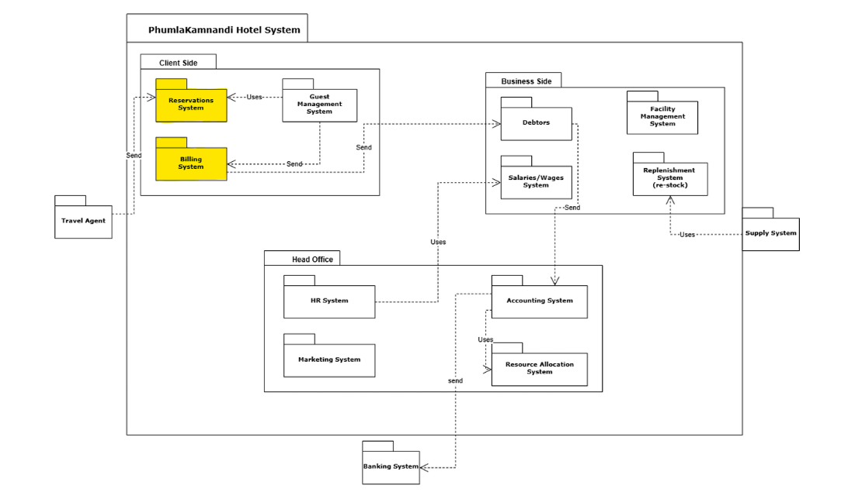

Actor Table
Actor Role | Level | Description
Customer | Primary | Makes reservations, checks in/out, pays bill, and uses services.
Receptionist | Primary | Manages bookings, performs check-in/out, updates guest accounts.
Catering/Bar Staff | Secondary | Records services consumed by guests to be added to the guest's bill.
Manager | Stakeholder | Oversees operations and reporting; uses management reporting features.
Accountant | Secondary | Processes payments, monitors open/closed accounts, handles invoices.
IT Support Staff | Stakeholder | Supports system rollout, maintenance, and upgrades.
Head Office(Exco) | Stakeholder | Uses consolidated reports for decision making and strategic planning.
Base use case Table
Use Case No. | Primary Actor | Use Case Name | Priority Level
1.1 | Customer | Make Reservation | High
1.2 | Customer | Pay deposit | High
1.3 | Receptionist | Check details | High
1.4 | Receptionist | Check Room Availability | High
1.6 | Receptionist | Create Booking | High
1.9 | Receptionist | Perform Check-In/out | High
1.10 | Receptionist | Update Guest Account | High
1.11 | Receptionist | Send weekly occupancy reports | High
1.12 | Receptionist | Monitor reservations | Medium
1.13 | Manager | Analyze report | Medium
2.1 | Customer | Receive bill | High
2.2 | Customer | Make payment | High
2.3 | Catering Staff | Make consumption form | Medium
2.4 | Receptionist | Process consumption form | Medium
2.5 | Receptionist | Charge bill | High
2.6 | Receptionist | Authorize Payment | High
2.7 | Accountant | Manage accounts | High

Use Case Diagram
Insert a Use Case Diagram that provides an “inventory” of all the actors, their uses of the system, and information about supporting actors and re-use (functionality common to more than one use case). Remember to remain within scope (Phumla Kamnandi Hotels Booking and Billing System).
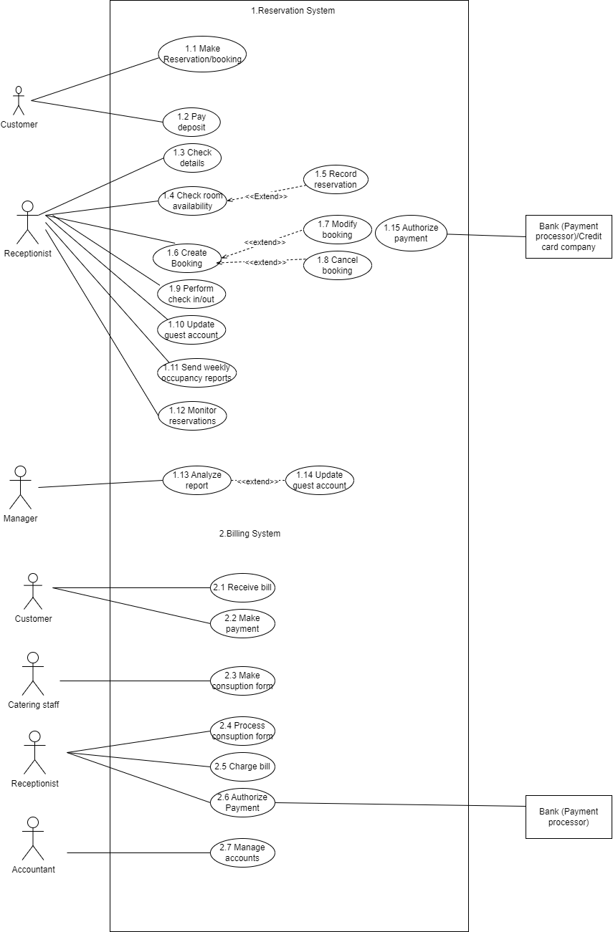

Use Case Narrative
Write a Use Case Narrative for the “Make a Guest Booking” use case. Use as many of the categories mentioned in the lecture slides as you think are appropriate to the description.
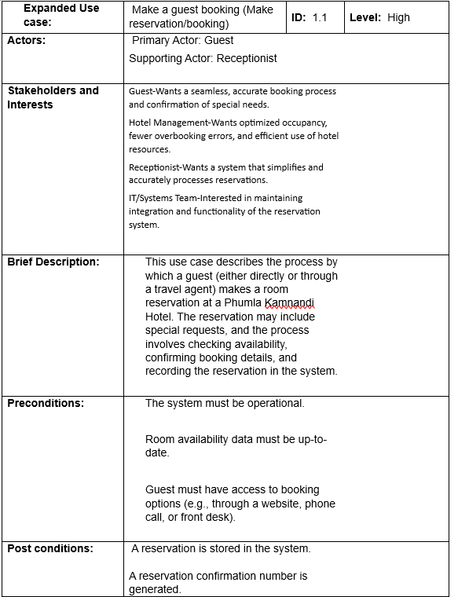
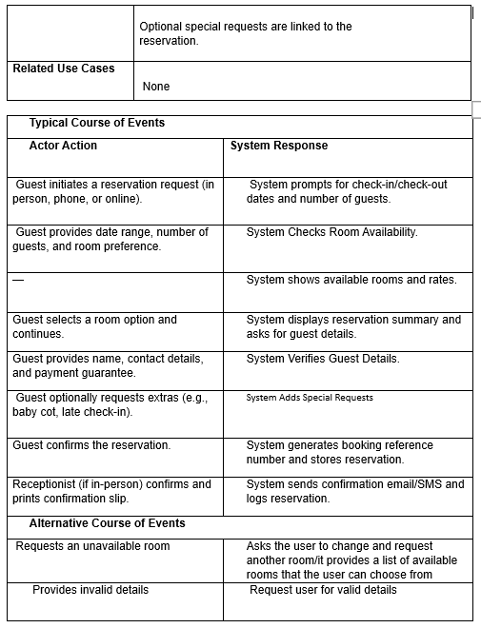
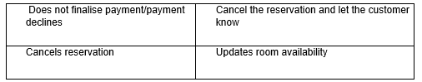

System Sequence Diagram
nd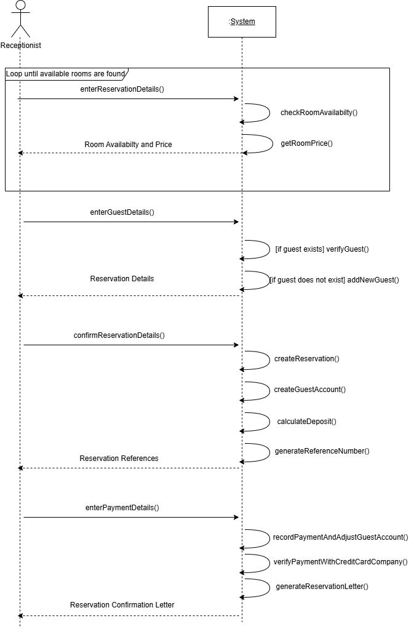

OBJECTS, RELATIONSHIPS AND BEHAVIOUR

Analysis Class Diagram
Draw an Analysis Class Diagram highlighting the main software classes required to support the system under discussion at Phumla Kamnandi Hotels. Include class associations, important attributes, generalisation/specialisation hierarchies and any aggregation that is present. You do not need to include methods.
Give a short description of each class and its purpose, either as UML notes on the diagram or as a separate “data dictionary”.
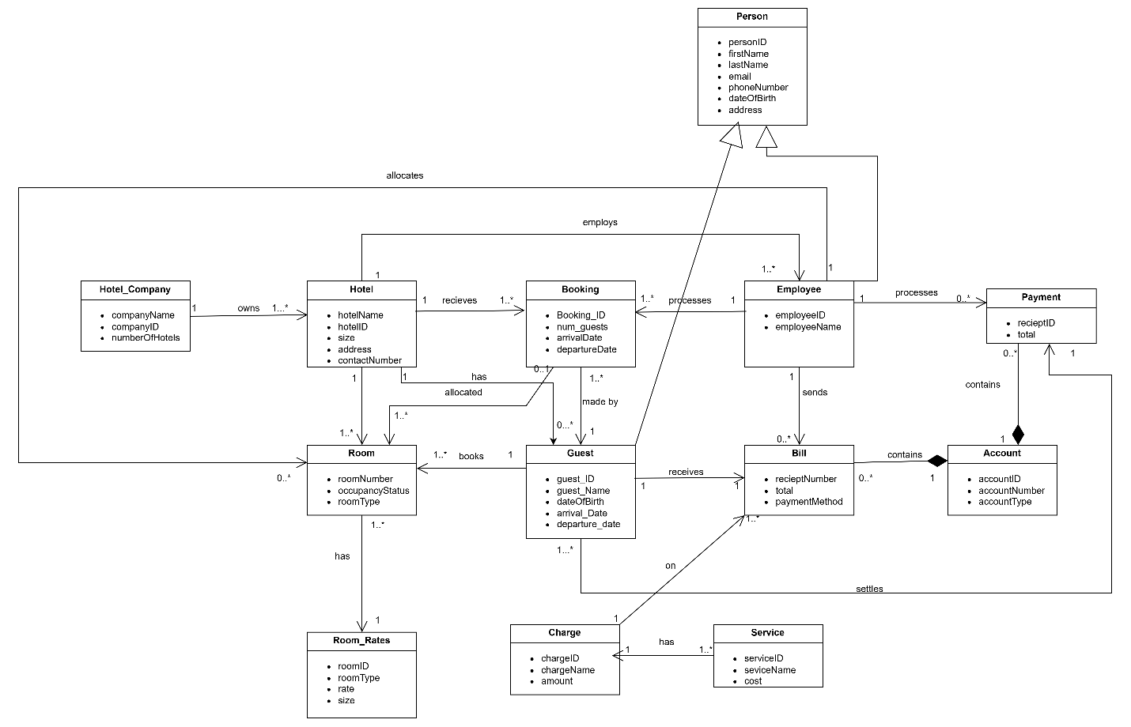
Data dictionary:
Person
- Represents any individual associated with the hotel system (can be a guest or employee).
- Attributes: personID, firstName, lastName, email, phoneNumber, dateOfBirth, address
Guest (inherits Person)
- A person who makes a booking or stays at the hotel.
- Attributes: guest_ID, guest_Name, dateOfBirth, arrival_Date, departure_Date

Employee (inherits Person)
- A hotel staff member who may assist in bookings, room service, or management.
- Attributes: employeeID, employeeName
Hotel_Company
- Represents the Phumla Kamnandi Hotel group at the corporate level.
- Attributes: companyName, companyID, numberOfHotels
Hotel
- Represents an individual hotel under the group.
- Attributes: hotelName, hotelID, size, address, contactNumber
Room
- Represents a physical hotel room.
- Attributes: roomNumber, occupancyStatus, roomType
Room_Rates
- Defines pricing per room type, size, or rate plan.
- Attributes: roomID, roomType, rate, size
Booking
- Records details of a guest’s reservation.
- Attributes: booking_ID, num_guests, arrivalDate, departureDate
Account
- Tracks the billing account tied to a room or guest stay.
- Attributes: accountID, accountNumber, accountType
Bill
- Represents the final amount due and payment method after checkout.
- Attributes: receiptNumber, total, paymentMethod
Payment
- Represents a specific payment transaction.
- Attributes: receiptID, total
Charge
- Records a service or item added to a guest's account.
- Attributes: chargeID, chargeName, amount
Service
- Represents any service offered by the hotel (laundry, bar, meals).
- Attributes: serviceID, serviceName, cost

NON-FUNCTIONAL REQUIREMENTS
Briefly explain what is meant by “non-functional requirements” and why they are documented separately from the functional requirements.
Non-functional requirements focus on how well the system performs its functions, rather than what the system is meant to do. They are documented separately from functional requirements because they are not the core needs for the system to function, but they are useful to have and enhance performance. They do not describe the system’s actual functionality; instead, they capture aspects that aim to improve the system’s functionality.
Document the non-functional requirements for your system under the subheadings below. Put Nil under each subheading where there are no requirements relevant to your system. Most of these requirements have not been provided in the case study and marks will be awarded for the identification of appropriate requirements in each category.

Performance requirements
- The reservation aspect of the system must have high performance, as it is the first point of contact with Phumla Kamnandi. Subsystems such as Room Allocation, Payment, and Check-In must process transactions within 2 seconds to enhance customer satisfaction and reduce booking abandonment.

Usability requirements
- The system must be easy to operate; staff members must be able to use the system after one full day of training.
- The system must be universally accessible, supporting users with disabilities through screen reader compatibility, large text options, and keyboard navigation.

Security requirements
- The system must protect private and sensitive data, such as passwords for guest accounts and credit card details, using encryption.
- There must be access control on account access; only authorized staff members must be able to access guest accounts.
- The system must allow hotel managers to access the systems that manage the overall operation of the hotels, except the finance department.
- The system must limit access to the hotel’s financial affairs to the Accountant/Bookkeeper.
- The system must have a 3-step verification method to ensure that individuals are restricted from accessing information they are not authorized to have.

Volume and storage requirements
- The system must be able to store and retrieve the data of customers who interact with Phumla Kamnandi. This can help prevent any anomalies in the database.
- The system must store all staff data, such as existing staff, remuneration methods, positions, and shifts.
- The system must have a scalable database volume that can expand based on the amount of data it needs to store.
- The database must store all monetary transactions, including charges to customers and transactions with vendors or external parties, as this will assist with the processing of accounts.
- All significant events that occur and output data involving the system as a third party must be stored in the database.

Configuration / compatibility requirements
- The system must allow customers to make bookings on any device or browser to improve accessibility, and the interface must adjust to the screen size being used.
- The system must be able to operate under poor network conditions, which may result from load shedding.

Reliability requirements
- The system must be readily available for use at any time of day; this means that customers can make bookings at any hour and hotel managers can access the data at any time.
- The system must be maintained annually to ensure that its operations are dependable and maintain integrity.
- The system must have proper error handling and data validation features to ensure that data always maintains integrity and that the system does not crash.

Backup / recovery requirements
- The system must be able to recover reservation details and any form of payment that occurred with Phumla Kamnandi for at least 2 years, as these are the areas that tend to have the most errors and where proof and documentation will be needed.
- The system must conduct regular backup updates of the data so that all necessary unchanged data can be recovered if the system suddenly crashes.

Training requirements
- Training must be compulsory for all staff members, as Phumla Kamnandi will be integrating a new system. This will reduce human error and ensure that the new system effectively works in Phumla Kamnandi’s favour.

SUMMARY

Project status to date
The project has progressed through several key phases of implementation, this includes:
- System Analysis and Design
- Conducted interviews and observed for period of times.
- Spotted some inefficiencies with the current IT system and manual processes.
- System Analysis and Design
- Developed a Use Case Diagram to map interactions between actors and the system.
- Created a Use Case Narrative for detailed interactions.
- Designed a System Sequence Diagram to demonstrate interactions between the user and the system
- Built an Analysis Class Diagram depicting key entities and their relationships.
- Non-Functional Requirements
- Highlighted key performance features, usability, security, storage, reliability, backup requirements and ensured alignment with what the business aims to achieve (cost reduction, standardization, improved guest experience).
- Methodology and Process Planning
- We used a hybrid methodology to balance flexibility with standardization, and we established a 12-month time frame.

Project planning
What is left is:
System Development: This includes software selection that will be customized and integrated for our group operations
Testing: We will conduct many tests to test how the system is being received by workers and closely monitor its performance, test for security and backup protocols if the system perhaps crashes and goes offline.
Deployment and Training: We will deploy the system in all 30 hotels and transfer old data to the new system and offer mandatory training for receptionists, managers and other staff through workshops and creating user manuals.
Post-Implementation Review: We will evaluate all the goals the brand aimed to achieve and assess whether they have been achieved (cost reduction, standardization, guest satisfaction).

