Modeling functional diversity and resilience of the
Amazon forest to climate change beyond carbon stocks

Responsible reasearcher: David Montenegro Lapola

Host Institution: Centro de Pesquisas Meteorológicas e Climáticas Aplicadas à Agricultura . CEPAGRI – UNICAMP

Research Team: Bianca Fazio Rius^{1,2}, David Montenegro Lapola^{3,4}

¹ Qualification: Msc and PhD candidate

² Host institutions: Programa de Pós-Graduação em Ecologia – UNICAMP;
Centro de Pesquisas Meteorológicas e Climáticas Aplicadas à Agricultura . CEPAGRI – UNICAMP
³Qualification: PhD Professor

⁴Host institutions: Programa de Pós-Graduação em Ecologia – UNICAMP;
Centro de Pesquisas Meteorológicas e Climáticas Aplicadas à Agricultura . CEPAGRI – UNICAMP;
Programa de Pós-Graduação em Ecologia e Biodiversidade – Unesp, Rio Clao

Process number: 2019/04223-0

Fellowship period: 01/06/2019 to 28/02/2021

Period covered by this Scientific Report: 01/06/2019 to 01/06/2020

Scientific Report
Campinas 2020
Project summary

The uncertainties regarding the resilience of Amazon basin forests to climate change is of primary importance. Here resilience is considered as "the capacity of an ecosystem to absorb a disturbance and reorganize while undergoing change so as to retain essentially the same function, structure identity, and feedbacks" (FOLKE et al., 2010), providing, in this way, the same ecosystem services and without changing to an alternative state (CÔTÉ; DARLING, 2010; HODGSON; MCDONALD; HOSKEN, 2015; THOMPSON et al., 2009). This concept encompasses two processes: resistance (the capacity of the system to deal with the effects of exogenous disturbances) and recovery (endogenous processes that allow the system to return to its previous state and the time that takes to it happen; CÔTÉ; DARLING, 2010; HODGSON; MCDONALD; HOSKEN, 2015). It has been argued that functional diversity plays a vital role in determining ecosystem resilience. Besides that, some authors claim that considering only one ecosytem function to evaluate resilience may under or overestimate it. In that sense, this proposal intends to investigate the resilience of Amazon forest to climate change taking into account the ecosystem's multifunctionality and the role of functional diversity in promoting it (or not). For this, we are developing and applying the Dynamic Global Vegetation Model (DGVM) named CAETÊ (Carbon and Ecosystem Functional Trait Evaluation model), a trait-based model that seeks to represent plant functional diversity more reliably through the usage of empirical values (that are variants in space and time) for functional traits. Four functional traits compose the focus of the present proposal: specific leaf area, wood density, nitrogen and phosphorous contents on leaves and g1 (stomatal condunctance sensitivityto CO₂ assimilation rate). In this proposal we will develop and improve some formulations of the CAETÊ model: we will change the model's carbon allocation scheme from a constant fraction for each plant compartment to an allometric scheme in order to better represent the biomass spatial distribution, as evidenced by some authors (CHAVE et al., 2004, 2014; DE KAUWE et al., 2014).
As specific objectives we intend to answering the following questions: (i) How consistent is the representation of functional diversity, in terms of its different facets (functional identity, richness, evenness, divergence and redundancy), generated by the employed trait-based modeling approach when compared to empirically measured functional diversity in different regions of Amazon basin?; (ii) What is the relationship between the different facets of functional diversity (i.e., functional identity, richness, evenness, divergence and redundancy) generated by the CAETÊ model for Amazon forest and different ecosystem functioning processes (net primary productivity, evapotranspiration and vegetation carbon stock)? Which of these facets is the most determinant for each process? Are the mentioned ecosystem processes better represented through separate traits or through trait syndromes (i.e., the combination of traits)?; (iii) How are the different functional diversity components (functional identity, richness, evenness, divergence and redundancy) in Amazon forest affected by different levels (from low to high severity) of climate change disturbances (increase of temperature and CO₂ concentration and decrease of precipitation)?; (iv) How resilient, in terms of its resistance and recovery rate, are Amazon forest to the different levels (from low to high severity) of climate change disturbances? That is, how resistant are the different ecosystem functioning processes (net primary productivity, evapotranspitation and vegetation carbon stock) to these disturbances and how long they take to recover? Does functional diversity matters for the resilience of these processes and which of its facet is more important?

1. Performed activities during the period
1.1. National and international courses
The course “Communities diversity and structure” taught by the PhD Prof. Mathis Pires at the Universty of Campinas was taken in order to complete the requireds credits for the PhD degree. Two other courses are still missing to complete the credits, but because of the COVID-19 pandemic they have been canceled withn onew offer date expected until now
The international course Max Planck Earth System Modelling School was taken from 16 to 20 September 2019 at the International Max Planck Research School on Earth System Modelling (IMPRS-ESM) in Hamburng, Germany. In this course the fundamental processes and dynamics of the natural Earth system was introduced what included lectures on the different geophysical and biogeochemical Earth system components (atmosphere, ocean, land) and on their representation in the Max Planck Institute Earth System Model (MPI-ESM). The MPI-ESM was used by the students with the super-computing resources of the German Climate Computing Center (DKRZ). The main part of the school was devoted to the analysis of the simulation results in ‘hands on sessions’. The participants also developed their own understanding of the simulation results guided by hypotheses for simulation outcome formulated in group work in advance. At the end of the course the results were presented for discussion with all participants and tutors in a final seminar.
Finally, the beneficiary of the present scholarship took part on the “JULES introductory training” course given at th University of Campinas (Unicamp). The Joint UK Land Environment Simulator (JULES; CLARK et al., 2011)⁠ is a land surface model that allows different land surface processes (surface energy balance, hydrological cycle, carbon cycle, dynamic vegetation, etc.) to interact with each other. It also provides a framework to assess the impact of modifying a particular process on the ecosystem as a whole, e.g. the impact of climate change on hydrology, and to study potential feedbacks (https://jules.jchmr.org/). The course included a ‘hands-on’ training led by Lina Mercado and Stephen Sitch, both part of the developing model team.

1.2. Scientific events participation and presentation
a) Europian Geosciences Union (EGU) General Assembly – April 7-12, 2019. Austria Center Vienna (ACV), Vienna, Austria. Oral presentation (section 4.a)

b) 56th Annual Meeting of the Association for Tropical Biology and Conservation (ATBC) - July 30 – August 3, 2019. Ivato International Conference Center (CCI Ivato), Antananarivo, Madagascar. Oral presentation (section 4.b)

c) GINGKO Workshop on Plant Traits in DGVMs - October 7-8, 2019. Senckenberg Biodiversity and Climate Research Centre, Frankfurt, Germany. Oral presentation (section 4.c)

1.3. Short-term internship
During the year of 2019 I took part of two events in Germany: the Max Planck Earth System Modelling School from 16 to 20 September (section 1.1) and the GINGKO Workshop on Plant Traits in DGVMs from 7 to 8 October (section 1.2c). Given the proximity of the date of the two events, returning to Brazil and later returning to Germany would not be worth it (I used the technical reserve of my scholarship to cover the costs of airfare, accommodation, food and transportation). Thus, during the period between the events, a short-term internship was carried out under the supervision of PhD Prof. Simon Scheiter (http://www.bik-f.de/root/index.php?page_id=292) at the Senckenberg Biodiversity and Climate Research Centre, Frankfurt. Scheiter has extensive knowledge in vegetation models, including the development of trait-based models for tropical forests such as the model aDGVM (SCHEITER; HIGGINS, 2008, 2009)⁠ and aDGVM2 (SCHEITER; LANGAN; HIGGINS, 2013)⁠, widely used by academic society. During the internship I had the opportunity to present the CAETÊ model to Scheiter and his lab team, what resulted in a rich debate about the main CAETÊ principles with questions and sugestions for future implementations.
During the internship I also had the opportunity to interact with other researches from the institute in order to know their work and what has been developed in this area of knowledge. A particular partnership was made with the post doctoral Liam Langan, from Scheiter’s lab group. Langan was also responsible for the development of the aDGVM2 (LANGAN; HIGGINS; SCHEITER, 2017)⁠. He provided great assistance in my comprehension of allometric relations and its respective equations, what resulted in a first version of the script code for the allometry implementation in CAETÊ (see section 1.5). We expect that this collaboration will enable us to publish a scientific paper related to the importance of the allometry in vegetation models in order to improve the geographical representation of carbon storage across Amazon basin.

1.4. Scientific paper writing
During the first period of the present scholarship an scientific paper has been written and will be submitted until July for the scientific journal Global Change Biology.
This paper used the prelimirary results obtained in the master’s degree of the beneficiary in which the first version of CAETÊ model was developed and applied. This version differ from the one that is being used for the development of the present proposal because the former is a non-dynamic version of the CAETÊ model, which calculates equilibrium solutions based on long-term mean monthly climate variables (for the period between 1980 and 2010). For the current proposal a dynamic version of the model is being developed.
It was not possible, during the master period of the student, to analyse the functional diversity results due to a lack of familiarity with the methods. In that sense, it demanded from the student an statiscal and ecological comprehension of the methods and such a gap has been filled during the first period of this scholarship. The methods used for this paper (Trait Probability Density Distribution – TPD; CARMONA et al., 2016) will be the same to be used in the development of the present proposal, in that sense this compreehension is fundamental for the analyses to be made in the development of this study.
For the above cited paper we applied the model CAETÊ for the Amazon basin with two climatic scenario: regular climate (refence climatology from 1980-2010) and reduced precipitation (homogenous decrease in precipitation of 50% for the whole basin).We aimed to understand the impact of reduced precipitation on functional diversity and on the ability of the forest to absorb and store carbon. For this, we used six functional traits: allocation and residence time for leaves, aboveground woody tissues and fine roots. In order to understand the role of functional diversity on the response of Amazon forest, we initiated the model using two types of modelling approaches that provided us two levels of initial funcional diversity: high and low. For the low diversity approach we used 3 tropical PFTs and the values of the functional traits were assigned by consulting previous literature. For the high functional diversity we used a trait-based modelling approach in which the values of the traits are randomly sampled from ranges of values for each functional traits, what creates a functional space with thousands of trait value combinations what we call as Plant Life Strategy (PLS) from which we sampled 3000 PLS. All the grid-cells were initiated with the same amount and indentity of PFTs/PLS, and with envinronmental filtering, the trade-offs between the functional traits and the physiological processes we end up with each grid-cell with its own community. From this we were able to create TPDs and analyze the distribution of all 6 traits, comparing both the two modelling approaches and the climatic scenarios (Fig. 1; here we only represent the results for the allocation traits).
In summary what we found was that for both approaches the dissimilarities between the probability density curves (pre and post disturbance) are high (greater than 0.5) and we concluded that the reduced precipitation changed the functional structure and diversity of the communities. In commmon, both approaches showed an expressive reduction of dominance for all the traits, what enabled the occurrence of strategies that were rare or that were not occuring before, in agreement with the compensatory dynamics theory (Fig. 1). Despite of this similirarity between the approaches responses, the distribution curves are quite different. One can observe, for example, that the PFT approach presents for all traits a limitied possibility of the occurrence of new trait values, presenting, in the the reduced precipitation scenario, trimodal curves. On the other hand the trait-based approach showed a more spreaded occupation of the functional space. It reflected on the functional diversity facets: both approaches showed an increase in functional richness for the considered functional traits, however it was in a much higher magnitude for the trait-based approach. In terms of evenness, the trait-based approach showed an increase (higher than 100%) for all traits, while the PFT approach showed a decrease in this variable for the majority of the traits. Finally, divergence decreased (except for leaf allocation) in the drought scenario for trait-based approach; on the other hand the PFT approach showed an increase in divergence (except for leaf allocation and fine roots. These results indicate that the trait-based approach was able to better occupy the functional space with the disturbance in comparison with the PFT approach, enabling the chances of the community to adapt to different climatic conditions. These constranst in the results must be due to the difference between response diversity of the approaches imposed by the level of functional diversity in which the model was initiated: very limited for the PFT approach since it had only 3 possibilities of trait combinations against 3000 for the other modelling approach.
In terms of composition, with the reduced precipitation we observed, for the trait-based approach, an increase in the investment for fine roots to the detriment of woody tissues and leaves, while the carbon partioning for the PFT approach did not change. The change on composition allowed the trait-based approach to deal better with the drought, allowing the maintenance of carbon storage in several regions where the other approach was not able to. Nevertheless, as fine roots contribute in a lesser extent to total carbon stock when compared to woody tissues and also present lower residence times, it implies in a relative smaller ability to store carbon when considering the ecosystem scale.
The results of this study show: (i) the model CAETÊ in fact allows functional diversity analysis (e.g. how it responds to climate change) and (ii) the model enables the investigation of the relation between functional diversity and ecosystem processes being that our results show that functional diversity plays a major role in the ecosystem response for changes in climate.

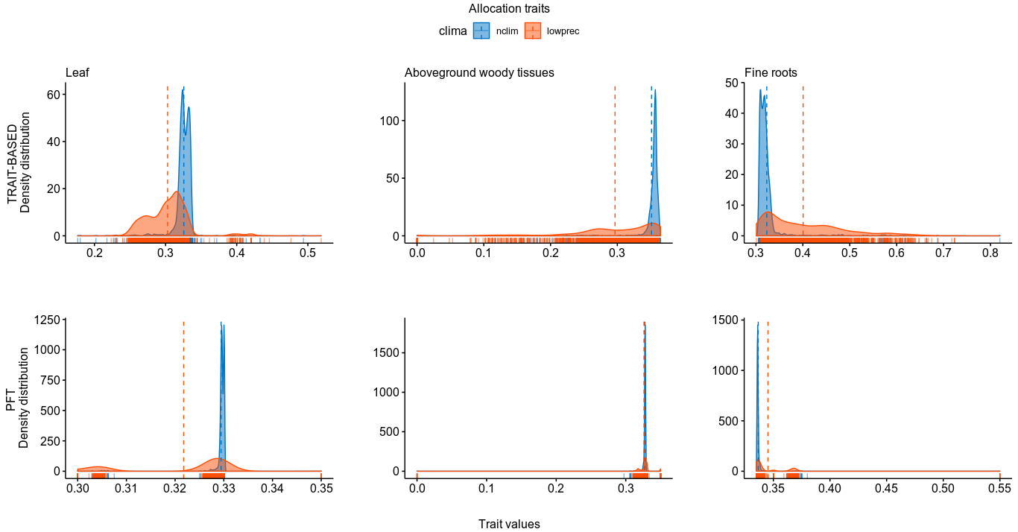Figura 1. Density distributions of allocation traits. The curves corresponds to the density of the allocation traits values across the Amazon basin. The red curves represent the results with the applied low precipitation scenario (low prec. in the graph) and the blue ones represent the results concerning to the regular conditions of climate (nclim in the graph). The upper side of the figure show the results regarding to the employed traid-based (high functional diversity) modelling approach, while the bottom side presents the results obtained with the PFT (Plant Functional Type; low functional diversity) modelling approach. Since the figure corresponds to the allocation traits the unit of the Trait values is in percentages.
1.5. Allometric scheme development and implementation
As foreseen in the proposal of this study, one of the first tasks to be accomplished is the change of the model's carbon allocation scheme from a constant fraction for each plant compartment to an allometric scheme in order to better represent the biomass spatial distribution. For this, a literature review was made for the improvement of allometry theory knowledge, as well as in order to establish the equations to be used. This project phase count on the collaboration and on the assistance of the post-doctorate Liam Langan, during the stay in the laboratory of Prof. Simon Scheiter (Senckenberg Biodiversity and Climate Research Centre – Frankfurt, Germany; task described in section 1.3). Thereby it was possible to develop the necessary programing script to be implemented in CAETÊ model. This script was made in collaboration with the master’s student Barbara Cardelli (FAPESP scholarship number 19/06486-9) and with the technician Caio Fascina (FAPESP TT3 scholarship number 19/07972-4); both of them develop their projects in the same laboratory of the present study.
Follow the allometric equations chosen to be used in the model. The majority of them was based on the Lund-Potsdamn-Jena Model (LPJ; SITCH et al., 2003; SMITH; PRENTICE; SYKES, 2001⁠). Allometric relationships of a PLS are calculated based on the diameter (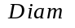; cm), the height (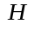; m), the crown area (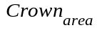; m²) and the leaf area index (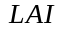; m²m⁻²):
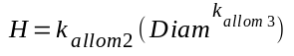
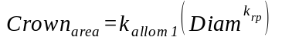
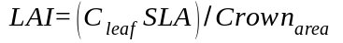
where 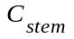is the amount of carbon on the stem (kgC), 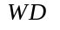is the wood density (gcm⁻³), 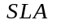is the specific leaf area (m²kg⁻¹), 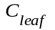is the carbon stored on leaves (kgC) and 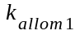,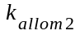,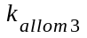and 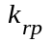are allometric constants equal to 100.0, 40.0, 0.5 and 1.6, respectively.
From the allometry constraints of a PLS is now possible to determine its grid-cell occupation in an area-based approach instead of the biomass-based approach used in the CAETÊ previous version, which emploeyd biomass-ratio hypothesis (GRIME, 1998; PAVLICK et al., 2013)⁠. Using biomass-ratio approach may overfavour the PLSs with high biomass (especially the ones with high carbon storage on stem) and lead to the hyperdominance of certain traits combinations that affect the community assamblage as well as the ecosystem processes. In the present version, a grid-cell is occupied by a mosaic of PLSs (each one represented by a single average individual), being that the area that each one occupies is called as fractional projective cover (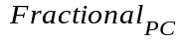, m²) that is based on the projection of the leaf area of a PLS, the so called foliar projective cover (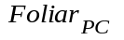, unitless) and on the estimation of the density of average individuals (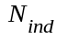 ) of a certain PLS given its diameter (SMITH, 2001)⁠. The use of the diameter for calculating the density of individuals is based on the the self-thinning rule (the number of trees per unit area decrease as average tree size increases; WELLER, 1987; WESTOBY, 1984⁠); here we consider the “size” of the PLS as its diameter and, indirectly, its crown area. As in LPJ model, we assume canopy closure but no overlap between crowns, hence, the sum of the of all PLSs in a grid cell cannot exceed 1, also meaning that there is no vertical overlap among PLSs. At least 5% of the grid cell is intended for grasses, in that sense, the sum of all woody PLS occupation can not exceed 95%. If so, all the PLSs present a percentage reduction in its occupation in order to respect the maximum occupation area.
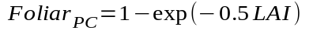
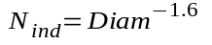
From the allometry relations and the implementation of an area-based scheme of grid-cell occupation we were able to develop a light competition module; light competition in the previous CAETÊ version was very simple and non-mechanistic. Now, the PLSs present in a grid-cell are designated to an specific vertical layer depending on its height, what will specify the amount of light that this PLS will receive considering the light extinction according to Lambert-Beer law (SITCH et al., 2003)⁠. The number of layers (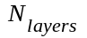) in a grid-cell is determined by the heighest PLS (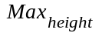, m) on it and its size (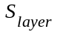, m) is uniform across the vertical profile.
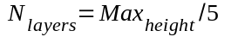
where 5 is an standardized number for all the grid-cells in order to determine the stratification.
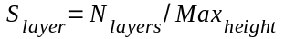
The incident photosynthetic active radiation available in a layer 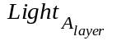 depends on the incident light in the previous layer 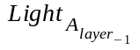 discounted the amount of light used by this same layer 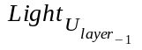, the light usage and, consequently, the light extinction respects Lambert-Beer law (MONSI & SAEKI, 1953). Sun angle is not directly taken into account.
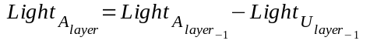
All the PLS in a layer receive the same amount of light. Since more than one PLS can be in the same layer, the used LAI is the mean LAI of all PLS occupying the same layer .
The mortality in the previous version of CAETÊ was very simplistic and only considered a negative carbon balance as a mortality factor. Now, besides the negative carbon balance, the mortality of a PLS depends also on the grid cell space occupation if the sum of the of all woody 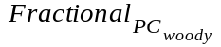 exceeds 95%, then the number of average individuals is reduced, in its turn reducing the occupation area. Then, the mortality due to space 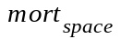 (formulation based on (ZENG; LI; SONG, 2014)⁠:
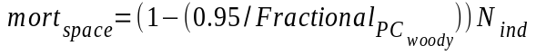
The light competition can turn into a mortality factor if it leads to a negative carbon balance. Besides, the height of a PLS must obey a mechanical stability that imposes a critical height 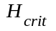. This formulation is derived from the model aDGVM2 (LANGAN; HIGGINS; SCHEITER, 2017):
Beyond that, we also implemented a mortality (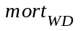 ) linked to wood density based on LPJmL-FIT (SAKSCHEWSKI et al., 2016):
Now, the next step is implementing the code developed “offline” into the model itself. It also includes decisions concerning where, in the model, theses formulation will be implemented (depending on, for example, if they will be uptaded monthly or anually). After, preliminary tests will be made in order to verify if the implemented equations provide reasonable results.

2. Description and evaluation of the institutional support
All the support needed during the period was received by the student: our laboratory room has been renovated to accommodate the number of people using it. The institute has the support of secretaries as well as computer technical support to solve possible problems with the internet and software installation, for example. All the computational resources necessary for the development of this project were provided: notebooks exclusively for the student (made available by the fapesp project linked to the present one (process number: 2015/02537-7); a server with higher computational capacity in order to make the model runs since it demands high computational demands and a technician support for the model code development ( FAPESP TT3 scholarship number 19/07972-4). Besides that, meeting rooms suitable for holding group meetings with available power point. Finally, we have a support center for communication with FAPESP with highly qualified and helpful staff.

3. Schedule for the next period
 | Jul. | Aug. | Sep. | Oct. | Nov. | Dez. | Jan. | Fev. | Mar.
Sientific paper submission
Qualification exam ª
Finalization of allometric scheme insertion in CAETÊ
CAETÊ run (regular climate)
FD^{b} comparison between CAETÊ and measurements
Testing FD facets and ecosystem functioning relation
CAETÊ run (climate changed)
Climate change effect on FD
Climate change effect on tropical
forests' resilience analysis
Scientific report

ªThe qualification exam should have done in the first semester of 2020, however because of the suspension activities at the university owing to COVID-19 pandemic it was canceled. There is still no forecast for the activities return. ^{b}Functional Diversity.
In the next month two work fronts will be on focus: the first one is the completion and submission of the aforementioned scientific paper (section 1.4). Together, the conclusion and implementation of the allometric scheme at the CAETÊ model, with a expected completion in september. Then, the first model runs wil be made in order to verify bugs on the program as well as problems of implementation. With the model results we will be able to compare them with benchmarks and also compare the functional diversity obtained with field measurements. For november and december the analysis to undersand the relation between functional diversity (with its different components) and ecosystem functioning will be developed; this phase will require the dedication of the student in understand the analysis both theoretically as well as how to put it in practice, since she is not familiarized with this type statistical analysis. Also in these two months the model runs with changed climatology will be made and will be followed by the seek for understanding the effects of climate change on functional diversity and then on the resilience of the studied ecosystem. It is foreseen the requirement of program Reasearch Internship Abroad (BEPE) mainly to the development and interpretation of the results concerned to the functional diversity-ecosystem functioning relationship and also about the ecosystem resilience (these two themes are not the expertise of the responsible reasearcher; in that sense we see that an additional assistance will be fundamental for a high quality work).
Given the complexity of the development of this project, as well as the expected request for scientific internship, we will require the scholarship extension of 12 months.

4. List of publications in the present period
a) Oral presentation at EGU 2019 in session Plant traits, adaptation and biogeochemical cycles – from measurements to models. Title: Increase in functional diversity compensates reduction on Amazon basin's net primary productivity in drier climate: exploring a new trait-based model. Authors: Bianca Rius, João Darela, Moara Canova, and David Lapola.

b) Oral presentation at ATBC 2019 in session Tropical Biodiversity and Global Changes. Title: Increase in functional diversity in drier climate conditions can buffer reduction in Amazon forest carbon stock. Authors: Bianca Rius, João Darela, Moara Canova, and David Lapola.

c) Oral presentaiton at GINGKO meeting 2019. Title: The role of functional diversity on Amazon forest carbon stock: employing a new trait-based model. Authors: Bianca Rius, João Darela, and David Lapola.

5. Referências bibliográficas
CARMONA, C. P. et al. Traits Without Borders: Integrating Functional Diversity Across Scales. Trends in Ecology and Evolution, v. 31, n. 5, p. 382–394, 2016.
CÔTÉ, I. M.; DARLING, E. S. Rethinking ecosystem resilience in the face of climate change. PLoS Biology, v. 8, n. 7, 2010.
DE KAUWE, M. G. et al. Where does the carbon go? A model-data intercomparison of vegetation carbon allocation and turnover processes at two temperate forest free-air CO2 enrichment sites. New Phytologist, v. 203, n. 3, p. 883–899, ago. 2014.
FOLKE, C. et al. Resilience Thinking : Integrating Resilience, Adaptability and Transformability. Ecology and Society, v. 15, n. 4, 2010.
GRIME, J. P. Benefits of plant diversity to ecosystems: Immediate, filter and founder effects. Journal of Ecology, v. 86, n. 6, p. 902–910, 1998.
HODGSON, D.; MCDONALD, J. L.; HOSKEN, D. J. What do you mean, “resilient”? Trends in Ecology and Evolution, v. 30, n. 9, p. 503–506, 2015.
LANGAN, L.; HIGGINS, S. I.; SCHEITER, S. Climate-biomes, pedo-biomes or pyro-biomes: which world view explains the tropical forest-savanna boundary in South America? Journal of Biogeography, v. 44, n. 10, p. 2319–2330, out. 2017.
MALHI, Y. et al. The above-ground coarse wood productivity of 104 Neotropical forest plots. Global Change Biology, v. 10, n. 5, p. 563–591, 2004.
MONSI, M.; SAEKI, T. Über den lichtfaktor in den Pflanzengesellschaften und seine Bedeutung für die Stoffproduktion. Japanese Journal of Botany, v. 14, p. 22–52, 1953.
PAVLICK, R. et al. The Jena Diversity-Dynamic Global Vegetation Model (JeDi-DGVM): a diverse approach to representing terrestrial biogeography and biogeochemistry based on plant functional trade-offs. Biogeosciences Discussions, v. 9, n. 4, p. 4627–4726, 2012.
SAKSCHEWSKI, B. et al. Resilience of Amazon forests emerges from plant trait diversity. Nature Climate Change, p. 1–16, 2016.
SCHEITER, S.; HIGGINS, S. I. aDGVM : An adaptive dynamic global vegetation model for tropical ecosystems . Version 1 . 0. p. 1–42, 2008.
SCHEITER, S.; HIGGINS, S. I. Impacts of climate change on the vegetation of Africa: An adaptive dynamic vegetation modelling approach. Global Change Biology, v. 15, n. 9, p. 2224–2246, 2009.
SCHEITER, S.; LANGAN, L.; HIGGINS, S. I. Next-generation dynamic global vegetation models: learning from community ecology. The New phytologist, v. 198, n. 3, p. 957–69, 2013.
SITCH, S. et al. Evaluation of ecosystem dynamics, plant geography and terrestrial carbon cycling in the LPJ dynamic global vegetation modelGlobal Change Biology, 2003. Disponível em: <http://dx.doi.org/10.1046/j.1365-2486.2003.00569.x>
SMITH, B. LPJ-GUESS – an ecosystem modelling framework. Department of Physical Geography and Ecosystems Analysis. INES, Sölvegatan, v. 12, p. 22362, 2001.
SMITH, B.; PRENTICE, I. C.; SYKES, M. T. Representation of vegetation dynamics in the modelling of terrestrial ecosystems: Comparing two contrasting approaches within European climate space. Global Ecology and Biogeography, v. 10, n. 6, p. 621–637, 2001.
THOMPSON, I. et al. Forest resilience, biodiversity, and climate change. [s.l: s.n.]. v. 43
WELLER, D. E. Self-thinning exponent correlated with allometric measures of plant geometry. Ecology, v. 68, n. 4, p. 813–821, 1987.
WESTOBY, M. The Self-Thinning Rule. [s.l: s.n.]. v. 14, 1984.
ZENG, X.; LI, F.; SONG, X. Development of the IAP Dynamic Global Vegetation Model. Advances in Atmospheric Sciences, v. 31, n. 3, p. 505–514, 2014.

