Modeling functional diversity and resilience of the
Amazon forest to climate change beyond carbon stocks

Responsible reasearcher: David Montenegro Lapola

Host Institution: Centro de Pesquisas Meteorológicas e Climáticas Aplicadas à Agricultura . CEPAGRI – UNICAMP

Research Team: Bianca Fazio Rius^{1,2}, David Montenegro Lapola^{3,4}

¹ Qualification: Msc and PhD candidate

² Host institutions: Programa de Pós-Graduação em Ecologia – UNICAMP;
Centro de Pesquisas Meteorológicas e Climáticas Aplicadas à Agricultura . CEPAGRI – UNICAMP
³Qualification: PhD Professor

⁴Host institutions: Programa de Pós-Graduação em Ecologia – UNICAMP;
Centro de Pesquisas Meteorológicas e Climáticas Aplicadas à Agricultura . CEPAGRI – UNICAMP;
Programa de Pós-Graduação em Ecologia e Biodiversidade – Unesp, Rio Clao

Process number: 2019/04223-0

Fellowship period: 01/06/2019 to 20/12/2020

Period covered by this Scientific Report: 01/06/2020 to 20/12/2020

Scientific Report
Campinas 2020
Project summary

The uncertainties regarding the resilience of Amazon basin forests to climate change is of primary importance. Here resilience is considered as "the capacity of an ecosystem to absorb a disturbance and reorganize while undergoing change so as to retain essentially the same function, structure identity, and feedbacks" (FOLKE et al., 2010), providing, in this way, the same ecosystem services and without changing to an alternative state (CÔTÉ; DARLING, 2010; HODGSON; MCDONALD; HOSKEN, 2015; THOMPSON et al., 2009). This concept encompasses two processes: resistance (the capacity of the system to deal with the effects of exogenous disturbances) and recovery (endogenous processes that allow the system to return to its previous state and the time that takes to it happen; CÔTÉ; DARLING, 2010; HODGSON; MCDONALD; HOSKEN, 2015). It has been argued that functional diversity plays a vital role in determining ecosystem resilience. Besides that, some authors claim that considering only one ecosytem function to evaluate resilience may under or overestimate it. In that sense, this proposal intends to investigate the resilience of Amazon forest to climate change taking into account the ecosystem's multifunctionality and the role of functional diversity in promoting it (or not). For this, we are developing and applying the Dynamic Global Vegetation Model (DGVM) named CAETÊ (Carbon and Ecosystem Functional Trait Evaluation model), a trait-based model that seeks to represent plant functional diversity more reliably through the usage of empirical values (that are variants in space and time) for functional traits. Four variant functional traits compose the focus of the present proposal: specific leaf area, wood density, nitrogen and phosphorous contents on leaves and g1 (stomatal condunctance sensitivityto CO₂ assimilation rate). In this proposal we will develop and improve some formulations of the CAETÊ model: we will change the model's carbon allocation scheme from a constant fraction for each plant compartment to an allometric scheme in order to better represent the biomass spatial distribution, as evidenced by some authors (CHAVE et al., 2004, 2014; DE KAUWE et al., 2014).
As specific objectives we intend to answering the following questions: (i) How consistent is the representation of functional diversity, in terms of its different facets (functional identity, richness, evenness, divergence and redundancy), generated by the employed trait-based modeling approach when compared to empirically measured functional diversity in different regions of Amazon basin?; (ii) What is the relationship between the different facets of functional diversity (i.e., functional identity, richness, evenness, divergence and redundancy) generated by the CAETÊ model for Amazon forest and different ecosystem functioning processes (net primary productivity, evapotranspiration and vegetation carbon stock)? Which of these facets is the most determinant for each process? Are the mentioned ecosystem processes better represented through separate traits or through trait syndromes (i.e., the combination of traits)?; (iii) How are the different functional diversity components (functional identity, richness, evenness, divergence and redundancy) in Amazon forest affected by different levels (from low to high severity) of climate change disturbances (increase of temperature and CO₂ concentration and decrease of precipitation)?; (iv) How resilient, in terms of its resistance and recovery rate, are Amazon forest to the different levels (from low to high severity) of climate change disturbances? That is, how resistant are the different ecosystem functioning processes (net primary productivity, evapotranspitation and vegetation carbon stock) to these disturbances and how long they take to recover? Does functional diversity matters for the resilience of these processes and which of its facet is more important?

1. Performed activities during the period
1.1. Model developments
As foreseen in the proposal of this study, one of the first tasks to be accomplished is the change of the model's carbon allocation scheme from a constant fraction for each plant compartment to an allometric scheme in order to better represent the biomass spatial distribution. In the last scientific report we described the main developments related to the allometric equations, the grid cell occupation and the mortality; now we point out the developments regarding to the allocation itself. Also, after the first report is written, the literature review continued in order to improve the equations as well as the code computational logic.
The main development made in the period of this report was to develop the script that represent the carbon allocation for the compartments, so that later it can be applied in the allometric equations that represent the plants structure (height, diameter, crown area and leaf area index) described in the previous report. The programing script to represent allocation was written in association with the master’s student Barbara Cardelli (FAPESP scholarship number 19/06486-9), with the former technician Caio Fascina (FAPESP TT3 scholarship number 19/07972-4) and with Phillip Papastefanou, a PhD student at the Technical University Munich (TUM – Munique, Alemanha). In his thesis, Philip is responsible to develop and implement plant hydraullics for Amazon forest in the LPJ-GUESS model (Lund-Potsdam-Jena General Ecosystem Simulator; SMITH et al, 2001), which we used as the main reference for the carbon allocation equations development. This script, together with the allometric script was made offline from the main CAETÊ program code in order to test the programming logic and the ability of equations to represent the expected correlation between the variables.
The allocation module of CAETÊ is responsible for allocate the NPP (net primary productivity) between the plant compartments: leaves, roots, sapwood and heartwood. In other words, it computes the carbon increment in each compartment discounting the carbon loss by tissues dead (i.e. turnover). The carbon lost because of the turnover is then transferred to the litter. The following equations show how it is made.
The amount of carbon (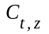; kgCm²) in a time step (; year) in a compartment (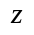) is given by the its previous carbon content (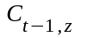; kgCm²), the carbon increment (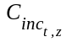; kgCm²year⁻¹) and the loss of carbon by turnover ( 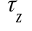; kgCyear⁻¹):
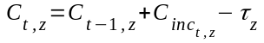 | (1)

Each compartment presents its own turnover rate: 0.5 kgCyear⁻¹ for leaves and roots and 0.05 kgCyear⁻¹ for sapwood. The carbon lost from leaves and roots go directly to compose the litter, while the carbon turned-over in sapwood is converted to heartwood. In that sense, carbon in heartwood (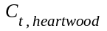; kgCm²) is given by:
(2)

The total increment in a time step , that is, the total NPP (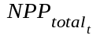; kgCm²year⁻¹) is allocated to tissue pools (i.e. the increment for each compartment) in a way to satisfy the allometric relations:
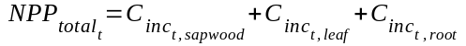 | (3)

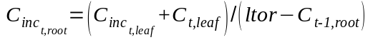 | (4)

where 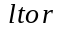 is a constant equal to 0.773 that represents the ratio between the leaf and the root.
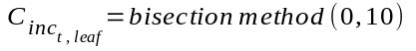 | (5)

The is calculated in the productivity module of the model, which is also responsible to compute photosynthesis and respiration. Thus, the variable is a known number from which enable us to calculate the sapwood increment (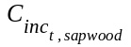; Eq. 3).
For calculating 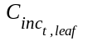 (Eq. 5) a mathematical algorithm is required, the so-called bisection method, a root-finding method for a function using an interval of resolution (Burden & Douglas, 1985). The function (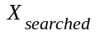 ; Eq. 6) used for the bisection method is described below. It uses variables (Eq. 7, 8, 9 and 10) that ensure the allometric restrictions and relations between the plant compartments.
(6)

where  are the numbers in the chosen interval (from 0 to 10) that will be used in each algorithm iteration.
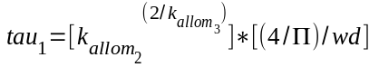 | (7)

the variables 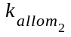 and 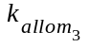 are allometric constants with values equal to 36.0 and 0.22, respectively;  is the pi number and 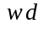 is the wood density (one of the variant functional traits; for more details see the section Project summary).
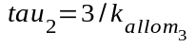 | (8)

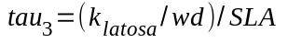 | (9)

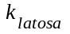 is a constant equal to 6000.0 that represents the ratio between leaf area and sapwood area. The variable 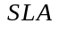 is the specific leaf area, and as wood density is a variant functional trait.
(10)

The allocation module, when implemented in the main CAETÊ code, will also be connected to the nutrients (nitrogen and phosphorus) cycle recently implemented by the PhD student João Paulo Darela Filho (FAPESP scholarship number 17/00005-3 ). Carbon will be allocated to an specific compartment only if nitrogen and phosphorus are available; if not, the carbon will be reallocated to an storage compartment that can be used by the plant life strategy in future situations.
1.2. Scientific paper writing and submission
1.2.1. “Modeled changes on functional diversity and carbon storage driven by drought in the Amazon forest: a plant-trait vs. PFT-based comparison”

In the previous report I presented the scientific paper that has been written during the first period of the present scholarship to be submitted for the scientific journal Global Change Biology: ‘Modeled changes on functional diversity and carbon storage driven by drought in the Amazon forest: a plant-trait vs. PFT-based comparison’. From that period to the current report several improvents were needed, mainly regarding to the description of results, the discussion and the figures. After that, the text was recently sent for review to possible co-authors beyond the advisor of the benefitiary: João Paulo Darela Filho (PhD. Student at São Paulo State University – Unesp, Rio Claro-SP), Katrin Fleischer (PostDoc at Technical University Munich - TUM – Munique, Alemanha), Anja Rammig (Prof. Dr. at Technical University Munich - TUM – Munique, Alemanha), Florian Hofhansl (PostDoc at International Institute for Applied Systems Analysis – IIASA – Laxenburg, Austria) and Tomas Ferreira Domingues (Prof. PhD at University of São Paulo – Ribeirão Preto, SP). The deadline for reviewing is at the end of January, after that possible adjustments will be done and then the paper will be submitted for the above cited journal. The first page of the paper can be found as an attachment at the end of this document in section 6.a.
1.2.2. “Trait-based modeling yet to improve our functional knowledge of ecosystems”
The beneficiary is also co-author of a scientific paper led by her laboratory colleague João Paulo Darela Filho (FAPESP scholarship number 17/00005-3): “Trait-based modeling yet to improve our functional knowledge of ecosystems”. It will be submitted to the New Phylogist journalin the next coming months.
The main objective of the article is to explore the use of approaches based on variant functional attributes (trait-based models) has been implemented in dynamic vegetation models (DGVMs). This type of approach seeks to simulate the plant functional traits variability and the emergent life-history tradeoffs in DGVMs. The paper explores if it can improve the understanding of functional relationships in highly diverse plant communities, such as tropical forests, and the somewhat more subtle changes that ecosystems may be subjected to in the face of global environmental changes. For this, we present a brief overview of the currently available trait-based DGVMs, focusing on the chosen varying traits, ecological assumptions and overall performance, then discussing to which extent these models have contributed to the pressing global change ecology questions. We also explore the major scientific pathways that can be addressed through way of these models in the near future.
This paper is a result of a collaboration between our scientific group and the group led by Anja Rammig (Prof. Dr. at Technical University Munich - TUM – Munique, Alemanha) an expert in the impact of global environmental change on ecosystems and potential feedbacks to the climate system, developing using and applying vegetation models. The first page of the paper can be found as an attachment at the end of this document in section 6.b.

1.3. National Courses and events
The course “Ecologia de organismos” taught by the PhD Prof. André Victor and the PhD Prof. Paulo Oliveira at the Universty of Campinas has being taken in order to complete the requireds credits for the PhD degree. This online course (because of the COVID-19 pandemic) started at 19/112020 and will end up at 14/11/2021. To complete this course is necessary to write a monograph that encompasses the subjects covered in the course: phylogeny and animal behaviour. My monograph, that is already being written, is about how human behaviour, such as the type of diet and the medicines used to used to fight bacterial infections (antibiotics) affects the human gut phylogenetic diversity and how it in its turn affects human mental health such as depression, anxiety and Alzheimer disease.
The online course “Curso de comunicação e escrita científica” taught by PhD Prof. Osvaldo Novais de Oliveira Junior promoted by the American Chemical Society (ACS) was taken on October 7th, 14th, and 21^{th ,} totaling the hourly load of four and a half hours. In this course the Professor addressed topics related to tips for writing a scientific paper, the “anatomy of a scientific paper”: detailed description of the various sections of a paper and what they should contain and, finally, strategies for learning academic English for non-native speakers.
The student also participated as a listener in the webinar “Webinários PFPMCG - Plano Estratégico Mudanças Climáticas 2020-2030” promoted by the “FAPESP Research Programme on Global Climate Change” – RPGCC” on September 1st, 15th and 29th; on October 13th and 27th ; and on November 10th and 24th . The lectures and debates focused on the following themes: Energy Policy and Socioeconomics, Climate and Environmental Modeling, Biodiversity and Ecosystems, Land Use Change and Agriculture, Urbanization and Climate Change, Health and Climate Change, Social and Economic Dimensions. The webinar was important for the student to update herself about the contents related to climate change as well as to understand the scientific agenda Strategic Plan for climate changes 2020-2030, which implements a scientific agenda focused on the search for answers to reduce greenhouse gas emissions, its impacts and mitigation of climate change.
1.4. Scientific events participation
a) Online “Webinários PFPMCG - Plano Estratégico Mudanças Climáticas 2020-2030” - September 1st, 15th and 29th; on October 13th and 27th ; and on November 10th and 24th.

1.5. Scientific publication at national conferences
a) The following work was remote and orally presented by the initiation scientific student Thalia Marques Andreuccetti (FAPESP scholarship number 19/14406-5) at the “XXVIII Congresso {virtual} de Iniciação Científica da Unicamp”. Title: “Melhoria da representação da respiração autotrófica em um modelo de vegetação baseado em atributos funcionais e sua sensibilidade à mudanças climáticas”. Authors: Thalia Marques Andreucetti, Bianca Fazio Rius & David Montenegro Lapola. See attached at SAGe platform the presentation certificate and at section 6.c. the first page of the summary sent to the event.
1.6. Qualification exam
On December 2nd, the benetiary performed the qualification exam required by the Post-graduate program in which she is developing this project. For the qualification exam the evaluation committee chooses one topic related to Ecology from a set of themes pre-established by the Post-graduate program: (https://www.ib.unicamp.br/pos_ecologia/
sites/www.ib.unicamp.br.pos_ecologia/files/Temas_EQ_doutorado1s2017.pdf). The exam was made remotely throough the Google Meet platform.
From the choice of the theme by the committee, the student has 15 days to prepare and carry out a 50-minute class with an updated and appropriate approach level for an audience of graduate students and trained professionals. The evaluation is based on the following criteria: pertinence, relevance and timeliness of the bibliography used; clarity in the organization and presentation of the theme; mastery of content and proper use of the chosen exhibition tools. The theme chosen by the committee was “Functional and phylogenetic diversity”. In its exam the student addressed the following topics about the proposed theme: basic concepts by defining functional and phylogenetic diversity; the relations between these two dimensios of biodiversity and their relation with ecosystem processes and services; and finally how these two emerging branches of Ecology can be applied to understand: ecosystems resilience, extinctions and plans for biodiversity conservation, and human health. The result of the evaluation was very positive and the student was considered qualified and able to proceed with its PhD development. The document proving the qualification exam is not yet available, so it is attached to the SAGe platform a copy of the email sent by the academic board confirming the exam result. The presentation made by the student is also attached.
1.7. Additional activities
a) The co-authorship of the scientific initiation work (mentioned in section 1.5.a) is a partial result of the development of a Scientific Initiation project by student Thalia Marques Andreuccetti (FAPESP scholarship number 19 / 14406-5), under the guidance of Prof. Dr. David Montenegro Lapola and co-supervision of the beneficiary of this report. Co-orientation occurs through the help in the development of the project, mainly with regard to bibliographic review and development of computational code to be inserted in the dynamic vegetation model CAETÊ (under development by the laboratory group). The co-orientation certificate can be found attached to the SAGe platform.

b) As an additional activity, the student Bianca gave a lecture jointly with the Post-Doc Maíra Padgurschi on “Functional diversity and provision of Ecosystem Services” from the perspective of global climate change. This lecture was given during the graduate course “Global Ecology and Climate Change” taught by the beneficiary's advisor in the second semester of 2020.

c) The beneficiary also assists the master student Bárbara Cardelli, under the guidance of Prof. Dr. David Montenegro Lapola, in the development of her project entitled "Ecological competition and functional traits of plants under increased atmospheric CO₂ concentration in the Amazon rainforest". This assistance is mainly related to the development of computational codes to represent ecological competition in the CAETÊ model.

d) dados Amz face

2. Data management plan
At the inital request for this scholarship the data management plan was not yet mandatory. So, here we present for the first time the management plan. It can be found attached on the SAGe platform.
3. Description and evaluation of the institutional support
Because of the new coronavirus pandemic, the university temporarily interrupted its activities, so the beneficiary was unable to attend the laboratory room in which this project is being developed. Thus, the student had to work from home during the period of this report. However, the university has a "task force" for the pandemic (https://covid.ic.unicamp.br/) which is responsible for providing information about the disease, for testing if the student or employee presents symptoms in addition to a communication channel. Also, the academic board continued with its activities in order to allow qualification exams and thesis defense to be carried out remotely. The biology institute to which the beneficiary is linked was also organized so that postgraduate courses could take place and thus allow students to obtain the required credits. Finally, the FAPESP support center fo comunication at Unicamp also returned with its activities with highly qualified and helpful staff.

4. Schedule for the next period
In the next months two work fronts will be on focus: the first one is the completion and submission of the aforementioned scientific paper (section 1.4.). Together, the conclusion and implementation of the allocation and allometric scheme at the main CAETÊ model code. Then, the first model runs wil be made in order to verify bugs on the program as well as problems of implementation. With the model results we will be able to compare them with benchmarks and also compare the functional diversity obtained with field measurements. Then, the analysis to undersand the relation between functional diversity (with its different components) and ecosystem functioning will be developed; this phase will require the dedication of the student in understand the analysis both theoretically as well as how to put it in practice, since she is not familiarized with this type statistical analysis. Also the model will be run with changed climatology and will be followed by the seek for understanding the effects of climate change on functional diversity and then on the resilience of the studied ecosystem. It is foreseen the requirement of program Reasearch Internship Abroad (BEPE) mainly to the development and interpretation of the results concerned to the functional diversity-ecosystem functioning relationship and also about the ecosystem resilience (these two themes are not the expertise of the responsible reasearcher; in that sense we see that an additional assistance will be fundamental for a high quality work).
4.1. Calendar
 | 2021 |  |  |  |  |  |  |  |  |  |  |  | 2022
 | Jan | Feb | Mar | Apr | May | Jun | Jul | Aug | Sep | Oct | Nov | Dec | Jan | Feb | Mar
Sientific paper submissionª
Finalization of offlline allometric and allocation
module
Insertion of the offline module of allocation and allometry into CAETÊ main code
CAETÊ testing first runs
CAETÊ run (regular climate)
CAETÊ validation
FD^{b} comparison between CAETÊ and field measurements
Testing FD facets and ecosystem functioning relation
CAETÊ run (climate changed)
Climate change effects on FD
Climate change effects on tropical
forests' resilience analysis
Scientific papers writing^{c}
Scientific final report
Thesis writing
Thesis defense

ª This submission is related to the scientific paper specified in the section 1.4.1; ^{b}Functional Diversity; ^{c}At least two other scientific papers are foreseen to be led by the beneficiary: one about how the use of an allometric approach for carbon distribution affects the representation of biomass along the Amazon basin when compared to the approach previously used in the CAETÊ model (which does not considered the allometric restrictions between the compartments of the plant); the other scientific article will be about the results obtained in relation to the analysis of the relationship between functional diversity and ecosystem functioning, as well as the analysis to be carried out on the resilience of the Amazon forest in the face of climate change.

4.2. Scholarship extension requirement
Together with the submission of this report we are also requiring an extension of 12 months for th present scholarship. This requirement is justified given the complexity of the development of this project. There are many activities to be performed (as indicated in the calendar) that will not be able to be accomplished without this extension. Also, we will make a requirement for scientific internship due to the reasons mentioned in the previous sesion.
Beyond that, the COVID-19 pandemic, together with the inability to attend the research laboratory, affected the work rate of the beneficiary, which delayed the progress of activities, since the student spent some periods unable to work due to the worsening of previous psychological problems, which were already accompanied by professionals with medication administration prescribed by a psychiatrist (see psychiatric report attached to the SAGe system).

5. Referências bibliográficas
BURDER, R. L. & FAIRES, D. J., "2.1 The Bisection Algorithm", Numerical Analysis (3rd ed.), PWS Publishers, ISBN 0-87150-857-5, 1985
CARMONA, C. P. et al. Traits Without Borders: Integrating Functional Diversity Across Scales. Trends in Ecology and Evolution, v. 31, n. 5, p. 382–394, 2016.
CÔTÉ, I. M.; DARLING, E. S. Rethinking ecosystem resilience in the face of climate change. PLoS Biology, v. 8, n. 7, 2010.
DE KAUWE, M. G. et al. Where does the carbon go? A model-data intercomparison of vegetation carbon allocation and turnover processes at two temperate forest free-air CO2 enrichment sites. New Phytologist, v. 203, n. 3, p. 883–899, ago. 2014.
FOLKE, C. et al. Resilience Thinking : Integrating Resilience, Adaptability and Transformability. Ecology and Society, v. 15, n. 4, 2010.
GRIME, J. P. Benefits of plant diversity to ecosystems: Immediate, filter and founder effects. Journal of Ecology, v. 86, n. 6, p. 902–910, 1998.
HODGSON, D.; MCDONALD, J. L.; HOSKEN, D. J. What do you mean, “resilient”? Trends in Ecology and Evolution, v. 30, n. 9, p. 503–506, 2015.
LANGAN, L.; HIGGINS, S. I.; SCHEITER, S. Climate-biomes, pedo-biomes or pyro-biomes: which world view explains the tropical forest-savanna boundary in South America? Journal of Biogeography, v. 44, n. 10, p. 2319–2330, out. 2017.
MALHI, Y. et al. The above-ground coarse wood productivity of 104 Neotropical forest plots. Global Change Biology, v. 10, n. 5, p. 563–591, 2004.
MONSI, M.; SAEKI, T. Über den lichtfaktor in den Pflanzengesellschaften und seine Bedeutung für die Stoffproduktion. Japanese Journal of Botany, v. 14, p. 22–52, 1953.
PAVLICK, R. et al. The Jena Diversity-Dynamic Global Vegetation Model (JeDi-DGVM): a diverse approach to representing terrestrial biogeography and biogeochemistry based on plant functional trade-offs. Biogeosciences Discussions, v. 9, n. 4, p. 4627–4726, 2012.
SAKSCHEWSKI, B. et al. Resilience of Amazon forests emerges from plant trait diversity. Nature Climate Change, p. 1–16, 2016.
SCHEITER, S.; HIGGINS, S. I. aDGVM : An adaptive dynamic global vegetation model for tropical ecosystems . Version 1 . 0. p. 1–42, 2008.
SCHEITER, S.; HIGGINS, S. I. Impacts of climate change on the vegetation of Africa: An adaptive dynamic vegetation modelling approach. Global Change Biology, v. 15, n. 9, p. 2224–2246, 2009.
SCHEITER, S.; LANGAN, L.; HIGGINS, S. I. Next-generation dynamic global vegetation models: learning from community ecology. The New phytologist, v. 198, n. 3, p. 957–69, 2013.
SITCH, S. et al. Evaluation of ecosystem dynamics, plant geography and terrestrial carbon cycling in the LPJ dynamic global vegetation modelGlobal Change Biology, 2003. Disponível em: <http://dx.doi.org/10.1046/j.1365-2486.2003.00569.x>
SMITH, B. LPJ-GUESS – an ecosystem modelling framework. Department of Physical Geography and Ecosystems Analysis. INES, Sölvegatan, v. 12, p. 22362, 2001.
SMITH, B.; PRENTICE, I. C.; SYKES, M. T. Representation of vegetation dynamics in the modelling of terrestrial ecosystems: Comparing two contrasting approaches within European climate space. Global Ecology and Biogeography, v. 10, n. 6, p. 621–637, 2001.
THOMPSON, I. et al. Forest resilience, biodiversity, and climate change. [s.l: s.n.]. v. 43
WELLER, D. E. Self-thinning exponent correlated with allometric measures of plant geometry. Ecology, v. 68, n. 4, p. 813–821, 1987.
WESTOBY, M. The Self-Thinning Rule. [s.l: s.n.]. v. 14, 1984.
ZENG, X.; LI, F.; SONG, X. Development of the IAP Dynamic Global Vegetation Model. Advances in Atmospheric Sciences, v. 31, n. 3, p. 505–514, 2014.

6. Attachments

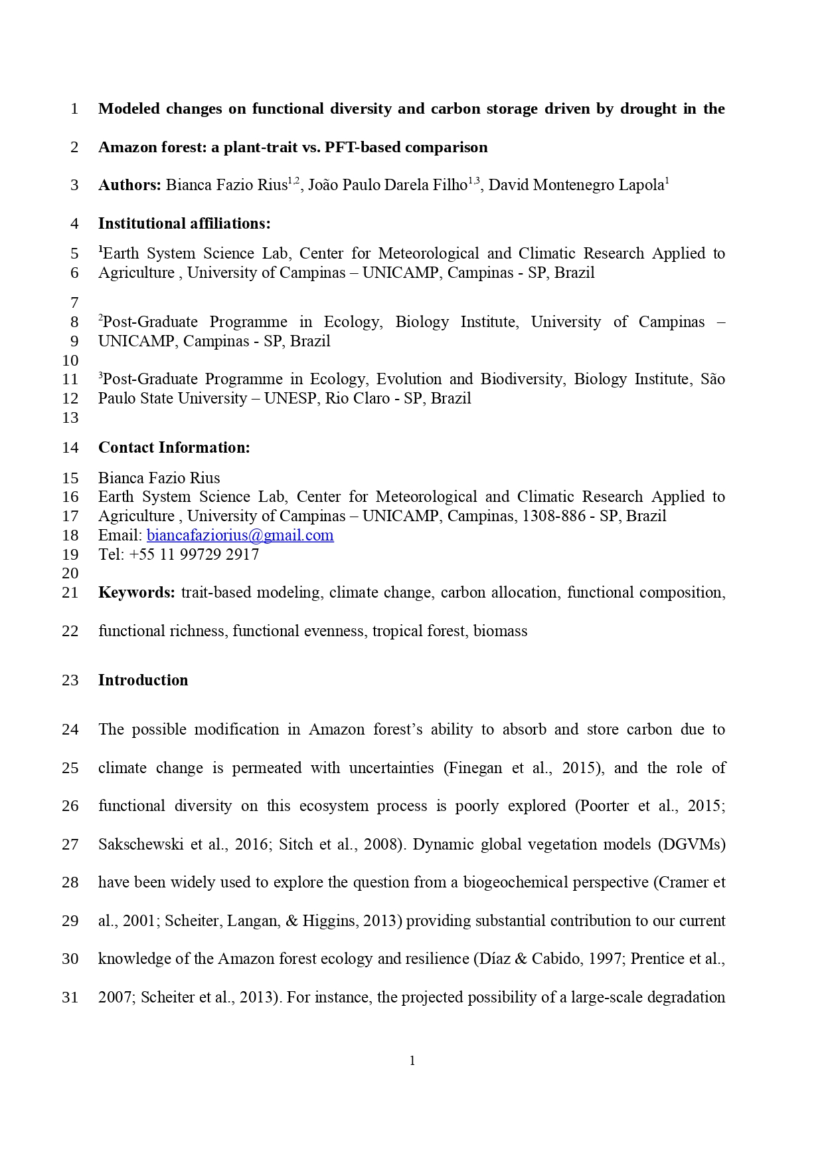
a)

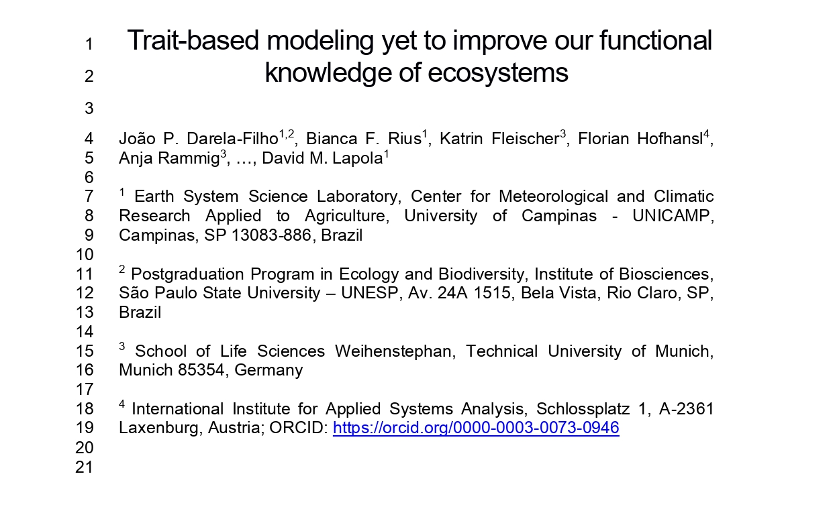
b)

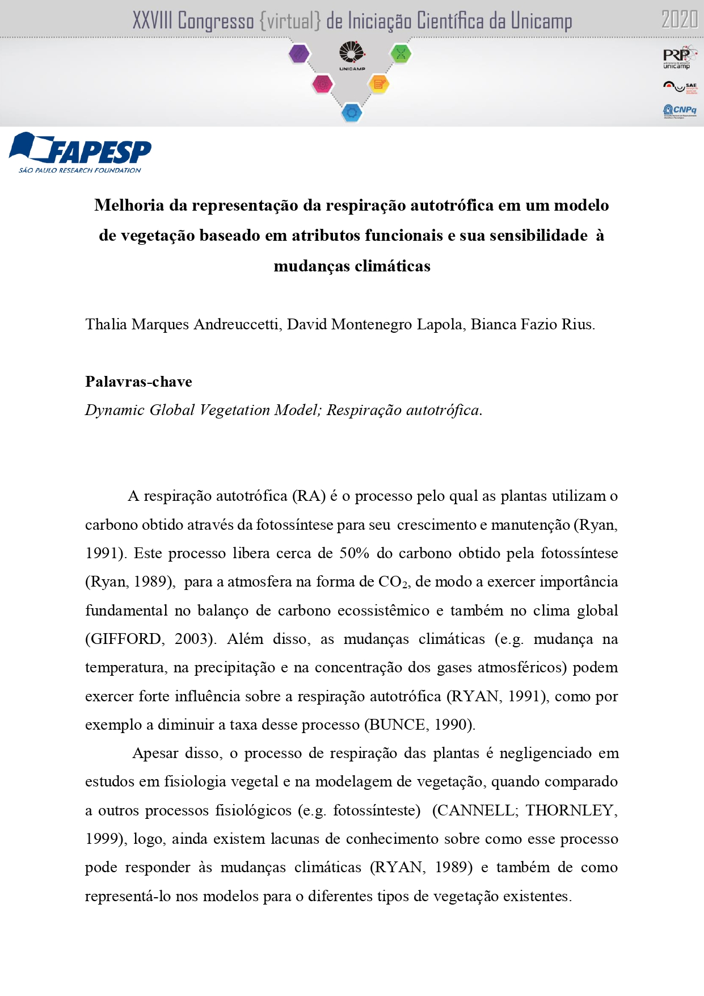
c)

