Appendix
A.1 Creating and sampling PLS
In order to create the hypervolume that contains all the possible combinations of functional traits and, hence, the PLSs, each trait owns a range of values that determines the minimum and the maximum value that will be sampled (Table A3). From this initial range of values, for allocation traits, XXXX. For the residence time traits the values are randomly and uniformly sampled. All the sampled traits are combined to create the potential functional space that contains all the possible combination of values. From this potential space some combinations are excluded following a viability standard: first, the combination of values for allocation functional traits, necessarily, must sum 100%, otherwise this combination is excluded from the functional space. After that, all the combinations are submitted to a spinup simulation in order to verify if it presents carbon content on fine roots and on leaves that are higher than 0.001. Then, from the combinations that respect this premise 3000 PLSs (see A.2 for the sensitivity number test) are sampled and seeded in each grid-cell
Grasses and herbs percentage

A.2 Sensitivity for the sampled number of PLS
After creating the potential functional space with more than 10⁵ a problem emerges: how many PLSs are enough to be sampled in order to make meaningful representation of all? To answer this question a set of 6 ensembles with different numbers of sampled PLSs (number of PLSs = 50, 100, 200, 500, 1000, 3000) was ran to test the model sensitivity. Each ensemble contains 10 runs, this is required because of the random nature of the initial sampling process. The only difference between the ensembles is the number of initialized PLS.
To explore the sensitivity of the model for the number of sampled PLSs we assessed the mean values and the variance in each of the 10 runs for the 6 ensembles for total plant carbon storage and for all the six functional traits (Figure A.1). With this strategy we seeked to understand how the mean and the variances change between the runs for each ensemble of PLS number. Our idea is that since the sampling of functional trait values is random, we expect that the higher the number of PLSs the lower the difference in mean and variance between the runs. It would ensure that the results that emerge from the model, both for biogeochemical and functional diversity variables, are not a product of a “false” diversity derived from the simple difference between the runs.
As expected, it is notable that the number of PLSs sampled from all the possible combinations presents a meaningful influence on estimating the mean value and variance between the runs, both for the total plant carbon stock and the functional traits. We observed that as more PLSs are sampled, the greater the convergence in the mean values (orange ticks on Figure A.1) and in the variance between the 10 runs. These results emerge from the fact that the increase in the number of sampled PLSs turns better the ability in representing the total traits combinations in the potential functional space.

A.3 CAETÊ formulation description
The symbols used for each variable, its description and unit can be found in Table A.4. The constants with its respective values are shown in Table A.5.
A.3.1 Gridcell occupation and survivorship
The model CAETÊ is an area-based model, thus, the abundance of a strategy (a PLS or a PFT) is the fraction of the grid cell that it occupies based on the biomass contribution of this strategy in relation to the total grid cell biomass. This procedure has support in the biomass-ratio hypothesis (Grime, 1998) that predicts that the immediate effects of a species is proportional to its relative contribution to the total biomass of the community. Then, from the relative abundances it is possible to aggregate the biogeochemical variables to the grid cell scale. This approach is also necessary because the competition scheme in CAETÊ model is still not mechanistic. However, the differential capture of carbon, water and light through the differential combination of functional traits is capable of leading to difference of abundances (Grime, 1998) between the PLSs (for the trait-based modeling approach) and between the PFTs (for the PFT modeling approach) in a grid cell. In that sense, the competition is indirectly considered by deriving the relative abundances (Grime, 1998). A PLS/PFT is considered as a survivor if it presents a positive carbon balance and also if it presents, concomitantly, at least 100 g of carbon in fine roots and in leaves.
In the subsequent formulasmeans that the values is specific for a PFT or PLS in a grid cell. The allocation traits 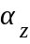(Table A1 and A2) seeks to represent the percentage of the net primary productivity (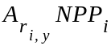; Eq. A15) distributed to each compartment; the carbon residence time traits (Table A1 and A2) seeks to represent how long the carbon stays in each of these compartments. Together, these functional traits ultimately define the amount of carbon (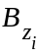; Eq. A1) in each compartment of a PLS or PFT in a certain time, and then, the total plant carbon of that PLS or PFT (; Eq. A2).
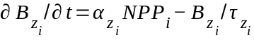 | (A1)
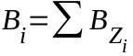 | (A2)

The abundance of a strategy is the fraction of the grid cell that it occupies based on the biomass contribution of a strategy in relation to the total grid cell biomass. Therefore, the relative abundance (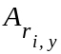; Eq. A3) of a PLS/PFTin a grid cellis assumed to be proportional to its relative contribution to the total grid cell biomass (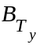; Eq. A4), in its turn determined by the sum of biomass of all the survival PLS/PFT () in that grid cell:
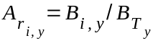 | (A3)
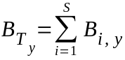 | (A4)

From the relative abundance is possible to aggregate the biogeochemical variables from a PFTs/PLSs to the grid cell scale. For example, the net primary production (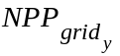; Eq. A5) of a grid cellis equal to the sum of the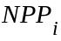of all PFT/PLSthat survived () in that grid cell, weighted by their respective relative abundance ():
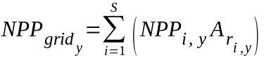 | (A5)

A.3.2 Functional traits trade-offs and associated ecophysiological processes
Hereafter we describe the ecophysiological processes linked to the traits trade-offs. The first trade-off of CAETÊ’s traits linked to allocation emerges from the fact that the carbon allocated to one function or organ becomes unavailable to others. As a consequence, some capabilities are, necessarily, prioritized at the expense of others (Weiner, 2004). In order to include the limitation of photosynthesis by water availability and to include a trade-off for the fine roots traits investment, we added to the photosynthesis (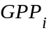; Eq. A14) equation a water stress factor (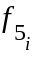; Eq. A6). This factor is calculated in function of the ratio between the potential water supply for transpiration (; Eq. A7) and the atmospheric demand for transpiration (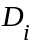; Eq. A32). This approach is based on Pavlick et al. (2013).
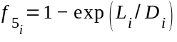 | (A4)

The potential water supply for transpiration () is a function of the carbon stock on fine roots compartment (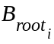; Eq. A1) multiplied by a constant water uptake capacity (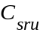) with a value of 0.0005 mmH₂OkgC⁻¹day⁻¹, and of the degree of water soil saturation in the grid cell (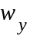; Eq. A39). It is important to highlight that the value for is correspondent to that of the previous day calculated by the water balance sub-model (see section Water balance submodel) .
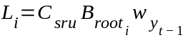 | (A5)

Following Pavlick et al. (2013), the leaf area index (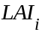; Eq. A8) takes into account the carbon content on leaves (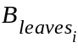; Eq. A1) and its specific leaf area (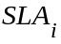; Eq. A9). In order to consider the part of the canopy that receives direct light and the other that receive only diffused light,(Eq. A8) is partitioned in 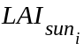(Eq. A30) and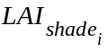(Eq. A31; see section General ecophysiological formulations).
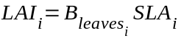 | (A8)
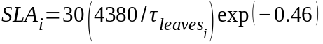 | (A6)

where 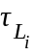 is the carbon residence time on leaves. This equation uses an empirical relationship derived from Reich et al. (1997) and aims to compute the so-called leaf economic spectrum (Wright et al., 2004).
The carbon stored on aboveground wood tissues are highly correlated to light competition (Reich, 2014). However, the model CAETÊ is still not able to represent the competition ecological process mechanistically, since there is no representation of shading of PFTs/PLSs that resemble understory plants by the ones that resemble trees with higher height and higher canopy area, for example. The majority of models represents the plants competitive ability for light associated to woody tissues through variables that describe height, wood density and canopy ratio [e.g. aDGVM (Scheiter, Langan, & Higgins, 2013) and LPJ (Sitch et al., 2003). These variables are estimated via allometric relationships that were not used by CAETÊ in this study. So in order to implement a trade-off for the traits (allocation and residence time) that determines the carbon content on ABGW (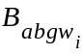; Eq. A1), we used a simplified approach for the sake of representing the differential light capture between the different PFTs/PLSs in a grid cell. We considered that 5% of the PFTs/PLSs that present the higher relative carbon content on ABGW in a grid cell can capture 100% of the incident photosynthetically active radiation (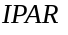; Eq. A10), while the other ones can capture 80% of the. Hererepresents 50% of the shortwave radiation (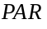; input) that reaches the surface:
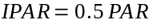 | (A7)

⁠⁠Lastly, all the plant compartments and, consequently, all the traits are associated to respiratory costs for maintenance and grwoth that, ultimately, imposes restrictions to investment in each of the compartments. The autotrophic respiration (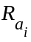; Eq. A11) is splitted in growth respiration (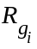; Eq. A12) and maintenance respiration (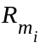; Eq. A13) following Ryan (1991a; 1991b).
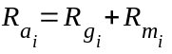 | (A11)

The formulation is based on Ryan et al. (1991a; 1991b), which postulates that a reasonable growth respiration estimate can be done assuming that its metabolics costs in each tissue consumes an amount of carbon equal to a quarter of the carbon incorporated in the new tissue (i.e. the difference between the carbon content in a compartment in a time (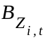) and the carbon content in the same compartment in a time 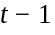(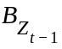).
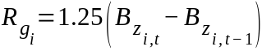 | (A12)

The maintenance respiration is calculated according to the nitrogen and carbon content in each compartment. The nitrogen content on plant tissues is intimately connected to the maintenance respiration since about 60% of it is used to protein repair and substitution (Ryan, 1991a, 1991b). Yet, the nitrogen supriment is not considered as a limiting factor.
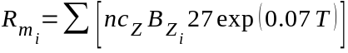 | (A13)

where 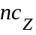represents the N:C ratio for each plant compartment and (ºC) is the mean annual temperature. A considerable amount of the woody tissues do not respire (the so called heartwood; (Ryan, 1991b), and then we consider only 5% of the aboveground woody tissues carbon content on the maintenance respiration for this compartment. This 5% aims to represent the sapwood (Pavlick, Drewry, Bohn, Reu, & Kleidon, 2013). The N:C ratio is equal to 0.034, 0.003 and 0.034 for leaves, sapwood and fine roots, respectively (Levis, Bonan, Vertenstein, & Oleson, 2004; Sitch et al., 2003). The parameter 0.07 is a sensibility factor of the maintenance respiration to temperature. Because in tropical forests the soil temperature is lower than the air temperature, then for calculating the fine roots maintenance respiration we used the soil temperature (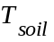; see Oyama & Nobre, 2004).
General ecophysiological formulations
The photosynthesis equation () and the ones associated to it are based on Farquhar et al. (1980) formulation, which takes into account three limiting factors: rubisco carboxylation (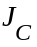; Eq. A18), light (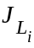; Eq. A19) and electron transport (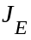; Eq. A20). We also included water stress limitation () as above described.
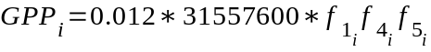 | (A14)

where 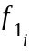 (Eq. A16) is the leaf level gross photosynthesis and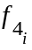 is a function for upscaling the leaf level photosynthesis to the canopy level.
The net primary productivity (; Eq. A15) is the carbon available from photosynthesis () discounting the respiratory costs ().
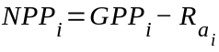 | (A15)

In the following equationsare constants summarized in Table A5. The is calculated as the smallest root between the three limiting rates:(Eq. A18),(Eq. A19) and (Eq. A20):
(A16)

where 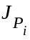(Eq. A17) is the minimum between and :
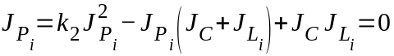 | (A17)

is the photosynthesis rate limited by the Rubisco carboxylation capacity:
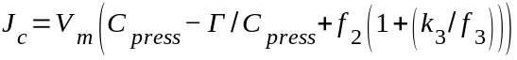 | (A18)

where 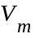(Eq. A21) is the rate of Rubisco carboxylation, 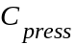 (Eq. A22) is the partial CO₂ pressure at leaf interior,(Eq. A23) is the photorespiration compensation point, (Eq. A24) is the Michaelis-Menten constant for CO₂ and (Eq. A25) the Michaelis-Menten constant for O₂..
is the photosynthetic rate limited by light as a function of 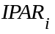:
(A19)

The photosynthetic rate limited by the electron transport is given by:
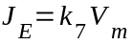 | (A20)
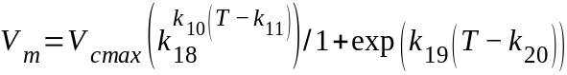 | (A21)

where 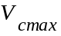(Table A5) is the maximum rate of Rubisco carboxylation and (input) is temperature.
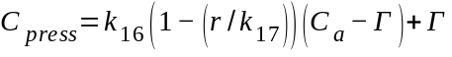 | (A22)

where is the leaf level moisture deficit and 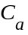is the atmospheric CO₂ concentration.
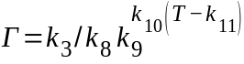 | (A23)
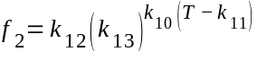 | (A24)
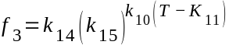 | (A25)

The leaf level moisture deficit (; Eq. A26) is obtained by the actual mixing ratio on leaf level and the saturated mixing ratio (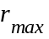; Eq. A27):
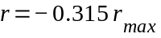 | (A26)

is a function of partial pressure of water vapor (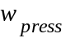; Eq. A28) and the surface pressure (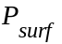; input):
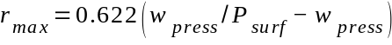 | (A27)

(A28)

The function is used in the canopy scaling of photosynthesis. Since we assume a canopy division in sun and shade parts the function is subdivided in 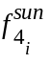(Eq. A29) and 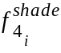(Eq. A30). The sun part aims to represent the canopy portion in which solar radiation reaches it directly in a 90º angle, while the shade part receives diffuse radiation in a 20º angle.
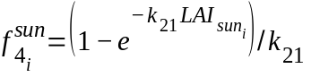 | (A29)
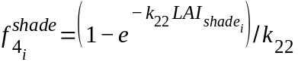 | (A30)

where is the leaf area index also splitted in(Eq. A31) and(Eq. A32) in order to follow the canopy subdivision. Then, following Beer-Lambert’s Law (see De Pury & Farquhar, 1997):
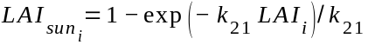 | (A31)
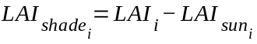 | (A32)

Following Gerten et al. (2004), the atmospheric demand for transpiration (; Eq. A33) used to calculate the water stress factor () represents the condition of a “unstressed transpiration” which occurs when stomatal opening is not limited by reduced water potential in the plant:
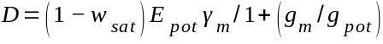 | (A33)

where 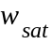(Eq. A39) is the degree of water soil saturation,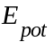the potential evapotranspiration, 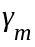is a maximum Priestley-Taylor coefficient equal to 1.391 and 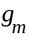is the upscaling of stomatal conductance to canopy with value equal to 3.26 mms⁻¹ (Gerten, Schaphoff, Haberlandt, Lucht, & Sitch, 2004). Lastly, 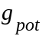(Eq. A34) is the canopy potential conductance when there is no water limitation and is calculated through the minimum stomatal resistance (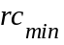) that is equal to 100:
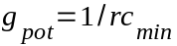 | (A34)

The productivity () is coupled to the water balance sub-model (see section Water balance submodel) through the calculation of canopy resistance (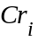; Eq. A35) and the stomatal conductance (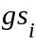; Eq. A36):
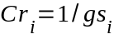 | (A35)

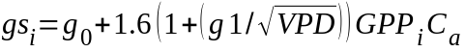 | (A36)

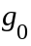is the minimal stomatal conductance with a fix value of 0.001,is the conductance sensibility to the carbon assimilation (Medlyn et al., 2011) and has a constant value of 3.77. Lastly, 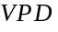(Eq. A37) is the the deficit of vapor pressure on the leaf surface:
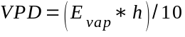 | A37)

where (input) is the relative humidity and 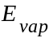is the evapotranspiration (see Water balance sub-model)
A.3.3 Water balance sub-model
The CAETÊ uses a sub-model to calculate the water balance in a grid cell scale. This sub-model is based on Oyama & Nobre (2004) and is evaluated over an homogeneous soil layer with a unique water maximum holding capacity (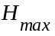) equal to 500 mm. In the present study different types of soil are not considered. Developments on CAETÊ have being done in order to increase the amount of soil layers and to implement different soil types with different water holding capacity and different nutrients availability.
The model here employed calculates soil water and snow budgets separately, however given the climatic conditions of the study area we do not present here the soil snow budget formulation [see Oyama & Nobre (2004) for accessing it]. The actual soil water content (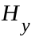; Eq. A38) in a grid cell in a time depends on the precipitation (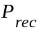, input) , the evapotranspiration (; see Oyama & Nobre, 2004) and the runoff ( 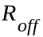; see Oyama & Nobre, 2004) on this grid cell:
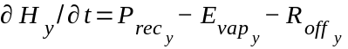 | (A38)

Then, the degree of water soil saturation in the grid cell (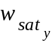; Eq. A39) can be calculated:
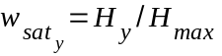 | (A39)

For more in-depth information about the water balance submodel access Oyama e Nobre (2004).
A.3.4 Spinup simulation
Before the model initialization a spinup simulation was performed to determine the initial carbon content on plant compartments. This spinup was run until the stability attainment of the total biomass (i.e. the sum of carbon in all plant compartments) in all the grid cells, with a sensibility of 10% of difference between and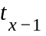. Thus, the initial amount of carbon (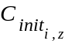; Eq. A40) in each plant compartment in an specific PFT or PLS in a given time :
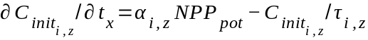 | (A40)

where 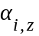 (Table A1 and A2) is the fraction of 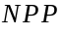 allocated to a plant compartment in each PFT/PLSand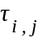(Table A1 and A2) represents the carbon residence time in a compartment. Here,is potential (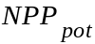) calculated from the model CPTEC Potential Vegetation Model 2 (CPTEC-PVM2; Lapola, Oyama, & Nobre, 2009)⁠, a precursor model for CAETÊ. The potential NPP was calculated using the same climatology applied to CAETÊ.

References
De Pury, D. G. G., & Farquhar, G. D. (1997). Simple scaling of photosynthesis from leaves to canopies without the errors of big-leaf models. Plant, Cell and Environment, 20(5), 537–557. https://doi.org/10.1111/j.1365-3040.1997.00094.x
Farquhar, G. D., Caemmerer, S. Von, & Berry, J. a. (1980). A biochemical model of photosynthetic CO2 assimilation in leaves of C3 species. Planta, 90, 78–90. https://doi.org/10.1007/BF00386231
Gerten, D., Schaphoff, S., Haberlandt, U., Lucht, W., & Sitch, S. (2004). Terrestrial vegetation and water balance - Hydrological evaluation of a dynamic global vegetation model. Journal of Hydrology, 286(1–4), 249–270. https://doi.org/10.1016/j.jhydrol.2003.09.029
Grime, J. P. (1998). Benefits of plant diversity to ecosystems: Immediate, filter and founder effects. Journal of Ecology, 86(6), 902–910. https://doi.org/10.1046/j.1365-2745.1998.00306.x
Lapola, D. M., Oyama, M. D., & Nobre, C. A. (2009). Exploring the range of climate biome projections for tropical South America: The role of CO2 fertilization and seasonality. Global Biogeochemical Cycles, 23(3), 1–22. https://doi.org/10.1029/2008GB003357
Levis, S., Bonan, G. B., Vertenstein, M., & Oleson, K. W. (2004). The Community Land Model’s Dynamic Global Vegetation Model (CLM-DGVM). Ncar/Tn-459+Ia, 50. https://doi.org/10.5065/D6P26W36 CN - 03559 LA - en
Medlyn, B. E., Duursma, R. A., Eamus, D., Ellsworth, D. S., Prentice, I. C., Barton, C. V. M., … Wingate, L. (2011). Reconciling the optimal and empirical approaches to modelling stomatal conductance. Global Change Biology, 17(6), 2134–2144. https://doi.org/10.1111/j.1365-2486.2010.02375.x
Oyama, M. D., & Nobre, C. a. (2004). A simple potential vegetation model for coupling with the Simple Biosphere Model (SiB). Rev. Bras. Meteorol., 19, 203–216.
Pavlick, R., Drewry, D. T., Bohn, K., Reu, B., & Kleidon, A. (2013). The Jena Diversity-Dynamic Global Vegetation Model (JeDi-DGVM): a diverse approach to representing terrestrial biogeography and biogeochemistry based on plant functional trade-offs. Biogeosciences, 10(6), 4137–4177. https://doi.org/10.5194/bg-10-4137-2013
Reich, P B, Walters, M. B., & Ellsworth, D. S. (1997). From tropics to tundra: global convergence in plant functioning. Proceedings of the National Academy of Sciences of the United States of America, 94(25), 13730–13734. https://doi.org/10.1073/pnas.94.25.13730
Reich, Peter B. (2014). The world-wide “fast-slow” plant economics spectrum: A traits manifesto. Journal of Ecology, 102(2), 275–301. https://doi.org/10.1111/1365-2745.12211
Ryan, M. G. (1991a). A simple method for estimating gross carbon budgets for vegetation in forest ecosystems. Tree Physiology, 9(1_2), 255–266. https://doi.org/10.1093/treephys/9.1-2.255
Ryan, M. G. (1991b). Effects of Climate Change on Plant Respiration, 1(2), 157–167.
Scheiter, S., Langan, L., & Higgins, S. I. (2013). Next-generation dynamic global vegetation models: learning from community ecology. The New Phytologist, 198(3), 957–969. https://doi.org/10.1111/nph.12210
Sitch, S, Smith, B., Prentice, I. C., Arneth, A., Bondeau, A., Cramer, W., … Venevsky, S. (2003). Evaluation of ecosystem dynamics, plant geography and terrestrial carbon cycling in the LPJ dynamic global vegetation model. Global Change Biology. https://doi.org/10.1046/j.1365-2486.2003.00569.x
Sitch, Stephan, Huntingford, C., Gedney, N., Levy, P. E., Lomas, M., Piao, S. L., … Woodward, F. I. (2008). Evaluation of the terrestrial carbon cycle, future plant geography and climate-carbon cycle feedbacks using five Dynamic Global Vegetation Models (DGVMs). Global Change Biology, 14(9), 2015–2039. https://doi.org/10.1111/j.1365-2486.2008.01626.x
Weiner, J. (2004). Allocation, plasticity and allometry in plants. Perspectives in Plant Ecology, Evolution and Systematics, 6(4), 207–215. https://doi.org/10.1078/1433-8319-00083
Wright, I. J., Reich, P. B., Westoby, M., Ackerly, D. D., Baruch, Z., Bongers, F., … Gulias, J. (2004). The worldwide leaf economics spectrum. Nature, 428, 821–827.

