**Fig. 1**

**Fig 2.**

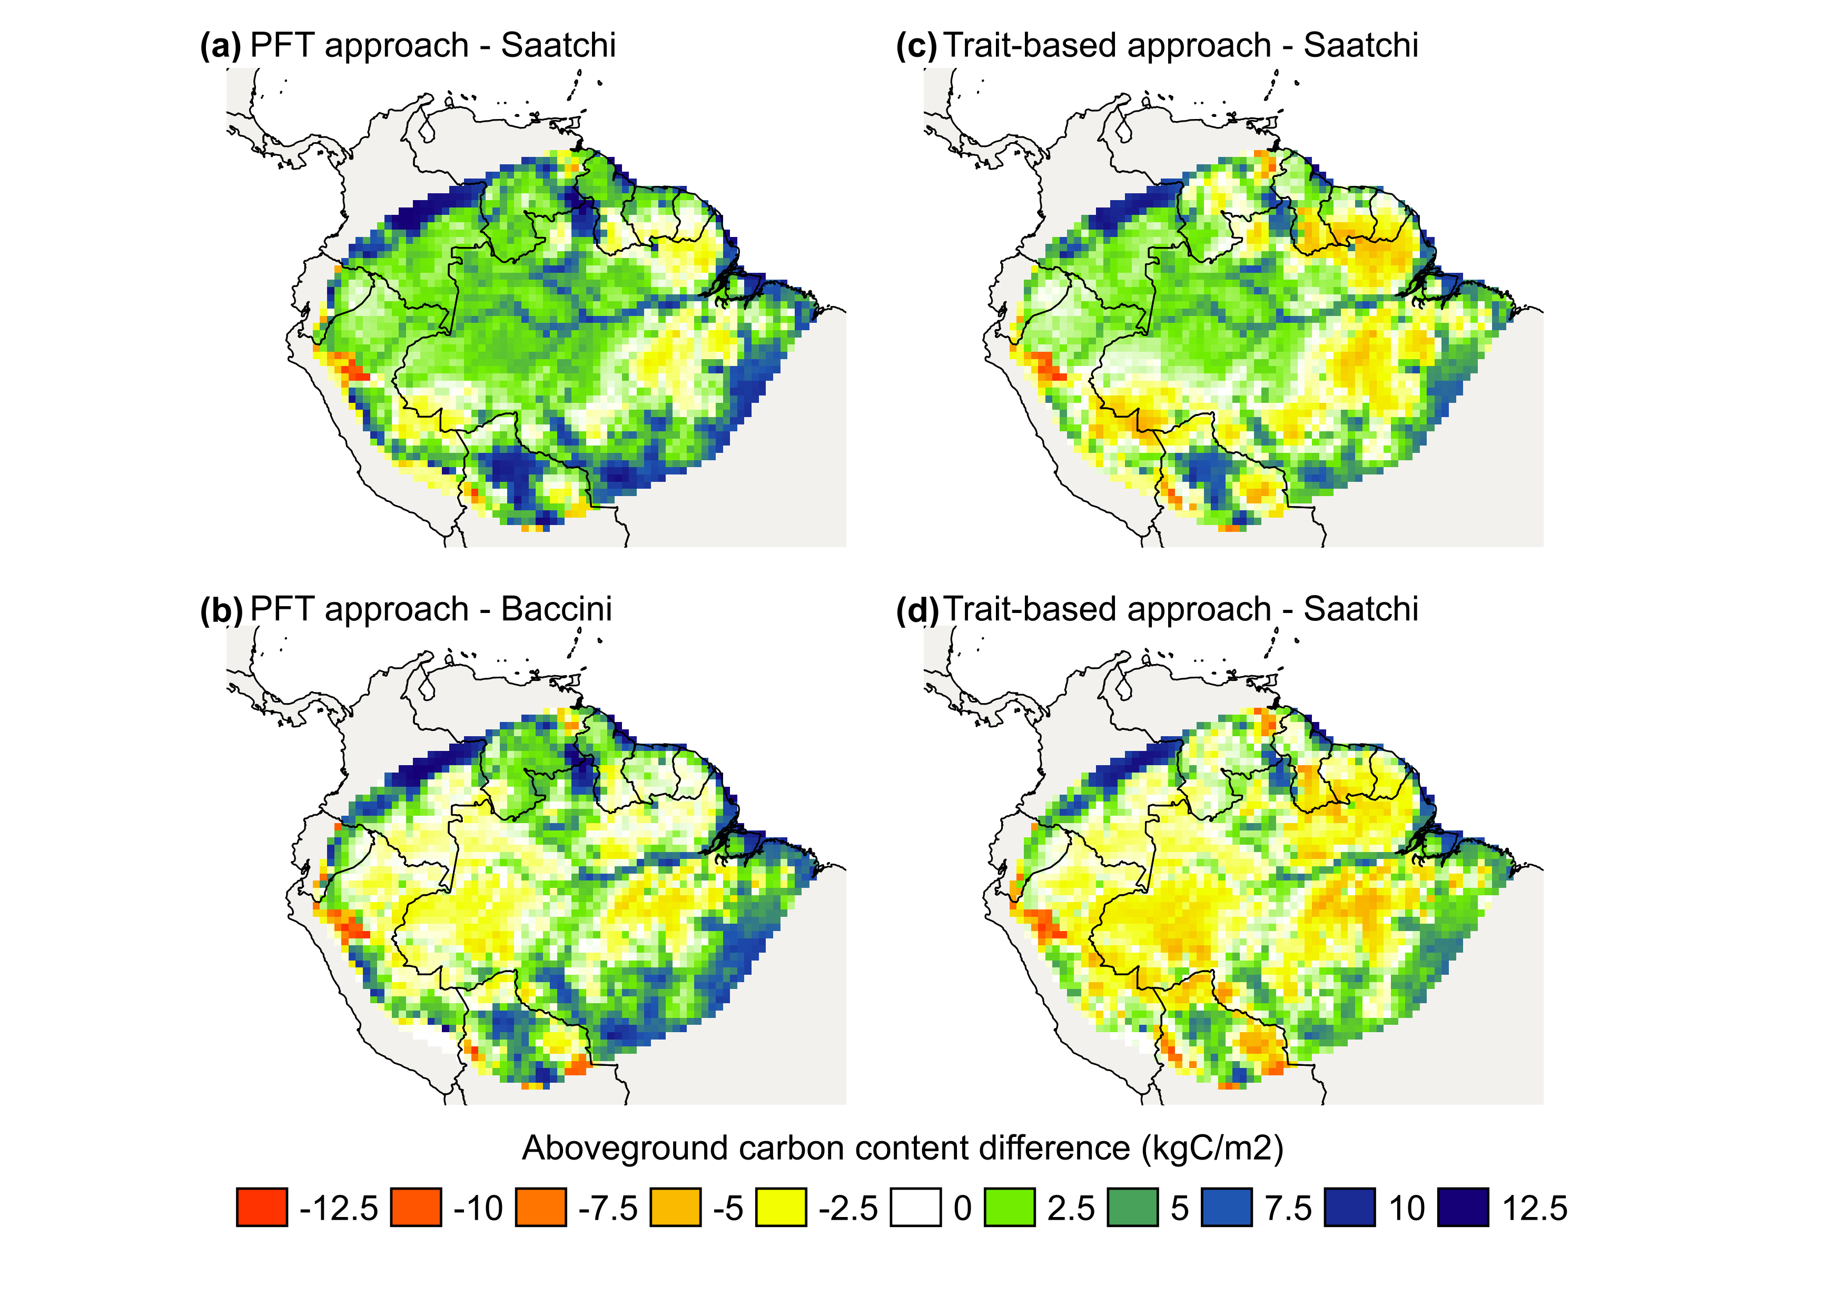

**Fig. 3**

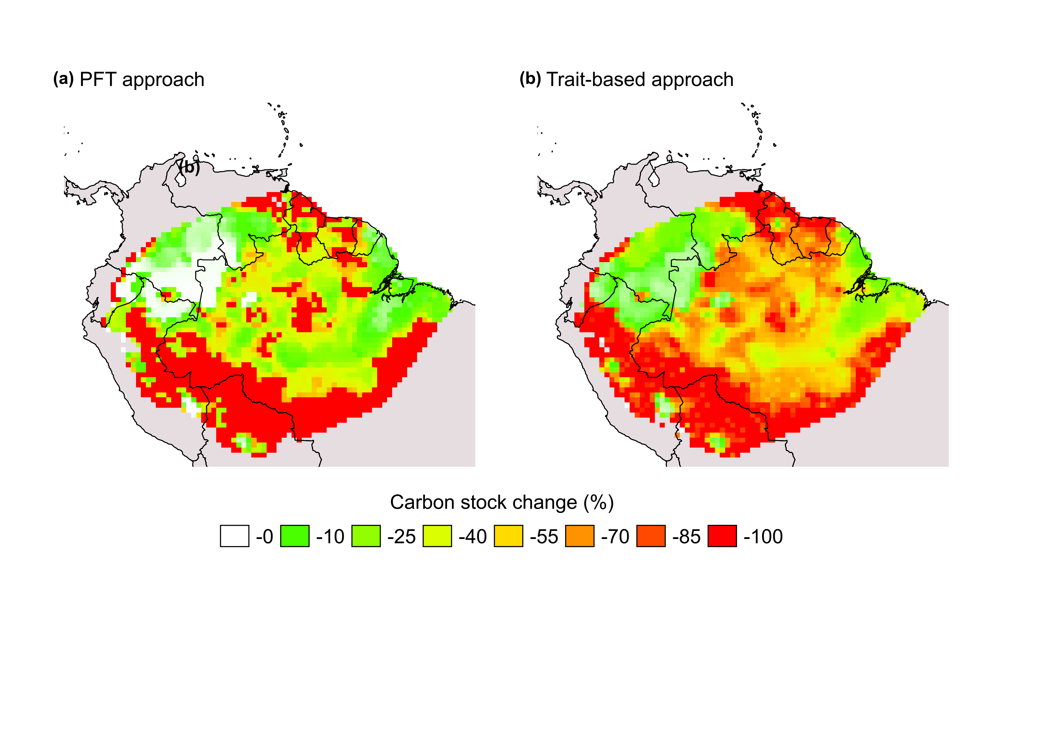

**Fig. 4**

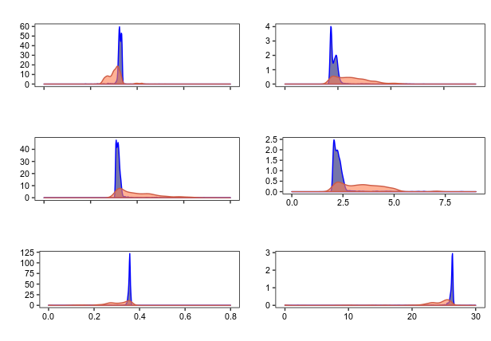

**(a)** Leaf allocation

**(b)** Fine roots allocation

**(c)** Abg. woody tissues allocation

**(d)** Leaf residence time

**(e)** Fine roots residence time

**(f)** Abg. woody tissues residence time

Trait value (%)

Trait value (years)

regular climate

low precipitation

**Fig. 5**

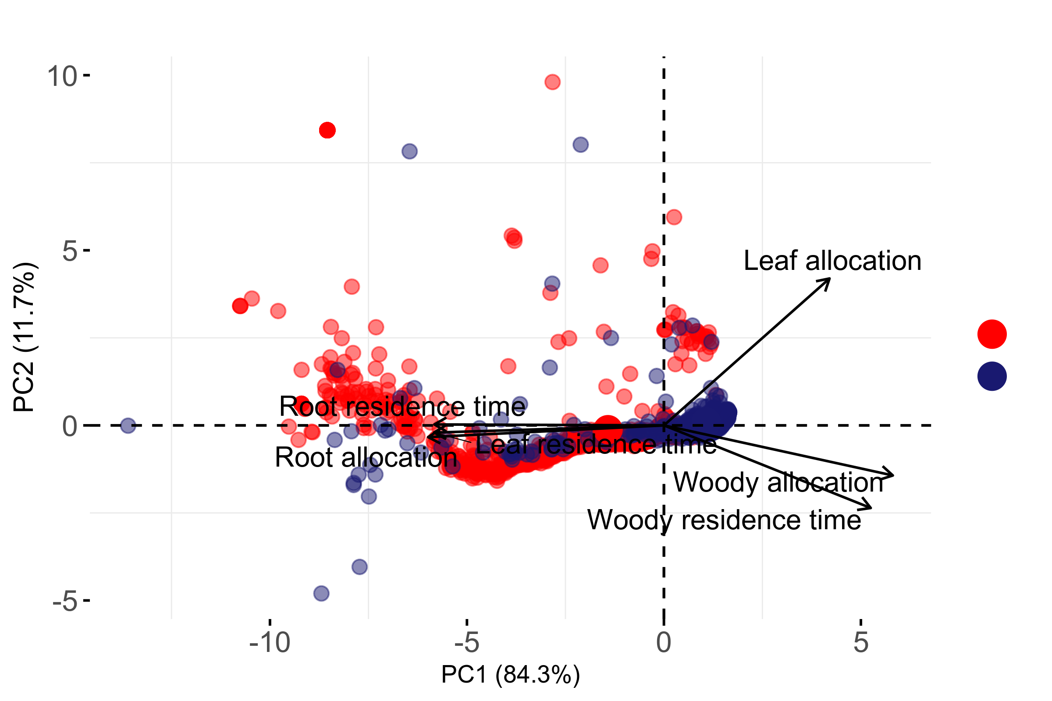

Low precipitation

Regular climate

**Fig. 6**

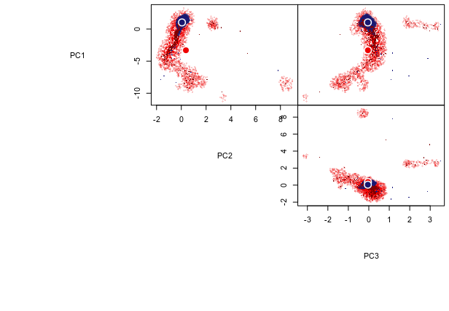

Regular climate

Low precipitation

**Fig. S1**

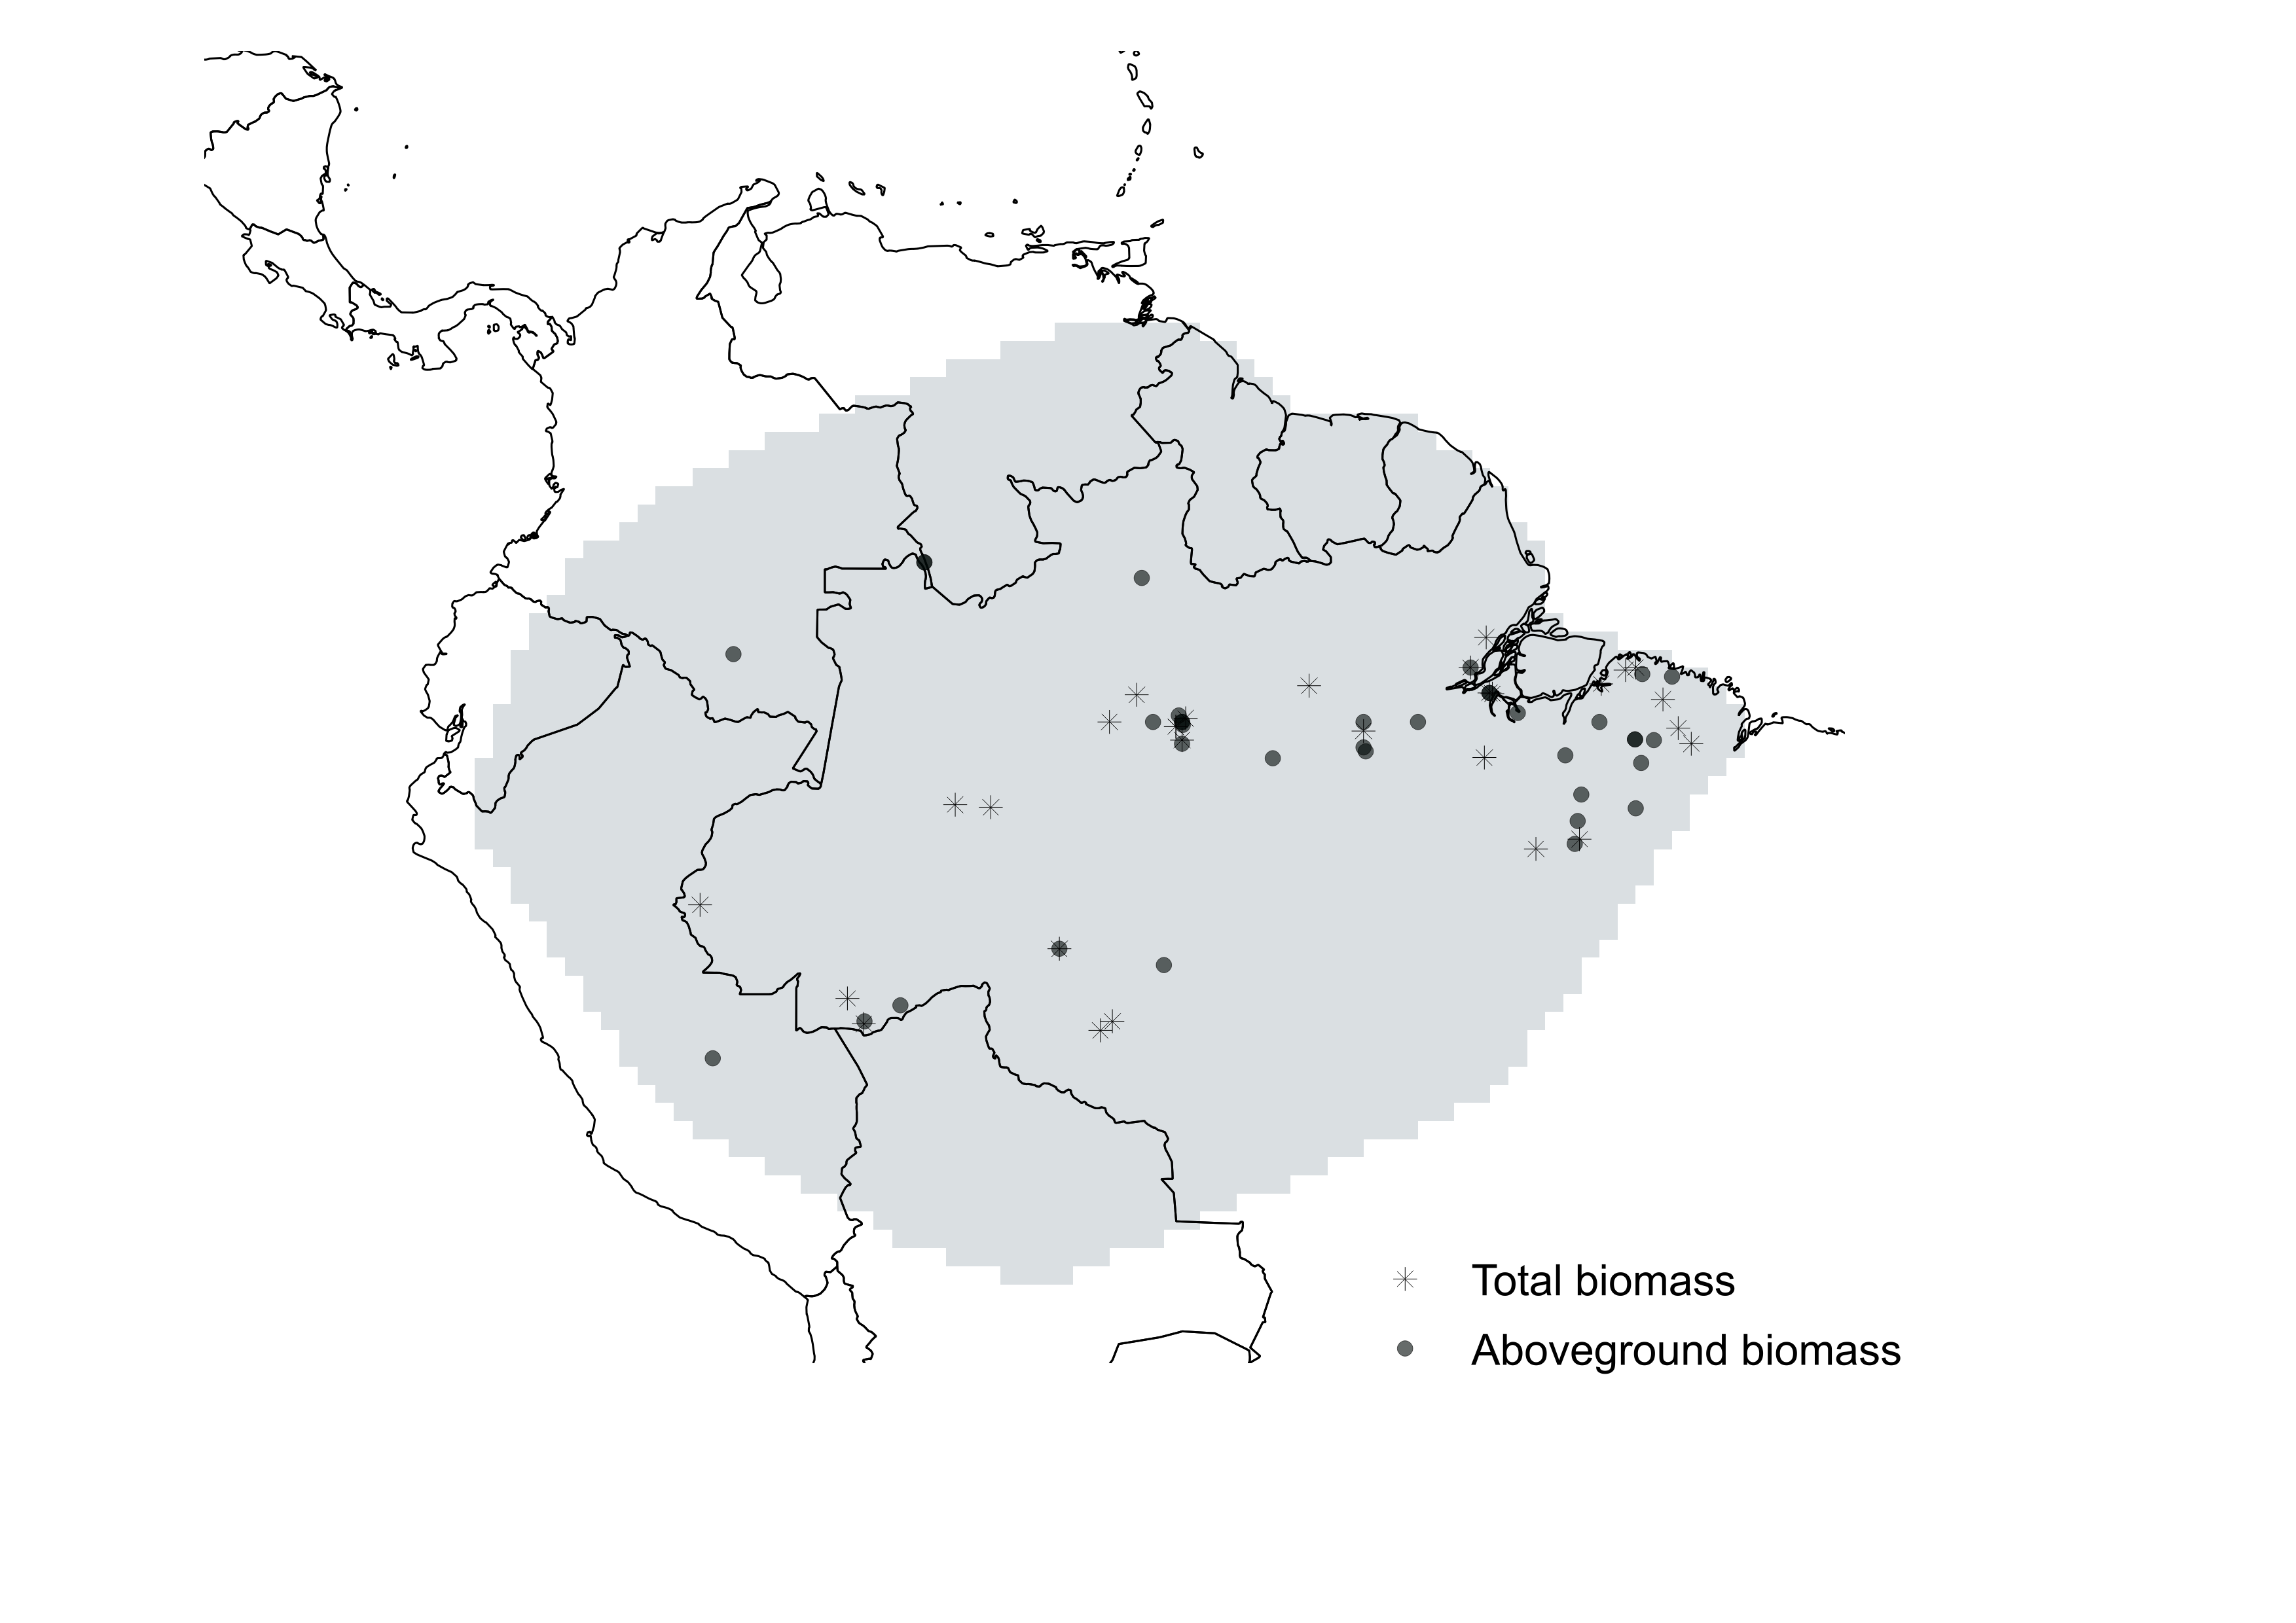

Total carbon content

Aboveground carbon content

**Fig. S2**

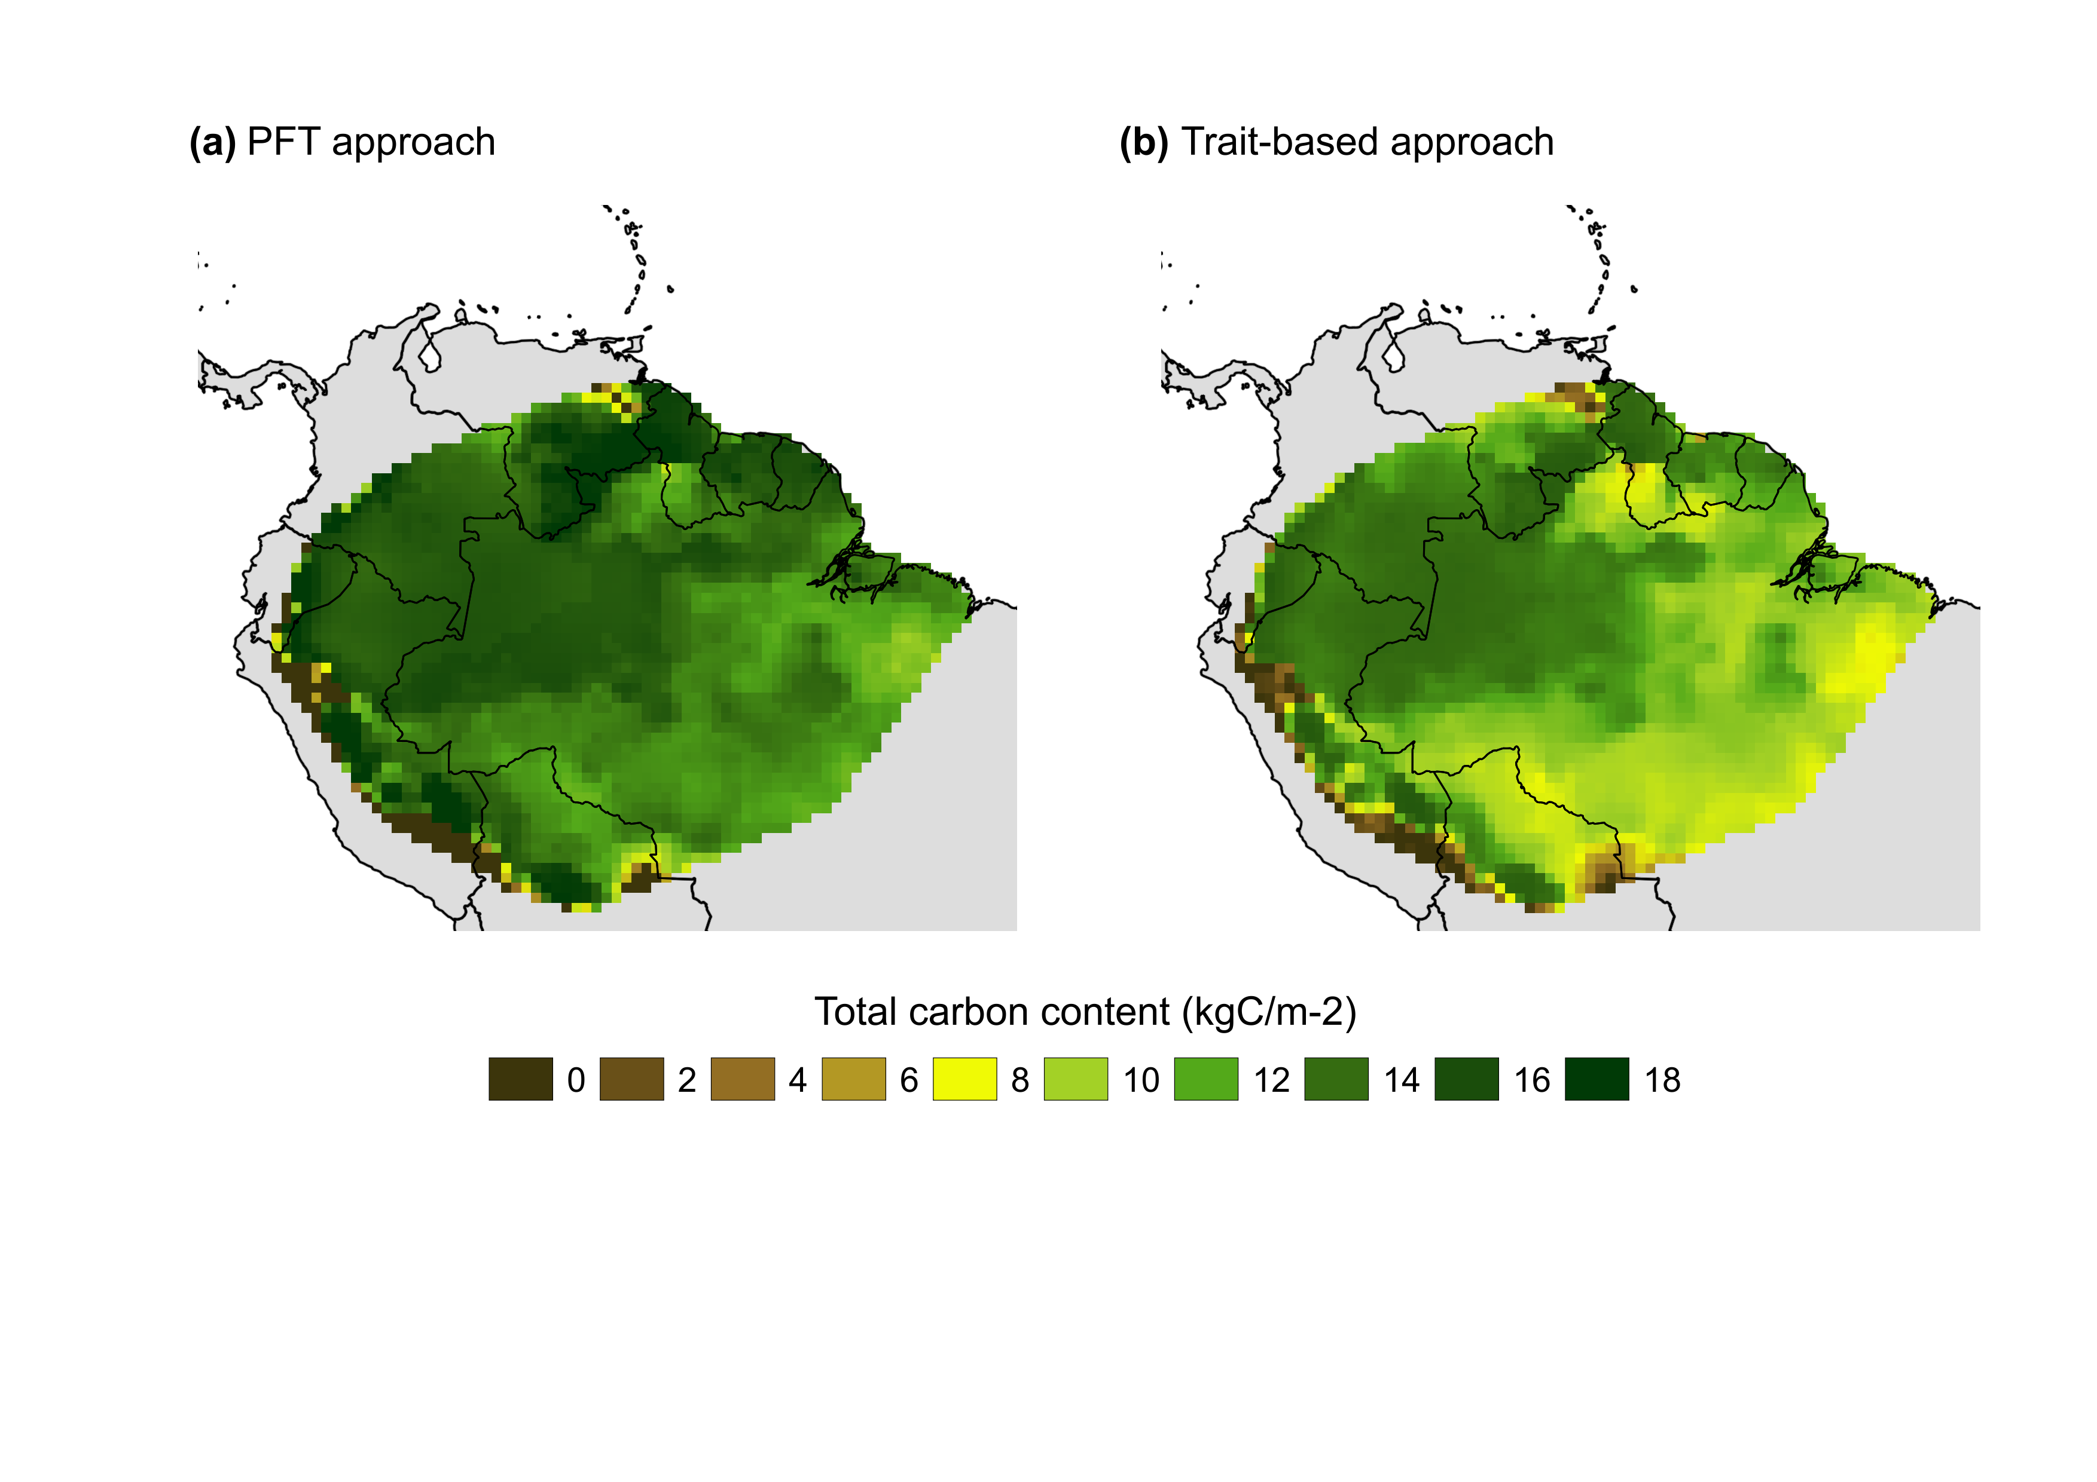

**Fig. S3**

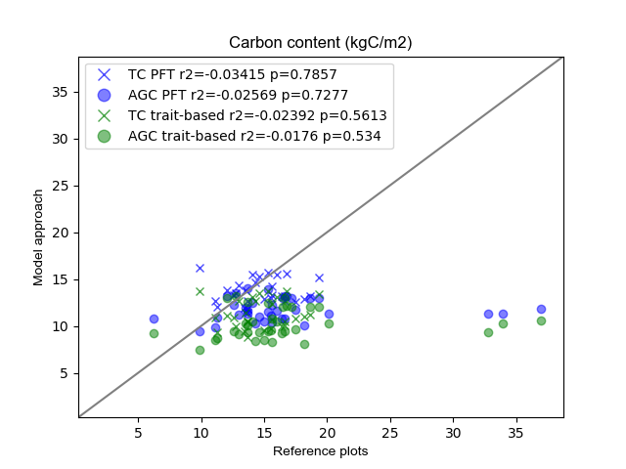

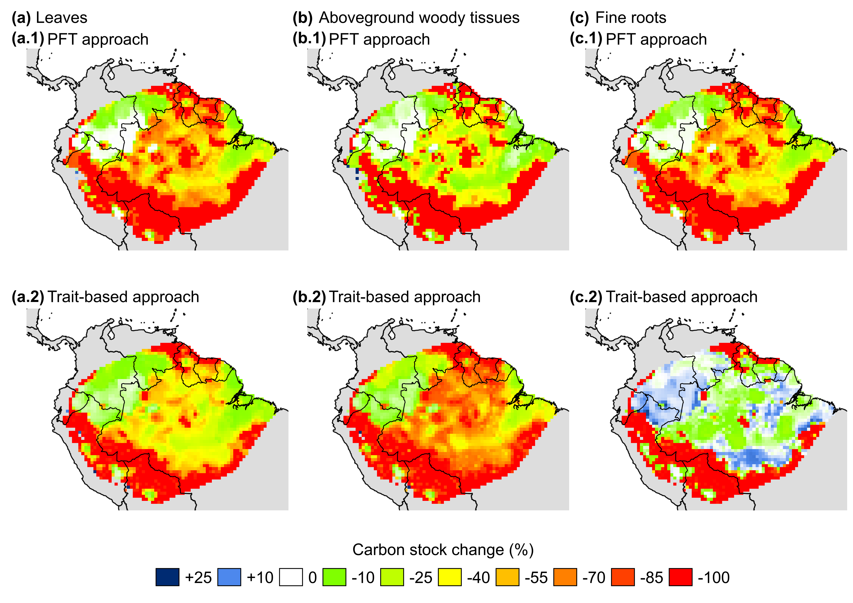

**Fig. S4**

**Table 1**

|  |  |  |  |  |  |  |  |
| --- | --- | --- | --- | --- | --- | --- | --- |
|  | Functional trait value | | | | | | |
|  | allocation (%) | | | | residence time (years) | | |
| PFT | αL | αW | αR | τL | | τW | τR |
| Tropical evergreen tree | 30 | 35 | 35 | 3 | | 30 | 3 |
| Tropical deciduous tree | 35 | 35 | 30 | 2 | | 30 | 2 |
| Tropical grass | 35 | 0 | 55 | 2 | | 0 | 2 |

**Table 2**

|  |  |  |  |  |  |
| --- | --- | --- | --- | --- | --- |
| Functional trait range value | | | | | |
| allocation (%) | | | residence time | | |
| αL | αW | αR | τL | τW | τR |
| 15 - 85 | 15 - 85 | 15 - 85 | 1 (m*) - 8 (y**) | 1 (m) – 8 (y) | 1(y) – 80 (y) |

*months; ** years

**Table 3**

|  |  |  |
| --- | --- | --- |
| Functional trait | Trade-offs | Equation |
| Leaves allocation | Leaves carbon content | Eq. AXX |
| Total plant carbon stock | Eq. AXX |
| Leaf area index | Eq. AXX |
| Maintenance respiration | Eq. AXX |
| Growth respiration | Eq. AXX |
| Aboveground woody tissues allocation | Aboveground woody tissues  carbon content | Eq. AXX |
| Total plant carbon stock | Eq. AXX |
| Light capture | Eq. AXX |
| Maintenance respiration | Eq. AXX |
| Growth respiration | Eq. AXX |
| Fine roots allocation | Fine roots carbon content | Eq. AXX |
| Total plant carbon stock | Eq. AXX |
| Hydraulic stress | Eq. AXX |
| Maintenance respiration | Eq. AXX |
| Growth respiration | Eq. AXX |
| Leaves residence time | Leaves carbon content | Eq. AXX |
| Total plant carbon stock | Eq. AXX |
| Leaf area index | Eq. AXX |
| Maintenance respiration | Eq. AXX |
| Specific leaf area |  |
| Growth respiration | Eq. AXX |
| Aboveground woody  tissues residence time | Aboveground woody tissues  carbon content | Eq. AXX |
| Total plant carbon stock | Eq. AXX |
| Light capture | Eq. AXX |
| Maintenance respiration | Eq. AXX |
| Growth respiration | Eq. AXX |
| Fine roots residence time | Fine roots carbon content | Eq. AXX |
| Total plant carbon stock | Eq. AXX |
| Hydraulic stress | Eq. AXX |
| Specific leaf area | Eq. AXX |
| Maintenance respiration | Eq. AXX |
| Growth respiration | Eq. AXX |

**Tabela 4**

|  |  |  |  |  |
| --- | --- | --- | --- | --- |
| Functional Trait | Compartment | Climate | Mean | Mode |
| Allocation (%) | αL | Regular climate | 0.326 | 0.324 |
| Low precipitation | 0.303 | 0.316 |
| αW | Regular climate | 0.351 | 0.357 |
| Low precipitation | 0.297 | 0.353 |
| αR | Regular climate | 0.323 | 0.309 |
| Low precipitation | 0.401 | 0.325 |
| Residence  Time (years) | τL | Regular climate | 2.363 | 2.170 |
| Low precipitation | 3.162 | 2.284 |
| τW | Regular climate | 26.052 | 26.357 |
| Low precipitation | 23.354 | 25.570 |
| τR | Regular climate | 2.313 | 2.066 |
| Low precipitation | 3.382 | 2.272 |

|  |  |  |  |  |  |  |  |  |  |
| --- | --- | --- | --- | --- | --- | --- | --- | --- | --- |
| Approach | Trait | Scenario | Distribution dissimilarity | Richness | Change | divergence | Change | evenness | change |
| TB | αLeaf | Reg. clim. | 0.68 | 0.376 | 15.15 | 0.083 | 207.22 | 0.117 | 116.24 |
| Low prec. | 0.433 | 0.255 | 0.253 |
| PFT | Reg. clim. | 0.71 | 0.045 | 6.66 | 0.209 | 87.55 | 0.077 | 220.78 |
| Low prec. | 0.048 | 0.392 | 0.247 |
| TB | αAbgw | Reg. clim. | 0.64 | 0.380 | 25 | 0.972 | -19.65 | 0.114 | 256.14 |
| Low prec. | 0.475 | 0.781 | 0.406 |
| PFT | Reg. clim. | 0.49 | 0.285 | 9.82 | 0.999 | 0.1 | 0.119 | 36.97 |
| Low prec. | 0.313 | 1 | 0.163 |
| TB | αFineroots | Reg. clim. | 0.65 | 0.566 | 19.26 | 0.976 | -26.02 | 0.113 | 277.0 |
| Low prec. | 0.675 | 0.722 | 0.426 |
| PFT | Reg. clim. | 0.72 | 0.162 | 17.28 | 0.999 | -6.21 | 0.235 | -45.96 |
| Low prec. | 0.190 | 0.937 | 0.127 |
| TB | τLeaf | Reg. clim. | 0.68 | 5.399 | 6.61 | 0.978 | -31.29 | 0.149 | 228.19 |
| Low prec. | 5.756 | 0.672 | 0.489 |
| PFT | Reg. clim. | 0.7 | 0.943 | 7.32 | 0.179 | 66.48 | 0.075 | 210.66 |
| Low prec. | 1.012 | 0.298 | 0.232 |
| TB | τAbgw | Reg. clim. | 0.75 | 32.815 | 26.96 | 0.614 | -4.723 | 0.102 | 146.07 |
| Low prec. | 41.665 | 0.585 | 0.251 |
| PFT | Reg. clim. | 0.5 | 26.507 | -14.29 | 0.999 | -3.81 | 0.118 | 49.15 |
| Low prec. | 22.720 | 0.961 | 0.176 |
| TB | τFineroots | Reg. clim. | 0.66 | 6.819 | 20.21 | 0.967 | -34.02 | 0.152 | 176.97 |
| Low prec. | 8.197 | 0.638 | 0.421 |
| PFT | Reg. clim. | 0.7 | 0.943 | 7.32 | 0.179 | 66.48 | 0.075 | 210.66 |
| Low prec. | 1.012 | 0.298 | 0.233 |

**Tabela S1**



|  |  |  |  |  |  |  |
| --- | --- | --- | --- | --- | --- | --- |
| Paper reference | Lat | Long | Measurement  type | Reference  measurement  (kgC/m2) | PFT  approach  (kgC/m2) | PLS  approach  (kgC/m2) |
| Malhi et al.,  2009 | -1.7 | -51.53 | ABG | 20.1 | 11.29 | 10.26 |
| -2.5 | -55 | ABG | 15.27 | 11.51 | 9.48 |
| -2.5 | -60 | ABG | 16.5 | 12.99 | 12.00 |
| Clark et al.,  2001 | -2.5 | -60 | ABG | 17.18 | 12.99332 | 12.00328 |
| -2.98 | -47.52 | ABG | 6.25 | 10.75881 | 9.19228 |
| Baker et al.  2004 | -1.7 | -51.53 | ABG | 33.91 | 11.29417 | 10.26325 |
| -3.31 | -54.94 | ABG | 32.76 | 11.3478 | 9.33899 |
| -1 | -52.05 | ABG | 36.97 | 11.85597 | 10.59317 |
| Houghton et al., 2001 | -2.5 | -53.5 | ABG | 16.64 | 10.77646 | 9.43 |
| -3.5 | -57.5 | ABG | 15.65 | 12.26 | 10.81 |
| -2.25 | -50.75 | ABG | 16.02 | 11.57 | 10.52 |
| -2.5 | -48.5 | ABG | 15.52 | 11.14 | 9.59 |
| -3.63 | -47.35 | ABG | 18.18 | 10.01 | 8.04 |
| -1.25 | -46.5 | ABG | 17.46 | 11.73 | 9.65 |
| 1.47 | -61.11 | ABG | 12.95 | 11.23 | 9.09 |
| -2.98 | -47.52 | ABG | 16.41 | 10.75 | 9.19 |
| -1.18 | -47.32 | ABG | 14.1 | 12.50 | 10.48 |
| -2.58 | -59.98 | ABG | 19.33 | 12.99 | 12.0 |
| -3.1 | -60 | ABG | 18.64 | 12.96 | 11.99 |
| -2.5 | -60.8 | ABG | 15.29 | 13.90 | 12.5 |
| -3.42 | -49.44 | ABG | 14.61 | 11.0 | 9.36 |
| -2.32 | -60.09 | ABG | 13.68 | 14.0 | 12.55 |
| -5.23 | -49.1 | ABG | 14.3 | 10.25 | 8.42 |
| -4.88 | -47.5 | ABG | 9.87 | 9.42 | 7.44 |
| 1.9 | -67.1 | ABG | 12.02 | 13.22 | 13.01 |
| -0.63 | -72.36 | ABG | 12.73 | 13.47 | 13.15 |
| -3 | -47 | ABG | 14.97 | 10.51 | 8.46 |
| -8.75 | -63.38 | ABG | 13.55 | 11.98 | 10.31 |
| -10.75 | -68.75 | ABG | 12.57 | 12.22 | 9.41 |
| -10.31 | -67.76 | ABG | 11.26 | 10.93 | 8.68 |
| 1.9 | -67.1 | ABG | 16.63 | 13.22 | 13.01 |
| -3.2 | -55 | ABG | 13.7 | 11.34 | 9.33 |
| -11.77 | -72.93 | ABG | 16.81 | 13.17 | 12.13 |
| -5.86 | -49.18 | ABG | 15.61 | 10.34 | 8.27 |
| -9.2 | -60.5 | ABG | 13.64 | 11.67 | 10.09 |
| -4.5 | -49 | ABG | 11.09 | 9.87 | 8.44 |
| Malhi et al., 2006 | -3.1 | -45.97 | TOT | 13.48 | 11.93 | 9.43 |
| -2.67 | -46.33 | TOT | 16.64 | 13.19 | 10.46 |
| -2.4 | -59.9 | TOT | 15.65 | 14.22 | 12.4 |
| -2.63 | -60.17 | TOT | 16.02 | 15.45 | 13.09 |
| -10.75 | -61.92 | TOT | 15.52 | 12.95 | 9.79 |
| -0.17 | -51.62 | TOT | 18.18 | 12.90 | 10.99 |
| -1.7 | -51.53 | TOT | 17.46 | 12.53 | 10.84 |
| -3 | -60 | TOT | 12.95 | 14.38 | 12.66 |
| -10.12 | -69.22 | TOT | 16.41 | 13.18 | 9.91 |
| -2.63 | -60.17 | TOT | 14.1 | 15.45 | 13.09 |
| -2.5 | -62 | TOT | 19.33 | 15.12 | 13.37 |
| -1 | -52.05 | TOT | 18.64 | 13.14 | 11.19 |
| -4.78 | -66.25 | TOT | 15.29 | 15.69 | 13.74 |
| -1.75 | -61.25 | TOT | 14.61 | 15.30 | 13.46 |
| -5.73 | -49.05 | TOT | 13.68 | 11.39 | 8.79 |
| -1.45 | -48.45 | TOT | 14.3 | 14.66 | 12.62 |
| -7.54 | -73.28 | TOT | 9.87 | 16.16 | 13.66 |
| -1 | -47.5 | TOT | 12.02 | 13.84 | 11.08 |
| -10.82 | -68.77 | TOT | 12.73 | 13.50 | 10.0 |
| -11 | -62.25 | TOT | 14.97 | 12.86 | 9.58 |
| -1.07 | -47.78 | TOT | 13.55 | 13.82 | 11.42 |
| -8.75 | -63.38 | TOT | 12.57 | 13.28 | 10.9 |
| -6 | -50.25 | TOT | 11.26 | 12.05 | 9.35 |
| -2.75 | -55 | TOT | 16.63 | 12.71 | 10.04 |
| -1.5 | -56.5 | TOT | 13.7 | 12.64 | 10.43 |
| -4.85 | -65.27 | TOT | 16.81 | 15.62 | 13.72 |
| -1.88 | -46.75 | TOT | 15.61 | 13.28 | 10.64 |
| -3.48 | -51.67 | TOT | 13.64 | 11.88 | 10.42 |
| Doughty et al. 2013 | -1.72 | -51.45 | TOT | 11.09 | 12.65 | 10.89 |

|  |  |  |  |
| --- | --- | --- | --- |
| Functional trait | PC1 | PC2 | PC3 |
| αL | 0.3108934 | 0.832850106 | 0.37087922 |
| αW | 0.4297393 | -0.284001326 | -0.06299128 |
| αR | -0.4426094 | -0.066843815 | -0.07925189 |
| τL | -0.4316101 | -0.040922066 | 0.45606807 |
| τW | 0.3882543 | -0.468545447 | 0.67368565 |
| τR | -0.4309730 | 0.005138063 | 0.43629051 |