Figura 1: caete flowchart

Figura 2a: perda total de cabrono

Figura 2b: perda raizes finas

Figura 3: TPD distributions

Figure 4: hypervolumes

Table 1: resultados FD

Table A1: PFTs

Table A2: Traits based traits

Table A3: traits, functional trade-offs and equations

Table A4: symbols, units etc

Fig A1: PLS sensitivity

SM

Fig SM 1: caete vs. benchmark

Fig SM 2: PCA

Fig. SM 3: perda de carbono leaves e abgw

Fig SM 4 : hypervolume together

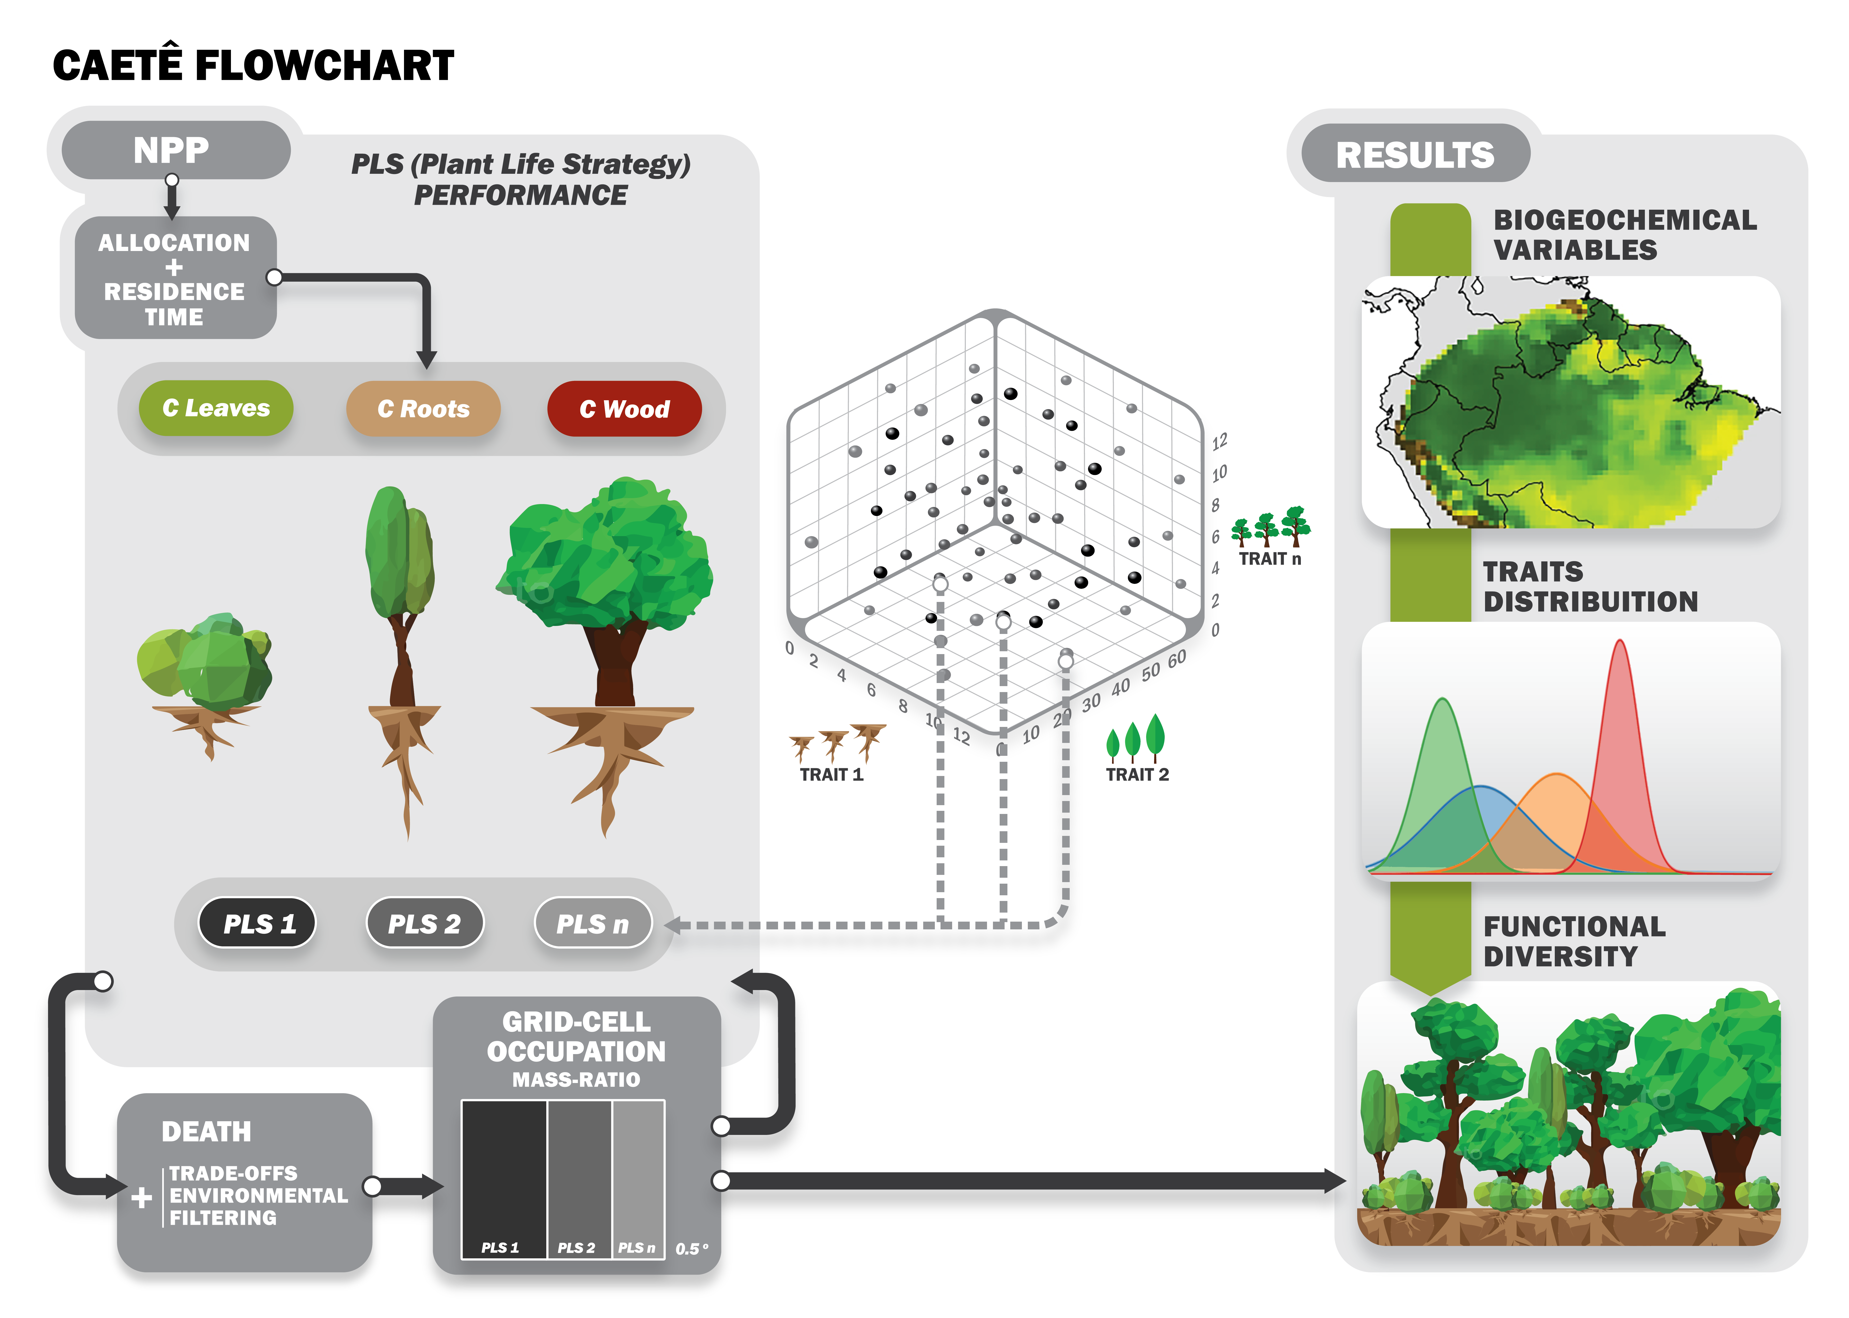

Figure 1: Schematic diagram of CAETÊ in its trait-based model approach. From functional trait ranges the values are uniformly sampled and the combination of all creates a potential functional space. Each combination of trait values is a Plant Life Strategy (PLS) which will present a different performance, in terms of carbon balance, depending on the grid cell. From the potential functional space 3000 PLS are randonmly sampled. The environmental filtering, the trade-offs between the chosen functional traits and the physiological processes determine if a PLS survives (positive carbon balance) or dies. From the performance (its relative biomass in the grid-cell) of the PLSs the grid-cell is occupied as a mosaic. This modelling framework allow us to access the model results not only regarding to biogeochemical varibles but also in terms of trait distribution and functional diversity.

Figura 6: Hypervolumes created with the six functional traits together for the trait-based (a) and the PFT (b) modelling approach through the method of Blonder et al. (2018). The hypervolumes were created after the data to be submited to a PCA analysis. The PCA can be seen in Figure SMXXX. The blue points indicate the dara in a regular climate scenario and the red ones the scenario of low precipitation (-50%). The darkest the color of the point the higher the density of the value within the functional space. The bigeer circles represent the centroyd (i.e. the values mean) of data distribution. Here the volumes of the different approaches are shown separetely to improve readability, hence, they are not presented in the same unit. The blue points indicate the dara in a regular climate scenario and the red ones the scenario of low precipitation (-50%) For the volumes of the two approaches together see Figure SMXXXX.

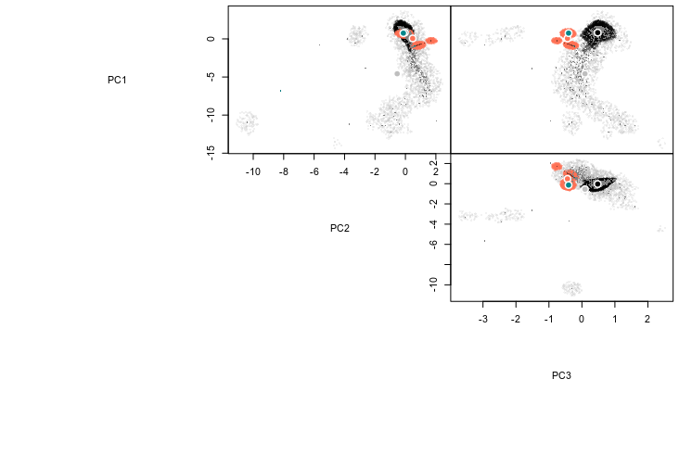

Trait-based regular climate

Trait-based low precipitation

PFT regular climate

PFT low precipitation

Table 1: Functional traits values for each Plant Functional Type (PFT) used in the PFT modelling approach. The values were chosen based on previous literature: Enquist & Niklas, 2002, Foley, 1996; Krinner et al., 2005; Kucharik et al., 2000; Malhi et al., 2009; Malhi, Doughty, Galbraith, 2011; Sitch et al., 2003. α: allocation; τ: residence time; Abgw: aboveground woody tissues  
Table 1: Functional traits values for each Plant Functional Type (PFT) used in the PFT modelling approach. The values were chosen based on previous literature: Enquist & Niklas, 2002, Foley, 1996; Krinner et al., 2005; Kucharik et al., 2000; Malhi et al., 2009; Malhi, Doughty, Galbraith, 2011; Sitch et al., 2003. α: allocation; τ: residence time; Abgw: aboveground woody tissues

Table 2: Range of functional traits values from which values are sampled and its combinations create the different Plant Life Strategys (PLSs). Used in the trait-based modelling approach. α: allocation; τ: residence time; Abgw: aboveground woody tissues; *months; **years



Table 3: Functional traits and its respective trade-offs and associated equations. The equations are described in the Appendix together with the model description.

|  |  |  |
| --- | --- | --- |
| **Functional trait** | **Trade-offs** | **Equation** |
| Leaves allocation | Leaves carbon content | Eq. AXX |
| Total plant carbon stock | Eq. AXX |
| Leaf area index | Eq. AXX |
| Maintenance respiration | Eq. AXX |
| Growth respiration | Eq. AXX |
| Aboveground woody tissues allocation | Aboveground woody tissues  carbon content | Eq. AXX |
| Total plant carbon stock | Eq. AXX |
| Light capture | Eq. AXX |
| Maintenance respiration | Eq. AXX |
| Growth respiration | Eq. AXX |
| Fine roots allocation | Fine roots carbon content | Eq. AXX |
| Total plant carbon stock | Eq. AXX |
| Hydraulic stress | Eq. AXX |
| Maintenance respiration | Eq. AXX |
| Growth respiration | Eq. AXX |
| Leaves residence time | Leaves carbon content | Eq. AXX |
| Total plant carbon stock | Eq. AXX |
| Leaf area index | Eq. AXX |
| Maintenance respiration | Eq. AXX |
| Specific leaf area | Eq. AXX |
| Growth respiration | Eq. AXX |
| Aboveground woody  tissues residence time | Aboveground woody tissues  carbon content | Eq. AXX |
| Total plant carbon stock | Eq. AXX |
| Light capture | Eq. AXX |
| Maintenance respiration | Eq. AXX |
| Growth respiration | Eq. AXX |
| Fine roots residence time | Fine roots carbon content | Eq. AXX |
| Total plant carbon stock | Eq. AXX |
| Hydraulic stress | Eq. AXX |
| Specific leaf area | Eq. AXX |
| Maintenance respiration | Eq. AXX |
| Growth respiration | Eq. AXXX |

Table 4: Change on functional diversity components (richness, evenness and divergence) for all the six functional traits considered with the applied reduction on precipitation (50%). Here is also shown the dissimilarity of traits distribution before and after the disturbance (the closer to the value 1, the more dissimilar the curves are to each other).α: allocation; τ: residence time; Abgw: aboveground woody tissues.