Figure 1: Schematic diagram of CAETÊ in its trait-based model approach. From functional trait ranges the values are uniformly sampled and the combination of all creates a potential functional space. Each combination of trait values is a Plant Life Strategy (PLS) which will present a different performance, in terms of carbon balance, depending on the grid cell. From the potential functional space 3000 PLS are randonmly sampled. The environmental filtering, the trade-offs between the chosen functional traits and the physiological processes determine if a PLS survives (positive carbon balance) or dies. From the performance (its relative biomass in the grid-cell) of the PLSs the grid-cell is occupied as a mosaic. This modelling framework allow us to access the model results not only regarding to biogeochemical varibles but also in terms of trait distribution and functional diversity.

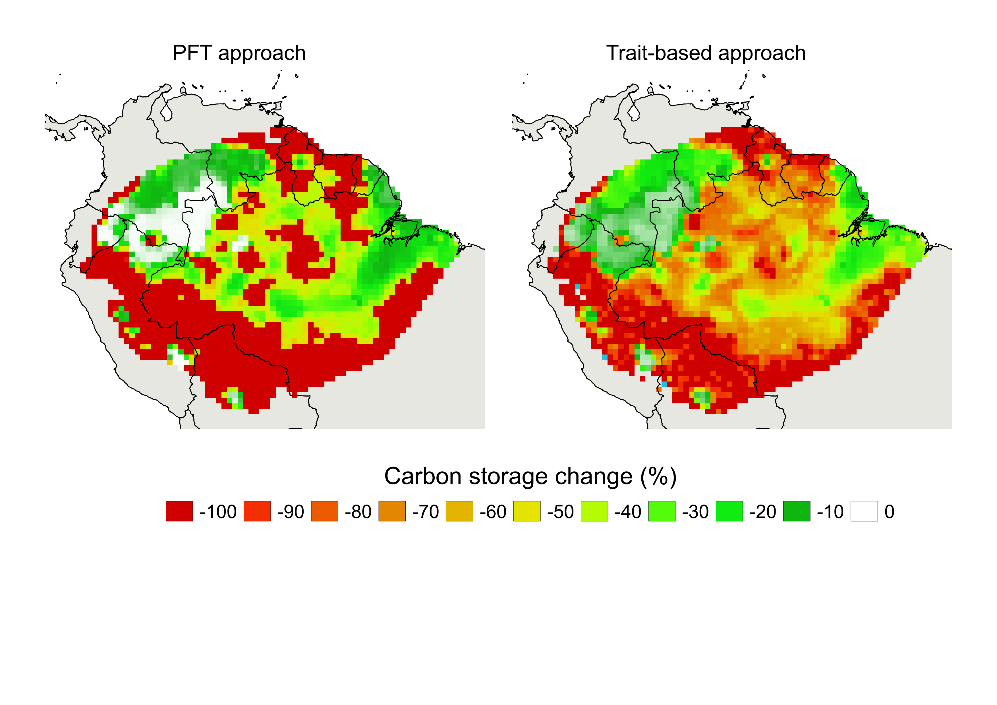  
Figure 2: Percentage change on total carbon storage with reduced precipitation (-50%) for the two employed modelling approaches: the PFT (low functional diversity) and the trait-based (high functional) diversity.

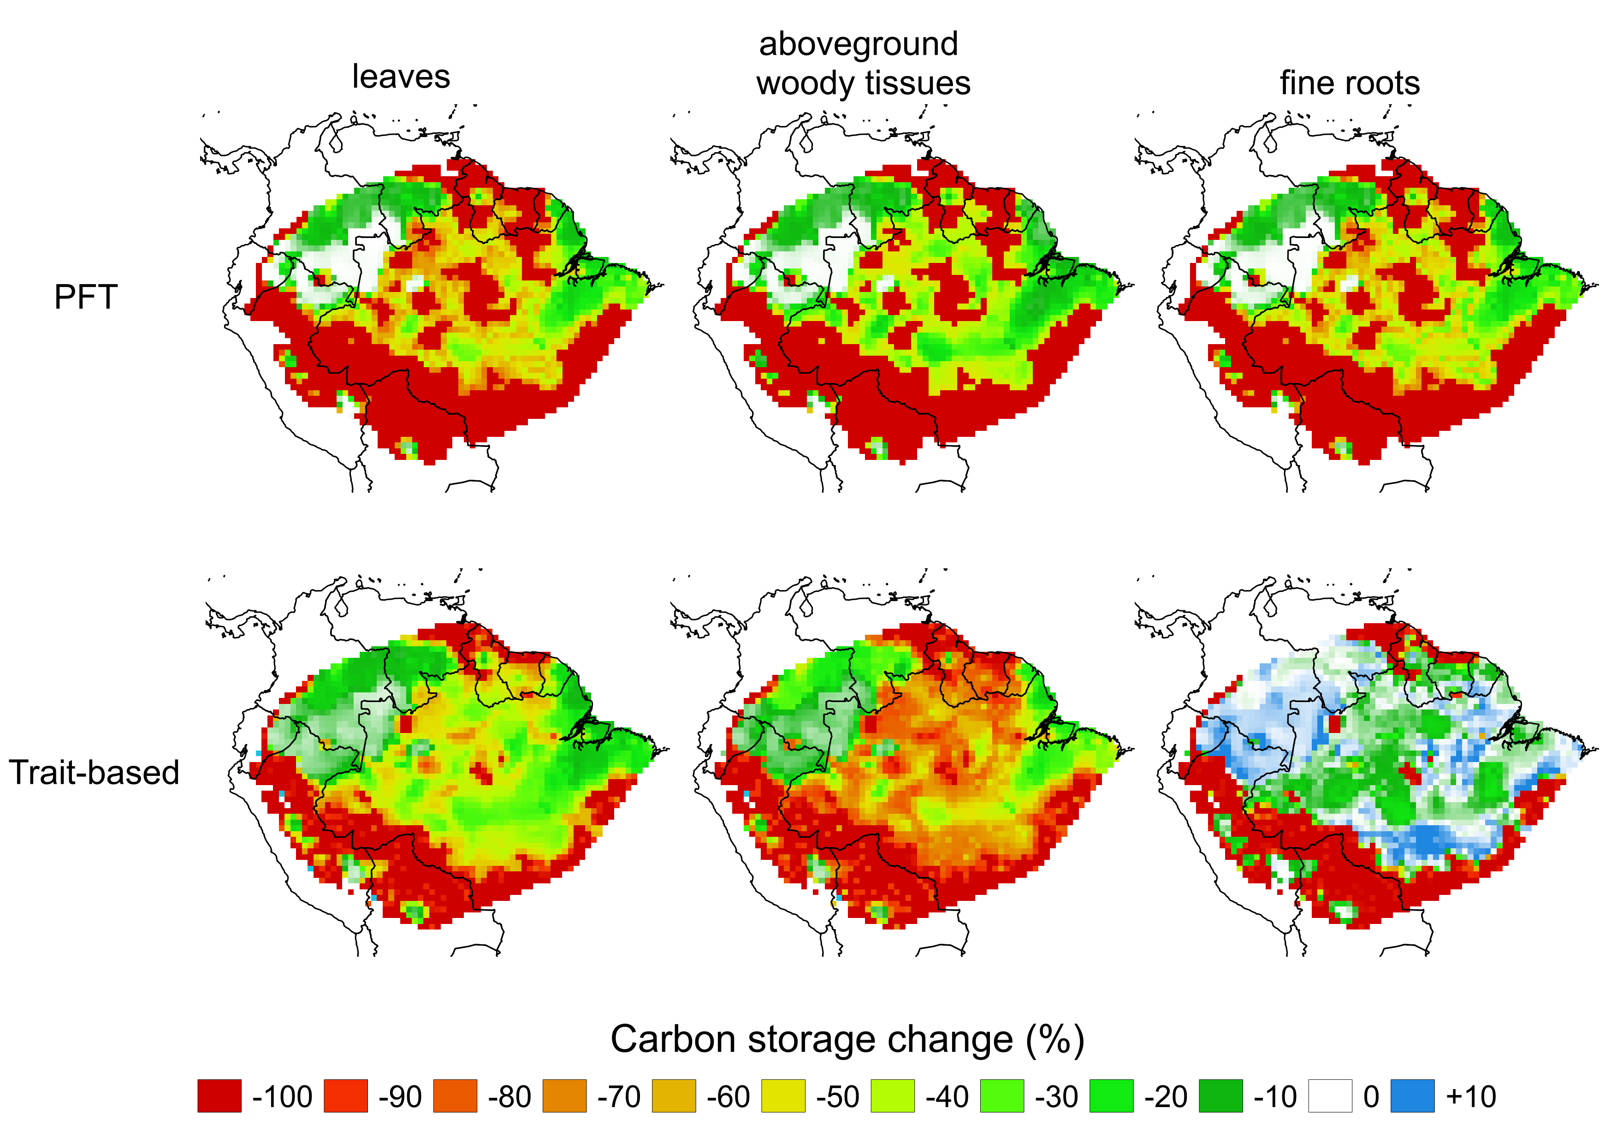  
Figura 3: Carbon storage change (in percentage) for the three different considered plant compartments with the application of a reduction on precipitation (50%). At the top of the figure are shown the results regarding to the employed PFT (low functional diversity) modelling approach; at the bottom of the figure the change on carbon stock for the trait-based (high functional diversity) modelling approach.

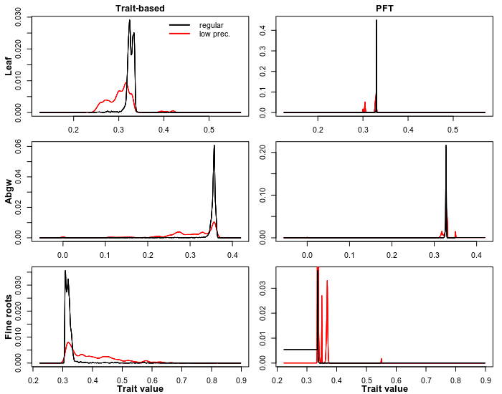

**(a)**

**(b)**

**(a)**

**(a)**

**(c)**

**(d)**

**(a)**

**(e)**

**(a)**

**(f)**

Figure 4: Density distributions of allocation traits using the Trait probability densities method (TPD; Carmona et al., 2016). The curves correspond to the density of traits values across the Amazon basin. The red lines represent the results with the applied low precipitation scenario (low prec. in the graph) and the black ones represent the results concerning to the regular conditions of climate (regular in the graph). The figures a-c show the results regarding to the employed traid-based (high functional diversity) modelling approach, while the figures d-f present the results obtained with the PFT (Plant Functional Type; low functional diversity) modelling approach. Since the figure corresponds to the allocation traits the unit of the trait values is in percentages. Abgw: aboveground woody tissues. Low prec.: low precipitation.

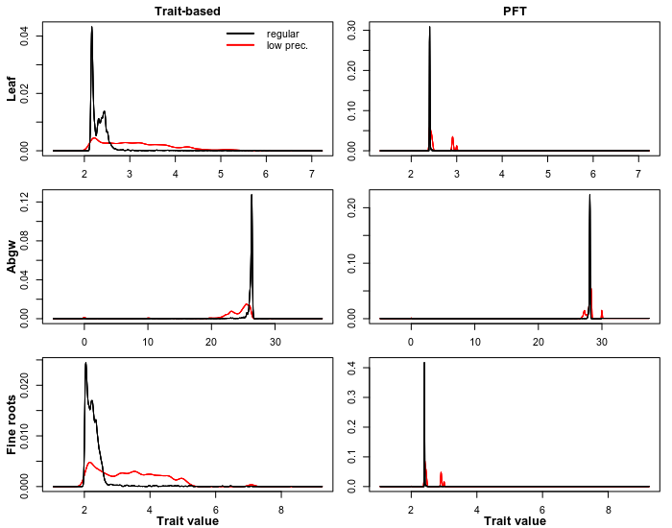

**(a)**

**(b)**

**(c)**

**(d)**

**(e)**

**(f)**

Figura 5 : Density distributions of residence time traits using the Trait probability densities method (TPD; Carmona et al., 2016). The curves corresponds to the density of traits values across the Amazon basin. The red lines represent the results with the applied low precipitation scenario (low prec. in the graph) and the black ones represent the results concerning to the regular conditions of climate (regular in the graph). The figures a-c show the results regarding to the employed traid-based (high functional diversity) modelling approach, while the figures d-f present the results obtained with the PFT (Plant Functional Type; low functional diversity) modelling approach. Since the figure corresponds to the residence time trais the unit of the trait values is in years. Abgw: aboveground woody tissues. Low prec.: low precipitation.

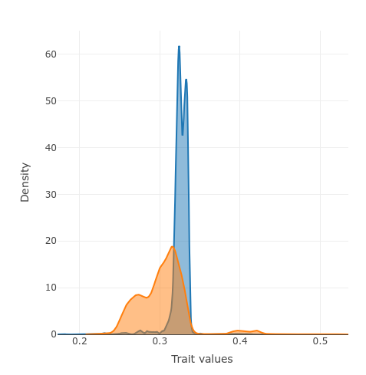

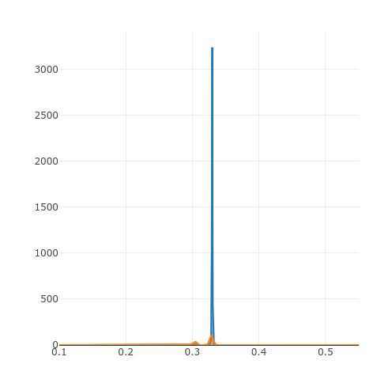

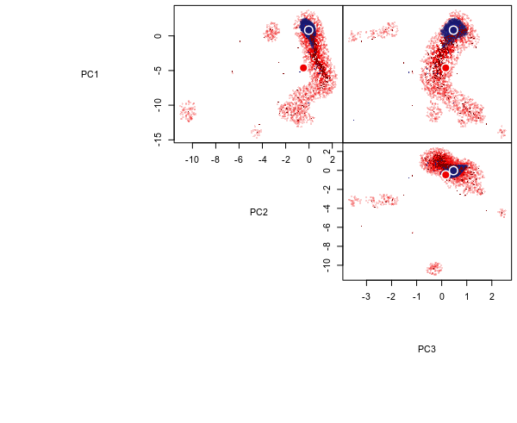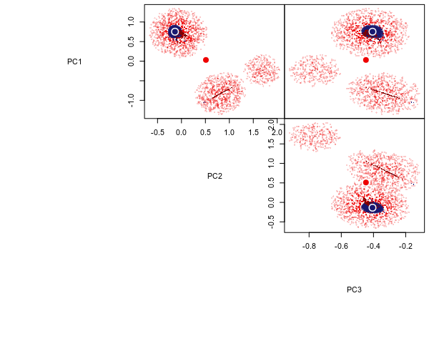

**(a)** Trait-based

**(b)** PFT

Regular climate

Low precipitation



Figura 6: Hypervolumes created with the six functional traits together for the trait-based (a) and the PFT (b) modelling approach through the method of Blonder et al. (2018). The hypervolumes were created after the data to be submited to a PCA analysis. The PCA can be seen in Figure SMXXX. The blue points indicate the dara in a regular climate scenario and the red ones the scenario of low precipitation (-50%). The darkest the color of the point the higher the density of the value within the functional space. The bigeer circles represent the centroyd (i.e. the values mean) of data distribution. Here the volumes of the different approaches are shown separetely to improve readability, hence, they are not presented in the same unit. The blue points indicate the dara in a regular climate scenario and the red ones the scenario of low precipitation (-50%) For the volumes of the two approaches together see Figure SMXXXX.

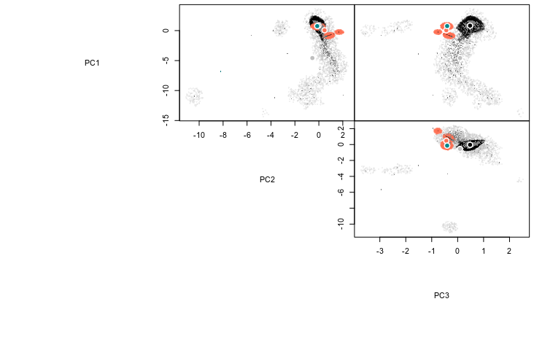

Trait-based regular climate

Trait-based low precipitation

PFT regular climate

PFT low precipitation



Table 2: Range of functional traits values from which values are sampled uniformly and its combinations create the different Plant Life Strategys (PLS). Used in the trait-based modelling approach. α: allocation; τ: residence time; Abgw: aboveground woody tissues; *months; **years

Table 1: Functional traits values for each Plant Functional Type (PFT) used in the PFT modelling approach. The values were chosen based on previous literature: Enquist & Niklas, 2002, Foley, 1996; Krinner et al., 2005; Kucharik et al., 2000; Malhi et al., 2009; Malhi, Doughty, Galbraith, 2011; Sitch et al., 2003. α: allocation; τ: residence time; Abgw: aboveground woody tissues  
Table 1: Functional traits values for each Plant Functional Type (PFT) used in the PFT modelling approach. The values were chosen based on previous literature: Enquist & Niklas, 2002, Foley, 1996; Krinner et al., 2005; Kucharik et al., 2000; Malhi et al., 2009; Malhi, Doughty, Galbraith, 2011; Sitch et al., 2003. α: allocation; τ: residence time; Abgw: aboveground woody tissues

Table 3: Functional traits and its respective trade-offs and associated equations. The equations are described in the Appendix together with the model description.

|  |  |  |
| --- | --- | --- |
| **Functional trait** | **Trade-offs** | **Equation** |
| Leaves allocation | Leaves carbon content | Eq. AXX |
| Total plant carbon stock | Eq. AXX |
| Leaf area index | Eq. AXX |
| Maintenance respiration | Eq. AXX |
| Growth respiration | Eq. AXX |
| Aboveground woody tissues allocation | Aboveground woody tissues  carbon content | Eq. AXX |
| Total plant carbon stock | Eq. AXX |
| Light capture | Eq. AXX |
| Maintenance respiration | Eq. AXX |
| Growth respiration | Eq. AXX |
| Fine roots allocation | Fine roots carbon content | Eq. AXX |
| Total plant carbon stock | Eq. AXX |
| Hydraulic stress | Eq. AXX |
| Maintenance respiration | Eq. AXX |
| Growth respiration | Eq. AXX |
| Leaves residence time | Leaves carbon content | Eq. AXX |
| Total plant carbon stock | Eq. AXX |
| Leaf area index | Eq. AXX |
| Maintenance respiration | Eq. AXX |
| Specific leaf area | Eq. AXX |
| Growth respiration | Eq. AXX |
| Aboveground woody  tissues residence time | Aboveground woody tissues  carbon content | Eq. AXX |
| Total plant carbon stock | Eq. AXX |
| Light capture | Eq. AXX |
| Maintenance respiration | Eq. AXX |
| Growth respiration | Eq. AXX |
| Fine roots residence time | Fine roots carbon content | Eq. AXX |
| Total plant carbon stock | Eq. AXX |
| Hydraulic stress | Eq. AXX |
| Specific leaf area | Eq. AXX |
| Maintenance respiration | Eq. AXX |
| Growth respiration | Eq. AXXX |



Table 4: Change on functional diversity components (richness, evenness and divergence) for all the six functional traits considered with the applied reduction on precipitation (50%). Here is also shown the dissimilarity of traits distribution before and after the disturbance (the closer to the value 1, the more dissimilar the curves are to each other).α: allocation; τ: residence time; Abgw: aboveground woody tissues.

