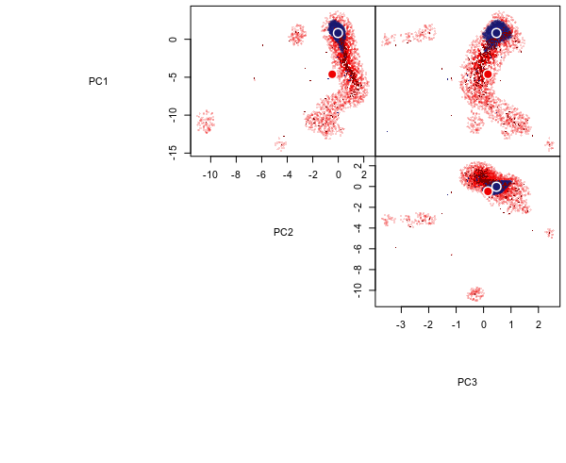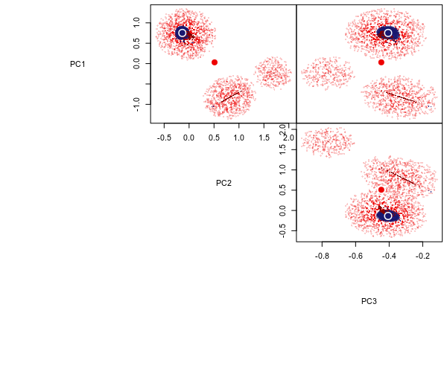

**(a)** TBA

Regular climate

Low precipitation



**(b)** PFTA

