**DISEASES DIAGNOSIS & NEED:**

Goat diseases can cause huge economic loss to the farmers due to high intensity to goat farming with poor management practices. Diseases affect the production of small ruminants in several ways . It incurs increase in the cost of production, reduces production rate, which directly or indirectly affects the quantity and quality of animal products and causes a great loss to the farmer.There are some human health risks directly associate with dealing with diseased animals, while some diseases affecting goats do not have any zoonotic effect to human health.

**Anthrax**

Mainly characterized by staggering, trembling, difficulty in breathing, convulsions and manifest high fever, increased heart rate, excitement, depression, incoordination, cessation of rumination.

**Reason of choice:**

* Anthrax is widely spread and endemic disease in southern India .
* As per the article (TEMPORAL AND GEOGRAPHICAL DISTRIBUTION OF

ANIMAL ANTHRAX IN TAMIL NADU STATE, INDIA ,2011) , A total

of 619 anthrax outbreaks in cattle were documented over 15 years in 28 of the 30 districts

from April 1991 to March 2006 .

#### 

#### Figure 1.

Absence of rigor mortis in goat with anthrax

**Dermatophilosis**

Dermatophilosis is contagious bacterial disease of skin that affects sheep and goats. It is an infection affecting multiple species of animals world-wide, most common in young cattle.

**Reason of choice:**

* In Dermatophilosis, loss of condition and motion, scab formation on the lips, muzzle, nose, ears are the clinical signs .
* The scabs can become detached and reveal a yellow, creamy or hemorrhagic exudate.

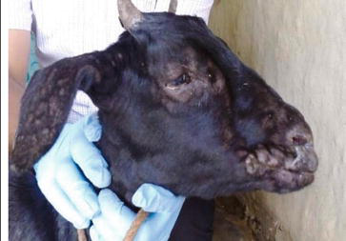

#### Figure 2.

Scab formation on the lips, muzzle and nose.

**Blue tongue disease:**

(BTV) Blue tongue disease is an insect borne viral disease in cattle especially goats.It is an epidemic disease of India specially Tamilnadu wherein during the monsoon season of 1997-98 , outbreak of this disease caused the death of 300,000 goats.It is still a major disease in goats of Tamilnadu.

Reasons: It shows these symptoms externally,

* excessive salivation, and nasal discharge and swelling of lips, tongue, and jaw;
* inflammation of the coronary band (above the hoof) and lameness;
* weakness, depression, weight loss;
* ‘blue’ tongue .

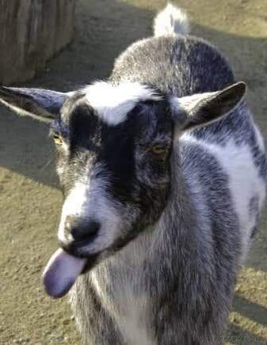

**Figure 3.**

Blue tongue disease in goat.

**Tetanus:**

It is a non-contagious, infectious disease of mammals caused by bacterial toxin characterized by spasmodic contraction of skeletal muscles.Sheep and goat are more susceptible than cattle. It is the third most spread goat disease in Tamilnadu.

**Reasons:**

* The initial signs consist of restricted movement, muscular stiffness and difficulty in walk, lack of coordination,  
  unusual walking.
* Prolapse of the third eye lid, head drawn on one side or back ward, pump handle position of the tail, erection of the   
  ears, immobility of the ears and characteristic “saw horse stance” are the features.
* The rigidity of the facial muscles gives an anxious expression.
* Animal remains hypersensitive and over reaction to sudden noise or physical contact and reflex irritability is noted from the start of symptom.

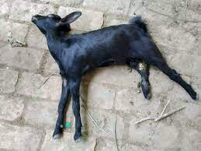

**Figure 4.**

Tetanus in goat.

**Enterotoxemia:**

Enterotoxemia is a frequently severe disease of goats of all ages. It is caused by two strains of bacteria called *Clostridium perfringens.*

**Reason**:

* The affected goat shows a wide range of early symptoms which can be found out externally.
* The animals may abruptly go off of feed and become lethargic. Affected animals may

show signs of stomach pain, such as kicking at their belly, repeatedly laying down and

getting up, laying on their sides, panting, and crying out. .

* Diarrhea, depression, lack of coordination, digestive upsets, coma, and death  ingoat kids.Hence a faster prediction is required.
* Prevention of enterotoxemia is far more likely to be successful than trying to treat the disease.

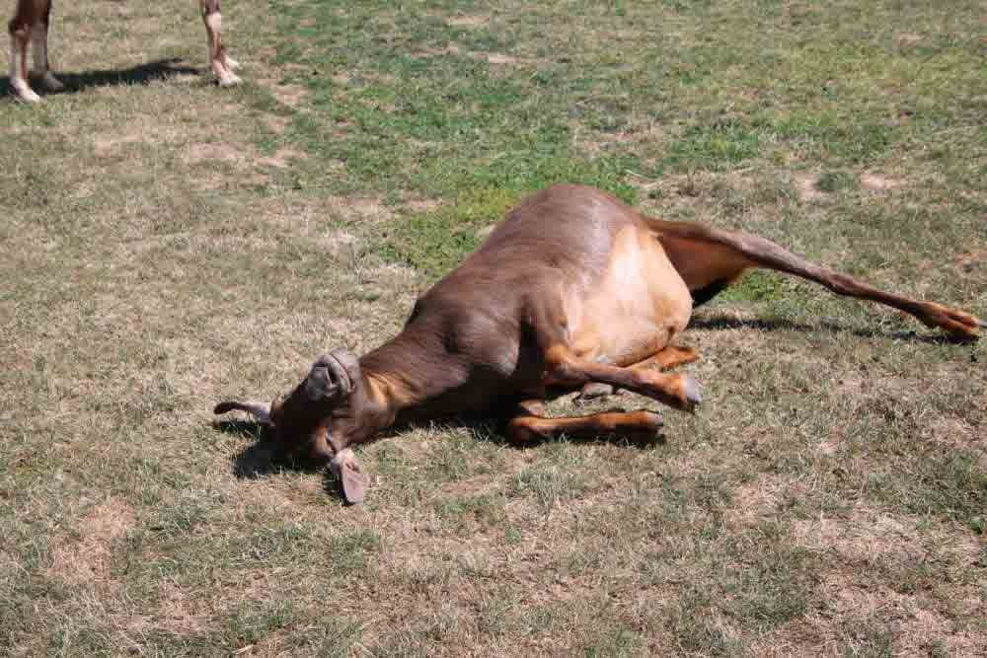

**Figure 3.**

Enterotoxemia in goat.