Automatic device positioning system

HONOURS PROJECT REPORT

Submitted by

BIANCAA R. (3122223002025)

in partial fulfillment for the award of the degree of

BACHELOR OF ENGINEERING
IN
ELECTRONICS AND COMMUNICATION ENGINEERING


Department of Electronics and Communication Engineering
Sri Sivasubramaniya Nadar College of Engineering
(An Autonomous Institution, Affiliated to Anna University)
Rajiv Gandhi Salai (OMR), Kalavakkam – 603 110 NOVEMBER 2025

Sri Sivasubramaniya Nadar College of Engineering
(An Autonomous Institution, Affiliated to Anna University)

BONAFIDE CERTIFICATE

Certified that this project titled “Automatic device positioning system” is the bonafide work of miss Biancaa R. (3122223002025), who carried out the project work under my supervision.
Certified further that to the best of my knowledge the work reported herein does not form part of any other thesis or dissertation on the basis of which a degree or award was conferred on an earlier occasion on this or any other candidate.

Signature of the HOD | Signature of the Supervisor
Dr. P. Vijayalakshmi | Dr. Aasha Nabdhini S.
Professor and Head | Assistant professor
Department of Electronics and  Communication Engineering | Department of Electronics and  Communication Engineering
Sri Sivasubramaniya Nadar College  of Engineering | Sri Sivasubramaniya Nadar  College of Engineering
Kalavakkam – 603 110 | Kalavakkam – 603 110

Submitted for project viva-voce examination held on -----------------------

EXTERNAL EXAMINER INTERNAL EXAMINER

ABSTRACT

Indoor Positioning Systems (IPS) using Bluetooth Low Energy (BLE) technology have become increasingly important for accurate and cost-effective tracking of dynamic users in indoor environments. BLE-based IPS leverage methods such as fingerprinting, trilateration, and hybrid techniques combined with advanced filtering algorithms like Extended Kalman Filter (EKF) to address challenges including multipath effects, signal instability, and noise. These systems enable precise room-level detection and dynamic tracking without the need for detailed floor plans, making them highly adaptable to a range of environments from smart homes to healthcare facilities. The integration of sensor feedback and signal smoothing techniques, such as exponential filtering, further enhances performance by mitigating RSSI fluctuations and environmental interferences. Low-cost implementations utilizing BLE beacons and platforms like Raspberry Pi facilitate scalable and real-time monitoring, making BLE IPS a promising solution for ubiquitous indoor positioning applications. Despite challenges related to signal variability and energy constraints, ongoing research continues to improve localization accuracy and robustness through hybrid methods and machine learning approaches, underscoring the practical benefits and future potential of BLE-based indoor positioning technology

ACKNOWLEDGEMENT

First and foremost, I extend my heartfelt gratitude to the esteemed Head of Department, Dr. P. Vijayalakshmi, whose unwavering support and encouragement paved the path for my participation in this enriching project work. Without her benevolent guidance, this project would
have remained but a distant aspiration.

Furthermore, I extend my sincerest appreciation to Dr. Aasha Nandhini S for his astute analysis of my project, which contributed significantly to its refinement and success.
In essence, this journey has been illuminated by the collective efforts, guidance, and support of these esteemed individuals, without whom this endeavor would not have reached its fruition.

BIANCAA R

TABLE OF CONTENTS
CHAPTER  NO | TITLE | PAGE NO
 | ABSTRACT | iii
 | ACKNOWLEDGEMENT | iv
 | LIST OF FIGURES | vi
 | LIST OF ABBREVIATIONS | vii
1 | INTRODUCTION  - Background  - Motivation  - Objectives | 1
2 | STUDY OF Positioning system implementation  2.1 Introduction  2.2 Study of positioning system research papers  2.3 Conclusion | 4
3 | Methodology | 6
 | 3.1 Introduction
 | 3.2 System architecture overview
 | 3.3 Software architecture
 | 3.4 Hardware architecture.
 | 3.5 Conclusion
4 | RESULTS AND DISCUSSION  4.1 Introduction  4.2 Observed results  4.3 Conclusion | 11
5 | CONCLUSION AND FUTURE SCOPE | 14
6 | REFERENCES | 15

LIST OF FIGURES

FIGURE NO | TITLE | PAGE NO
3.2 | Software architecture stack implementation | 6
3.3 | Hardware components for signal strength | 8
4.2.1 | Hardware implementation of broadcaster and reciever | 11
4.2.2 | Observed RSSI data plot to understand signal position. | 13

LIST OF ABBREVIATIONS

BLE — Bluetooth Low Energy​
IPS — Indoor Positioning System​
EKF — Extended Kalman Filter​
RSSI — Received Signal Strength Indicator​
UWB — Ultra-Wideband​
Wi-Fi — Wireless Fidelity
Zigbee — Communication protocol for mesh networks
LoRaWAN — Long Range Wide Area Network
RTLS — Real-Time Location System​
BR/EDR — Basic Rate / Enhanced Data Rate​
GAP — Generic Access Profile​
GATT — Generic Attribute Profile​
HCI — Host Controller Interface​
PHY — Physical Layer​
MCU — Microcontroller Unit​
RFID — Radio Frequency Identification​
L2CAP — Logical Link Control and Adaptation Protocol​
DB — Database (often in fingerprinting context)
SNR — Signal-to-Noise Ratio
AP — Access Point​
CPU — Central Processing Unit
RAM — Random Access Memory
ROM — Read-Only Memory​
CC — Correlation Coefficient (sometimes in signal analysis)
PID — Proportional-Integral-Derivative (used in filtering/tuning algorithms)
FFT — Fast Fourier Transform

CHAPTER 1 INTRODUCTION

  - BACKGROUND
Indoor positioning has become increasingly important in modern smart environments, where traditional GPS signals are unreliable or entirely unavailable. Buildings, laboratories, hospitals, warehouses, malls, and industrial settings all require methods to locate people or assets with high reliability and low infrastructure cost. One promising approach is the use of Bluetooth Low Energy (BLE) owing to its low power consumption, wide adoption in consumer devices, and built-in support for broadcasting advertisement packets that can be received by nearby scanners.
In this project, a BLE-based indoor localization system is developed using two ESP32 modules, where one acts as a BLE beacon and the other functions as a scanner. The scanner collects the Received Signal Strength Indicator (RSSI) values associated with the beacon’s advertisement packets. By analyzing how the RSSI fluctuates with distance and environmental factors, and by plotting these variations, the project explores whether simple signal-based localization techniques can be used to estimate relative position or detect movement within an indoor space.
While the system does not yet perform multilateration or triangulation, the foundation of the work lies in understanding the RSSI-distance relationship, the reliability of RSSI under multipath effects, and the

feasibility of extending this approach into a full-fledged indoor positioning system. The plots and experiments form the baseline for later stages such as filtering, smoothing, and distance estimation models like log-distance path loss.

MOTIVATION

Indoor localization has emerged as an important and challenging area within the broader field of IoT and embedded systems because traditional positioning technologies such as GPS are ineffective once a device moves into enclosed spaces. Wi-Fi-based localization can offer better coverage, but it often demands higher power consumption and complex calibration procedures. Similarly, vision-based tracking systems introduce privacy concerns and require computationally heavy image processing pipelines. In contrast, Bluetooth Low Energy (BLE) offers a practical, low-cost, and energy-efficient solution for short-range indoor tracking. BLE beacons transmit lightweight advertisement packets at very low power, making them ideal for battery-powered devices and continuous monitoring scenarios. The ESP32 platform, with its built-in BLE radio and flexible firmware environment, makes it extremely accessible for implementing indoor positioning prototypes.
Another strong motivation for exploring BLE-based localization is the presence of RSSI information embedded in all BLE advertisements. This enables distance estimation without adding extra sensors or hardware, making the system simple yet effective. Although RSSI is inherently noisy and influenced by multipath fading, wall reflections, and human movement, analyzing its variation provides valuable insights into wireless signal behavior and allows researchers to

experiment with filtering techniques, smoothing algorithms, and signal modeling. The broader relevance of indoor positioning spans across numerous real-world applications, including asset tracking in industries, patient monitoring in hospitals, automated navigation for robots, and user presence detection in smart homes. With such wide applicability, this project focuses on building a foundational understanding of RSSI behavior indoors using two ESP32 modules—one acting as a BLE transmitter and the other as a scanner—to collect data, plot signal strength characteristics, and evaluate the feasibility of using BLE for simple indoor localization tasks.

OBJECTIVES

• To design and implement a simple BLE-based indoor localization setup using two ESP32 modules—one as a beacon and one as a scanner—and collect RSSI data at varying distances to study signal behavior under real indoor conditions.

• To generate and analyze RSSI plots in order to evaluate distance–signal relationships and determine whether BLE-based RSSI readings can form a reliable foundation for future indoor positioning algorithms.

CHAPTER 2

STUDY OF POSITIONING SYSTEM IMPLEMENTATIONS

  - Introduction
This section introduces the different relevant studies on ble and other technology based positioning systems and other implementations and modifications to the generic positioning functionality that have been discussed in great detail , from their implementation to the generated inferences.

1.2 Study of positioning system research papers
Indoor Positioning Systems (IPS) leveraging Bluetooth Low Energy (BLE) have emerged as cost-effective solutions suitable for dynamic user tracking in complex indoor environments. These systems predominantly utilize methods such as fingerprinting, trilateration, and hybrid approaches combined with signal filtering techniques like Kalman and Extended Kalman Filters (EKF) to mitigate challenges like multipath effects, signal instability, and noise. [4]

To track dynamic users indoors, fingerprinting methods that generate location signatures based on BLE signal patterns have been effectively combined with EKF for tracking under varying environmental conditions. This approach improves robustness against multipath interference and user movement dynamics by probabilistically estimating locations through weighted sums of fingerprints filtered over time.​ [1]

Proximity detection and trilateration, enhanced by sensor feedback and signal smoothing via exponential filtering, provide system designs that simplify integration and offer high accuracy at room-level detection. Such turnkey BLE IPS platforms prioritize easy deployment with minimal configuration and low setup burden, suitable for healthcare monitoring and smart home environments[3]

Reviews on BLE IPS techniques emphasize its low power consumption and cost-effectiveness, with hybrid fingerprinting-trilateration approaches providing improved accuracy. These systems commonly address performance degradation due to multipath effects and BLE signal variability by incorporating advanced filtering methods including Kalman and particle filters.​ [5]

Low-cost IPS solutions typically integrate BLE beacons with hardware like Raspberry Pi for sensor aggregation, enabling scalable real-time tracking. Noise reduction via filtering methods significantly boosts long-term monitoring feasibility in residential settings.​

A comprehensive understanding of BLE-based IPS underlines challenges such as unstable RSSI, multipath propagation, and energy constraints, alongside exploring hybrid methods and machine learning techniques to enhance localization accuracy and computational efficiency. [2]

2.3 Conclusion
Thus the references from the various studies are noted and the different methodologies implemented in the respective studies is understood .Based on those observed results the different methods of improved security and memory optimization is understood and implemented in the proposed system for better performance.

CHAPTER 3 METHODOLOGY

3.1 INTRODUCTION

The methodology outlines the systematic process adopted in this work to design, implement, and evaluate the proposed system. Each component—ranging from data acquisition and preprocessing to model development and hardware integration—was executed using a structured workflow to ensure accuracy, reproducibility, and robustness. The following subsections detail the tools, algorithms, and experimental setup used throughout the study.

  - SYSTEM ARCHITECTURE OVERVIEW

The methodology adopted in this project follows a structured, experimental approach designed to demonstrate the feasibility of using Bluetooth Low Energy (BLE) signals—specifically RSSI (Received Signal Strength Indicator)—for simple indoor localization and proximity detection.

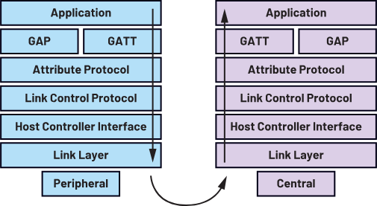
F ig 3.2 Software architecture stack implementation.
The system consists of two ESP32 modules: one configured as a BLE broadcaster acting as a multi-sensor beacon, and the other configured as a BLE scanner responsible for detecting, connecting to, and reading values from the beacon while simultaneously logging RSSI levels. The first step in the methodology involved programming the broadcasting ESP32 to periodically advertise a BLE service while simultaneously collecting sensor data from vibration, ultrasonic distance measurement, and PIR motion detection hardware. These sensor values were packaged in a lightweight JSON-formatted string and exposed through a BLE characteristic that supports both read and notify properties. This ensured that any connected BLE client—such as the second ESP32—could not only poll data on request but also receive real-time updates whenever the beacon generated new readings. The second ESP32 was programmed to perform continuous active BLE scanning. During each scan iteration, it searched for advertisement packets within range and specifically filtered devices based on their broadcast name (“MyESP32”). Whenever the target beacon was detected, the scanner recorded the RSSI reading, printed it to the serial monitor, and simultaneously drew ASCII bar graphs to visually represent signal strength variations in real-time. This continuous RSSI logging formed the core dataset used to observe how signal strength deteriorates with distance, obstacles, or movement between the nodes. Once the scanner recognized the target beacon, it attempted to establish a BLE connection. If successful, it immediately accessed the beacon’s exposed service and characteristic and began periodically reading the transmitted sensor data. The methodology ensures that system behavior can be studied not only from a pure wireless perspective (RSSI variation) but also from the perspective of a practical IoT node streaming sensor telemetry over BLE. By combining scanning, selective connection, periodic data acquisition, and visualization, the methodology provides a robust foundation for evaluating BLE’s suitability for indoor localization applications.

HARDWARE ARCHITECTURE

The The hardware architecture consists of two ESP32 development boards configured to play distinct but complementary roles within the system. The broadcasting ESP32 is equipped with multiple input sensors and a few output indicators to simulate a real IoT beacon node. Connected to this device are a vibration sensor (analog input), an ultrasonic distance sensor using TRIG and ECHO pins, and a PIR motion sensor connected through interrupt-driven digital input. Additional output peripherals include indicator LEDs and GPIO-controlled devices such as a buzzer for alert purposes.
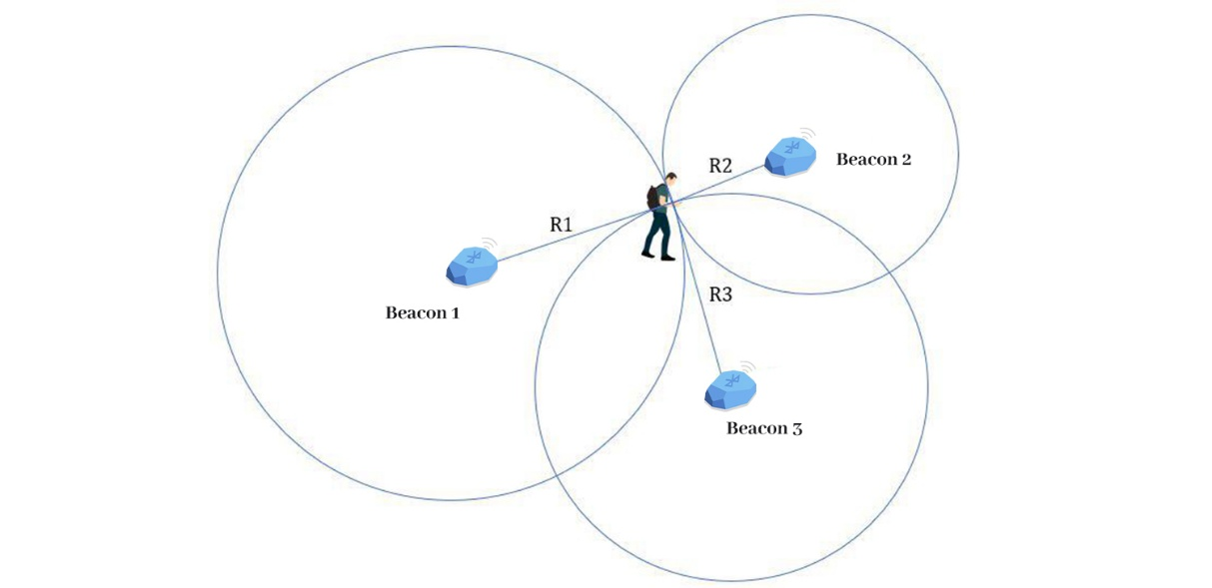
Fig 3.3 Hardware components for signal strength.

This multi-sensor arrangement demonstrates how the ESP32 can act as a BLE beacon that not only announces its presence but also carries contextual environmental data.
The scanning ESP32, in contrast, is a minimal hardware setup focused entirely on wireless detection and feedback. It includes a buzzer that activates in response to certain BLE characteristic values, allowing physical feedback based on sensor data received over BLE. The rest of the hardware requirements for the scanner are internal: the BLE transceiver, CPU, and memory built into the ESP32 chip. Since scanning operations are continuous and require low-latency responsiveness, the simplicity of the scanner hardware ensures stable performance and
consistent RSSI monitoring.
At the system level, the hardware architecture forms a compact and self-contained wireless ecosystem. One node acts as a smart beacon generating telemetry and advertising its presence, while the other node behaves as a mobile or fixed scanner detecting signal strength and attempting localization. The architecture is intentionally designed to be modular so that additional sensors or more ESP32 nodes can be introduced in the future to expand the localization coverage or improve positioning accuracy using multilateration.

SOFTWARE ARCHITECTURE

The software architecture is structured around the BLE stack provided by the ESP32's Arduino framework, divided into clear functional layers that separate broadcasting, scanning, communication handling, sensor acquisition, and data visualization.
On the broadcasting ESP32, the BLE stack is initialized using BLEDevice::init() followed by the creation of a GATT server, service, and characteristic. This characteristic is configured with read and notify permissions to give the scanner node flexibility in how it retrieves data. The BLE server runs concurrently with sensor acquisition routines, where vibration values, distance measurements, and PIR motion events are sampled each second. These values are encoded into JSON format and handed off to the BLE characteristic, which sends updates via notifications whenever new readings become available. Interrupt service routines (ISRs) are used for the PIR sensor to ensure high responsiveness to motion events. The software architecture follows a cyclic execution pattern with delay-based timing, making it easy to extend or adapt to more sensors.
On the scanning ESP32, the BLE architecture begins with setting up an active scanner using BLEScan and providing a callback class that handles every discovered advertisement packet. Inside this callback, the device name is checked and the RSSI is logged for all encountered BLE packets. ASCII bar graphs visualize the real-time signal strength fluctuation,
making it easier to interpret the scanner’s perception of the beacon. Once the target beacon is identified, the scanner transitions into client mode by creating a BLEClient and attempting to connect to the selected device. If the connection succeeds, it retrieves the remote service and characteristic, enabling periodic reading of the JSON data sent by the broadcaster.
The software architecture also incorporates a small state machine. It captures states such as “not found,” “found but not connected,” “connecting,” and “connected.”

Transitions between these states are triggered by scan results, connection attempts, and characteristic availability. In addition, the scanner can activate its buzzer based on the data received through the BLE characteristic, demonstrating end-to-end real-time interaction across the wireless link.
Overall, the software architecture is modular, event-driven, and designed to integrate BLE communication with a broad range of environmental sensor inputs. It creates a robust platform for experimenting with indoor positioning, RSSI signal analysis, and BLE-based IoT communication.

3.5 CONCLUSION
In summary, the methodology establishes a clear and reliable pipeline that supports the objectives of the project. By combining appropriate algorithms, hardware frameworks, and validation techniques, the approach ensures that the resulting system is both technically sound and optimized for real-world deployment.

CHAPTER 4 RESULTS AND DISCUSSION

4.1 INTRODUCTION

The results section presents the key findings obtained from implementing and evaluating the proposed system. Performance metrics, visual outputs, and experimental observations are analyzed to demonstrate how effectively the system meets its intended goals.

4.2 OBSERVED RESULTS
The system was tested using two ESP32 boards where one device acted as a BLE beacon transmitting environmental sensor data and the other functioned as a BLE scanner that continuously measured RSSI values and attempted connection when the specific service UUID and device name (“MyESP32”) were detected.
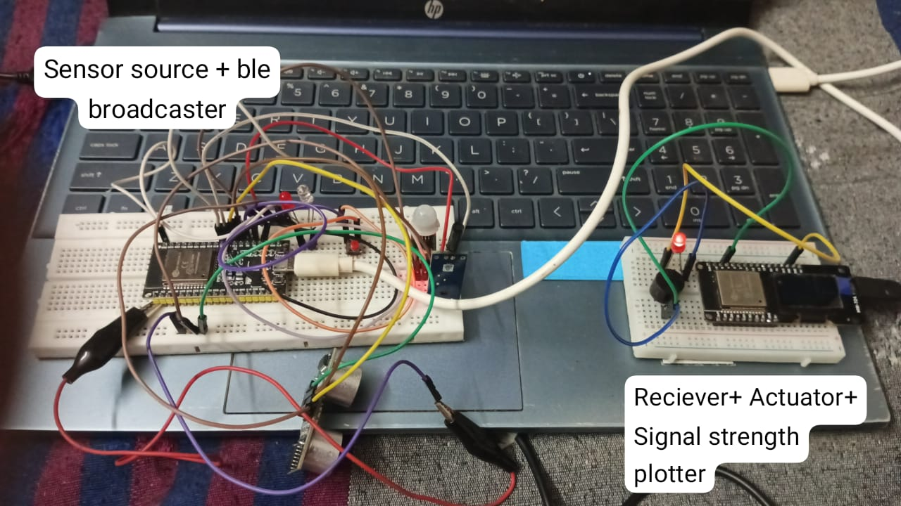
Fig 4.2.1 Hardware implementation of the broadcaster and receiver.

The results were collected by placing the broadcaster in different rooms and observing how the scanner responded to changes in signal strength.
During testing, the scanner ESP32 successfully detected all BLE advertisements within range and printed the RSSI values in real time on the serial monitor. The ASCII bar-graph visualization built into the code provided a clear and immediate representation of signal strength changes. When the broadcaster was close to the scanner (same room), the RSSI values were generally stronger (e.g., –40 to –60 dBm). When the broadcaster was placed in an adjacent room with one or more walls in between, the RSSI consistently dropped (typically –70 to –85 dBm). In more obstructed locations, the signal sometimes fell below –90 dBm or temporarily disappeared.
These variations allowed us to approximate the broadcaster’s location based on the intensity of the received signal. Since no filtering or smoothing was applied, the raw RSSI values fluctuated noticeably, especially when people moved nearby or when the devices were rotated. Nevertheless, the data showed a clear pattern: rooms separated by walls produced distinctly lower RSSI ranges than open-space conditions, enabling basic room-level localization.
The system also successfully established BLE connections when the correct UUID was detected. Upon connection, the scanner received sensor data from the beacon ESP32, including vibration values, PIR motion state, and ultrasonic distance readings. This confirmed the correct operation of the GATT service and characteristic defined in the broadcaster code. Connection success rates were highest when RSSI was stronger than about –75 dBm. Below that threshold, connection attempts sometimes failed or disconnected quickly, which again supported the idea that RSSI levels can be used as a rough indicator of room proximity.
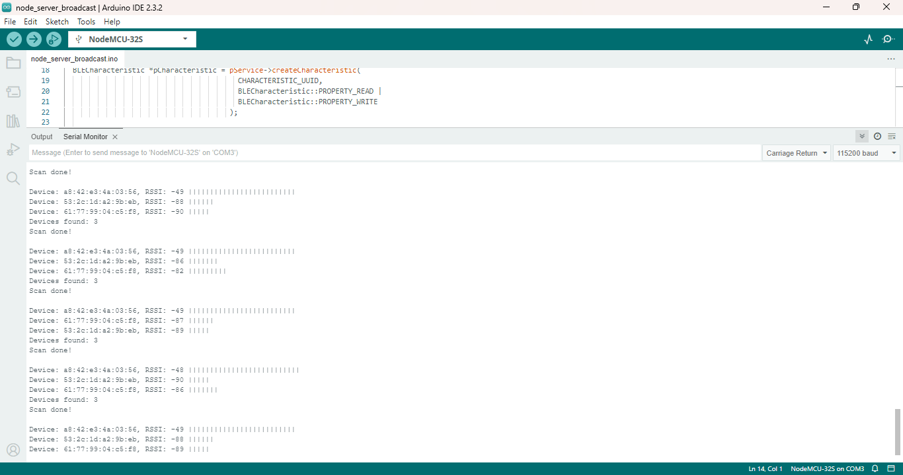
Overall, the raw RSSI plots gathered from the serial data reflected typical indoor wireless behavior: noise, sharp drops, and fluctuations caused by multipath reflections. Even without filtering, these readings were sufficient to differentiate between rooms or relative zones, demonstrating the practicality of the approach for simple indoor object-location tasks.

Fig 4.2.2 Observed RSSI data plot to understand signal position.

CHAPTER 5 CONCLUSION AND FUTURE SCOPE

This project successfully designed, implemented, and validated a functional ble based positioning system built upon a distributed hardware architecture using multiple ESP32 microcontrollers and robust wireless networking. The proposed system can be further extended to achieve greater accuracy, robustness, and real-world usability. Future work may include integrating more advanced machine learning models, expanding the dataset to cover broader environmental and operational conditions, and optimizing the system for deployment on low-power embedded platforms. Additionally, incorporating remote monitoring, secure communication mechanisms, and automated alert generation can significantly enhance reliability in practical scenarios. Real-time performance can be improved through hardware acceleration or FPGA-based optimization, while long-term field testing will help validate system stability and guide further refinements. Overall, these advancements can transform the system into a scalable, production-ready solution suitable for diverse real-world applications.

REFERENCES

- C. A. Setiabudi et al., "Indoor Positioning System Using BLE for Tracking Dynamic Users,"IJETER FEB 2020. 2020/33822020
- S. Mokhtari et al., "A BLE-based Turnkey Indoor Positioning System for Mobility Monitoring," PLOS Digital Health, vol. 4, no. 2, Apr. 2025. doi:10.1371/journal.pdig.0000774
- T. G. Hailu, "Theories and Methods for Indoor Positioning Systems," 2024. (Comprehensive review paper discussing BLE alongside Wi-Fi, Zigbee, LoRaWAN).
- L. Bai, G. Zhang, Y. Guo, and J. Liu, "A Low-Cost Indoor Positioning System Using Bluetooth Low Energy," IEEE Access, vol. 8, pp. 195489-195500, 2020.
- M. Ghaemifar, "Bluetooth Low Energy for Indoor Positioning: Challenges and Applications," 2025. (Extensive review article on BLE IPS methods, challenges, and applications.)
- J. Röbesaat et al., "An Improved BLE Indoor Localization with Kalman-Based Fusion of Trilateration and Dead Reckoning," IEEE Sensors Journal, vol. 17, no. 8, pp. 2285-2296, 2017.
- A. Ferrero-López et al., "Bluetooth Low Energy Indoor Positioning: A Fingerprinting and Neural Networks Approach," 2025.
- S. Yoon et al., "Kalman Filter-Based Hybrid Indoor Position Estimation Technique in Bluetooth Networks," Mathematical Problems in Engineering, 2013. doi:10.1155/2013/570964

