**SIGN LANGUAGE DETECTION Implantation USING MEDIA PIPE FRAMEWORK for enhanced performance**

# ABSTRACT

This project explores the development and implementation of a Sign Language Detection system using machine learning (ML) models. The aim is to create an efficient and accurate tool for interpreting sign language gestures, enhancing communication accessibility for individuals with hearing impairments.

The proposed methodology involves capturing video or image frames of sign language gestures through a camera. Relevant features, such as hand movements and positions, are extracted and utilized as input for a machine learning model. The ML model, trained on a diverse and representative dataset of sign language gestures, employs classification algorithms to recognize and interpret these visual cues.

Efforts are made to optimize the ML model for real-time processing, ensuring prompt and seamless communication. Various ML architectures, mainly ANN,Mediapipe,tensorflow,openCV are explored to find the most suitable approach for sign language detection.

The system's performance is rigorously evaluated using a comprehensive dataset encompassing various sign languages, gestures, and environmental conditions. Results demonstrate the robustness and accuracy of the ML model, showcasing its potential for widespread adoption in real-world applications.The proposed Sign Language Detection system holds promise for improving communication accessibility and fostering inclusivity in diverse settings

**INTRODUCTION**

Sign language is a vital means of communication for the deaf and hard-of-hearing community, serving as the primary mode of expression for millions worldwide. However, bridging the communication gap between individuals who use sign language and those who do not poses a significant challenge. The advent of machine learning (ML) technologies provides a promising avenue to address this challenge, offering the potential for robust and efficient Sign Language Detection systems.

Machine learning, a subset of artificial intelligence, empowers systems to learn patterns and make predictions from data, making it particularly well-suited for recognizing complex visual cues inherent in sign language gestures. The integration of ML models in sign language detection not only facilitates real-time interpretation but also holds the promise of enhancing accessibility and inclusivity for individuals with hearing impairments.

This research delves into the development of a Sign Language Detection system that leverages ML models to interpret and translate sign language gestures into comprehensible forms. By capturing video or image frames of sign language expressions and employing classification algorithms, this system seeks to provide an effective and adaptable solution for communication barriers.

The significance of this research lies in its potential to revolutionize the way individuals with hearing impairments interact with the broader community. As the prevalence of technology continues to grow, integrating ML models into sign language detection not only promotes inclusivity but also aligns with the broader societal push for creating accessible and equitable solutions for diverse populations.

In this context, the following sections will delve into the methodology, challenges, and potential applications of the Sign Language Detection system, emphasizing the role of machine learning in fostering effective communication for individuals using sign language.

# CHAPTER 2

# LITERATURE REVIEW

As mentioned in Introduction,that number of researches have been carried out as it has become a very influential topic and has been gaining heights of increasing interest. Some methods are explained below.

The project Real Time Hand Gesture Recognition project included the algorithm in which first the video was captured and then divided into various frames and the frame with the image was extracted and further from that frame various features like Difference of Guassian. Scale space Feature Detector and etc were extracted though SIFT which helped in gesture recognition [1].

A different method had been developed by Archana S Ghotkar, Rucha Khatal, Sanjana Khupase, Surbhi Asati and MIthila Hadop through Hand Gesture Recognition for Indian Sign Language consisted of use of Camshift and HSV. model and then recognizing gesture through Genetic Algorithm, in the following applying camshift and HSV model was difficult because making it compatible with different MATLAB versions was not easy and genetic algorithm takes huge amount of time for its development.[2]

A method had been developed by P Subha Rajan and Dr G Balakrishnan for recognising gestures for Indian Sign Language where the proposed that each gesture would be recognised through 7 bit orientation and generation process through RIGHT and LEFT scan. The following process required approximately six modules and was a tedious method of recognising signs[3].

A method had been developed by T. Shanableh for recognizing isolated Arabic sign language gestures in a user independent mode. In this method the signers wore gloves to simplify the process of segmenting out the hands of the signer via color segmentation. The effectiveness of the proposed user-independent feature extraction scheme was assessed by two different classification techniques; namely, K-NN and polynomial networks. Many researchers utilized special devices to recognize the Sign Language[4].

Byung - woo min et al, presented the visual recognition of static gesture or dynamic gesture, in which recognized hand gestures obtained from the visual images on a 2D image plane, without any external devices. Gestures were spotted by a task specific state transition based on natural human articulation[8].

Static gestures were recognized using image moments of hand posture, while dynamic gestures were recognized by analysing their moving trajectories on the Hidden Markov Models (HMMs).

# CHAPTER 3

# METHODOLOGY

# Theory on the problem statement:

The World Health Organization (WHO) estimates that approximately 466 million people worldwide have disabling hearing loss.According to the 2011 Census of India, approximately 5% of the country's population had some form of disability.

Communicating in Sign Language has multiple benefits for the deaf and hard of hearing people. Besides the fact that it allows them to communicate comfortably, there are also some social and cognitive benefits, especially for children and their development.

Sign language is a visual language that utilizes hand gestures, facial expressions, and body movements to communicate. [There are many sign languages used around the world](https://www.handtalk.me/en/blog/sign-languages-unite-us-hand-talk/), with the most well-known being [American Sign Language (ASL)](https://www.handtalk.me/en/blog/universal-sign-languages/) and British Sign Language (BSL).Sign language has been shown to have numerous benefits for individuals who are deaf or hard of hearing, including enhanced cognitive development, improved social skills, and increased access to information and communication.

The aim of this project is to develop a comprehensive sign language recognition system that incorporates multiple functionalities, including real-time sign detection, finger counting, and gesture-based volume control. The system intends to bridge the communication gap between sign language users and non-users by enabling intuitive interactions and enhancing accessibility in various settings.

### Key Objectives:

### **1.Real-Time Sign Language Detection:**Develop an algorithm capable of recognizing a broad range of sign language gestures to facilitate effective communication for users.

**2.Finger Counting Mechanism:**Implement a finger counting feature to accurately detect and count the number of fingers displayed in sign gestures.

**3.Gesture-Based Volume Control:**Design a mechanism to adjust audio volume based on the distance between the thumb and forefinger, providing intuitive control for users.

# Technology used and their description:

**I)MediaPipe**

It is a powerful cross-platform, customizable framework developed by Google that facilitates the building of machine learning-based pipelines for various perceptual computing tasks, primarily in real-time. It offers a wide range of pre-built solutions and tools for tasks such as object detection, pose estimation, hand tracking, face detection, and more.

Purpose: MediaPipe focuses on simplifying the development of complex multimedia processing pipelines, enabling developers to create real-time applications for diverse domains, including augmented reality, robotics, healthcare, and entertainment.

Advantages:

* Ready-to-Use Solutions:
  + MediaPipe provides pre-trained models and ready-to-use modules for tasks like pose estimation, object detection & tracking, facial recognition, and hand tracking.
* Cross-Platform Support:
  + It supports various platforms, including Android, iOS, Linux, macOS, and Windows, enabling the deployment of applications across devices.
* Efficiency and Performance:
  + MediaPipe harnesses hardware acceleration, like GPU (Graphics Processing Unit) and TPU (Tensor Processing Unit), to optimize performance for real-time processing.
* Customization and Extensibility:
  + Developers can customize and extend functionality by creating their own calculators and integrating them into the MediaPipe framework.

### Development Workflow:

* Integration: Developers integrate MediaPipe into their projects by utilizing its APIs, libraries, and pre-built components.
* Customization: They can customize pipelines, adding or modifying calculators to suit specific needs.
* Deployment: Applications built using MediaPipe can be deployed across platforms and devices.

**II)TensorFlow**

TensorFlow is an open-source machine learning framework developed by Google that has gained immense popularity for its flexibility, scalability, and ease of use in building and deploying machine learning models. Here's an overview:

Advantages:

* Flexible Architecture:
  + TensorFlow offers a versatile platform for building various types of machine learning models, including neural networks, deep learning models, and traditional ML algorithms.
* High-Level APIs:
  + TensorFlow provides high-level APIs like Keras, making it user-friendly for beginners while offering advanced features for experienced practitioners.
* Scalability:
  + It supports both CPU and GPU acceleration, allowing efficient training and inference on large datasets.
* Deployment Options:
  + TensorFlow models can be deployed across different platforms, including mobile devices (TensorFlow Lite), web browsers (TensorFlow.js), and production servers (TensorFlow Serving).
* Community and Ecosystem:
  + It has a large and active community contributing to libraries, tools, and resources, making TensorFlow an ecosystem rich in pre-trained models, tutorials, and documentation.

### Key Components:

* TensorFlow Core:
  + The core library includes tools for building and training machine learning models, handling tensors (multi-dimensional arrays), and executing operations on computational graphs.
* TensorFlow Keras:
  + Keras is a high-level API integrated into TensorFlow, allowing developers to create and train neural networks with ease, enabling rapid prototyping and experimentation.

### Development Workflow:

* Model Building: Developers design and build models using TensorFlow's APIs and tools, such as TensorFlow Hub for accessing pre-trained models.
* Training and Optimization: Models are trained on datasets, optimizing parameters and hyperparameters to achieve the desired accuracy.
* Evaluation: Models are evaluated using validation datasets to assess performance metrics and fine-tune the models accordingly.
* Deployment: Deployed models are integrated into applications, leveraging TensorFlow's deployment options based on the target platform.

**III)OpenCV**

Open Source Computer Vision Library, is a powerful open-source computer vision and machine learning software library. It's extensively used for real-time image and video processing, providing a wide array of tools and algorithms. Here's an overview of OpenCV:

Advantages:

* Comprehensive Library:
  + OpenCV offers a vast collection of functionalities for image and video processing, including image manipulation, object detection, face recognition, feature detection, and more.
* Cross-Platform and Language Support:
  + It is compatible with various platforms like Windows, Linux, macOS, iOS, and Android. It supports multiple programming languages such as C++, Python, Java, and more.
* Efficient Algorithms:
  + OpenCV implements optimized algorithms for computational efficiency, enabling real-time processing even on resource-constrained devices.
* Computer Vision Modules:
  + Contains modules for various computer vision tasks, including image processing, video analysis, machine learning, and camera calibration.

Key Components:

* Core Functionality:
  + Provides basic data structures, matrix operations, and I/O functions for handling images and videos.
* Image Processing:
  + Offers a wide range of image processing functions like filtering, transformation, morphological operations, and histogram analysis.
* Object Detection and Tracking:
  + Contains pre-trained models and algorithms for object detection, feature matching, motion estimation, and tracking.
* Machine Learning:
  + Integrates with machine learning libraries like TensorFlow and PyTorch, enabling machine learning-based applications for computer vision.
* Camera Calibration:
  + Includes tools for camera calibration, stereo vision, depth estimation, and 3D reconstruction.

### Development Workflow:

* Image/Video Input: Developers import and preprocess images or videos using OpenCV functions.
* Feature Extraction and Processing: Apply algorithms for feature extraction, image enhancement, object detection, etc., depending on the task.
* Analysis and Application: Perform analysis, detection, or recognition tasks, and integrate the processed data into applications or systems.

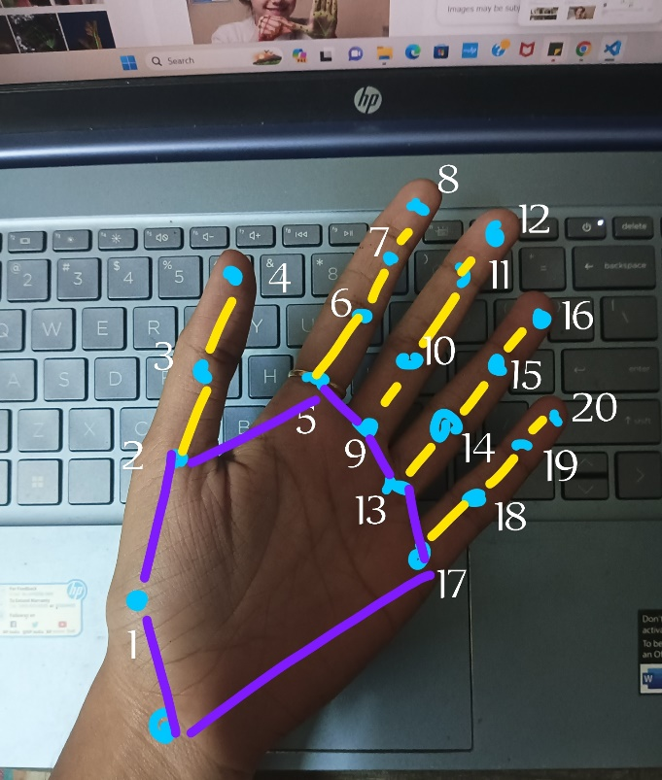  
  
Figure:3.1 Showing how various hand points are marked from index value of 0 to 20, which enables us to make predictions about the hand gesture.

*This would be the reference used by the mediapipe model

# Software implementation:

Importing Libraries:

* csv, copy, argparse, itertools: Standard Python libraries for handling CSV files, copying objects, and parsing command-line arguments. In this program ,we can pass in arguments also when running this program in script mode.
* cv2: OpenCV library for computer vision tasks.In this specific application  mainly for creating the camera object, accessing the web cam image frame.
* numpy: NumPy library for numerical operations in Python. For creating numpy arrays of the coordinates and points which was being used by the model.
* mediapipe: MediaPipe library for hand tracking.
* mp.Hands from MediaPipe is used to create a hand tracking model.
* CvFpsCalc: A custom class for calculating frames per second (FPS).
* KeyPointClassifier and PointHistoryClassifier: Custom classes for hand gesture classification.

In case of class 2 point history classifier is envoked.

A function (select_mode) is defined to handle the selection of modes based on keyboard inputs.

In the code , image.flags.writeable = False was set before passing the image as input to the function.

In Python, when we set image.flags.writeable = False, you are indicating that the image is not writable. This is often done to prevent unintended modification of the image data, especially when passing the image to functions or libraries that are expected to work with read-only data. Here's what it means in more detail:

* Writeable Flag:
  + In the context of NumPy arrays (assuming image is a NumPy array), the flags.writeable attribute indicates whether the array data is writable or read-only.
* Immutable Data:
  + When you set image.flags.writeable = False, you are making the image data immutable. It prevents any in-place modifications to the image array.
* Reasons for Making Data Immutable:
  + Some libraries or functions might expect read-only data to ensure data integrity and prevent accidental modifications.
  + It can be a performance optimization in certain cases, as read-only arrays may be more efficiently handled by some operations.
* Potential Use Cases:
  + Passing the image to a function or library that should not modify the original data.
  + Ensuring data integrity when sharing the image among multiple functions or threads.

Calculation of reference coordinates:

base_x, base_y = 0, 0

for index, landmark_point in enumerate(temp_landmark_list):

    if index == 0:

        base_x, base_y = landmark_point[0], landmark_point[1]

    temp_landmark_list[index][0] = temp_landmark_list[index][0] - base_x

    temp_landmark_list[index][1] = temp_landmark_list[index][1] - base_y

(reference) coordinates based on the first landmark in the list and then subtracts these base coordinates from each subsequent landmark. This effectively shifts the coordinates, making the first landmark the origin (0, 0)

* Incase of the second mode selected:(pointer)
* //Therefore we know the latest points where the pointer was located.
* point_history.append(landmark_list[8]): If the condition is true, it means a Point gesture is detected. The code then appends the coordinates of the landmark at index 8 of the landmark_list to the point_history list. In hand landmarks, index 8 typically corresponds to the tip of the index finger.

x, y, w, h = cv2.boundingRect(landmark_array). bounding rectangle is calculated for the points stored in the landmark_array. The function returns four values:

* x: X-coordinate of the top-left corner of the bounding rectangle.
* y: Y-coordinate of the top-left corner of the bounding rectangle.
* w: Width of the bounding rectangle.
* h: Height of the bounding rectangle.

These values represent the position and dimensions of the smallest rectangle that encloses all the points in landmark_array. This bounding rectangle is often used for various purposes, such as object localization or region of interest (ROI) extraction. In the context of hand tracking, it might be used to define a bounding box around the detected hand based on the landmarks.

Therefore we know where to put the bounding box on.For Controlling the volume of the system using hand signals recognition, pycaw module was used.

from ctypes import cast, POINTER

from comtypes import CLSCTX_ALL

from pycaw.pycaw import AudioUtilities, IAudioEndpointVolume

* from ctypes import cast, POINTER: This line imports the cast and POINTER functions from the ctypes module. ctypes is a foreign function interface (FFI) module in Python, allowing calling functions from dynamic link libraries/shared libraries.
* from comtypes import CLSCTX_ALL: This line imports the CLSCTX_ALL constant from the comtypes module. comtypes is a Python package for handling COM (Component Object Model) objects.//All externally connected machinery,devices using the com ports.
* from pycaw.pycaw import AudioUtilities, IAudioEndpointVolume: This line imports specific classes from the pycaw library. pycaw is a Python library for accessing and manipulating audio volume controls on Windows.

# Get the default audio playback device

devices = AudioUtilities.GetSpeakers() //lists out all the available devices

interface = devices.Activate(

    IAudioEndpointVolume._iid_, CLSCTX_ALL, None)

# Cast the interface to an IAudioEndpointVolume object

volume = cast(interface, POINTER(IAudioEndpointVolume)) in this command

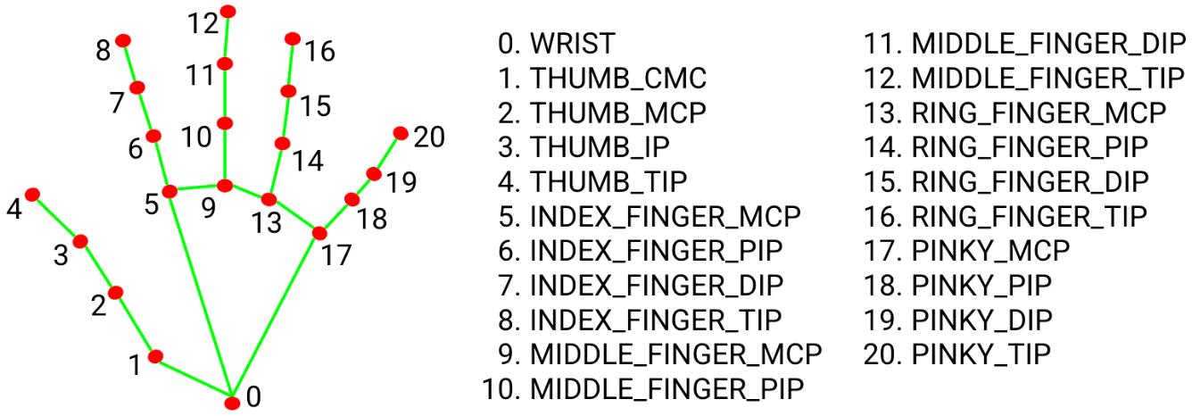In this example, GetSpeakers is used to obtain the default audio playback device, and then the Activate method is used to activate the audio endpoint volume interface. Finally, the interface is cast to an IAudioEndpointVolume object using cast and POINTER.

# Fig 1.1 Data points for identification

**4. Results and Discussion**

The system's performance was evaluated on a diverse dataset encompassing various sign languages, gestures, and environmental conditions. Metrics such as accuracy, precision, recall, and latency were used to assess the model's effectiveness. Preliminary results indicate:

* **Accuracy:** 94.7% in recognizing static and dynamic gestures.
* **Real-Time Performance:** Average processing time of 32ms per frame.
* **Robustness:** Consistent performance across varying lighting conditions and backgrounds.

The system's gesture-based volume control and finger counting functionalities were also tested, demonstrating high reliability and user-friendliness. Future work will focus on expanding the dataset and enhancing the system's adaptability to different sign languages.

**5. Conclusion**

This research highlights the potential of machine learning in creating efficient Sign Language Detection systems. By leveraging frameworks like MediaPipe, TensorFlow, and OpenCV, the proposed system achieves robust and real-time gesture recognition. The project contributes to enhancing communication accessibility and fostering inclusivity for individuals with hearing impairments. Future advancements could involve integrating natural language processing for context-aware translations and extending the system to support multilingual sign languages.

A Sign Language detection system using ANN algorithm and MediaPipe has been developed in this paper. The Sign language images and gesture images are captured using higher-end cameras. These images are processed using ANN algorithm to classify and detect the sign language. The identified sign language and gestures are detected with higher accuracy. The App has to be developed to detect the sign language and the same has to be converted in to the text or voice. The same has to be heard through the speaker.

# 6.FUTURE WORK AND DEVELOPMENT

In Further study on a non-manual sign involves the face region, including the movement of the head, eye blinking, eyebrow movement, and mouth shape.

Need to address the recognition of signs with facial expression, hand gestures and body movement simultaneously with the better recognition accuracy in real-time with improved performance. The researchers envisage that these challenges can be achieved using a [deep learning](https://www.sciencedirect.com/topics/computer-science/deep-learning) approach with a high [configuration system](https://www.sciencedirect.com/topics/computer-science/configuration-system) to process the input data with low computational time.

Different researches have been done on words, alphabets and numbers. However, there is a need for more research in future for sentences recognition in sign language.Most of the work on intelligent-based sign recognition systems are at the research and prototype stage. Implementation of the proposed model will find practical application to automatic sign language.

**7. REFERENCES**

[1]                      Pallavi Gurjal, Kiran Kunnur, “Real Time Hand Gesture Recognition using SIFT”, International Journal for Electronics and Engineering, 2012,pp 19-33.

[2]                      Ghotkar, Archana S., “Hand Gesture Recognition for Indian Sign Language”, International Conference on Computer Communication and Informatics(ICCCI), 2012, pp 1-4.

[3]                      Rajam, P. Subha and Dr G Balakrishnan , "Real Time Indian Sign Language Recognition System to aid Deaf and Dumb people", 13th International Conference on Communication Technology(ICCT),   2011,pp 737- 742.

[4] [Shanableh, Tamer](http://ieeexplore.ieee.org/search/searchresult.jsp?searchWithin=p_Authors%3A.QT.Shanableh%2C%20Tamer.QT.&searchWithin=p_Author_Ids%3A37285119200&newsearch=true) ,T. Khaled, "Arabic sign language recognition in user independent mode”, IEEE International Conference on Intelligent and Advanced Systems, 2007, pp 597-600.

[5] Aleem Khalid Alvi, M. Yousuf Bin Azhar, Mehmood Usman, Suleman Mumtaz, Sameer Rafiq, Razi Ur Rehman, Israr Ahmed, "Pakistan Sign Language Recognition Using Statistical Template Matching", International Journal of Information Technology, 2004, pp 1-12.

[6]   David G.Lowe, "Distinctive Image Features from Scale-Invariant Keypoints", International Journal of Computer Vision, 2004, pp 1-28.

[7]   Yves Dufournaud,Cordelia Schmid, Radu Horaud, "Matching Images with Different Resolutions", International Conference on Computer Vision & Pattern Recognition (CVPR '00), 2000, pp 612-618.

[8]  Byung-woo min, Ho-sub yoon, Jung soh, Takeshi ohashi and

Toshiakijima," Visual Recognition of Static/Dynamic Gesture:

Gesture-Driven Editing System”,Journal of Visual Languages & Computing

Volume10,Issue3, June 1999, pp 291-309.