# Colorado Risk Limiting Audit

# County Run Book

## Introduction

This Run Book guides County election administrators in Colorado who will be implementing a Risk Limiting Audit (RLA) with a comparison audit. The RLA Tool, developed by Free & Fair for the Colorado Department of State for use in elections in November 2017 and later, supports running a Risk-Limiting Audit as required by Colorado statute and as described in the [Colorado Secretary of State's Rule 25](http://www.sos.state.co.us/pubs/rule_making/CurrentRules/8CCR1505-1/ElectionRules.pdf) for elections.

The RLA Tool helps each County fulfill the requirements of Rule 25.2.2 and Rule 25.2.3. First the County uploads verified ballot manifests and cast vote record (CVR) files. For each round of the RLA, the RLA Tool tells the County which ballot cards to audit, allows the County to enter Audit Boards interpretations of the ballot cards and allows the Audit Board to sign off on the round.

Orange arrows on the screenshots indicate features described in the text of the Runbook.

### Launching and Logging In

A County user can launch the RLA Tool by pointing a browser to the URL provided by the Colorado Department of State.

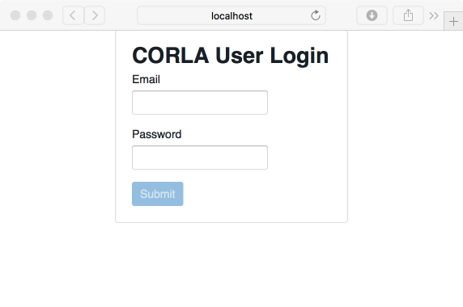

Login

Successful entry of username and password will lead to a two-factor authentication grid challenge.

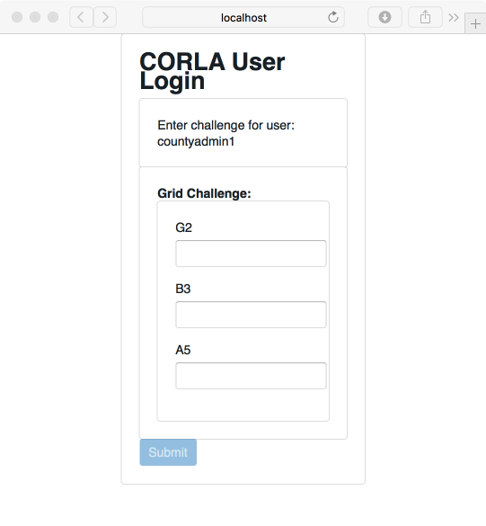

Grid Challenge

County users will see the County home page. Note the logout button Logout Button, in the upper right of this (and every) page.

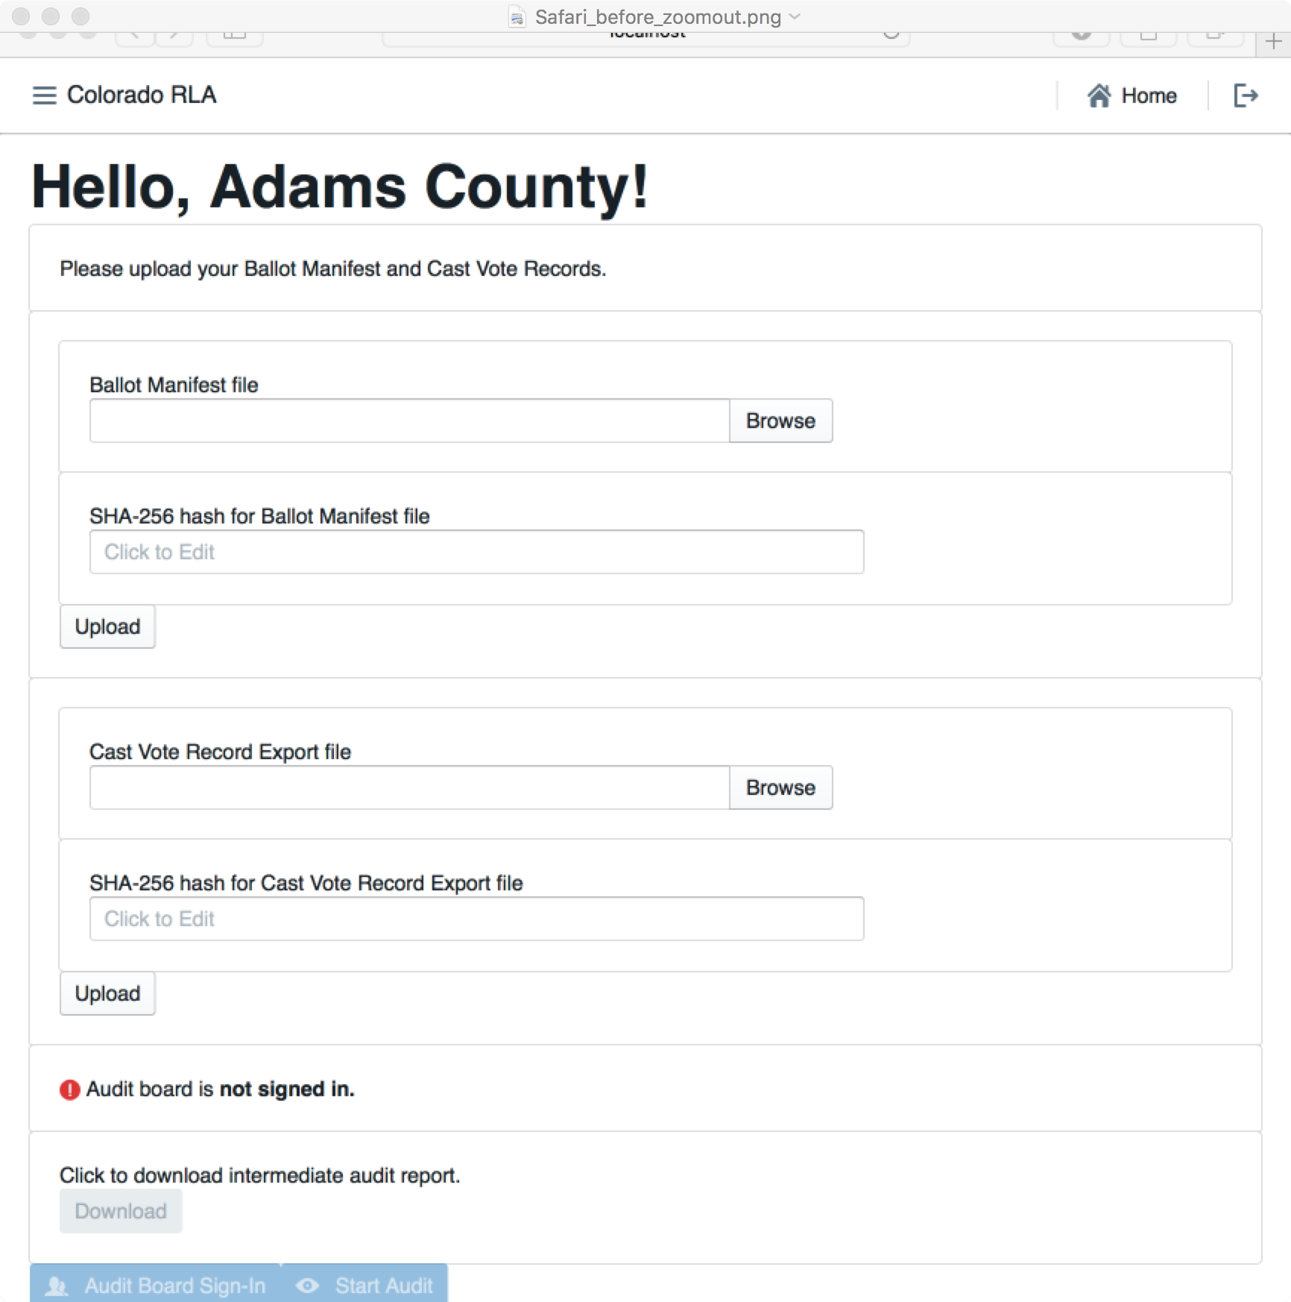

County Home Page

### Navigation

In the upper left corner of every page the County site has a menu that can be used to navigate to the County home page, the Audit Board Sign-In/Out pages or the Audit (Ballot Review) pages.



Navigation Icon

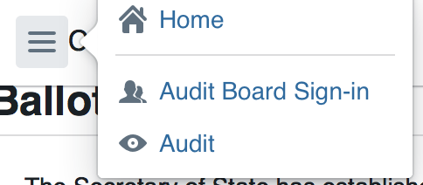

Navigation Menu

In the upper right corner of each page is a button to return to the County home page

Home Button

Home Button

and a button to log out of the system altogether.



Logout Button

### Ballot Manifest and CVR File Uploads

To prepare for upload, the County's ballot manifest and CVR files must each be hashed using any SHA-256 hash utility. The RLA Tool itself does not provide a utility for verification or hashing.

Once the ballot manifest and CVR files are hashed, they can be uploaded into the RLA Tool. If the upload is interrupted the process will have to be repeated. It is not possible to resume an interrupted upload — just start that file upload again. If a County uploads multiple Ballot Manifest files, only the data from the last file will be used. Similarly, if a County uploads multiple CVR files, only the data from the last file will be used.

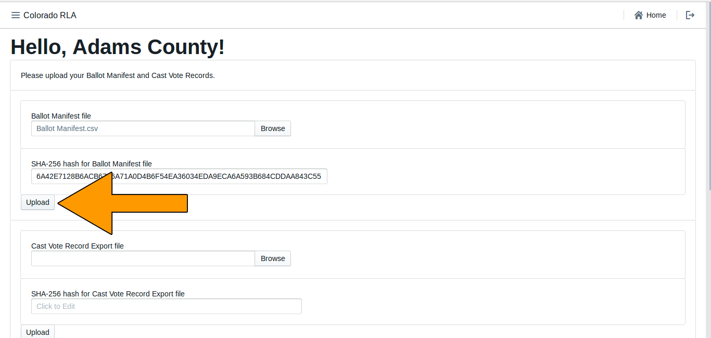

About to Upload Ballot Manifest

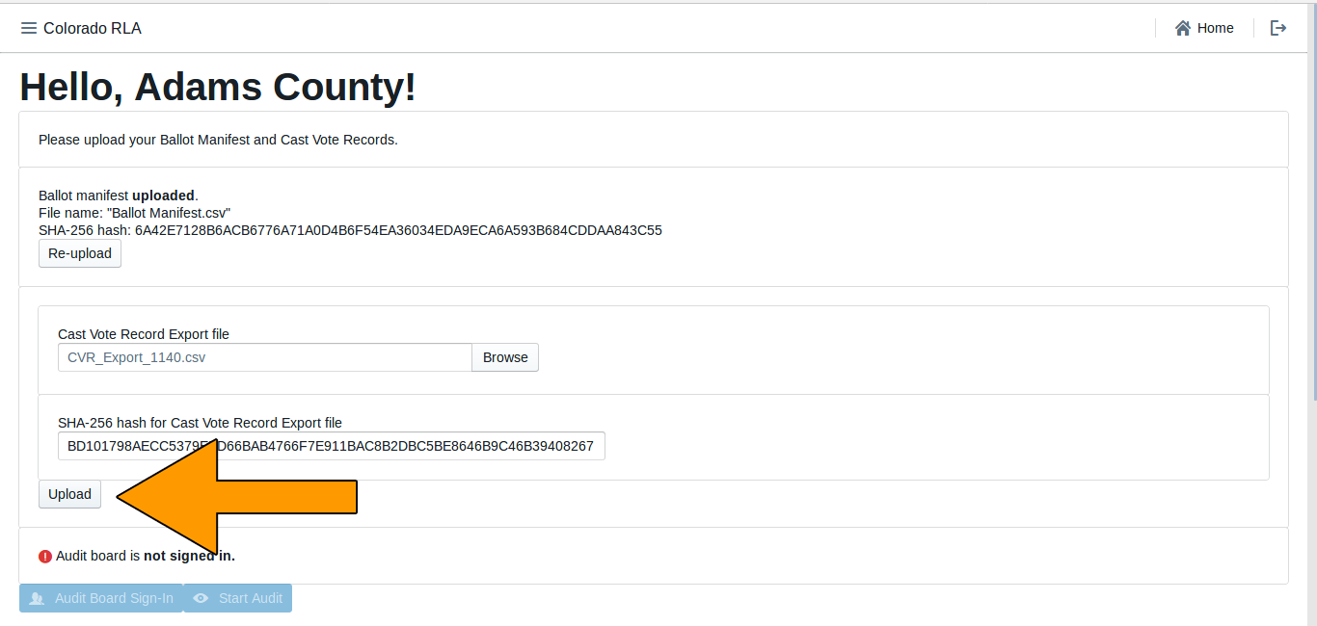

About to Upload CVR

If the hash does not match the file (either because the wrong hash was entered, or because the file was changed as it traveled over the network), the data from the file will be uploaded but the data will not be imported. The user will see the following messages.

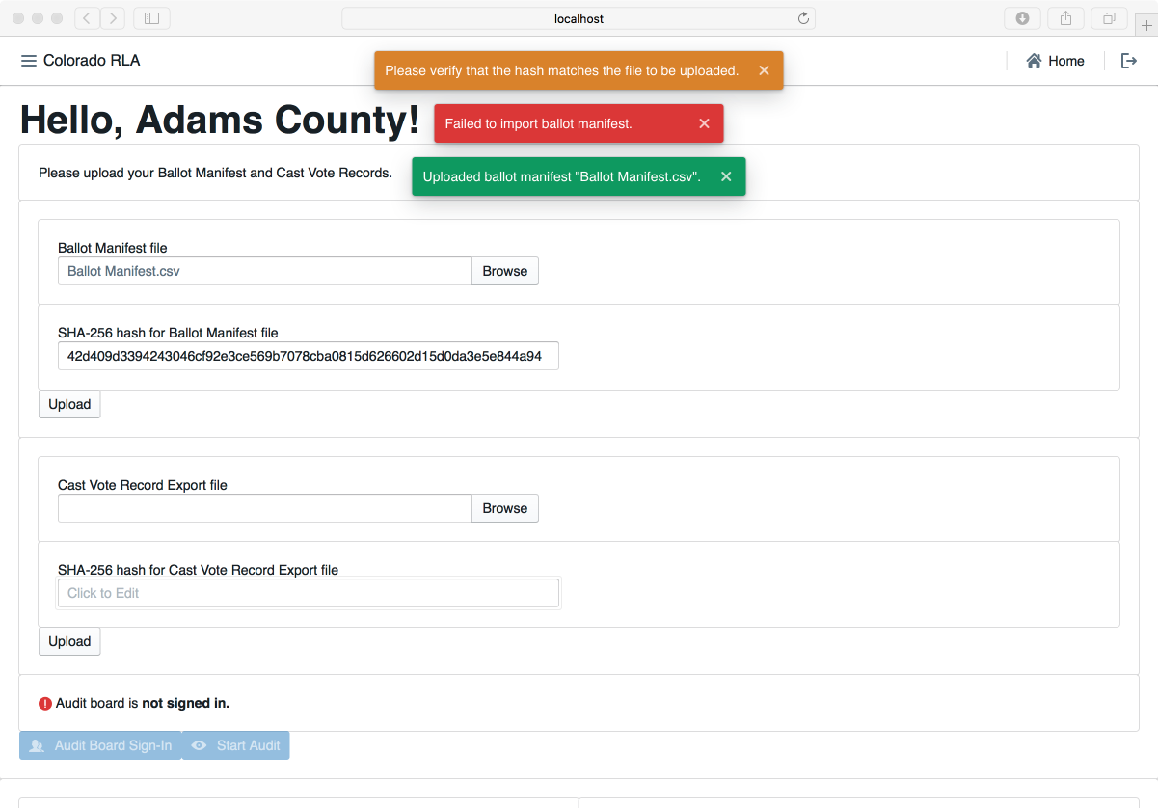

Hash Mismatch Error

If the hash matches the file but the file is not in the proper format, the data from the file will not be imported. The user will see the following messages.

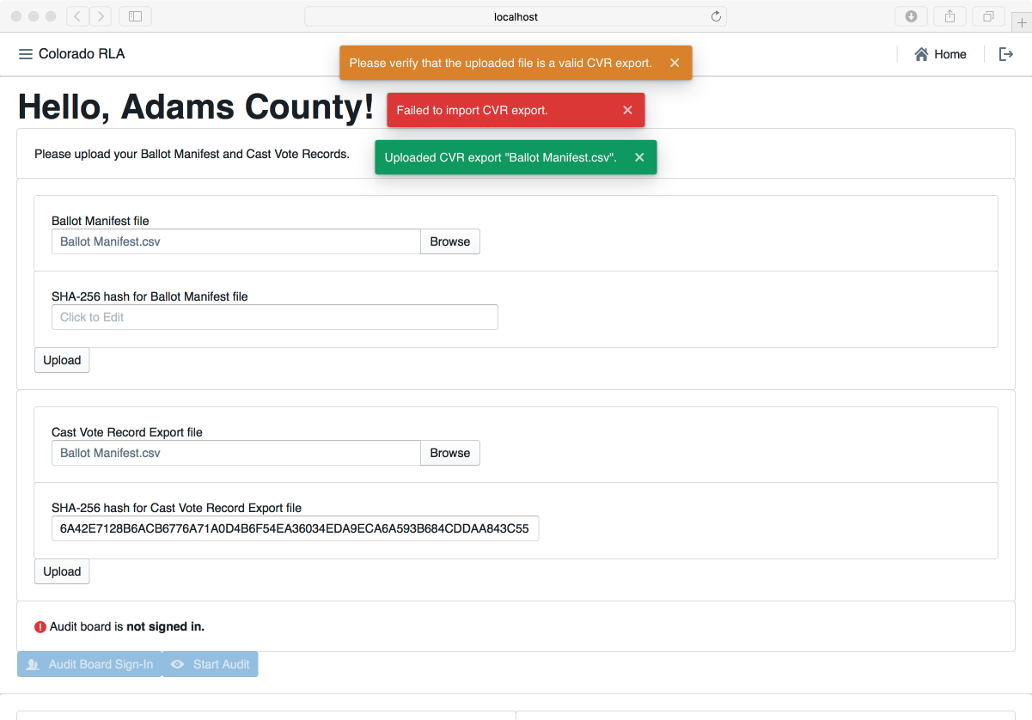

Format Error

If the hash matches and the file format is correct, the system will import the data from the file. The user will see the following messages.

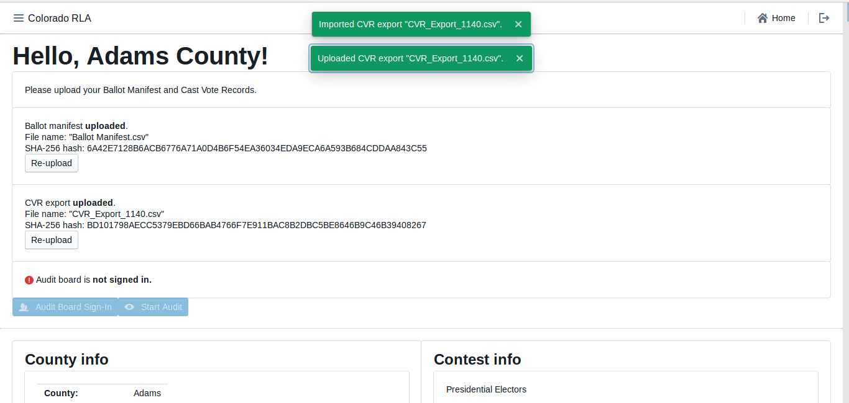

File Uploads Successful

The time required for data import depends on the size of the file. Import time for the CVR file will depend on the number of ballot cards represented in the file. A file with fewer than 10,000 CVR lines should take less than a minute, while a file with 500,000 CVR lines or more might take about a half hour. The ballot manifest file upload and import will be quicker than the CVR file upload and import.

Once both the ballot manifest and CVR files are successfully uploaded and imported users will see them both listed as **uploaded**. It is possible to re-upload either or both files, if necessary.

After successfully upload and import of both the Ballot Manifest and the CVR files, the Contest Info table near the bottom of the County home page shows the status of ballot cards and all contests on all CVRs.

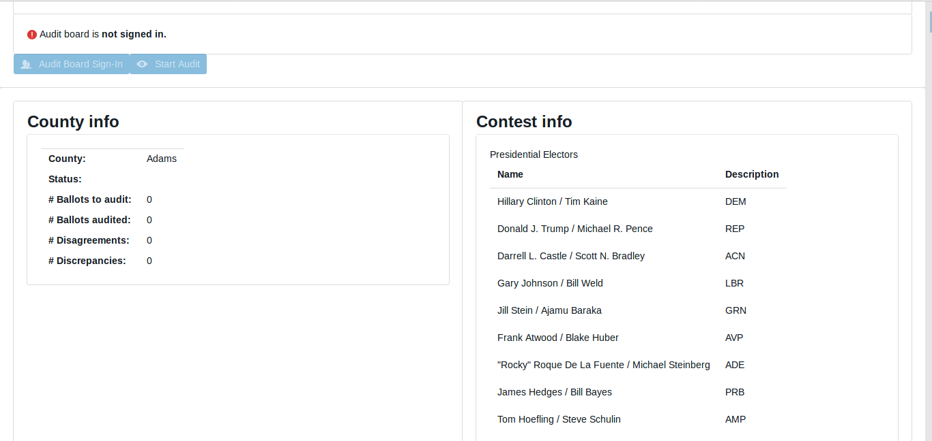

Contest Info Displayed on Home Page

### Audit Board Sign In and Sign Out

The Audit Board does not log directly into the RLA Tool with usernames and passwords. However, whenever the Audit Board begins to interact with the RLA Tool, either at the beginning of an audit round or after taking a break, there is an informal sign-in process.

To allow the Audit Board to sign in, use the button on the County home page.

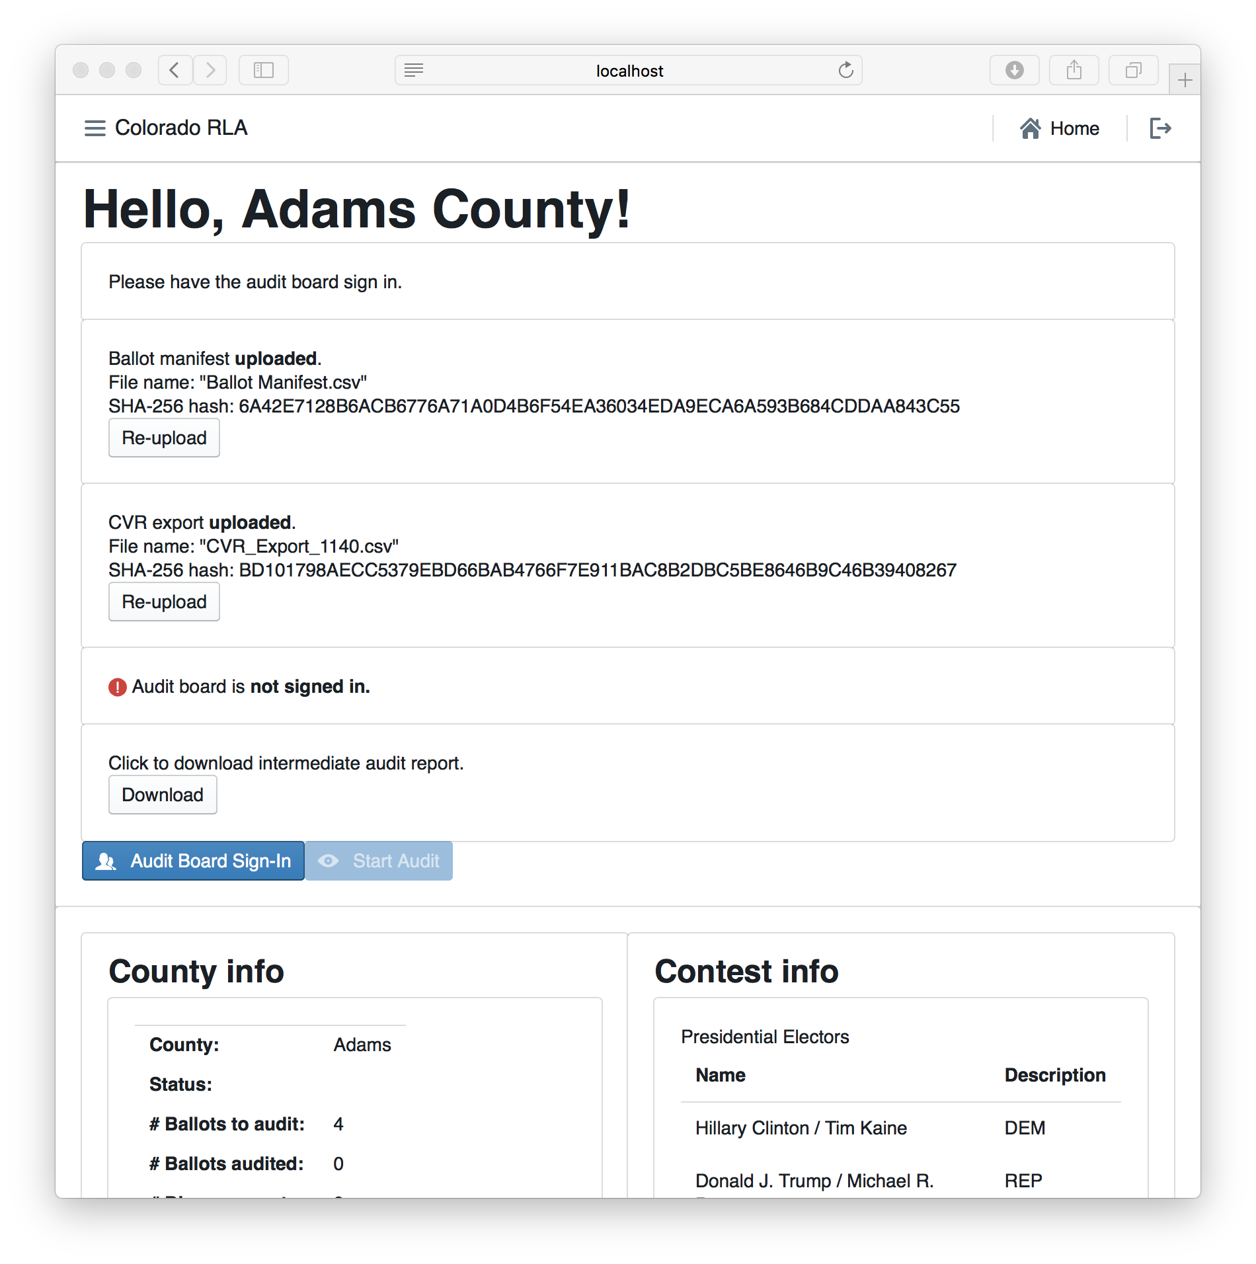

Audit Board Sign-In Button

Another way to reach the Audit Board Sign-In page is to use the navigation menu.



Navigation Menu

Either method will take the user to the Audit Board Sign-In page.

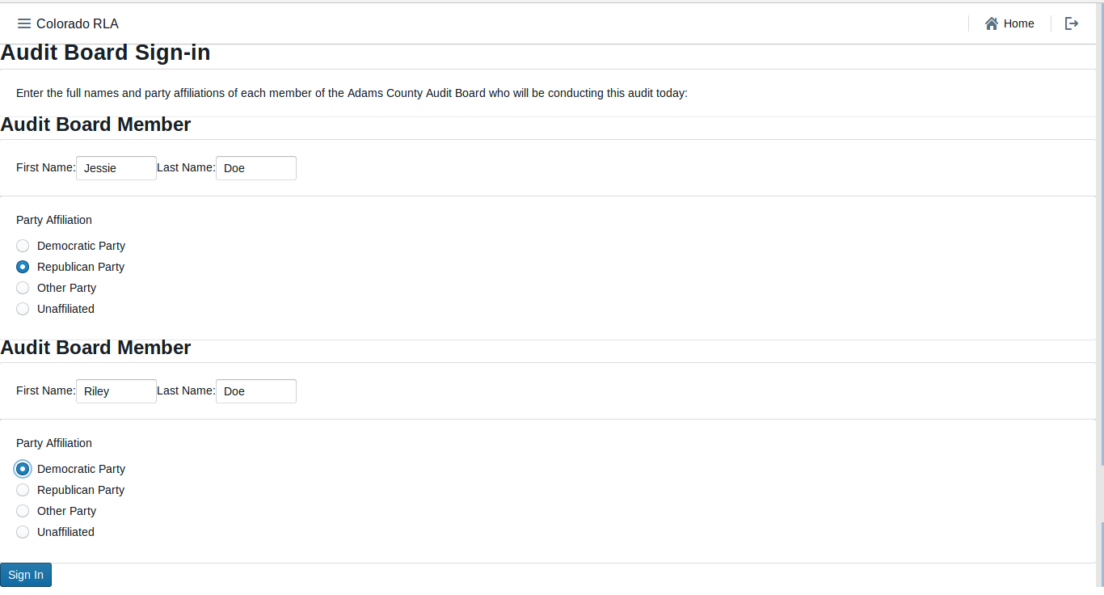

Audit Board Sign In

After the Audit Board has signed in, the Audit Board Sign-In Screen will show the names and party affiliations. If the Audit Board takes a break, use the Sign Out button on this page.

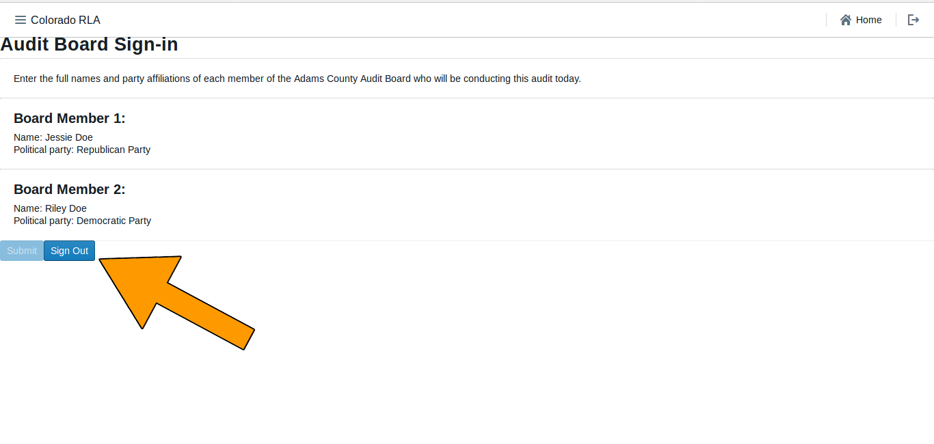

Audit Board Sign Out

Once the Audit Board is signed in use the navigation panel at the top of the screen to begin the ballot review process.

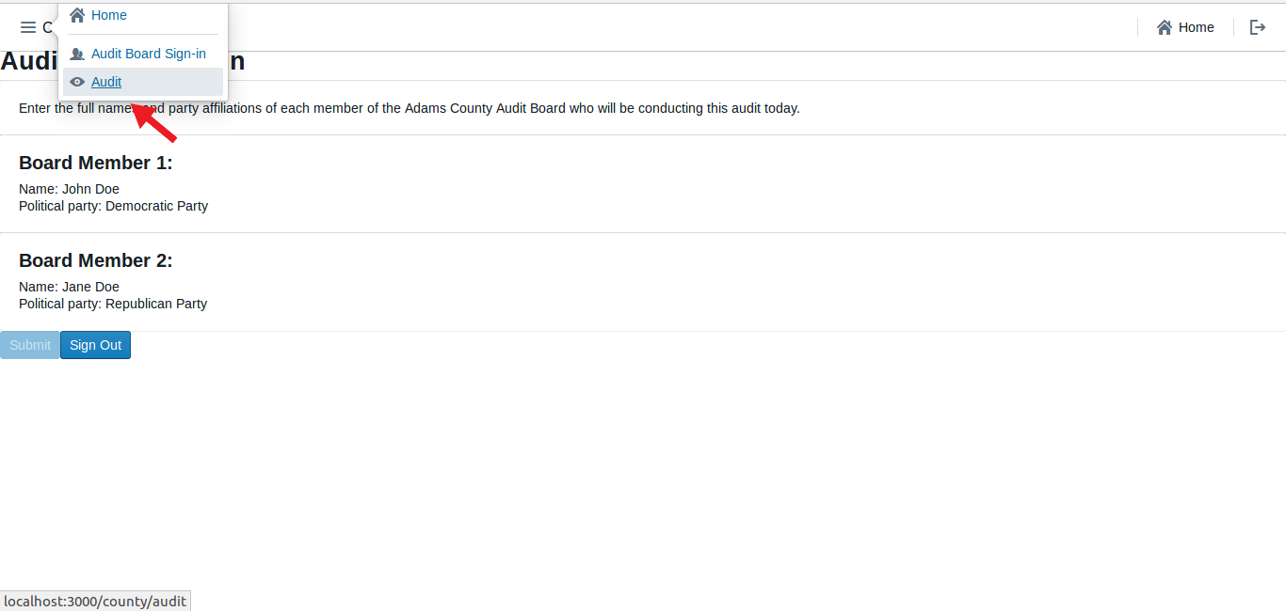

Launch_Audit_Navigation_Button_Screenshot

### Ballot Card Review Rounds

Once the Secretary of State launches the audit the County user will see a list of ballot cards to be audited in the current round. The list includes the Scanner #, Batch #, Ballot Position #, and (if available) the Storage Bin.

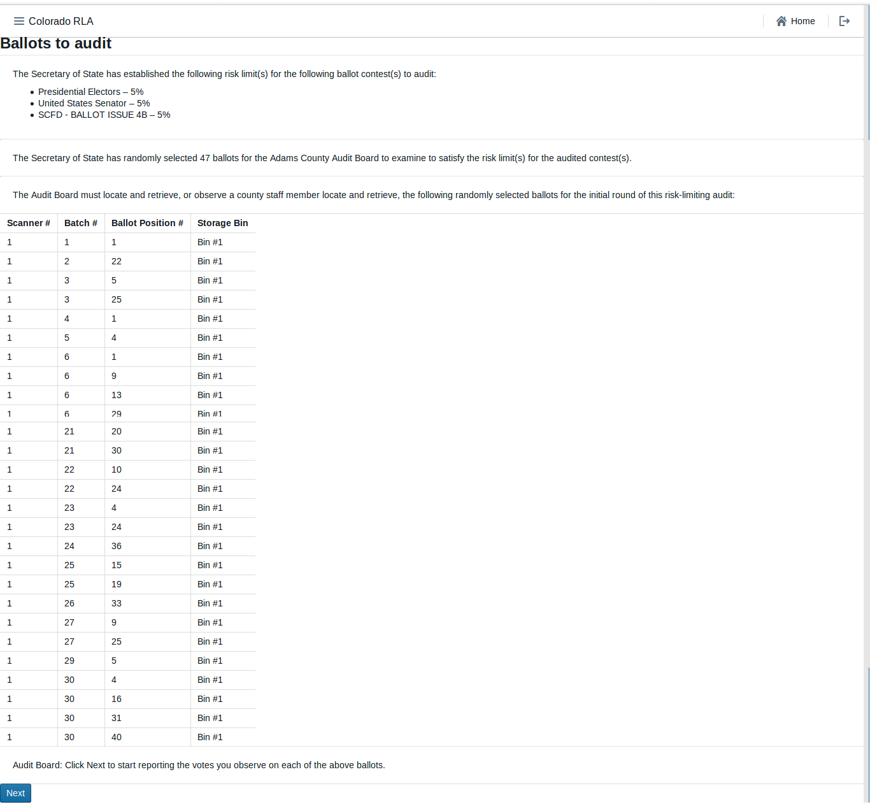

Ballot Cards to Auditt

Once the ballot cards have been retrieved, click "Next" to start reviewing.

The RLA Tool allows Audit Board members to report the markings on each individual ballot card. Before recording voter intent, please double-check that the paper Ballot Type matches the Ballot Type listed on the screen.

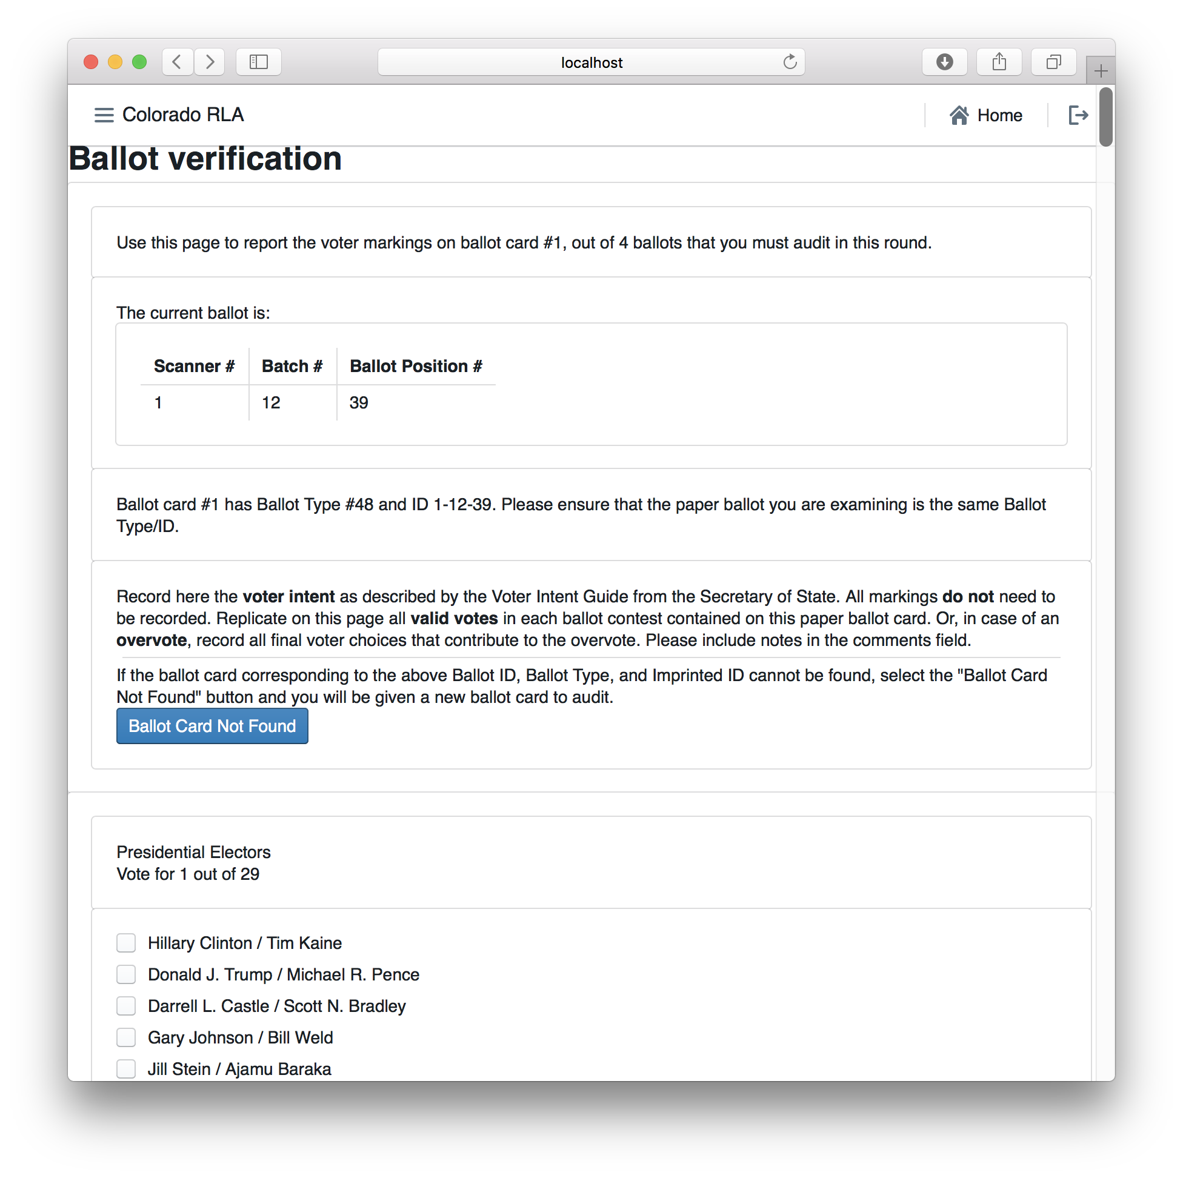

Ballot Card Verification Page

If a ballot card is not found click the "Ballot Card Not Found" Button.

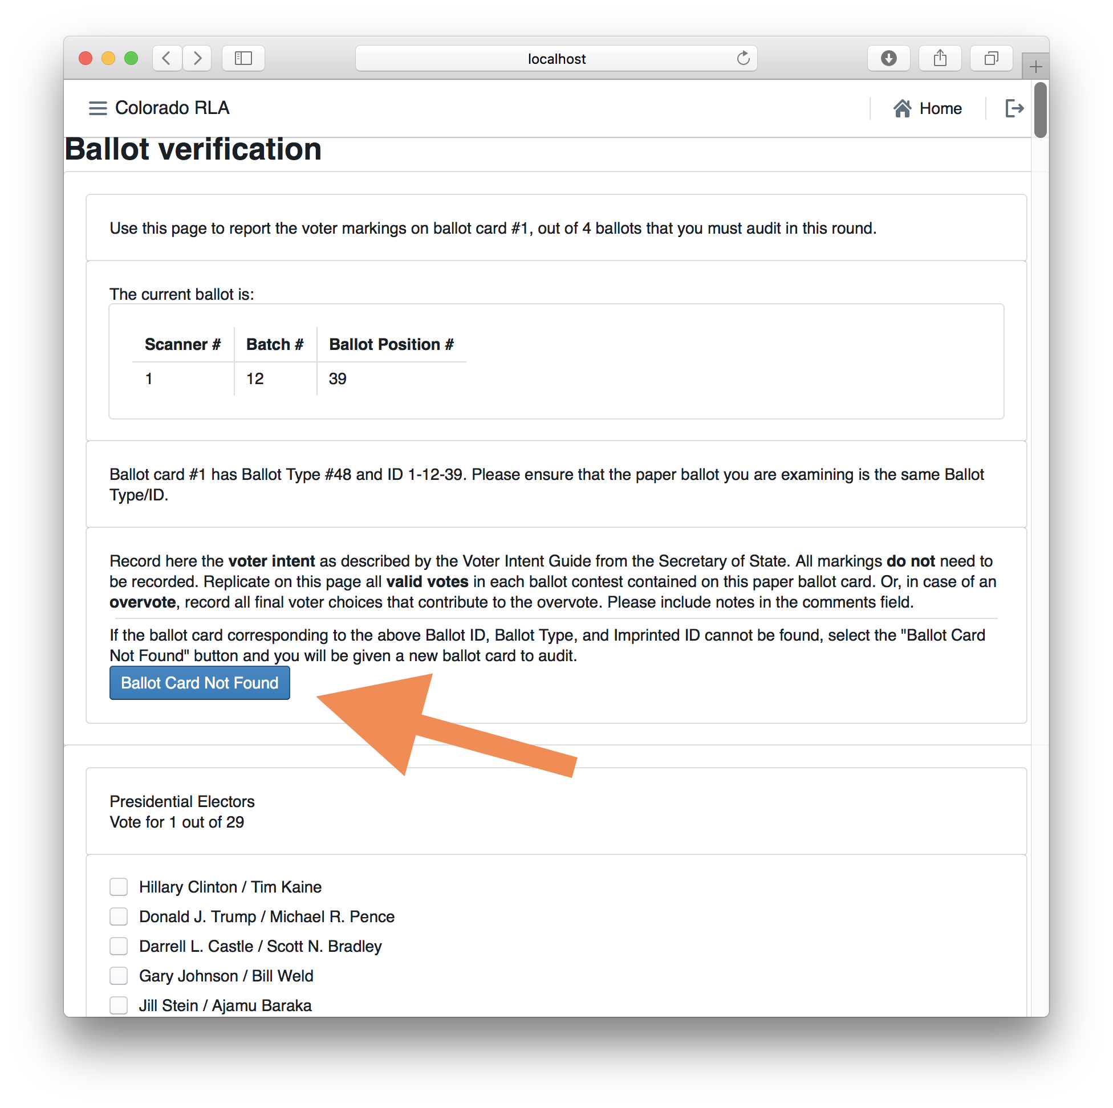

Ballot Card Not Found

Otherwise record on the screen all final voter intent marked on the paper ballot card.

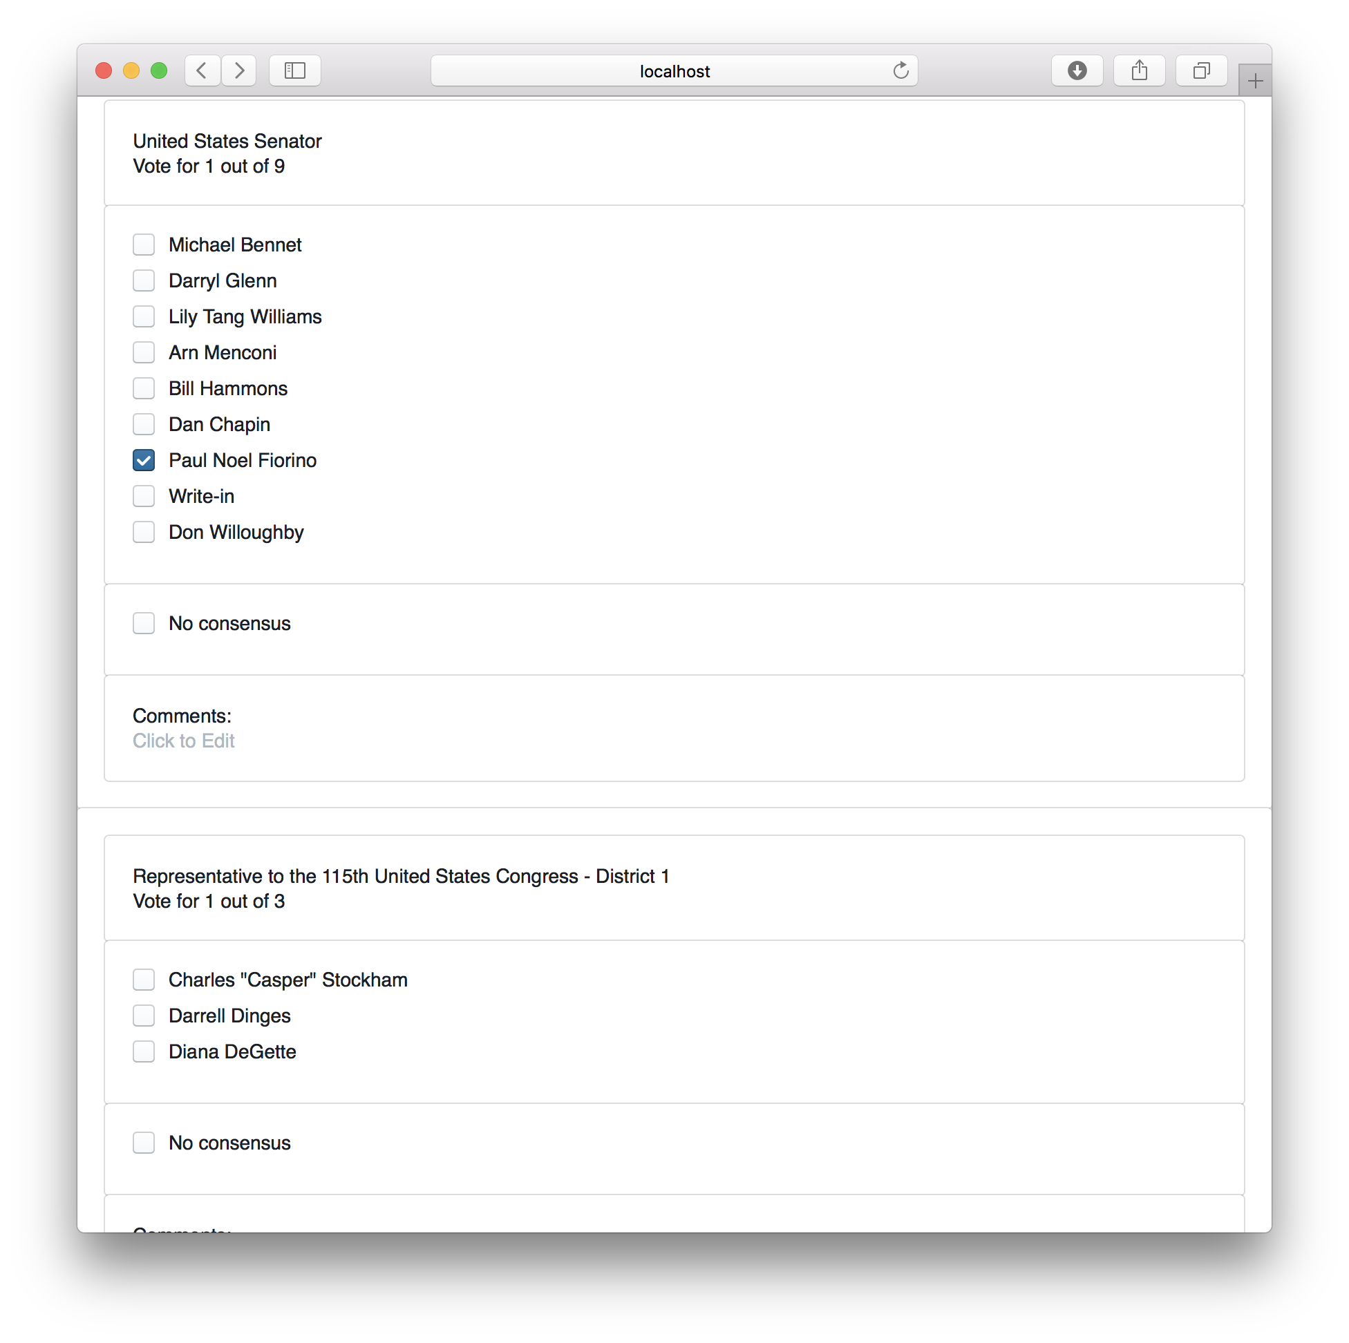

Recording Voter Intent

In case of an overvote, mark each of the (too many) choices the voter intended; the RLA tool will recognize overvotes and undervotes.

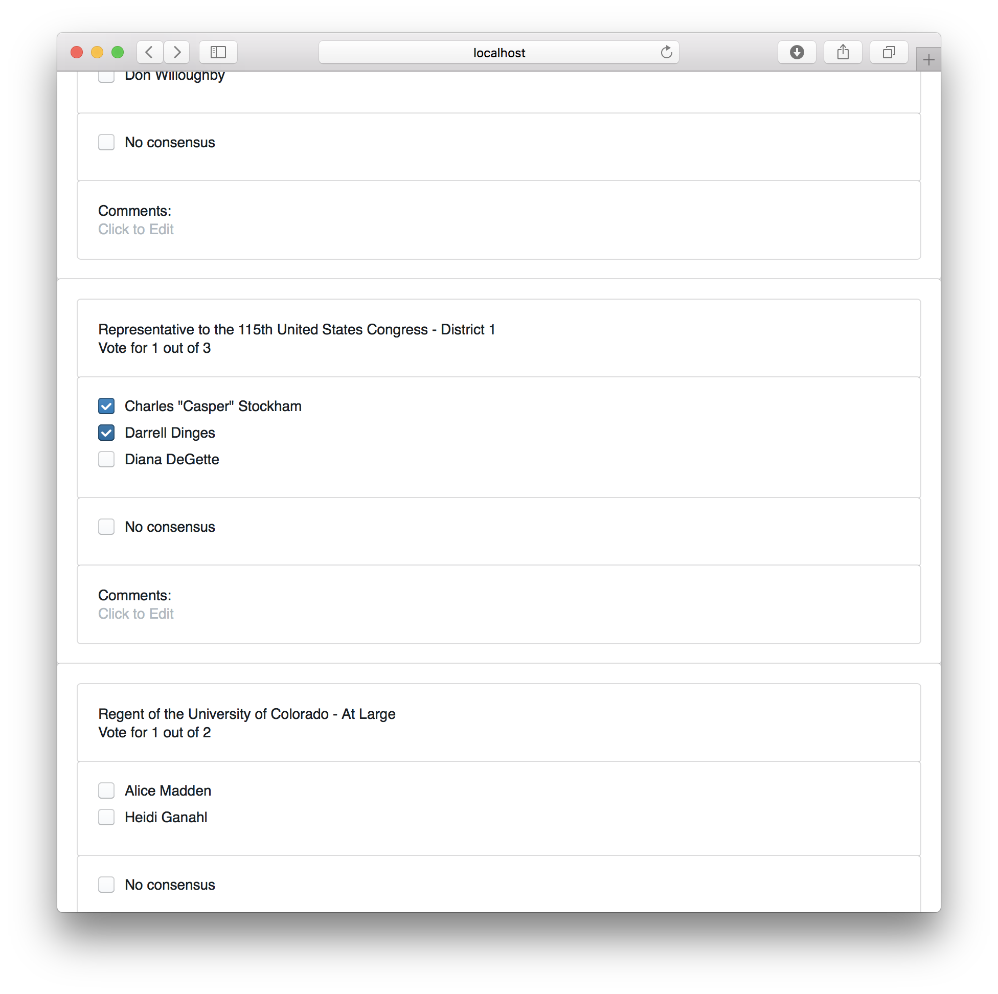

Marking an Overvote

If the Audit Board cannot reach consensus, mark the "No Consensus" box on the screen. There is a text box for any comments.

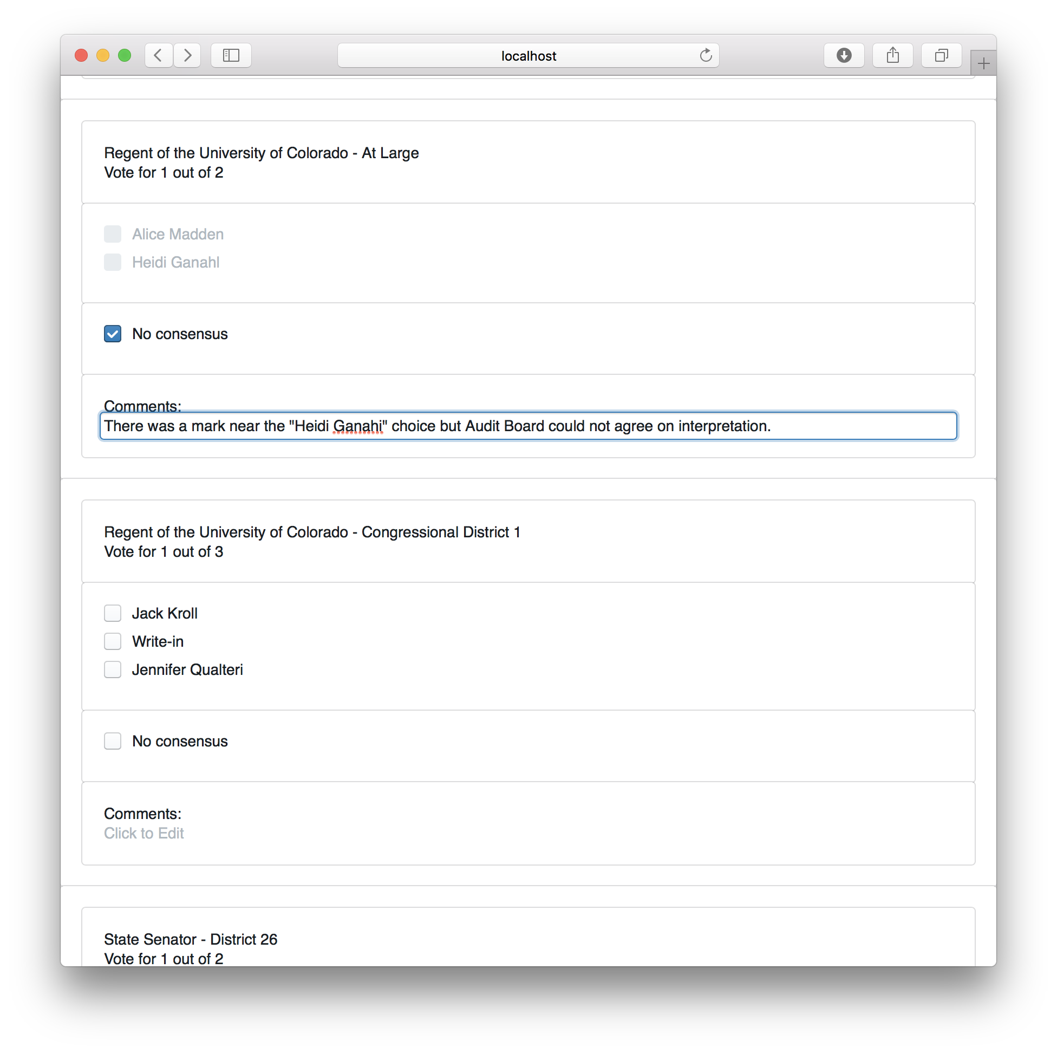

No_Consensus

After entering the interpretation of the markings from any one ballot, the Audit Board can click the Review button.

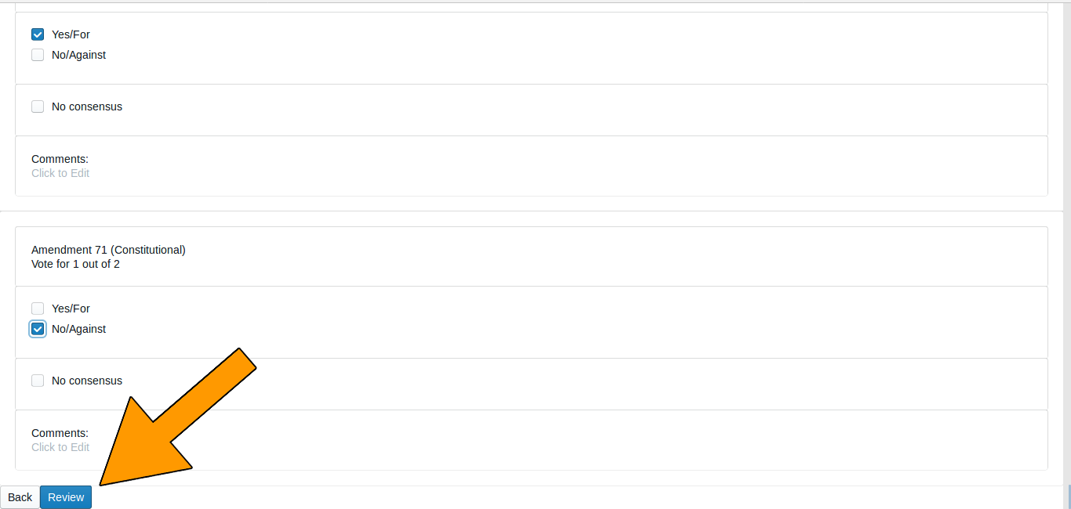

Review Button

On the Review screen, check that the information shown reflects the Audit Board's interpretation of the ballot.

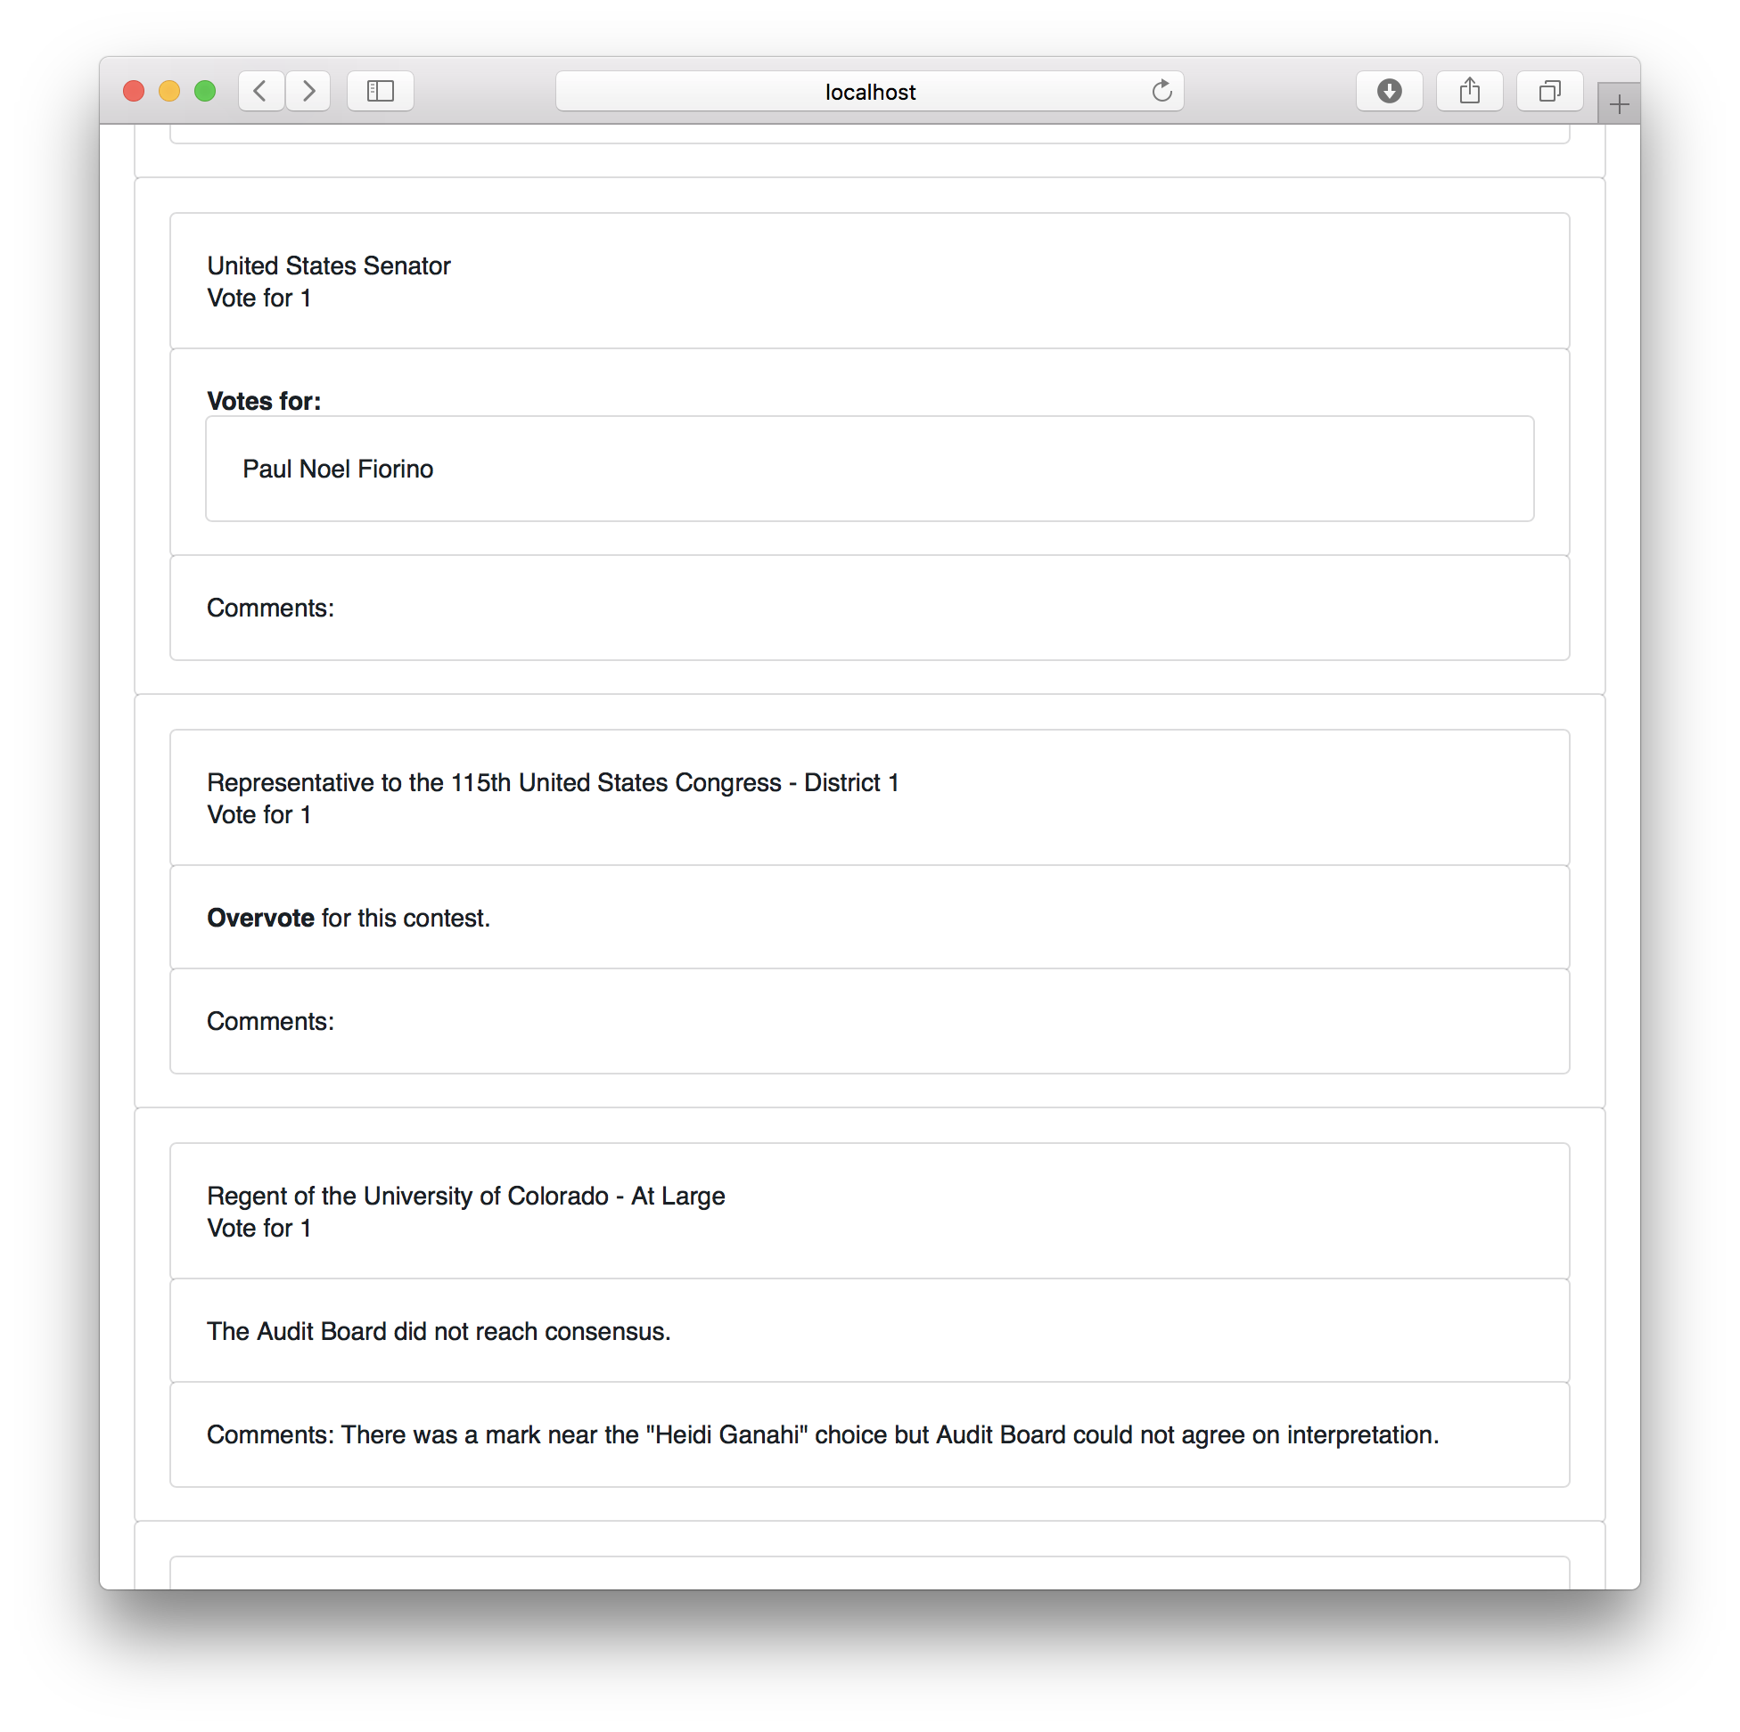

Review Screen

Note that in case of an overvote, the review screen will say "Overvote for this contest".

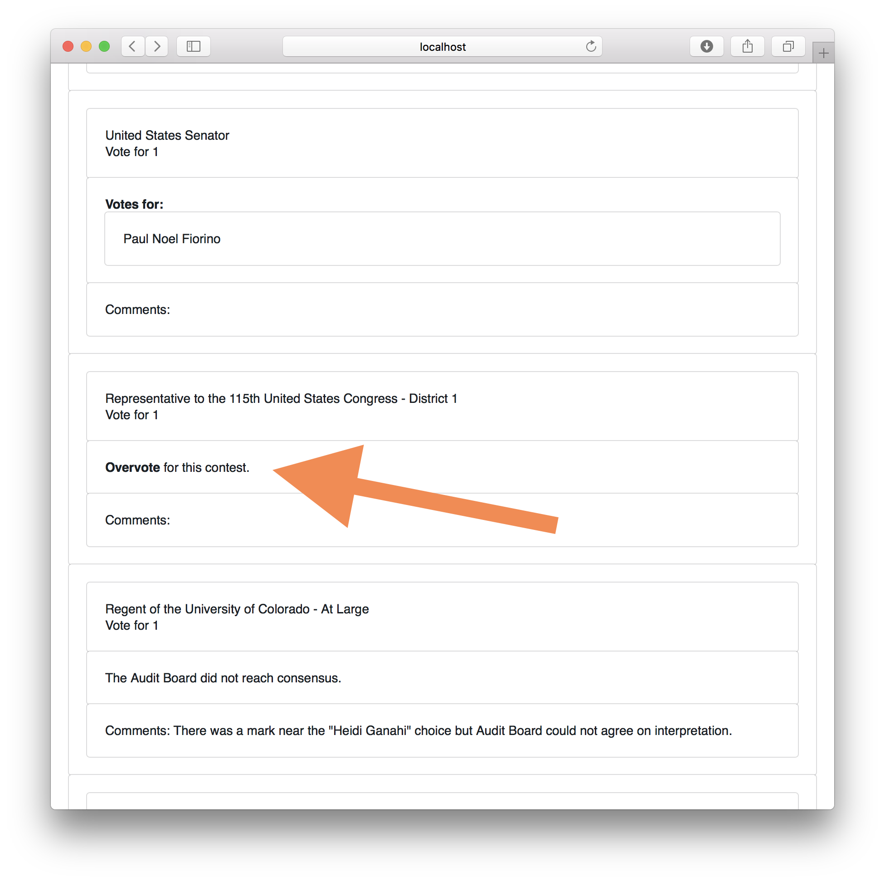

Overvote Review

If the review screen does not match the Audit Board's interpretation, click the "Back" button. If the information on the review screen is correct, click "Submit & Next Ballot".

This submission is final. There is no way to revise a ballot interpretation once it has been submitted from the Review Screen.

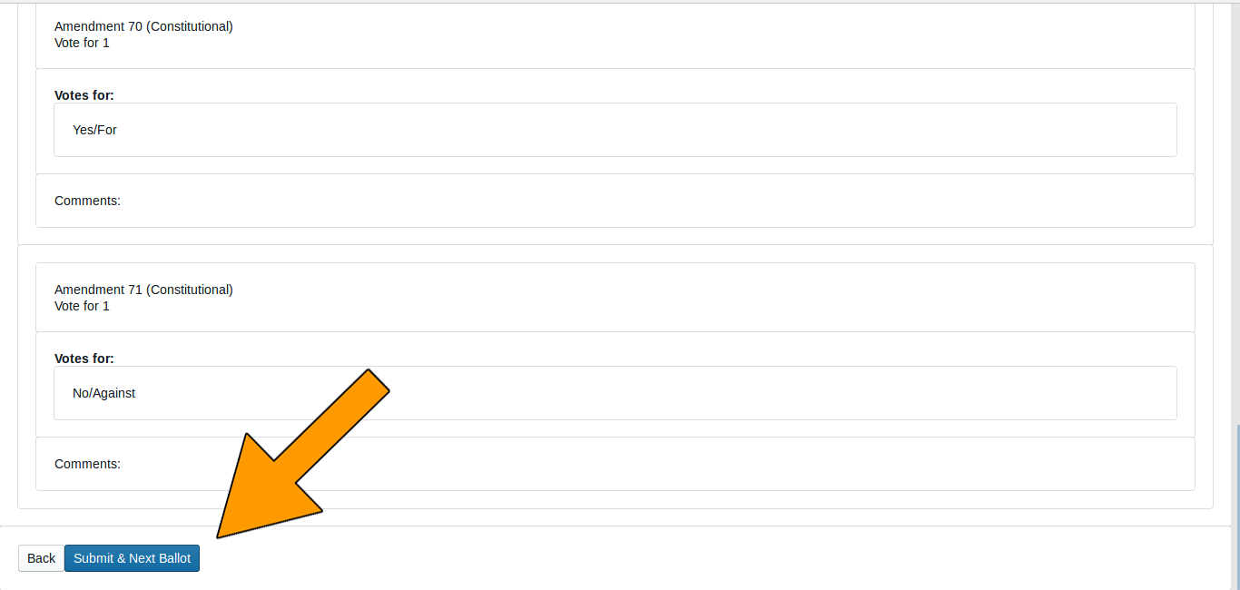

Review_Screen

The screen for the next ballot card will then be displayed. The process continues until the Audit Board has reviewed all the ballot cards assigned to that County for that round. After the last ballot card has been reviewed, the end-of-round page will appear. with boxes for the Audit Board to "sign" their approval of the round by entering their names as indicated.

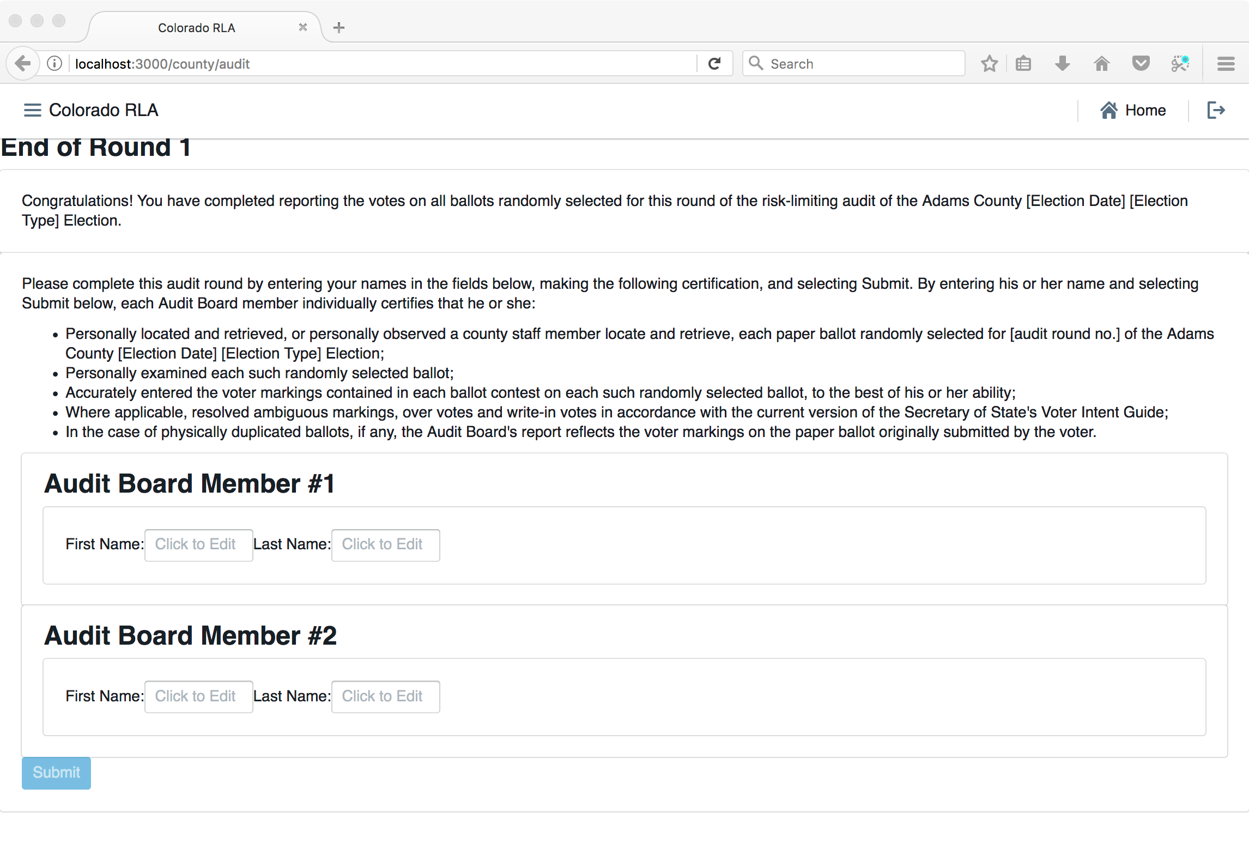

End of Round

Clicking the "Submit" button on this page ends the County's work for the audit round. The Audit Board will still be signed in to the RLA Tool. If the Audit Board wishes to sign out (say, for a coffee break) then they may use the main menu to navigate to the "Audit Board Sign-In" page and click the "Sign Out" button.

### County Home Page During Audit

Note that while the audit is in progress, the County Home page gives a summary of progress. The County Info table shows how many Ballot Cards are required for the current round, and how many have already been audited. The number of "disagreements" is the number of ballot cards on which the Audit Board could not come to complete consensus. The number of "discrepancies" is the number of ballot cards where the Audit Board's interpretation differs from the interpretation in the uploaded CVR file, or where the ballot card in question could not be found.

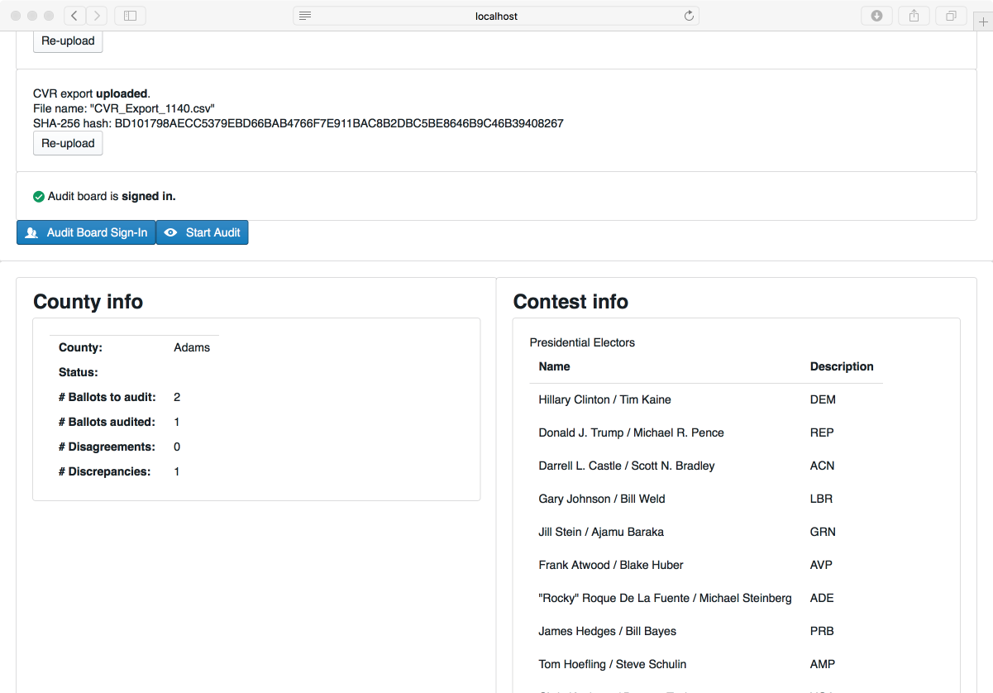

County_Mid-Audit_Screen

### Audit Board Intermediate Audit Report Page

If the Audit Board needs to take a break, go to lunch, head home for the night, or pause their work for any reason, then the Audit Board must file an "Intermediate Audit Report" on their auditing. They should use the Sign Out button on the Audit Board Sign-in Page. *(Ed. note: Intermediate Audit Reports are not included in this release.)*



Audit_Board_Sign_Out

### Audit Board Final Audit Report Page

When the County has completed the entire audit, the County will be able to download a final audit report by clicking the button on the End of Audit page.

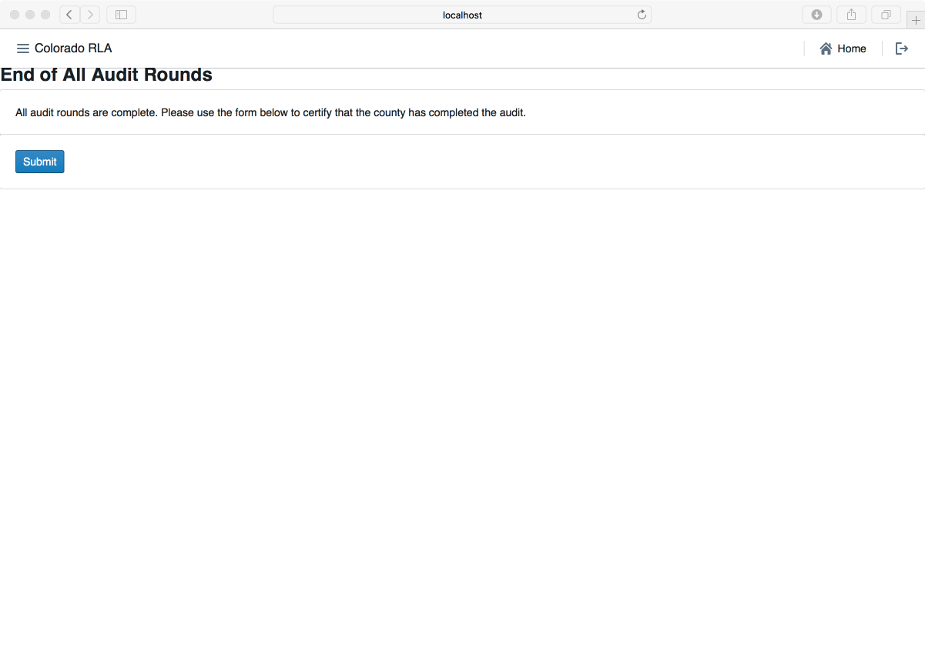

Final Audit Report