# Colorado Risk Limiting Audit

# Run Book

## Introduction

This Run Book is written for election administrators who will be implementing a Risk Limiting Audit (RLA) using the RLA Tool. The Run Book will assist these election administrators in using to tool to carry out the actions required for a RLA.

The Risk-Limiting Audit (RLA) Tool, developed by Free & Fair for the Colorado Department of State for use in elections from November 2017 forward, supports running a Risk-Limiting Audit as required by Colorado statute and as described in the [Colorado Secretary of State's Rule 25](http://www.sos.state.co.us/pubs/rule_making/CurrentRules/8CCR1505-1/ElectionRules.pdf) for elections. The RLA Tool supports a variety of requirements of Rule 25.2.2 and Rule 25.2.3, as described in detail below.

The RLA Tool enables the Secretary of State and each individual County to carry out a Risk-Limiting Audit. Using the RLA Tool, Secretary of State enter the risk limit, the publicly-generated random seed, and the contests that drive the audit process. The Secretary of State can also identify, at any time, contests that should go to a full hand count. Counties upload verified ballot manifests and cast vote record (CVR) files. The RLA Tool performs the necessary calculations to run the RLA, such as choosing random samples of ballots for audit and determining actual risk levels. County Audit Boards then enter interpretations of ballots into the Tool. While audits are ongoing, the Secretary of State can monitor the progress of the individual Counties.

The RLA Tool also creates export files for use in the Audit Center, a website required by Rule 25 to disseminate audit-related information to the public.

### Logging In

Persons from the Secretary of State's office as well as persons from the County first must log in to the RLA Tool.

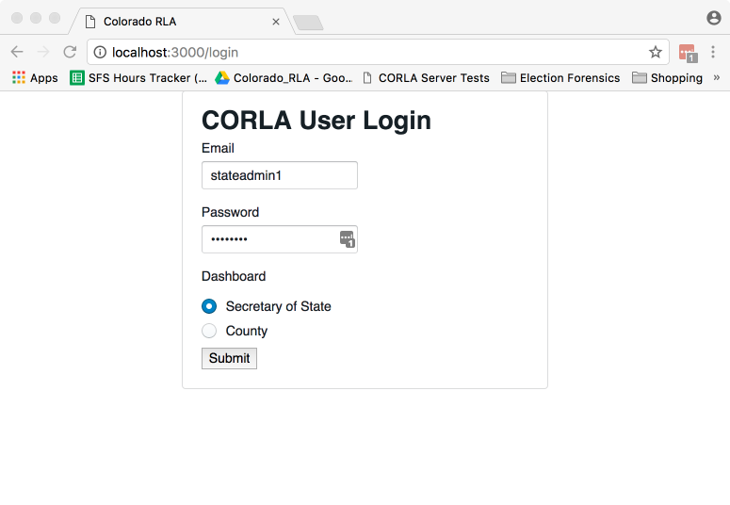

State Login Screenshot

The RLA Tool will direct each user to the appropriate home page. A user from the Department of State will see the Department of State home page.

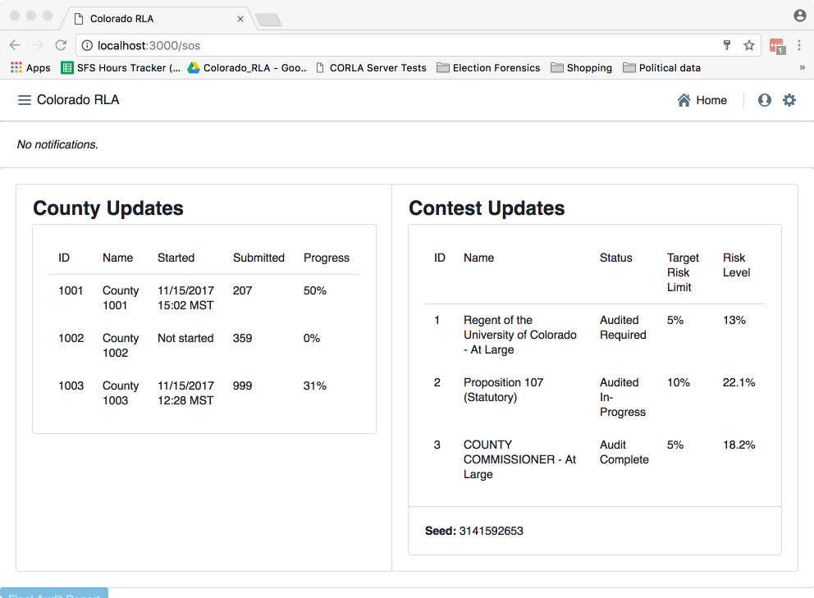

Secretary of State Home Screenshot

A County user will see a home page tailored to that County.

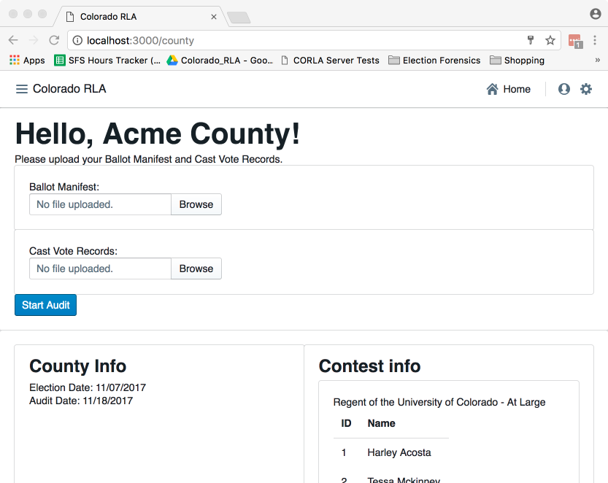

County Home Screenshot

### Navigation

Both the Secretary of State site and each County site has a navigation menu in the upper left corner.

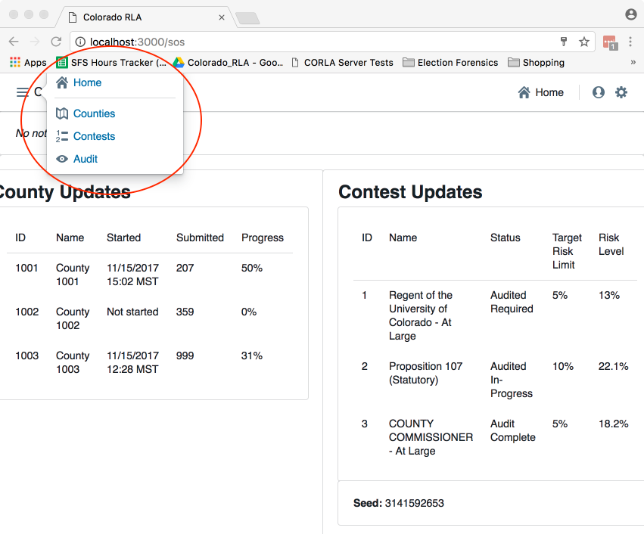

Secretary of State Navigation Screenshot

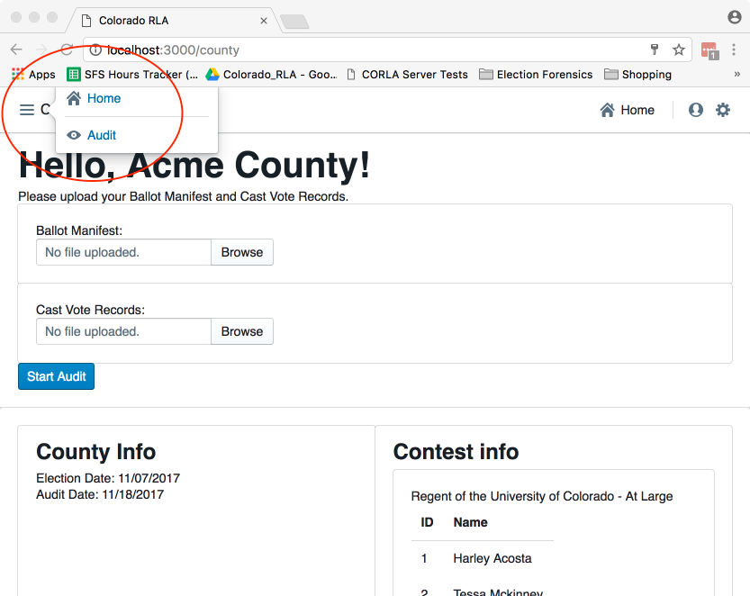

County Navigation Screenshot

### 25.2.2 (A), Entering the Risk Limit

The Secretary of State will enter the Risk Limit for comparison audits.

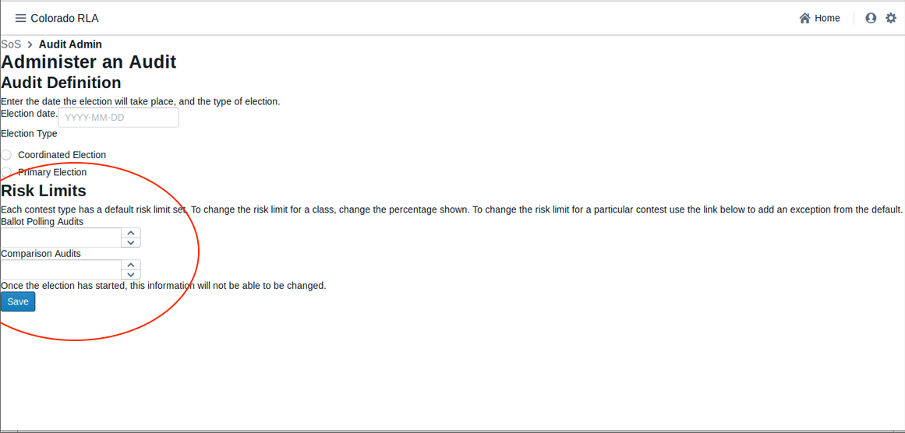

State Risk Limit Entry Screenshot

### 25.2.2 (B) - (E)

These parts of Rule 25 must be completed outside of the RLA Tool.

### 25.2.2 (F) or (G), Audit Uploads

To prepare for upload, the ballot manifest and the CVR file must be first verified and hashed using any SHA-256 hash utility. The RLA Tool itself does not provide a utility for verification or hashing.

Once the ballot manifest and CVR files are verified and hashed, they can be uploaded into the RLA Tool. If the upload process is interrupted the process will have to be repeated. It is not possible to resume interrupted uploads.

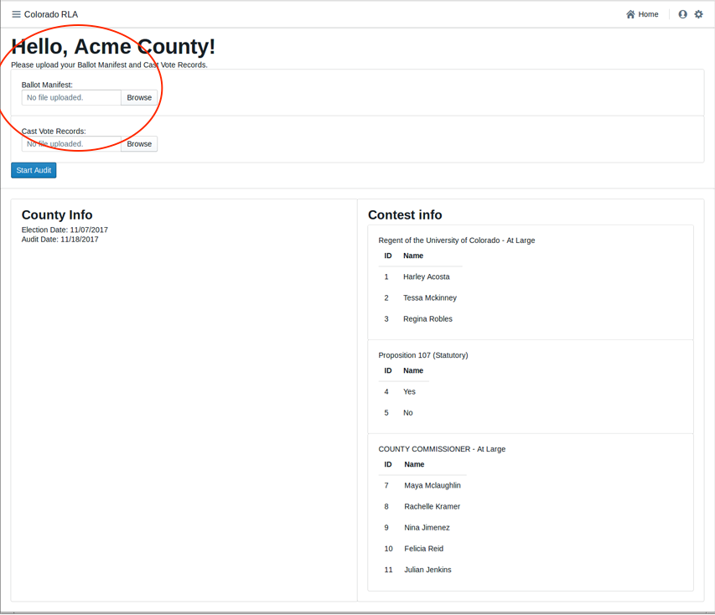

Audit Upload Screenshot

The upload of RLA Tabulation Results Export to the State's Election Night Reporting System required by 25.2.2 (F)(3) must be completed outside of the RLA Tool.

### 25.2.2 (H), Entering the Random Seed

The Secretary of State will enter the random seed.

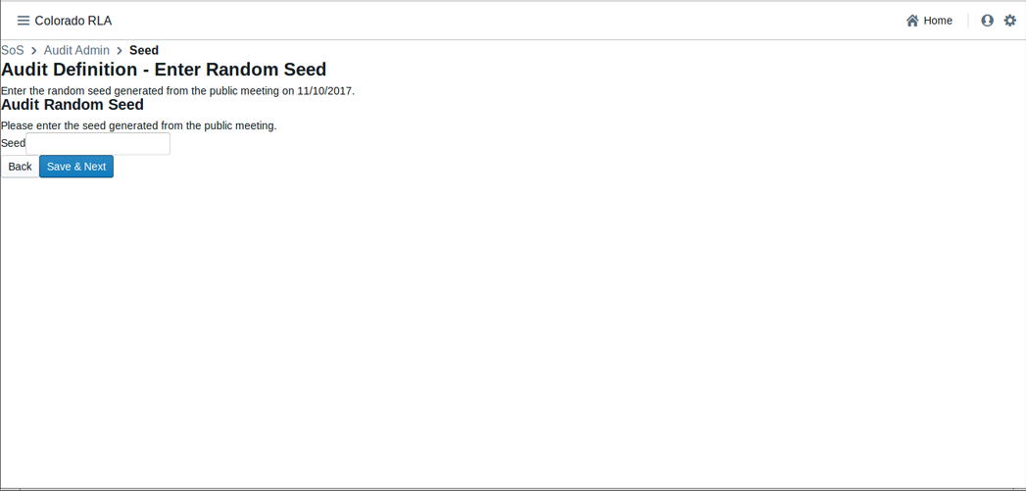

State Random Seed Entry Screenshot

The RLA Tool uses the random seed in the required pseudo-random number generator. The RLA Tool also exports the random seed in a standard format, which the Secretary of State can post to the Audit Center hosted on the Secretary of State website. *(Ed. note: This feature is not included in the stage-1 deliverable.)*

### 25.2.2 (I) Selecting Contests

The Secretary of State will select the contests that will drive the sample size and stop/go decisions for each round. Note that while Rule 25 calls these "contests to be audited", the RLA Tool effectively audits all contests, while using the contests selected by the Secretary of State to calculate the risk levels. *(Ed. note: The notion of "rounds" is still under discussion and not included in the stage-1 deliverable.)*

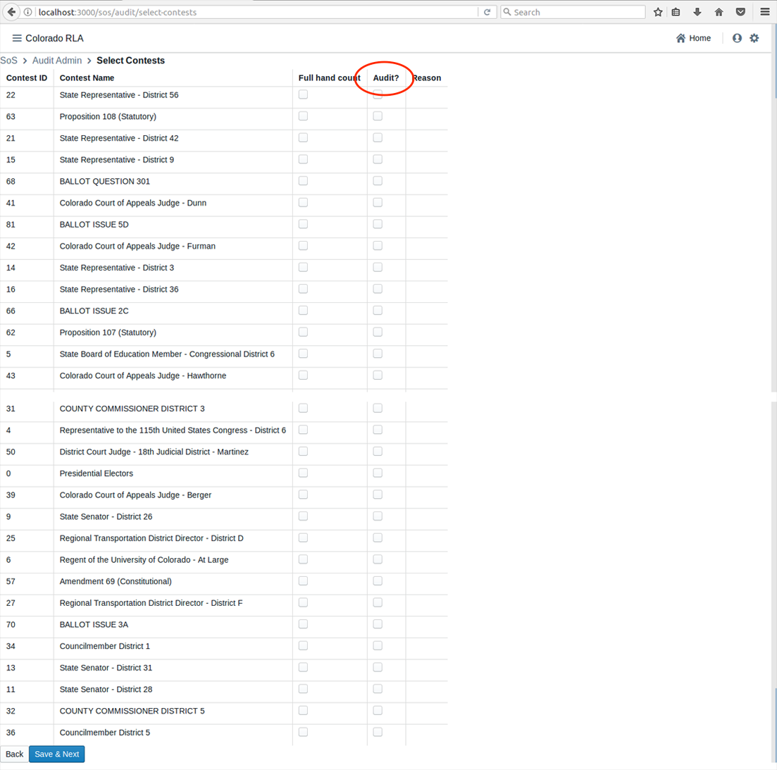

State Contest Selection Screenshot

### 25.2.2 (J) Number of Ballot Cards to Audit

The number of ballot cards to audit changes during the course of the audit depending on the risk level, which in turn depends on the number of overstatements (i.e., ballots whose correction by the Audit Board decreases a margin of victory in one of the selected contests) so far.

### 25.2.2 (K) Random Selection of Ballot Cards for Audit

Based on the pseudo-random number generator and random seed from 25.2.2 (H) and the current risk levels, the RLA Tool determines the selection of ballot cards for audit.

### 25.2.3 (A) Ballot Retrieval, Chain of Custody and Examination

Ballot retrieval from storage container and verification of seals relative to the chain-of-custody logs must be done outside the RLA Tool.

#### 25.2.3 (A)(1) Comparison Audits

The Audit Board does not log directly into the RLA Tool with usernames and passwords. However, whenever the Audit Board begins to interact with the RLA Tool, either at the beginning of an audit round or after taking a break, there is an informal sign-in process. After the authenticated County Audit Administrator formally logs in, there is a screen where the identity and party affiliation of Audit Board Members can be entered or changed.

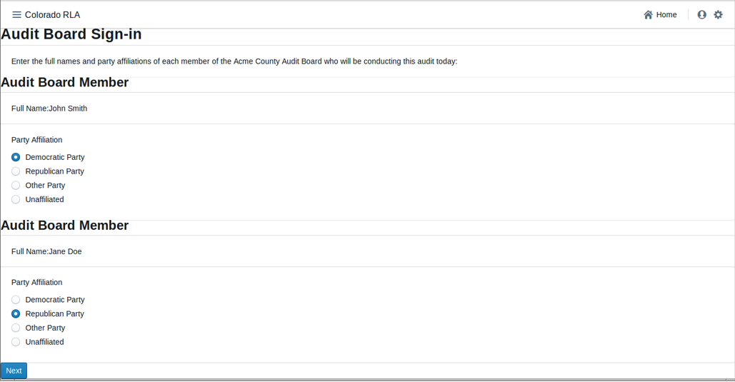

Audit Board Signin Screenshot

The RLA Tool allows Audit Boards to report the markings on each individual ballot.

Before recording voter intent, please double-check that the paper ballot ID and Ballot Style match the ID and ballot style listed on the screen. Then record on the screen all final voter intent marked on the paper ballot. In case of an overvote, mark each of the (too many or too few) choices the voter intended; the RLA tool will recognize overvotes and undervotes. In case the Audit Board cannot reach consensus, mark the "No Consensus" box on the screen. Audit Board members can make notes in the comment field.

Click "Review"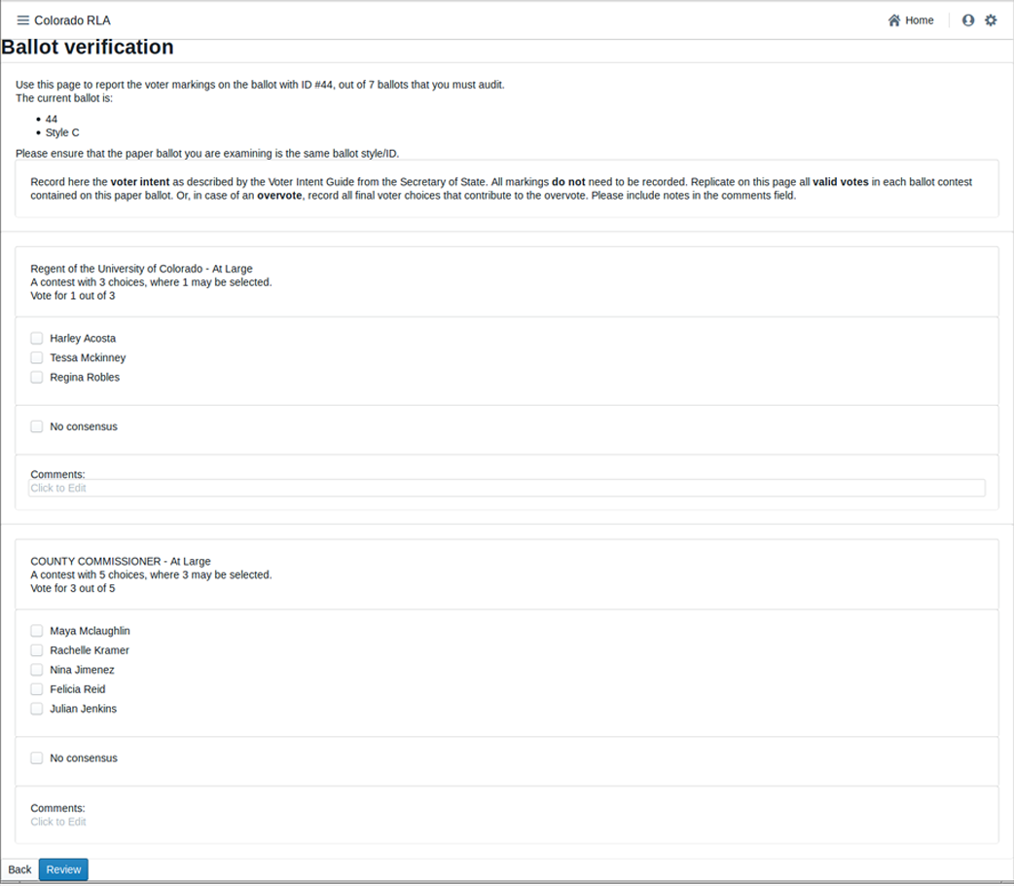

After entering the interpretation of the markings from any one ballot, the Audit Board can review what was entered.

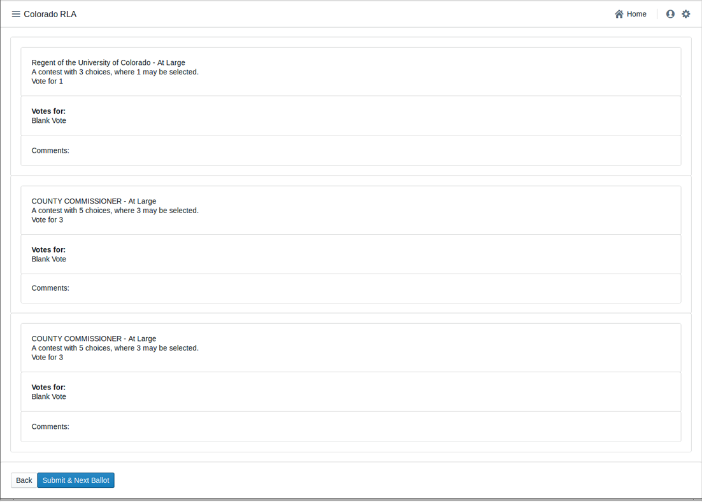

Review Marks Screenshot

Check that the information on the review screen reflects the Audit Board's interpretation of the ballot. Note that in case of an overvote, the review screen will say, simply, "overvote".

If the review screen matches the Audit Board's interpretation, click "Submit and Next Ballot". This submission is final. There is no way to revise a ballot interpretation once it has been submitted from the Review Screen.

Note: do *not* use your browser's "back" arrow during the audit process. If the review screen does not match the Audit Board's interpretation, click the "Back" button. *(Ed. note: We intend to ensure that pressing the brower's back button is not harmful in a later delivery.)*

### 25.2.3 (A)(2) Ballot Polling Audits

The conduct and reporting of the Audit Board for a Ballot Polling Audit must be completed outside the RLA Tool.

### 25.2.3 (B) Non-Unanimous Audit Board

An Audit Board can use the RLA Tool to report lack of consensus on any particular contest on any particular ballot.

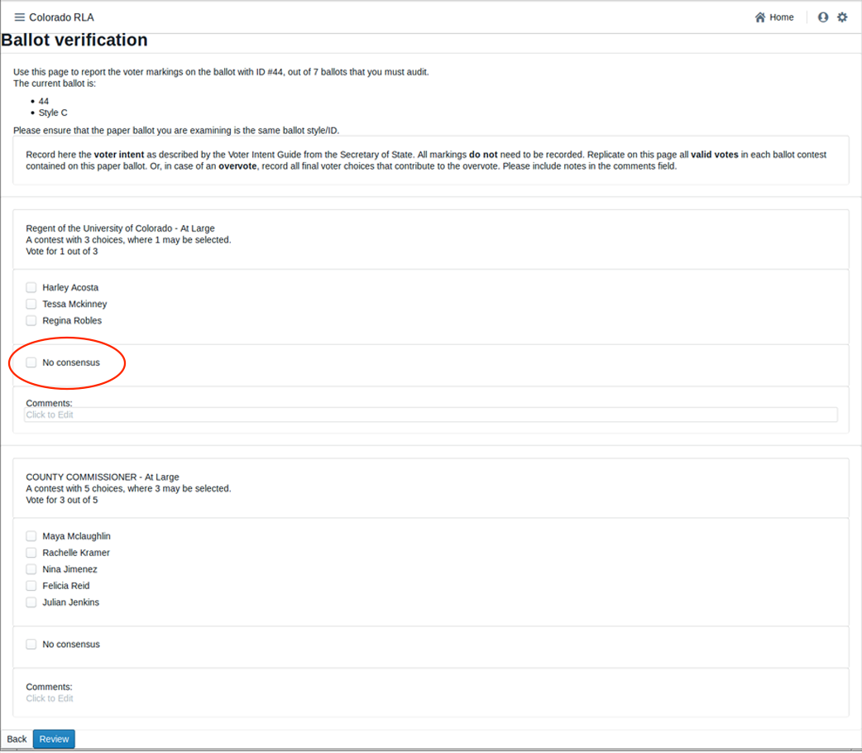

No Consensus Screenshot

### 25.2.3 (C) Comparisons, Termination, Additional Ballots

The RLA Tool performs the comparison of the Audit Board's interpretations with the corresponding cast vote record from the voting computer system. The results of this comparison are exported for the Secretary of State to post on the Audit (outside the RLA Tool). The RLA Tool will allow the Secretary of State to see if the required Risk Limit has been met for the selected contests.

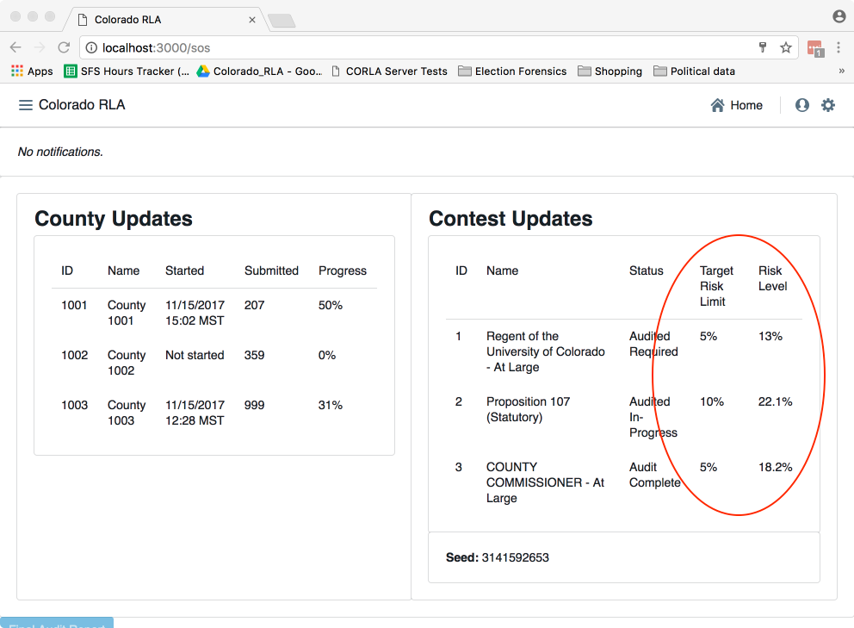

Risk Limit Met Query Screen

The RLA Tool also allows the Secretary of State to designate a contest for hand counting at any time. *(Ed. note: Handling this asynchronous notification is not supported in the stage-1 deliverable.)*

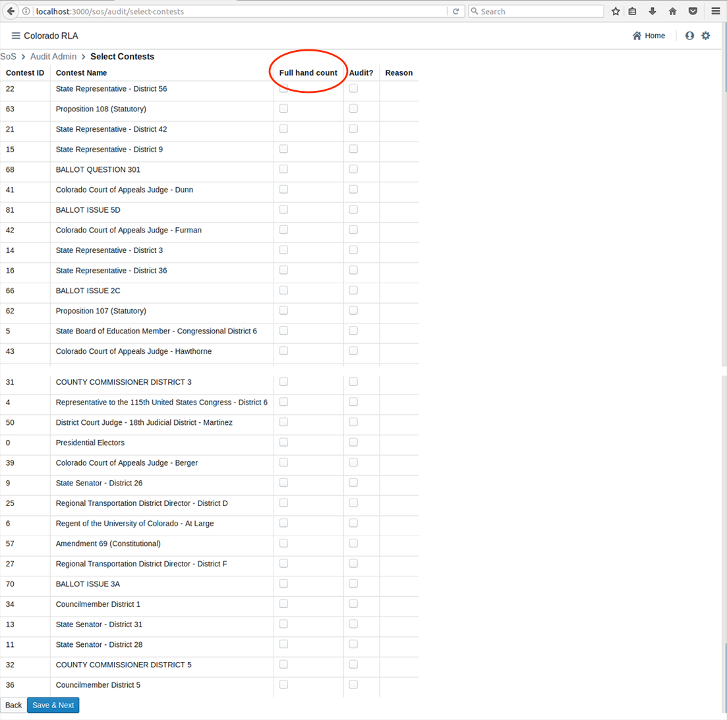

Full Hand Count Screen

The RLA Tool automatically randomly selects additional ballots for audit as necessary.