admin test account: admin@test.com

admin test password: admin

registered user account 1: tom@test.com

registered user account 1 password : test

registered user account 2: jerry@test.com

registered user account 2 password : test

NON- REGISTERED USER:

non registered user can only read the post with comments , message below only for test use:



REGISTERED USER:

---- Registered non admin user could do

1. read the post and comments,
2. post the comment on cliick add comment, the createOn and Fullname field will be auto generated



The number of comments will be shown, View all the comments by click View Comments

1. manager the comment posted by themselves on click Manage your comments



The status of the comments will be shown as “published”, which is already approved by admin, and as “pending…”, which is waiting for the approve .

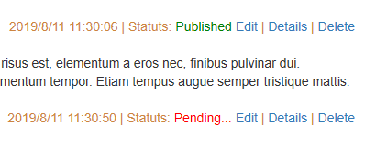

Registered non admin user can also edit , view detail and delete the comments they posted, BUT the edit of a published comment will change it’s status to pending automatically.

---- Admin user could do

1. Add a new post：if sign in as an admin , a Link “Add Post ” Will appear on the top menu. On click this link , admin can add a new post



createOn and PublicOn will be autogenerated.

1. Manage the post on click on Edit Post



All the date field will been displayed only, and when click save, the “updated on “ will be updated automatically

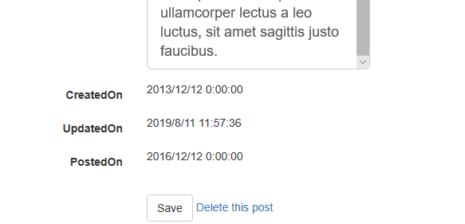

1. Manage all the comments

Admin can approve any comment and delete it as well. If there is comment need to be approved, “New ” will added after “edit comments”.



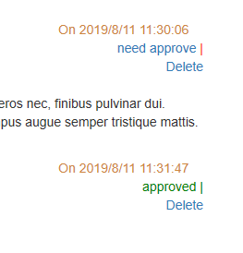

1. Add a comment.

Admin can also add a comment to any post without need to be approved by himself.