**Ultra-sensitive and Wide-Range temperature sensing utilizing a Microbottle Resonator coupled with Fiber Mach–Zehnder Interferometer**

Biao Li,1 Liying Liu,1* and Lei Xu1,2

1 Key Lab for Micro and Nanophotonic Structures (Ministry of Education), Department of Optical Science and Engineering, School of Information Science and Engineering, Fudan University, Shanghai 200433, China

2 Department of Physics, Fudan University, Shanghai 200433, China

*lyliu@fudan.edu.cn

**Abstract:** A novel ultra-sensitive and wide-range temperature detection method has been proposed based on coupling a microbottle resonator with a Fiber Mach–Zehnder Interferometer (FMZI), which can change the small mode shift into large intensity variation. We theoretically and experimentally investigated the sensing performance of this method. Through appropriately adjusting the length difference of FMZI, microbottle resonant peaks and FMZI peak moves in opposite direction. Measuring the Fano dip depth gives a temperature sensitivity of up to 307.5 dB/°C and a temperature resolution of 4×10-3 °C. Theoretical calculations demonstrate that the temperature detection limit can reach 4×10⁻⁶ °C under an 80 dB Signal-to-Noise Ratio (SNR). Moreover, experiments have confirmed that by using the encoding method of universal commercial barcodes to record the changes in the resonant frequencies and intensities of the modes and by matching the proposed barcodes with Bit Error Rate, temperature sensing with an almost unlimited range can be achieved. The proposed method makes it possible to achieve high sensitivity and wide range of temperature sensing applications.

1. **Introduction**

The measurement of temperature holds great significance in modern industry, medicine, daily life and many other aspects. Leveraging optical principles, optical temperature sensors convert temperature changes into optical signals and feature free of electromagnetic interference, small size, lightweight, and remote measurement, laying a solid foundation for temperature measurement. Up to now, numerous optical sensing structures, such as Mach-Zehnder interferometer[1], Fabry-Perot cavity[2], Photonic Crystal Fibers[3], fiber Bragg grating[4], along with optical whispering gallery mode (WGM) microcavities[5], have been utilized for temperature detection. The variations in cavity sizes and material refractive indices caused by temperature can be manifested through the shifts in the resonant frequencies of WGM microcavities. In combination with the high Q-factor characteristic of WGM microcavities, which significantly improves the spectral resolution, this sensing configuration demonstrates excellent adaptability for high-accuracy temperature sensing applications.

The WGM-based temperature sensors typically rely on detecting the shift of the resonance wavelength or frequency. To detect smaller temperature variations, current research primarily focuses on improving temperature sensing sensitivity by using materials with high thermo-optic or thermal expansion coefficients. The silica microsphere with a Q-factor of 4×107 has a sensing sensitivity of 13.89 pm/°C[6], meanwhile an organic PMMA (Polymethyl methacrylate) microbubble with higher thermo-optic or thermal expansion coefficients can increase the sensitivity to 39 pm/°C and it’s Q-factor is 1.6×104[7]. By fabricating the resonant cavity with PDMS (Polydimethylsiloxane)[8], cholesteric liquid crystal[9] and silk[10], the sensitivity can be further increased to 245 pm/°C, 960 pm/°C and 1170 pm/°C, respectively, however, the Q-factor decreased to 9.1×105, 749 and 105, respectively. According the relationship between temperature resolution (*Tresolution*), sensing sensitivity (***S***), Q factor (***Q***) and signal-to-noise ratio (SNR) : *Tresolution*≈λ/(4.5QS(SNR0.25))[11]，the transition from silica microspheres to silk microdisks results in a 100-fold increase in sensitivity, yet this improvement is counterbalanced by a reduction in the Q factor exceeding 100-fold, thus offering no significant enhancement in temperature resolution. This results in the temperature resolution of the WGM-based temperature sensor being constrained to the order of 10⁻⁴ °C. Moreover, the increase in sensitivity will further cause the resonance mode to rapidly deviate from the swept-frequency range, leading to a decline in the sensing range. This phenomenon poses a crucial challenge for the practical application of the WGM-based temperature sensing system.

In this paper, we propose a novel temperature sensing mechanism based on coupling a microbottle resonator with a Fiber Mach–Zehnder Interferometer (FMZI), which can transform small frequency shift into large intensity change in the transmission spectrum. We theoretically investigated the sensing performance and experimentally demonstrate the proposed method has a great improvement in sensitivity. By precisely adjusting the length difference of the FMZI, the spectral responses of the microbottle resonator and the FMZI are engineered to shift in opposite directions, a temperature sensitivity of 307.5 dB/°C has been achieved by measuring the depth of the Fano dip in the spectrum. Theoretical analysis indicates that the MCFMZI attains a temperature detection limit of 4×10⁻⁶ °C at 80 dB SNR, representing a two-order-of-magnitude improvement over the WGM's detection limit of 3.5×10⁻⁴ °C. Additionally, we adopt the encoding method of universal commercial barcodes to record the positions and intensities of spectrum modes and apply Bit Error Rate (BER) for barcode matching. This approach enables high-sensitivity and wide-range temperature sensing, showing great potential for application.

**2．Sensing mechanism and analysis.**

The structure of Microbottle Coupled with a Fiber Mach–Zehnder Interferometer (MCFMZI) is shown in Fig. 1(a), the FMZI consists of two fiber splitters, whose one pathway act as sensing arm evanescently coupled with microbottle resonator and the other is the reference arm. The microbottle resonator and the sensing arm are both placed on the heater. The heating length of the sensing arm is ***L***. The reference arm is ***ΔL*** longer than the sensing arm. The output transmission is determined by[12]:

(1)

The amplitude *H* and phase *φc*modulation by the resonator and the phase difference *φf* between two arms have the following forms[13]:

 (2)

Where ***ω0*** is eigenfrequency of the resonator. ***κ0*** *and****ke***denotes the decay rate due to cavity intrinsic loss and external coupling to mode. ***neff***is mode effective index of optical fiber and **c** is vacuum velocity. ***a*** is the thermal-optic coefficient of silica fiber. ***s*** is the temperature sensitivity of cavity mode. The transmission intensity at ***ω0*** is

(3)

Where *h* = (κ0-κe)/ (κ0+κe). Considering the coefficient of the quadratic term in the cosine function is very small, the intensity ***Tω0*** varies with temperature in the following period:

. (4)

Period ***P*** here represents the required temperature change for an intensity variation period, thus, the smaller ***P***, the faster ***Tω0*** changes with temperature, which provide a larger temperature sensitivity：

. (5)

Here, ***ER*** is the difference between the maximum and minimum values of ***Tω0*** and is determined by the extinction ratio of the FMZI and the coupling state of microbottle. As indicated by Eq. (5), the temperature-induced variation in the Fano dip stems from two contributing factors. One factor is associated with the temperature-driven shift of the whispering-gallery mode (WGM), and the other originates from the spectral shift of the FMZI transmission (as illustrated in Fig. 1(c)). The magnitude and direction of the FMZI spectrum shift are predominantly influenced by ***ΔL*** and ***L***. The transmission spectrum of the FMZI shifts red with increasing temperature when ***ΔL*** > 0, otherwise, it shifts blue. In contrast, the temperature-induced shift of WGM mode can only move blue due to the positive thermo-optic coefficient of the microbottle. This indicates the WGM mode's transmission spectrum shifts in the opposite direction to that of the FMZI when ***ΔL*** > 0. As shown in Fig. 1(e), the temperature sensitivity increases as ***ΔL*** and ***L*** increase for ***ΔL*** > 0. While zero-sensitivity regions exist in the figure, these arise when ***ΔL*** < 0, causing co-directional shifts of WGM and FMZI. It should be noted that although larger values of ***ΔL*** and ***L*** lead to higher sensitivity, as shown in Eq. (4), the temperature variation period becomes smaller, which implies a reduction in the temperature sensing range. To resolve this issue, Section 4 introduced a barcode method to enhance the temperature sensing range.

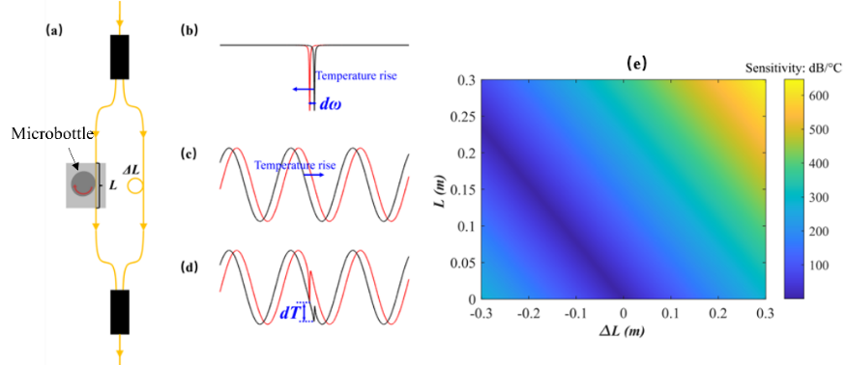

**Fig. 1** (a)Schematic of the microbottle coupled with FMZI. (b)-(d) represent the spectra of the WGM, FMZI, and MCFMZI, respectively. The increase in temperature results in a decrease in the resonance frequency. By adjusting the length difference of FZMI (***ΔL***), the spectrum can be induced to shift in the opposite direction, leading to a significant change in the Fano resonance dip (***dT***) in the MCFMZI's spectrum. (e) Calculated temperature sensitivity versus ***ΔL*** and ***L.***

1. **Experimental Setup and Temperature sensing results**

In our experiments, the FMZI is composed of two fiber splitter (FS1 and FS3 as shown in Fig. 2) and a tapered microfiber in it’s one pathway acting as the sensing arm evanescently couple with a microbottle resonator. The microbottle resonator with a maximum radius 70 μm was fabricated by single mode fiber (Corning, SMF28e) using a standard fiber fusion splicer (Fujikura FSM-27S) similar to the “heat-and pull” method[14]. In order to monitor the transmission spectrum of WGM, a fiber splitter with 90:10 splitting ratio is embedded in the sensing arm. The arrangement of the three beam splitters with different splitting ratios is to achieve a better extinction ratio of FMZI. Both of the microbottle resonator and sensing arm are placed on a polyimide heating film (R=5.6 Ω), which is controlled by a TEC temperature controller (TEC-1091, meerstetter engineering). A four-wire PT1000 temperature sensor with a temperature accuracy of 0.001 °C is placed close to the microbottle, and the real-time temperature is recorded by the TEC temperature controller. A cw laser (Toptica CTL 1550) with a linewidth smaller than 100 kHz, after passing a polarization controller (PC), is launched into FMZI and then received by two photodetectors, which are connected to a computer with a data acquisition card for control of laser scanning and signal processing.

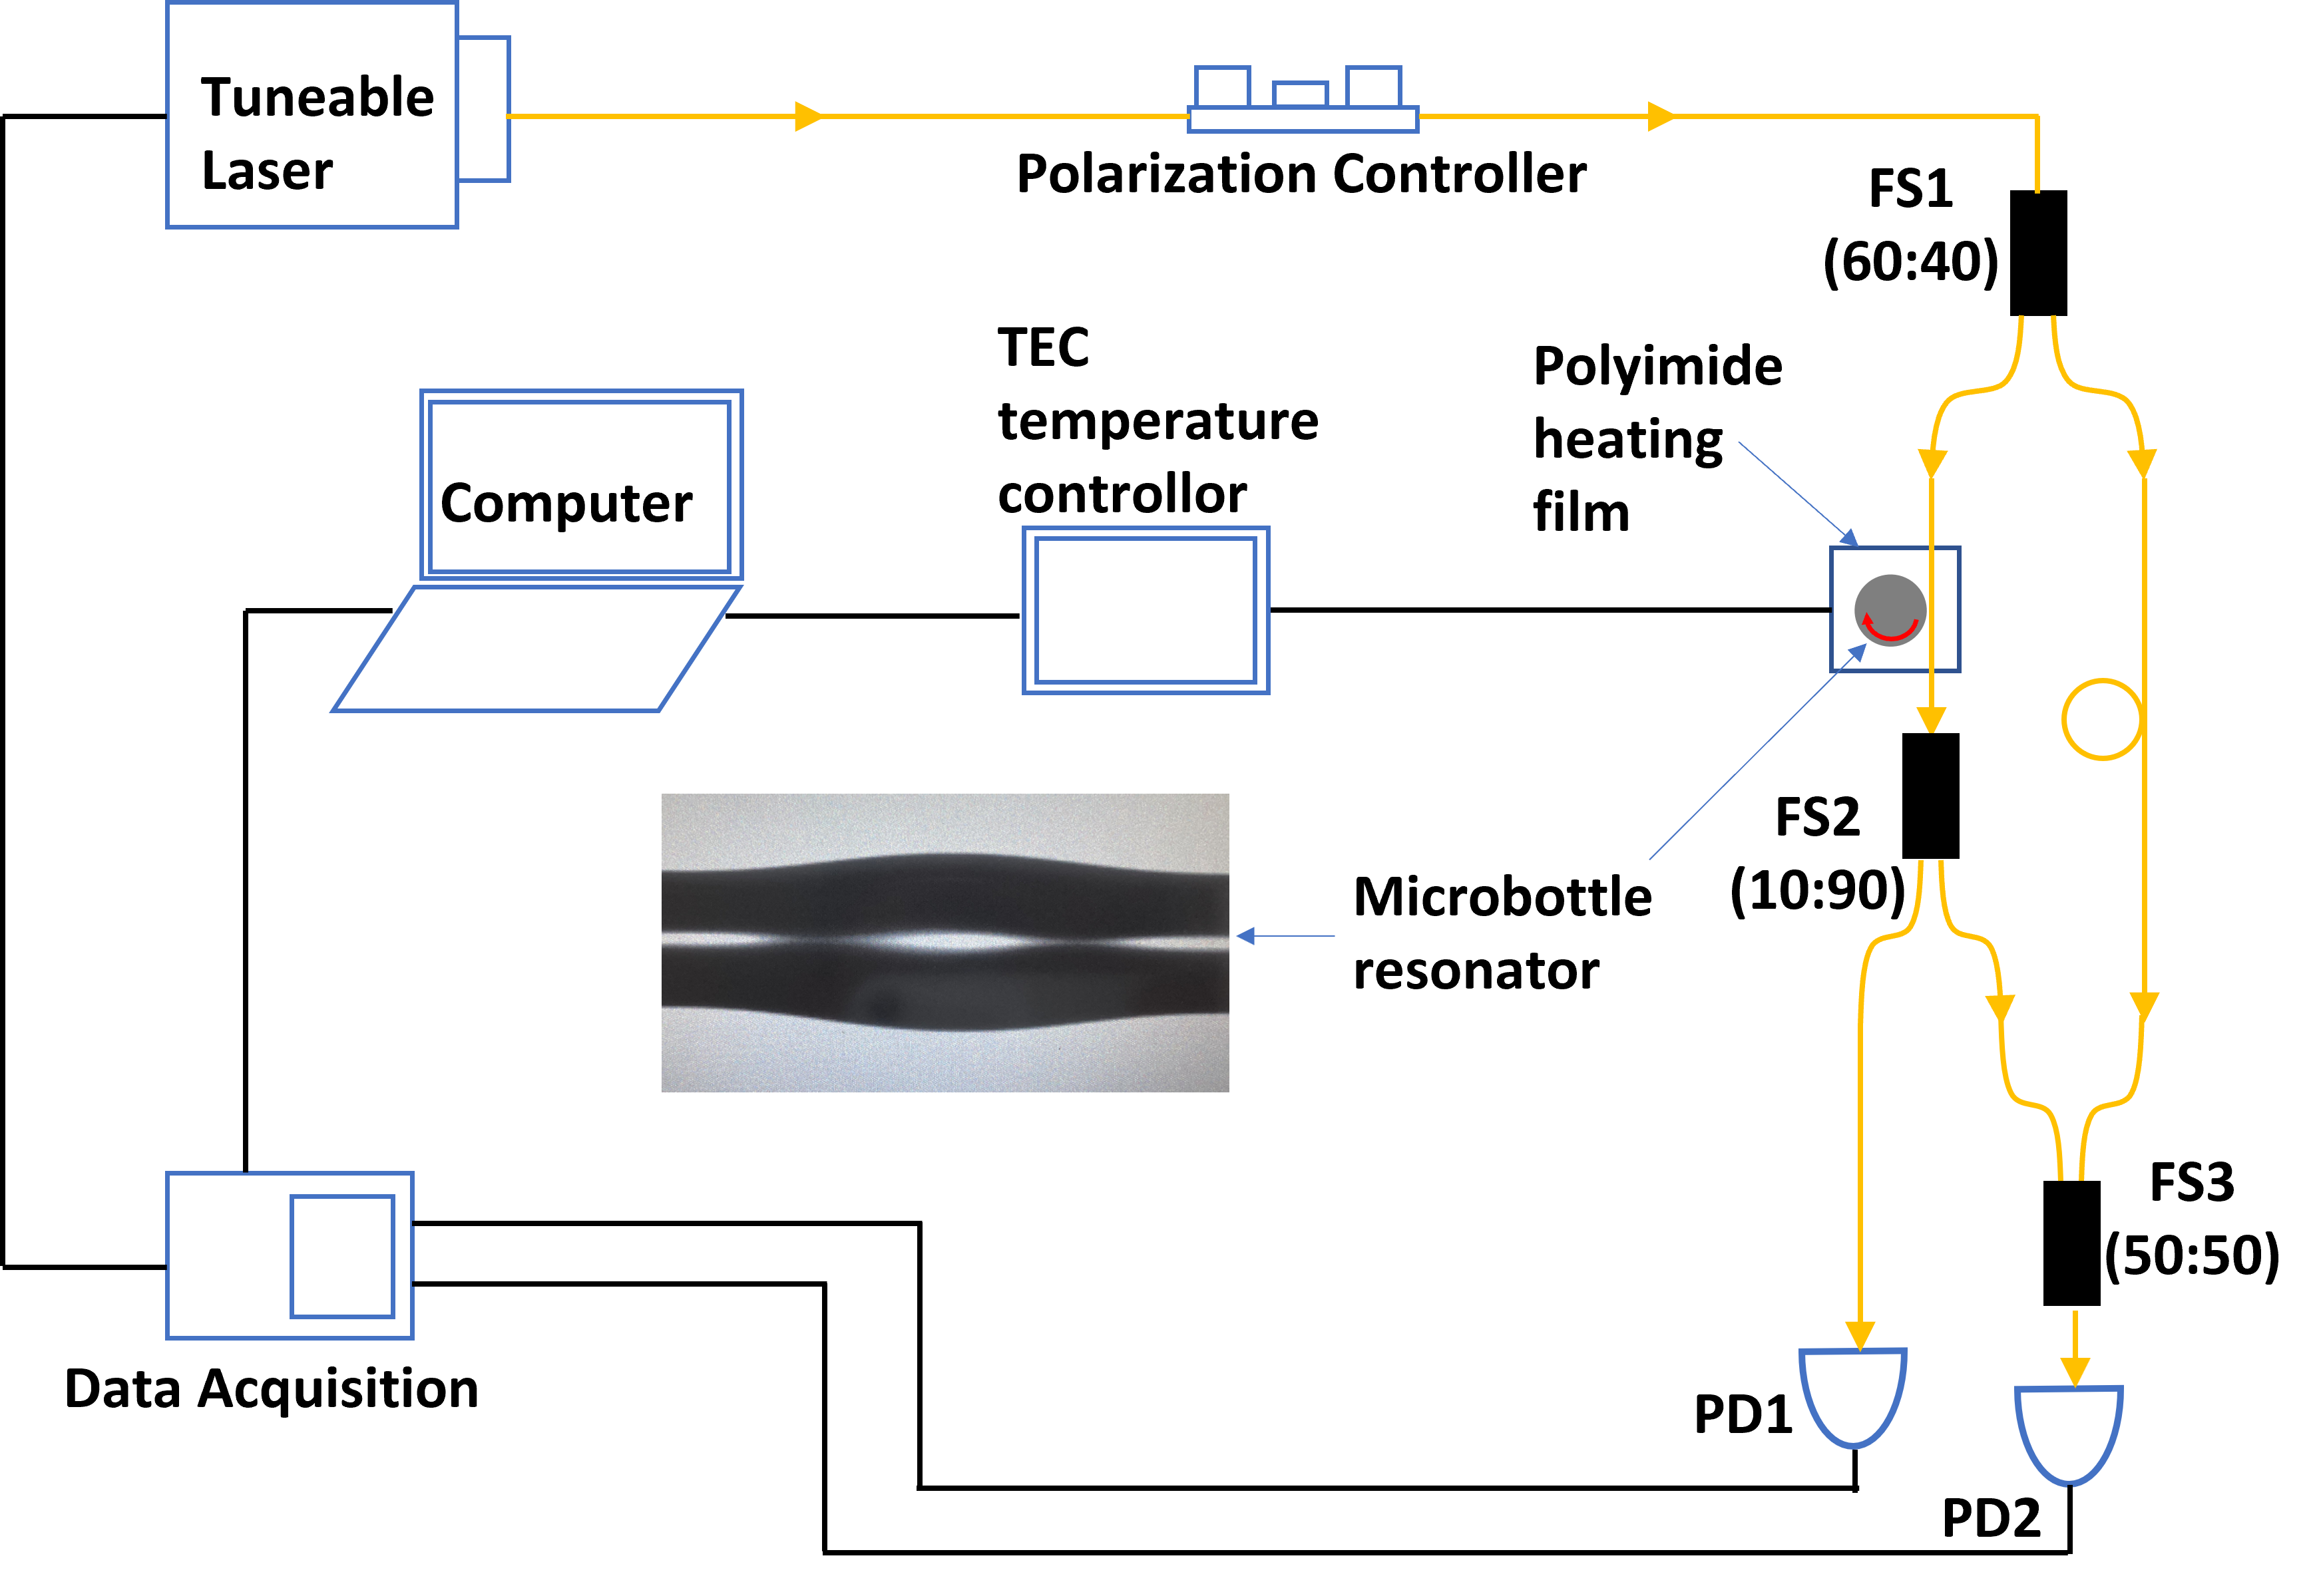

**Fig. 2** Schematic of the experimental setup. FS: Fiber Splitter. PD: Photodetector. The light from a tunable laser is used to probe the spectrum of the WGM and MCFZMI and its polarization is controlled by the polarization controller. The transmission spectrum of WGM and MCFZMI are received by two photodetectors, which are both connected to a computer with a data acquisition card for control of laser scanning and signal processing

As previously analyzed, ***ΔL*** and ***L*** are critical for the temperature sensing. In our experiment, ***ΔL*** and ***L*** are 13.6 cm and 52 cm respectively. Fig. 3(a) and 3(b) respectively illustrate the experimentally measured spectra of the WGM and the MCFZMI, as the temperature is incrementally raised in 0.01 °C steps from an initial 25 °C under the regulation of a TEC temperature controller. The red and blue lines in Fig. 3(a) and (b) depict the shifts of the WGM mode and FMZI, respectively, exhibiting a clear opposite trend. The WGM resonant frequency and the trough of FMZI change with linear temperature-dependent rates of 1.92 GHz/°C and 9.28 GHz/°C as is fitted in Fig. 4(a). The temperature detection limits of both methods were calculated by dividing the standard deviation of the resonant frequency by the fitted sensitivity. As shown in Fig. 4(b), the WGM achieves a temperature detection limit of 0.0015°C, whereas the FMZI only reaches 0.005°C. The temperature detection limit of the FMZI is primarily limited by the trough jitter in the FMZI caused by factors such as fiber vibration. Fig. 4(c) depicts the intensity variation of the red points marked in Fig. 3(b). In Fig. 4(c), the error bars represent the standard deviation of intensity from 40 repeated measurements. Under experimental conditions, the maximum standard deviation of intensity does not exceed 1.2 dB. In accordance with Eq. (3), the intensity exhibits a trigonometric dependence on temperature. Consequently, the following trigonometric function was employed to fit the experimental data:

. (6)

An R² of 0.9839 indicates a good fitting accuracy. By differentiating Eq. (6), the sensitivity at different temperatures shown by the red line in Fig. 4 (d) can be obtained. The sensitivity varies roughly within the range of 20 – 300 dB/°C, with a maximum up to 307.5 dB/°C. This sensitivity is greater than the 7.49 dB/°C achieved in waveguide-microring Fano structure[15] and 1.596 dB/°C obtained by a silicon eye-like double-rings structure[16]. The blue dots in Fig. (d) represent the temperature detection limits calculated by dividing the standard deviation of intensity by the sensitivity.

The intensity-based detection method achieves a temperature detection limit of approximately 0.004 °C, which is higher than the 0.0015 °C limit attained by the WGM frequency shift. However, existing theoretical work[17] have shown that, compared with frequency shift, intensity detection is immune to frequency noise and exhibits better sensing performance at high signal-to-noise ratios. Therefore, we compared the performances of the two sensing methods under different noise conditions through numerical calculations. We fitted the WGM and MCFMZI spectra at 25.07 °C in Fig. 3, then added random frequency and intensity noise to the fitted spectra. By calculating the spectra 10,000 times, we obtained the distributions of the resonance frequency in the WGM spectrum and the Fano dip in the MCFMZI spectrum. Based on the sensitivity obtained from the experiment, the temperature detection limit can be calculated. Fig. 4(e) shows that the MCFMZI temperature detection limit is immune to frequency noise, while the WGM limit increases linearly with such noise. When the frequency noise of the measurement system exceeds 8 MHz, MCFMZI outperforms WGM in sensing performance. Additionally, SNRs of 30 dB, 50 dB, and 70 dB barely affect the temperature detection limits of both MCFMZI and WGM. For WGM, this is mainly due to its high Q factor, rendering its detection limit insensitive to SNR variations. MCFMZI's detection limit, constrained by MZI spectrum jitter from fiber vibrations, does not vary when SNR changes. By controlling MZI spectral jitter (e.g., via on-chip integration), MCFMZI can achieve superior sensing performance at high SNRs. As shown in Fig. 4(f), in the absence of MZI spectral jitter, the temperature detection limit of the MCFMZI progressively surpasses that of the WGM under 1 MHz frequency noise as the signal-to-noise ratio (SNR) increases, achieving 1.14×10−5 °C at 70 dB SNR and 4×10−6 °C at 80 dB SNR, compared to the WGM’s limit of 3.5×10−4 °C, demonstrating the remarkable potential of MCFMZI for temperature sensing applications.

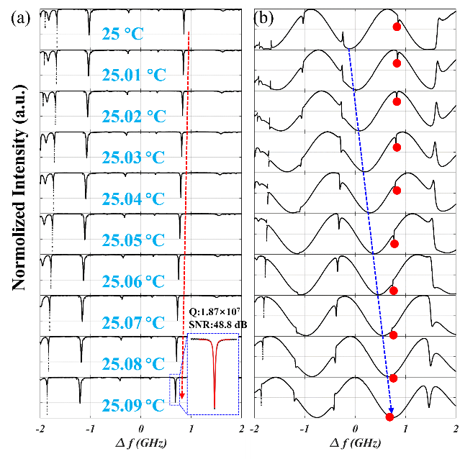

**Fig. 3** Measured transmission spectrum of microbottle (a) and MCFMZI (b) at difference temperature. The red and blue dash lines in (a) and (b) illustrate the shifts of the WGM mode and FMZI respectively when temperature changes. The inset in (a) is the result of fitting with a Lorentzian function. The Q value of the fitted mode is 1.87×107 and the signal-to-noise ratio (SNR) is 48.8 dB.

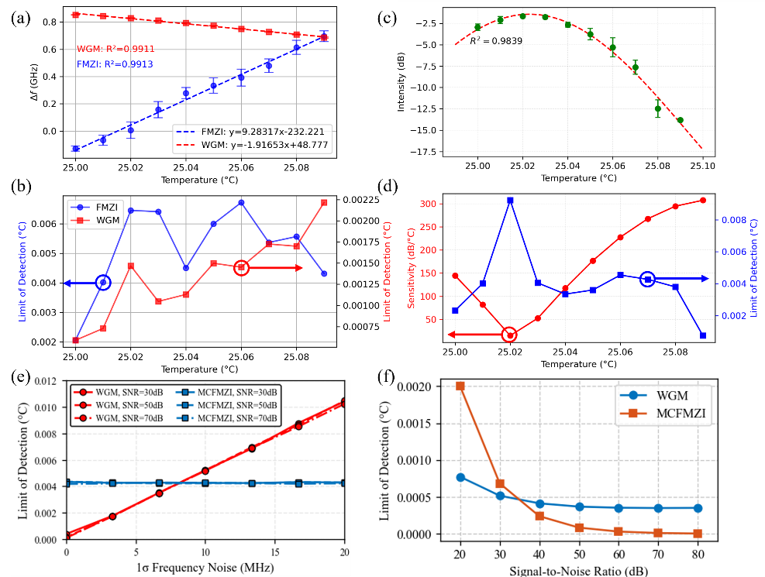

**Fig. 4** (a) shows the linear fitting of WGM (red line) and FMZI (blue line) shifts in Figure 3, and (b) presents the corresponding detection limit calculated by the ratio of standard deviation to sensitivity. (c) shows the intensity of Fano dip (the red dots in Figure 3(b)) at different temperature, red dash line is the sine function fitting curve. (d) shows the sensitivity (red dots) and detection limit (blue dots) of MCFMZI at different temperatures. (e) shows comparison of numerically calculated detection limit between MCFMZI (blue dots) and WGM (red dots) under different frequency noises at 25.07 °C. The performance of both methods was evaluated at SNR of 30 dB, 50 dB, and 70 dB respectively. (f) A comparison of the temperature detection limits between MCFMZI and WGM under different SNRs at 1 MHz frequency noise without FMZI spectral jitter.

**4. Photonic barcode for wide-range temperature sensing**

Although an ultra-high sensitivity can be achieved based on the strategy of converting small frequency shifts into large intensity changes, intensity changes following sine wave function as shwon in Eq. (6), the period is 0.28 °C, which means that intensity repeats every 0.14 °C (half cycle). To address this issue, the photon barcoding technique has been put forward[18, 19]. Its approach involves barcoding the spectrum at a specific temperature to form a barcode database, and the real-time temperature can be obtained by looking up the table during sensing. The proposed photonic barcode exhibits the following advantages:

* **Large detection range:** Photonic barcode records the entire spectrum rather than a specific mode, enabling continuous temperature recording even when some modes move out of the detection range.
* **Enhanced sensing precision:** the concurrent recording of multiple WGMs mitigates mode position uncertainties, leading to an enhancement in temperature sensing precision[20].

Despite the aforementioned advantages, the existing photonic barcoding technology still has the following shortcomings:

* **Bulky database**: Intensity information of all sampling points in the spectrum is needed to convert to barcode, but only the intensity of certain specific frequency points is truly used for sensing, a large amount of redundant information is recorded, which increases the difficulty of barcode matching during calibration and table lookup. Meanwhile calibrating temperature through interpolation becomes difficult.

Here instead, we utilized the universal barcode encoding rules to encode the frequency and intensity information of the spectrum. This approach not only preserves the high sensitivity of intensity-based methods but also extends the temperature detection range and significantly improves the practical applicability of the barcode-based sensing scheme.

Our encoding method is illustrated in the Fig. 5 (a)-(d), the encoding steps are as follows:

Step 1: Select three modes with the deepest coupling depth on the spectrum of the microbottle and record their relative positions (the offset relative to the lowest frequency of the frequency sweep). Compared with a single mode, three modes contain more Fisher information, which allows for a more accurate estimation of the spectral shift. To quantitatively analyze the improvement in sensing performance brought about by the three modes, we refer to the Cramér–Rao bound (CRB) from estimation theory and statistics to evaluate the spectral shift. The CRB of spectral shift estimation is expressed as[21]:

 (7)

The CRB here represents the minimum variance of the spectral mode shift caused by photon noise. The smaller this value is, the higher the estimation accuracy of the spectral shift can be achieved, that is, it indicates better sensing performance. In the formula, ***Δ*f** is the sampling resolution, **SNR** is the signal-to-noise ratio, **T*(f)*** is the normalized spectral intensity, and **w** is the frequency range. For the spectrum of the WGM shown in Figure 5(a), with ***Δf*** = 4 GHz/25000 and SNR=48 dB, the CRB of Mode 2 in the figure calculated according to Eq. (7) is 2.73×10−7 GHz2, while that of the three modes is 1.47×10−9 GHz2. Therefore, in theory, three modes can achieve better accuracy in spectral mode shift. Moreover, the abundant modes of the microbottle cavity make it possible to find three modes at any temperature.

Although multi-mode sensing is capable of achieving higher accuracy in spectral shift, the primary factor influencing the spectral shift accuracy within our sensing system is thermal noise. The mode jitter induced by thermal noise is roughly on the order of 0.005 GHz. Considering the frequency-sweeping range of 4 GHz, each recorded frequency can be represented by a three - digit decimal number. For example, 0.66 GHz is represented as 066. Therefore, a nine-digit decimal number can record the positions of three modes.

Step 2: Based on the resonant frequencies of the three WGMs, the corresponding intensity can be retrieved from the same positions in the spectrum of the MCFMZI. Similar to the encoding of frequencies, taking into account the extinction ratio of 15 dB of the MZI, each intensity value can be represented by a three-digit decimal number. For example, -1.7 dB is represented as 085(1.7/0.2, the reason for dividing by 0.2 is that the ratio of the standard deviation to the mean intensity for all temperature points in Fig. 4(c) is less than 0.2). Therefore, three intensity values can also be represented by a nine-digit decimal number.

Step 3: The R-type encoding rule used in the product encoding of EAN-13[22] is adopted to encode the 18 digits that record the frequencies and intensities. The encoding rule is shown in Fig. 5(c). Each digit is represented by a 7-bit binary number, and the binary digits 0 and 1 are represented by black and white bars of equal width (black for 1 and white for 0). The advantage of this encoding method is that even if some bars are blocked, the entire barcode information can still be correctly read. Based on this rule, the barcode at a specific temperature obtained is shown in Fig. 5(d). This barcode can not only accurately calibrate the temperature but can even enable a barcode scanning machine to read the temperature.

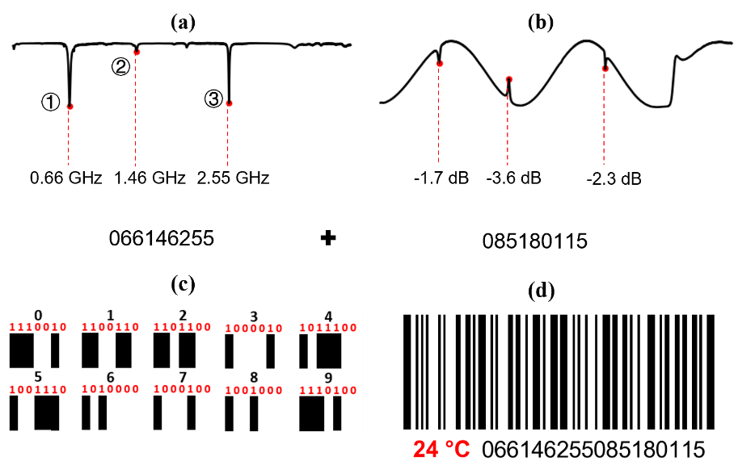

**Fig. 5** illustrate the encoding mechanism. Specifically, (a)-(b) present the calculated spectra of the microbottle and MCFZMI, respectively. (c) demonstrates the R-type encoding rule, and (d) shows the barcode at a specific temperature obtained according to the encoding rule.

The barcodes implemented based on the R-type coding rules have another advantage: the matching between barcodes can be achieved through the Bit Error Rate (BER). Fig. 6 demonstrates this matching mechanism. As shown in Fig. 6(a), when the BER between the measured barcode and the calibrated barcode is lower than 20%, it is considered a successful match, and the measured temperature is taken as the calibrated temperature.

It should be noted that the calibrated barcode here refers to the barcode obtained by taking the average of multiple measurements. Fig. 6(b) shows the source of the 20% threshold. The green dots in Fig. 6(b) represent the BERs calculated between the barcode calibrated at 25 °C and 40 real-time measured barcodes at 25 °C with a 10-second interval. Notably, the average BER at identical temperatures is 13%, with the maximum value reaching 18%. On the other hand, the red dots in Figure 6(c) tell that the BERs between the calibrated barcodes corresponding to temperatures ranging from 25.01 to 25.09 °C and the 25 °C-calibrated barcode all exceed 20%. Therefore, choosing a BER threshold of 20% can precisely determine temperature and guaranteeing barcode matching at the same temperature.

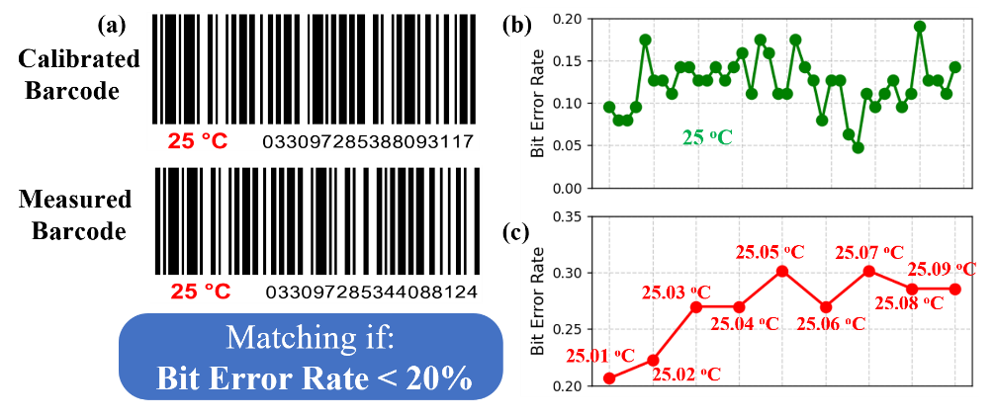

**Fig. 6** Matching Mechanism of Photonic Barcodes. (a) shows the calibrated barcode and the real-time measured barcode. Matching is achieved by calculating the Bit Error Rate (BER) between them. The BER threshold is 20%, and a match is considered successful if the BER is lower than this threshold. (b) BERs calculated between the barcode calibrated at 25 °C and 40 real-time measured barcodes at 25 °C with a 10-second interval. (c) BERs calculated between the barcode calibrated at 25 °C and barcodes obtained at several other temperatures.

The temperature-recording capability of the barcodes across various thermal increments were systematically investigated. As delineated in Fig. 7(c), under precisely controlled temperature gradients of 0.01 °C, 0.1 °C, 1 °C, 5 °C, and 10 °C, rigorous experimental protocols and high-fidelity data analytics confirm that the barcodes facilitate accurate and error-resilient registration of corresponding thermal data. Irrespective of subtle thermal differentials (0.01 °C) or pronounced temperature excursions (10 °C), the barcodes exhibit exceptional robustness and reproducibility in encoding and retrieving thermal information.

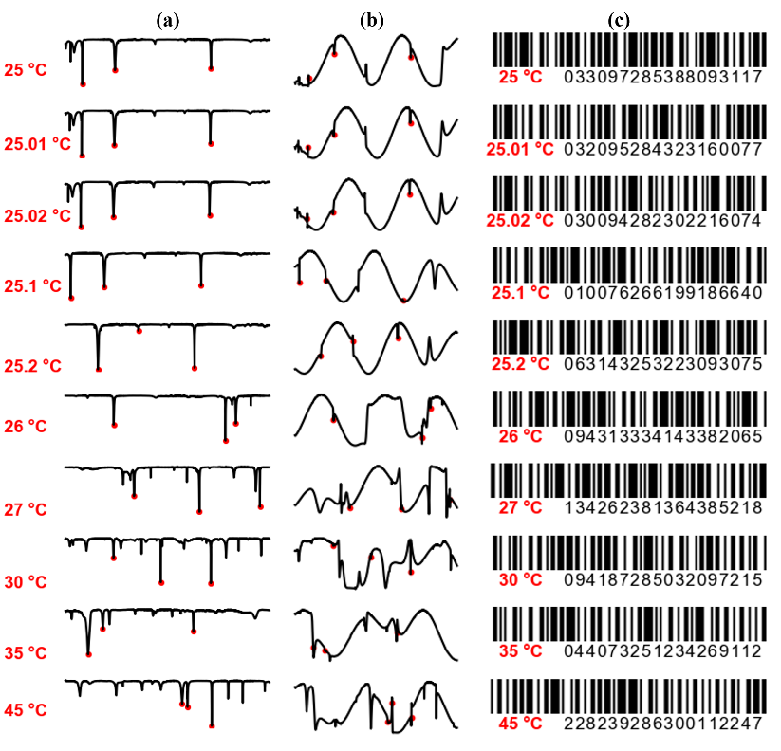

**Fig. 7** (a)-(b) the experimentally measured spectra of the microbottle and MCFZMI at different temperatures, (c) represents the barcodes corresponding to different temperatures.

1. **Conclusion**

In conclusion, a novel ultrasensitive and wide-range temperature detection method has been proposed based on coupling a microbottle resonator with a fiber Mach–Zehnder interferometer. The mechanism of the method is to change the small mode shift into large intensity variation. A temperature sensitivity of 307.5 dB/°C and a temperature resolution of 4x103 °C has been experimentally achieved. Theoretical analysis shows that the MCFMZI is capable of reaching a temperature detection limit of 4×10-6 °C under an 80 dB SNR, demonstrating a two-order-of-magnitude enhancement compared to the WGM's detection limit of 3.5×10-4 °C. Moreover, experiments have confirmed that by using the encoding method of universal commercial barcodes to record the changes in the resonant frequencies and intensities of the modes, temperature sensing with an almost unlimited range can be achieved. This method enables the realization of high-sensitivity and broad-range temperature sensing, offering significant potential for temperature sensing applications. Meanwhile, we used the Bit Error Rate as the matching condition for barcodes, making the proposed barcodes more valuable for practical applications. In the prospective outlook, despite the necessity of extensive calibration efforts for temperature sensing based on barcodes, it remains technically viable to enhance the temperature resolution through interpolation techniques within a restricted temperature domain. This approach holds potential for advancing the precision of barcode-based temperature sensing systems, thereby facilitating more accurate thermal measurements and analyses.

**Funding**. This research was funded by National Natural Science Foundation of China (NSFC) (11874122, 11474070, 61327008 and 11074051) and Doctoral Program of Higher Education (20130071130004).

**Disclosures.** The authors declare no conflicts of interest.

**Data availability.** Data underlying the results presented in this paper are not publicly available

at this time but may be obtained from the authors upon reasonable request.

**References**

1. A. Zhou, Y. Zhang, Q. Xu, et al., "Semi-open cavity in-fiber Mach–Zehnder interferometer for temperature measurement with ultra-high sensitivity," Appl. Opt. 53(12), 2696-2701 (2014).
2. B. Sun, Y. Wang, J. Qu, et al., "Simultaneous measurement of pressure and temperature by employing Fabry-Perot interferometer based on pendant polymer droplet," Opt. Express 23(3), 1906-1911 (2015).
3. W. Qian, C.-L. Zhao, S. He, et al., "High-sensitivity temperature sensor based on an alcohol-filled photonic crystal fiber loop mirror," Opt. Lett. 36(9), 1548-1550 (2011).
4. A. Arora, M. Esmaeelpour, M. Bernier, et al., "High-resolution slow-light fiber Bragg grating temperature sensor with phase-sensitive detection," Opt. Lett. 43(14), 3337-3340 (2018).
5. Z. Liu, L. Liu, Z. Zhu, et al., "Whispering gallery mode temperature sensor of liquid microresonastor," Opt. Lett. 41(20), 4649-4652 (2016).
6. Q. Ma, T. Rossmann, and Z. Guo, "Temperature sensitivity of silica micro-resonators," J. Phys. D: Appl. Phys. 41(24), 245111 (2008).
7. C. He, H. Sun, J. Mo, et al., "Temperature sensor based on high-Q polymethylmethacrylate optical microbubble," Laser Phys. 28(7), 076202 (2018).
8. C.-H. Dong, L. He, Y.-F. Xiao, et al., "Fabrication of high-Q polydimethylsiloxane optical microspheres for thermal sensing," Appl. Phys. Lett. 94(23)(2009).
9. L. Zhao, Y. Wang, Y. Yuan, et al., "Whispering gallery mode laser based on cholesteric liquid crystal microdroplets as temperature sensor," Opt. Commun. 402, 181-185 (2017).
10. L. Xu, X. Jiang, G. Zhao, et al., "High-Q silk fibroin whispering gallery microresonator," Opt. Express 24(18), 20825-20830 (2016).
11. I. M. White and X. Fan, "On the performance quantification of resonant refractive index sensors," Opt. Express 16(2), 1020-1028 (2008).
12. Y. Lu, J. Yao, X. Li, et al., "Tunable asymmetrical Fano resonance and bistability in a microcavity-resonator-coupled Mach–Zehnder interferometer," Opt. Lett. 30(22), 3069-3071 (2005).
13. X. T. Gan, C. Y. Zhao, Y. D. Wang, et al., "Graphene-assisted all-fiber phase shifter and switching," Optica 2(5), 468-471 (2015).
14. X. Jin, X. Xu, H. Gao, et al., "Controllable two-dimensional Kerr and Raman–Kerr frequency combs in microbottle resonators with selectable dispersion," Photonics Res. 9(2), 171-180 (2021).
15. C. Zhang, G. Kang, Y. Xiong, et al., "Photonic thermometer with a sub-millikelvin resolution and broad temperature range by waveguide-microring Fano resonance," Opt. Express 28(9), 12599-12608 (2020).
16. C. Qiu, T. Hu, P. Yu, et al., "A temperature sensor based on silicon eye-like microring with sharp asymmetric fano resonance," in The 9th International Conference on Group IV Photonics (GFP), (IEEE, 2012), 123-125.
17. H. Ren, C.-L. Zou, J. Lu, et al., "Dissipative sensing with low detection limit in a self-interference microring resonator," **J. Opt. Soc. Am. B: Opt. Phys.** 36(4), 942-951 (2019).
18. H. Li, Y. Lu, S. Zhou, et al., "Packaged WGM MBR sensor for high-performance temperature measurement using CNN-based multimode barcode images," Opt. Express 32(4), 5515-5528 (2024).
19. J. Liao and L. Yang, "Optical whispering-gallery mode barcodes for high-precision and wide-range temperature measurements," Light: Sci. Appl. 10(1), 32 (2021).
20. J. Liao and L. Yang, "Multimode Sensing by Optical Whispering-Gallery-Mode Barcodes: A New Route to Expand Dynamic Range for High-Resolution Measurement," IEEE Trans. Instrum. Meas. 73(1-10 (2024).
21. H. Chen, Z. Wang, Y. Wang, et al., "Machine learning-assisted high-accuracy and large dynamic range thermometer in high-Q microbubble resonators," Opt. Express 31(10), 16781-16794 (2023).
22. https://www.ean-search.org/.