Ultra-sensitive Active Whispering Gallery Mode Sensor in an Optofluidic Microcapillary with Vernier Effect of Coupled Modes

Biao Li,1 Liying Liu,1* and Lei Xu1,2

1 Key Lab for Micro and Nanophotonic Structures (Ministry of Education), Department of Optical Science and Engineering, School of Information Science and Engineering, Fudan University, Shanghai 200433, China

2 Department of Physics, Fudan University, Shanghai 200433, China

*lyliu@fudan.edu.cn

**Abstract:** Ultrahigh sensitivity is achieved in an optofluidic microcapillary active sensor by utilizing the Vernier effect of coupled whispering gallery modes. A refractive index sensitivity of 2924 nm/RIU is obtained experimentally, which is 7 times higher than the sensitivity limit of a conventional whispering gallery mode sensor. By reducing the wall thickness of the microcapillary to decrease the difference of free spectral range of the coupled whispering gallery modes, further improvement in refractive index sensitivity can be as high as 48426 nm/RIU. This sensing strategy allows us to design a robust, easily fabricated ultra-sensitive optical sensor for microfluidic sensing applications.

1. **Introduction**

Optical refractive index (RI) sensors, with advantages like high sensitivity, real-time and label-free detection, detect target substances by measuring refractive index changes and are widely used in biomedical detection, environmental monitoring, and chemical analysis. Among the various types of optical RI sensors, including Mach-Zehnder interferometers[1], fiber Bragg gratings[2], and surface plasmon resonance sensors[3], fiber directional couplers[4] etc., microcavity-based RI sensors[5] stand out for their small size, high Q-factor, high sensitivity, and ease of integration, with Whispering Gallery Mode (WGM) microcavity serving as a representative example.

Optical whispering gallery mode (WGM) microcavity confines light to the surface of a smooth circular dielectric structure. Analytes contact with the evanescent waves of the resonant mode and is naturally suitable for RI sensing applications. Of the various WGM structures[6], such as microdisks, microspheres, microbubbles, etc., microcapillaries received significant attention because of its easy fabricated structure, simplified mode spectrum, and hollow fluid channels, which are crucial for bio- and chemical sensing applications.

Microcapillary sensors are mainly divided into two types: passive sensors[7] and active sensors[8]. In passive sensors, single frequency laser light is coupled to the capillary, whispering gallery modes can be clearly observed by scanning the input laser frequency, they have demonstrated to have significant potential for biomolecule detection[9] and chemical-vapor sensing[10]. However, light coupling schemes by tapered fiber[11] or prism[12] make these passive sensors less robust for practical sensing application. The active sensor on the other hand addresses light coupling problem. By coating an active layer on the microcapillary or using an active core, fluorescent whispering gallery modes (WGM) spectrum is generated under external optical pumping, resonance shift can be measured and providing sensing property. In active sensors, no precise control of input/output light coupling is required, making microcapillary sensors more suitable for microfluidic sensing applications[13-16].

In principle, the sensitivity (***S***) of a whispering-gallery mode (WGM) RI sensor quantifies the resonance wavelength (or frequency) shift(***Dl***) induced by variations in the refractive index of the analyte(***Δn***). It is fundamentally governed by the fraction of the mode field interacting with the analyte and typically falls within the range of 30 nm/RIU[17] to 570 nm/RIU[18]. Since the mode field cannot be entirely confined within the analyte, traditional WGM sensors have a sensitivity limit of ***λ***/***n***, where ***λ*** is the working wavelength and ***n*** is the refractive index of the analyte. Many efforts have been carried out to approach the sensitivity limit. Take microcapillary sensor as an example, methods include reducing wall thickness[19], increasing the radial order number in the evanescent sensing regime[20], using a low-refractive-index inner-coating[21] etc.. On the other hand, coupled modes provide an approach to break the sensitivity limit. In our previous work, a sensitivity of 2510 nm/RIU was achieved in a sensor consisting of a cylindrical ring laser and a thin-wall optofluidic capillary, the ultra-high sensitivity came from Vernier effect generated by the coupling[22], but precise control of the coupling of two cavities is difficult. There were also attempts to use mode coupling in one capillary sensor. W.Morrish et al reported a sensitivity up to 914 nm/RIU[23] and 863 nm/RIU in a laser microcapillary, they attributed the over-limit sensitivity to the opposite shift of a "triangle" modes and whispering gallery modes when refractive index of the core changed[24].

In this work, we systematically investigated theoretically and experimentally the mode coupling in a single optofluidic microcapillary active sensors (OMAS). By using the Vernier effect of coupled modes, an RI sensitivity of 2924 nm/RIU is experimentally achieved, which is 7 times higher than that of the sensitivity limit. Further calculation predicts that by reducing the wall thickness of the capillary, the sensitivity can be as high as 48426 nm/RIU. This sensing strategy considerably simplifies the fabrication of the coupled cavity, improves the robustness of the sensor, and promotes the application of microcapillary in optical microfluidic sensing.

1. **Principle and calculation of sensing**

The proposed OMAS sensing system is shown in Fig. 1(a), the hollow structure of capillary provides a channel for liquid refractive index sensing. By adding a gain medium in the liquid under test and applying external pumping, high-sensitivity refractive index detection is achieved by measuring the emitted laser spectrum. Fig. 1(b), shows the cross-section of the microtubule. The capillary has an outside radius ***R***, wall thickness ***t***. The refractive index of the optofluidic core, wall, and surrounding medium are denoted by ***n3***, ***n2*** and ***n1***. When ***n3*** > ***n2*** > ***n1***, both the interfaces of microcapillary can generate WGM. The WGM that exists on the liquid core/microcapillary interface is called "Core mode", while that exists on the microcapillary/surrounding medium interface is "Wall mode". These modes are represented by the blue and red lines in Fig. 1(b), respectively. The radial distribution of the WGM in microcapillary can be described by Mie theory[25]:

(1)

Where ***Jm*** and ***H1 m*** are the ***m***th Bessel function and the ***m***th Hankel function of the first kind, respectively. ***k*** is the wave vector in vacuum, ***r*** is the distance from the center of the capillary. The resonant wavelength and field distribution of the microcapillary can be solved by using boundary conditions[17]. Fig. 1(c) illustrates the calculated 18th to 22nd radial modes of capillary with parameters: ***n2***= 1.4568, ***n1*** = 1.0, ***R*** = 62.94 μm, ***t*** = 11.53 μm, and ***m*** = 753. As for the wall mode and core mode indicated as black dotted lines in Fig. 1(c), *Er* can be independently calculated by:

(2)

As shown in Fig. 1(c), when the refractive index of the liquid core changes, the wall mode and the core mode tend to become identical at a certain liquid-core refractive index(anti-crossing point), resulting in strong coupling. The coupling between the 1st core mode and the 19th wall mode leads to the formation of two super-modes: the 19th mode and the 20th mode. According to the coupled mode theory[26], these two super-modes have the following resonance frequency expressions:

(3)

Where ***ω***c and ***γ***c correspond to the eigen frequency and loss coefficient of the 1st core mode, while ***ω***w and ***γ***w correspond to those of the 19th wall mode, ***g*** denotes the coupling strength. **ω-** and **ω+** are the resonance frequencies of 19th mode and the 20th mode. The square root term in Eq. (3) represents the splitting of the coupled modes. When the resonance frequency of the core mode and the wall mode are equal, the splitting reaches its maximum, indicating the strongest coupling. Fig. 1(d) provides a zoomed-in view of the anti-crossing region and highlights the anti-crossing point near ***n3*** = 1.5126. Fig. 1(e) shows the field distributions of the 19th and 20th modes under different liquid core refractive index. As the refractive index increases, the field of the 19th mode shifts from the capillary wall to the liquid core, while the 20th mode behaves oppositely. At the anti-crossing point, the field distributions of the two modes become nearly identical. The similar field distributions lead to identical free spectral ranges (FSR) for both modes, which in turn impacts on the sensitivity of the sensor.

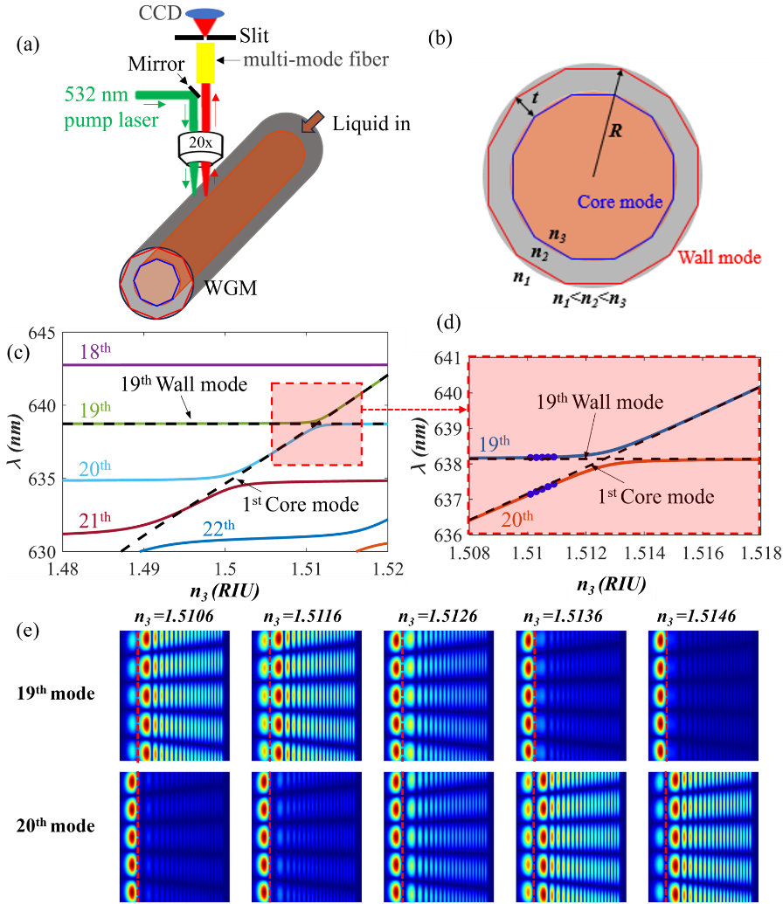

Fig. 1 (a) Schematic of OMAS sensing system. (b) Cross section of OMAS, the outer radius and the wall thickness are ***R*** and ***t***. (c) Calculated changes of resonant wavelength of different radial mode with the refractive index of liquid core ***n3***, the black dotted lines are calculated radial 19th wall mode and 1st core mode. (d) is enlarged shadow part in Fig. 1(c), the blue points in the figure correspond to refractive indices of 1.5101, 1.5103, 1.5105, 1.5107, and 1.5109, respectively. (e) Field distributions of the 19th and 20th modes under different liquid core refractive index, the red dashed line marks the interface between the liquid core and the tube wall.

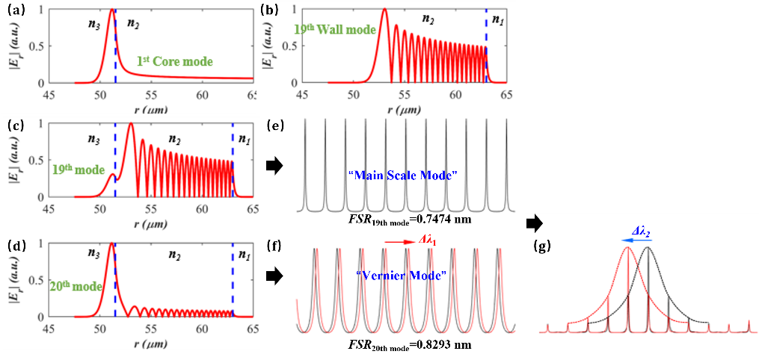

Fig. 2 (a)-(d) Calculated field intensity distributions of the 1st core mode、19th wall mode、19th coupled mode and 20th coupled mode at liquid core refractive index of 1.5101. (e) and (f) are the spectra of the 19th and 20th coupled mode, (g) is the modulated spectrum generated by the two coupled modes. The blue arrow indicates the direction of the modulated spectrum's shift when 20th mode undergoes a redshift.

Fig. 2 (a)-(d) show the calculated field distributions of the 1st core mode、19th wall mode、19th coupled mode and 20th coupled mode at liquid core refractive index of 1.5101. The field distribution of the 19th mode closely resembles that of the 19th wall mode, and this mode is referred to as the "Main Scale mode". In contrast, the field distribution of the coupled 20th mode is similar to that of the 1st core mode and is highly sensitive to changes in ***n₃***, which we designate as the "Vernier mode".

Fig. 2(e)-(f) exhibits the corresponding resonant spectrum of the modes. Due to the slightly different FSR of the main scale mode and vernier mode, the spectral modulation between the two modes forms a Lorentzian envelope. When ***n3*** changes to ***n3*** +Δ***n3***, the spectrum of the vernier mode undergoes a red shift **Δ*λ1***, indicated by the red arrow in Fig. 2(f). Meanwhile, the spectrum of the main scale mode remains unchanged, because it almost does not depend on ***n3***. Simultaneously, the Lorentzian envelope peak in the detected spectrum generates a blue shift of **Δ*λ2***:

(4)

Where FSRmainscale/|FSRmainscale – FSRvernier| is the sensitivity amplification factor (***M***) of the Vernier effect. If the main scale mode also experiences a slight red shift **Δ*λ3***, then Eq. (4) can be modified to:

(5)

thus, the sensitivity (***S***) of the OMAS is:

*S* =(6)

Where ***S***mainscale and ***S***vernier correspond to the sensitivities of main scale mode and vernier mode, respectively. Therefore, the sensitivity of OMAS mainly depends on the difference in FSR (DFSR) between main scale mode and vernier mode. Additionally, note that since *FSRvernier* > *FSR*mainscale,the redshift of the vernier mode results in a smaller detuning occurring first at shorter wavelengths, manifesting as a blue shift in the envelope of the spectrum. The result agrees with the observation when two cavities are coupled[22, 27]. Consequently, in systems employing Vernier effect sensing, if the FSR of the vernier mode is smaller than that of main scale mode, the envelope of the modulated spectrum is expected to exhibit a redshift or blueshift in tandem with the vernier mode.

Furthermore, when ***n3*** < ***n2***, meaning the refractive index of the analyte is lower than 1.45, mode coupling no longer occurs. However, mode coupling can still be achieved by coating the inner wall of the capillary with a low-refractive-index thin film[21]. Therefore, the proposed mode coupling strategy remains effective for sensing aqueous phases and biomolecules.

1. **Experimental Setup and Results**

We also experimentally investigated the sensing properties of the OMAS. The experimental setup is illustrated in Fig. 1(a). A silica capillary has an approximate outer radius of 63 μm and wall thickness of 11.5 μm, dye solution (dissolving RhB in different reagents at 0.5 mg/mL, the reagent details are below.) was filled into the tube by a syringe pump. A nanosecond pulse laser (Minilite Ⅱ, repeat frequency 10 Hz, 20 mJ per pulse) operating at 532 nm with TM polarization was focused perpendicularly on capillary using a 20× microscope objective. The TM mode was chosen for its higher sensitivity compared to the TE mode[28]. The focused spot on capillary was about 10 µm². The spectrum emitted by the capillary was also collected by the objective lens and then coupled into a multimode fiber. The end of the multimode fiber was aligned with the slit of the spectrometer(Acton, SpectraPro-2750), and the spectrum was captured by the CCD after passing through the slit. The laser spectra captured from OMAS at a pump energy density of 2.5 μJ/mm2 and a CCD integration time of 1 ***s*** are shown in Fig. 3(a)-(b).

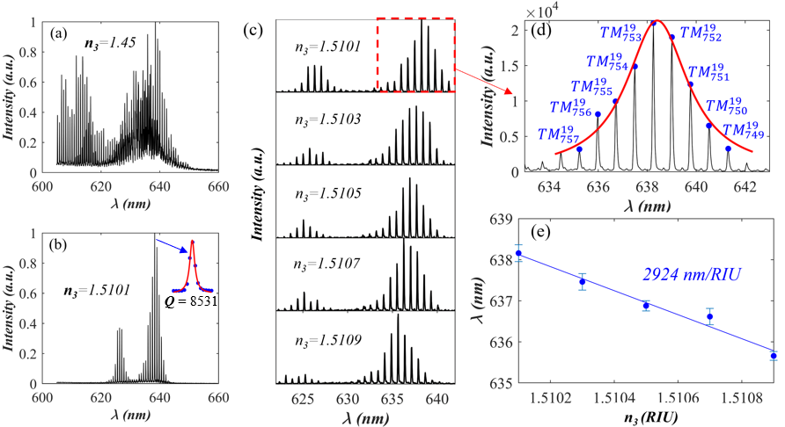

Fig. 3 Measured emission spectra of OMAS when the liquid channel is filled with different dye solutions. (a) The refractive index of the core is ***n3*** = 1.45. (b) ***n3*** = 1.5101. The illustration in (b) shows the Lorentzian fitting result of the highest spectral peak, with a fitted Q value of 8531 (c) The measured emission spectra of the active microcapillary at different core refractive index. (d) A zoomed-in image of the emission spectrum at ***n3*** = 1.5101. The red curve is the Lorentzian fitting. The blue point is the mode calculated with the parameter: ***R*** = 62.94 μm and ***t*** = 11.53 μm. ***TMq m*** indicates the polarization state and order of the calculated mode, ***q*** and ***m*** represent the radial and angular orders, respectively. (e) Change of fitted Lorentzian envelope center versus ***n3***, a linear fitting gives a sensitivity of 2924 nm/RIU.

Fig. 3(a) shows the fluorescence spectrum of RhB in a DMSO/ethanol mixture with a volume ratio of 3.5:1, where the refractive index of the mixture is ***n₃*** = 1.45. At this refractive index, a chaotic multimode laser spectrum emerged. Fig. 3(b) is the emitted spectrum when the solvent is changed to a mixture of DMSO/benzyl alcohol at a ratio of 1:1.6, with ***n3*** = 1.5101. A prominent modulated envelope with a Lorentzian profile is observed in the emission spectrum, and the Q-factor of the mode is approximately 8×10³. Fig. 3(c) shows the spectra when ***n3*** changes in a step of 0.0002 RIU, the modulated spectrum envelope progressively blue shifts. The blue dots in Fig. 3(d) denote the theoretically calculated mode resonant wavelength based on parameters ***R*** = 62.94 μm and ***t*** = 11.53 μm. The mode, characterized by a radial order of 19 and an angular order varying from 757 to 749, exhibits a calculated resonance that closely aligns with the experimental results. By performing a linear regression analysis of the Lorentzian envelope center at different core refractive indices as depicted in Fig. 3(e), an RI sensitivity up to 2924 nm/RIU was obtained, this sensitivity is nearly 7 times the sensitivity limit of a single microcapillary sensor (638 nm / 1.5101 RIU = 422.5 nm/RIU). Conventional WGM-based RI sensors, even with ultrathin walls, exhibit a sensitivity of only 570 nm/RIU at an operating wavelength of 980 nm[18]. In comparison, the RI sensitivity achieved in our work is 5.2 times higher.

The RI sensitivity can also be calculated once resonant modes in Fig. 3(d) are identified. At ***n3***=1.5101, the calculated sensitivities for the 19th mode (main scale mode) and the 20th mode (vernier mode) are 18.93 nm/RIU and 348.98 nm/RIU, respectively, with corresponding FSRs of 0.8293 nm and 0.7474 nm. According to Eq. (6)，the calculated sensitivity of the OMAS is 3029 nm/RIU, agrees well with the experiment results.

1. **Sensing sensitivity analysis**

The sensitivity of OMAS primarily depends on its wall thickness, because the wall thickness determines ΔFSR. Fig. 4(a) presents the calculated sensitivity of 6 microcapillaries with different wall thickness, as shown by the blue and green points. The calculated wall thickness is: 2.523 µm、4.169 µm、6.504 µm、8.815 µm、11.53 µm and 12.60 µm, with corresponding sensitivity of 31088 nm/RIU、12311 nm/RIU、6454 nm/RIU、4276 nm/RIU、3029 nm/RIU and 2662 nm/RIU.

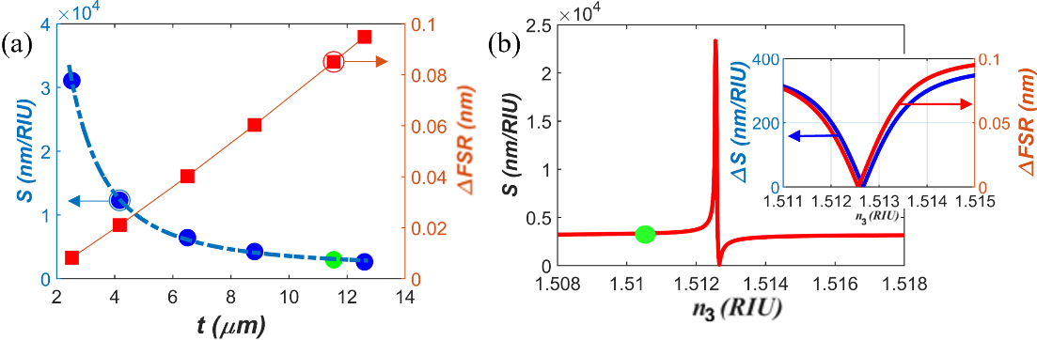

Fig. 4 (a) Calculated sensitivity (left axis) and FSR difference (right axis) versus wall thickness. Solid blue dots and red squares are calculated data points, dash line and solid line are fitted curves. Green dot is the experimental data point. (b) Calculated sensitivity versus ***n3***. Green dot is the experimental data point. The inset shows the variation of the sensitivity difference (right axis, blue line) and the FSR difference (left axis, red line) versus ***n3***.

The FSR of the main scale model is inversely proportional to the wall thickness. As the wall thickness increases, the order of the main scale mode becomes higher, resulting in a smaller FSR. ΔFSR is directly proportional to the wall thickness, as indicated by the red line in Fig. 4(a). Thus, the blue points in Fig. 4(a) can be well fitted by:

(7)

in which the units of ***t*** and ***S*** are μm and nm/RIU respectively. Sensitivity as high as 48426 nm/RIU is expected at a wall thickness of 2 µm, with a magnification factor of approximately 138.2. Moreover, due to pump laser power fluctuations, the envelope shift measurement accuracy of our system is 0.35 nm (as shown in Fig. 3(e), where the bars represent results from multiple samples taken at 10-second intervals), resulting in a RI detection limit of 7.2×10-6 RIU. In molecule detection, the molecular detection limit is directly proportional to RI detection limit and the molecular surface density[29]. By applying the molecular detection limit calculation equation (Eq. 6 in Ref. [29]) in conjunction with the surface density data of bovine serum albumin (BSA) protein from Ref. [30], our sensing system is expected to achieve a BSA molecule detection limit of 6.3 pg/mm². This demonstrates the potential of our system for high-precision biomolecular detection applications.

Sensitivity can be further enhanced by adjusting the coupling strength. When ***n3*** increases and approaches the anti-crossing point, the coupling strength is enhanced. As depicted in Fig. 4(b), the sensitivity gradually increases and then goes up sharply at a specific liquid core refractive index (critical point), after that, sensitivity dives rapidly and become zero at the anti-crossing point. This phenomenon arises because, as shown in the inset of Fig. 4(b), ΔFSR approaches zero at the critical point, sensitivity increases very fast according to Eq. (6). After the critical point, ΔFSR increases, sensitivity difference between the two modes also reduces and become zero at the anti-crossing point. Consequently, the overall sensitivity rapidly drops to zero. The sensitivity difference increases again after the anti-crossing point, thus the overall sensitivity goes up. Therefore, setting the liquid core refractive index closer to the critical point significantly enhances the coupling strength, and enables a substantial improvement in sensitivity. Although this ultra-sensitive region is limited to 10⁻⁴ RIU, it still has great potential for high-resolution liquid refractive index sensing, such as nanoliter-scale chemical analysis, where detection precision reaches 10⁻⁸ RIU[31]. This sensing strategy opens a novel way of ultra-high-sensitivity optical microfluidic sensing and further promoting the advancement and application of optical microfluidic sensor technologies.

1. **Conclusion**

In summary, an optofluidic microcapillary active sensor with simple structure and ultra-high sensitivity is proposed. Based on the Vernier effect, an RI sensitivity as high as 2924 nm/RIU is obtained experimentally. This sensitivity is 7 times that of microcapillary sensitivity limit and is comparable to that of two coupled cavities but with simpler and more robust structure. Moreover, by reducing the wall thickness of the microcapillary, we can theoretically achieve a sensitivity up to 48426 nm/RIU and this sensitivity can be further improved by increasing the coupling strength. This sensing strategy allows for the development of an easily fabricated, robust and ultra-high sensitivity optical sensor, which is ideal for microfluidic sensing applications.

**Funding.** This research was funded by National Natural Science Foundation of China (NSFC) (11874122, 11474070, 61327008 and 11074051) and Doctoral Program of Higher Education (20130071130004).

**Disclosures.** The authors declare no conflicts of interest.

**Data availability.** Data underlying the results presented in this paper are not publicly available

at this time but may be obtained from the authors upon reasonable request.

**References**

1. X. Lei, X. Dong, T. Sun*, et al.*, "Ultrasensitive refractive index sensor based on Mach–Zehnder interferometer and a 40μm fiber," J. Lightwave Technol. **39**(17), 5625-5633 (2021).
2. A. Iadicicco, A. Cusano, A. Cutolo*, et al.*, "Thinned fiber Bragg gratings as high sensitivity refractive index sensor," IEEE Photonics Technol. Lett. **16**(4), 1149-1151 (2004).
3. N. Kazanskiy, S. Khonina, and M. A. Butt, "Plasmonic sensors based on Metal-insulator-metal waveguides for refractive index sensing applications: A brief review," Physica E: Low-Dimens. Syst. Nanostruct. **117**, 113798 (2020).
4. G. Bawa and S. M. Tripathi, "Refractive index sensing free from critical wavelength referencing using fiber-optic directional coupler," J. Lightwave Technol. **40**(1), 284-290 (2022).
5. T. Yoshie, L. Tang, and S.-Y. Su, "Optical microcavity: Sensing down to single molecules and atoms," Sensors **11**(2), 1972-1991 (2011).
6. S. Yang, Y. Wang, and H. Sun, "Advances and prospects for whispering gallery mode microcavities," Adv. Opt. Mater. **3**(9), 1136-1162 (2015).
7. H. Zhu, I. M. White, J. D. Suter*, et al.*, "Opto-fluidic micro-ring resonator for sensitive label-free viral detection," Analyst **133**(3), 356-360 (2008).
8. C. K. Manchee, V. Zamora, J. Silverstone*, et al.*, "Refractometric sensing with fluorescent-core microcapillaries," Opt. Express **19**(22), 21540-21551 (2011).
9. H. Zhu, I. M. White, J. D. Suter*, et al.*, "Phage-based label-free biomolecule detection in an opto-fluidic ring resonator," Biosens. Bioelectron. **24**(3), 461-466 (2008).
10. Y. Sun, S. I. Shopova, G. Frye-Mason*, et al.*, "Rapid chemical-vapor sensing using optofluidic ring resonators," Opt. Lett. **33**(8), 788-790 (2008).
11. G. Yang, I. M. White, and X. Fan, "An opto-fluidic ring resonator biosensor for the detection of organophosphorus pesticides," Sens. Actuators B Chem. **133**(1), 105-112 (2008).
12. T. Ling and L. J. Guo, "A unique resonance mode observed in a prism-coupled micro-tube resonator sensor with superior index sensitivity," Opt. Express **15**(25), 17424-17432 (2007).
13. J. Chan, T. Thiessen, S. Lane*, et al.*, "Microfluidic Detection of Vitamin D 3 Compounds Using a Cylindrical Optical Microcavity," IEEE Sens. J. **15**(6), 3467-3474 (2015).
14. S. Lane, P. West, A. François*, et al.*, "Protein biosensing with fluorescent microcapillaries," Opt. Express **23**(3), 2577-2590 (2015).
15. S. McFarlane, C. Manchee, J. W. Silverstone*, et al.*, "Synthesis and operation of fluorescent-core microcavities for refractometric sensing," J. Vis. Exp., **73**, e50256 (2013).
16. K. J. Rowland, A. François, P. Hoffmann*, et al.*, "Fluorescent polymer coated capillaries as optofluidic refractometric sensors," Opt. Express **21**(9), 11492-11505 (2013).
17. N. M. Hanumegowda, C. J. Stica, B. C. Patel*, et al.*, "Refractometric sensors based on microsphere resonators," Appl. Phys. Lett. **87**(20)(2005).
18. H. Li and X. Fan, "Characterization of sensing capability of optofluidic ring resonator biosensors," Appl. Phys. Lett. **97**(1)(2010).
19. G. Huang, V. A. Bolanos Quinones, F. Ding*, et al.*, "Rolled-up optical microcavities with subwavelength wall thicknesses for enhanced liquid sensing applications," ACS Nano **4**(6), 3123-3130 (2010).
20. T. Ling and L. J. Guo, "Analysis of the sensing properties of silica microtube resonator sensors," J. Opt. Soc. Am. B **26**(3), 471-477 (2009).
21. T. Ling and L. J. Guo, "Sensitivity enhancement in optical micro-tube resonator sensors via mode coupling," Appl. Phys. Lett. **103**(1)(2013).
22. L. Ren, X. Wu, M. Li*, et al.*, "Ultrasensitive label-free coupled optofluidic ring laser sensor," Opt. Lett. **37**(18), 3873-3875 (2012).
23. W. Morrish, N. Riesen, S. Stobie*, et al.*, "Geometric resonances for high-sensitivity microfluidic lasing sensors," Phys. Rev. Appl. **10**(5), 051001 (2018).
24. Z. Zhang, W. Morrish, K. Gardner*, et al.*, "Functional lasing microcapillaries for surface-specific sensing," Opt. Express **27**(19), 26967-26978 (2019).
25. I. M. White, H. Oveys, and X. Fan, "Liquid-core optical ring-resonator sensors," Opt. Lett. **31**(9), 1319-1321 (2006).
26. H. A. Haus and W. Huang, "Coupled-mode theory," Proc. IEEE **79**(10), 1505-1518 (1991).
27. X. Zhang, L. Ren, X. Wu*, et al.*, "Coupled optofluidic ring laser for ultrahigh-sensitive sensing," Opt. Express **19**(22), 22242-22247 (2011).
28. S. Lane, F. Marsiglio, Y. Zhi*, et al.*, "Refractometric sensitivity and thermal stabilization of fluorescent core microcapillary sensors: theory and experiment," Appl. Opt. **54**(6), 1331-1340 (2015).
29. H. Zhu, I. M. White, J. D. Suter, *et al*., "Analysis of biomolecule detection with optofluidic ring resonator sensors," Opt. Express **15**(15), 9139-9146 (2007).
30. F. Vollmer, D. Braun, A. Libchaber, *et al*., "Protein detection by optical shift of a resonant microcavity," Appl. Phys. Lett. **80**(21), 4057-4059 (2022).
31. D. Markov, D. Begari, and D. J. Bornhop, "Breaking the 10-7 barrier for RI measurements in nanoliter volumes," Anal. Chem. **74**(20), 5438-5441 (2002).