
Bioinformatics – Rami AlOuran



Bibars Bshoukhoj
23110366
Table of Contents
Q1) Problem Definition and Dataset Justification: 3
Q2) Pipeline Implementation: 5
Q3) Implementation Decisions: 9
Q4) Performance Metrics: 14
Q5) Visualization of Results and XAI: 20
Q6) Results Interpretation: 26
Q7) Design Evaluation: 30
Q8) Critical Reflection and Future Directions: 32
References 36

Q1) Problem Definition and Dataset Justification:
Clinical / Research Problem
- The selected clinical problem is brain tumor MRI image classification.
The aim of this project is to build a clinical AI pipeline that can classify brain MRI images into one of four categories: Glioma, Meningioma, Pituitary Tumor, or No Tumor.
- This problem is clinically relevant because brain tumors require early and accurate detection.
MRI is one of the main imaging methods used to examine brain structures, and automated classification can support the diagnostic workflow by helping identify whether an MRI scan shows a tumor and what type of tumor it may be.
- The research question for this project is:
Can a deep learning-based clinical AI pipeline classify brain MRI images into tumor and no-tumor categories, and also distinguish between different tumor types?
Data source: https://www.kaggle.com/datasets/masoudnickparvar/brain-tumor-mri-dataset?utm_source.com

Dataset Description
- The dataset consists of brain MRI images grouped into four classes:
  - Glioma
  - Meningioma
  - Pituitary
  - No Tumor
- The dataset is suitable for a supervised learning task because each image already has a class label. This allows the pipeline to learn the relationship between MRI image patterns and the correct diagnostic category.
- The data represents a medical imaging component, which matches the assignment requirement that the project should involve either medical imaging, omics, or clinical/tabular healthcare data.

Why This Dataset Is Appropriate for the Project
- It is publicly available and comes from a recognized repository.
The dataset from a known public source Kaggle.
- It is directly related to a real healthcare problem.
Brain tumor detection and tumor-type classification are meaningful clinical imaging tasks.
- It contains multiple clinically meaningful classes.
The presence of tumor classes and a no-tumor class makes the task more useful than simple binary classification.
- It is suitable for deep learning image classification.
MRI images contain visual patterns such as tissue intensity, tumor location, shape, and contrast differences, which can be learned from image data.
Q1-Level Limitations
- The dataset is public and may not fully represent real hospital data.
It may not include the same variation found in clinical practice, such as different MRI machines, imaging protocols, or patient populations.
- The labels are image-level labels only.
The dataset tells us the class of each image, but it does not provide detailed clinical information such as patient history, symptoms, treatment, or outcome.
- There is no detailed clinical metadata in the current project pipeline.
Therefore, the analysis focuses on image classification rather than combining MRI images with patient records.
- The dataset does not provide tumor segmentation masks.
A segmentation mask is an extra image/annotation that marks the exact tumor area or boundary inside the MRI. Therefore, the project is designed mainly as a classification pipeline. Even though I did XAI, Grad-CAM is used only as an explainability tool to show the regions that influenced the model’s prediction, but it does not replace medical-grade tumor segmentation.

Q2) Pipeline Implementation:

Data Loading
- The dataset was loaded from the project directory using PyTorch image dataset tools.
- The images were organized into class folders, which allowed the labels to be detected automatically.
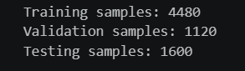
- The four classes used in the pipeline were:
  - Glioma
  - Meningioma
  - Pituitary
  - No Tumor
- Separate datasets were prepared for training, validation, and testing. The validation set was created by splitting the original training folder using a stratified 80/20 split.
- DataLoaders were used to load the images in batches during training and evaluation for both models.
- The training DataLoader used shuffling to make sure the models did not learn the images in a fixed order.
- The test DataLoader did not use shuffling, so the evaluation order stayed consistent for both models.
Preprocessing and Augmentation
- All MRI images were converted into a format suitable for the deep learning model.
- Images were resized and cropped to 224 × 224 pixels, which is the input size expected by the pretrained models.
- Some of the MRI images were grayscale, they were all converted into 3-channel RGB format.
- This conversion was necessary because the pretrained image models expects three input channels.
- ImageNet normalization was applied using the standard ImageNet mean and standard deviation.
- Normalization helped make the input image distribution compatible with the pretrained models.
- For the training set, augmentation was applied using RandomRotation(10) and RandomHorizontalFlip to increase data variability and improve model generalization.
- Validation and test images were not augmented to ensure fair and consistent evaluation.
Model Development
- Two deep learning models were implemented in the pipeline for the MRI classification task:
  - Model 1: ResNet18
  - Model 2: EfficientNet-B0
- Both models were loaded as pretrained convolutional neural network architectures.
- The pretrained models were used because transfer learning allows the pipeline to benefit from visual features learned from large image datasets.
- For each model, the original final classification layer was replaced with a new output layer.
- The new output layer was adjusted to predict the four MRI classes:
  - Glioma
  - Meningioma
  - Pituitary
  - No Tumor
- The models were moved to the available computation device, using GPU when available.
- ResNet18 was used as the main baseline model because it is a clear and widely used CNN architecture.
- EfficientNet-B0 was also implemented as a second model to compare another pretrained architecture within the same pipeline.

Transfer Learning and Feature Extraction
- Transfer learning was applied to both ResNet18 and EfficientNet-B0.
- Each model was trained in two stages.
- Stage 1: Feature Extraction
  - The pretrained backbone was frozen.
  - Only the final classification layer was trained.
  - This allowed the model to reuse general visual features while learning the four MRI classes.
- Stage 2: Fine-Tuning
  - The backbone was unfrozen.
  - The full model was trained again using a lower learning rate.
  - This allowed the pretrained features to adapt more carefully to the MRI image dataset.
- This two-stage training strategy was applied to both implemented models.

Validation Strategy
- The dataset was handled using separate training, validation, and test sets.
- The original training folder was split into training and validation sets using a stratified 80/20 split.
- Stratification was used to keep the class distribution balanced between the training and validation sets.
- The training set was used for model learning.
- The validation set was used during training to monitor generalization and save the best model checkpoint.
- The separate test set was kept for final evaluation after training.
- The same validation strategy was applied to both implemented models:
  - ResNet18
  - EfficientNet-B0
- For each model and training stage, the checkpoint was saved based on the lowest validation loss.
- This helped keep track of the best version of each model instead of relying only on the final epoch.

Model Training
- Both models were trained using CrossEntropyLoss, which is suitable for multi-class classification.
- The Adam optimizer was used to update the model parameters.
- Each model was trained in two stages:
- Feature extraction with the backbone frozen.
- Fine-tuning after unfreezing the backbone.
- During the feature extraction stage, a higher learning rate was used because only the final classification layer was being trained.
- During the fine-tuning stage, a lower learning rate was used because the full pretrained model was being updated.
- The training process was divided into training and evaluation functions.
- For each epoch, the notebook performed:
  - Forward pass
  - Loss calculation
  - Backpropagation during training
  - Optimizer update
  - Evaluation on the validation set
  - Saving the best model checkpoint when validation loss improved
- The best checkpoint for each model was saved so it could be reused later for evaluation.
Notebook Organization
- The notebook was structured to run from start to finish as a complete pipeline.
- Comments were included in the code to explain the main purpose of each step.

Q3) Implementation Decisions:
1. Preprocessing Decisions
- MRI images were converted to RGB format because the pretrained CNN models expect input images with three channels.
- Although MRI images may appear grayscale, converting them to 3-channel RGB made them compatible with models pretrained on ImageNet.
- All images were resized to 224 × 224 pixels to create a consistent input size for the deep learning models.
- A fixed image size was necessary because CNN models require batches of images with the same dimensions.
- ImageNet normalization was used because both ResNet18 and EfficientNet-B0 were loaded with pretrained ImageNet weights.
- Using the same normalization style as the pretrained models helps make the MRI image inputs closer to the format expected by the original pretrained networks.

From Cell 7: Visualize Transformed Images, “Quality Check” before model training .
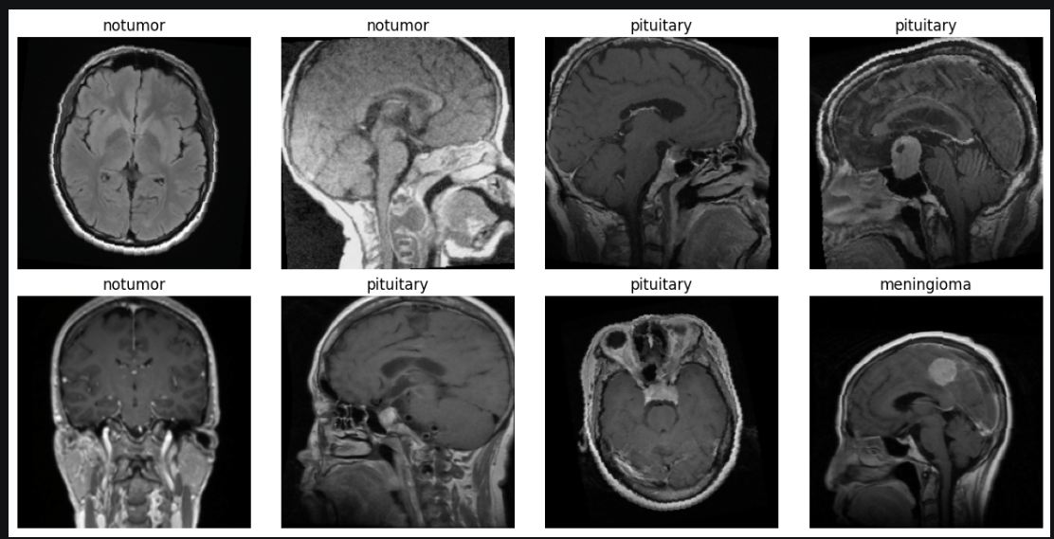

2. Augmentation Decisions
- Data augmentation was applied only to the training set to increase image variability during learning.
- The training images used random horizontal flipping and small random rotation.
- These transformations help reduce overfitting by making the model see slightly different versions of the training images.
- Validation and test images were not augmented; they used fixed preprocessing so evaluation would remain fair, consistent, and reproducible.
- This separation prevents random transformations from affecting the validation or final test results.
3. Model Architecture Decisions
- Two pretrained CNN architectures were implemented:
  - ResNet18
  - EfficientNet-B0
- ResNet18 was chosen because it is a reliable and widely used CNN model for image classification, making it a clear baseline for this project.
- EfficientNet-B0 was chosen as a second pretrained model because it is a modern and efficient CNN architecture.
- Using both models allowed the project to compare two different pretrained architectures within the same pipeline.
- The final classification layer was replaced in each model because the original pretrained models were not designed for the four brain MRI classes.
- The new output layer was adjusted to predict:
  - Glioma
  - Meningioma
  - Pituitary
  - No Tumor
Table: Summary of the pretrained CNN architectures used in the project and their modified output layers.
Model | Pretrained | Final layer changed to
ResNet18 | ImageNet | 4 classes
EfficientNet – B0 | ImageNet | 4 classes

4. Transfer Learning Decisions
- Transfer learning was used instead of training from scratch because the dataset is a medical imaging dataset and training a deep CNN from zero would require huge data and computation.
- Pretrained CNNs already learn useful visual features such as edges, shapes, and texture patterns.
- These general image features can still be useful for MRI classification after adapting the model to the new task.
- The training was done in two stages:
  - Feature extraction
  - Fine-tuning
- In the feature extraction stage, the pretrained backbone was frozen and only the final classifier was trained.
- This was done to first learn the mapping between extracted image features and the four MRI classes without changing the pretrained weights too quickly.
- In the fine-tuning stage, the backbone was unfrozen so the model could adapt more deeply to the MRI dataset.
- This gradual approach is safer than updating the whole model from the beginning.

5. Training and Optimization Decisions
- CrossEntropyLoss was used because the project is a multi-class classification problem.
- Each MRI image belongs to one class out of four, so CrossEntropyLoss is appropriate for learning class probabilities.
- Adam optimizer was used because it is commonly used in deep learning and adapts the learning rate during training.
- A higher learning rate was used during feature extraction because only the final classification layer was being trained.
- A lower learning rate was used during fine-tuning because the full pretrained model was being updated.
- This helped avoid changing the pretrained weights too aggressively during fine-tuning.
- The same training logic was applied to both ResNet18 and EfficientNet-B0 to keep the implementation fair and consistent.
6. Validation and Checkpointing Decisions
- The original training folder was split into training and validation sets using a stratified 80/20 split.
- Stratification was used to keep the class distribution balanced between training and validation.
- The validation set was used during training to monitor generalization.
- The separate test set was kept aside for final evaluation after training. *
- Model checkpointing was based on the lowest validation loss.
- This was used because the final epoch is not always the best model.
- Saving the best validation checkpoint helped keep the best version of each model for later final evaluation.

7. Suitability for Brain MRI Classification
- This approach is suitable because the dataset contains labelled MRI images and the goal is to assign each image to one of four classes.
- CNN-based models are appropriate for image classification because they can learn spatial patterns from image data.
- Transfer learning is suitable because it reduces the need for very large medical datasets while still allowing strong image feature extraction.
- The two-stage training strategy allowed the models to first learn the classification task, then adapt more specifically to MRI images.
- Overall, the chosen methodology fits the project because it combines medical image preprocessing, pretrained CNN models, supervised classification, validation-based model selection, and reproducible training.

Q4) Performance Metrics:
1. Metrics Selected for Evaluation
- Several metrics were used to evaluate the models because accuracy alone does not fully explain model behavior.
- Accuracy shows the overall percentage of correctly classified MRI images.
- However, accuracy alone is not always enough because it can hide class-level weaknesses. For example, in this project, the models achieved strong overall accuracy, but the confusion matrices show that glioma was harder to classify than the other classes. This means a model can look strong overall while still making more mistakes in one specific class.
- Precision helps show how reliable the model’s predictions are for each class.
- In the classification reports, precision helps us understand whether the images predicted as a certain tumor type are usually correct.
- Recall helps show how well the model detects all images that actually belong to each class.
- This was useful in the results because some classes were detected almost perfectly, while glioma had lower recall compared with the other classes.
- F1-score combines precision and recall into one balanced value.
- This makes it useful for comparing class-level performance when one class has a difference between precision and recall.
- In this project, F1-score helps summarize which classes were handled more consistently by each model.
- The confusion matrix shows the exact pattern of correct and incorrect predictions.
- This was important because it showed that most mistakes were not spread equally across all classes.
- The main difficulty appeared in separating glioma from some other classes, while no-tumor and pituitary were classified more consistently.

2. Learning Curve Analysis
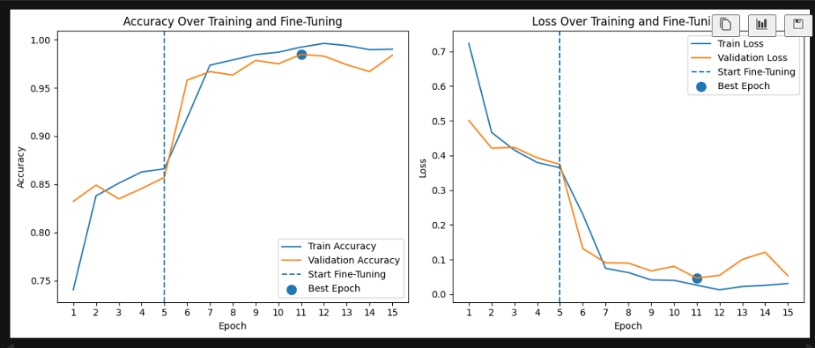
- The learning curves show how training and validation accuracy/loss changed during training.
- The vertical line marks the start of fine-tuning.
- The curves show that performance improved after fine-tuning, meaning the models benefited so much from adapting the pretrained features to the MRI dataset.
- The validation curve was important because it helped choose the best checkpoint instead of depending only on the last epoch.

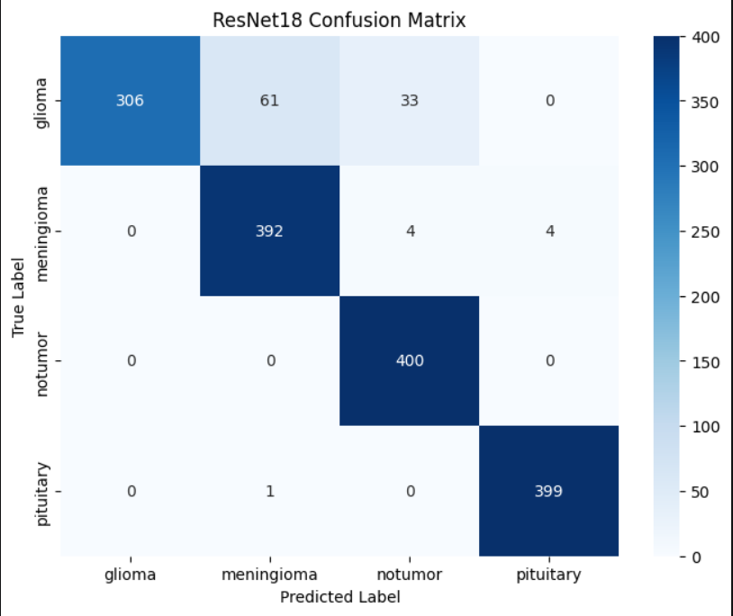
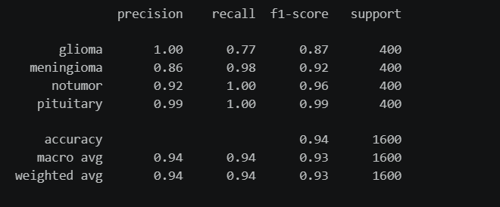
3. ResNet18 Performance

- ResNet18 showed strong performance across most MRI classes.
- The classification report shows good overall performance across the four classes.
- The confusion matrix shows that no-tumor and pituitary were classified very consistently.
- The main challenge for ResNet18 was the glioma class, with some glioma images predicted as meningioma and others as no tumor, as shown in the confusion matrix, 61 and 33.
- This shows why looking only at accuracy would not be enough; the class-level metrics and confusion matrix give a clearer view of where the model struggled.

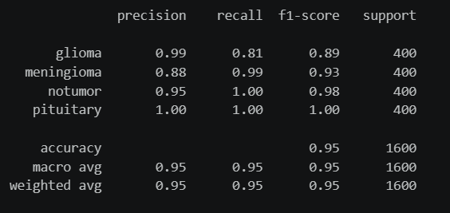
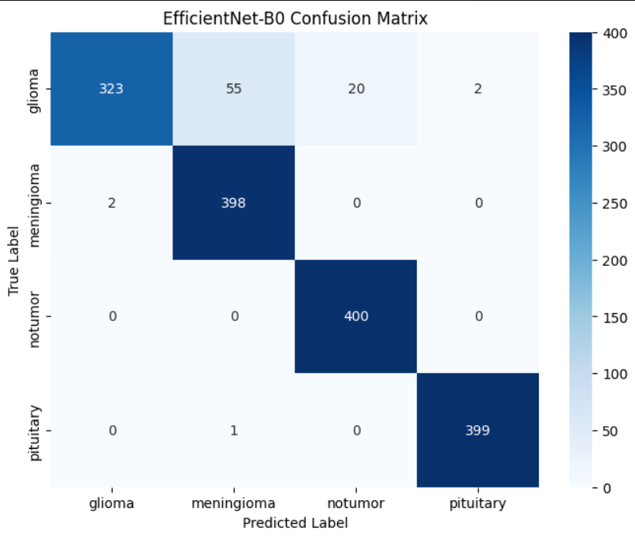
4. EfficientNet-B0 Performance

- EfficientNet-B0 showed slightly better overall performance than ResNet18 in this project.
- The classification report shows stronger balance across the classes compared with ResNet18.
- The confusion matrix shows that EfficientNet-B0 improved glioma classification compared with ResNet18. (from 0.77 recall to 0.81 recall)
- No-tumor and pituitary were again classified very consistently.
- The remaining mistakes were mainly related to glioma, which suggests that this class was the most challenging for both models.

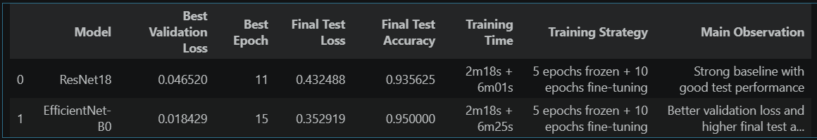
5. Model Comparison

- The comparison table summarizes the main evaluation results for both models.
- EfficientNet-B0 performed slightly better overall than ResNet18.
- ResNet18 also achieved strong results, but EfficientNet-B0 showed slightly better overall performance.
- The most useful comparison was not only the final accuracy, but also the class-level behavior shown in the classification reports and confusion matrices.
- EfficientNet-B0 was stronger because it improved the more difficult class (glioma) while keeping strong performance on the easier classes.

6. Why These Metrics Are Suitable for This Problem
- The test set was balanced, so accuracy was useful as a general summary.
- However, accuracy alone was not enough because the models did not perform equally across all classes.
- Precision, recall, and F1-score were needed because they explain performance for each MRI class separately.
- The confusion matrix was useful because it showed the actual direction of the mistakes, not only the final score.
- A useful example is the no-tumor class. Both models detected all actual no-tumor images, so recall was perfect for this class. However, precision was lower because some tumor images were also predicted as no-tumor. This is important because predicting a tumor image as no-tumor is a serious issue in a medical classification task.
- For ResNet18, the model predicted 437 images as no-tumor, but 400 of them were actually no-tumor.
- For EfficientNet-B0, the model predicted 420 images as no-tumor, and 400 of them were actually no-tumor.
- This shows why the confusion matrix is important: it explains where the extra no-tumor predictions came from, while precision and recall explain how these mistakes affected the class performance.
- Together, these metrics gave a clearer evaluation of the models than accuracy alone.

Q5) Visualization of Results and XAI:

1. Purpose of Visualization and XAI
- Visualizations were used to make the model outputs easier to understand, not only to show numbers.
- In medical image classification, it is important to see:
  - what the input MRI images look like,
  - whether preprocessing preserved image quality,
  - where the model succeeds or fails,
  - and which image regions influenced the model prediction.
- Explainable AI was included because doctors and clinical users would not only want the predicted class; they would also want to understand what part of the MRI image affected the decision.
- Since the models are CNN-based image classifiers, Grad-CAM was an appropriate explainability method.

2. Dataset and Preprocessing Visualizations
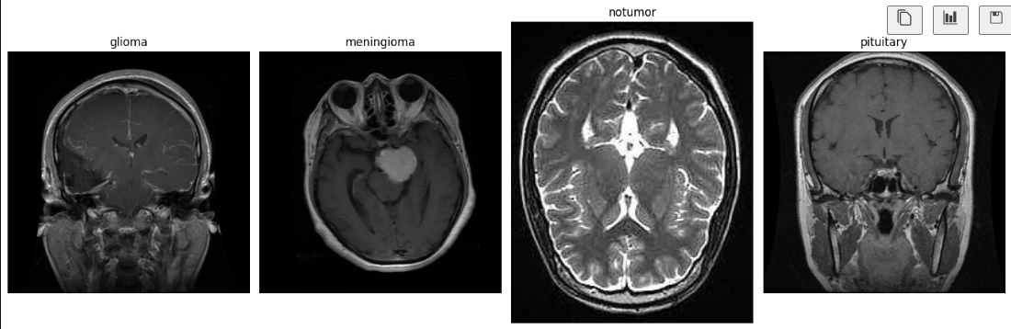
- This visualization shows example MRI images from the four classes:
  - Glioma
  - Meningioma
  - No Tumor
  - Pituitary
- It helps confirm that the dataset is image-based and suitable for a CNN classification task.
- It also gives a first visual check that the classes have meaningful MRI appearances that the model can learn from.
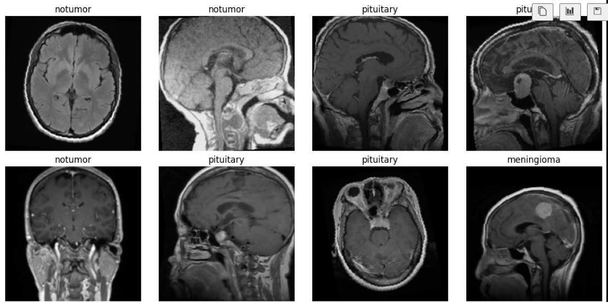
- This visualization shows MRI images after preprocessing and transformation.
- It helps verify that resizing, RGB conversion, and normalization prepared the images correctly before training.
- The important MRI structures are still visible after preprocessing, so the images remain suitable to be passed into the models.
- This step is important because poor preprocessing could damage the visual information needed for classification.

3. Correct and Misclassified Prediction Visualization
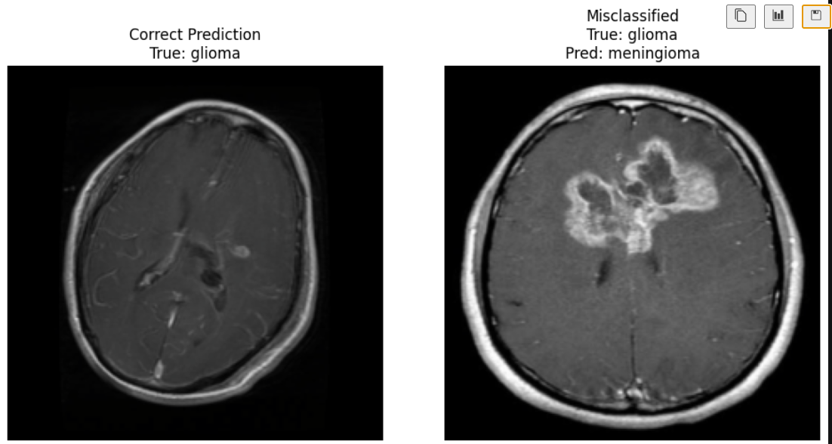
- This visualization shows one correct prediction and one misclassified prediction side by side.
- It shows that some MRI images are easier for the model to classify than others.
- The misclassified example is useful as a case to investigate later using Grad-CAM. Since this figure only shows the image and predicted label, the explanation of where the model focused is discussed in the Grad-CAM section.

4. Grad-CAM Explainability for Correct Predictions

ResNet18:
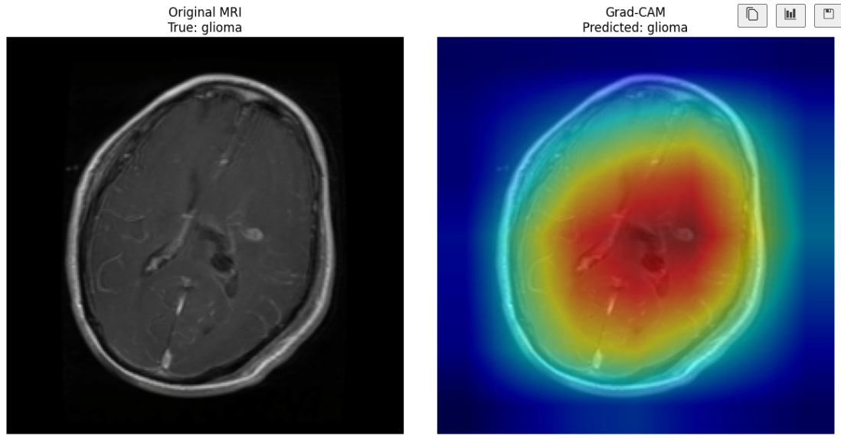
EfficientNet-B0:
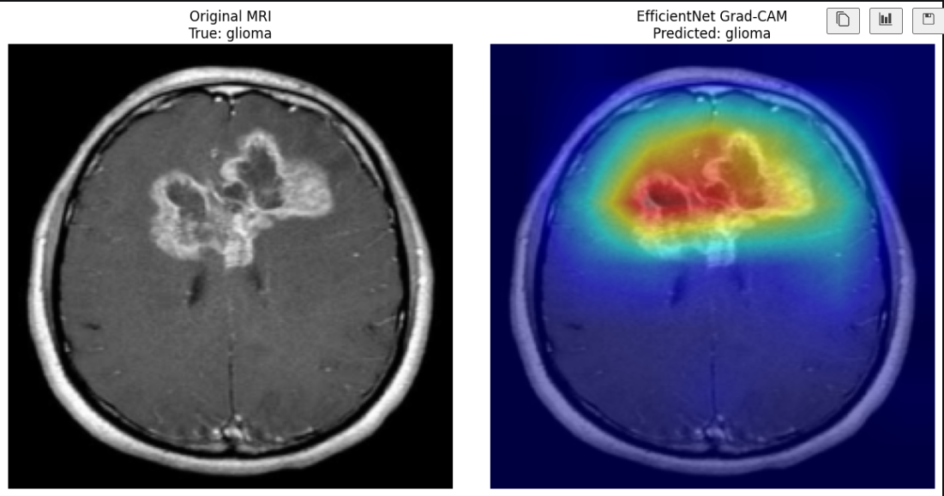
- Grad-CAM was used to highlight the MRI regions that had the strongest influence on the predicted class.
- The correct prediction examples show that both models focused mainly on the abnormal/tumor-related regions.
- Warmer colors in the heatmap represent regions that contributed more to the model’s decision.
- This supports that both models were using meaningful image areas instead of relying mainly on background information.
- Showing correct Grad-CAM examples helps make the successful predictions more understandable.
5. Grad-CAM Explainability for Misclassified Predictions
ResNet18:
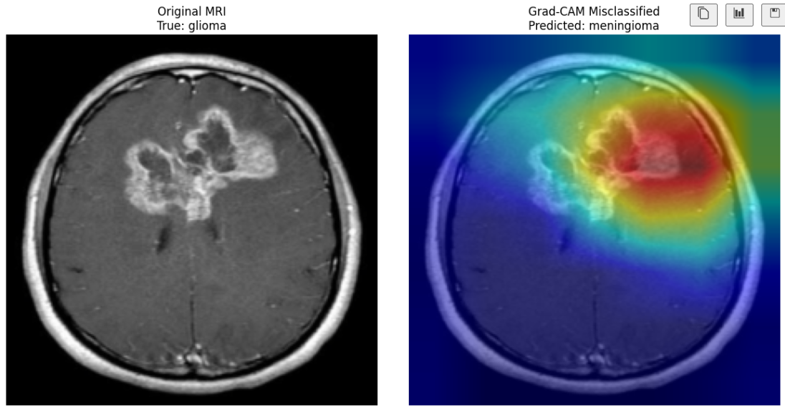
EfficientNet-B0:
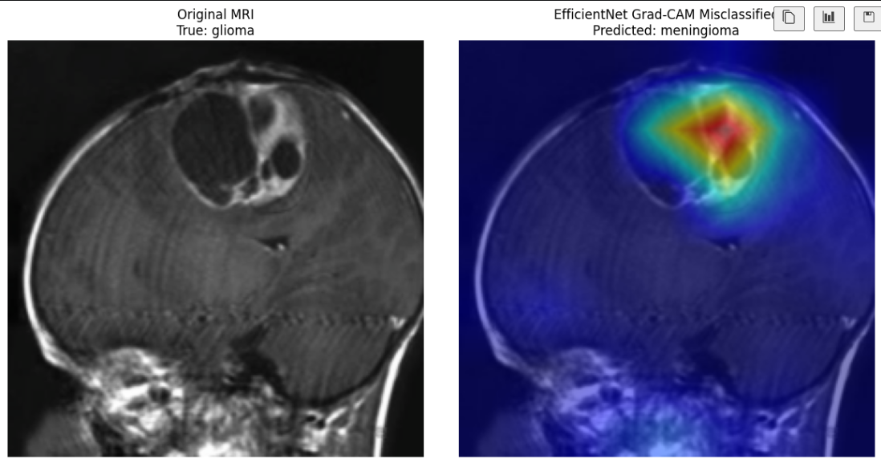
- The misclassified Grad-CAM examples show how the models behaved when the prediction was incorrect.
- In both examples, the heatmaps still focused near the abnormal/tumor-related regions, which is good actually. This suggests that the errors were not random, but may be related to visual similarity between tumor classes.
- These examples are useful because they show where the models were looking when they confused one class with another.
Comparing correct and misclassified Grad-CAM outputs gives a more balanced understanding of model behavior.

6. What the XAI Results Suggest About Model Behaviour
- The Grad-CAM results show that the models usually focused on meaningful MRI regions.
- In the correct prediction examples, the highlighted areas were on the abnormal/tumor-related regions.
- This suggests that the models were not only guessing the class label, but were using useful visual information from the MRI image.
- In the misclassified examples, the heatmaps still focused near the abnormal region.
- This means the mistakes were not completely random. The models may have looked at the right area, but confused tumor types because some MRI appearances are visually similar.
- Overall, Grad-CAM helped explain where the models were looking when they made their predictions.

7. Usefulness for Clinical Understanding
- These visualizations make the project easier to understand for clinical users, not only technical users.
- Sample MRI images show what the dataset looks like before modelling.
- Preprocessed images show that the important MRI structures were still visible before entering the models.
- Correct and misclassified examples show that some images were easier for the models, while others were more difficult.
- Grad-CAM is useful because it shows the image region that influenced the prediction.
- This is important because a doctor would not only care about the predicted class, but also whether the model focused on a reasonable MRI region.
- However, Grad-CAM is only an explanation tool. It does not prove that the prediction is medically correct.
- Grad-CAM also does not replace expert diagnosis or tumor segmentation, because it does not draw an exact tumor boundary.

Q6) Results Interpretation:
1. Overall Meaning of the Results
- The results show that both models were able to learn useful visual patterns from the brain MRI images.
- The models performed well across the four classes, which suggests that the MRI images contain enough visual information for supervised classification.
- EfficientNet-B0 showed slightly stronger overall performance than ResNet18, but both models produced meaningful classification results.
- The results suggest that transfer learning was suitable for this task because pretrained CNN models were able to adapt to the MRI classification problem.
In my opinion, the results are promising because the models learned useful patterns from the MRI images and performed well on the available dataset. However, I would not consider the model ready for real hospital use yet. The project was tested on a public dataset, but real clinical data can be more complex because MRI images may come from different machines, hospitals, image qualities, and patient conditions. Also, the model only used the MRI image itself, without extra clinical information such as patient history or doctor notes. Because of that, the model could be useful as a research prototype or supportive tool, but it would still need more testing and clinical validation before being used in real diagnosis.
2. Clinical Meaning of Correct Classifications
- Correctly classifying no-tumor images is important because it means the model can recognize MRI scans that do not show a tumor pattern.
- Correctly classifying tumor images is also important because the model can support the separation of different tumor-related classes.
- The strong performance on no-tumor and pituitary images suggests that these classes had clearer visual patterns for the models.
- This means the models were not only learning random image noise; they were able to identify class-related MRI features.
Clinically, correct classifications are useful because they could help separate normal-looking MRI cases from tumor-related cases and support the prioritization of images for specialist review.

3. Interpretation of Model Errors
- The main weakness appeared in the glioma class.
- Some glioma images were confused with other classes, especially meningioma and sometimes no-tumor.
- This suggests that glioma cases may have more variable or visually difficult appearances in the dataset.
- The errors also show that some tumor types can share similar MRI patterns, making them harder for the model to separate.
- The most important type of mistake was when a tumor image was predicted as no-tumor. This is serious in a medical classification task because it could hide a case that actually needs attention.
- The confusion matrices helped reveal these weaknesses clearly.
In my opinion, these errors show that the model would need more careful validation before real use, especially for glioma cases. To reduce this type of error, the dataset would need more diverse glioma examples, images from different MRI conditions, and possibly extra clinical information to help distinguish difficult tumor cases.

4. What the XAI Results Add to the Interpretation
The Grad-CAM visualizations helped explain the model behaviour beyond only showing the predicted class. In many examples, the highlighted regions were close to abnormal or tumor-related areas, which supports that the models were often focusing on meaningful MRI regions. In the misclassified examples, the heatmaps still focused near abnormal regions, suggesting that some mistakes were not completely random. The models may have looked at an important area but confused visually similar tumor types.
So I’d say that the XAI part was one of the most useful parts of the project because it reduced the “black box” feeling of the deep learning models. Instead of only saying that the model predicted glioma or meningioma, Grad-CAM showed where the model was looking in the MRI image. This is especially important in medical imaging because doctors and clinical users need more than just a prediction; they need some explanation of why the model made that decision. However, Grad-CAM should still be treated as an explanation aid, not as medical proof or a replacement for expert diagnosis. Medical decisions are sensitive, even with explainability!

Additional note:
This visual was generated from an earlier version of my code, but I included it because it shows an important Grad-CAM example: the model predicted no tumor even though the true image was glioma.
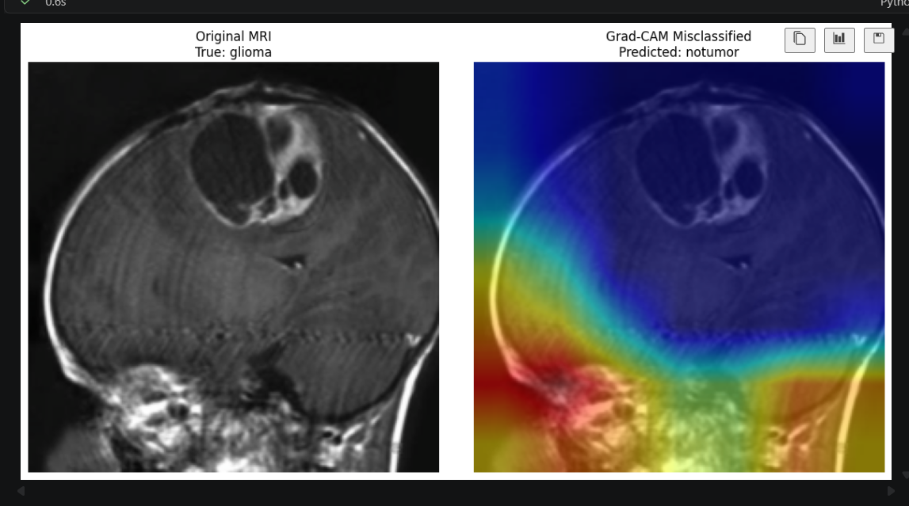
Additional note: This example shows a different type of mistake. In the previous misclassified examples, the model still focused near the tumor region, but confused the tumor type. Here, the model predicted no tumor, and the Grad-CAM helps explain why: the heatmap is mainly focused away from the visible tumor area. This suggests that the model did not pay enough attention to the abnormal region, so it failed to recognize the tumor. This makes Grad-CAM useful because it does not only show that the prediction was wrong; it also helps explain why the model may have made that wrong decision.

5. Usefulness in a Clinical or Research Setting
- The results suggest that the model is useful as a research prototype for brain MRI classification.
- It could support doctors by organizing MRI images or highlighting cases that may need closer review.
- However, it should not be used alone for diagnosis, because real medical decisions need expert radiologist review and clinical validation.
- The Grad-CAM outputs make the model more transparent, but they do not make it automatically ready for hospital use.
Again and again: Medical are sensitive.

6. Limitations of the Interpretation
- The dataset is public and may not fully represent real hospital data.
- The project used image-level labels only, without patient history, symptoms, MRI acquisition details, or clinical metadata.
- The dataset does not include segmentation masks, so the model was trained for classification, not exact tumor boundary detection.
- The models were evaluated on the available dataset split, so stronger validation on external hospital data would be needed before any real clinical use.
- Overall, the results are promising for a research pipeline, but they should be interpreted carefully and not overclaimed as a deployable medical diagnostic system.

Q7) Design Evaluation:
Overall, I think the workflow is reliable as a student research pipeline because it follows a clear end-to-end structure: data loading, preprocessing, validation split, model training, testing, and explainability. The use of a separate validation set and a separate test set makes the evaluation more trustworthy than training and testing on the same data. The model checkpoint was also saved based on validation loss, which is a good design choice because it avoids depending only on the final training epoch.
The preprocessing strategy also supports the reliability of the workflow. Resizing the images to a fixed size made the data consistent for the CNN models, and converting grayscale MRI images to RGB made them compatible with pretrained models. ImageNet normalization was also reasonable because both ResNet18 and EfficientNet-B0 were pretrained using ImageNet-style inputs. However, this is still not perfect because MRI images are different from natural ImageNet images. So, even though this preprocessing was practical and appropriate for transfer learning, it may not fully match the real medical image distribution.
The model design was suitable for this project because CNN-based models are appropriate for image classification tasks. Using ResNet18 and EfficientNet-B0 gave the project two pretrained architectures to compare instead of relying on only one model (I think this is important because comparing more than one model gives a clearer evaluation, and future work could include more models). Transfer learning was also a good choice because training a deep network from scratch would need much more data and computing power. The two-stage training strategy, feature extraction followed by fine-tuning, made the training more controlled. In my opinion, this made the pipeline stronger because the models first learned the final classification task, then adapted more deeply to the MRI images.
The explainability of the predictions was improved by using Grad-CAM. This was important because deep learning models can feel like black boxes, especially in medical imaging. Grad-CAM helped show which parts of the MRI image influenced the prediction. In several examples, the heatmaps focused near abnormal or tumor-related regions, which made the model behaviour more understandable. However, Grad-CAM is not a perfect explanation. It gives a rough attention area, not an exact tumor boundary, and it should not be treated as medical proof.
The main weakness of the workflow is that it depends on a public dataset. Public datasets are useful for research and learning, but they may not represent real hospital data well. In real clinical settings, MRI images can come from different machines, hospitals, imaging protocols, image qualities, and patient populations. The model may perform differently when tested on data from a new hospital. Because of that, the results are valid for this dataset, but they cannot automatically be generalized to real clinical use.
Another weakness is that the model only used MRI images. It did not use extra clinical information such as patient history, symptoms, radiology reports, age, or treatment information. In real diagnosis, doctors do not depend only on one image; they combine the image with patient context and medical expertise. This means the pipeline is limited as an image classification system and does not represent a full clinical decision-making system.
The error patterns also show that the workflow still has limitations. The models performed well overall, but glioma was more difficult than some other classes. Some glioma images were confused with meningioma or no-tumor. This shows that some tumor types may have similar visual patterns, and the model may need more diverse examples or additional information to separate them better. This is especially important when predicting a tumor image as no-tumor would be a serious issue in a medical setting.
In my opinion, before this workflow could be used in a real clinical setting, it would need more testing. The model should be tested on MRI images from different hospitals, machines, and image qualities to check if it still performs well outside this dataset. It would also need review by medical experts and possibly extra clinical information such as patient history or radiology notes. Also, if the goal was to locate the tumor exactly, the project would need segmentation masks. A segmentation mask is a label that marks the tumor area pixel by pixel, while Grad-CAM only shows the general region the model focused on. So, Grad-CAM is useful for explanation, but it is not enough for exact tumor boundary detection.

Q8) Critical Reflection and Future Directions:
1. Comparison with Published Work
To critically evaluate my project, I compared my results with two published works on similar brain tumor MRI classification problems. The first paper is Mathivanan et al. 2024 from Scientific Reports, which used transfer learning models for brain tumor detection. The second paper is Farhan et al. 2025, which proposed PRCnet, a custom CNN model for automatic brain tumor MRI classification.
Table 1: Benchmark Comparison
Study / Project | Dataset | Model / Approach | Validation Strategy | Best Accuracy | Explainability | Main Difference from My Work
My project | Kaggle Brain Tumor MRI Dataset | ResNet18 and EfficientNet-B0 using transfer learning | Train/validation/test split | EfficientNet-B0 = 95.00% | Grad-CAM used | Simpler student/research pipeline
Mathivanan et al. 2024 | Kaggle brain tumor MRI dataset | ResNet152, VGG19, DenseNet169, MobileNetv3 | Five-fold cross-validation | MobileNetv3 = 99.75% | Not clearly emphasized in this paper | Used deeper transfer learning models and stronger validation
Farhan et al. 2025 / PRCnet | Kaggle Brain Tumor MRI Dataset | Custom PRCnet model with parallel residual convolutional layers | Train/validation/test split and robustness testing | PRCnet = 97.1% on Dataset B | Grad-CAM and layer visualization | Used a custom architecture designed specifically for brain tumor MRI classification

This comparison is useful, but it should be interpreted carefully. My project used standard pretrained transfer learning models, specifically ResNet18 and EfficientNet-B0, while Mathivanan et al. used deeper transfer learning models such as ResNet152 and MobileNetv3 with five-fold cross-validation, which gives a stronger and more stable evaluation. Farhan et al. used a custom PRCnet architecture designed specifically for brain tumor MRI classification, with parallel convolutional layers, robustness testing, and Grad-CAM explainability. Because of these differences, their higher results do not mean my pipeline failed. Instead, they show that my work is a simpler transfer learning pipeline, and that stronger architectures, stronger validation methods, and more tuning can improve performance. Therefore, my result is promising, but it should still be treated as a research prototype rather than a deployable clinical system.
2. Critical Reflection
The comparison with the two benchmark papers helped me understand my project more realistically. My EfficientNet-B0 result is strong for a student research pipeline, but it is still lower than the published benchmark results. This does not mean the project failed; it shows that published systems usually use stronger experimental setups, such as deeper models, custom architectures, stronger validation, more tuning, and more detailed testing.
Compared with Mathivanan et al., my project used a simpler train/validation/test split, while their work used five-fold cross-validation. This does not mean my validation was wrong, but cross-validation gives a stronger and more stable evaluation because it tests the model on multiple splits.
Compared with Farhan et al., my project used standard pretrained transfer learning models, while PRCnet was designed specifically for brain tumor MRI classification. This explains why their model achieved stronger results.
The most important lesson from my results is that overall accuracy is not enough. Even though the models performed well overall, glioma was still the weakest class. This means future work should focus more on class-level weaknesses, not only on improving the final accuracy number.
Grad-CAM was a useful strength in my project because it added interpretability and helped show where the models were focusing. However, compared with stronger published work, my XAI is still basic. It helps explain the prediction, but it does not prove that the model is clinically safe or ready for real diagnosis.
3. Ethical and Clinical Considerations
Ethical and clinical issues are important in my project and also in the two benchmark papers, because all of them work with brain MRI medical images. In my work, the dataset is public and does not include direct patient information, but if this type of system was used clinically, patient privacy, anonymization, secure storage, and proper consent would still be required. The same concern applies to Mathivanan et al. and Farhan et al., because their models also depend on medical imaging datasets.
Dataset bias is another important point. My model was trained and tested on the available Kaggle dataset, so it may not fully represent MRI images from different hospitals, machines, patient groups, or imaging conditions. Mathivanan et al. tried to make their evaluation stronger by using five-fold cross-validation, while Farhan et al. tested PRCnet on two datasets and included robustness testing. This makes their evaluation stronger than mine, but even these published works would still need real clinical validation before hospital use.
Clinically, the most serious concern in my project is when a tumor image is predicted as no-tumor, because this could delay medical attention. This is why the model should not be judged only by overall accuracy. Class-level mistakes, confusion matrices, and recall are important for understanding the real risk of the model. Farhan et al. also emphasized explainability using Grad-CAM, and my project used Grad-CAM for the same reason: doctors need to understand where the model is looking, not only see the predicted label.
Overall, my work, Mathivanan et al., and Farhan et al. show that AI can be useful for brain tumor MRI classification, but none of these systems should be used alone without doctor review. Before real clinical use, the model would need privacy protection, fairness checks, external hospital validation, and expert radiologist approval.

4. Future Directions
Table 2: Future Improvements
Improvement | Why It Is Needed | Expected Benefit
External validation on hospital data | The current results are based on a public dataset | Tests if the model works on real clinical data
More diverse dataset | MRI images can vary between hospitals, machines, and patients | Improves fairness and generalization
Better glioma error analysis | Glioma was the weakest class | Helps reduce the most important class-level mistakes
Cross-validation / stronger testing | A single split may not fully show model reliability | Gives a more stable performance estimate
Add clinical metadata | Real diagnosis uses more than MRI images | Could help the model understand difficult cases better
Segmentation masks if exact localization is needed | Grad-CAM only shows general attention areas | Allows exact tumor boundary detection if the task changes

The most important future improvement would be external validation on MRI images from different hospitals, machines, and patient groups. This is important because my current results only show performance on the available Kaggle dataset, while real clinical data can be more variable. The benchmark papers also show that stronger evaluation methods, such as cross-validation, robustness testing, and more specialized architectures, can improve the reliability of the results. Another important direction is focusing on glioma errors, because glioma was the main weakness in my model results. If the project goal becomes exact tumor localization instead of only classification, segmentation masks would also be needed because Grad-CAM only explains general attention areas and does not provide precise tumor boundaries.
5. Final Honest Answer
If a clinical team asked whether this pipeline is ready to support real clinical decisions, I would say not yet. The project is promising as a research prototype because the models learned useful MRI patterns and achieved strong results for a student pipeline. However, compared with published work such as Mathivanan et al. and Farhan et al., my pipeline is still simpler and needs stronger validation before real use. It would need external hospital testing, radiologist review, privacy and fairness checks, and stronger evaluation on difficult cases such as glioma. Therefore, the model could be considered a supportive research tool, but not a replacement for doctors or an independent diagnostic system.
Table 3: Key Lessons from the Critical Comparison
Key Lesson | What It Means for My Project
Published papers achieved higher results | My pipeline is promising, but it is not at the same level as stronger benchmark systems yet.
Stronger validation matters | Using methods like cross-validation or testing on external data would make the evaluation more reliable.
Model design affects performance | Custom or deeper architectures, such as PRCnet or deeper transfer learning models, can improve results.
Class-level errors are important | The glioma weakness shows that overall accuracy alone is not enough to judge the model.
Explainability supports trust | Grad-CAM helps explain model behaviour, but it does not prove clinical safety.
Clinical use needs more evidence | The model would need external validation, fairness checks, and expert review before real use.

References
1 - Kaggle Brain Tumor MRI Dataset
https://www.kaggle.com/datasets/masoudnickparvar/brain-tumor-mri-dataset?utm_source.com
2 - Mathivanan et al. 2024 — Scientific Reports
https://www.nature.com/articles/s41598-024-57970-7
3 - Farhan et al. 2025 — PLOS ONE / PRCnet
https://journals.plos.org/plosone/article?id=10.1371/journal.pone.0292768
4 - ResNet paper — He et al. 2016
https://ieeexplore.ieee.org/document/7780459
5 - EfficientNet paper — Tan and Le 2019
https://proceedings.mlr.press/v97/tan19a.html
6 - Grad-CAM paper — Selvaraju et al. 2017
https://doi.org/10.1109/ICCV.2017.74
7 - Adam optimizer paper — Kingma and Ba 2015
https://arxiv.org/abs/1412.6980
8 - PyTorch paper — Paszke et al. 2019
https://papers.nips.cc/paper_files/paper/2019/hash/bdbca288fee7f92f2bfa9f7012727740-Abstract.html
9 - ImageNet paper — Deng et al. 2009
https://doi.org/10.1109/CVPR.2009.5206848
10 - Image data augmentation survey — Shorten and Khoshgoftaar 2019
https://doi.org/10.1186/s40537-019-0197-0

https://en.wikipedia.org/wiki/Bioinformatics
https://www.mdpi.com/2078-2489/16/3/195

