

Tribhuvan University
Faculty of Humanities and Social Science

Shop Sphere (An online shopping system)
A Project Report

Submitted To Department of Computer Application
Shahid Smarak College, Naya bazar, Kirtipur – 10

In the partial fulfillment of the requirements for the Bachelor in Computer Application

Submitted By:
Name: Nikesh Shrestha
Roll No: 26202071
Submitted By:
Name: Bibash Bayalkoti
Roll No: 26202062

April 2026
Under the Supervision of
Hari Lal Chalise


Tribhuvan University
Faculty of Humanities and Social Science Shahid Smarak College

SUPERVISOR’S RECOMMENDATION

I hereby recommend that this project prepared under my supervision by NIKESH SHRESTHA and BIBASH BAYALKOTI entitled “Shop Sphere” in partial fulfillment of the requirements for the degree of the Bachelor of Computer Application is recommended for the final evaluation.

Mr. Hari Lal Chalise
SUPERVISOR
Shahid Smarak College
Kirtipur-10, Kathmandu



Tribhuvan University
Faculty of Humanities and Social Science Shahid Smarak College

LETTER OF APPROVAL
This is to certify that this project prepared by NIKESH SHRESTHA and BIBASH BAYALKOTI entitled “Shop Sphere” in partial fulfillment of the requirements for the degree of Bachelor of Computer Application has been evaluated. In our opinion it is satisfactory in the scope and quality as a project for the required degree.

Mr. Hari Lal Chalise Supervisor  Shahid Smarak College Kirtipur, Naya bazar | Mr. Hari Lal Chalise Coordinator  Shahid Smarak College Kirtipur, Naya bazar
Internal Examiner | External Examiner

ACKNOWLEDGEMENT
After a rigorous and continuous quantum of united efforts, we are glad to be doing this project report as our minor project report on “Shop Sphere”. We express our sincere gratitude to those helping hands that come forward and directed us towards the success of the whole project with the desired output.
We extend our genuine thankfulness to our project supervisor Hari Lal Chalise for his valuable and great support and guidance in all the happenings regarding to the project. We must express out thanks to Hari Lal Chalise, HOD for his encouragement and guidance throughout the project.
We are indebted to the department of information technology for providing support to add on out venture. Last, but not the least, we would like to thank our teachers and colleagues who have been knowingly or unknowingly the part of this project and gave support and views during the entire development time.
We would like to acknowledge that this project was completed entirely by us and not by someone else.

Nikesh Shrestha (Roll No: 26202071) Bibash Bayalkoti (Roll No: 26202062)

ABSTRACT
“Shop Sphere – An Advanced E-commerce System” is a web-based online shopping platform developed to provide a smart, efficient, and personalized shopping experience using modern web technologies and recommendation systems. The system implements an item-based collaborative filtering algorithm to analyze user behavior such as product views, purchases, and ratings, and recommends products that are most relevant to the user. This approach enhances customer satisfaction by reducing search time and improving product discovery.
The frontend of the system is developed using HTML, CSS, JavaScript, Bootstrap, and jQuery to ensure a responsive and user-friendly interface across different devices. The backend is implemented using the Python Django framework, and a PostgreSQL database is used to manage product, user, and transaction data securely and efficiently.
The application is designed with a secure authentication system where users can register and log in as customers, suppliers, or administrators. The Customer Module allows users to browse products, add items to the cart, place orders, view recommendations, and provide reviews and ratings. The Supplier Module enables sellers to manage products, inventory, and orders, while the Admin Module provides full control over users, products, and system activities.
Additionally, the system integrates the eSewa payment gateway, allowing users to perform secure and reliable online transactions. Features such as shopping cart management, order processing, product reviews, and personalized recommendations make the platform dynamic and interactive.
Overall, Shop Sphere aims to bridge the gap between traditional shopping and intelligent e-commerce systems by providing a scalable, user-friendly, and recommendation-driven online marketplace.
Keywords: Item-Based Collaborative Filtering; Django; PostgreSQL; E-commerce Web Application; Recommendation System; eSewa Payment Integration

TABLE OF CONTENTS
ACKNOWLEDGEMENT iv
ABSTRACT v
TABLE OF CONTENTS vi
LIST OF FIGURES viii
LIST OF TABLES ix
LIST OF ABBREVIATIONS x
Chapter 1 Introduction 1
1.1 Introduction 1
1.2 Problem Statement 1
1.3 Objectives 2
1.4 Scope and Limitation 2
1.5 Report Organization 3
Chapter 2 Background Study and Literature Review 4
2.1 Background Study 4
2.2 Literature Review 5
Chapter 3 System Analysis and Design 7
3.1 System Analysis 7
3.1.1 Requirements Analysis 7
3.1.2 Feasibility Study 9
3.1.3 Data Modelling (ER-Diagram) 12
3.1.4 Process Modelling (Data Flow Diagram) 13
3.2 System Design 14
3.2.1 Architectural Design 14
3.2.2 Database Schema Design 15
3.2.3 Interface Design 16
3.2.4 Physical DFD 19
3.3 Description of Algorithm 19
Chapter 4 Implementation and Testing 21
4.1 Implementation 21
4.1.1 Tools Used 21
4.1.2 Implementation Details of Modules 23
4.2 Testing 27
4.2.1 Test Case for Unit Testing 27
4.2.2 Test Case for System Testing 29
Chapter 5 Conclusion and Future Recommendations 30
5.1 Lesson Learnt / Outcome 30
5.2 Conclusion 30
5.3 Future Recommendations 31
REFERENCES 33
APPENDIX 34

LIST OF FIGURES
Figure 1: Agile Development Model 7
Figure 2: Use Case Diagram for ShopSphere 8
Figure 3: Gantt Chart for ShopSphere 10
Figure 4: ER Diagram of ShopSphere 11
Figure 5: DFD Level 0 of ShopSphere 12
Figure 6: DFD Level 1 of ShopSphere 12
Figure 7: Architectural Design of ShopSphere 13
Figure 8: Database Schema of ShopSphere 14
Figure 9: Interface Design for Login Form 15
Figure 10: Interface Design for Registration Form 16
Figure 11: Interface Design for Checkout Form 17
Figure 12: Interface Design for Customer Dashboard 17
Figure 13: Physical Dataflow Diagram for ShopSphere 18
Figure 14: Edit Profile Page 32
Figure 15: Place Order Page 32
Figure 16: Review Section 33
Figure 17: Checkout Page 33
Figure 18: Add to Cart Page 33
Figure 19: Login Form 34
Figure 20: Registration Form 34
Figure 21: Customer Dashboard 35
Figure 22: Home Page 35
Figure 23: Product Detail Page 36
Figure 24: Admin Panel 36

LIST OF TABLES
Table 1: Test Case for Registration Form 25
Table 2: Test Case for Login Form 26

LIST OF ABBREVIATIONS

AI | Artificial Intelligence
API | Application Programming Interface
CASE | Computer Aided Software Engineering
CRUD | Create, Read, Update, and Delete
CSS | Cascading Style Sheets
DB | Database
DFD | Data Flow Diagram
ER | Entity Relationship
HTML | Hypertext Markup Language
IDE | Integrated Development Environment
JS | JavaScript
SQL | Structured Query Language
UI | User Interface
UX | User Experience
VS Code | Visual Studio Code

Chapter 1 Introduction

1.1 Introduction
E-commerce has transformed the way people shop by providing fast, convenient, and accessible online marketplaces. With the growth of internet usage and digital platforms, customers now expect personalized shopping experiences. A recommendation system enhances user satisfaction by suggesting products based on user behavior, preferences, and trends.
“Shop Sphere” is a web-based e-commerce platform focused on clothing brands, enabling individuals or organizations to browse, select, and purchase a wide range of apparel items over the internet. It will empower users to explore trending clothing from various brands, with personalized recommendations powered by a machine learning algorithm. This project aims to bridge the gap between fashion enthusiasts and quality clothing suppliers, reducing the need for physical store visits and minimizing business overhead costs.
Beyond basic online shopping functionalities, Shop Sphere's core feature will be an integrated product recommendation system. This system will analyze user behavior and product characteristics to suggest relevant items, personalizing the shopping experience and encouraging further exploration.
The main purpose of this system is to deliver high-quality clothing products and services to customers anytime, anywhere, via secure online transactions. Additionally, the recommendation algorithm will enhance user engagement by suggesting relevant items, improving the overall shopping experience.

1.2 Problem Statement
Many existing online shopping systems in developing countries face the following problems:
• Users find it difficult to discover relevant products quickly.
• Lack of personalization in product suggestions.
• Manual product searching consumes more time.
• Poor user experience due to non-intelligent systems.

1.3 Objectives
The main objectives of the Shop Sphere are as follows:
- To develop an ecommerce platform.
- To implement an intelligent product recommendation system.
- To provide a user-friendly shopping interface.
- To increase sales and user satisfaction through personalization.

1.4 Scope and Limitation
Scope
- To develop a complete and functional eCommerce platform.
- To provide secure user registration and login functionality.
- To allow users to browse products and view detailed product information.
- To enable users to add products to a shopping cart and place orders easily.
- To implement an intelligent product recommendation system for personalized shopping.
- To provide a user-friendly and responsive interface.
- To allow administrators to manage products, users, and orders efficiently.
- To build a scalable system that can be enhanced with advanced features in the future.

Limitation

- The recommendation system may be basic and not use advanced machine learning algorithms.
- Online payment gateway integration may be limited or not fully implemented.
- The system may not support multi-vendor functionality.
- Real-time inventory management may be limited.
- Advanced sales analytics and reporting features may not be fully developed.
- The platform may require further optimization to handle very high traffic.
- Mobile application support may not be included.

1.5 Report Organization
The first chapter of the report contains the summarized introduction of the whole project report. It includes the overview, scope and limitation, problem statement and objectives of this project.
The second chapter includes background study i.e., description of fundamental theories, general concepts and terminology related to the project. It also includes the literature review i.e. review of the similar projects, research and theories done by others.
The third chapter includes the system analysis and design phase in which the report of functional and non-functional requirements of the project is stated using use case. It also includes the feasibility study about the system which explains whether the system development process is affordable and within the knowledge range of the developers. It includes data modeling and process modeling which is explained by using ER diagram and Data Flow Diagram. The architectural design, database design and the user interface design is also listed in this chapter.
The fourth chapter includes the implementation and testing phase of the proposed system. In the implementation phase, it includes how the tools like CASE tools, programming languages and database platforms are implemented. In testing, it includes the test cases tables for testing.
The fifth chapter includes conclusion and future recommendation. It contains the final paragraphs of the report and in this phase the overall outcome and the developer point of view is written. The lesson that we learnt from all the phases is included in this chapter.

Chapter 2 Background Study and Literature Review

2.1 Background Study
The rapid advancement of internet technology and digital communication has significantly transformed the way businesses operate and how consumers purchase products. eCommerce platforms have emerged as powerful tools that enable customers to browse, compare, and purchase products online without geographical limitations. Popular platforms such as Amazon, eBay, and Alibaba have demonstrated how online marketplaces can successfully replace or complement traditional physical stores. These platforms provide user-friendly interfaces, secure payment systems, product management features, and personalized recommendation systems to enhance user engagement and increase sales.
Modern eCommerce systems focus not only on selling products but also on improving customer experience through personalization and intelligent recommendations. Recommendation systems analyze user behavior, preferences, and purchase history to suggest relevant products, thereby increasing customer satisfaction and business profitability. Additionally, administrative dashboards play a crucial role in managing products, users, and orders efficiently. Inspired by these existing platforms and technological advancements, Shop Sphere is developed as an eCommerce solution that integrates essential online shopping functionalities with intelligent product recommendations and efficient management tools to create a smooth and engaging shopping experience.

2.2 Literature Review
The rapid evolution of e-commerce has shifted traditional shopping to digital platforms, integrating features like product browsing, intelligent recommendation systems, and secure payment gateways. These enhancements improve user experience, personalization, and transaction efficiency, driving higher engagement and sales.
E-commerce platforms manage vast catalogs and user bases, making manual product discovery challenging. Personalization techniques, particularly recommendation systems, mitigate information overload by delivering tailored suggestions. Empirical studies show that personalized recommendations significantly boost user satisfaction, engagement, session duration, and sales conversion rates—often increasing conversions by 15-30% or more, with reports of up to 288% lifts in some cases through relevant product guidance [1] [2].
Recommendation systems form a core component of intelligent e-commerce, analyzing implicit (views, clicks, purchases) and explicit (ratings) user behavior to generate personalized suggestions. Major platforms like Amazon, Netflix, and YouTube rely on them for product discovery, customer retention, and revenue growth—Amazon attributes up to 35% of its sales to recommendations [3].
Collaborative filtering (KNN) remains one of the most effective and widely adopted approaches due to its ability to leverage user-item interaction data without extensive feature engineering.
Item-based collaborative filtering has become predominant in large-scale applications for its superior scalability and stability. Item similarities are more static than user preferences, enabling efficient real-time recommendations even with millions of users and items. A seminal work by Sarwar et al. [4] introduced and evaluated item-based KNN, demonstrating its advantages in scalability and prediction quality over user-based methods, particularly for e-commerce datasets. Their experiments on real-world data showed improved performance and reduced computational bottlenecks.
Item-based KNN computes item-item similarities (e.g., via cosine similarity, Pearson correlation, or adjusted cosine) from the user-item interaction matrix. For a user interacting with an item, the system recommends the most similar items based on precomputed scores. Its efficiency stems from offline computation of the item similarity matrix, which remains relatively stable over time compared to dynamic user neighborhoods.
Seamless, secure payment processing is essential alongside recommendations. In Nepal, digital wallets like eSewa have transformed e-commerce by enabling fast, reliable transactions and reducing reliance on cash-on-delivery. Adoption studies highlight that integrating local gateways like eSewa builds user trust, enhances convenience, and supports business growth, particularly amid rising smartphone and internet penetration [5]. It facilitates financial inclusion and accelerates online transactions in a market transitioning from cash-dominant to digital economies.
While global platforms (e.g., Amazon) excel with advanced item-based K-Nearest Neighbour and integrated payments, many academic prototypes and small-to-medium e-commerce systems—especially in emerging markets like Nepal—lack fully integrated, deployable solutions. These often miss combined implementations of scalable item-based collaborative filtering for personalization, local payment gateways (e.g., eSewa), and production-ready architectures tailored to regional constraints such as data sparsity, infrastructure limitations, and user trust issues.

Chapter 3 System Analysis and Design

3.1 System Analysis
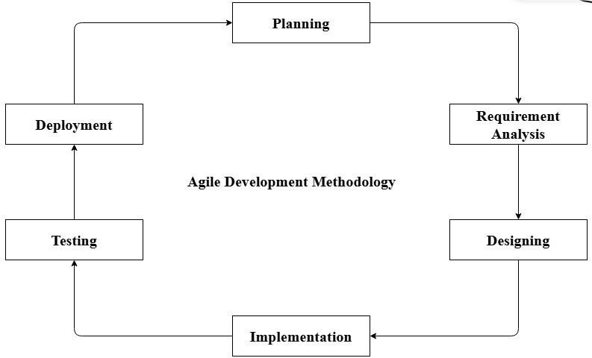
We have used the Agile model for this project because it is well suited for a small team like ours, consisting of just two friends. Agile allows us to work in small iterations, making it easier to divide tasks, collaborate closely, and track progress regularly. It also provides flexibility to modify requirements or features at any stage of development, which is helpful for a student project where ideas evolve over time. Regular testing in each iteration helps us identify and fix errors early, ensuring better project quality and timely completion.
Figure 1: Agile Development Model

3.1.1 Requirements Analysis
This system fulfills the following functional and non-functional requirements.
      - Functional Requirements
- The system shall provide secure user authentication with role-based access for Admin, Seller, and Customer.
- The system shall allow sellers to manage products by adding, updating, viewing, and deleting product information including price, description, category, and stock details.
- The system shall allow customers to browse, search, and view product details, add items to a shopping cart, modify cart contents, and place orders successfully.
- The system shall integrate online payment functionality using eSewa to enable customers to complete transactions securely.
- The system shall verify payment status and store transaction details after successful payment processing.
- The system shall generate order confirmation for customers and notify sellers after successful payment.
- The system shall provide an admin panel that enables the admin to manage users, monitor products, track orders, and oversee payment records efficiently.
- The system shall implement a product recommendation feature to personalize the shopping experience and enhance user satisfaction.
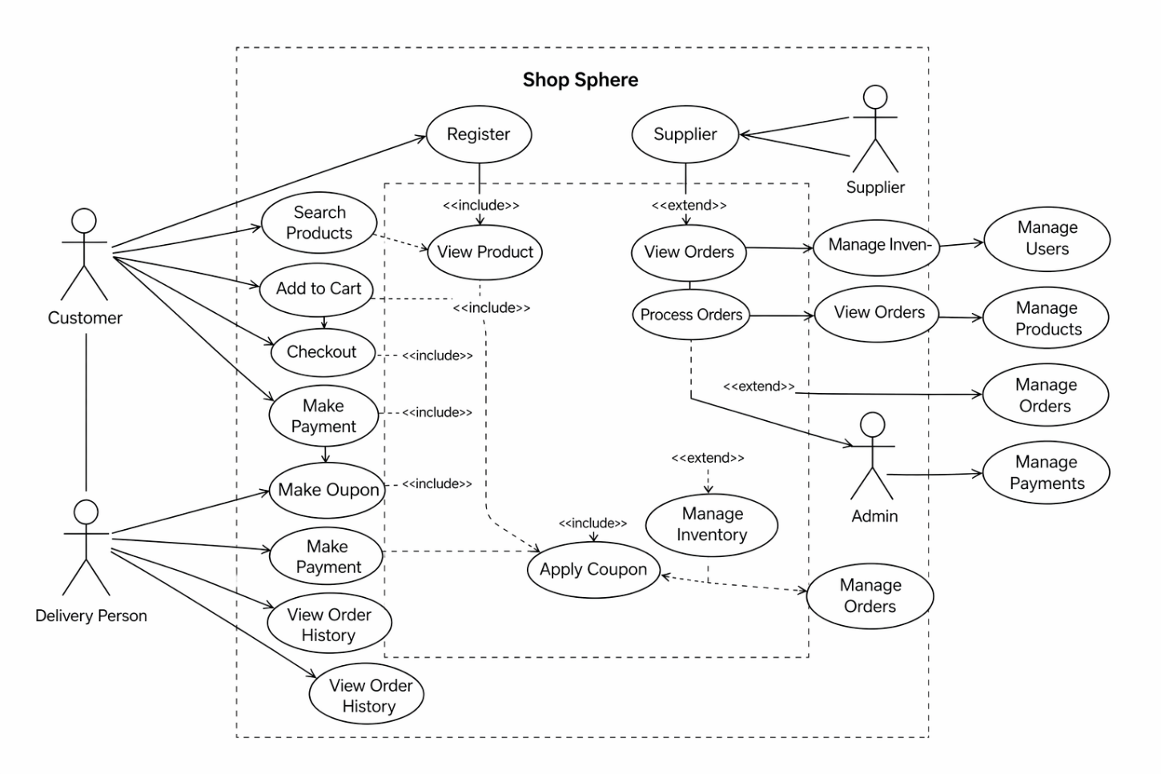
Figure 2: Use Case Diagram for ShopSphere
There are four actors as Admin, Customer, Seller and Delivery Person. The actors can perform the only actions they are linked to by the straight lines. There are bunch of actions which can be performed when the actors are signed in to the system.

      - Non-Functional Requirements
- The system shall provide fast response time for product browsing, cart operations, and order processing, even when multiple users access the platform simultaneously.
- The system shall ensure secure authentication, encrypted password storage, and secure online payment processing through eSewa integration to protect user and transaction data.
- The system shall provide a simple, user-friendly, and responsive interface that allows users to navigate and complete purchases easily.
- The system shall operate consistently without data loss and ensure accurate storage of user, product, order, and payment information.
- The platform shall be designed to handle future growth in the number of users, products, and transactions.
- The system shall be accessible online at all times except during scheduled maintenance.
- The system shall be structured in a modular way so that updates, bug fixes, and feature enhancements can be implemented easily.

3.1.2 Feasibility Study
A feasibility study is an evaluation and analysis of a project or system that somebody has proposed. It is carried out to analyze that the project is worthwhile or not. Following feasibility was studied before building the system to see if the system could be built with exact requirements in required time.
- Technical Feasibility
The development of Shop Sphere is technically feasible as it utilizes reliable and widely used technologies. The frontend of the system is developed using HTML, CSS, and JavaScript to create an interactive and responsive user interface. The backend is implemented using Python, which ensures efficient server-side processing and business logic handling. PostgreSQL is used as the database management system to securely store and manage user, product, order, and payment data. These technologies are well-supported, scalable, and suitable for building a secure and high-performance eCommerce platform. Additionally, integration with eSewa for online payment further strengthens the technical capability of the system.
- Operational Feasibility
The proposed system is operationally feasible as it is designed to provide a simple, efficient, and user-friendly online shopping experience. Shop Sphere addresses common challenges faced in traditional shopping and existing online platforms by allowing customers to browse products, receive personalized recommendations, and complete secure transactions easily. The system also enables sellers to manage products effectively and administrators to monitor overall operations. The platform is easy to operate, requires minimal training, and can be accessed from any location with internet connectivity, making it practical for real-world use.
- Economic Feasibility
The project is economically feasible because it is developed using open-source and freely available technologies, which significantly reduces development costs. There is no requirement for expensive software licenses or proprietary tools. The infrastructure requirements are minimal, and the system can be deployed on affordable hosting services. Therefore, the overall cost of development and implementation is low compared to the potential benefits of increased sales, improved customer satisfaction, and efficient business management.
- Schedule Feasibility:
The schedule feasibility is the most important study to be done, as it is responsible for the project overall success; because the project is failed if not completed on time.
In this project, the Gantt Chart is used for schedule feasibility study. The Gantt Chart is shown below:

3.1.3 Data Modelling (ER-Diagram)
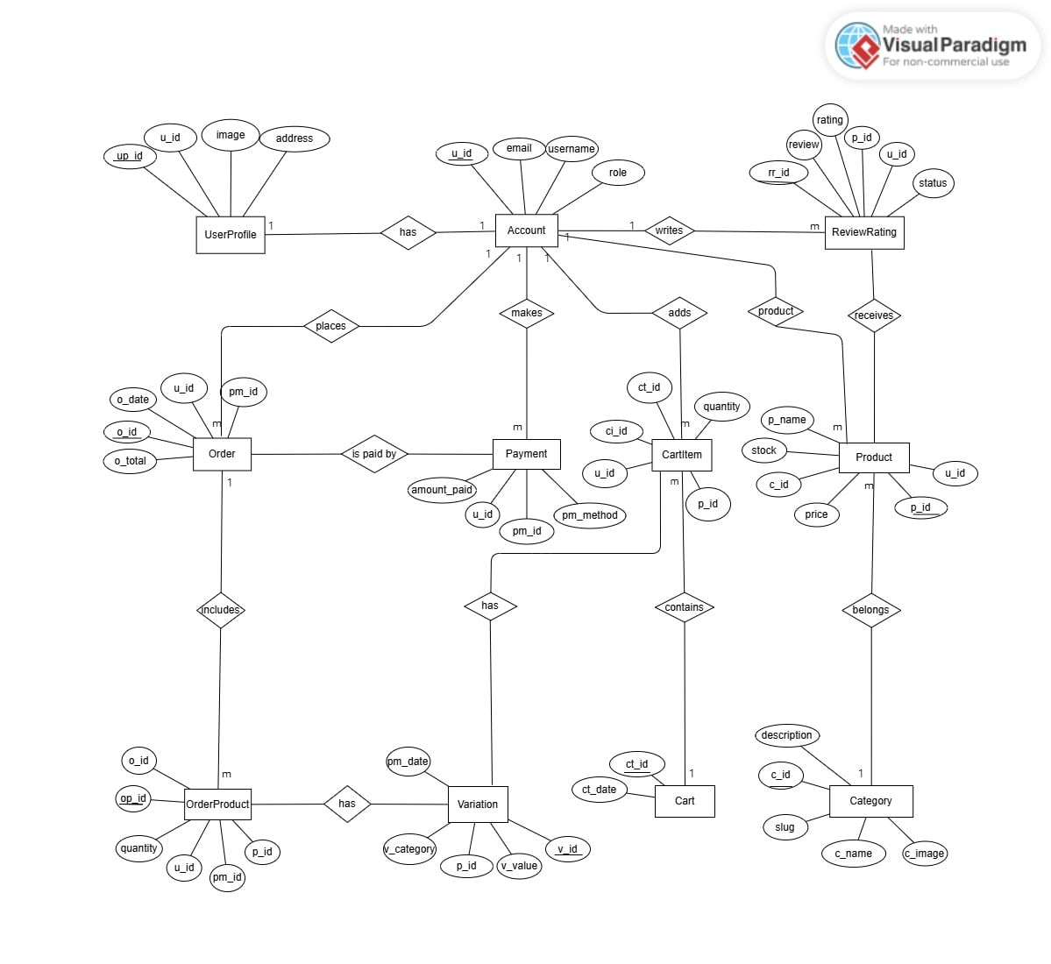
Figure 4: ER Diagram of ShopSphere

3.1.4 Process Modelling (Data Flow Diagram)
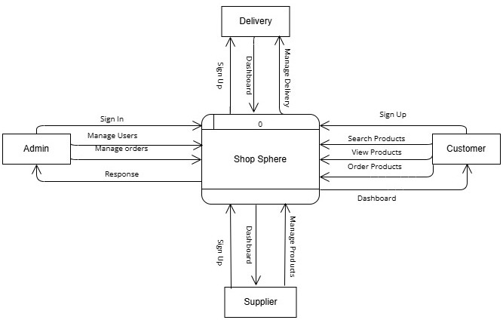
Figure 5: DFD Level 0 of ShopSphere

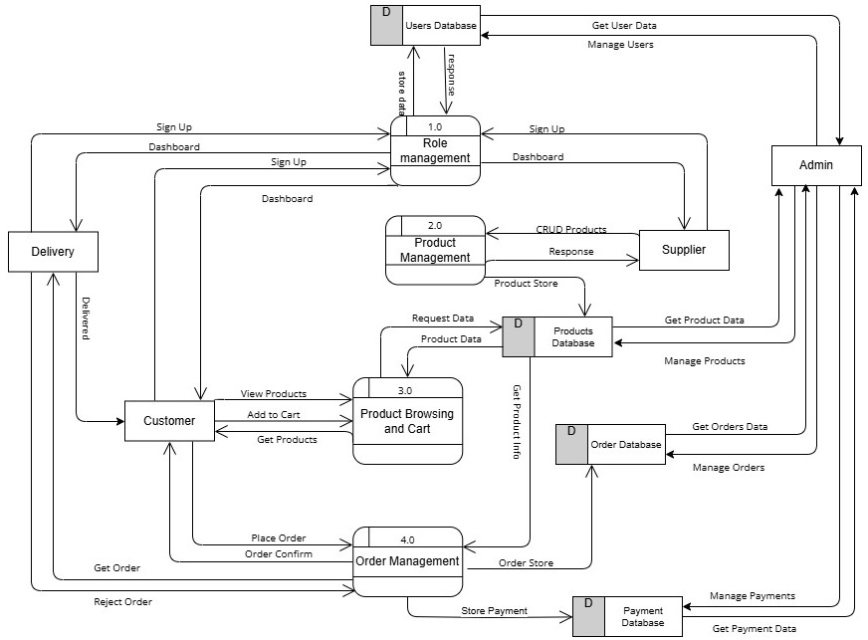
Figure 6: DFD Level 1 of ShopSphere

3.2 System Design
For this analysis, we have studied articles, journals, and visited related websites for requirement identifications, feasibility study, and high-level design including process modelling and data modelling of the system [9].

3.2.1 Architectural Design
This system follows data-centered architecture. All the data are stored in the database and is accessed by all the parties involved with the system. Features like User Authentication, User Registration, Viewing Information and editing profiles are included in the Front-end portion. Prediction, and confidence score are included in the processing.
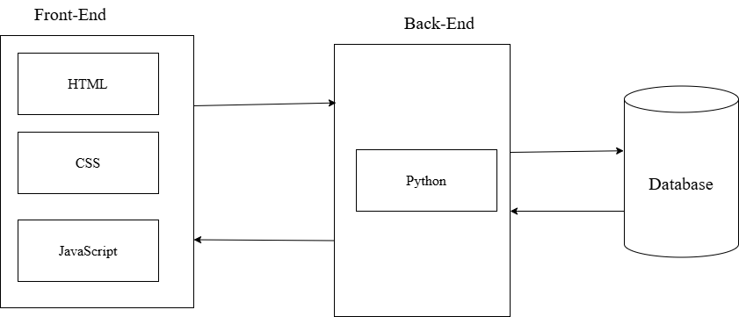
Figure 7: Architectural Design of ShopSphere

3.2.2 Database Schema Design
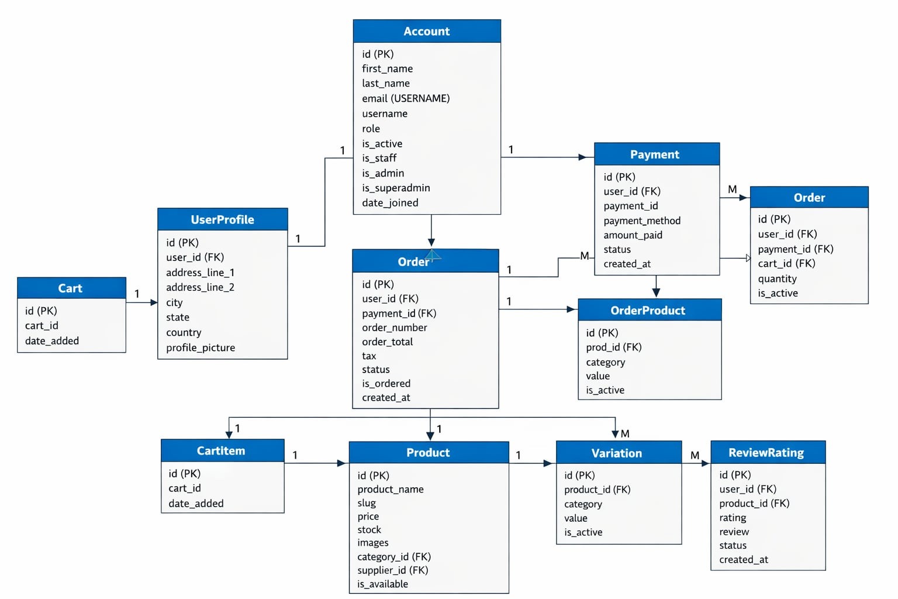
Figure 8: Database Schema of ShopSphere

3.2.3 Interface Design
Some of the interface that we have created in this project are as follow:
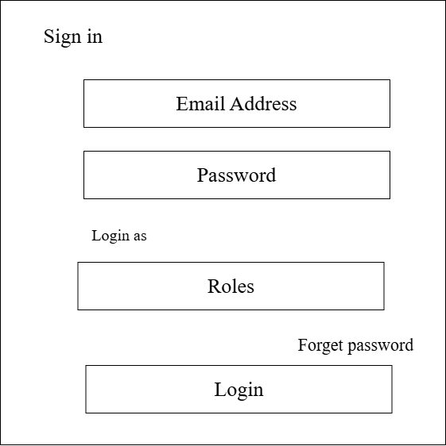
Figure 9: Interface Design for Login Form

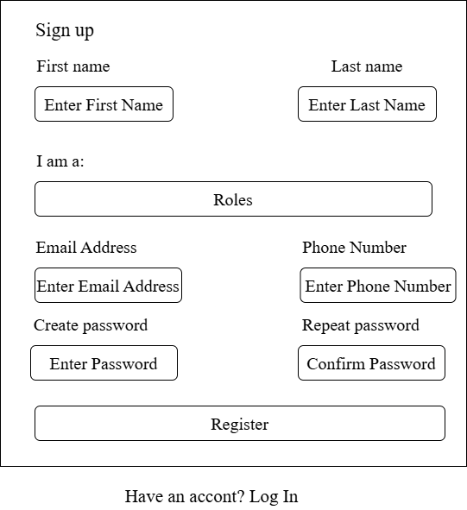
Figure 10: Interface Design for Registration Form

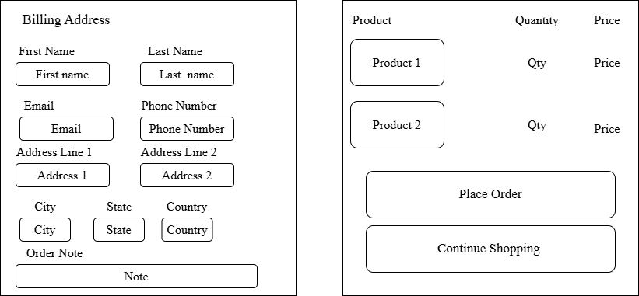
Figure 11: Interface Design for Checkout Form

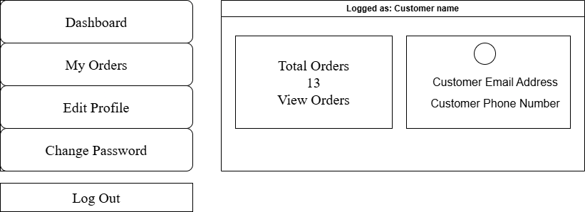
Figure 12: Interface Design for Customer Dashboard

3.2.4 Physical DFD
Physical data flow diagram shows how the data flow is implemented in the system. Physical DFD is more specific and closer to implementation.
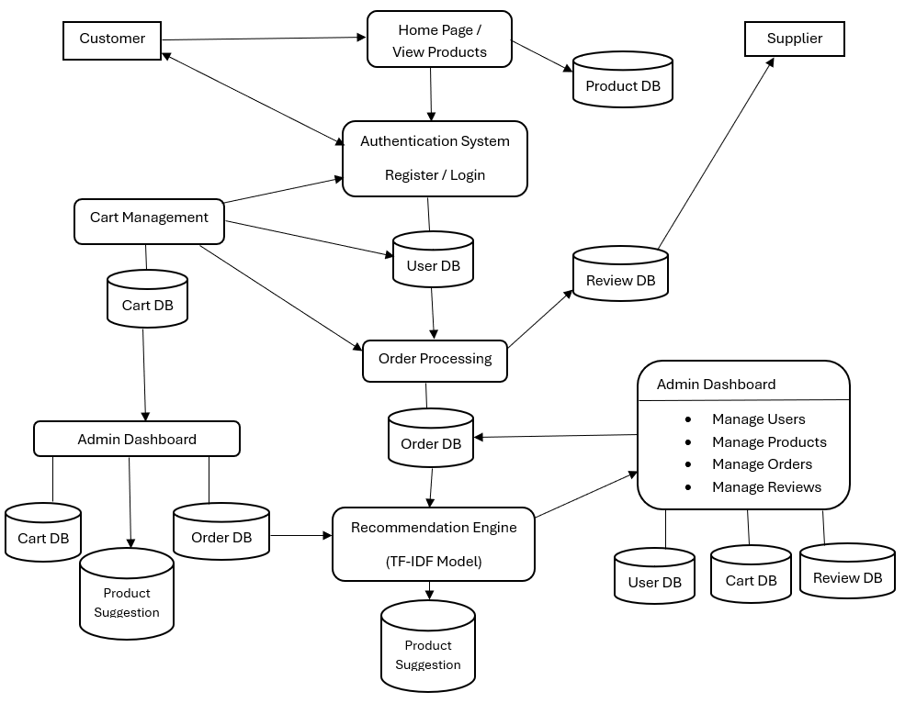
Figure 13: Physical Dataflow Diagram for ShopSphere

3.3 Description of Algorithm
K-Nearest Neighbors (KNN) Algorithm
K-Nearest Neighbors (KNN) is a non-parametric, supervised learning algorithm used for both classification and regression. In the context of recommendation systems, it operates as a memory-based approach. The fundamental assumption of KNN is that "similar data points exist in close proximity to each other within a feature space." Unlike many other algorithms, KNN does not "learn" a model during a training phase; instead, it stores the entire dataset and performs all calculations at the time of prediction, making it a "lazy learner."
Process Workflow
A typical implementation of the K-Nearest Neighbors algorithm follows four main steps:
- Data Representation: Represent every object (user or item) as a vector in a multi-dimensional feature space. In your e-commerce project, these dimensions are defined by the ratings given by various users.
- Distance Calculation: When a prediction is needed for a specific point, the algorithm calculates the distance between that target point and every other point in the dataset. This determines how "close" or "similar" the points are.
- Neighborhood Selection: The algorithm identifies the $k$ points in the dataset that are closest to the target point. The value of $k$ is a user-defined constant that determines the size of the neighborhood.
- Voting or Averaging: * For Classification: The algorithm takes a "majority vote" from the $k$ neighbors to assign a label.
  - For Regression/Recommendation: The algorithm computes the average (often weighted by distance) of the neighbors' values to predict a specific score or rating.
Mathematical Representation
The most common way to measure the "proximity" in KNN is through Euclidean Distance, which calculates the straight-line distance between two points $p$ and $q$ in an $n$-dimensional space:
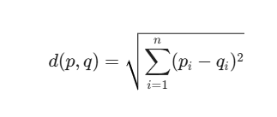
Where:
- d(p, q) is the distance between the target point $p$ and a neighbor $q$.
- n represents the number of dimensions (features or users).
- p_i and q_i are the coordinates of the points in the $i^{th}$ dimension.
While Cosine Similarity (which we used in your code) focuses on the angle between vectors to find similarity, Euclidean Distance focuses on the magnitude of the difference between points.

Chapter 4 Implementation and Testing

4.1 Implementation
Implementation includes user notification, user training, installation of hardware, installation of software onto production computers, and integration of the system into daily work processes. This phase continues until the system is operating in production in accordance with the defined user requirements.

4.1.1 Tools Used
The various system tools that have been used in developing both the frontend and backend have been discussed in this chapter.
Front End
HTML, CSS, JavaScript, Bootstraps, jQuery.
      - HTML: HTML is used in to describes the meaning and structure of web content.
      - CSS: It is used for specifying the presentation and styling of a document written in a markup language.
      - JavaScript: It is used to add interactivity and dynamic content to web pages, enhancing the user experience (UX). It enables the use of JSON and AJAX.
Back End
Python with Django Framework, PostgreSQL, Python ML libraries like Scikit-learn.
      - Python – Django Framework: It is a server-side language that handles the business logic, request processing, authentication, and prediction processing.
      - PostgreSQL: It is used to store the data gathered from the users i.e., doctors and patients and also store the predicted data securely.
CASE Tools
Draw.io, Visual Paradigm
      - Draw.io
Draw.io is the designing tool used to design the interface of this project.
      - Visual Paradigm
Visual Paradigm is a popular tool for designing various UML diagrams like USE CASE diagram, ER-diagram, DFD, etc.
IDE Tools
VS Code and Chrome Console
      - VS Code and Chrome Console is used to write the code and display output.

4.1.2 Implementation Details of Modules
After the design was made and the problems arising from the design process were clarified and dealt with, it was time to start implementing the application. Implementing application this scale requires lots of resources and explaining the whole implantation process will not be clarified in this paper. However major important aspects in the implementation are described. Some modules of the shopping websites are listed below:
      - Header
Header is the container for the system’s logo, called navbar. It is used to provide the links to other pages in the system. In this system too, navbar contains links to different parts and pages of the website along with warn welcome to the logged in users.
      - Registration Form
Registration form is used to register new users in the website. It contains the input fields for username, email, password, confirm password, etc. Various types of validation are applied to these field to ensure the data integrity. The information entered here is further stored to be used in the login form. View called signup(request) is used to register the doctor to the system as follows:
def signup(request):
if request.method == 'POST':
first_name = request.POST.get('first_name')
last_name = request.POST.get('last_name')
email = request.POST.get('email')
username = request.POST.get('username')
phone = request.POST.get('phone')
password = request.POST.get('password')
confirm_password = request.POST.get('confirm_password')
role = request.POST.get('role')
profile_image = request.FILES.get('profile_image')

# password match validation
if password != confirm_password:
messages.error(request, "Passwords do not match.")
return redirect('signup')

# password length validation
if len(password) < 6:
messages.error(request, "Password must be at least 6 characters long.")
return redirect('signup')

# email format validation
email_regex = r'^[\w\.-]+@[\w\.-]+\.\w+$'
if not re.match(email_regex, email):
messages.error(request, "Invalid email format.")
return redirect('signup')

# phone validation need 10 digits
if not phone.isdigit() or len(phone) != 10:
messages.error(request, "Phone number must be 10 digits.")
return redirect('signup')

# image validation (.jpg, .jpeg, .png)
if profile_image:
allowed_extensions = ['jpg', 'jpeg', 'png']
file_extension = profile_image.name.lower()

if not any(file_extension.endswith(ext) for ext in allowed_extensions):
messages.error(request, "Profile image must be a .jpg, .jpeg, or .png file.")
return redirect('signup')

# unique username and email validation
if User.objects.filter(username=username).exists():
messages.error(request, "Username already taken.")
return redirect('signup')

if User.objects.filter(email=email).exists():
messages.error(request, "Email already registered.")
return redirect('signup')

role_map = {
'supplier': 'SUPPLIER',
'customer': 'CUSTOMER',
'delivery_personnel': 'DELIVERY'
}

if role not in role_map:
messages.error(request, "Invalid role selected.")
return redirect('signup')

user = User.objects.create_user(
username=username,
email=email,
password=password,
first_name=first_name,
last_name=last_name
)

UserProfile.objects.create(
user=user,
role=role_map[role],
profile_image=profile_image
)

messages.success(request, "Account created successfully. Please sign in.")
return redirect('signin')

return render(request, 'signup.html')
      - Login Form
Login form is responsible for providing the roadmap to the main system. It has input fields like username and password that are stored through the registration form to authenticate the valid user and give further access and direction.
View called signin(request) is used to login users in the system. The module for this functionality is as follows:
def signin(request):
if request.method == 'POST':
email = request.POST.get("email")
password = request.POST.get("password")

try:
user_obj = User.objects.get(email=email)
user = authenticate(
request,
username=user_obj.username,
password=password
)
except User.DoesNotExist:
user = None

if user is None:
messages.error(request, "Invalid email or password!")
return redirect('signin')

login(request, user)

# SAFE UserProfile access
try:
profile = user.userprofile
except UserProfile.DoesNotExist:
messages.error(request, "User profile not found. Contact admin.")
return redirect('signin')

role = profile.role

if role == 'CUSTOMER':
return redirect('customer_dashboard')

elif role == 'SUPPLIER':
return redirect('supplier_dashboard')

elif role == 'DELIVERY':
# document check
if DeliveryDocument.objects.filter(user=user).exists():
return redirect('delivery_personnel_dashboard')
else:
return redirect('document_form')

# final fallback
messages.error(request, "Invalid user role.")
return redirect('signin')

return render(request, 'signin.html')

4.2 Testing
Following testing is done to check the behavior of a complete and fully integrated software product based on the software requirement specification document. Hence test cases written to test this application are explained below. We have carried-out the testing for the form validation for login and registration. Due to the time scale to present the project, we have considered only these testing in order to check the working mechanism and correctness of the system.

4.2.1 Test Case for Unit Testing
Test Case for registration form:
T01: Check user registration with null data T02: Check user registration with invalid data T03: Check user registration with valid data
Table 1: Test Case for Registration Form

ID | Test Case  Description | Test Data | Expected  Result | Actual  Result | Pass/Fail  Status
T01 | User enters empty or null data. | Username: Email: Password:  Confirm Password: | **  All the fields are required to fill up to register.  ** | As expected, | Pass
T02 | User enters invalid data. | Username: test Email:test@.example.com Password: 111222  Confirm Password: 111222 | **  User should not  register.  ** | As expected, | Pass
T03 | User enters valid data. | Username: user  Email: user@example.com Password: 111111  Confirm Password: 111111 | User should register | As expected, | Pass

Test Cases for Login Form:
T04: Check user login with null data
T05: Check user login with invalid username or password or user type T06: Check user login with valid data
Table 2: Test Case for Login Form

ID | Test Case  Description | Test Data | Expected  Result | Actual  Result | Pass/Fail  Status
T04 | User enters empty or null data. | Username: Password: | **  All the fields are required to fill up to login.  ** | As expected, | Pass
T05 | User enters invalid username or password or  usertype. | Username: user Password: 111222 | **  User should not  login.  ** | As expected, | Pass
T06 | User enters valid data. | Username: user@example.com  Password: 111111 | User should login. | As expected, | Pass

4.2.2 Test Case for System Testing
- Verified all the specified input fields are present on the registration page.
- Verified clicking submits button after entering all the necessary fields, submits the data to the server.
- Verified the validation rules that are applied both using server-side script and client-side script functions properly.
- Verified validation on numeric typed input fields by entering the alphabets and special characters.
- Verified the database connection is well maintained.
- Checked that the data present in the website is directly connected to the database and are being fetch through the data stored in the database.
- Checked the admin and user login redirection. Admin should redirect to the dashboard of the admin panel and user should redirect to the website.
- Checked that the AJAX connection either it is working properly or not in order to fetch the data from the database.
- Verified that the session variables being defined are correctly used in the website and the whole system.
- Verified the alert and confirm boxes being called working properly or not when related events are fired to trigger them.
Hence, these are some of the test cases being developed for the overall system testing after the unit testing was fully completed.

Chapter 5 Conclusion and Future Recommendations

5.1 Lesson Learnt / Outcome
During the development of Shop Sphere – An Advanced E-commerce System, we gained valuable practical experience in both web development and recommendation systems. Implementing the item-based collaborative filtering algorithm helped us understand how user behavior and product similarities can be analyzed to generate personalized product recommendations. This enhanced our knowledge of how modern e-commerce platforms improve user experience through intelligent systems.
We also learned how to integrate front-end technologies such as HTML, CSS, JavaScript, and Bootstrap with a powerful back-end using Python Django framework and PostgreSQL for efficient database management. This project helped us build a fully dynamic, responsive, and user-friendly web application with real-time functionalities.
Additionally, we gained hands-on experience in implementing secure user authentication, role-based access control (Admin, Customer, Supplier), and efficient product and order management systems. Integration of the eSewa payment gateway provided practical exposure to real-world online payment systems and transaction handling.
The development of features like shopping cart, order processing, product reviews, and recommendation system improved our understanding of full-stack development and system integration. We also learned the importance of data handling, system security, and performance optimization in large-scale applications.
Overall, this project enhanced our skills in problem-solving, system design, database management, and teamwork. The outcome of this project successfully addresses the challenges of modern online shopping by providing a smarter, faster, and more personalized shopping experience for users, making the platform reliable and efficient for both customers and sellers.

5.2 Conclusion
Shop Sphere – An Advanced E-commerce System successfully demonstrates how modern web technologies and intelligent recommendation systems can be applied in the e-commerce domain to enhance user experience and business efficiency. By implementing the K-Nearest Neighbor algorithm, the system provides personalized product recommendations based on user behavior, helping customers discover relevant products quickly and improving overall satisfaction.
The project also integrates a secure and user-friendly platform with essential e-commerce functionalities such as product browsing, cart management, order processing, reviews, and role-based dashboards for customers, suppliers, and administrators. The integration of the eSewa payment gateway ensures safe and reliable online transactions, making the system practical and aligned with real-world applications.
Overall, Shop Sphere bridges the gap between traditional shopping and intelligent online systems by providing a smart, efficient, and accessible digital marketplace. The project successfully meets its objectives and provides valuable insights into full-stack web development, recommendation systems, and secure payment integration. It serves as a strong foundation for building scalable and user-centric e-commerce platforms in the future.

5.3 Future Recommendations
Here are some enhancements that can be implemented in the future to improve the usability, user experience, and scalability of the website. Although these features require additional time and resources, they are practical and achievable for future versions of the system.
Future versions of Shop Sphere can be significantly improved by integrating more advanced recommendation techniques such as hybrid recommendation systems (combining collaborative and content-based filtering) and machine learning models to increase accuracy and personalization. This will allow the platform to better understand user preferences and provide smarter product suggestions. Additionally, implementing AI-based analytics can help predict user behavior, optimize product listings, and improve sales strategies.
The platform can also be enhanced by expanding features such as real-time inventory management, advanced search with filters, and personalized dashboards. Introducing automated product recommendations based on browsing history, purchase patterns, and user interests will further improve customer engagement. Moreover, adding a wishlist system and order tracking with real-time updates can enhance user convenience.
To improve accessibility and user experience, a mobile application version of Shop Sphere can be developed, allowing users to shop anytime and anywhere. Integration of multi-language support will make the platform more inclusive and accessible to a wider audience. Additionally, implementing voice search functionality can make product searching faster and more user-friendly.
Further improvements can include integrating multiple payment gateways beyond eSewa, such as international payment systems, to increase flexibility. Enhancing security features like two-factor authentication (2FA) and advanced data encryption will make the system more secure and reliable.

REFERENCES
[1] WiserNotify, “50+ e-commerce personalization statistics & trends (2026),” 2026. [Online]. Available: https://wisernotify.com/blog/ecommerce-personalization-stats/
[2] McKinsey & Company, “How much value do AI recommendations really add to e-commerce,” 2025.
[3] Firney, “Amazon’s 35% revenue from recommendations: The full data,” Jan. 2026. [Online]. Available: https://www.firney.com/
[4] B. Sarwar, G. Karypis, J. Konstan, and J. Riedl, “Item-based collaborative filtering recommendation algorithms,” in Proceedings of the 10th International Conference on World Wide Web (WWW ’01), Hong Kong, 2001, pp. 285–295, doi: 10.1145/371920.372071.
[5] S. Nepal, “Factors influencing affinity of eSewa-Mobile Wallet: A case study in Kathmandu Valley,” Nepalese Journal of Management, vol. 11, no. 2, pp. 135–154, Apr. 2024.

APPENDIX
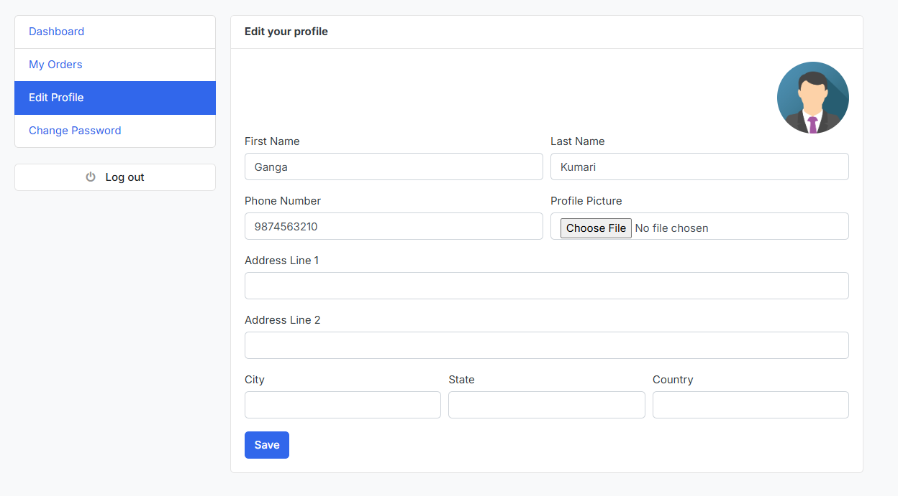
Figure 14: Edit Profile Page

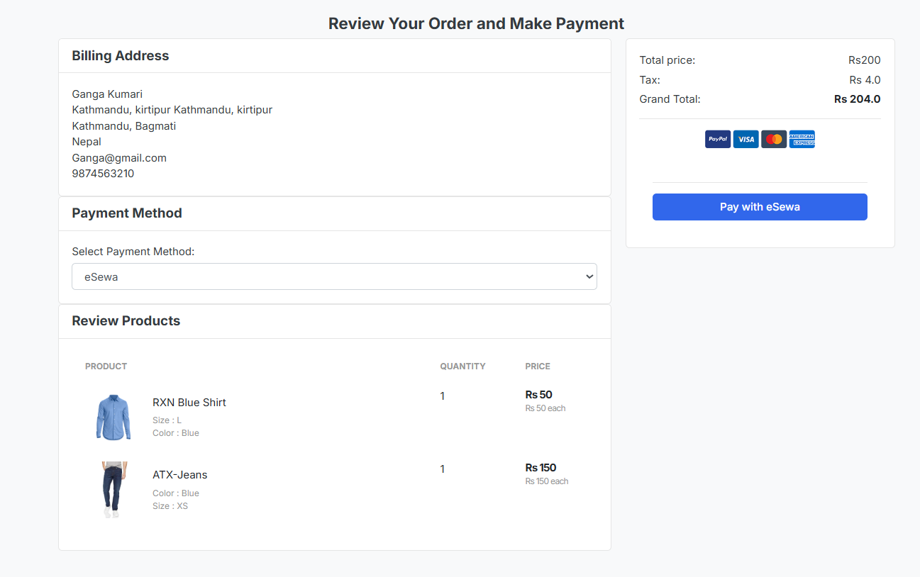
Figure 15: Place Order Page
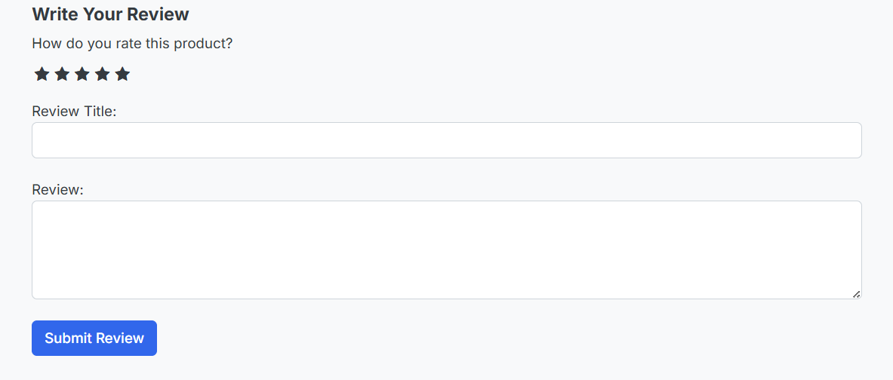
Figure 16: Review Section
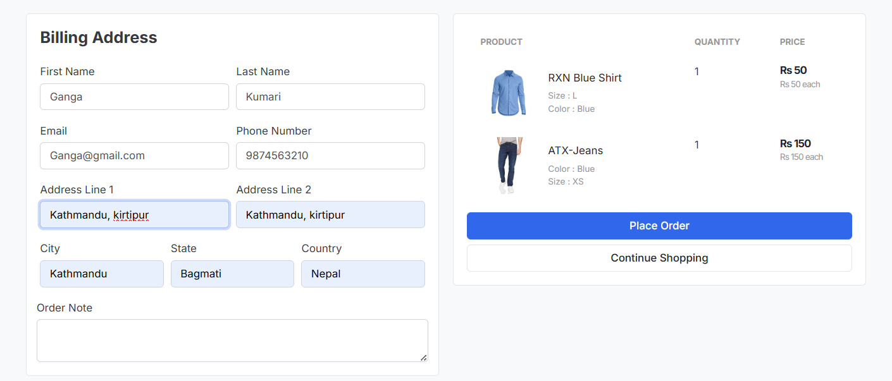
Figure 17: Checkout Page
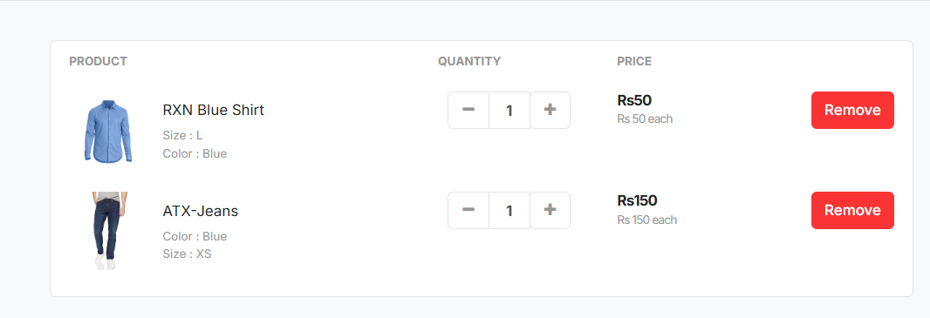
Figure 18: Add to Cart Page

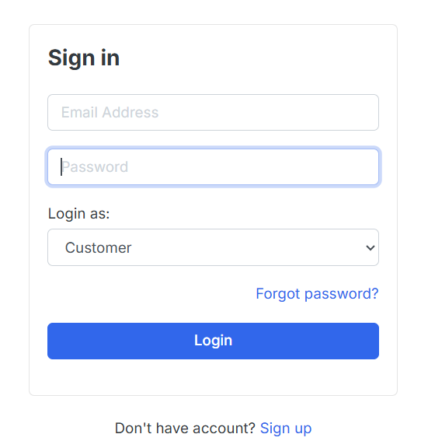
Figure 19: Login Form
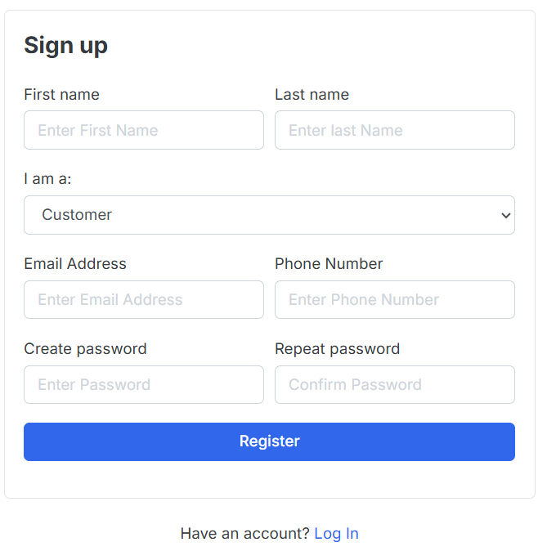
Figure 20: Registration Form

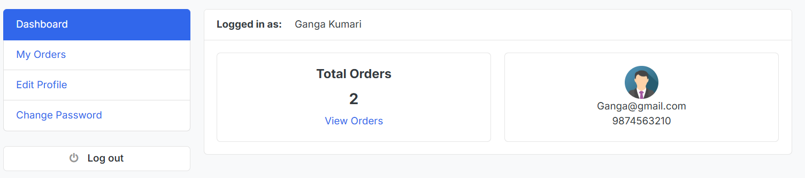
Figure 21: Customer Dashboard
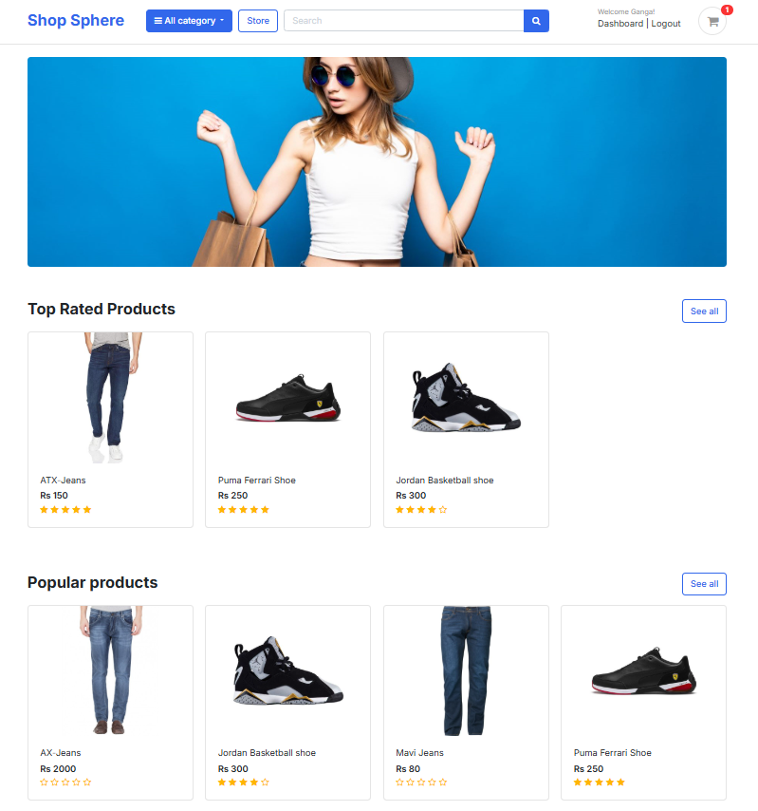
Figure 22: Home Page

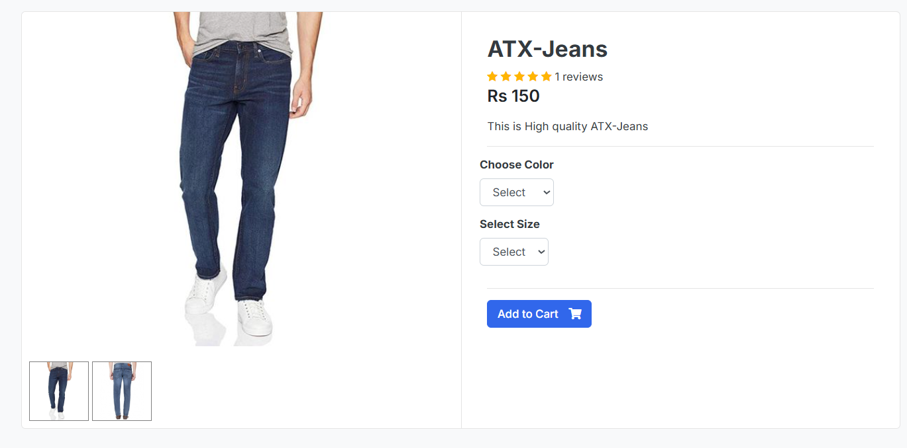
Figure 23: Product Detail Page
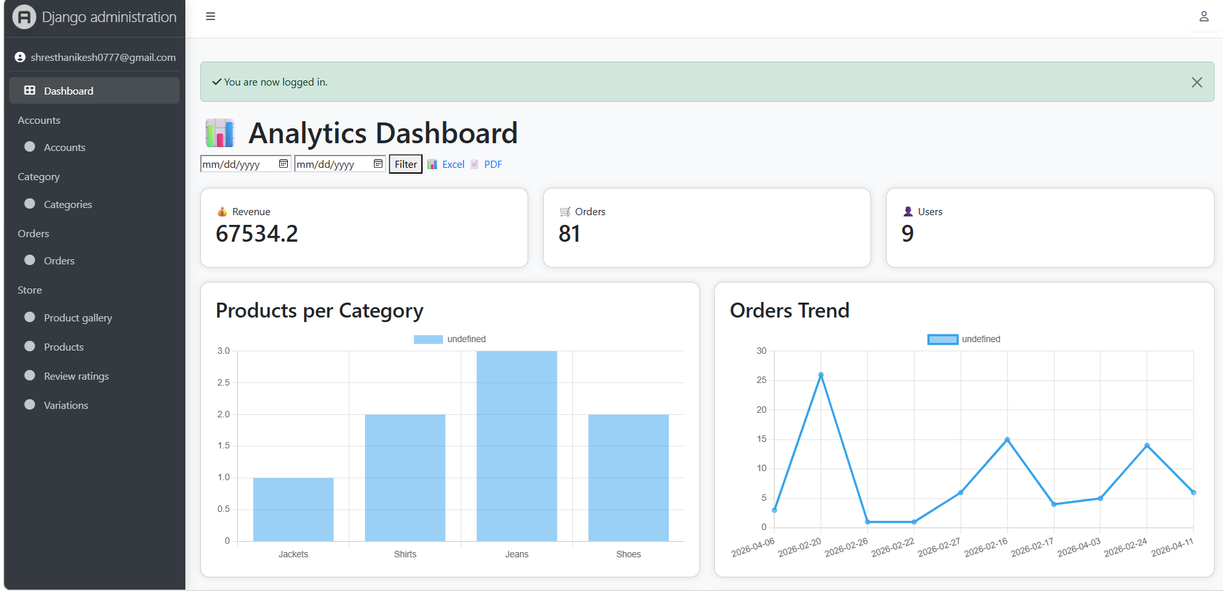
Figure 24: Admin Panel

