**A**

**LAB REPORT**

**ON**

**Artificial intelligence**

**By: Bibek Raj Joshi**

**Symbol Number:14540/22**



**Submitted to: Pradip Bochhibhoya**

**Department of Computer Science**

**Kantipur College of Management and Information Technology**

In partial fulfilment of the requirements for the Course

Artificial Intelligence

Mid Baneshwor, Kathmandu

April 2025

Table of Contents

Introduction 3

Features and functionality: 3

Technology Used: 3

5. Mysql: This is used to store in the information about the pages.Introduction 3

Features and functionality 4

➔ CMS 4

Homepage: 4

Gallery: 5

Blog page: 6

Bungee page: 7

Paragliding page: 8

Zipline page: 9

Problems found/lesson learned: 10

Future works: 10

Reference 10

Conclusion: 11

# Introduction

A web project involves designing and developing user interface and visual elements of a website that users interact directly. It focuses on creating the user-facing components of a website, encompassing everything that the users see, interact with, and experience when they visit a web page. This includes designing the layout, styling and interactive elements to provide an engaging and user-friendly experience. Hungry Travels Nepal.com is a website that serves the people a platform to experience the adventure in Nepal. The website is thoughtfully designed to increase tourism in Nepal and establish the great adventure and tourism sector's development in Nepal .It aims to help the government to generate the income from tourist.

# Features and functionality:

                                   Our Travel website is dedicated to those who are interested in adventure. We have various adventure services on our website. The home page welcomes the user and introduces the website and highlights its key features. It contains a menu that links to other sections of the website.

* We have different features in our website like the users can explore the adventurous places in Nepal and they can choose the various adventurous destination within Nepal.
* Users can easily reach out to the website owners and mention their queries if any. Also there is a contact number and location is available in the contact us page. The users have to submit their details in the contact us section.
* Reference sources are mentioned in the website so that the user can go through the books if they have any queries. Provide a list of reference books with title, authors and description.

# Technology Used:

There are altogether three technologies used in our Hungry Travel Nepal Website. They are HTML, CSS and JavaScript.

1. HTML: We have created the websites skeleton via html and used various elements to create a structure of our website.

2. CSS: CSS is used for decorating the page to make it look more beautiful. Each page has been decorated with different color combinations. We have also implemented animation in our website via CSS.

3. JavaScript: We used the Javascript on our website for validating the login form and signup form. Also it is used in our website in home while we are scrolling the webpage the service section reveals.

4: Php: The php is used build the backend of the website.

# 5. Mysql: This is used to store in the information about the pages.Introduction

A web project involves designing and developing user interface and visual elements of a website that users interact directly. It focuses on creating the user-facing components of a website, encompassing everything that the users see, interact with, and experience when they visit a web page. This includes designing the layout, styling and interactive elements to provide an engaging and user-friendly experience. Hungry Travels Nepal.com is a website that serves the people a platform to experience the adventure in Nepal. The website is thoughtfully designed to increase tourism in Nepal and establish the great adventure and tourism sector's development in Nepal .It aims to help the government to generate the income from tourist.

# Features and functionality

# CMS

We have implemented the CMS in our website. It will streamline content management, enhance user experience and support future scalability. The CMS will help us to easily edit delete or manage the content on our website.

# Homepage:

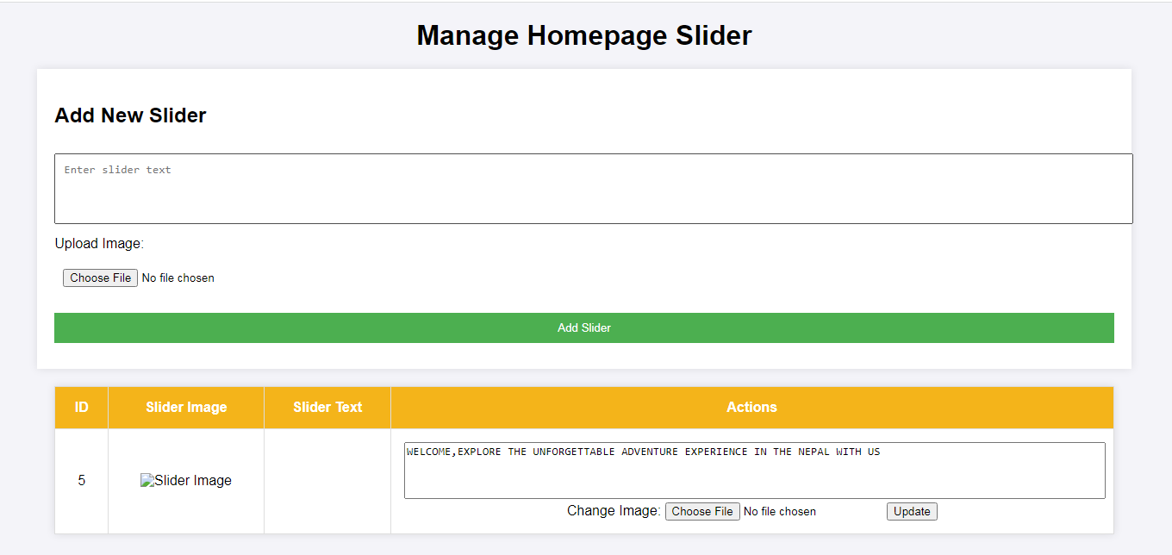

In this page we can change the content of the homepage .

# Gallery:

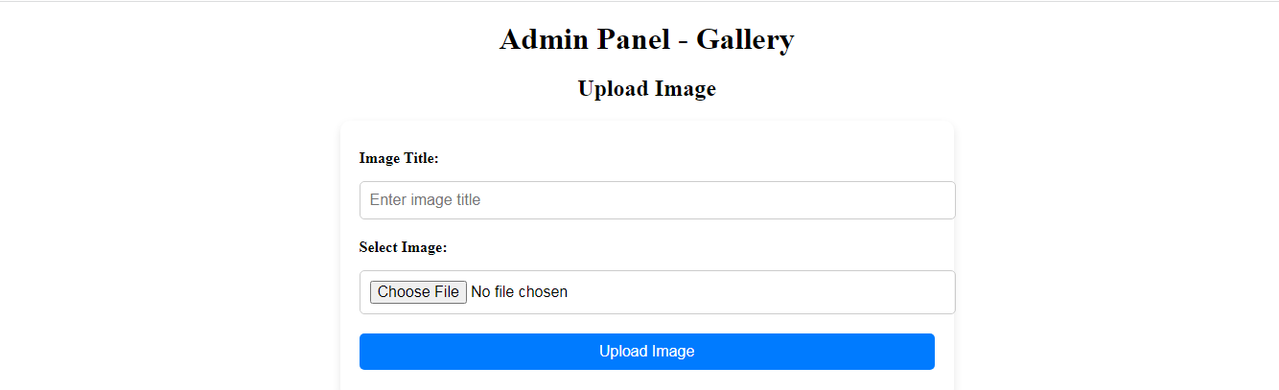

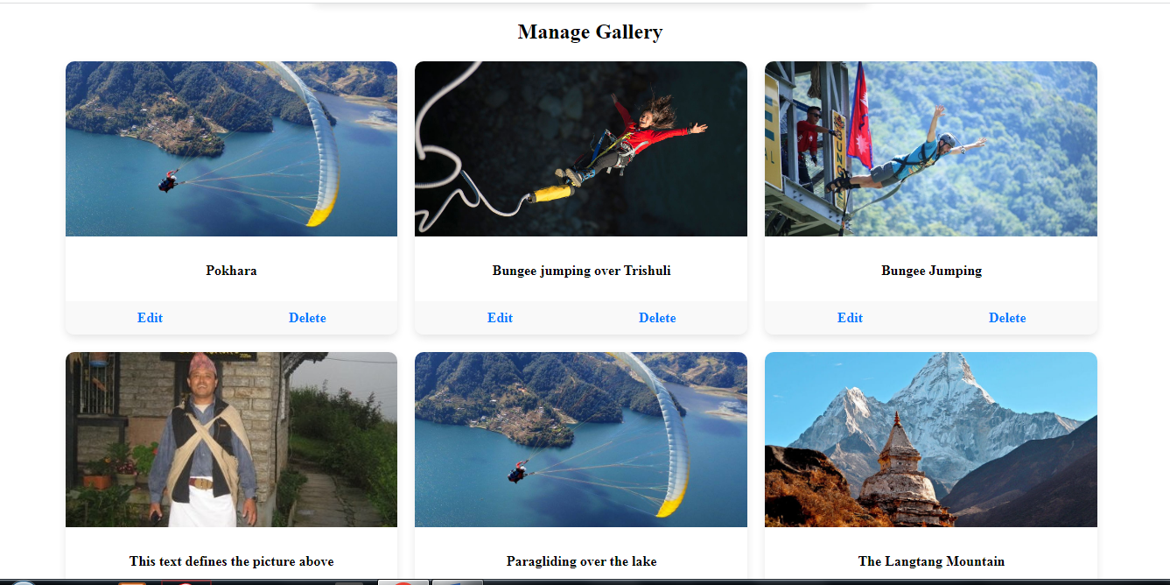

In this we can manage the content of the gallery. We can edit or the delete the content in the website. We can dynamically change the content In the website.

# Blog page:

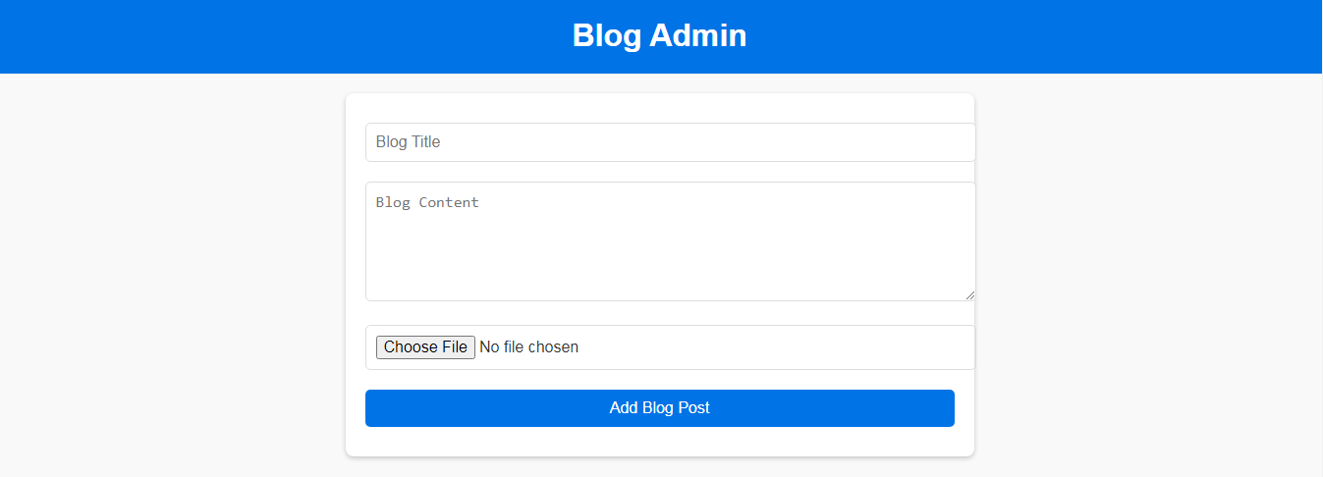

The blog page contains the blog title and the content. We can upload the content in the blog page. It also allows to delete the existing blogs in the page.

# Bungee page:

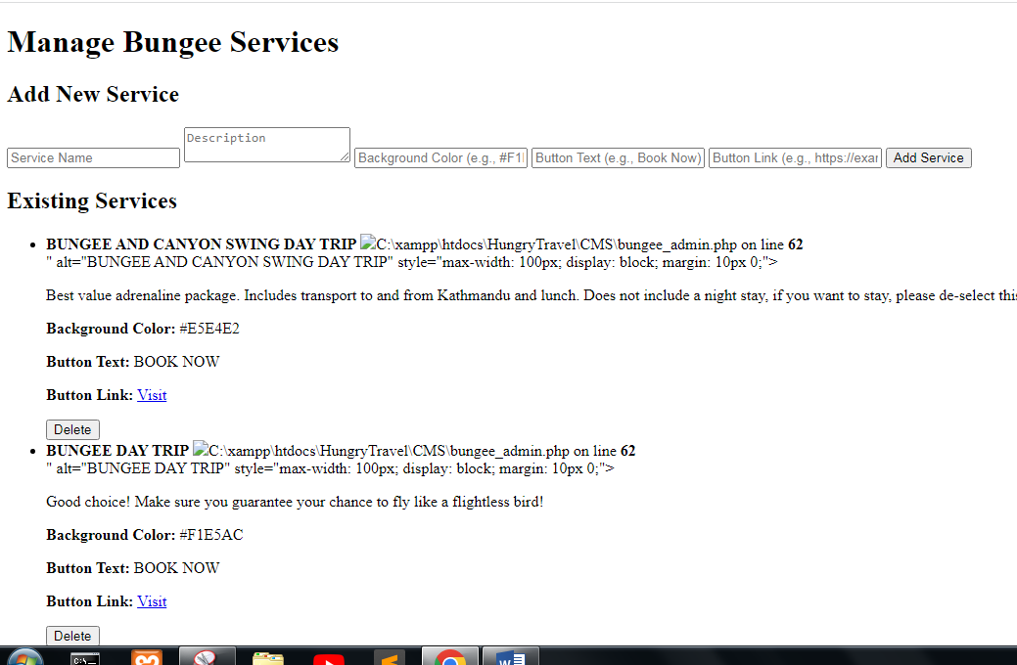

In this we can add the content in the bungee page also we can delete the existing services in the bungee page.

# Paragliding page:

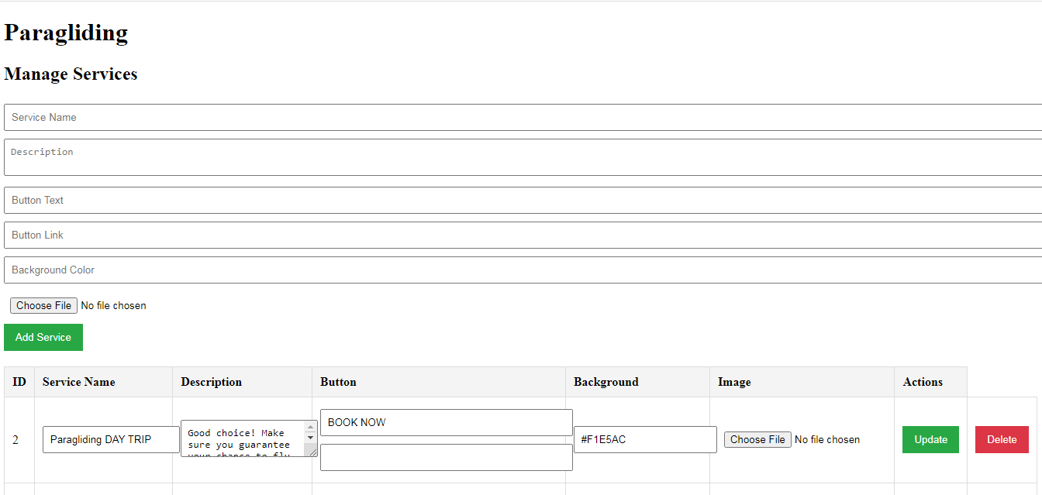

This is paragliding page and in this we can edit or the delete the content in the paragliding page.

We can also add the content in the page.

# Zipline page:

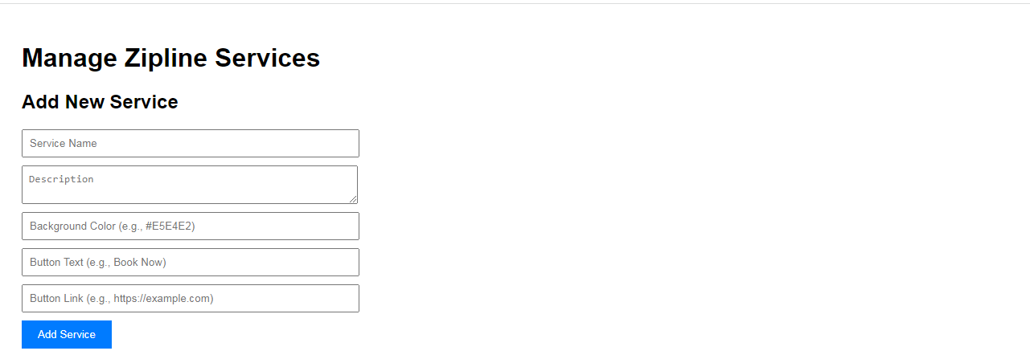

This is zipline page and in this page we can edit or delete the existing content in the website and also we can add the content.

# Problems found/lesson learned:

While working on the project we faced a lot of problems along the way that we had to tackle. At the beginning we were unclear about the goals on what type of website to create. Some problems are mentioned below:

1) Communication issues:

There was ineffective communication among team members which led to delay of the work further more. We found that unless we had open communication among team members the work would not move further. We began holding regular meeting and maintain clear documentation to make everyone to work together.

2) Time management: Poor time management led us to rushed work and decreased project quality. Even though there was not tight deadline due to exams between the time periods we were not able to focus properly on the project which led us to rushed work but we managed to complete it within the time period.

3) Inadequate planning:

Another issue we faced was inadequate planning. We underestimated the importance of detailed planning and this led to missed tasks and confusion. We learned that through planning and assigned responsibilities was absolutely crucial.

4) Lack of documentation:

Poor documentation was another problem we faced as we didn’t first share and keep records of the progress and the changes in project and programs which led to wasted time. We quickly learned the importance of maintaining the documents and share it with team members.

# Future works:

* Code rewrite/ code optimize

# Reference

We used different platform to build our website and they were really helpful for us. We got different idea from there.

1. You Tube
2. W3school
3. AI
4. Google

# Conclusion:

In conclusion, the journey of making the travel website has been a rewarding experience for all of us. Our project is adventure website that we developed with a vision to enjoy and experience the adventure in Nepal. The travel and adventure website dedicated to increase the tourism and adventure in Nepal. It offers a dynamic and interactive platform in which the users enjoy their vacations time and made it life time experience. It has given access to various valuable materials.  As technology advances, this website stands as a reliable resource for those seeking to thrive in the digital age. Along the way, we encountered several challenges. The technical complexities of building and maintaining a functional website demanded continuous learning. It was a life-changing experience.