Land-Cover Classification of the Khumbu Icefall Region
using Sentinel-2 — Notebook Explanation
Course report covering Khumbu_Icefall_Sentinel2_Classification.ipynb (main) and s2_simple.ipynb (baseline)

Abstract
This report explains two Jupyter notebooks that classify the Khumbu Icefall / Everest Base Camp area from Sentinel-2 imagery. The main notebook (Khumbu_Icefall_Sentinel2_Classification.ipynb) builds a cloud-masked Sentinel-2 L2A median composite for Oct–Dec 2021, takes ESA WorldCover 2021 as ground truth remapped to four classes (Vegetation, Bare/Rock, Snow/Ice, Water), engineers spectral indices, and compares a pixel-wise MLP against a patch-based CNN with a leak-free spatial block split. The supporting notebook (s2_simple.ipynb) classifies 64x64 RGB patches into snow / ice / debris with a small CNN, reaching 94.7% test accuracy (macro-F1 0.929). In the recorded Khumbu run both models collapsed to the majority Snow/Ice class (macro-F1 ~0.17, AUC ~0.5), so the report also discusses why the two notebooks differ in outcome and what to fix.

1. Study area and data sources

1.1 Khumbu Icefall notebook
- Area: bounding box [86.84, 27.96, 86.96, 28.05] (lon/lat), icefall centre (86.899, 27.988); UTM 45N (EPSG:32645), 10 m grid.
- Imagery: Sentinel-2 L2A via Microsoft Planetary Computer STAC, 2021-10-01/2021-12-15, scene cloud cover < 20%; 6 scenes found; cloud-masked (SCL classes 0,1,3,8,9,10) median composite of B02, B03, B04, B08, B11, B12.
- Ground truth: ESA WorldCover 2021 v200 (10 m), resampled to the same grid with nearest neighbour.
- Cache: composite stored in khumbu_s2_worldcover_cache.npz; trained weights in mlp_khumbu.pt / cnn_khumbu.pt.

1.2 s2_simple notebook (baseline)
- Pre-cut 64x64 RGB patches listed in data_s2/patches.csv: train n=389, val n=186, test n=265; classes snow / ice / debris.
- Normalisation statistics computed on training pixels (mean ~[0.569, 0.559, 0.538], std ~[0.332, 0.342, 0.355]).
- Train augmentation: random horizontal flip + rotation in [-10, 10] degrees.

2. Label mapping (Khumbu)
WorldCover codes are remapped to four target classes:
WorldCover code | Meaning | Target class
10, 20, 30, 40, 90, 95, 100 | trees, shrub, grass, crop, wetland, mangrove, moss | 0 Vegetation
50, 60 | built-up, bare / sparse vegetation | 1 Bare/Rock
70 | snow and ice | 2 Snow/Ice
80 | permanent water | 3 Water

Pixels with no valid mapping (-1) or non-finite reflectance are excluded. Rare classes (< 500 pixels) are dropped and ids made contiguous before training.

3. Methods - Khumbu notebook

3.1 Feature engineering
Six surface-reflectance bands plus three normalised indices (9 channels total):
- NDSI = (B03 - B11) / (B03 + B11) — snow (high green, low SWIR).
- NDVI = (B08 - B04) / (B08 + B04) — vegetation.
- NDWI = (B03 - B08) / (B03 + B08) — water.

3.2 Leak-free spatial split
Neighbouring pixels are highly correlated, so a random pixel split would leak (especially for the CNN whose patches overlap). The scene is cut into 64x64 px blocks assigned 70/15/15 to train/val/test, then pixels are sampled per class with caps (train 20000, val 5000, test 10000 per class). Channel mean/std are computed on training pixels only. Seed 42.

3.3 Models
Model | Input | Architecture
MLP (pixel-wise) | (N, 9) single-pixel spectra | Linear 9-128 + BN/ReLU/Dropout(0.2), 128-64, 64-32, 32-n_cls
CNN (patch-based) | (N, 9, 9, 9) centred windows | Conv blocks 9-32, 32-64, MaxPool, 64-128, AdaptiveAvgPool, head Dropout(0.3) + Linear 128-64-n_cls

Training: Adam (lr 1e-3, weight decay 1e-4), class-weighted cross-entropy, ReduceLROnPlateau (factor 0.5, patience 3), early stopping on validation macro-F1 (patience 8). Epochs: MLP 40, CNN 25 (batch 512 / 256). Metrics: accuracy, macro precision/recall/F1, macro AUC-ROC one-vs-rest, per-class report, confusion matrices, ROC curves, full-scene prediction maps + Khumbu Icefall zoom.

4. Methods - s2_simple notebook (brief)
Item | Choice
Model | CNN: Conv 3-32 + ReLU + MaxPool, Conv 32-64 + ReLU + MaxPool, AdaptiveAvgPool(4x4), head Flatten + Dropout(0.3) + Linear(1024-128) + ReLU + Dropout(0.3) + Linear(128-3); ~150,979 params
Optimiser/loss | Adam lr 1e-3, weight decay 1e-4; class-weighted CE (weights [1.39, 5.4, 0.48] for train counts snow 93 / ice 24 / debris 272)
Schedule | 5 epochs, batch 32; monitored val accuracy + macro-F1
Artefacts | outputs/s2_simple.pt, outputs/s2_simple_confusion.png

5. Results - Khumbu (recorded run)
From sentinel2/results_summary.csv and results_per_class.csv:
Model | Accuracy | Precision (macro) | Recall (macro) | F1 (macro) | AUC-ROC (macro OvR)
MLP | 0.4990 | 0.1248 | 0.2500 | 0.1665 | 0.5000
CNN | 0.5025 | 0.3275 | 0.2517 | 0.1711 | 0.5013

Class | MLP Prec/Rec/F1 | CNN Prec/Rec/F1
Vegetation | 0 / 0 / 0 | 0 / 0 / 0
Bare/Rock | 0 / 0 / 0 | 0.809 / 0.009 / 0.018
Snow/Ice | 0.499 / 1.0 / 0.666 | 0.501 / 0.998 / 0.667
Water | 0 / 0 / 0 | 0 / 0 / 0

Interpretation: both models collapsed to the majority Snow/Ice class (recall ~1.0 on Snow/Ice, ~0 elsewhere; AUC ~0.5 is random). The CNN's +0.005 F1 lead is noise, not a real win. Confusion is concentrated on Snow/Ice vs Bare/Rock — expected around debris-covered ice, shadowed slopes, and noisy WorldCover labels (debris-covered ice is often labelled bare ground). Note: Khumbu figures (RGB composite, label map, index maps, loss curves, confusion/ROC, scene maps) are generated at notebook run time and were not saved as image files in this checkout, so they are described rather than embedded here.

6. Results - s2_simple
- Epoch log: val accuracy 97.3 / 95.7 / 91.4 / 97.9 / 94.6%; val macro-F1 ending 0.7446 (best 0.8225 at epoch 4).
- Final: train 96.14%, val 94.62%, test 94.72%; macro avg precision 0.9205 / recall 0.9384 / F1 0.9290.
- Per class (test, n=265): snow P 0.9636 / R 0.9815 (n=54); ice P 0.8222 / R 0.8810 (n=42); debris P 0.9758 / R 0.9527 (n=169).
- Single-image demo (data_s2/patches/test/debris/2003.2.24_0379.png): predicted debris at 99.94% confidence.

Figure: s2_simple test confusion matrix
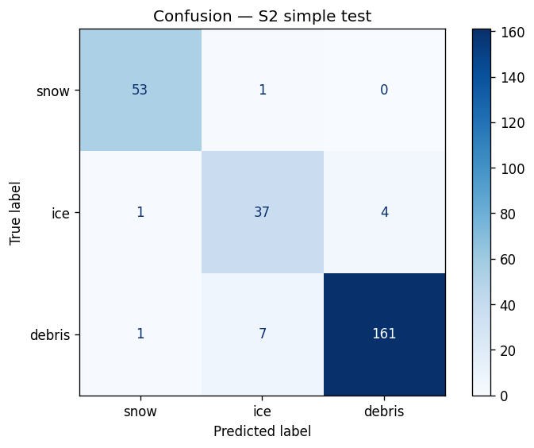
Confusion matrix on the s2_simple test set (265 patches).

7. Comparison and discussion
- Task difficulty: s2_simple classifies curated RGB patches (snow vs ice vs debris) with balanced, clean labels; Khumbu does dense per-pixel mapping over a whole mountain scene with severe imbalance and label noise.
- Why the CNN should win on Khumbu in principle: 9x9 spatial context (texture, crevasses, neighbours) on top of spectra + indices; the MLP sees only one pixel. The recorded run shows no meaningful gap only because neither model learned the minority classes.
- What to fix on Khumbu first: stronger imbalance handling (focal loss / oversampling / lower caps), more epochs or lower LR, check val-F1 curves for early-stopping behaviour, add terrain features (Copernicus DEM elevation/slope), consider a U-Net for dense prediction and multi-temporal inputs.
- AUC vs F1: per-class AUC can look high even when F1 is low since AUC measures ranking, not the decision threshold.

8. Limitations and reproducibility
- WorldCover labels are a derived product (Sentinel-1/2 based), not field survey — treat as noisy reference.
- Single post-monsoon composite (Oct–Dec 2021); no terrain or multi-season information.
- Class caps change the test-sample prior; whole-scene accuracy includes training blocks — use test-block metrics.
- Reproduce Khumbu: set DATA_SOURCE=planetary_computer (needs internet), QUICK_TEST=1 for a smoke run; config SEED 42, PATCH 9, BLOCK 64, BANDS B02/B03/B04/B08/B11/B12, EPSG 32645, RES 10.
- Reproduce s2_simple: needs data_s2/patches.csv + patch PNGs; 5 epochs on CUDA/CPU; reload check outputs/s2_simple.pt.
- Source files: sentinel2/Khumbu_Icefall_Sentinel2_Classification.ipynb (+ .bak.ipynb with original narrative), sentinel2/s2_simple.ipynb, results_summary.csv, results_per_class.csv.

