Entities

1. Tbluser
2. Bus
3. Operators
4. Route
5. Booking
6. Payment

# Entity-Relationship Diagram (ERD)



Fig.erd for bus booking system

# Relational Schema Diagram

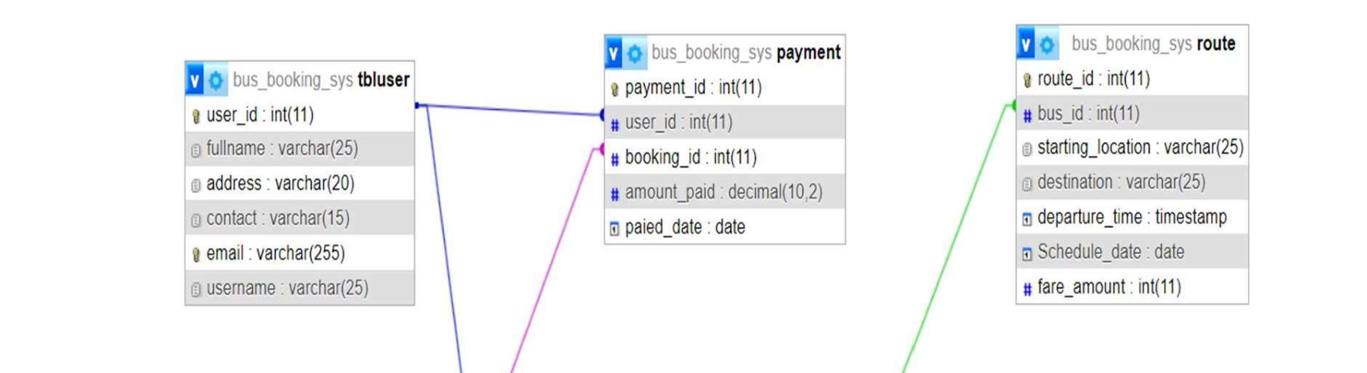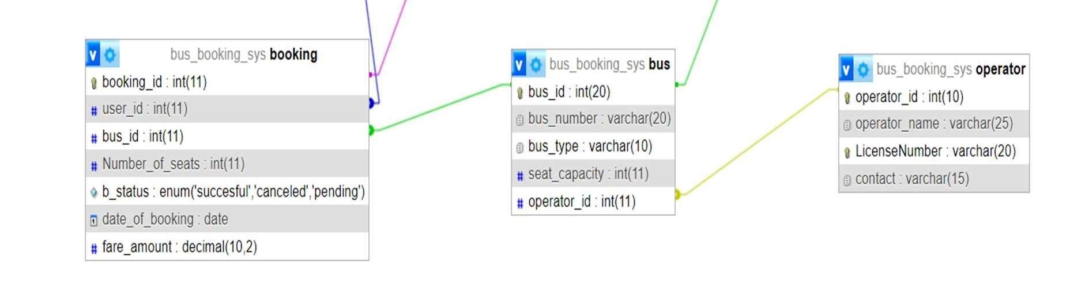

Fig.relational schema diagram