



Android project proposal

On

**Rideshare**

Submitted by: Bibek Ayadi

Batch: TP-SEPT-2019 - ‘C’

Module Leader: Kiran Rana

Contents

1 Introduction 3

a. Project introduction 3

b. Justification of the project 3

II. Problem statement 3

c. Description of the project 4

2. Aims and objective of the project 4

a. Aims of the project 4

b. Objective of the project 4

3. Development methodology 5

a. Description of the methodology (Waterfall) 5

b. Design pattern (MVC) 6

4. Configuration Management 8

5. Prototyping 9

6. Conclusion 12

7. References 13

# 1 Introduction

## a. Project introduction

Rideshare is an android mobile application that helps users to discover a ride within the spots around urban communities. The vehicle owner needs to enroll their vehicle so as to share the ride which can be free or paid relying upon an owner will. The essential idea of developing this application is that the rider does not need to go alone during travel, alongside can have companions during travel or earn either way the owner can have benefited from the ride. In addition, this assists users to save time as sitting tight for transports or maneuvers may not be simple. The application helps clients utilizing a mobile device on their hands to gets a simple ride in transit.

## b. Justification of the project

I. Background of the project

The system will be developed on an android platform through which vehicle owners have to registers their vehicles authenticated by the administrator in order to share the ride. Moreover, to book a ride user also needs to have an account on the application. The vehicle owner had to share the pick and destination point along with arrival time or can share the location on the mobile device. In addition, the ride becomes economic since the travel expenses are shared.

### II. Problem statement

In the present context with the expansion of the vehicle, the blockage of streets has been a great problem due to which it has been difficult to get a ride on time. Not only that the prices of the ride are expensive so to which the common people cannot afford to hire a ride during the travel. To maintain an environment-friendly and cheap way of traveling the rideshare application helps both the vehicle owner and user through digital media.

## c. Description of the project

Features of the project are listed as:

* **Login and registration**

The user and vehicle owner first have to verify themselves through registration and login.

* **Vehicle registration**

The owner of the vehicle has to register and verify their ride through the vehicle registration phase as authenticated by the admin.

* **Ride sharing**

The registered vehicle owner has can share the ride with pick up and destination point with time of arrival at the point. The ride can be free or paid depending on the owner will, as user can selects ride which they find suitable for.

* **Ride request**

The user can post a request a ride which is made public and vehicle owner finding the request favorable for them accepts the request.

* **Location tracking**

The ride picks up and destination point can be view on the google map shared by vehicle owner or user.

# 2. Aims and objective of the project

## a. Aims of the project

* To develop the application which helps to make the ride easy and comfortable to share.
* To secure a ride by providing an authenticated vehicle registration process.
* To make easy available of ride on time using real-time sharing of location between the riders.
* To manage vehicle and user related information during travel.

## b. Objective of the project

* To provide a vehicle owner and user an economic traveling with environment-friendly.
* To save time form waiting for vehicle to travel which may or may not be available on time.
* To make user understandable GUI which may help the user to use the application easily.

# 3. Development methodology

## a. Description of the methodology (Waterfall)

I will be using waterfall methodology to develop the application. Waterfall is the sequential process of developing application i.e. step by step process so by implementing this methodology the project tracking becomes smoother (JavaTpoint, 2019)

.

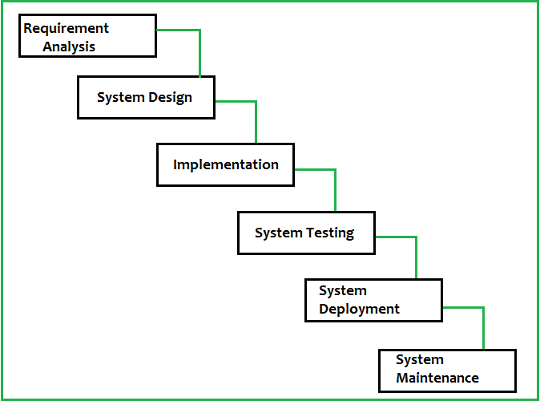

**Figure 1 Waterfall model**

**Requirements**

* The first stage of project development where requirements of the system are documented. The gathering of the requirements takes place between the developer and customer which includes through different process as interviews, questionnaires and survey.

**Design**

* The design stage means to change the necessities assembled into an appropriate structure which allows further coding in a programming language. The overall system pattern with high level and detailed structure are characterized.

**Implementation**

* The design is implemented in this stage. The documented requirements and design are implemented smoothly. Furthermore, the program is examined and modified which are tested in isolation initially to complete the system.

**System testing**

* This stage is vital as the nature of the final result is dictated by the adequacy of the testing perform during implementation. The better yield will prompt fulfilled clients, lower upkeep costs, and exact outcomes.

**Maintenance**

* During this final stage task performed by each client once the product has been conveyed to the client and introduced, securing the errands for patches, updates are carried out maintaining the system operational.

## b. Design pattern (MVC)

I will implement the MVC (Model, View, Controller) design pattern to develop the system. It isolates the user interface (View), rules and information (Model) and a connector between (Controller) to associate the model to the view.

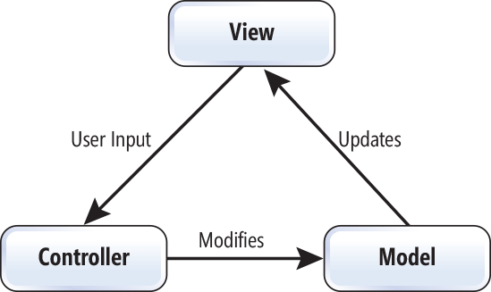

**Figure 2 MVC design pattern**

**View**

* The view of design pattern takes care of UI of the application which includes XML data’s acting as views.

**Model**

* The system information and rules are implemented in the model part of the design pattern.

**Controller**

* The intermediate between the model and view, which transfer information from model and associate the UI to view. Any changes made does not affect rules, information and vice versa (MrBool, 2019).

# 4. Configuration Management

Configuration management is the regulatory exercises concern about the creation, upkeep, controlled change and quality control of the extent of work (APM, 2019) while the project is being developed. In other words, it is a version control of the system where data and information are modified for future reference.

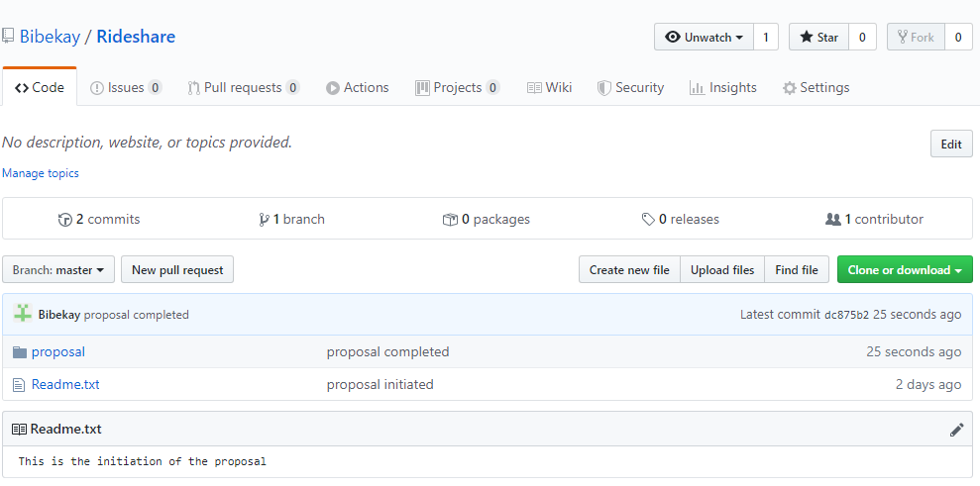

**Figure 3: Git hub link initiated for the reference**

# 5. Prototyping

Prototyping is the process of creating a design verification of a system that represents how will be developed which may not be the same as it looks when a complete system is developed.

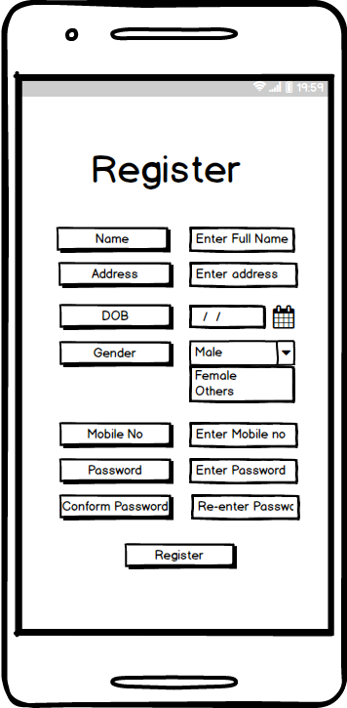

**Figure 4 User registration Prototype**

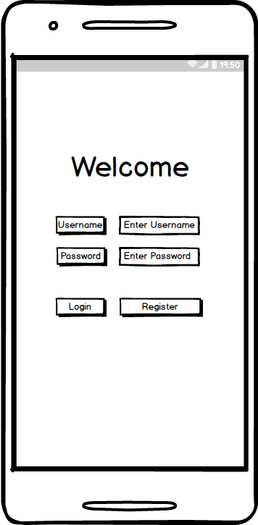

**Figure 5 Login Prototype**

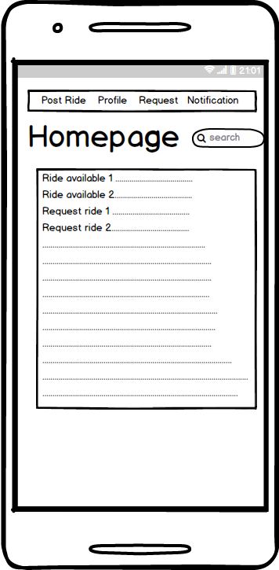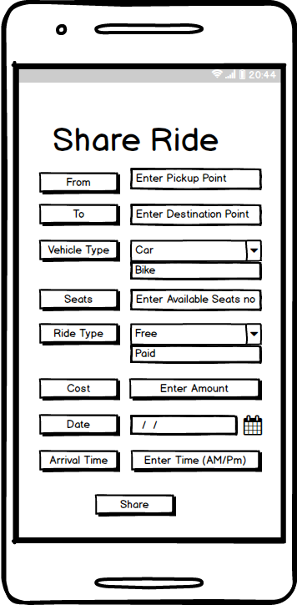

**Figure 6 Share ride Prototype**

**Figure 7 Homepage Prototype**

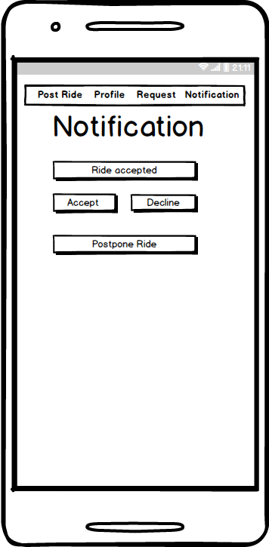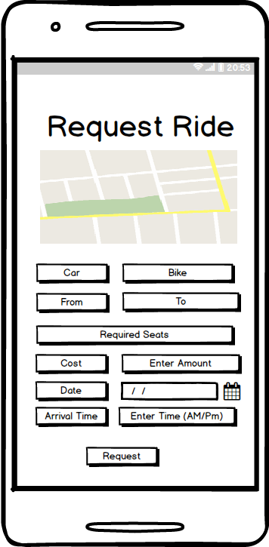

**Figure 8 Ride notification Prototype**

**Figure 9 Request ride Prototype**

# 6. Conclusion

Therefore, I have included all the details about the project development which includes project aims, objective, project configuration and prototyping which may suffice to initiate a project.

# 7. References

APM. (2019, nov 27). *APM*. Retrieved from APM: https://www.apm.org.uk/body-of-knowledge/delivery/scope-management/configuration-management/

JavaTpoint. (2019, nov 25). *JavaTpoint*. Retrieved from https://www.javatpoint.com/software-engineering-waterfall-model

MrBool. (2019, nov 26). *MrBool.* Retrieved from http://mrbool.com/android-mvc-creating-a-model-view-controller-framework-for-android/34463