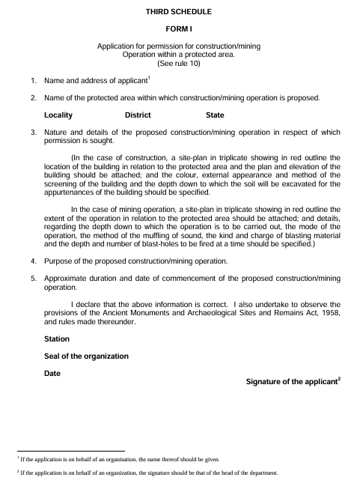
Addressed to :- The Director General, Archaeological Survey of India, Dharohar Bhawan, 24 Tilak Marg, New Delhi - 100011

