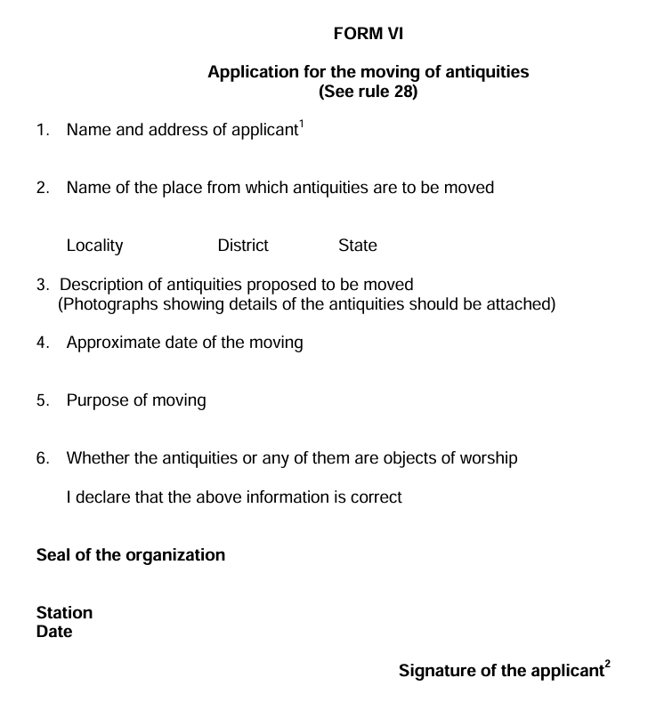

1. If the application is on behalf of an organization, the name thereof should be given.
2. If the application is on behalf of an organization, the signature should be that of the head of that organization.
Addressed to :- The Director General, Archaeological Survey of India, Dharohar Bhawan, 24 Tilak Marg, New Delhi – 100011, at least three months before the proposed date of the moving.

