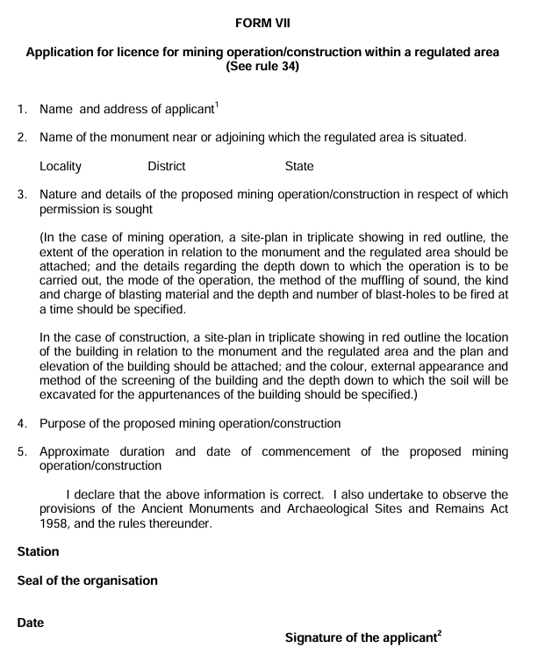

- If the application is on behalf of an organization, the name thereof should be given.
- If the application is on behalf of an organization, the signature should be that of the head of that organization.

Apply to the Director-General in Form VII at least three months before the date of commencement of such operation or construction, Addressed to: - The Director General, Archaeological Survey of India, Dharohar Bhawan, 24 Tilak Marg, New Delhi - 100011

