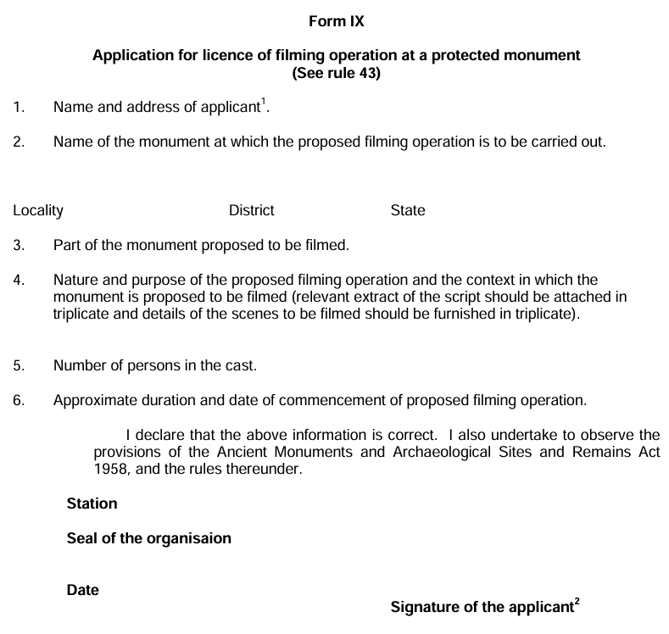

Apply to the Director-General in Form IX at least three months before the proposed date of the commencement of such operation. Addressed to :- The Director General, Archaeological Survey of India, Dharohar Bhawan, 24 Tilak Marg, New Delhi - 100011
¹If the application is on behalf of an organisation, the name thereof should be given.
²If the application is on behalf of an organization, the signature should be that of the head of that organization.

