# Appendix:

**1. A Brief Overview of Dataset** **3**

**2. Analyzing Supply and Demand of Houses In Ashbury** **5**

Summary: 6

Visualisation Technique 6

**3. Property Prices** **7**

Summary: 8

Visualisation Technique 8

**4. House Financial status** **9**

Summary: 9

Visualisation Technique 10

**5. Ownership and household information** **10**

Summary: 11

Visualisation Technique 11

**6. Workforce status** **11**

Summary: 13

Visualisation Technique 13

**7. Dwelling status** **13**

Summary: 14

Visualisation Technique 14

**8. Family information** **15**

Summary: 16

Visualisation Technique 17

**Executive Summary:** **17**

**Conclusion:** **18**

# 

# 

# 

# 

# 

# 

# 

# 

# 

# 

# 

# 

# 

# 

# 

# 1. A Brief Overview of Dataset

The dataset is collected from two different sources:

1. **Australian Bureau of Statistics (ABS) Census All persons QuickStats** for Ashbury
2. **Pricefinder**: Property Data Analytics for Australia

The dataset consists of information for the following categories:

1. Supply and Demand
2. Property price
3. House finance status
4. Population and marriage status
5. Ownership and household information
6. Workforce status
7. Dwelling status
8. Family information

ABS is Australia’s national statistical agency, which is an official source of independent, reliable information. They tell the real story of Australia, its economy and its people by bringing life and meaning to numbers. <https://www.abs.gov.au/about>

Pricefinder is a leading property intelligence platform, delivering comprehensive property data and analytics that powered businesses across Australia since 1989. It has features that make it easy to navigate data and reporting, helping produce better insights. <https://www.pricefinder.com.au/>

These sites collected various information about the above category for Ashbury, NSW area using different methods like surveys, census, scraping etc.

The main datasheet has all the information colour coded according to their categories. It has later been divided into different sheets for analysis and visualisation purposes.

The datasheet also contains missing values. Those values are either replaced by means or removed completely for analysis purposes, without harming the actual outcome.

The objective of the study is to find out whether investing in the Ashbury suburb is a good investment. This can be found by analysing various categories like property supply and demand, change in employment rate(economic activities), renting and buying trends, total income contribution towards the property(affordability), types of properties etc.

Furthermore, these 8 datasets have characters which are divided as below:

1. Supply and Demand
   1. Total Private Dwelling
   2. Median House Price
   3. Average Number of People Per Household
   4. Demand of Houses
   5. Supply of Houses
2. Property price
   1. Median House Price
   2. Households Rent Payments compared with Income
   3. Households Mortgage Repayments compared with Income
3. House finance status
   1. Median Personal Weekly Income
   2. Median Family Weekly Income
   3. Median Household WeeIkly Income
   4. Median Mortgage Weekly Payment
   5. Median Weekly Rent
4. Population and marriage status
   1. Population
   2. Median Age
   3. Birth In Australia
5. Ownership and household information
   1. Fully Owned
   2. Owned With Mortgage
   3. Rented
6. Workforce status
   1. Worked full-time
   2. Worked part-time
   3. Unemployment
   4. Less Than $650 Weekly Income
   5. More Than $3000 Weekly Income
7. Dwelling status
   1. Total Private Dwelling
   2. Occupied Dwellings
   3. Unoccupied Dwelling
   4. Separate House
   5. Semi-Detached House
   6. Flat Unit Apartment
8. Family information
   1. Families
   2. Couple Family No Children
   3. Couple Family Has Children
   4. One Parent Family
   5. Other Family

Note: Additional variables have been created from the above categories for the analysis proposes.

The dataset has quantitative data of categorical variables for analysis. These data have been collected for over 20 years, in five groups: 2001, 2006, 2011, 2016 and 2021.

After analysis of all the variables involved through tables, charts and other visualization techniques, a recommendation would be made on weather to invest in Ashbury suburb or not.

# 2. Analyzing Supply and Demand of Houses In Ashbury

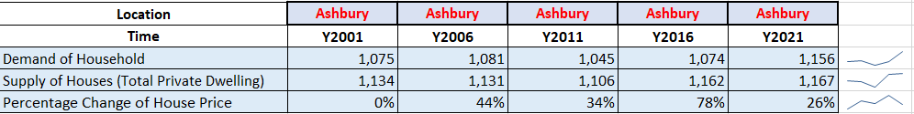

**Graph: 1**

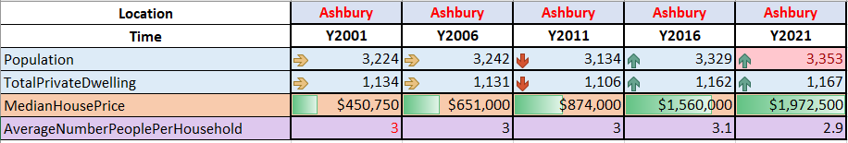

**Graph: 2**

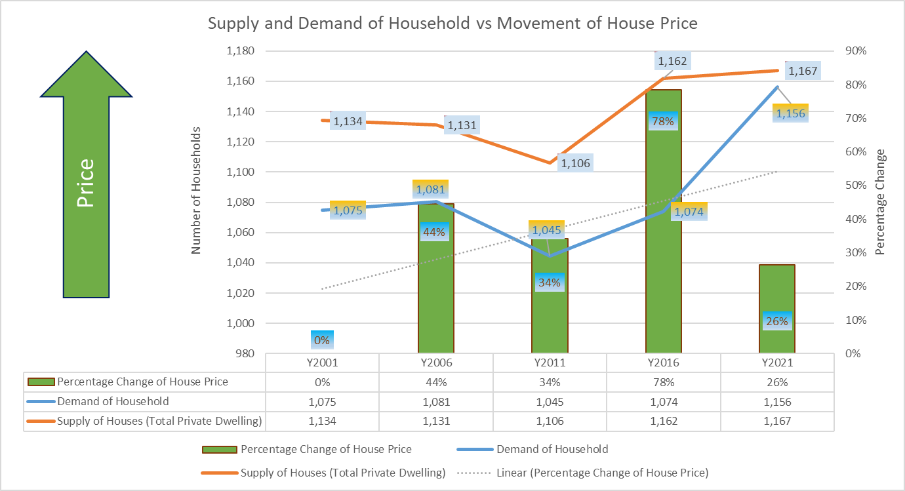

**Graph: 3**

## Summary:

* Analysis of the Supply and Demand of House Prices is attempted here.
* Even though there was a huge gap between the demand and supply of houses back in 2001, now they are at the same level. There's a huge jump in supply for household from 1106 to 1167 ie 5.51% and an even bigger jump in demand from 1015 to 1156 13.89% from year 2011 to 2021. This is due to increment in the household prices by 78%.
* Now, for 2026, the demand for the household may not increase as much or even decrease because the property growth for 2021 has been all time low at 26%. So, it maynot be a good time to invest.

## Visualisation Technique

**Graphs 1 and 2** are colour coded to match the category from the main data sheet. Further conditional formattings like Icon Set and Data bars have been used along with sparkline to have a better understanding of the data.

A combination chart is ideal when there are variables with 2 or more 2 formats. For **Graph 3**, the Change in House price is evaluated in percentage as a clustered column along the right vertical axis; the Demand and Supply of households are evaluated in numbers as a line chart along the left vertical axis. A trendline for House Prices shows us the change in the movement of House Prices.

The Chart Title, Axis Titles, Data Labels, Data Table, Legend, Color Coded Gradient, and Arrows with summaries have been added for better visuals and enhanced understanding of the chart.

# 3. Property Prices

**Graph: 4**

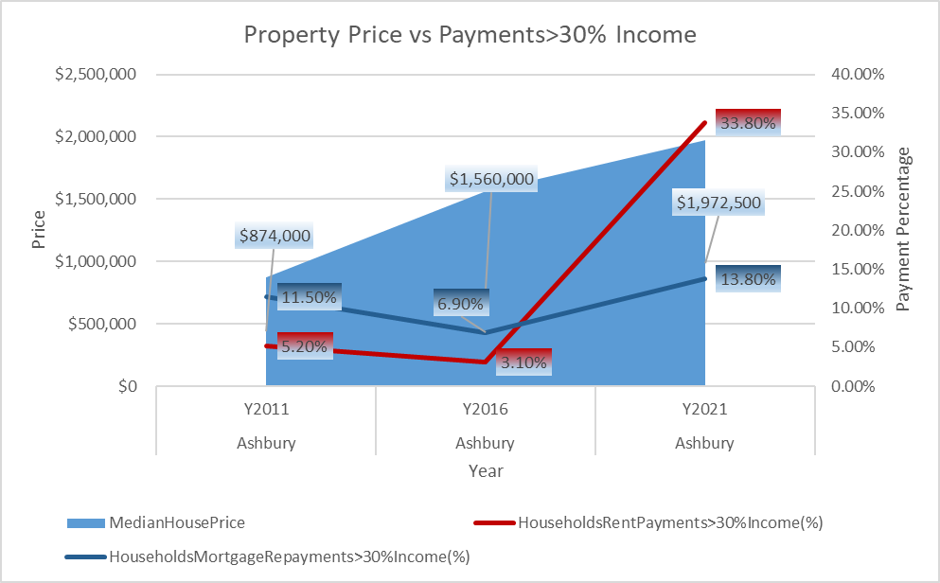

**Graph:5**

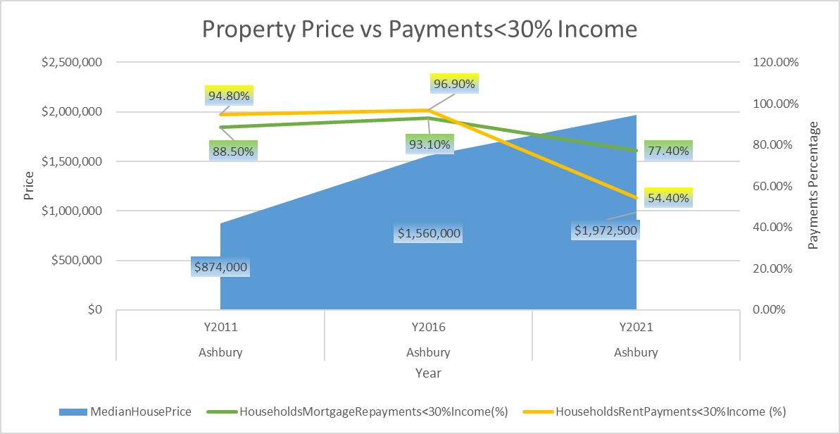

**Graph:6**

## Summary:

* Analysis of the Property Prices is attempted here.
* As the property price increases, the Mortgage Repayments and the Rent Payments also increases. But the increment in rent payments is higher compared to mortgage repayments.
* The rent prices rose sharply from the year 2016 to 2021.
* It is better to buy a property as property prices keep on increasing(good for capital gains) and the mortgage repayments comparatively increase less as compared to rents.

## Visualisation Technique

Graph 4 is colour coded and has conditional formatting as colour scales where Green represents the highest value, red represents the lowest value and yellow represents the value in between.

Here, Graphs 5 and 6 are combination charts where the Median House Price is evaluated in dollar value as a Stacked Area along the left vertical axis; Households Mortgage repayments and Rent Payments are evaluated in percentage as a line chart along the right vertical axis.

The Chart Title, Axis Titles, Data Labels, Legend and Color Coded Gradient with summaries have been added for better visuals and enhanced understanding of the chart.

# 4. House Financial status

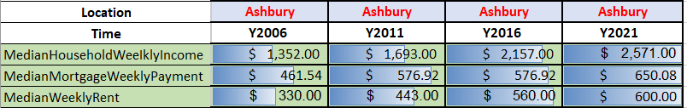

**Graph: 7**

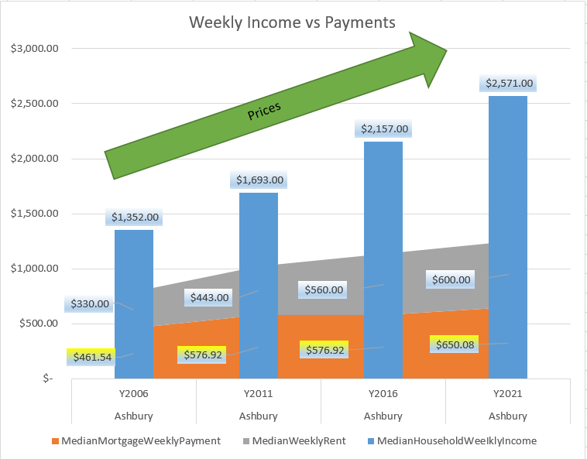

**Graph: 8**

## Summary:

* Analysis of the House Finance Status is attempted here.
* All of the variables ie Median Household Weekly Income, Median Mortgage Weekly Payments and Median Weekly Rent increase from 2006 to 2021. But the Household Weekly **Income** increased by **90.16%**, Median **Mortgage** Weekly Payments increased by **40.85%** and Median Weekly **Rent** increased by **81.81%**.
* According to these stats, the weekly rent payment will be more than the weekly mortgage payments.

## Visualisation Technique

**Graph 7** is colour coded to match the category from the main data sheet. Further conditional formatting ie Data bars have been used to have a better understanding of the data.

For **Graph 8**, a combination chart has been used where the Median Weekly Mortgage Payment and Median Weekly rent is plotted as a Stack Area chart and Median Household Weekly Income is plotted as Clustered Column. All of these variables are plotted along the same vertical and horizontal axis.

The Chart Title, Data Labels, Legend, Color Coded Gradient, and Arrows with summaries have been added for better visuals and enhanced understanding of the chart.

# 5. Ownership and household information

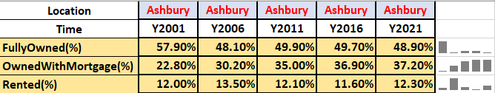

**Graph: 9**

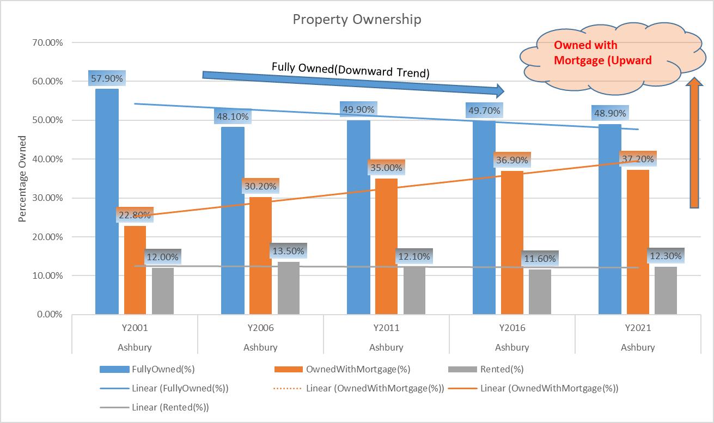

**Graph: 10**

## Summary:

* Analysis of the Ownership and Household Information is attempted here.
* The fully owned properties are in decreasing whereas property owned with mortgage is increasing. The properties that are rented is somewhat unchanged. The fully owned property went down by 15.54% whereas the property owned with mortgage increased by 63.15% from year 2001 to 2021.
* These changes could be because as the property price increased according to Graph 3, people had more equity and they might have refinanced to pay their other loan with higher interest rate or to buy another investment property etc.

## Visualisation Technique

**Graph 9** is colour coded to match the category from the main data sheet. Further Sparkline i.e Columns has been used to have a better understanding of the data.

For **Graph 10**, a Clustered Column chart has been used where all the variables are plotted along the same vertical and horizontal axis. A trendline for the variables shows us the movement of Property Ownership.

The Chart Title, Axis Titles, Data Labels, Legend, Color Coded Gradient, and Arrows with summaries have been added for better visuals and enhanced understanding of the chart.

# 6. Workforce status

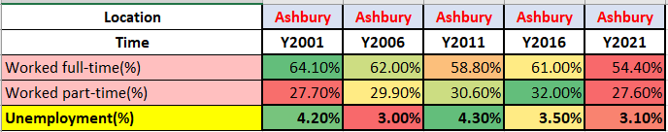

**Graph: 11**

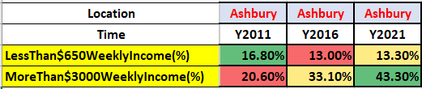

**Graph: 12**

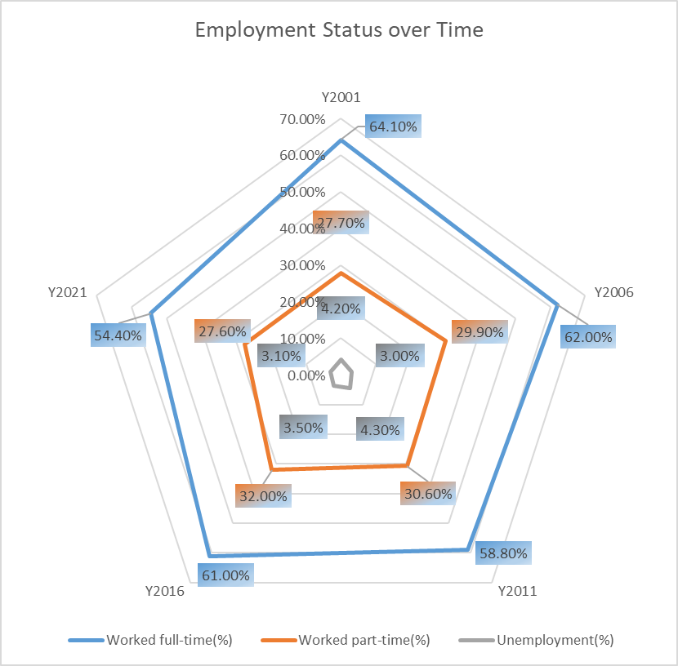

**Graph: 13**

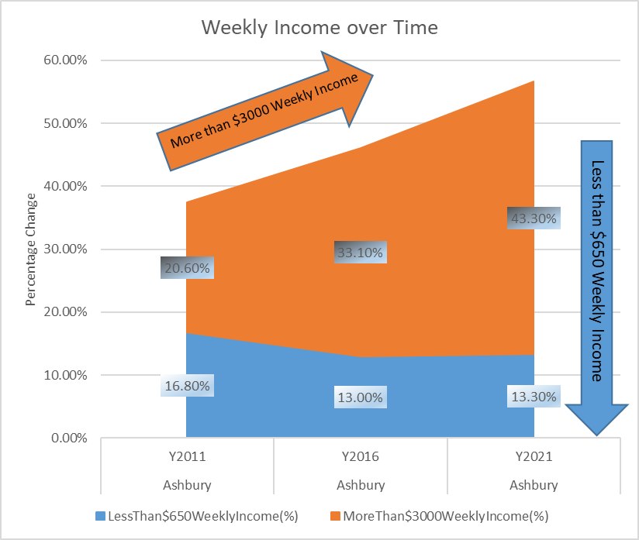

**Graph: 14**

## Summary:

* Analysis of the Workforce Status is attempted here.
* The percentage of the working groups is at an all-time low in 2021 and employment is also low in 2021, **this is an anomaly in the data.**
* Graph 14 shows that there is an increment in a number of people earning more than $3000 weekly every year from 2011 to 2021, and decrement in the number of people earning less than $650 a week. This shows good economic growth in the area.

## Visualisation Technique

**Graphs 11 and 12** are colour coded and have conditional formatting as colour scales where Green represents the highest value, red represents the lowest value and the colour shades change from green to red as the value decreases and vice versa.

Graph 13 is a Radar Chart. It's used to analyze the multivariate data ie the percentage of people who work full-time, part-time and are unemployed.

Graph 14 is a Stacked Area chart where Less than $650 Weekly Income % and More than $3000 Weekly Income % are plotted along the same vertical and horizontal axis.

The Chart Title, Axis Titles, Data Labels, Legend, Color Coded Gradient, and Arrows with summaries have been added for better visuals and enhanced understanding of the chart.

# 7. Dwelling status

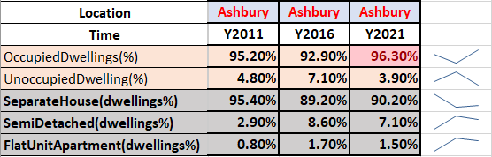

**Graph: 15**

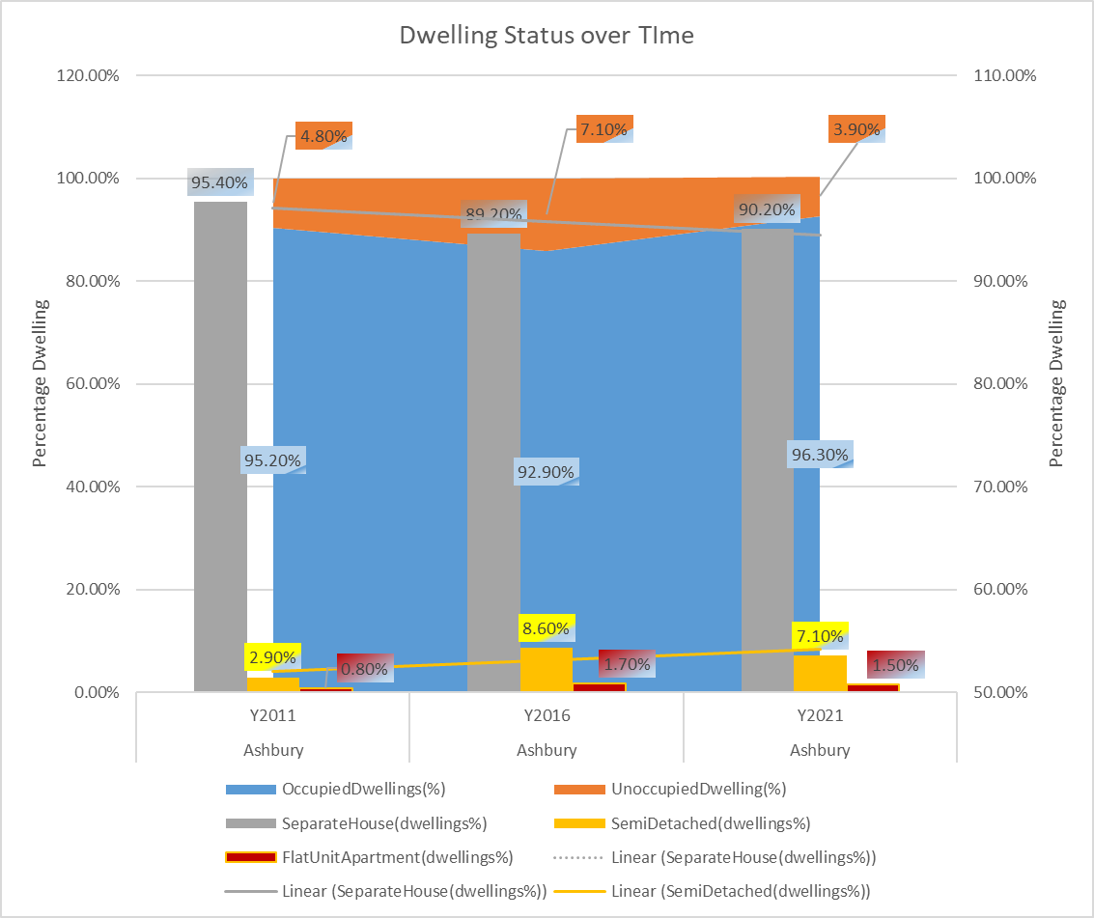

**Graph: 16**

## Summary:

* Analysis of the Dwelling Status is attempted here.
* The percentage of Occupied Dwelling has increased by 1.15% and percentage of the unoccupied dwelling has decreased by 18.75%.
* The Separate House Dwelling percentage increased by 1.12%, the Semi-Detached Dwelling percentage decreased by 17.44% and Flat Unit Apartment Dwelling percentage decreased by 11.76% from the year 2016 to 2021.

## Visualisation Technique

**Graph 15** is colour coded to match the category from the main data sheet. Further sparkline is added to have a better understanding of the data.

For **Graph 16**, a combination chart has been used where Occupied Dwelling and Unoccupied Dwelling is plotted as a Stack Area chart along the right vertical axis and Separate House, Semi-Detached House and Flat Unit Apartment is plotted as Clustered Column along the left vertical axis.

The Vertical axis is also rescaled for better comparison of the data.

The Chart Title, Axis Titles, Data Labels, Legend and Color Coded Gradient have been added for better visuals and enhanced understanding of the chart.

# 8. Family information

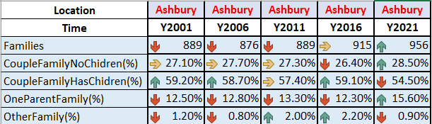

**Graph: 17**

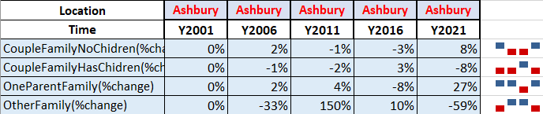

**Graph: 18**

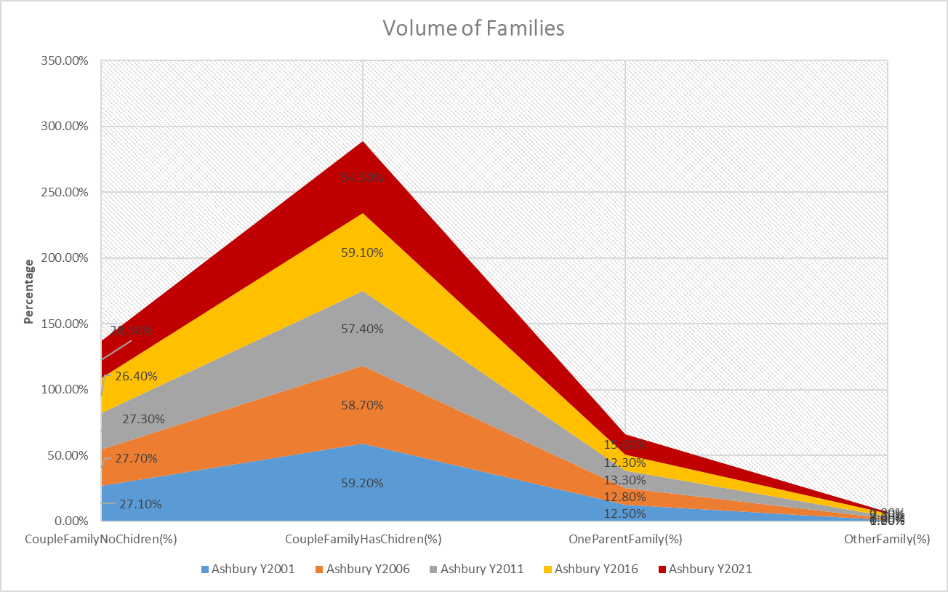

**Graph: 19**

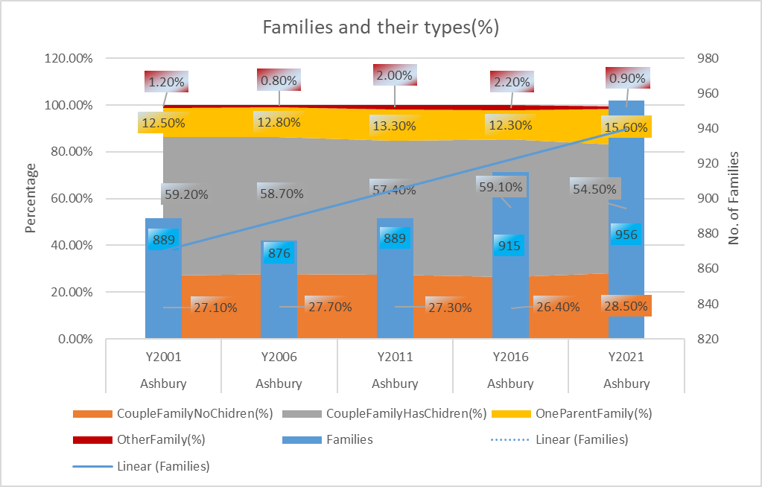

**Graph: 20**

## Summary:

* Analysis of the Family Information Status is attempted here.
* The number of families living in Ashbury has changed from 915 to 956 which is an increment of 4.48% from 2016 to 2021.
* The Couple Family with children has the highest volume in Ashbury followed by Couple Family with no children and One Parent Family. The Other Family has the lowest volume according to Graph 19
* The Couple Family with children increased by 8%, Couple Family with no children decreased by 8%, One Parent Family increased by 27% and The Other Family decreased by 59% from 2016 -2021.

## Visualisation Technique

**Graphs 17 and 18** are colour coded to match the category from the main data sheet. Further conditional formattings like Icon Set are used along with Win/Loss Sparklines to have a better understanding of the data.

Graph 19 is a Stacked Area Chart that compares the volume of the family types across different years.

Graph 20 is a Combination Chart where Families is plotted as a Clustered Column chart along the right vertical axis as numbers and Couple Family with and without CHildren plus One parent family is plotted along the left vertical axis as a percentage

A trendline for Families shows us the upward trend for Families.

The Chart Title, Axis Titles, Data Labels, Legend, and Color Coded Gradient have been added for better visuals and enhanced understanding of the chart.

# 9. Population Information

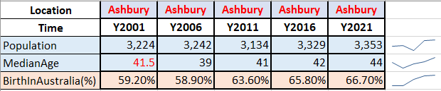

**Graph 21**

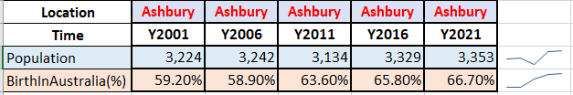

**Graph 22**

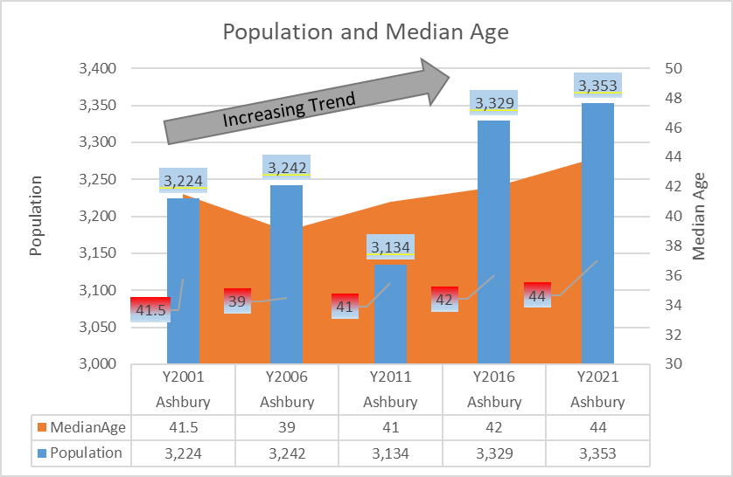

**Graph 23**

## Visualisation Technique

**Graphs 21 and 22** are colour coded to match the category from the main data sheet. Further conditional formattings like Icon Set are used along with Win/Loss Sparklines to have a better understanding of the data.

Graph 13 is a Combination Chart of Stacked Area Chart and Clustered Column that compares Median Age with Population..

The Chart Title, Axis Titles, Data Labels, Legend, and Color Coded Gradient have been added for better visuals and enhanced understanding of the chart.

# Executive Summary:

Data visualization is the study of the visual representation of data, and “information that has been abstracted in some schematic form, including attributes or variables for the units of information (Friendly, 2008)”.​

When the dataset was collected, it had very little to no value. After carefully categorizing the data into 8 different categories and using different visualization techniques we were able to make the data meaningful. The charts used for the analysis are Stacked Column, Line, Stacked Area, Databar, Sparkline, Conditional Formatting, Trendline, Radar Chart etc. These charts in combination with the Chart Title, Axis Titles, Data Labels, Data Table, Legend, and Color Coded Gradient and Arrows with summaries have been added for better visuals and enhanced understanding of the chart.

# Conclusion:

The investor should look to buy a property because of the following reasons:

| Analysis | Invest(Y/N) | Reason |
| --- | --- | --- |
| Supply and Demand | N | the property growth for 2021 has been all time low at 26% |
| Property price | Y | better to buy a property as property prices keep on increasing(good for capital gains) and the mortgage repayments comparatively increase less as compared to rents. |
| House finance status | Y | the weekly rent payment will be more than the weekly mortgage payments which are good for an investor who owns to rent the property |
| Population and marriage status | Y | Increment in population means more demand |
| Workforce status | Y | Higher income means higher affordability means higher rent |
| Family information | Y | Increment in the family means more demand long term renter and more demand for property |